Annexure 3b — Complete Filing
INVENTION DISCLOSURE FORM
1. TITLE
System and Method for Cause-Attributed Adaptation Gating in On-Device Machine Learning, Comprising Unlabeled Disambiguation of Sensor Faults from Genuine Concept Drift via Cross-Channel Coherence, Temporal-Signature, and Plausibility-Prior Fusion, and Cause-Conditioned Routing of Model-Update Operations
2. INTERNAL INVENTOR(S) / STUDENT(S)
All fields in this column are mandatory to be filled.
A. Full name | Ankita Maji
Mobile Number | 9307014709
Email (personal) | ankitamaji7033@gmail.com
UID/Registration number | 12319054
Address of Internal Inventors | Lovely Professional University, Punjab-144411, India
Signature (Mandatory)

A. Full name | Lalith Gona
Mobile Number | 8184844141
Email (personal) | gonalalith2005@gmail.com
UID/Registration number | 12308280
Address of Internal Inventors | Lovely Professional University, Punjab-144411, India
Signature (Mandatory)

EXTERNAL INVENTOR(S): (INVENTORS NOT WORKING IN LPU)
A. Full name
Mobile Number
Email
UID
Address of External Affiliations
Signature (Mandatory)
3. DESCRIPTION OF THE INVENTION
Disclosed herein are a system and method for governing the online adaptation (self-learning or model updating) of a machine-learning model executed on a resource-constrained device coupled to one or more sensors. When the statistical distribution of sensor-derived inputs or the model's outputs changes following deployment, the disclosed system does not immediately initiate retraining or model adaptation. Instead, a Cause-Attributed Adaptation Gate (CAAG), implemented by hardware-executable instructions, first determines the underlying cause of the observed change without requiring ground-truth labels.
More specifically, the CAAG differentiates between: (a) a sensor fault or measurement artifact, including electrode or contact degradation, motion or vibration artifacts, transducer gain or offset drift, channel dropout, sensor displacement or repositioning, signal saturation, or environmental contamination; and (b) genuine concept drift, corresponding to an actual change in the underlying phenomenon being modelled, such as variations in a subject's physiology, behaviour, operating conditions, or surrounding environment.
The cause determination is obtained by combining three complementary, label-free sources of evidence: a Cross-Channel Coherence Signature (CCS), a Temporal Signature (TSS) descriptor, and a Plausibility Prior Manifold (PPM) consistency score. These evidence channels are fused to generate a posterior probability associated with the identified cause, together with a corresponding confidence value.
Based on the determined cause, the system performs cause-conditioned routing. If the observed change is attributed to a sensor fault, model adaptation is suppressed, and one or more corrective actions, including channel masking or recalibration, are initiated. If the observed change is attributed to genuine concept drift with sufficient confidence, the system authorizes a Guarded Bounded Adaptation (GBA) update while maintaining a rollback safeguard to preserve model integrity. If the root cause of the problem cannot be determined, or the credibility of the existing evidence fails to meet the preset standard, the system will not rashly adjust its own state. It cannot arbitrarily modify its operating logic based on ambiguous judgments; it will first switch to the relative change tracking mode, in which it will faithfully record all fluctuations in relevant numerical values. Only after collecting enough new information to fully resolve the previous uncertainty and clarify the root cause of the problem will it proceed to the next step.
This process will generate a control signal that handles the local device model updates being executed by the processor as needed. This signal has full authority: it can initiate an update, halt an update, limit the scope of an update, and even roll back an update that has been partially carried out to restore the state before the update, preventing the problematic update from disrupting the normal operation of the device.
In some specific design schemes, the system will additionally output a machine-readable health telemetry data stream. This data stream is exclusively prepared for monitoring programs, and it encapsulates the previously determined root cause of the problem, the credibility value of the corresponding cause, and the respective reliability weight of each channel. All this content is packaged in the stream, specifically for state monitoring to facilitate subsequent troubleshooting and verification at any time.
3.1. PROBLEM ADDRESSED BY THE INVENTION
Once these models are put into practical use, the statistical patterns of the new data sent back by subsequent sensors will definitely differ from those of the dataset used for model training. When a model is newly completed and not yet officially put into use, it is first trained on a fixed set of data to learn the tasks it needs to complete, and that training dataset has its own set of statistical patterns. When the model is actually installed on a device and starts operating, the new data continuously transmitted by sensors has long had statistical patterns that differ from those during training, and such deviation is bound to occur.
There are only two completely distinct root causes for this type of data distribution shift. The mitigation methods corresponding to each cause are different, and in many cases even completely opposite, making them impossible to mix and use.
- Genuine concept drift — True concept drift — the underlying real-world phenomenon that the model originally intended to model has itself actually changed. The purpose of building the model is to reproduce a real existing phenomenon; if that real phenomenon itself undergoes a substantial change, this situation is called true concept drift. For example, changes in a user's physical state, activity type, or the operating conditions of the device all fall into this category.
- Sensor fault / measurement artifact — The underlying phenomenon being modelled remains unchanged; however, the acquired measurements become corrupted due to factors such as a loose electrode, motion artifacts, perspiration, transducer drift, channel dropout, sensor displacement, or other measurement errors. In such circumstances, the appropriate response is to suppress model adaptation. Adapting the model using corrupted measurements causes the model to learn erroneous representations, resulting in silent degradation of model performance and, in devices that update model parameters in place, potentially irreversible corruption of the deployed model.
- The primary technical challenge addressed by the present invention is that existing on-device adaptation and drift-detection mechanisms respond solely to the observable symptom of a distributional change in the input data or model outputs without determining the underlying cause of the change. We noticed that because of this these mechanisms cannot tell the difference, between a concept drift and a sensor fault or a measurement artifact. As a result, these mechanisms use one generic response. Usually, this response means that this model is retrained or adapted whenever a distribution shift is detected.
- This approach that does not focus on the cause leads to two problems. First the model might be changed because of a short-term sensor problem or a mistake in the measurements, which makes a model that was working well start to perform. This kind of performance often happens without anyone noticing because the change happens without any clear error message or warning. Second the model might not be updated in time when there is a change in the data or situation because the system is too careful and thinks the change is just from measurement mistakes. This makes the model stop being up, to date and its ability to predict things correctly gets worse over time.
- I find that the challenge is even bigger on edge and wearable devices. On these devices we rarely have ground-truth labels after deployment. We have tight limits, on computing power, memory and energy. Also, the patterns that come from sensor glitches and measurement noise often look like real concept drift making it hard to differentiate them using normal distribution-shift detection methods.
Existing approaches each present significant limitations:
- Statistical / sequential concept-drift detectors: These methods detect significant distribution shifts and once they confirm a shift, they usually start model retraining or adaptation. They do not find out why the shift happened. In environments where label scarce, these methods normally need labelled data to update or refit the model. On-device approaches that are representative of this category openly admit that the need, for labelled data is a practical limitation.
- Sensor-fault detection / correction systems: These systems look for. Sort out problems with sensors or devices that send signals. They use rules that are set ahead of time between sensors. Then they fix the signals. Make adjustments. These systems think that the real-world rules never change. So, when things don't match what is expected they say there is a sensor problem. Because of this these systems don't consider changes, over time. They also don't have a way to control how the model changes based on what caused the change.
- Test-time / unsupervised domain adaptation: These approaches perform model adaptation using test or deployment data but remain vulnerable to corrupted or adversarial data batches that may destabilize or degrade the deployed model. Furthermore, these approaches treat the sensing subsystem as a black-box input source provide no way to find the cause of an observed distribution shift and lack a principled framework, for deciding whether model adaptation should be allowed or stopped.
- Production ML monitoring / anomaly detectors: These systems look for situations where a deployed machine-learning model no longer matches the data that is observed. These systems do not discover the reason, behind the deviation. These systems are mainly intended for server-side deployment. These systems often rely on labelled data or label-assisted performance monitoring.
There exists no on-device, label-free mechanism capable of diagnosing the underlying cause of a post-deployment distribution change and selectively routing the model-adaptation decision based on the diagnosed cause. The present invention addresses this technical problem.
3.2. OBJECTIVE OF THE INVENTION
Objective 1 — To provide a device-resident Cause-Attributed Adaptation Gate (CAAG) (see Figure 1) configured to intercept the model-update pathway such that, upon detection of a distributional change, execution of a model-update operation is deferred until the underlying cause of the detected change has been determined, thereby preventing cause-blind model adaptation.
Objective 2 — To provide a label-free cause-attribution engine configured to fuse three complementary evidence channels, namely a Cross-Channel Coherence Signature (CCS), a Temporal Signature (TSS) descriptor, and a Plausibility Prior Manifold (PPM) consistency score, to generate a posterior probability corresponding to the underlying cause together with an associated confidence value, without requiring ground-truth labels for post-deployment or field-acquired data.
Objective 3 — To provide a cause-conditioned routing controller (ARR) configured to map the attributed cause and the associated confidence value to corresponding model-management actions, comprising: (i) when the attributed cause is a sensor fault or measurement artifact, performing channel masking or recalibration while suppressing model adaptation; (ii) when the attributed cause is genuine concept drift with a confidence value exceeding a predetermined threshold, permitting a Guarded Bounded Adaptation (GBA) update while maintaining rollback capability; and (iii) when the attributed cause is ambiguous or associated with insufficient confidence, deferring model adaptation and initiating a relative-change tracking mode.
Objective 4 — To provide a Guarded Bounded Adaptation (GBA) mechanism configured to constrain each permitted model update, maintain an adaptation trust budget, and monitor an unlabeled task-health proxy such that any update determined to degrade model performance is automatically rolled back, thereby preserving model integrity.
Objective 5 — To provide a machine-readable health-telemetry output comprising the attributed cause, the associated confidence value, and per-channel reliability weights, the health-telemetry output being configured for use by downstream systems, including fleet monitoring, maintenance scheduling, and clinical alert gating.
3.3. STATE OF THE ART / RESEARCH GAP / NOVELTY
The present invention is distinguished from the prior art by four system-level architectural innovations. First, the invention introduces a cause-attributed adaptation gate into the model-update pathway such that model adaptation is conditioned on the diagnosed cause of a detected distributional change rather than solely on the occurrence of the distributional change itself. Second, the invention provides a label-free tri-evidence fusion framework that combines a Cross-Channel Coherence Signature (CCS), a Temporal Signature (TSS) descriptor, and a Plausibility Prior Manifold (PPM) consistency score to generate a posterior probability corresponding to the underlying cause. In particular, the framework utilizes cross-channel coherence as a discriminating feature to distinguish a channel-localized sensor fault from channel-coherent genuine concept drift, thereby departing from the conventional assumption employed by prior sensor-fault detection systems that every cross-channel inconsistency necessarily indicates a sensor fault. Third, the invention performs cause-conditioned routing, whereby different attributed causes are selectively mapped to corresponding model-management actions. Fourth, the invention provides a guarded, bounded, and rollback-protected model adaptation mechanism that operates within a defined adaptation trust budget and is governed by an unlabeled task-health proxy to ensure that only validated adaptation updates are retained.
Sr. | Patent / Publication ID | Prior Method (Abstract) | Research Gap | System-Level Difference (Novelty)
1 | US10578667B2 | Detects, classifies (bias/drift/spike/stuck) and mitigates sensor error using pre-defined inter-sensor “system equations”. | Assumes physical relationships are constant; attributes every inconsistency to a sensor fault. No concept of legitimate drift; pre-defined equations; signal correction, not ML-adaptation gating. | Uses cross-channel coherence to disambiguate a localized fault from a coherent genuine drift, and routes the ML model-update accordingly (suppress vs. guarded-adapt).
2 | US20200285997A1 | Near real-time ML anomaly detection on multi-sensor streams; retrains when the model no longer fits recent data. | No root-cause attribution (fault vs. drift); retrains cause-blind on any degradation; not fully unsupervised; no cross-sensor coherence for fault isolation. | Interposes an unlabeled cause-attribution gate before any retraining decision, preventing corruption from retraining on transient faults.
3 | Yamada & Matsutani, 2022 (arXiv:2212.09637) | Active/supervised sequential monitor of prediction-confidence distribution; retrains on confirmed drift; for low-end edge devices. | Author-acknowledged reliance on labels for retraining; treats any confidence shift as drift; no fault-vs-drift disambiguation; single-stream. | Unlabeled attribution and cause-conditioned action; multi-channel coherence attribution rather than single-stream thresholding.
4 | STUDD, 2021 (arXiv:2103.00903) | Student-teacher unsupervised drift detection; disagreement used as an unlabeled drift signal. | Provides an unlabeled change signal only; no cause attribution; no fault-vs-drift routing; no guarded adaptation with rollback. | Adds cause attribution and cause-conditioned, budgeted, rollback-protected adaptation on top of any unlabeled change trigger.
5 | Robust TTA line, e.g. MedBN 2024 (arXiv:2403.19326) | Test-time adaptation hardened against corrupted/adversarial test samples. | Black-box sensor; no explicit cause attribution, no per-channel reliability isolation, no principled withhold-adaptation decision keyed to a diagnosed fault. | Diagnoses why a batch is corrupted (which channel; transient vs. persistent; on/off manifold) and withholds or bounds adaptation, with trust budget and rollback.

Statement of Novelty and Inventive Step. Each individual component of the present invention, including drift detection, inter-sensor consistency checking, test-time adaptation, and anomaly monitoring, is known in the art. The inventive step resides in the non-obvious combination and functional inversion of these components. Conventional sensor-consistency systems operate on the assumption that a violation of an inter-sensor relationship indicates a sensor fault and, accordingly, provide no mechanism for permitting model adaptation when such a violation occurs. In contrast, the present invention interprets a coherent cross-channel change as evidence of genuine concept drift and, within that decision branch, selectively enables a guarded model-update operation. No cited reference teaches or suggests controlling an on-device model-update operation based on an unlabeled cause diagnosis. The resulting capability to prevent silent, irreversible model corruption in label-free devices provides a system-level technical advantage over the closest combined prior art.
Overall System Architecture and End-to-End Processing Pipeline
The disclosed invention may be understood, at a high level, as a sequential processing pipeline that transforms raw sensor signals into governed machine-learning model-update decisions. Before the individual modules are described in detail, the following overview outlines the end-to-end flow of information through the system and the governing principle that detection of a distributional change initiates a cause-diagnosis process rather than immediate model adaptation.
Referring to Figure 9, raw signals acquired from one or more sensors—for example, electrocardiogram, photoplethysmography, camera, inertial, or vibration channels—are received by a data acquisition layer and provided to a preprocessing and feature-extraction stage. The resulting features are monitored by a Change Trigger (CT), which generates an unlabeled shift indication when the input or output distribution departs from a reference distribution. The shift indication activates the Cause-Attributed Adaptation Gate (CAAG), comprising the Cross-Channel Coherence Signature (CCS), the Temporal Signature (TSS), the Plausibility Prior Manifold (PPM), and a Cause-Attribution Fusion (CAF) module. Collectively, these components determine, without requiring ground-truth labels, whether the detected change is attributable to a sensor fault or to genuine concept drift.
The attributed cause and the associated confidence value are provided to an Adaptation Routing and Response (ARR) controller, which selects one of three operational branches—sensor fault, genuine concept drift, or ambiguous state—and thereby generates a model-update control signal. When model adaptation is authorized, a Guarded Bounded Adaptation (GBA) executor performs a bounded, trust-budgeted, and rollback-protected model update to produce an updated model. When the attributed cause is a sensor fault, model adaptation is suppressed, and the affected channel is masked or recalibrated. When the cause is determined to be ambiguous, model adaptation is deferred in favour of relative-change tracking. The updated model subsequently performs inference and emits a health-telemetry stream, which may optionally be synchronized with a cloud or enterprise application programming interface as described in Section 3.6. Figure 10 illustrates the corresponding runtime decision flow. The individual modules summarized in this overview are described in detail in the sections that follow.
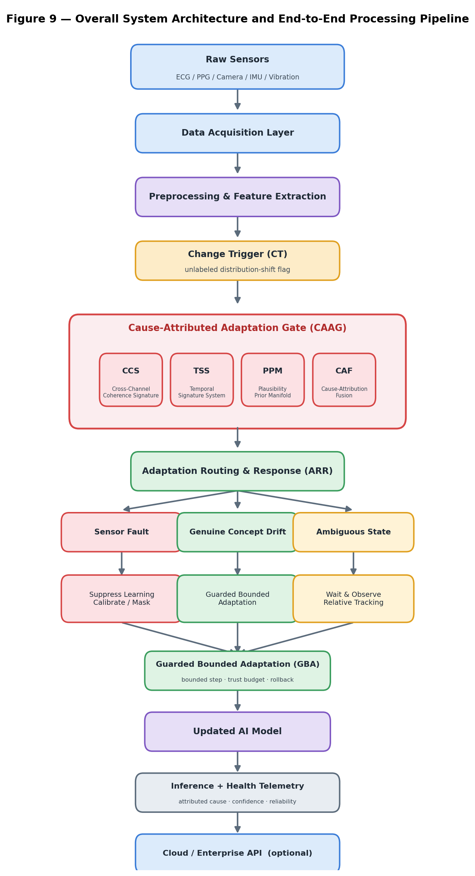
Figure 9 — Overall System Architecture and End-to-End Processing Pipeline
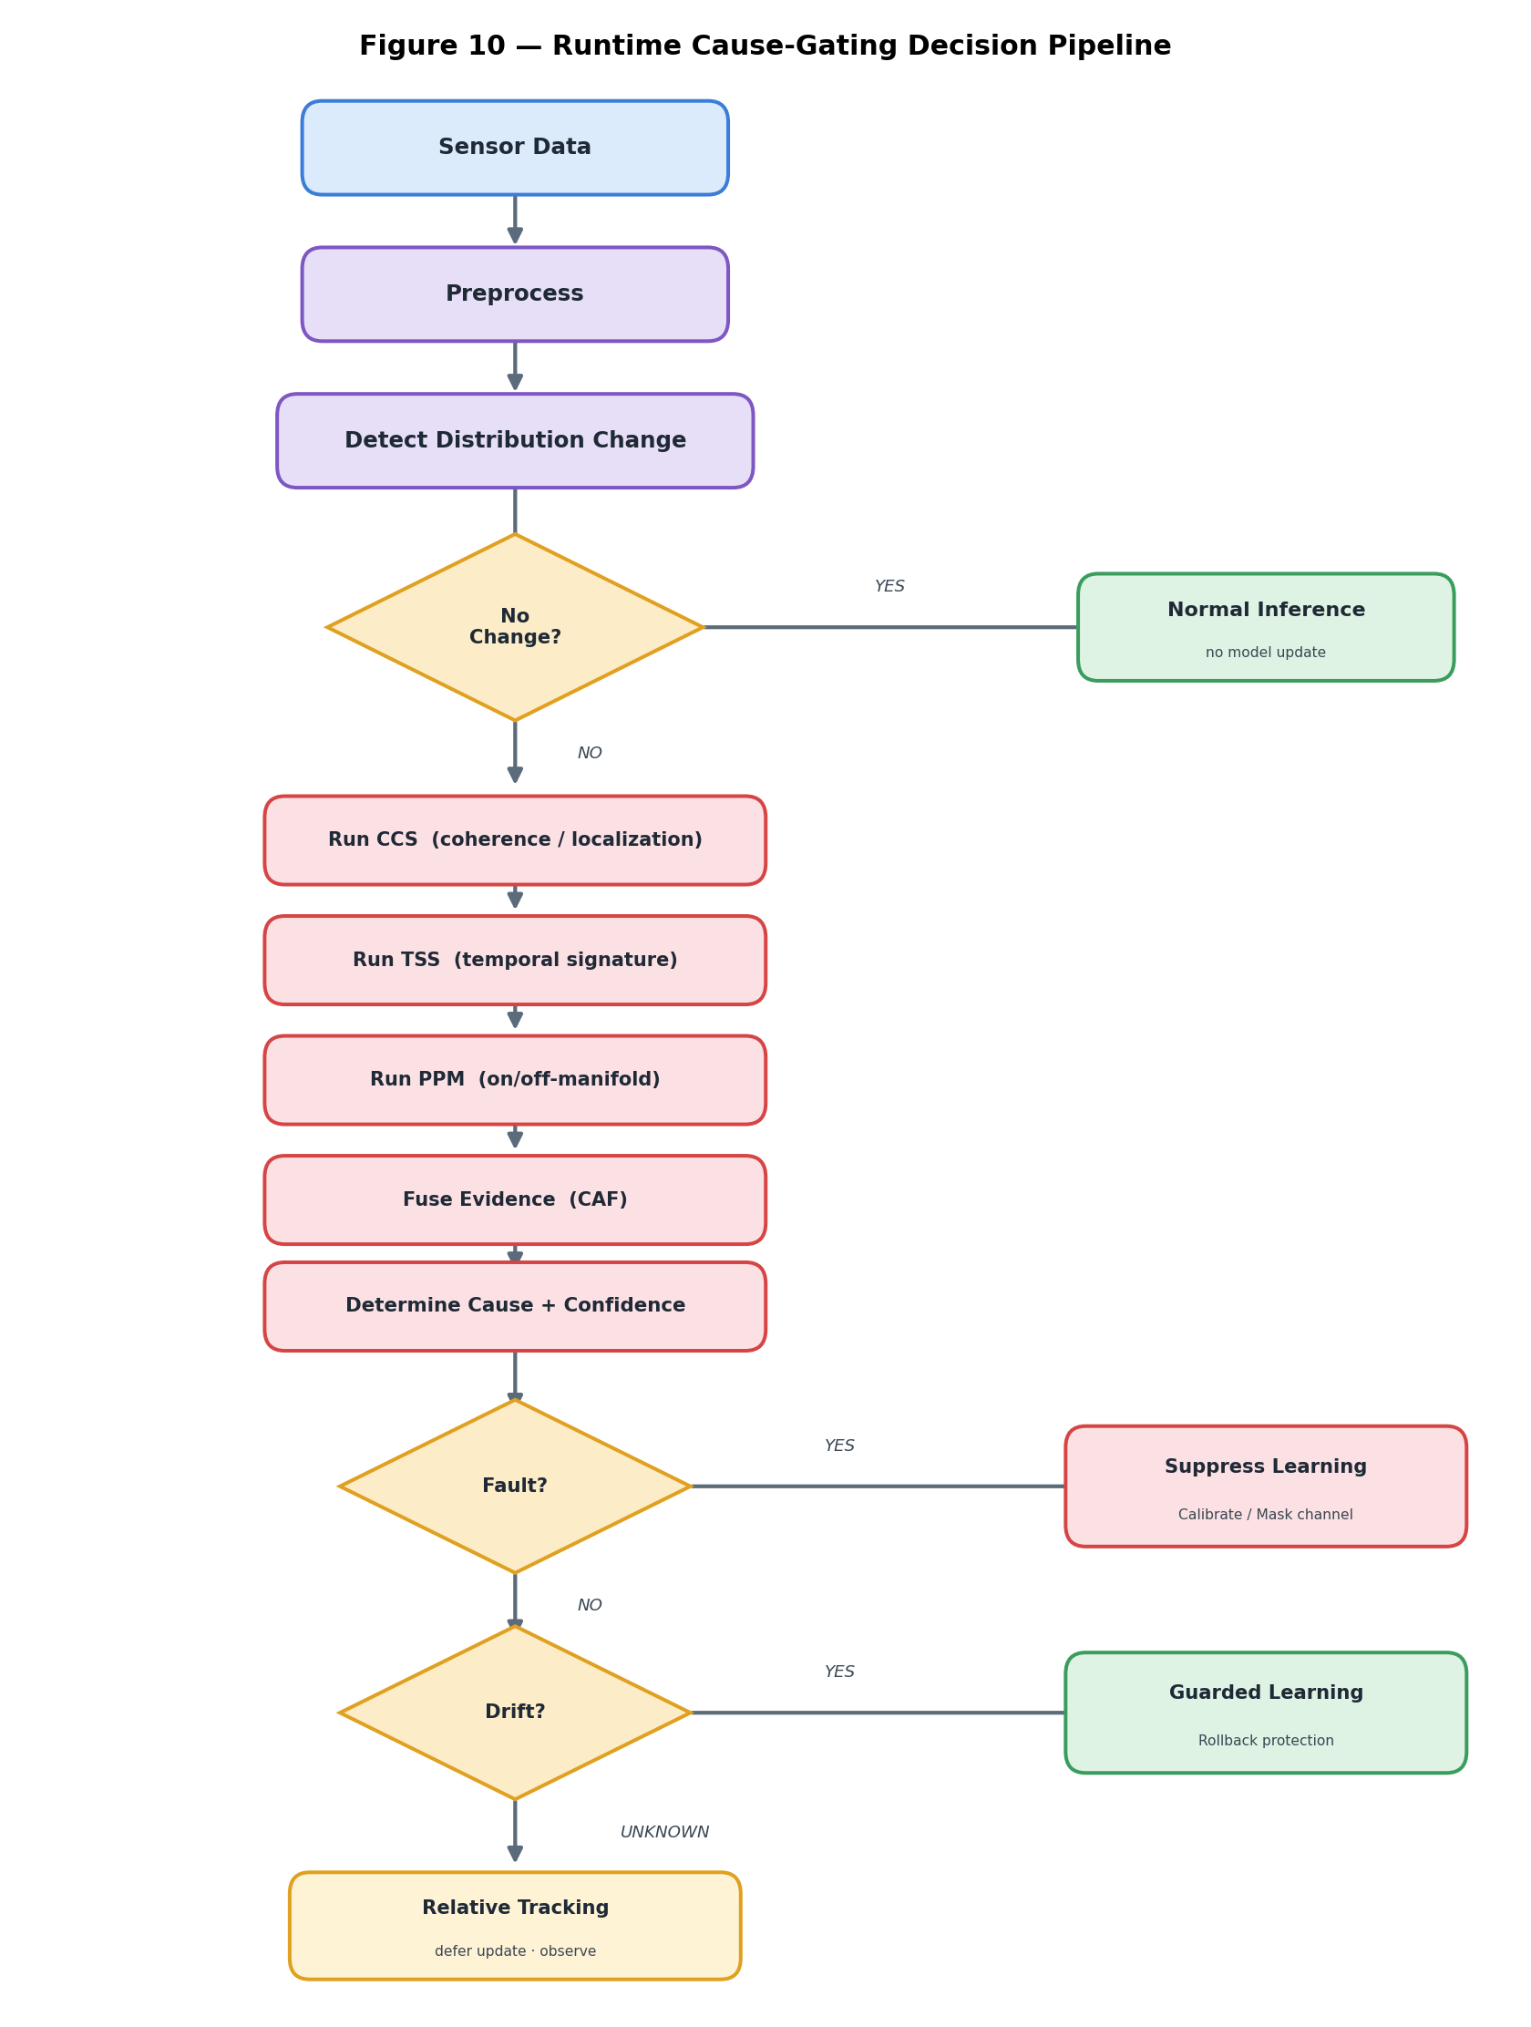
Figure 10 — Runtime Cause-Gating Decision Pipeline
End-to-End Numbered Workflow
Step 1 — Sensor acquisition. Raw multi-channel signals are acquired by the data acquisition layer and time-aligned prior to subsequent processing.
Step 2 — Preprocessing and feature extraction. Per-channel features are calculated for further analysis. These features are important for the steps. The process helps in understanding each channel. Each channel is examined individually. The data from each channel is used for work. This method makes it easier to analyse the information. The goal is to prepare the data for detailed study. Every channel is treated separately during this step. The results from each channel are gathered. This helps in getting results later on. The process is done before any final analysis takes place. Each channels data is used in the stage. The information is ready, for the part of the work.
Step 3 — Change monitoring (CT). A light weight no label change statistic is checked over a moving window. If there is no change that's meaningful enough the model keeps doing its usual work without changing anything and the process goes back to step one.
Step 4 — Diagnosis triggered. When a distributional change is spotted, control moves, to the CAAG. Importantly at this point no model-update operation takes place. The model-update operation is not performed. Thus the model remains unchanged during this stage.
Step 5 — Cross-channel analysis (CCS). Per-channel coherence residuals are computed. Suspect-channel localization vector is computed.
Step 6 — Temporal analysis (TSS). The temporal signature, including how symptoms start, how long they last and whether they go away is described.
Step 7 — Plausibility analysis (PPM). We check the plausibility of the data after it has changed. The comparison looks at on‑manifold plausibility, versus off‑manifold plausibility. After the review we give the data a plausibility score.
Step 8 — Evidence fusion (CAF). The three pieces of evidence are combined to create a probability that shows what is likely causing something. This probability comes with a confidence level that says how sure we are, about the reason.
Step 9 — Routing decision (ARR). The attributed cause and the associated confidence value are used to select one of three operational branches, as follows.
Step 10 — Fault branch. Model adaptation is suppressed. The suspect channel is. Recalibrated. A maintenance event or a health event is generated.
Step 11 — Drift branch. A Guarded Bounded Adaptation update is authorized. A parameter snapshot is kept. A bounded update is applied. An unlabelled task-health proxy is checked before and, after the update. The update is either committed or rolled back within the adaptation trust budget.
Step 12 — Ambiguous branch. The model update is. The system enters a relative-change tracking mode while more evidence is gathered.
Step 13 — Output and telemetry. The updated or preserved model does inference and the health telemetry stream is created to report the cause the confidence value and the reliability weight, for each channel.
Step 14 — Optional cloud synchronization. Adaptation metadata may be synchronized to a repository and aggregated across devices using a federated learning framework, while raw sensor data may remain resident on the device, as described in the Cloud Architecture section below.
3.4. DETAILED DESCRIPTION
3.4.1 System Overview
Referring to Figure 1, the disclosed system comprises a device including: (a) one or more sensors configured to provide a plurality of measurement channels; (b) a deployed machine-learning inference model M associated with an online model-update operation U (e.g., test-time normalization updates, incremental fitting, or on-device fine-tuning); (c) a Change Trigger (CT) configured to detect a distributional change and generate an unlabeled shift indication; and (d) a Cause-Attributed Adaptation Gate (CAAG) interposed between the Change Trigger (CT) and the model-update operation U.
The CAAG comprises a Cross-Channel Coherence Signature (CCS), a Temporal Signature (TSS) descriptor, a Plausibility Prior Manifold (PPM) consistency module, a Cause-Attribution Fusion (CAF) module, an Adaptation Routing and Response (ARR) controller, and a Guarded Bounded Adaptation (GBA) executor. The system generates a model-update control signal configured to selectively enable, suppress, constrain, or roll back execution of the model-update operation U, together with a machine-readable health-telemetry stream.
A fundamental architectural principle of the disclosed system is that the model-update operation U is not invoked directly in response to the Change Trigger (CT). Instead, detection of a distributional change first initiates a cause-diagnosis process before any model-management action is performed.
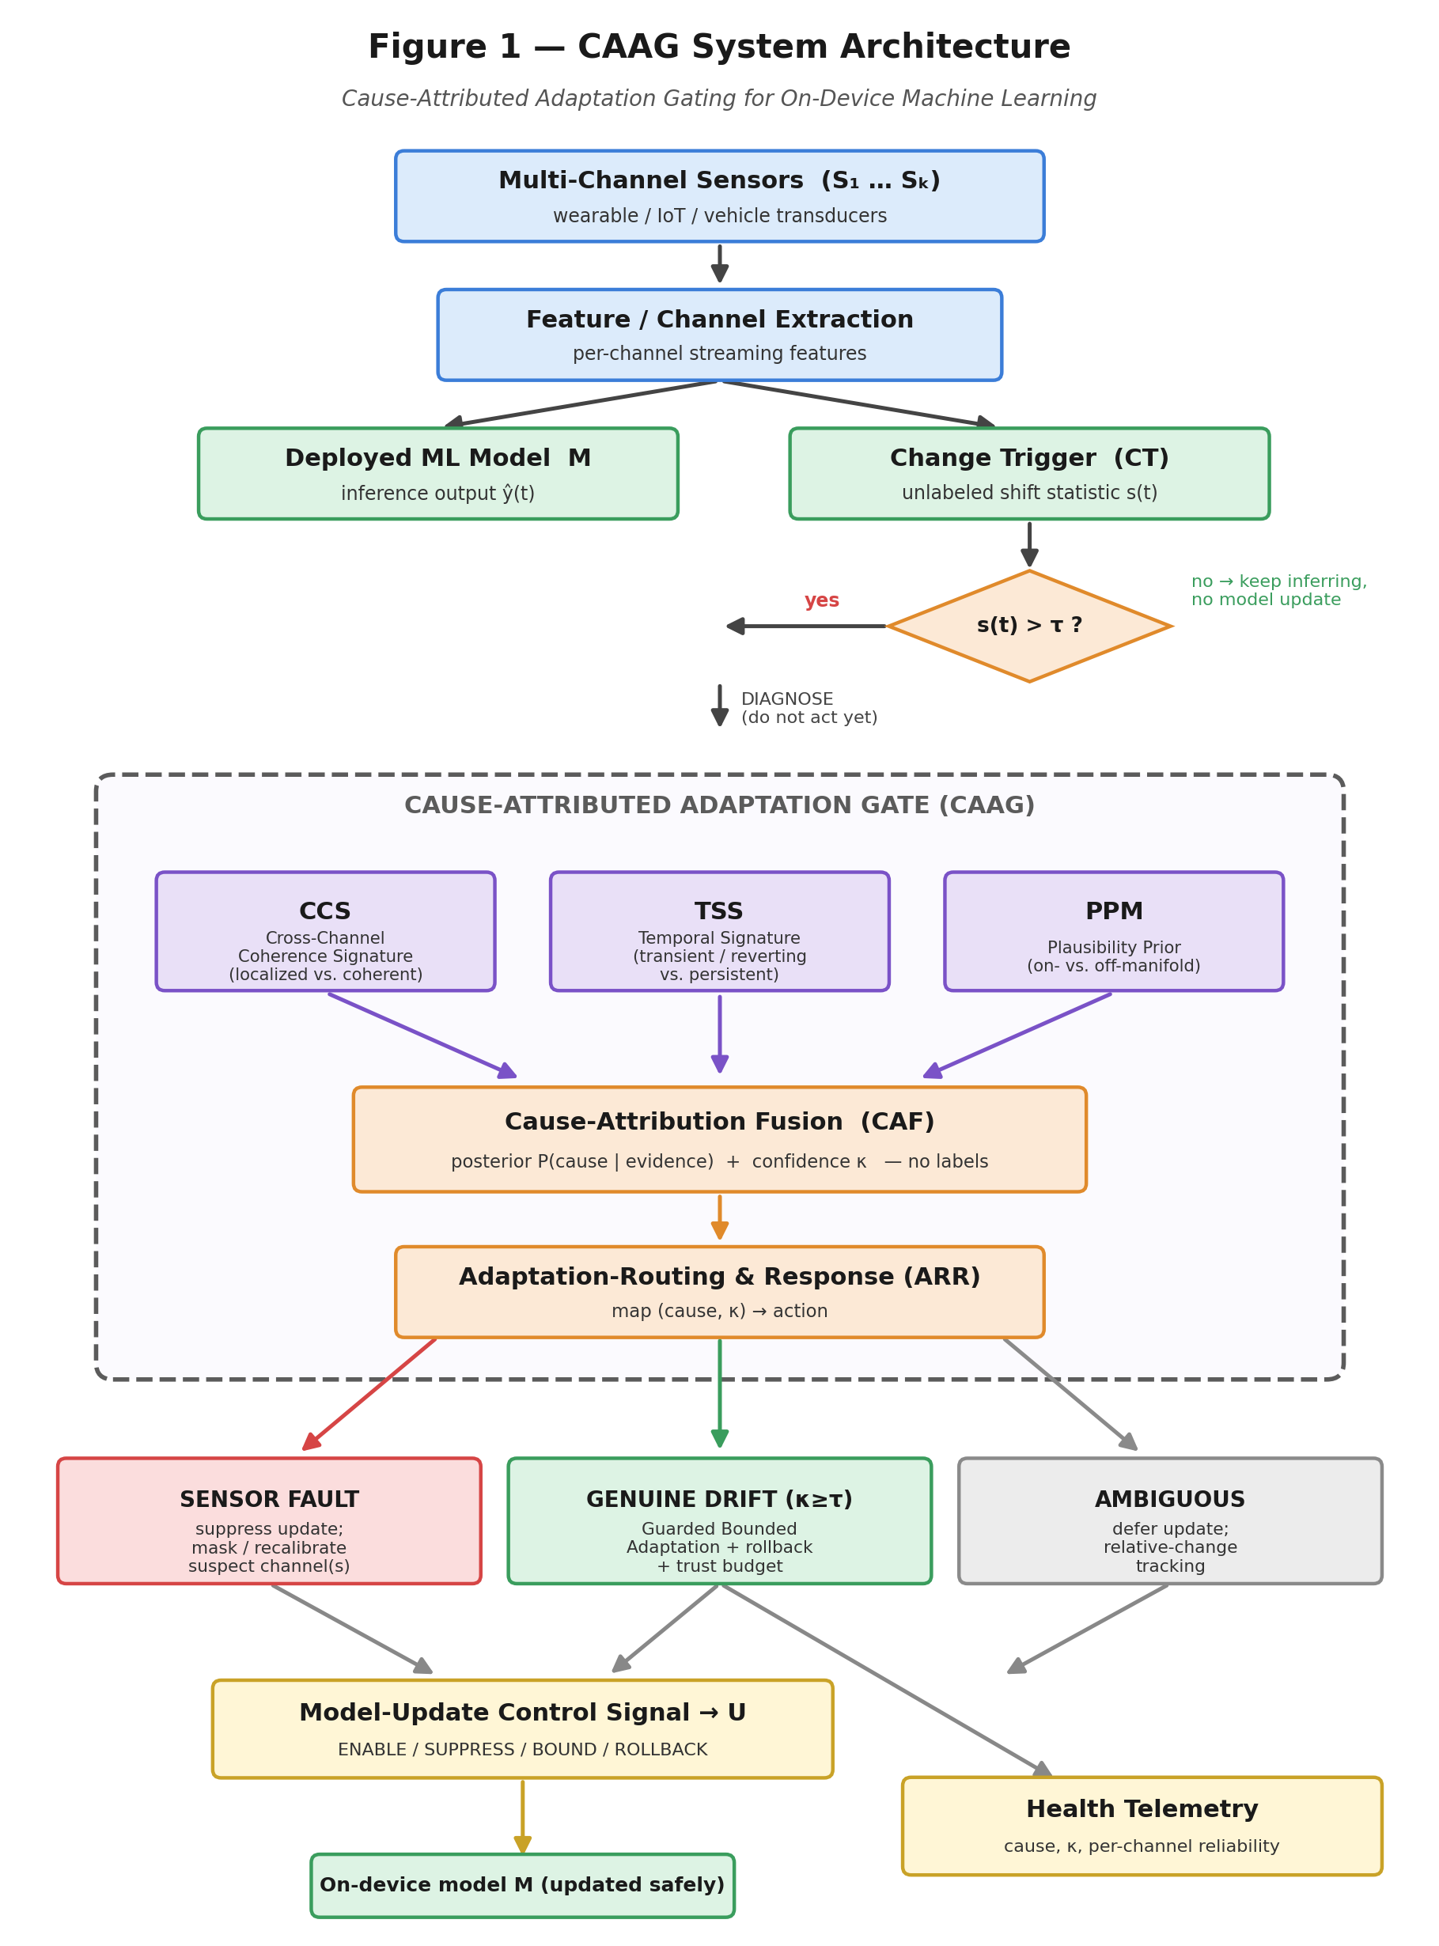
Figure 1 — CAAG System Architecture Block Diagram
3.4.2 Change Trigger (CT)
Purpose. To determine, in a computationally efficient and continuous manner, when cause diagnosis is warranted, without itself determining or initiating any model-management action.
Inputs. Streaming multi-channel features and/or the deployed model's output-confidence distribution (e.g., softmax probabilities or classification margins).
Internal working. Computes a lightweight, label-free change statistic over a sliding window—such as a divergence between recent and reference distribution summaries, an output-dispersion measure, or a student-teacher disagreement signal—and compares the computed statistic with an adaptive threshold.
Outputs. A binary shift indication that transfers control to the CAAG, without invoking any model-update operation.
Technical contribution. Provides a low-cost, continuously operating gating stage that decouples change detection from the more computationally intensive cause-diagnosis process, such that diagnostic and adaptation computations are performed only when a distributional change is detected.
Why it is novel. The disclosed system deliberately separates detection of a distributional change from the subsequent model-management decision. In contrast, conventional drift-detection mechanisms couple these functions by initiating model adaptation immediately upon detecting a distributional change.
The Change Trigger (CT) continuously computes a lightweight, label-free change statistic over a sliding window. In various embodiments, the change statistic may be based on a divergence between recent and reference feature-distribution summaries, such as streaming moments, statistical sketches, or histogram-based distance measures, and/or on the dispersion of the machine-learning model's own softmax or margin distribution, and/or on a student-teacher disagreement signal. When the computed change statistic exceeds an adaptive threshold, the CT generates a shift indication and transfers control to the Cause-Attributed Adaptation Gate (CAAG) without initiating any model-update operation.
The CT is intentionally designed to be computationally lightweight, with its function limited to determining when a cause-diagnosis process should be initiated, rather than determining the appropriate model-management action.
3.4.3 Cross-Channel Coherence Signature (CCS)
Purpose. To determine whether a detected change is localized to a subset of measurement channels, indicative of a sensor fault, or is coherent across multiple channels, indicative of genuine concept drift.
Inputs. Two or more measurement channels or redundant feature views, together with learned or physically derived inter-channel consistency relationships.
Internal working. Computes, for each measurement channel, a coherence residual that quantifies the deviation of the channel from the value jointly predicted by the remaining channels, and aggregates the resulting residuals into a scalar coherence score and a suspect-channel localization vector.
Outputs. A coherence score c in the range ([0,1]) and a localization vector identifying one or more suspect channels.
Technical contribution. Converts inter-channel redundancy into a quantitative, label-free discriminant comprising a coherence score and a suspect-channel localization vector, thereby enabling simultaneous discrimination between sensor faults and genuine concept drift while identifying the channel associated with the detected fault.
Why it is novel. The disclosed system uses mutually consistent measurement channels as an internal negative-control reference, thereby departing from the conventional assumption that any inter-sensor inconsistency necessarily indicates a sensor fault.
The Cross-Channel Coherence Signature (CCS) serves as the primary discriminating component within the disclosed framework. Given two or more measurement channels, or feature views derived from redundant or physically related sensors, the CCS evaluates whether an observed distributional change is coherent across multiple channels or localized to one or more individual channels. In a preferred embodiment, the CCS maintains, for each pair or group of channels, a learned or physically derived consistency relationship representing their expected joint behaviour under normal operating conditions. Based on this relationship, the CCS computes a per-channel coherence residual that quantifies the extent to which the behaviour of each channel deviates from the value jointly predicted by the remaining channels.
The discriminating principle underlying the present invention, and distinguishing it from conventional sensor-fault detection systems, is that genuine concept drift alters the task-relevant data manifold while preserving cross-channel consistency, resulting in low coherence residuals and a high degree of agreement in the direction of the observed change across channels. In contrast, a sensor fault or measurement artifact produces a localized deviation, characterized by one or more channels exhibiting comparatively large coherence residuals while the remaining channels continue to maintain mutual consistency.
The CCS generates a localization vector identifying one or more suspect channels together with a scalar coherence score, c ∈ [0,1]. Accordingly, the mutually consistent channels serve as an internal negative-control reference against which the behaviour of a potentially faulty channel is evaluated. This ability to distinguish localized sensor faults from channel-coherent concept drift is illustrated in Figure 2.
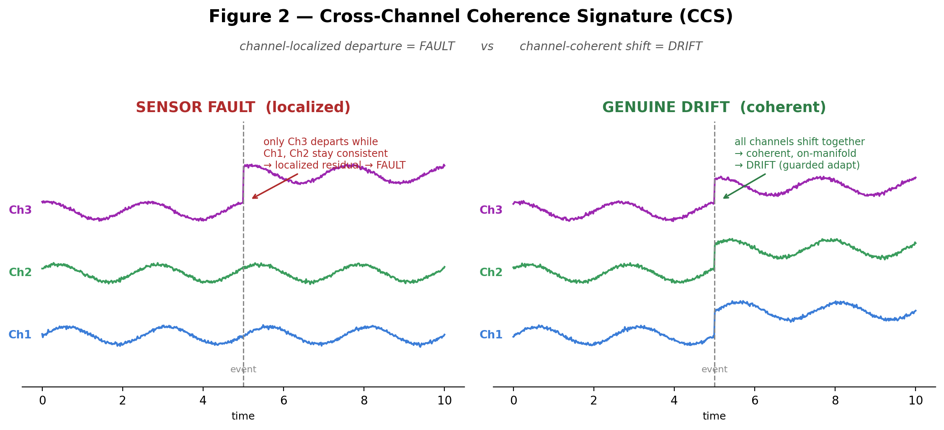
Figure 2 — Cross-Channel Coherence Signature: localized fault vs. coherent drift
3.4.4 Temporal-Signature module (TSS)
Purpose. To characterize the temporal profile of a detected change so as to distinguish transient or self-reverting sensor faults from persistent genuine concept drift.
Inputs. The recent time window corresponding to the changed measurement channel or channels.
Internal working. Extracts temporal descriptors including onset abruptness, persistence (or dwell time), reversibility, and spectral characteristics, and compares the extracted descriptors with known artifact signatures, including spike, step, stuck, erratic, and reverting patterns, as well as with the gradual, non-reverting temporal profile characteristic of genuine concept drift.
Outputs. A temporal-cause likelihood together with, where applicable, a provisional fault-type label.
Technical contribution. Supplies an independent temporal-evidence channel that resolves cases in which cross-channel coherence alone is insufficient to distinguish between competing causes by exploiting the distinct temporal dynamics of measurement artifacts and genuine physiological or environmental change.
Why it is novel. Encodes artifact-specific temporal priors as an independent, label-free evidence channel, rather than treating all detected distributional changes as statistically equivalent.
The Temporal Signature (TSS) characterizes the temporal behaviour of an observed distributional change. Sensor faults and measurement artifacts typically exhibit distinctive temporal signatures, including impulsive or spike-like events, step changes or offsets, stuck or flatline conditions, high-frequency irregular fluctuations, or rapid onset followed by recovery, in which the affected channel returns to its baseline state once the underlying contact issue or motion artifact has been resolved. By contrast, genuine concept drift generally exhibits a persistent, gradual, and non-reverting temporal profile.
The TSS computes one or more temporal descriptors, including onset abruptness, persistence (or dwell time), reversibility, and spectral characteristics, and generates a temporal-cause likelihood together with, where applicable, a provisional fault-type classification. Representative temporal signatures corresponding to different fault conditions and genuine concept drift are illustrated in Figure 3.
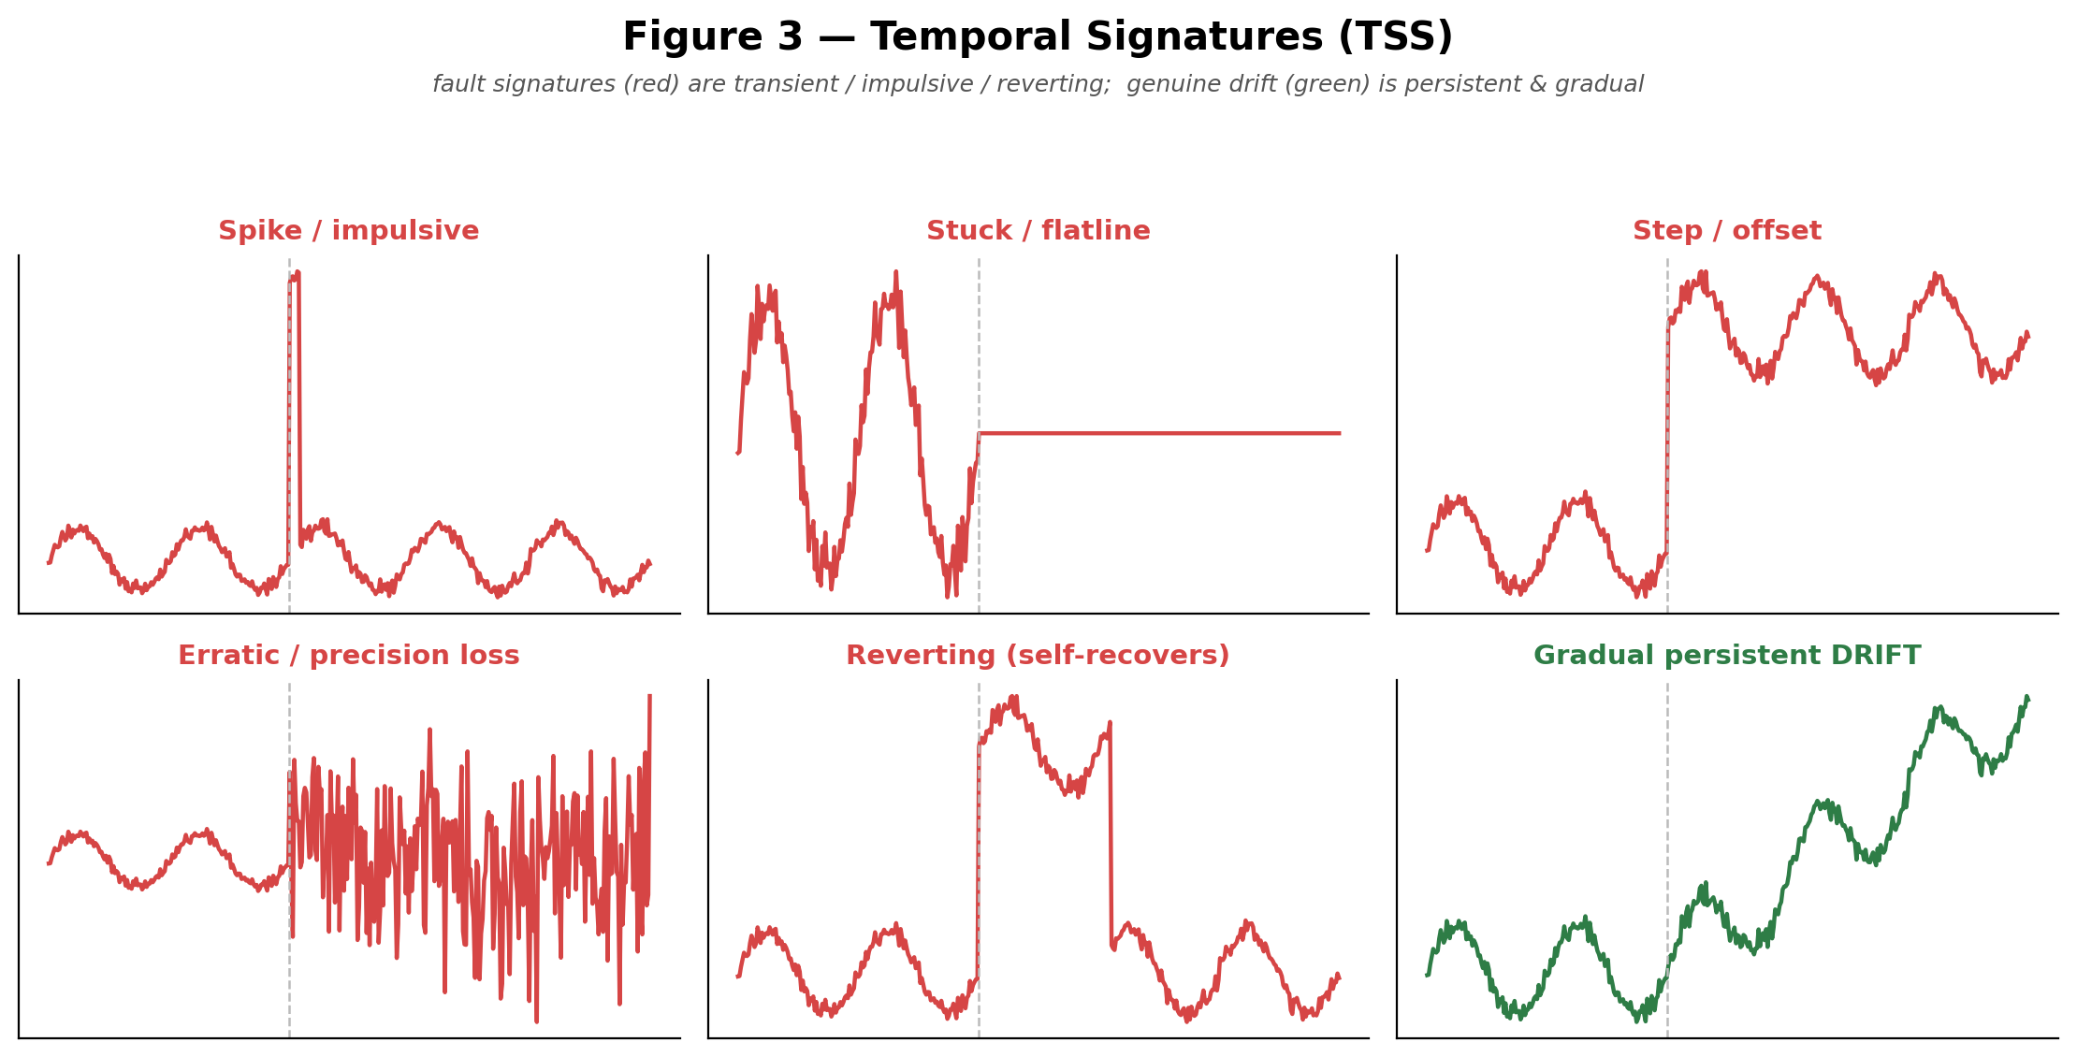
Figure 3 — Temporal signatures: transient/reverting faults vs. persistent drift
3.4.5 Plausibility-Prior module (PPM)
Purpose. To determine whether post-change data remains consistent with a plausible operating state of the modelled system.
Inputs. The post-change feature vector together with a compact learned manifold or density model.
Internal working. Scores on-manifold versus off-manifold membership using, for example, a compact autoencoder reconstruction error, a one-class classification score, or a nearest-prototype distance, and optionally reports the direction of departure from the learned manifold.
Outputs. An on-manifold plausibility score together with, optionally, a direction of departure from the learned manifold.
Technical contribution. Adds a plausibility-based evidence channel capable of identifying faults that are neither localized to individual channels nor characterized by distinctive temporal signatures, but that nevertheless correspond to physically implausible operating states, thereby addressing a failure mode that may not be detected by the other two evidence channels.
Why it is novel. Introduces physical and statistical plausibility as an independent decision axis. Genuine concept drift typically remains proximate to the learned manifold, whereas many sensor faults depart from the manifold in sensor-specific directions.
The Plausibility Prior Manifold (PPM) evaluates whether post-change data remains within a learned manifold representing plausible operating states. In a preferred embodiment, a computationally efficient density or manifold model, such as a compact autoencoder reconstruction error, a one-class classification score, or a nearest-prototype distance measure, is used to determine the extent to which newly acquired data corresponds to a plausible operating condition. Genuine concept drift typically results in data that remains on, or in close proximity to, the learned manifold, whereas many sensor faults or measurement artifacts cause the data to depart from the manifold in sensor-specific directions. For example, a stuck sensor channel may produce an implausible constant-valued signal that lies outside the learned manifold.
The PPM generates an on-manifold plausibility score and, in certain embodiments, further determines the direction of departure from the learned manifold. Representative examples of manifold-consistent and manifold-deviating data are illustrated in Figure 4.
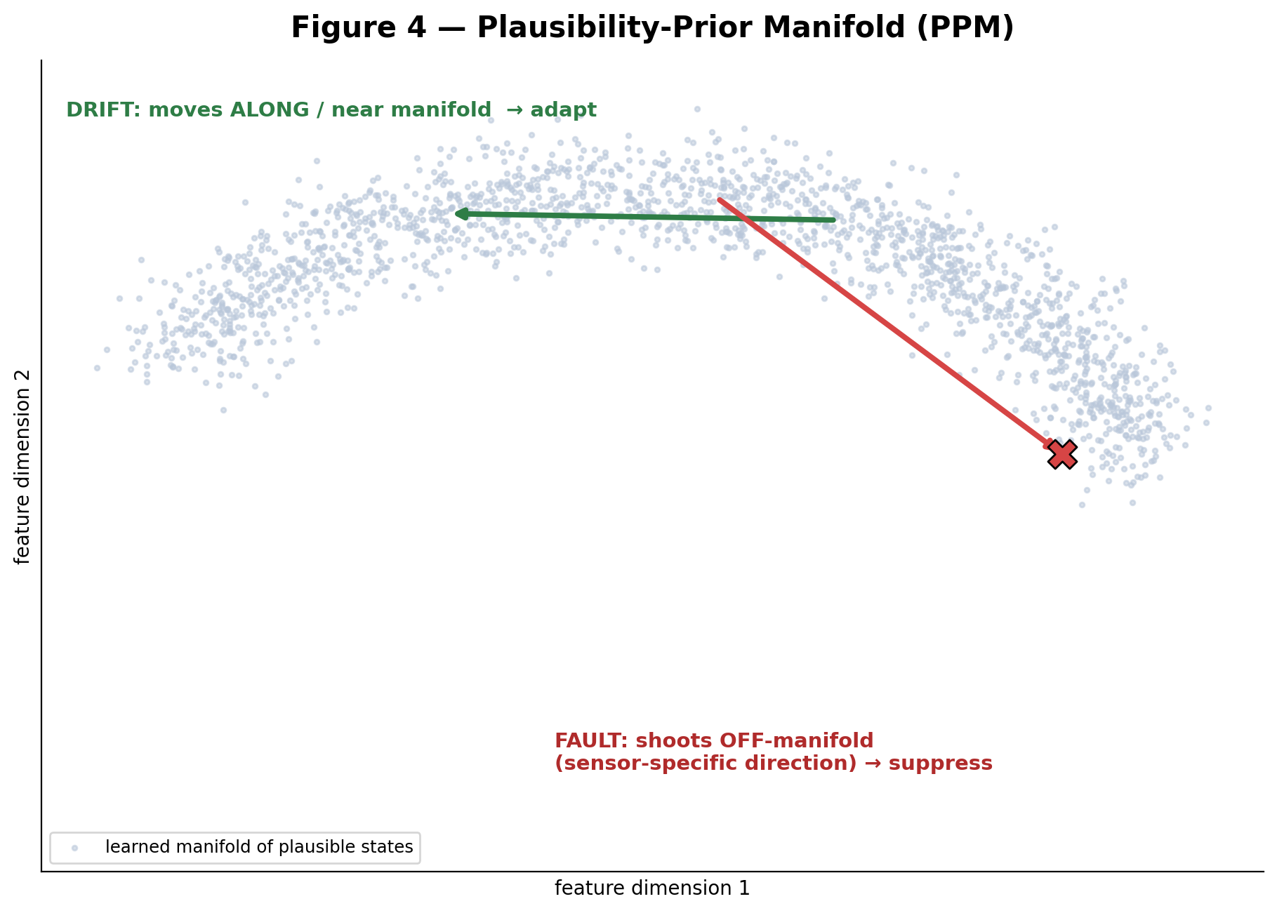
Figure 4 — Plausibility-Prior manifold: on-manifold drift vs. off-manifold fault
3.4.6 Cause-Attribution Fusion (CAF)
Purpose. To combine the three evidence channels into a single calibrated cause determination together with an associated confidence value.
Inputs. The CCS coherence score and localization output, the TSS temporal-cause likelihood, and the PPM plausibility score.
Internal working. Performs a calibrated probabilistic fusion, for example, using a Bayesian log-odds combination with learned evidence-specific weights or a compact decision function, to generate a posterior probability distribution over candidate causes together with a scalar attribution confidence derived from the sharpness of the posterior distribution.
Outputs. A posterior probability distribution over the candidate causes {sensor fault (including fault subtype and suspect channels), genuine concept drift, and ambiguous}, together with an associated confidence value.
Technical contribution. Combines three individually imperfect evidence channels into a single calibrated posterior probability distribution together with an explicit confidence value, thereby enabling a principled, threshold-based decision rather than a heuristic voting scheme.
Why it is novel. Generates a label-free posterior probability distribution over the underlying cause of a detected distributional change, rather than merely detecting the occurrence of the change itself, thereby enabling downstream cause-conditioned control.
The Cause-Attribution Fusion (CAF) module combines the outputs of the Cross-Channel Coherence Signature (CCS), the Temporal Signature (TSS), and the Plausibility Prior Manifold (PPM) to generate a posterior probability distribution over the candidate causes, including sensor faults (optionally identified by fault subtype and corresponding suspect-channel set), genuine concept drift, and ambiguous conditions. In a preferred embodiment, the fusion is implemented as a calibrated probabilistic combination, such as a lightweight Bayesian log-odds aggregation with learned evidence-specific weights or a computationally efficient decision function, to produce a posterior probability, P(cause | evidence), together with a scalar attribution confidence, κ, derived from the sharpness of the posterior probability distribution.
The CAF operates without requiring ground-truth labels during post-deployment operation, as each evidence channel is derived from self-referential information contained within the observed data. Figure 5 illustrates how the three complementary evidence dimensions collectively partition the decision space into regions corresponding to sensor faults, genuine concept drift, and ambiguous conditions.
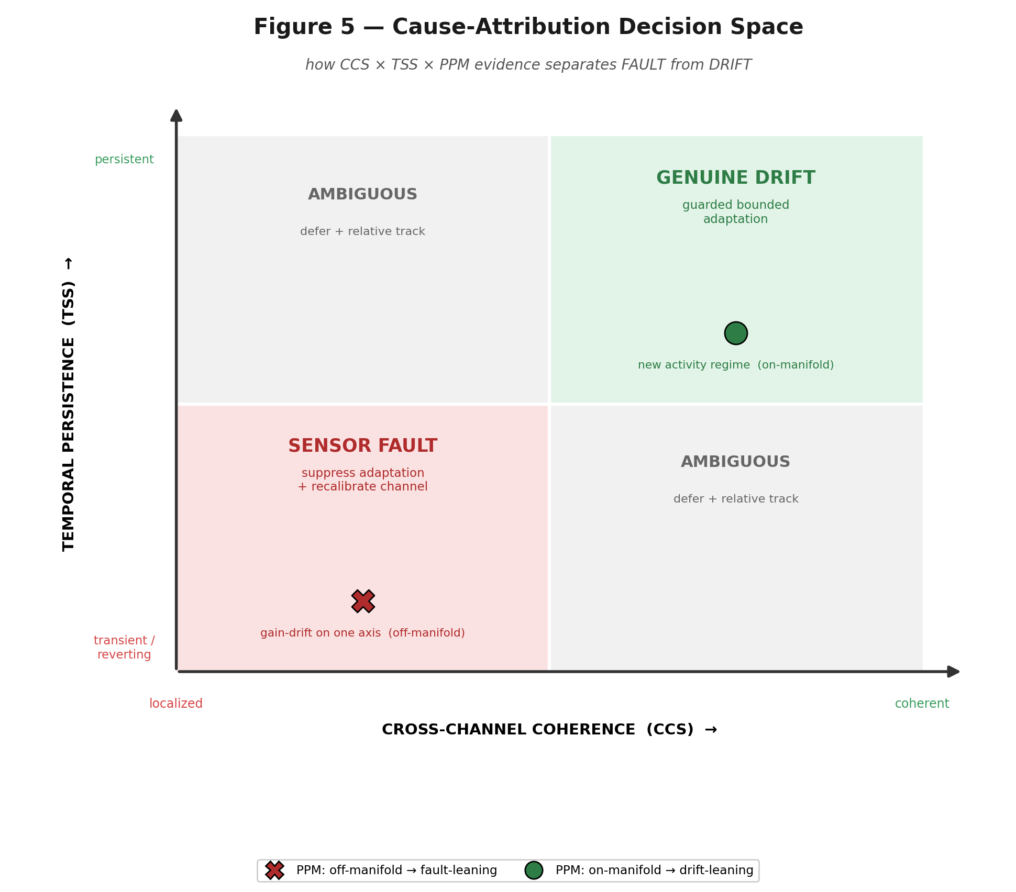
Figure 5 — Cause-Attribution Decision Space
3.4.7 Adaptation-Routing & Response controller (ARR)
Purpose. To map the attributed cause and the associated confidence value to a corresponding model-management action, including actions that may differ depending on the attributed cause.
Inputs. The posterior probability distribution and associated confidence value generated by the CAF, together with one or more configurable decision thresholds.
Internal working. Routes a sensor-fault attribution to suppression of the model update together with masking or recalibration of the suspect channel; routes a genuine concept drift attribution, when associated with a confidence value exceeding a predetermined threshold, to authorization of a Guarded Bounded Adaptation update; and routes an ambiguous or low-confidence attribution to deferral of the model update with initiation of a relative-change tracking mode.
Outputs. A model-update control signal configured to enable, suppress, constrain, or defer the model-update operation and, in the case of an attributed sensor fault, one or more channel-corrective actions together with a maintenance or health event.
Technical contribution. Translates a probabilistic cause estimate into a deterministic and auditable control action governing the model-update pathway, including deferral of the model-update operation as the default response when the attributed cause is associated with insufficient confidence.
Why it is novel. Performs cause-conditioned routing in which different attributed causes are mapped to corresponding, and potentially opposite, model-management actions, whereas conventional systems apply a single, cause-blind response to any detected distributional change.
The Adaptation Routing and Response (ARR) controller maps the attributed cause and the associated confidence value, κ, to a corresponding control action on the model-update pathway:
- Sensor-fault branch (P(fault) dominant): The model-update operation U is suppressed. Suspect channel or channels that are identified by the Cross-Channel Coherence Signature (CCS) are selectively masked, recalibrated or otherwise compensated. For example, we may apply offset or gain correction fill in values, from coherent channels or simply remove the affected channel from later processing. Inference can still continue with the remaining coherent channels but we mark that confidence is lower. The system also creates a maintenance or health‑telemetry event that matches the sensor fault or measurement artifact.
- Genuine-drift branch (P(drift) dominant and κ ≥ κ_adapt): A Guarded Bounded Adaptation (GBA) update is. Carried out as explained in Section 3.4.8.
- Ambiguous / low-confidence branch: The model-update operation U is put on hold. The system switches to a relative-change tracking mode. In this mode only the direction and speed of change, for the feature are watched. These changes serve as signs while more information is gathered. No final or permanent changes are made to the model parameters during this time.
3.4.8 Guarded Bounded Adaptation (GBA)
Purpose. To apply an approved model update in a way so that any leftover issues don't make it hard to know where a problem came from and so the model that is already out there doesn't get messed up.
Inputs. An authorization signal from the Adaptation Routing and Response (ARR) controller, the current model parameters, and the newly acquired data.
Internal working. Applies a bounded model update, for example, by using a clipped update step, restricting the update to a limited subset of model parameters, or updating only normalization statistics; retains a pre-update parameter snapshot; evaluates an unlabeled task-health proxy before and after the update; rolls back the update if degradation is detected; and enforces a per-window adaptation trust budget that is replenished only while the task-health proxy remains stable.
Outputs. An updated or rolled-back model together with an adaptation-status indication.
Technical contribution. Renders on-device model adaptation reversible and self-limiting by transforming an otherwise irreversible in-place parameter update into a bounded, continuously monitored, and rollback-protected operation.
Why it is novel. Constrains even a correctly attributed model adaptation by making it bounded, governed by an adaptation trust budget, and reversible under an unlabeled task-health proxy, in contrast to conventional unconstrained on-device retraining.
When model adaptation is authorized, the Guarded Bounded Adaptation (GBA) mechanism executes the update in a controlled manner. First, the magnitude of each model update is constrained, for example, by limiting the update step size, restricting the subset of model parameters eligible for modification, or, in the most resource-constrained embodiments, updating only normalization statistics. Second, a pre-update snapshot of the affected model parameters is retained to enable rollback, if required. Third, an unlabeled task-health proxy, such as prediction-confidence stability, reconstruction error, or agreement with a frozen reference sub-model, is evaluated before and after the model update. Fourth, if the task-health proxy degrades beyond a predetermined threshold, the update is automatically rolled back. Fifth, a per-window adaptation trust budget limits the cumulative extent of model adaptation and is replenished only while the task-health proxy remains stable, thereby preventing residual cause-attribution errors from accumulating into progressive model corruption.
The operation of the GBA mechanism is illustrated in Figure 6.
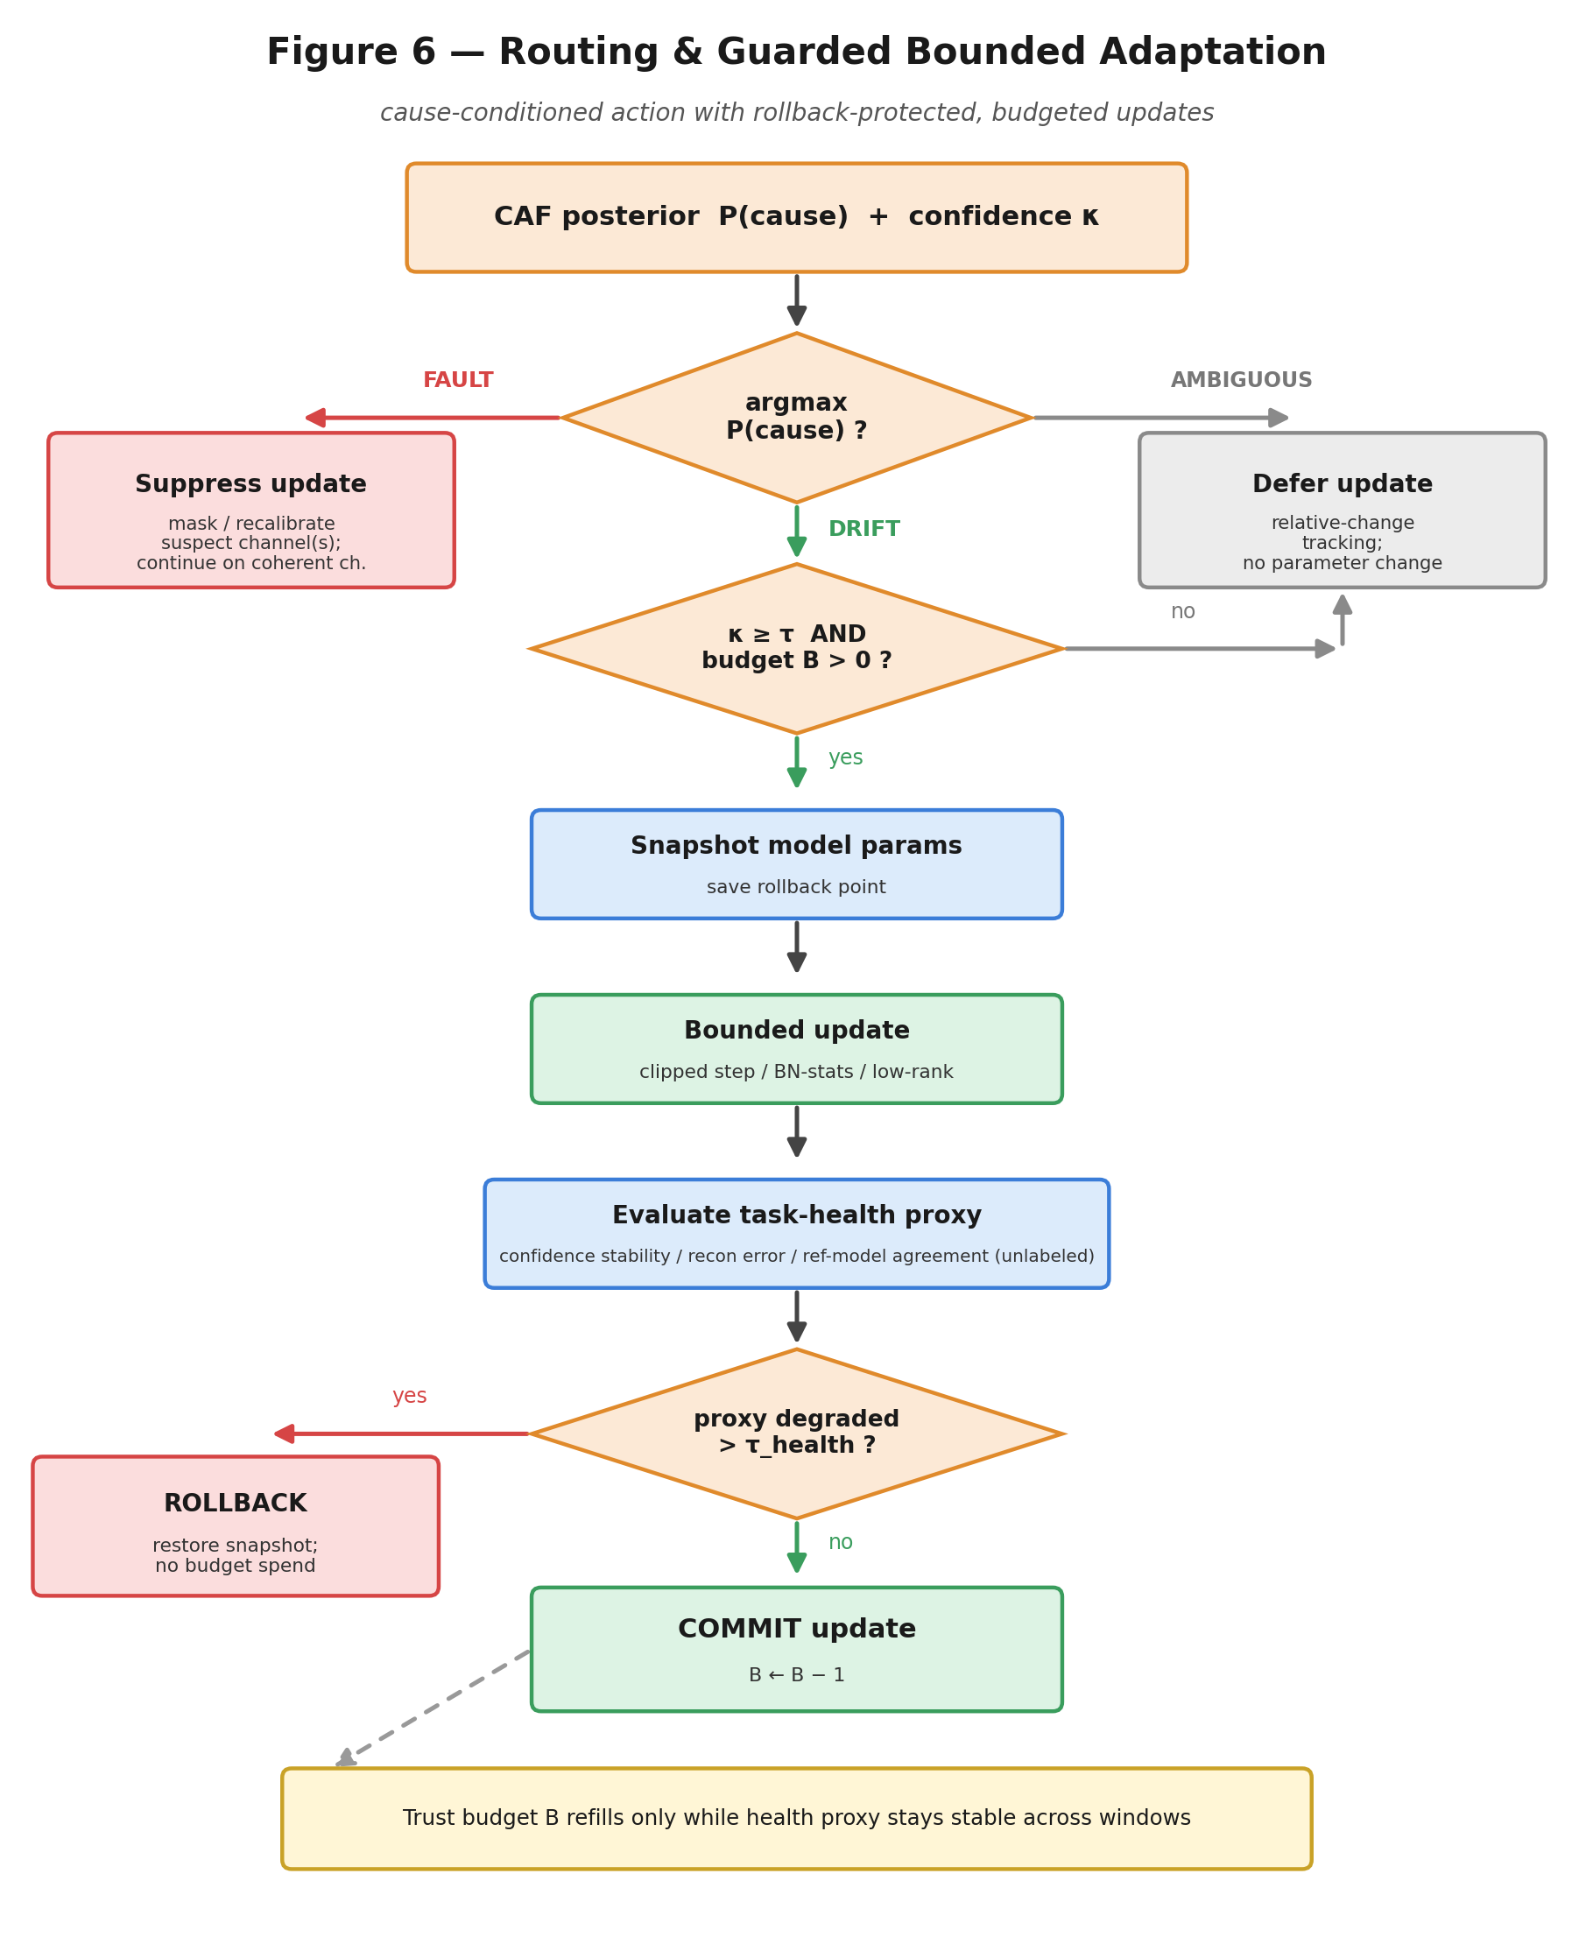
Figure 6 — Routing & Guarded Bounded Adaptation with Rollback
3.4.9 Health Telemetry and Fallback
Purpose. To expose the decisions generated by the Cause-Attributed Adaptation Gate (CAAG) as a reusable, machine-readable diagnostic output for use by external systems.
Inputs. The outputs generated by the Cause-Attribution Fusion (CAF), Adaptation Routing and Response (ARR), and Guarded Bounded Adaptation (GBA) stages.
Internal working. Assembles the attributed cause, fault subtype (where applicable), suspect-channel set, attribution confidence, per-channel reliability weights, and the selected routing action into a structured, machine-readable record, and explicitly indicates when the system has entered the relative-change tracking mode due to an ambiguous or low-confidence cause determination.
Outputs. A machine-readable health-telemetry stream configured for consumption by downstream systems, including fleet-monitoring, maintenance-scheduling, and clinical-alert-gating systems.
Technical contribution. Exposes the internal cause determination as a standardized, machine-readable signal, enabling external monitoring, maintenance, and alert-gating systems to consume the attributed cause and associated confidence directly without independently deriving or inferring those values.
Why it is novel. Treats cause attribution and the associated confidence value as first-class, externally exposed outputs rather than internal state variables, thereby enabling governance, monitoring, maintenance, and alert-management layers to operate directly on the decisions generated by the Cause-Attributed Adaptation Gate (CAAG).
The Cause-Attributed Adaptation Gate (CAAG) generates a machine-readable health-telemetry stream comprising the attributed cause, an associated fault subtype, a suspect-channel set, an attribution confidence value, κ, per-channel reliability weights, and the corresponding routing action performed by the system. When the attributed cause is classified as ambiguous, the CAAG explicitly indicates that the system has entered a relative-change tracking mode, thereby informing downstream systems that absolute outputs should be interpreted with caution while preserving meaningful directional information until a sufficiently confident cause attribution has been established.
3.4.10 Algorithm 1 — Cause-Attributed Adaptation Gating
Input : X(t) = multi-channel sensor features; model M; update op U;
thresholds tau_shift, kappa_adapt, tau_health; trust budget B
Output: model-update control signal; attributed cause; confidence kappa;
per-channel reliability weights

1. y_hat(t) <- M(X(t)) # normal inference proceeds
2. s(t) <- ChangeStatistic(X(t), reference) # cheap, unlabeled
3. if s(t) <= tau_shift: emit ENABLE_NORMAL; return # no change
4. # --- change detected: DIAGNOSE, do not act ---
5. (c, suspect_channels) <- CCS(X(t)) # coherence / localization
6. (tcause, ftype) <- TSS(X(t)) # temporal signature
7. p_manifold <- PPM(X(t)) # on/off-manifold plausibility
8. P(cause), kappa <- CAF(c, suspect_channels, tcause, p_manifold)
9. if argmax P = FAULT:
10. mask/recalibrate(suspect_channels); emit SUPPRESS_UPDATE
11. emit health_event(FAULT, ftype, suspect_channels, kappa); return
12. elif argmax P = DRIFT and kappa >= kappa_adapt and B > 0:
13. snapshot <- save(M_params)
14. M <- GBA_bounded_update(M, X(t)) # bounded step
15. if HealthProxy(M) degraded > tau_health:
16. M <- rollback(snapshot); emit ROLLBACK
17. else: B <- B - 1; emit ADAPT_COMMITTED
18. return
19. else: # ambiguous / low confidence
20. emit DEFER_UPDATE; enter RelativeChangeTracking(); return
The Cause-Attributed Adaptation Gate (CAAG) is distinguished from conventional drift-detection and test-time adaptation (TTA) techniques by three domain-specific features. First, execution of the model-update operation is governed by the diagnosed cause of a detected distributional change rather than solely by the occurrence of the distributional change itself. Second, cross-channel coherence is used as an internal negative-control reference to distinguish channel-localized sensor faults or measurement artifacts from channel-coherent genuine concept drift. Third, any authorized model adaptation is executed in a bounded, trust-budgeted, and rollback-protected manner under the supervision of a label-free task-health proxy.
3.4.11 Illustrative Implementation Details and Alternatives
The following non-limiting implementation alternatives are provided to facilitate enablement and illustrate the breadth of implementations contemplated for each module. Any one or any combination of the following implementations may be employed within the disclosed architecture.
Change Trigger (CT). May be implemented using adaptive windowing (ADWIN), Page-Hinkley, DDM/EDDM, Kolmogorov-Smirnov, or Maximum Mean Discrepancy (MMD) two-sample tests applied over sliding windows; output-entropy or prediction-margin monitoring; or student-teacher disagreement signals. In certain embodiments, streaming data structures, including reservoir sampling or bounded-memory statistical sketches such as Count-Min, KLL, or t-digest sketches, may be employed to support continuous operation under constrained memory resources.
Cross-Channel Coherence Signature (CCS). The inter-channel consistency function may be implemented using a linear predictor, a Gaussian process or kernel regressor, a compact autoencoder configured to perform leave-one-channel-out reconstruction, a correlation-, partial-correlation-, or copula-based model, or a graph-consistency model defined over a sensor graph. In various embodiments, the resulting coherence residuals may be normalized using robust scale estimators and localized by computing per-channel standardized scores.
Temporal Signature (TSS). May be implemented using cumulative-sum (CUSUM) analysis, Bayesian online change-point detection, wavelet or spectral decomposition, hidden Markov or state-space temporal models, or by extracting temporal features, including rise time, dwell time, autocorrelation, and spectral flatness, followed by classification using a compact machine-learning model.
Plausibility Prior Manifold (PPM). May be implemented using an autoencoder reconstruction error, a one-class support vector machine, an isolation forest, k-nearest-neighbour or kernel density estimation, a Mahalanobis-distance measure with respect to a Gaussian mixture model, or a normalizing-flow density model. In certain embodiments, the learned manifold may itself be updated gradually under the control of the disclosed Guarded Bounded Adaptation (GBA) mechanism to ensure bounded and safeguarded adaptation.
Cause-Attribution Fusion (CAF). May be implemented as a calibrated Bayesian log-odds combination, a logistic regression model, a compact multilayer perceptron, a gradient-boosted classifier, or a Dempster-Shafer evidential combination. In various embodiments, the attribution confidence may be derived from the posterior entropy or posterior margin and calibrated using temperature scaling or isotonic regression.
Adaptation Routing and Response (ARR). May be implemented as a threshold-based policy, a finite-state machine, a cost-sensitive decision rule that balances model staleness against the risk of model corruption, or a learned policy, such as a multi-armed bandit or a partially observable Markov decision process. In various embodiments, the routing thresholds may be predefined, configurable, or adaptively adjusted for a particular deployment.
Guarded Bounded Adaptation (GBA). The bounded model update may employ a clamped learning rate, gradient- or step-norm clipping, elastic-weight-consolidation-style regularization, low-rank (adapter-style) parameter updates, or normalization-statistics-only updates. In various embodiments, pre-update parameter snapshots may be retained in a ring buffer to facilitate rollback. The unlabeled task-health proxy may comprise prediction-confidence stability, reconstruction error, or agreement with a frozen reference sub-model. The adaptation trust budget may be implemented using a token-bucket data structure to regulate the cumulative extent of authorized model adaptation.
Health Telemetry. The health-telemetry output may be provided as a structured, machine-readable record, for example a JSON or Protocol Buffers message conforming to a predefined schema, comprising the attributed cause, fault subtype, suspect-channel set, attribution confidence, per-channel reliability weights, routing action, and one or more timestamps. In various embodiments, the health-telemetry output may be transmitted to monitoring, maintenance, or supervisory systems via MQTT, HTTP(S), Bluetooth® Low Energy (BLE), or other suitable communication protocols.
3.5. RESULTS AND ADVANTAGES
NOTE: The following system-level properties come from the architecture. Signal‑processing design that was described. The quantitative performance numbers will be verified by the computer validation program that is explained in Section 3.7. The example numbers shown in Section 3.7 are based on simulation. Are marked as such.
- Prevention of silent model corruption: By not changing the model when a sensor problem or a false reading's the reason for a change in the data the system described stops the main way that, on-device learning can fail. This main way is when bad data gets added to the model during the updating process.
- Label-free operation: Cause attribution and the model-adaptation decision are made without needing ground-truth labels for data collected after deployment or, in the field.
- Freshness without fragility: I notice concept drift. I address concept drift by carefully performing controlled model adaptation. Controlled model adaptation keeps the model fresh. Prevents model corruption that can come from sensor faults or measurement artifacts. This approach resolves the trade‑off between model staleness and corruption caused by model adaptation.
- Cross-channel negative-control robustness: Consistent sensor channels act as an internal reference. This helps find faulty or worse performing channels. It also helps create reliability weights for each channel. These weights are used for steps, like making decisions and checking how well the system is working.
- Bounded, reversible adaptation: I see that the adaptation trust budget and rollback mechanism work together to keep the adaptation trust budget and rollback mechanism from letting residual cause-attribution errors build up. Residual cause-attribution errors should not turn into an unbounded decline, in model performance. Model performance will stay steady as we run model-adaptation operations.
- Low footprint: All functional modules operate in a streaming manner and require memory proportional to O(1) to O(k), thereby making the disclosed system suitable for deployment on resource-constrained microcontrollers, edge processors, and edge neural processing units (NPUs).
- First-class health telemetry: The attributed cause, attribution confidence, and per-channel reliability weights collectively constitute a reusable, machine-readable diagnostic output configured for downstream monitoring, decision-making, maintenance, and system integration.
3.6. EXPANSION (Alternative Embodiments and Additional Variables)
- Wearable health monitoring: In one illustrative embodiment, the disclosed system processes multimodal physiological signals acquired from electrocardiogram (ECG), photoplethysmography (PPG), electrodermal activity (EDA), and accelerometer channels. Representative sensor faults include electrode-pop events, motion artifacts, poor sensor contact, and sweat-induced measurement artifacts, whereas genuine concept drift may arise from physiological or behavioural changes in the monitored subject. The machine-readable health-telemetry output generated by the Cause-Attributed Adaptation Gate (CAAG) is further employed to qualify or gate clinical alerts, thereby reducing the likelihood of fault-induced false alarms while preserving clinically relevant notifications.
- Industrial IoT / predictive maintenance: In another example the system described here works with data that comes from sensors linked to machines used in industry. Some common sensor problems are when the sensors stop working when the wires are damaged or when there are issues with the measurements. Real changes in how the system works can happen because the machine is running differently the load is. The machines behaviour is different. The Cause-Attributed Adaptation Gate (CAAG) tells the difference, between these situations. When there is a sensor problem or a measurement issue the system takes the steps to fix it or check it but it doesn't change the model. When the change is real and comes from the way the machine is working the model changes in a controlled way as described in the system.
- Automotive / ADAS and robotics: In another example the system works with data from perception and inertial sensors. The Cause-Attributed Adaptation Gate or CAAG checks whether sensor problems or measurement errors are happening or if real changes in the environment are occurring. It only allows updates to the machine-learning models inside the vehicle when it confirms the change is genuine. This stops updates caused by sensor faults while still permitting safe and controlled adaptation to actual shifts, in how the vehicle operates.
- Universal AI adaptation middleware (domain-independent). The Cause‑Attributed Adaptation Gate or CAAG is not limited to devices. CAAG can be used as a layer that works in any domain and can be placed between any sensor subsystem and almost any on‑device machine‑learning model. In such embodiments, only the sensor-specific adapter components—including channel definitions, inter-channel consistency relationships, and the plausibility manifold—are configured for a particular application domain, while the core Cross-Channel Coherence Signature (CCS), Temporal Signature (TSS), Plausibility Prior Manifold (PPM), Cause-Attribution Fusion (CAF), Adaptation Routing and Response (ARR), and Guarded Bounded Adaptation (GBA) components remain substantially unchanged across diverse application domains, including wearable devices, motor vehicles, robots, drones, industrial machinery, Internet-of-Things (IoT) devices, smart-home systems, and medical devices.
- Cloud-connected and API/SDK deployment. In a further embodiment illustrated in Figure 11, the device-resident Cause-Attributed Adaptation Gate (CAAG) synchronizes adaptation metadata—including attributed causes, attribution confidence values, fault signatures, per-channel reliability weights, and adaptation outcomes—to a secure repository in accordance with a predefined metadata schema and synchronization protocol, while raw sensor data may remain resident on the device where privacy, security, or bandwidth constraints so require. Third-party systems may integrate with the CAAG through a representational state transfer (REST) application programming interface (API), an embedded software development kit (SDK), or a firmware component. In certain embodiments, a coordinating server performs federated aggregation of the synchronized adaptation metadata to refine shared priors or model parameters employed by the Cross-Channel Coherence Signature (CCS), Temporal Signature (TSS), Plausibility Prior Manifold (PPM), and Cause-Attribution Fusion (CAF) modules, without requiring access to raw sensor data.
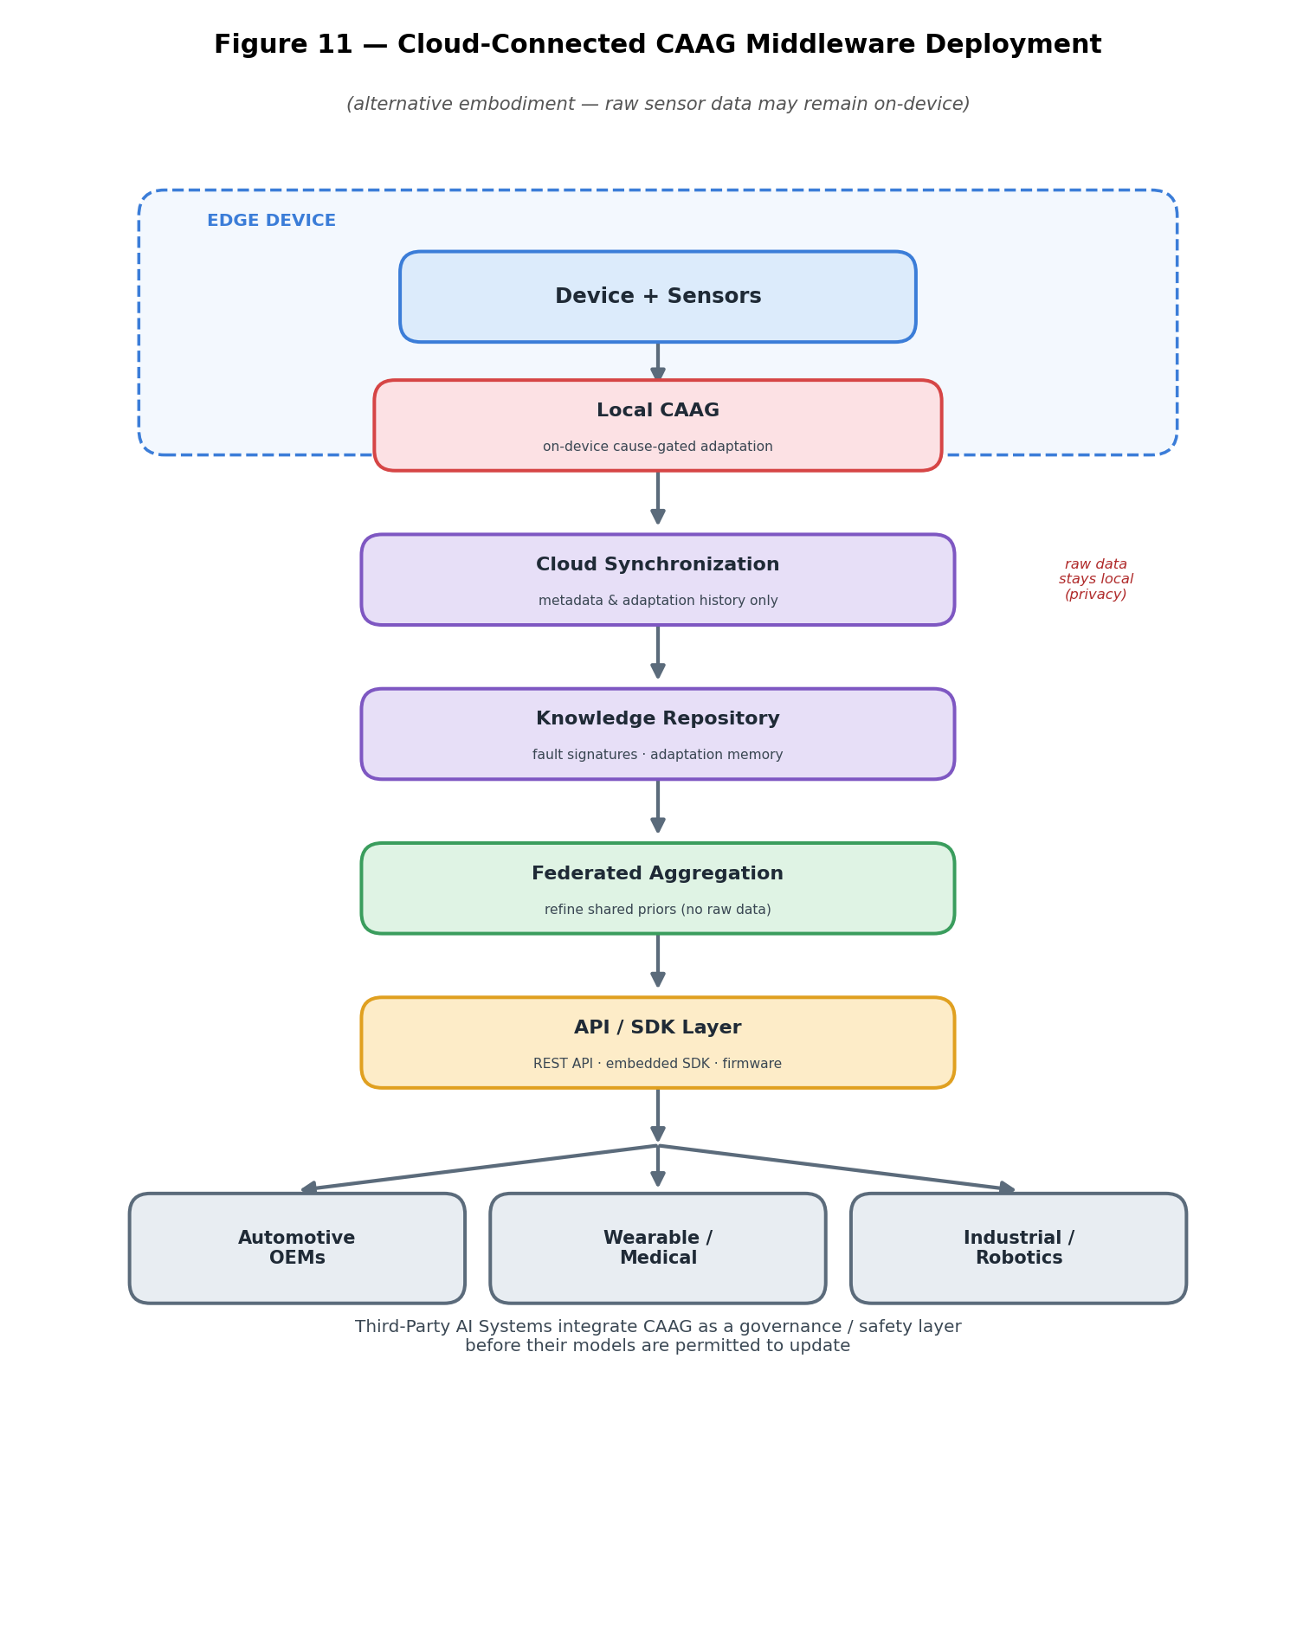
Figure 11 — Cloud-Connected CAAG Middleware Deployment (alternative embodiment)
- Adaptation memory and cross-device reuse. In a further embodiment, the Cause-Attributed Adaptation Gate (CAAG) maintains an adaptation-memory data structure that records recurring fault signatures, instances in which detected distributional changes were attributed to genuine concept drift, authorized model adaptations that improved an unlabeled task-health proxy, and model updates that were suppressed. The recorded entries constitute reusable priors that may be employed to initialize the Cross-Channel Coherence Signature (CCS), Temporal Signature (TSS), Plausibility Prior Manifold (PPM), and Cause-Attribution Fusion (CAF) modules of a newly provisioned device, thereby reducing cold-start attribution error and accelerating convergence toward reliable cause attribution.
- Cross-domain operation with an unmodified core engine. In each of the foregoing application domains, the Cause-Attributed Adaptation Gate (CAAG) performs the same fundamental determination for a channel or set of channels exhibiting a detected distributional change, namely whether the change reflects a genuine change in the operating environment or underlying phenomenon, in which case a guarded model update is authorized, or a sensor degradation or measurement fault, in which case model adaptation is suppressed and a maintenance or diagnostic indication is generated. By way of illustration, in an automotive embodiment monitoring engine vibration, temperature, steering, camera, radar, and LiDAR channels, a detected distributional change is attributed either to a changing operating environment or to sensor degradation or failure. The same design approach works for robot’s machines used in factories devices you wear on your body, flying machines and other systems that use sensors. The only thing that changes are how the sensors are set up. The CAAG design and the parts that make it work stay mostly the same.
- Single-sensor embodiment: In embodiments that use one physical sensor channel the Cross-Channel Coherence Signature (CCS) module works with several surrogate channels created from that single sensor. These surrogate channels can come from feature views frequency sub-bands or multiple model heads. The coherence analysis produced in this way gives a level of fault localization compared to systems that use multiple physical sensor channels. As a result the diagnostic confidence reported is also lower reflecting the reduced certainty, in pinpointing the fault.
- Federated embodiment: In some setups that use distributed learning or federated learning a special part inside the device called the Cause-Attributed Adaptation Gate (CAAG) connects the changes made to the model with information about why those changes happened. This information can include what the cause was, how sure we are about that cause and other details that help understand what happened. A main server can use this information to decide which model changes are important which ones to ignore or which ones to adjust, based on whether they were affected by problems with sensors or errors in measurements. This is done without needing to see the data, from the sensors.
- Processing embodiments: The disclosed system works with different deployment setups. It can be used in configurations depending on the needs. This flexibility allows it to fit into environments. The system supports a range of deployment architectures. Each setup is designed to meet requirements. Users can choose the one that best fits their situation. This makes the system adaptable and easy to use. In one embodiment, all functional modules, including the Cross-Channel Coherence Signature (CCS), Temporal Signature (TSS), Plausibility Prior Manifold (PPM), Cause-Attribution Fusion (CAF), Adaptation Routing and Response (ARR), and Guarded Bounded Adaptation (GBA) modules, execute entirely on a resource-constrained device, such as a microcontroller (MCU), edge processor, or neural processing unit (NPU). In another version the work is split between a device near the user and a phone that goes with it. They talk using a Bluetooth Low Energy link. In another version the CCS and TSS parts run on the device itself. The PPM part is on a server that's close, by. This lets hard calculations be done away. The device still handles why something happened, how to change the way things go and how to update the model.
- Other variables: Various ways to put things into action can be used without going outside the range of what the system shows. For example, the Change Trigger (CT) can use ways to find changes, like Kolmogorov–Smirnov (KS) numbers, Maximum Mean Discrepancy (MMD) methods, ways that change how much data is looked at over time or signals from a student and teacher disagreeing. The Cause-Attribution Fusion (CAF) part can use methods to combine information like Bayesian log-odds combining, logistic regression, a small multilayer perceptron (MLP) a classifier that uses boosting or a decision-tree classifier. The numbers that decide when something changes the rules for how sure we're about reasons the ways to send information and the limits, for how much trust is needed can be set ahead of time changed by a user or adjusted on the fly depending on what the situation needs. Likewise, the scope of guarded model adaptation may range from updates limited to normalization statistics in the most resource-constrained embodiments, through low-rank parameter adaptation, to full incremental model fitting, provided that the adaptation remains subject to the disclosed authorization, bounding, monitoring, and rollback mechanisms.
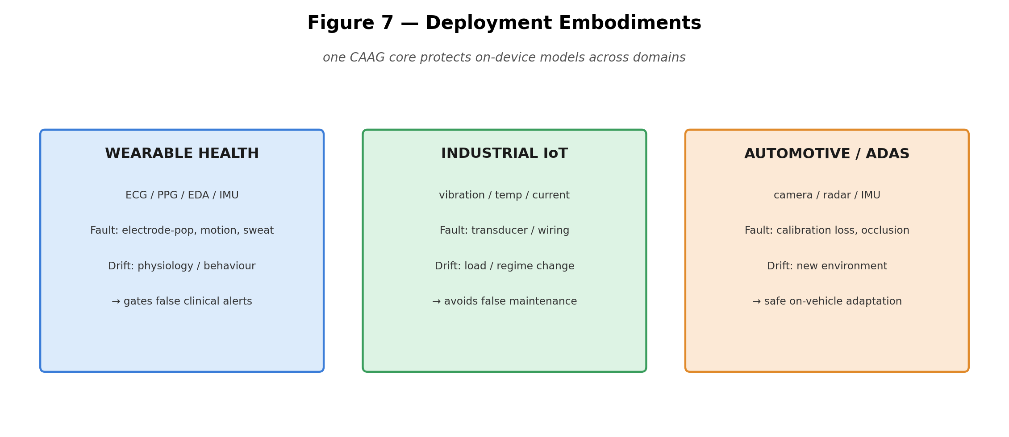
Figure 7 — Deployment embodiments across wearable, industrial, and automotive domains
Universal AI Middleware — A Domain-Independent Adaptation Layer
In a further aspect, the disclosed Cause-Attributed Adaptation Gate (CAAG) is embodied as a universal artificial-intelligence middleware, namely a domain-independent artificial-intelligence decision layer or adaptive-intelligence layer interposed between a sensor subsystem and a machine-learning model. Unlike the machine-learning model, the CAAG does not itself perform the primary inference task. Instead, it governs whether, when, and how the associated machine-learning model is permitted to adapt in response to post-deployment data. The core CAAG architecture operates substantially unchanged across diverse application domains, while only the sensor-specific adapter components—including channel definitions, inter-channel consistency relationships, and the plausibility manifold—are configured or reconfigured for a particular domain.
Representative application domains in which the substantially identical Cause-Attributed Adaptation Gate (CAAG) core may operate include, without limitation:
- Smart watches
- Smart rings
- Automobiles and advanced driver-assistance systems (ADAS)
- Robots
- Drones
- Industrial Internet-of-Things (IIoT) systems
- Manufacturing systems
- Medical devices
- Smart-home systems
- Consumer electronics
- and substantially any edge artificial-intelligence device
Because the core cause-attribution and adaptation-governance logic is independent of the particular sensing modality, the disclosed invention functions as a reusable artificial-intelligence middleware layer that may be integrated into heterogeneous devices while providing a consistent adaptation-governance interface across diverse application domains and hardware platforms.
The disclosed invention is further applicable, without limitation, to the following application domains, in each of which the sensor-specific adapter components are configured or reconfigured while the core Cause-Attributed Adaptation Gate (CAAG) architecture remains substantially unchanged. In embodiments in which the monitored inputs are not physical transducer signals, the term “channel” is to be understood as encompassing any plurality of concurrent input, feature, telemetry, data, or modality streams:
- Autonomous vehicles. Autonomous and highly automated driving systems employing sensor fusion across camera, radar, LiDAR, and inertial channels, in which a detected distributional change is attributed either to a genuine change in the driving environment, thereby authorizing a guarded model update, or to sensor degradation or a measurement fault, thereby suppressing model adaptation and generating a maintenance or diagnostic indication.
- Humanoid robots. Robotic systems employing proprioceptive, tactile, and visual sensing channels, in which genuine changes in the task or operating environment are distinguished from actuator faults, sensor faults, or measurement artifacts before control or perception models are permitted to undergo guarded adaptation.
- Factory automation and industrial robotics. Industrial automation and manufacturing systems employing multi-axis motion, process, and quality-monitoring channels, in which adaptation of control, predictive-maintenance, and quality-inspection models is governed by cause attribution, thereby permitting guarded model adaptation in response to genuine process changes while suppressing adaptation resulting from sensor faults or measurement anomalies.
- Drones and unmanned aerial systems. Unmanned aerial vehicles (UAVs) and drone systems employing inertial, positioning, vision, and barometric sensing channels, in which genuine changes in flight regime or operating environment are distinguished from sensor faults or measurement anomalies before navigation, perception, or flight-control models are permitted to undergo guarded adaptation.
- Smart agriculture. Precision-agriculture systems employing soil-condition, moisture, weather, and imaging channels, in which genuine seasonal, agronomic, or environmental changes are distinguished from sensor drift, sensor degradation, or measurement anomalies before crop-monitoring, irrigation, or decision-support models are permitted to undergo guarded adaptation.
- Aerospace and avionics. Aerospace and aviation systems use different ways to check the flight state and the health of the engine. These systems have channels to make sure they work properly. When it comes to adjusting the models that monitor health find faults. Predict future problems the reason, for the change must be clear. These changes are only allowed when the system is very reliable and safe.
- Cybersecurity and network intrusion detection. Cybersecurity and network-monitoring systems use channels made up of telemetry log or feature streams. The Cause-Attributed Adaptation Gate or CAAG is designed to tell changes in network traffic, system behaviour or threat patterns apart, from data that has been corrupted, spoofed, poisoned or otherwise tampered with. Because of this model adaptation is only allowed when genuine concept drift is detected. If the system suspects data corruption or adversarial manipulation adaptation is stopped. This helps reduce the risk of data poisoning during model adaptation keeping the deployed detection model secure and reliable.
- Multimodal large-language-model (LLM) agents. Artificial‑intelligence agent and intelligent‑assistant systems work with channels that handle input modalities, tool outputs, retrieval signals, memory signals and environment‑state streams. The Cause‑Attributed Adaptation Gate (CAAG) decides whether artificial‑intelligence agent model adaptation, artificial‑intelligence agent personalization or artificial‑intelligence agent long‑term memory updates are allowed. The CAAG distinguishes changes in user intent task context or operating environment, from corrupted, adversarial or anomalous input streams. Thus only legitimate concept drift triggers safe artificial‑intelligence agent adaptation while the CAAG stops any adaptation that might damage the deployed agent or its persistent knowledge.
Platform Architecture
In a platform embodiment, the disclosed invention is organized as a plurality of cooperating functional layers through which cause-attribution and adaptation-governance information flows:
- Device Layer. The physical device, the associated sensor subsystem, and the deployed machine-learning inference model.
- Local CAAG. The on-device Cause-Attributed Adaptation Gate (CAAG), which performs the Cross-Channel Coherence Signature (CCS), Temporal Signature (TSS), Plausibility Prior Manifold (PPM), Cause-Attribution Fusion (CAF), Adaptation Routing and Response (ARR), and Guarded Bounded Adaptation (GBA) operations locally, thereby enabling continued autonomous operation in the absence of network connectivity.
- Cloud Synchronization. A synchronization module configured to transmit compact adaptation metadata, rather than raw sensor data, to a remote repository in accordance with a predefined metadata schema and communication protocol.
- Cloud Knowledge Repository. A persistent repository configured to store fault signatures, adaptation outcomes, attribution metadata, and per-channel reliability profiles collected across a population of devices.
- API Layer. A representational state transfer (REST) application programming interface (API), or an equivalent interface, through which third-party systems invoke the Cause-Attributed Adaptation Gate (CAAG) and retrieve machine-readable health-telemetry outputs.
- SDK Layer. Embeddable software components, software development kits (SDKs), libraries, and firmware configured to enable integration of the Cause-Attributed Adaptation Gate (CAAG) into third-party machine-learning inference applications, embedded systems, and edge devices.
- Enterprise Integration. Connectors configured to expose cause-attribution results and machine-readable health-telemetry outputs to fleet-monitoring, maintenance-scheduling, model-lifecycle-management, and other supervisory management systems.
Information flows upward from the Device Layer in the form of compact adaptation metadata, including attributed-cause information and adaptation outcomes, and flows downward as refined priors, configuration parameters, and policy updates, as further illustrated in Figure 11.
Cloud Architecture and Long-Term Fleet Learning
In a cloud-connected embodiment, the disclosed system supports long-term, population-scale refinement of cause attribution and adaptation policies while preserving the option to retain raw sensor data on the originating device, thereby facilitating privacy-preserving, bandwidth-efficient, and federated operation:
- Local device learning. Each device performs on-device, cause-gated model adaptation independently, such that core inference, cause attribution, and adaptation control remain fully operational without network connectivity.
- Cloud synchronization. Attributed causes, attribution confidence values, fault signatures, per-channel reliability weights, and adaptation outcomes are periodically synchronized to a cloud-based repository as compact adaptation metadata in accordance with a predefined synchronization protocol.
- Metadata storage. The repository is configured to store compact derived adaptation metadata rather than raw sensor data or continuous sensor streams, thereby reducing communication overhead and supporting privacy-preserving operation.
- Privacy considerations. Raw sensor data may remain resident on the device where privacy, security, or bandwidth constraints so require, with only derived adaptation metadata being transmitted to external repositories or coordinating systems.
- Long-term learning. Accumulated adaptation memory enables recurring fault signatures, reliable cause-attribution patterns, and successful adaptation outcomes to be recognized, retained, and reused over time, thereby improving attribution accuracy, reducing cold-start behaviour, and facilitating progressively more reliable adaptation decisions across successive deployments.
- Fleet intelligence. A coordinating server performs federated aggregation of adaptation metadata collected from a plurality of devices to refine shared priors, model parameters, or decision statistics employed by the Cross-Channel Coherence Signature (CCS), Temporal Signature (TSS), Plausibility Prior Manifold (PPM), and Cause-Attribution Fusion (CAF) modules, without requiring access to the originating raw sensor data.
- Enterprise deployment. Refined priors, model parameters, and configuration updates are distributed back to participating devices to improve subsequent cause attribution and adaptation decisions, while machine-readable cause-attribution telemetry is exposed to enterprise monitoring, maintenance, fleet-management, and model-lifecycle-management systems through standardized interfaces.
Deployment Modalities
The disclosed Cause-Attributed Adaptation Gate (CAAG) is not limited to execution on the sensing device itself. In various embodiments, the CAAG operates as a general artificial-intelligence adaptation-governance layer and may be deployed: (i) entirely on the sensing device; (ii) on an edge server or gateway configured to receive sensor-derived data from one or more devices; (iii) in a cloud-computing environment configured to receive sensor-derived data or derived features over a communication network; (iv) in a hybrid architecture in which the functional modules are partitioned across the sensing device, an edge server, and the cloud; (v) within a federated-learning framework in which device-resident CAAG instances govern local model adaptation while contributing attributed-cause metadata to a coordinating server; and (vi) as a network-accessible service invoked, through an application programming interface (API), by a separate machine-learning system before that system performs a model-update operation.
In each deployment modality, the core cause-attribution and adaptation-governance logic remains substantially unchanged, with only the execution environment and the transport mechanism for sensor-derived data or derived features differing. Accordingly, the CAAG may be embodied as domain-independent adaptation-governance middleware, or as an adaptation-governance-as-a-service platform, interposed between arbitrary sensor or signal sources and arbitrary machine-learning models to provide consistent, cause-conditioned control of post-deployment model adaptation.
3.7. WORKING PROTOTYPE / DESIGN STATUS
The disclosed invention is presently at the conceptual engineering and computational feasibility stage. Reduction to practice and technical validation do not require dedicated laboratory hardware, as the disclosed methods may be implemented entirely in software and evaluated using publicly available multi-channel sensor datasets executed on a conventional computing platform, such as a standard laptop computer. The algorithmic specification presented in Sections 3.4.1–3.4.10 defines the disclosed methods with sufficient technical detail to enable implementation by a person having ordinary skill in the relevant art. Planned computational validation, executable using only a standard laptop computer and without dedicated laboratory equipment, includes, without limitation, the following:
- Phase 0 (Weeks 0–6): Implement the disclosed Cause-Attributed Adaptation Gate (CAAG) using a publicly available multi-channel wearable-sensor dataset. Controlled perturbations are introduced to simulate representative sensor faults, including transient spikes, stuck-at conditions, gain or offset drift, signal dropout, and sensor-placement rotation, together with simulated concept drift representing genuine changes in the underlying data distribution. A computational evaluation is planned to compare the disclosed system with a conventional change-detection-only baseline. Prophetic performance objectives include demonstrating a cause-attribution receiver operating characteristic area under the curve (ROC-AUC) for distinguishing sensor faults from genuine concept drift that is meaningfully higher than that achieved by the change-detection-only baseline. Any reported performance results are prophetic or simulation-based unless and until experimentally validated.
- Phase 1 (Weeks 4–12): Conduct an end-to-end computational comparison of model performance under three adaptation policies: (A) no model adaptation; (B) cause-blind model adaptation initiated in response to a detected distributional change, serving as the baseline; and (C) Cause-Attributed Adaptation Gate (CAAG)-controlled, cause-gated model adaptation in accordance with the disclosed methods. The planned computational evaluation compares predictive performance across scenarios containing both genuine concept drift and injected sensor faults or measurement artifacts. Prophetic performance objectives include demonstrating that policy (C) avoids the post-fault degradation in predictive performance associated with policy (B), while preserving substantially the same adaptation benefit under genuine concept drift that is unavailable under the non-adaptive policy (A). Any reported comparative performance results are prophetic or simulation-based unless and until experimentally validated.
- Phase 2 (Weeks 10–16): Perform computational ablation studies to evaluate the individual and combined contributions of the Cross-Channel Coherence Signature (CCS), Temporal Signature (TSS), and Plausibility Prior Manifold (PPM) by comparing CCS-only, TSS-only, and PPM-only configurations with the complete Cause-Attribution Fusion (CAF) architecture. Additional planned evaluations include measuring computational footprint, memory consumption, and inference latency on an emulated microcontroller (MCU) or other edge-computing target, together with assessing the robustness of the Guarded Bounded Adaptation (GBA) mechanism by deliberately introducing controlled cause-attribution errors to verify rollback behaviour, bounded recovery, and adaptation containment under mis-attribution scenarios. Prophetic performance objectives include demonstrating that the complete CAF architecture provides higher cause-attribution accuracy than any individual evidence channel while maintaining computational and memory requirements suitable for deployment on resource-constrained edge devices, and that the GBA rollback mechanism prevents sustained degradation of model performance following erroneous adaptation authorization. Any reported performance results are prophetic or simulation-based unless and until experimentally validated.
Prophetic Example 1 (Illustrative Computational Simulation): In a contemplated computational simulation employing a publicly available multi-channel human activity recognition (HAR) dataset, a gain-drift fault is introduced into one accelerometer axis at a first time point (t₀), followed by the introduction of a genuine activity-distribution change at a later time point (t₁). It is contemplated that the Cross-Channel Coherence Signature (CCS) will indicate strong localization of the anomaly at t₀, together with comparatively high cross-channel coherence at t₁. The Temporal Signature (TSS) is expected to characterize the event at t₀ as abrupt and at least partially reversible, while characterizing the event at t₁ as persistent and non-reverting over time. The Plausibility Prior Manifold (PPM) is expected to classify the observations at t₀ as off-manifold and those at t₁ as remaining substantially on or near the learned manifold. Based on these evidence channels, the Cause-Attribution Fusion (CAF) module is expected to attribute the event at t₀ to a sensor fault or measurement artifact, thereby suppressing model adaptation, and to attribute the event at t₁ to genuine concept drift, thereby authorizing a Guarded Bounded Adaptation (GBA) update. For comparison, a cause-blind adaptation baseline that performs model adaptation solely in response to a detected distributional change is expected to authorize adaptation at t₀, resulting in degradation of model performance through incorporation of fault-induced observations, whereas the disclosed Cause-Attributed Adaptation Gate (CAAG) is expected to preserve model performance by preventing fault-induced adaptation while remaining responsive to genuine concept drift at t₁.
This example is prophetic and is provided solely to illustrate the contemplated operation of the disclosed system. Any figures, numerical values, performance metrics, or comparative results associated with this example are illustrative only and are intended to be replaced, where appropriate, with measured computational simulation results in a subsequent implementation or complete specification.
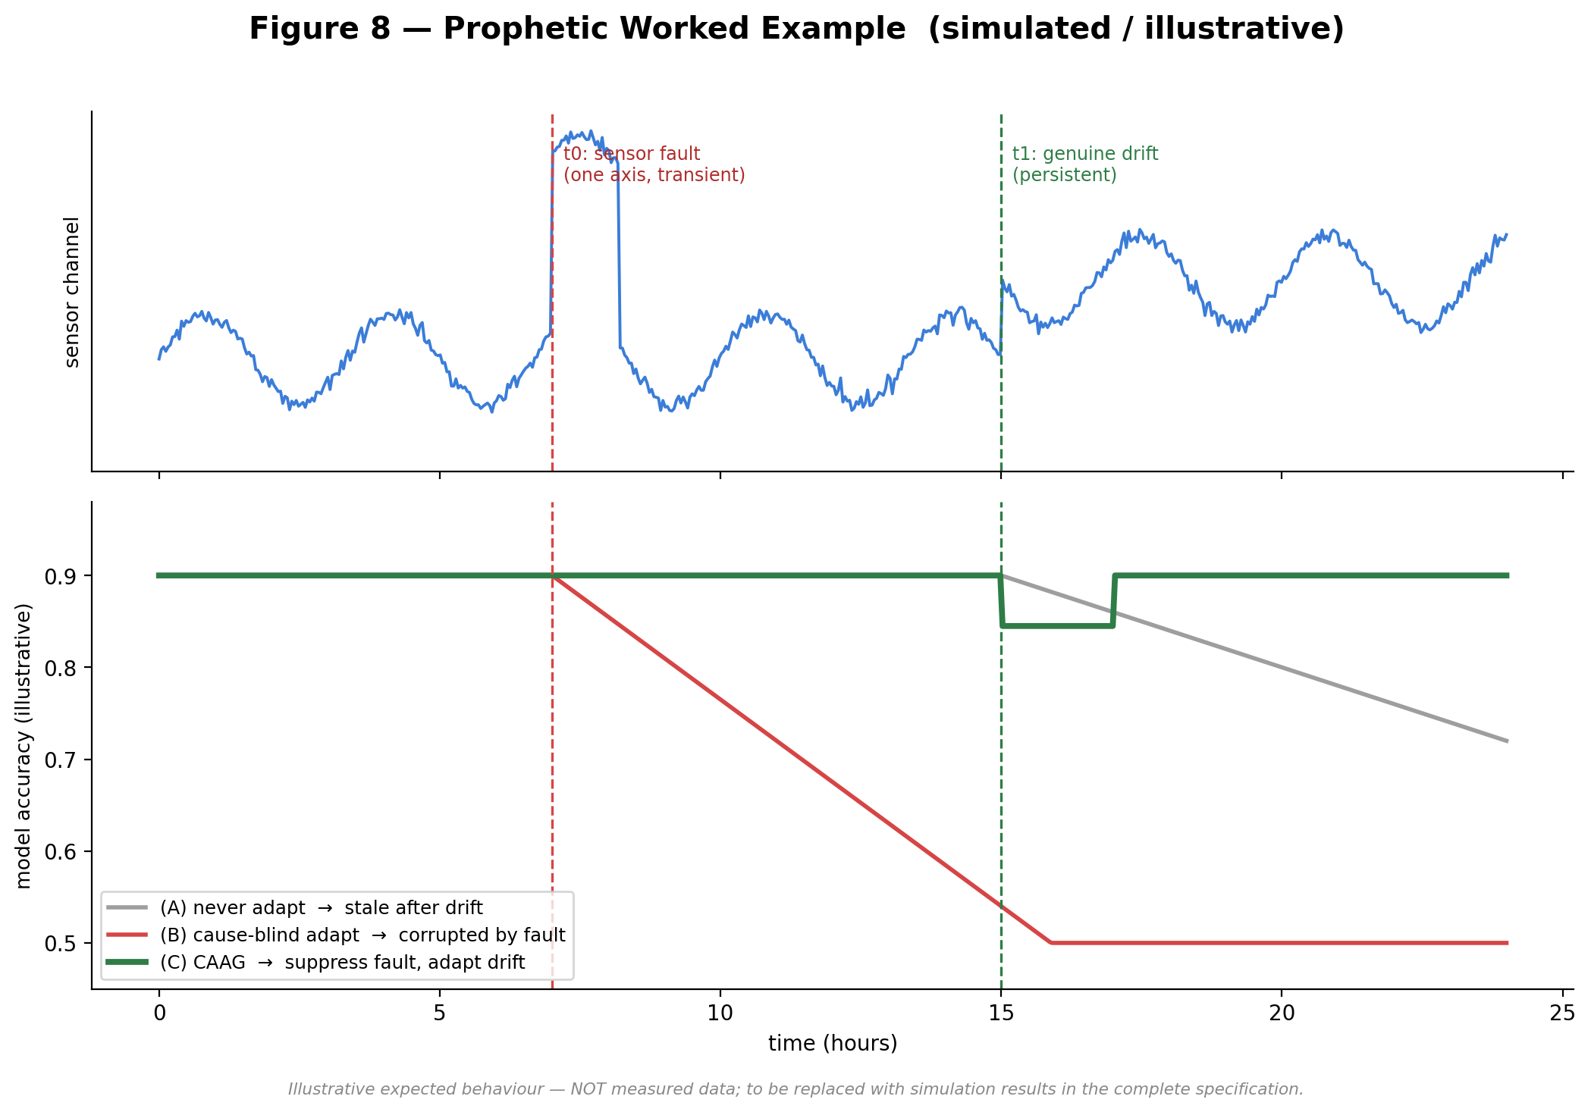
Figure 8 — Prophetic worked example (simulated / illustrative): CAAG preserves accuracy where cause-blind adaptation fails
The estimated time required to produce a demonstrable software reference implementation of the disclosed system is approximately three to four months. It is contemplated that the implementation and computational validation may be completed using a single conventional laptop computer without requiring wet-laboratory experimentation, custom hardware fabrication, or human-subject data collection, as the disclosed methods are designed to be implemented and evaluated entirely in software using publicly available datasets and simulated operating conditions. The resulting reference implementation is expected to provide a basis for subsequent experimental validation and deployment-specific optimization.
3.8. EXISTING DATA AND SCIENTIFIC SUPPORT
At the time of this disclosure, no proprietary datasets have been collected or generated for evaluation of the disclosed system. The technical feasibility of the disclosed methods is supported by established, peer-reviewed principles and prior developments in the relevant fields. In particular, (i) cross-sensor consistency and redundancy have been recognized as effective bases for sensor-fault detection, as reflected in the technical literature and exemplified by U.S. Patent No. 10,578,667; (ii) unlabeled concept-drift detection has been established in the literature, including representative approaches such as STUDD (2021) and sequential on-device drift detection described by Yamada and Matsutani (2022); and (iii) test-time and unsupervised model adaptation have likewise been established, with recent robust test-time adaptation approaches, including MedBN (2024), demonstrating that adaptation performed on corrupted or otherwise unsuitable data batches may result in degradation or collapse of model performance, thereby providing technical motivation for the disclosed guarded, cause-gated adaptation architecture.
The inventive contribution of the present disclosure does not reside in the individual constituent techniques themselves, but rather in their integration into a unified architecture in which label-free cause attribution governs whether, when, and how model adaptation is authorized. More particularly, the disclosed Cause-Attributed Adaptation Gate (CAAG) integrates cross-channel coherence analysis, temporal-signature analysis, plausibility assessment, probabilistic cause attribution, adaptation routing, and guarded model adaptation into a coordinated decision framework that distinguishes genuine concept drift from sensor faults or measurement artifacts before any model-update operation is permitted.
The present disclosure does not report measured experimental results or proprietary evaluation data. Any quantitative objectives, projected performance characteristics, illustrative examples, or performance metrics presented herein are expressly identified as prophetic or simulation-based and are provided solely to illustrate the contemplated operation of the disclosed system pending completion of the planned computational simulation studies described herein.
4. USE AND DISCLOSURE
# | Question | Answer
A | Have you described or shown your invention/design to anyone or in any conference? | NO
B | Have you made any attempts to commercialize your invention? | NO
C | Has your invention been described in any printed publication or other media, such as the Internet? | NO
D | Do you have any collaboration with any other institute or organization on the same? | NO
E | Name of Regulatory body or any other approvals if required. | Not applicable for the core software method. A downstream regulated wearable-medical product — not this method — may implicate SaMD pathways (FDA/CE/CDSCO).

5. Public Disclosure Links
Claim for Priority (if any): None.
Previous Public Disclosure: At the time of this disclosure, the applicant is not aware of any public disclosure relating to the disclosed invention by the applicant, including any patent, published patent application, scientific paper, pre-print, conference presentation, online publication, website, or other publicly accessible disclosure.
6. MOU / Collaboration Terms
Not applicable at the present provisional stage. No Memorandum of Understanding (MoU), research collaboration agreement, sponsored research agreement, or similar arrangement is currently in effect with respect to the disclosed invention. The invention was independently conceived and developed by students of Lovely Professional University. Any future research, validation, commercialization, licensing, or development activities involving external collaborators may be undertaken pursuant to appropriate agreements executed at the relevant time.
7. Potential Chances of Commercialization
Beyond licensing of a wearable-specific algorithm, the disclosed invention may be commercialized as a universal artificial-intelligence adaptation middleware positioned between sensor systems and machine-learning models, namely as a domain-independent decision layer that governs whether, when, and how a deployed adaptive model is permitted to update itself, rather than as a machine-learning model performing the primary inference task. In such embodiments, organizations may integrate the Cause-Attributed Adaptation Gate (CAAG) in substantially the same manner as they integrate payment-processing, authentication, or policy-enforcement services, by invoking the CAAG before authorizing any post-deployment model-update operation. Representative product embodiments and commercialization models include, without limitation, the following:
- AI adaptation middleware platform.
- Edge-AI software development kit (SDK).
- Cloud adaptation service.
- Enterprise API.
- TinyML runtime.
- Fleet-learning platform.
- AI safety and governance layer.
In each of the foregoing product and commercialization framings, the disclosed invention functions as the decision engine that an adaptive artificial-intelligence system invokes before performing a model-update operation. Any large-scale or cross-organization learning is achieved solely through the concrete cloud-synchronization, adaptation-memory, and federated-aggregation mechanisms described in Section 3.6, and not through any generalized or autonomous notion of global learning.
- Edge-AI / TinyML platforms: The disclosed technology may be embodied as a licensable firmware component, software library, or software development kit (SDK) that provides safe on-device model adaptation and model-lifecycle management. In such embodiments, the firmware, library, or SDK implements the disclosed Cause-Attributed Adaptation Gate (CAAG) architecture to improve the reliability, robustness, and trustworthiness of post-deployment model adaptation by distinguishing genuine concept drift from sensor faults or measurement artifacts before authorizing any model-update operation.
- Wearable & consumer health: In wearable health and wellness embodiments, the disclosed system is expected to reduce false clinical or wellness alerts attributable to sensor faults or measurement artifacts while preserving effective personalization through controlled adaptation to genuine concept drift. By distinguishing fault-induced distributional changes from genuine physiological or behavioural changes before authorizing model adaptation, the disclosed Cause-Attributed Adaptation Gate (CAAG) is expected to improve the reliability of alert generation while maintaining the benefits of individualized, post-deployment model adaptation.
- Industrial IoT / predictive maintenance: In industrial monitoring embodiments, the disclosed system is expected to reduce unnecessary maintenance actions and false maintenance indications resulting from transducer faults or measurement artifacts while continuing to perform controlled model adaptation in response to genuine operating-regime changes. By distinguishing sensor faults and measurement anomalies from legitimate changes in equipment behaviour before authorizing model adaptation, the disclosed Cause-Attributed Adaptation Gate (CAAG) is expected to improve the reliability of condition monitoring and predictive maintenance while reducing adaptation-induced model degradation.
- Automotive / robotics: In automotive embodiments, the disclosed system provides sensor-integrity-aware on-vehicle model adaptation for advanced driver-assistance systems (ADAS) and autonomous driving systems by authorizing model adaptation only after distinguishing genuine environmental or operational changes from sensor faults or measurement artifacts. Accordingly, the disclosed Cause-Attributed Adaptation Gate (CAAG) is expected to improve the reliability, robustness, and safety of post-deployment on-vehicle model updates while reducing the risk of adaptation-induced degradation arising from faulty or corrupted sensor inputs.
- MLOps / model-monitoring vendors: In certain embodiments, the disclosed technology may be provided as a premium model-observability module configured to expose machine-readable cause-attribution and health-telemetry outputs to downstream monitoring, analytics, governance, and model-lifecycle-management systems. The module may report the attributed cause, attribution confidence, suspect-channel set, per-channel reliability weights, adaptation status, routing action, and related diagnostic information, thereby enabling enhanced monitoring, auditing, governance, and operational management of deployed machine-learning models without requiring modification of the underlying inference application.
8. List of companies which can be contacted for commercialization
- Edge-AI silicon & tooling: Arm, Qualcomm, STMicroelectronics, Texas Instruments, Nordic Semiconductor, Edge Impulse.
- Wearables / digital health: representative smartwatch/ring/patch platforms.
- Industrial IoT / predictive maintenance: Bosch, Siemens, PTC.
- MLOps / model monitoring: vendors in the model-observability and drift-monitoring segment.
NOTE: Sector references only. No partnerships, licensing discussions, or commercialization agreements have been initiated.
9. Any basic patent which has been used and requiring royalty
At the time of this disclosure there are no known royalty-paying dependencies connected to the invention that is being shared. A first look at patent information that's open to the public like the United States Patent and Trademark Office database and Google Patents along with some related research papers has not found any one source that talks about the exact mix of features that are being shared here. These features include label-free cause attribution combined with cause-conditioned routing and authorization of on-device model adaptation. Each part of this system is already known in work; however, the new idea in this disclosure is how these parts are put together in a specific way. This includes using -channel consistency as a signal for label-free cause attribution, not just, for finding sensor problems and creating a cause-gated system that controls how models change after they are put into use.
The observations above are supplied as a preliminary technical assessment. The observations above are not intended to be an opinion about patentability, validity, enforceability or freedom to operate. A formal Freedom‑to‑Operate analysis, with any related patentability, validity and intellectual‑property assessments should be conducted by a registered patent attorney or another qualified intellectual‑property professional before filing a complete patent specification or before commencing commercial implementation of the disclosed invention.
10. FILING OPTIONS
Recommendation: File a Provisional Patent Application at the Indian Patent Office (IPO) under the Patents Act 1970 (as amended); optionally file a US provisional under 35 U.S.C. §111(b) concurrently or within 12 months.
Drafting guidance to maximise grant prospects (software-invention specific):
- India §3(k): In preparing the complete specification, the disclosed invention may be claimed in system, device, method, computer-readable medium, and computer-program-product formats, as appropriate, to emphasize its practical technical implementation and resulting technical effects. By way of example, independent system or device claims may be directed to a device comprising one or more sensors, one or more processors, and memory storing instructions that, when executed, cause the device to perform the disclosed cause-attribution and adaptation-governance operations. Corresponding method claims may be directed to operations for generating and applying a model-update control signal configured to authorize, suppress, constrain, defer, or roll back an on-device model-update operation based on an attributed cause of a detected distributional change.
The claims may further emphasize the technical effects achieved by the disclosed architecture, including improved reliability and robustness of post-deployment model adaptation, resistance to adaptation induced by sensor faults or measurement artifacts, bounded and reversible model updates, efficient operation on resource-constrained edge devices, and generation of machine-readable cause-attribution telemetry for downstream monitoring and system integration. Claim drafting should focus on the concrete technical implementation of the disclosed architecture and its interaction with physical sensing, signal processing, and model-management components, rather than on an abstract algorithm in isolation, while taking into account the applicable requirements of Section 3(k) of the Indian Patents Act and any subsequent examination guidance.
- US §101 (Alice): When drafting the specification, the claims should be based on real technical improvements in how the computing device operates how the sensor subsystem works and how the on-device machine-learning system operates, instead of just abstract data analysis. For example, the claims might say that the Cause-Attributed Adaptation Gate (CAAG) architecture stops damage to machine-learning models that are already running by telling the difference between true data changes (concept drift) and sensor problems or bad measurements before it lets the model be updated. The claims might also say that updates to the model are only allowed or are stopped or are limited or are delayed or are undone depending on what caused the problem, which makes the model adapt after it is deployed reliable and stronger. Other practical effects that the claims could cover are: cutting out model updates and the extra computing power and energy they need; making the on-device model life-cycle more reliable; producing machine-readable cause-attribution and health-telemetry data that can be used by monitoring and maintenance systems; and keeping good prediction ability, on small devices by controlling, limiting and protecting model updates with trust budgets and rollbacks. Therefore, the claims should focus on these technical improvements that come from the disclosed system and how it works with the sensors, computing and machine-learning parts and not describe the invention as just an abstract algorithm.
- Inventive-step defense: When preparing the specification I might use a tiered claim strategy. A tiered claim strategy begins with claims that're narrow, in implementations. A tiered claim strategy then moves those claims to embodiments. A tiered claim strategy keeps the specification clear and organized. For example, the independent claims may be directed to the disclosed architectural combination comprising the Cross-Channel Coherence Signature (CCS), Temporal Signature (TSS), Plausibility Prior Manifold (PPM), Cause-Attribution Fusion (CAF), Adaptation Routing and Response (ARR), and cause-conditioned control of on-device model adaptation. Dependent claims may then describe ways to implement each functional module, each fusion mechanism, each change-detection technique, each adaptation policy, each deployment architecture, each communication interface and each guarded-update mechanism that are described here. I see that this claim structure is meant to highlight the disclosed integrated architecture and how its components interact technically than focusing on any single technique alone.
During patent prosecution the claim scope may be. Broadened as needed based on the prior art that is found during examination. I think any changes or arguments can focus on the disclosed integration. This includes label-free cause attribution that controls authorization cross-channel coherence that acts as an internal negative-control reference to tell real concept drift apart from sensor faults or measurement artifacts and the resulting cause-conditioned, bounded and rollback-protected model-adaptation framework. This is different, from combinations of prior-art references that only show techniques.
Proposed Filing and Prosecution Strategy: Now we plan to file a provisional patent application so that we can set an initial priority date for the invention that we have disclosed. Over the three to four months, we will finish the planned computational validation. We will do this through simulation that uses publicly available datasets and runs on conventional computing hardware. When we have the simulation results, we will put everything into a patent specification. That specification will include the validation the simulation figures and any changes we make to the disclosure. We will file this specification before the priority period ends. Later depending on our business plan and our intellectual‑property goals we might file a patent application, under the Patent Cooperation Treaty, the PCT to seek patent protection in one or more chosen jurisdictions.

A corresponding claim strategy may include multiple complementary claim families directed to different inventive aspects of the disclosed technology. For example, one claim family may be directed to the Cause-Attributed Adaptation Gate (CAAG) architecture, including the Cross-Channel Coherence Signature (CCS), Temporal Signature (TSS), Plausibility Prior Manifold (PPM), Cause-Attribution Fusion (CAF), Adaptation Routing and Response (ARR), and Guarded Bounded Adaptation (GBA) modules implemented as a system, device, or computer-implemented platform. A second claim family may be directed to the cause-conditioned adaptation-governance methodology, including authorization, suppression, deferral, bounding, and rollback of on-device model adaptation in response to an attributed cause of a detected distributional change. Additional claim families may be directed to specific application embodiments, including wearable health-monitoring systems employing cause-gated alert management, industrial monitoring systems, automotive systems, artificial-intelligence agents, and other edge-computing applications, as well as to broader computer-implemented methods, computer-readable media, and software products for cause-gated post-deployment model adaptation applicable across multiple sensing and machine-learning domains.
The final claim structure may be refined during preparation and prosecution of the complete specification in view of the disclosed embodiments, the applicable prior art, and the patentability and examination requirements of the jurisdictions in which protection is sought.
Example Claim Skeleton (Proto-Claims — indicative only, not a filed claim set)
Claim 1 (System — device-tethered). A device comprising:
- A device comprising:
one or more sensors configured to generate a plurality of measurement channels;
a hardware processor configured to execute a machine-learning inference model and to perform an associated on-device model-update operation; and
a cause-attribution gate implemented as processor-executable instructions stored in a non-transitory computer-readable medium and executable by the hardware processor, the cause-attribution gate being configured, in response to detection of a distributional change in the plurality of measurement channels or in one or more outputs of the machine-learning inference model, to:
(a) compute a cross-channel coherence signature indicative of whether the detected distributional change is localized to a subset of the plurality of measurement channels or is coherent across the plurality of measurement channels;
(b) compute a temporal signature representative of the detected distributional change;
(c) compute a plausibility score indicative of consistency of post-change data with a learned manifold of operating states;
(d) fuse the cross-channel coherence signature, the temporal signature, and the plausibility score to generate, without use of ground-truth labels, a posterior probability distribution over a plurality of candidate causes of the detected distributional change and an associated attribution confidence; and
(e) generate, based at least in part on the posterior probability distribution and the associated attribution confidence, a model-update control signal configured to selectively control execution of the on-device model-update operation by:
(i) suppressing the on-device model-update operation when the detected distributional change is attributed to a sensor fault or a measurement artifact; and
(ii) authorizing the on-device model-update operation when the detected distributional change is attributed to genuine concept drift and the associated attribution confidence satisfies a predetermined confidence threshold.
Claim 2 (Method). A computer-implemented method of governing on-device model updating, the method comprising:
Acquiring, by a computing device, multi-channel sensor features from one or more sensors; detecting, without use of ground-truth labels, a distributional change associated with the multi-channel sensor features or with one or more outputs generated by an on-device machine-learning inference model;
Attributing a cause of the detected distributional change by:
(i) computing a cross-channel coherence signature;
(ii) computing a temporal signature;
(iii) computing a manifold-plausibility score indicative of consistency of post-change data with a learned manifold of operating states; and
(iv) fusing the cross-channel coherence signature, the temporal signature, and the manifold-plausibility score to generate a posterior probability distribution over a plurality of candidate causes of the detected distributional change and an associated attribution confidence; and
Routing, by the computing device, execution of an on-device model-update operation as a function of the posterior probability distribution and the associated attribution confidence, including:
(i) suppressing the on-device model-update operation when the detected distributional change is attributed to a sensor fault or a measurement artifact; and
(ii) executing the on-device model-update operation as a bounded model update when the detected distributional change is attributed to genuine concept drift and the associated attribution confidence satisfies a predetermined confidence threshold.
.
Claim 3 (dependent — CCS negative control). The device of claim 1, wherein computing the cross-channel coherence signature comprises, for each of the plurality of measurement channels, determining a coherence residual between an observed value of the respective measurement channel and a corresponding value jointly predicted from the remaining measurement channels, and identifying a channel-localized sensor fault when one or more coherence residuals associated with a subset of the plurality of measurement channels exceed a predetermined threshold while the remaining measurement channels remain mutually consistent.
Claim 4 (dependent — temporal signature).
The device of claim 1, wherein the temporal signature comprises one or more temporal characteristics selected from the group consisting of onset abruptness, persistence, reversibility, and spectral character of the detected distributional change, and wherein the cause-attribution gate is configured such that a reverting, impulsive, or otherwise transient temporal signature increases the posterior probability that the detected distributional change is attributable to a sensor fault or measurement artifact relative to a persistent, gradual, or non-reverting temporal signature.
Claim 5 (dependent — plausibility manifold). The device of claim 1, wherein the plausibility score is computed using one or more techniques selected from the group consisting of a reconstruction error generated by a compact autoencoder, a one-class anomaly score, a nearest-prototype distance, a kernel-density estimate, a Mahalanobis-distance measure, and a normalizing-flow density model, and wherein the cause-attribution gate is configured such that an off-manifold departure exhibiting a sensor-specific directional characteristic increases the posterior probability that the detected distributional change is attributable to a sensor fault or measurement artifact.
Claim 6 (dependent — guarded bounded adaptation). The device of claim 1, wherein authorizing the on-device model-update operation comprises:
(a) retaining a snapshot of one or more parameters of the machine-learning inference model prior to application of the on-device model-update operation;
(b) applying a bounded model update to the machine-learning inference model;
(c) evaluating an unlabeled task-health proxy before and after application of the bounded model update; and
(d) restoring the one or more parameters from the retained snapshot when the unlabeled task-health proxy indicates degradation exceeding a predetermined threshold following application of the bounded model update.
Claim 7 (dependent — trust budget). The device of claim 5, further comprising an adaptation trust budget maintained on a per-window basis, wherein the cause-attribution gate is configured to limit a cumulative extent of authorized on-device model-update operations in accordance with the adaptation trust budget, and wherein the adaptation trust budget is replenished only while the unlabeled task-health proxy indicates stable operation over one or more successive evaluation windows.
Claim 8 (dependent — fault response). The device of claim 1, wherein, in response to attribution of the detected distributional change to a sensor fault or measurement artifact, the cause-attribution gate is further configured to:
(a) identify one or more affected measurement channels;
(b) cause masking, recalibration, compensation, or exclusion of the identified one or more affected measurement channels;
(c) continue execution of the machine-learning inference model using one or more remaining measurement channels; and
(d) generate an inference output accompanied by a reduced-confidence indication.
Claim 9 (dependent — ambiguous fallback). The device of claim 1, wherein, in response to the posterior probability distribution indicating an ambiguous cause attribution or the associated attribution confidence failing to satisfy the predetermined confidence threshold, the cause-attribution gate is configured to:
(a) defer the on-device model-update operation; and
(b) place the device in a relative-change tracking mode, the relative-change tracking mode comprising monitoring a direction and/or rate of change of at least one dominant feature while refraining from committing a parameter update to the machine-learning inference model until a subsequent cause attribution satisfies the predetermined confidence threshold.
Claim 10 (dependent — single-sensor / federated). The device of claim 1, wherein:
(a) the plurality of measurement channels comprises a plurality of feature views, frequency sub-bands, model heads, or combinations thereof derived from a single physical sensor, the cause-attribution gate being configured to compute the cross-channel coherence signature using the plurality of derived measurement channels; or
(b) the device comprises a federated-learning client configured to associate an authorized model update with attributed-cause metadata including the attributed cause and an associated attribution confidence, the attributed-cause metadata enabling a federated-learning server to selectively weight, prioritize, or down-weight contributed model updates identified as potentially affected by a sensor fault or measurement artifact without requiring access to raw sensor data.
Claim 11 (dependent — firmware/SDK integration). The device of claim 1, wherein the cause-attribution gate is embodied as embedded firmware, a software library, or a software development kit (SDK) component integrated into a third-party inference application executing on the device, and wherein the third-party inference application invokes the model-update control signal generated by the cause-attribution gate before performing a model-update operation.
Claim 12 (dependent — metadata synchronization). The device of claim 1, further comprising a synchronization module configured to transmit adaptation metadata to a remote repository in accordance with a predefined metadata schema and communication protocol, the adaptation metadata comprising the attributed cause, the attribution confidence, one or more fault signatures, per-channel reliability weights, and one or more adaptation outcomes, while retaining raw sensor data resident on the device.
Claim 13 (dependent — federated aggregation). The device of claim 11, wherein a server is configured to perform federated aggregation of the adaptation metadata transmitted by a plurality of devices to refine one or more shared priors, model parameters, or decision statistics used by at least one of the cross-channel coherence signature, the temporal signature, the plausibility score, and the fusion, without the server accessing raw sensor data generated by the plurality of devices.
Claim 14 (dependent — adaptation memory). The device of claim 1, further comprising an adaptation-memory data structure configured to store recurring fault signatures, attributed-cause information, and adaptation outcomes as reusable priors, the reusable priors being configured to initialize one or more components of the cause-attribution gate of a further device prior to acquisition of device-specific data by the further device, thereby reducing cold-start attribution error and improving initial cause-attribution performance.
Claim 15 (System — deployment-agnostic). A system for governing updating of a machine-learning model, the system comprising one or more processors and memory storing instructions that, when executed by the one or more processors, cause the system to:
receive sensor-derived data comprising a plurality of measurement channels from one or more sensors;
responsive to detection of a distributional change in the sensor-derived data or in one or more outputs of the machine-learning model:
(a) compute a cross-channel coherence signature;
(b) compute a temporal signature;
(c) compute a plausibility score indicative of consistency of post-change data with a learned manifold of operating states; and
(d) fuse, without use of ground-truth labels, the cross-channel coherence signature, the temporal signature, and the plausibility score to generate a posterior probability distribution over a plurality of candidate causes of the distributional change and an associated attribution confidence; and
generate, based at least in part on the posterior probability distribution and the associated attribution confidence, a model-update control signal configured to:
(i) suppress a model-update operation of the machine-learning model when the distributional change is attributed to a sensor fault or a measurement artifact; and
(ii) authorize the model-update operation when the distributional change is attributed to genuine concept drift and the associated attribution confidence satisfies a predetermined confidence threshold,
wherein the one or more processors are disposed in at least one of: (a) a device associated with the one or more sensors; (b) an edge server or gateway; (c) a cloud-computing server; or (d) a distributed computing architecture comprising any combination thereof.
Claim 16 (non-transitory computer-readable medium). A non-transitory computer-readable medium storing instructions that, when executed by one or more processors, cause the one or more processors to:
detect, without use of ground-truth labels, a distributional change associated with multi-channel sensor-derived data or with one or more outputs of a machine-learning model;
attribute a cause of the detected distributional change by:
(a) computing a cross-channel coherence signature;
(b) computing a temporal signature;
(c) computing a manifold-plausibility score indicative of consistency of post-change data with a learned manifold of operating states; and
(d) fusing the cross-channel coherence signature, the temporal signature, and the manifold-plausibility score to generate a posterior probability distribution over a plurality of candidate causes of the detected distributional change and an associated attribution confidence; and
route a model-update operation as a function of the posterior probability distribution and the associated attribution confidence by:
(i) suppressing the model-update operation when the detected distributional change is attributed to a sensor fault or a measurement artifact;
(ii) executing the model-update operation as a bounded and rollback-protected update when the detected distributional change is attributed to genuine concept drift and the associated attribution confidence satisfies a predetermined confidence threshold; and
(iii) deferring the model-update operation when the posterior probability distribution indicates an ambiguous cause attribution or the associated attribution confidence fails to satisfy the predetermined confidence threshold.
Claim 17 (dependent — adaptation governance as a service). The system of claim 14, wherein the system is configured to be invoked, through an application programming interface (API), by a separate machine-learning system prior to the separate machine-learning system performing a model-update operation, and to return the model-update control signal to the separate machine-learning system, whereby the system operates as an adaptation-governance service configured to govern post-deployment model updates performed by the separate machine-learning system.
11. KEYWORDS
on-device machine learning | edge AI reliability | concept drift detection | sensor fault detection | unlabeled cause attribution | cross-channel coherence | test-time adaptation | guarded model update | silent model corruption prevention | TinyML | model-update gating | drift-versus-fault disambiguation | rollback-protected adaptation | health telemetry | predictive maintenance | wearable sensor robustness
NO OBJECTION CERTIFICATE
This is to certify that Lovely Professional University has no objection to the filing of an intellectual property rights (IPR) application, including but not limited to a patent, copyright, design, or any other form of intellectual property protection, entitled:
“System and Method for Cause-Attributed Adaptation Gating in On-Device Machine Learning, Comprising Unlabelled Disambiguation of Sensor Faults from Genuine Concept Drift via Cross-Channel Coherence, Temporal-Signature, and Plausibility-Prior Fusion, and Cause-Conditioned Routing of Model-Update Operations”
including the name(s) of the inventor(s) who are students and/or employees of Lovely Professional University.
The University further confirms that it shall not provide any financial assistance in connection with the preparation, filing, prosecution, maintenance, or commercialization of the aforesaid intellectual property. Accordingly, the University shall not raise any objection with respect to the filing, prosecution, commercialization, licensing, assignment, or other exploitation of the intellectual property, nor shall it assert any ownership, financial, or other proprietary interest in the invention or any intellectual property rights arising therefrom, except as may otherwise be expressly agreed in writing by the parties.
.

_________________________
(Authorised Signatory)

