Annexure3b- Complete filing
INVENTION DISCLOSURE FORM
Details of Invention for better understanding:
1. TITLE:
System and Method for Causal Attribution-Based Selective Retraining of Deployed Machine-Learning Models.
Technical field. The disclosure relates to the automated maintenance of deployed machine-learning models, and more particularly to a computer-implemented system and method that attributes an observed post-deployment performance degradation to responsible components spanning external input features and internal model state, predicts the recovery obtainable from repairing each such component, and selects and executes a minimal, resource-constrained corrective retraining scope.
2. INTERNAL INVENTOR(S)/ STUDENT(S):
All fields in this column are mandatory to be filled.
A.
Full name | Gona Lalith
Mobile Number | 8184844141
Email (personal) | gonalalith2005@gmail.com
UID/Registration number | 12308280
Address of Internal Inventors | Lovely Professional University, Punjab-144411, India
Signature (Mandatory) | 
B.
Full name | Ankita Maji
Mobile Number | 9307014709
Email (personal) | ankitamaji7033@gmail.com
UID/Registration number | 12319054
Address of Internal Inventors | Lovely Professional University, Punjab-144411, India
Signature (Mandatory) | 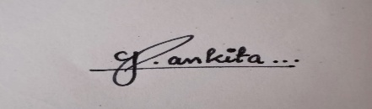
C.
Full name | Nihar Kanakam
Mobile Number | 6304856844
Email (personal) | niharkanakam@gmail.com
UID/Registration number | 12303615
Address of Internal Inventors | Lovely Professional University, Punjab-144411, India
Signature (Mandatory) | 
D.
Full name | Quaise Mallick
Mobile Number | 8002355970
Email (personal) | quaisemallick.wha@gmail.com
UID/Registration number | 12303709
Address of Internal Inventors | Lovely Professional University, Punjab-144411, India
Signature (Mandatory) | 
E.
Full name | Shailaja Singh
Mobile Number | 7906124399
Email (personal) | sshailaja2004@gmail.com
UID/Registration number | 12321463
Address of Internal Inventors | Lovely Professional University, Punjab-144411, India
Signature (Mandatory) | 
F.
Full name | Jasmeen Khatun
Mobile Number | 9056164792
Email (personal) | jasmeenkhatun536@gmail.com
UID/Registration number | 12319627
Address of Internal Inventors | Lovely Professional University, Punjab-144411, India
Signature (Mandatory) | 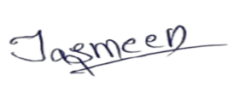
EXTERNAL INVENTOR(S): (INVENTORS NOT WORKING IN LPU)
A.
Full name | Dr. Ravin Kumar
Mobile Number | 9650105188
Email (personal) | ravinpal2009@gmail.com
Address of External Affiliations | School of Computer Science and Engineering, Lovely Professional University, Punjab, India
Signature (Mandatory) | 
For External Inventors, NOC (No Objection Certificate) from the affiliated institute/university/Industry/lab etc. is mandatory for each individual inventor and their respective topic. For NOC, format is attached below.
(FOR ADDITIONAL INVENTORS, PLEASE ADD ROWS)

3. DESCRIPTION OF THE INVENTION:
Disclosed herein are a system and a computer-implemented method for governing the continual retraining of a deployed machine-learning model. Upon detecting a post-deployment performance degradation, and before committing to any corrective retraining, the system determines (a) which upstream factor is responsible for the degradation, said factor being represented as a node in a graph whose node set unifies external input-feature statistics and internal model-state statistics of the deployed model; (b) a predicted performance recovery obtainable by repairing each candidate factor, estimated by a learned counterfactual recovery surrogate without executing a ground-truth retrain per hypothesis; and (c) a corrective maintenance action selected from a maintenance action space comprising at least a no-operation action, a targeted partial-retrain action, and a full-retrain action, said action being selected subject to a compute-cost budget and a service-level constraint.
With reference to Figure 1, the deployed production model (100) is reached only through an adapter interface (105) exposing a scoring operation, an activation-tap operation, a partial-fit operation, a full-fit operation, and snapshot/restore operations. A streaming collector (110) samples feature windows and internal activations; a drift-and-SLA trigger (120) detects degradation; a CDAG generator (130) constructs the unified graph; a responsibility scorer (140) comprising a graph message-passing model produces per-node responsibility values; a counterfactual recovery surrogate (150) predicts per-node recovery; a retraining-scope optimizer (160) selects the maintenance action under the constraints; a forgetting-constrained executor (170) applies the selected action; a shadow/canary validation module (180) validates the candidate model; a model registry (190) stores snapshots and promotes or rolls back; and a health-telemetry output (195) renders each decision auditable.
A. PROBLEM ADDRESSED BY THE INVENTION:
A deployed machine-learning model that is accurate at deployment does not remain accurate: as the production data-generating process drifts, predictive quality erodes. The two dominant operational responses are both blunt:
- Fixed-schedule (periodic) retraining refits every model on a calendar cadence regardless of need, expending substantial compute — and, at scale, non-trivial energy — on models that have not degraded.
- Reactive retraining waits until a downstream metric visibly drops and then retrains the entire model from scratch, incurring both the cost of degraded predictions during the delay and the full compute cost of a from-scratch retrain.
Neither policy reasons about whether, where, or how much a given model needs to change. Prevailing production drift monitors are additionally correlational: they raise an alarm when an input distribution shifts, but cannot state whether that shift is responsible for the degradation, nor which internal part of the model it broke. A further problem is catastrophic forgetting, whereby a naive full retrain to adapt to new drift destroys competence on sub-populations or tasks the model previously served. The technical problem addressed is the absence of an on-line mechanism that (i) attributes a degradation across both external inputs and internal model state, (ii) predicts the benefit of a candidate repair without performing it, and (iii) selects and executes the minimal, forgetting-constrained corrective scope subject to explicit compute and service-level constraints.
B. OBJECTIVE OF THE INVENTION (Provide minimum two):
Objective 1 — To provide a Causal Drift-Attribution Graph (CDAG) generator (130; see Figures 1, 4 and 5) whose node set unifies external input-feature nodes (210) and internal model-state nodes (220) together with a performance node (230), and whose edges (240) are inferred online, so as to localize which factor is responsible for a performance degradation rather than merely reporting that a distribution shifted.
Objective 2 — To provide a responsibility scorer (140) comprising a graph message-passing model, and a counterfactual recovery surrogate (150) configured to output, for each candidate node, a responsibility value and a predicted post-repair performance without executing a ground-truth retrain per hypothesis.
Objective 3 — To provide a retraining-scope optimizer (160; see Figure 7) that formulates selection over the maintenance action space as a constrained decision and selects a minimal-cost corrective action subject to a compute-cost budget and a service-level constraint enforced by a dual variable.
Objective 4 — To provide a mapping (see Figure 6) from an attributed node to a retrainable subnetwork, and a forgetting-constrained executor (170) that applies parameter-deviation-limited partial retraining to said subnetwork, validates in shadow/canary mode (180), and promotes (190) or rolls back the update.
Objective 5 — To provide an attribution-concentration guard configured to escalate from a targeted partial repair to a full retrain when responsibility is not concentrated on a small subset of nodes.
Objective 6 — To provide a model-agnostic adapter interface (105) and a machine-readable health-telemetry output (195), such that the identical attribution-decision-repair loop operates across neural, tree-ensemble, and linear/text models, and every maintenance decision is auditable.
C. STATE OF THE ART/ RESEARCH GAP/NOVELTY:
The invention is distinguished from the prior art by four system-level architectural features acting in combination: (i) a single attribution graph spanning both external input features and internal model state; (ii) prediction of a repair's benefit by a learned counterfactual surrogate, avoiding a ground-truth retrain per hypothesis; (iii) selection of retraining scope — not merely retraining timing — as a constraint-governed decision that couples the diagnosis of the cause to the choice of repair; and (iv) closing the loop with forgetting-constrained, budgeted, rollback-protected execution. The table contrasts representative prior art with the system-level differences of the present invention; the single inventive concept is the causal-attribution-driven selection of a minimal retraining scope, and the remaining features are supporting limitations.
Sr. No. | Patent I’d | Abstract | Research Gap | Novelty
1 | US10762444B2 — Quickpath Inc, 2020 (real-time drift detection in ML systems) | Prior method — statistical / windowed drift detection (PSI, KS-test, ADWIN): detect a distribution shift or an online-vs-offline degradation and raise a retraining alarm on a threshold breach. | Correlational: reports that an input shifted, not why the model degraded or which internal component broke; no repair-scope decision. | Attributes degradation across a unified feature-and-model-state graph and couples the attributed cause to a constraint-governed choice of repair scope.
2 | US11928011B2 — Dell Products LP, 2024 (enhanced drift remediation with causal methods) | Prior method — causal structure discovery / causal drift remediation (PC; NOTEARS): identify a drift root cause by causal reasoning over data variables and tag data for automated retraining, with A/B or canary testing. | Attributes over observed data variables and retrains on tagged data; excludes internal model-state nodes; no learned predicted-recovery surrogate; no cost/SLA scope decision. | Unifies internal-and-external nodes, predicts each candidate repair's recovery by a learned surrogate, and selects a cost/SLA-constrained minimal scope mapped to a subnetwork.
3 | US12518197B2 — IBM, 2026 (incremental learning without forgetting) | Prior method — continual / incremental learning without forgetting (EWC; GEM): expand or update a model to new data or classes while limiting forgetting of prior knowledge. | A mechanism for how to update, not a policy for whether / where / how-much; not driven by a diagnosis of the cause. | Invokes parameter-deviation-limited partial retraining only on the attributed subnetwork, under a learned scope policy with shadow validation and rollback.
4 | US20230139718A1 — Oracle Int'l Corp, 2023 (automated dataset drift detection) | Prior method — adaptive / cost-aware automated retraining; MLOps monitors: automatically detect data drift and trigger a retrain of the model, optionally under a resource budget. | Decides timing (whether / when); does not diagnose which component is responsible or select a repair scope accordingly. | Interposes a cause-attribution and benefit-prediction stage before the scope decision, so the repair is targeted rather than whole-model and timing-only.
5 | EP4046087A1 — Kinaxis Inc, 2022 (machine-learning interpretability using SHAP) | Prior method — prediction-level feature attribution (SHAP; Integrated Gradients): explain an individual prediction by attributing it to input features using Shapley values. | Explains predictions on a fixed model, not degradation of that model under drift; correlational w.r.t. the drift cause; no repair. | Attributes model degradation across internal and external nodes and predicts the recovery of a corrective intervention feeding a repair decision.
6 | WO2017201107A1 — PurePredictive Inc, 2017 (predictive drift detection and correction) | Prior method — predictive drift detection and data-level correction: detect model drift and correct it by modifying the training data (removing drift-affected features or reusing records consistent with the shifted range) and retraining the model. | Corrects at the data level and retrains the model holistically; no internal model-state attribution, no learned prediction of a repair's recovery before it is performed, and no selection of an internal parameter scope. | Predicts each candidate repair's recovery by a learned surrogate and selects a minimal internal parameter-scope repair mapped to a subnetwork, rather than modifying training data and retraining the whole model.
Note: the patent / publication numbers above are genuine, representative results of a preliminary search of granted-patent and published-application literature and were verified on a public patent database; the abstract, research-gap and system-level-difference columns state how the present invention differs from each. This preliminary search is NOT a professional freedom-to-operate or patentability opinion — a registered patent agent should complete a full prior-art search and the element-by-element claim chart of Section 4 prior to filing. The inventors do not assert absolute novelty herein.
Non-obviousness over a combination of references. Even a hypothetical combination of a causal drift root-cause reference (which attributes a shift over data variables and retrains on tagged or modified training data), a selective-weight-update reference (which updates a subset of weights for training efficiency), and a forgetting-penalty reference (which regularizes an update toward prior parameter values) does not arrive at the present invention. Such a combination at most teaches retraining the weights implicated by a data-level diagnosis; it does not teach, and provides no motivation to add, (i) a single graph spanning external input features and internal model state, (ii) a learned surrogate that predicts the performance recovery of each candidate repair without performing a retrain per candidate, or (iii) the selection of a parameter scope by the product of node responsibility and predicted recovery under a predicted-feasibility and least-cost constraint. The prior selective-update and forgetting references are driven by training-time weight statistics rather than by a diagnosis of a degradation, and the prior drift references decide whether, when, or on what data to retrain rather than which subnetwork's repair is predicted to most restore the metric at least cost. It is the interaction of the elements corresponding to features (e) through (h) of Claim 1 — predict the recovery, couple it to responsibility to choose the scope, then constrain the action by feasibility and cost — that is relied upon for inventive step, and this interaction produces the technical effect set out in Section 3.4.12 that the combination does not.
D. DETAILED DESCRIPTION:
3.4.1 System Overview
Referring to Figure 1, the disclosed system comprises a closed loop over a deployed model (100) reached through an adapter interface (105). Referring to Figure 2 (Level-0 data-flow diagram), the model supplies inference telemetry to the CADENCE loop, which returns a model-update control signal to the model and a health-telemetry stream to an operator, the operator supplying a service-level and cost policy. Referring to Figure 3 (Level-1 data-flow diagram), the loop comprises a monitor-and-trigger process, a CDAG-construction process, a responsibility-scoring process, the retraining-scope optimizer, and a guarded executor, together with a baseline-statistics store, a model registry, and an intervention-sandbox store.
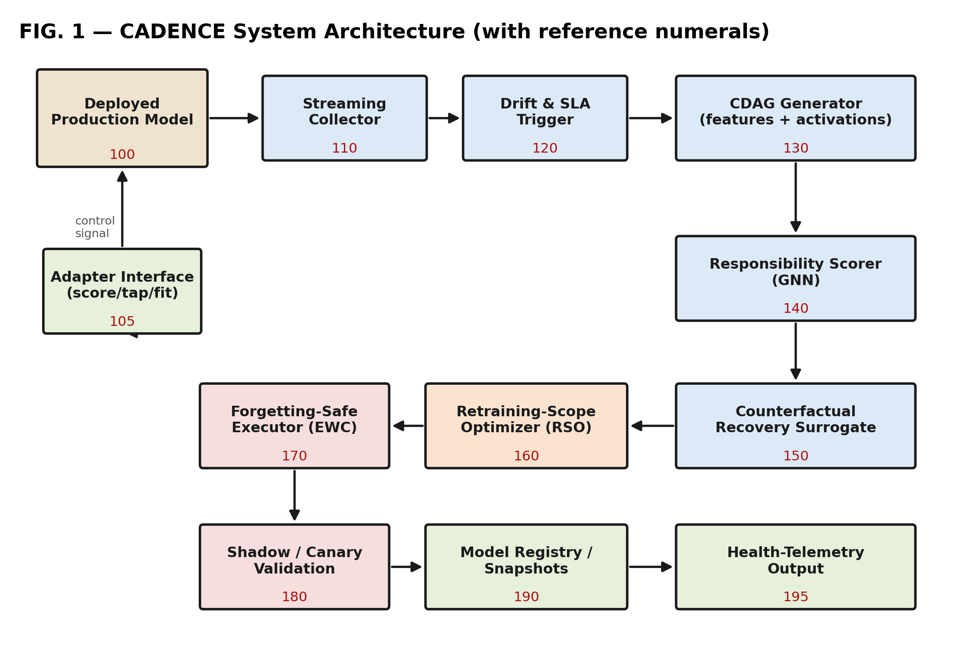
Figure 1 — System architecture with reference numerals (100–195).
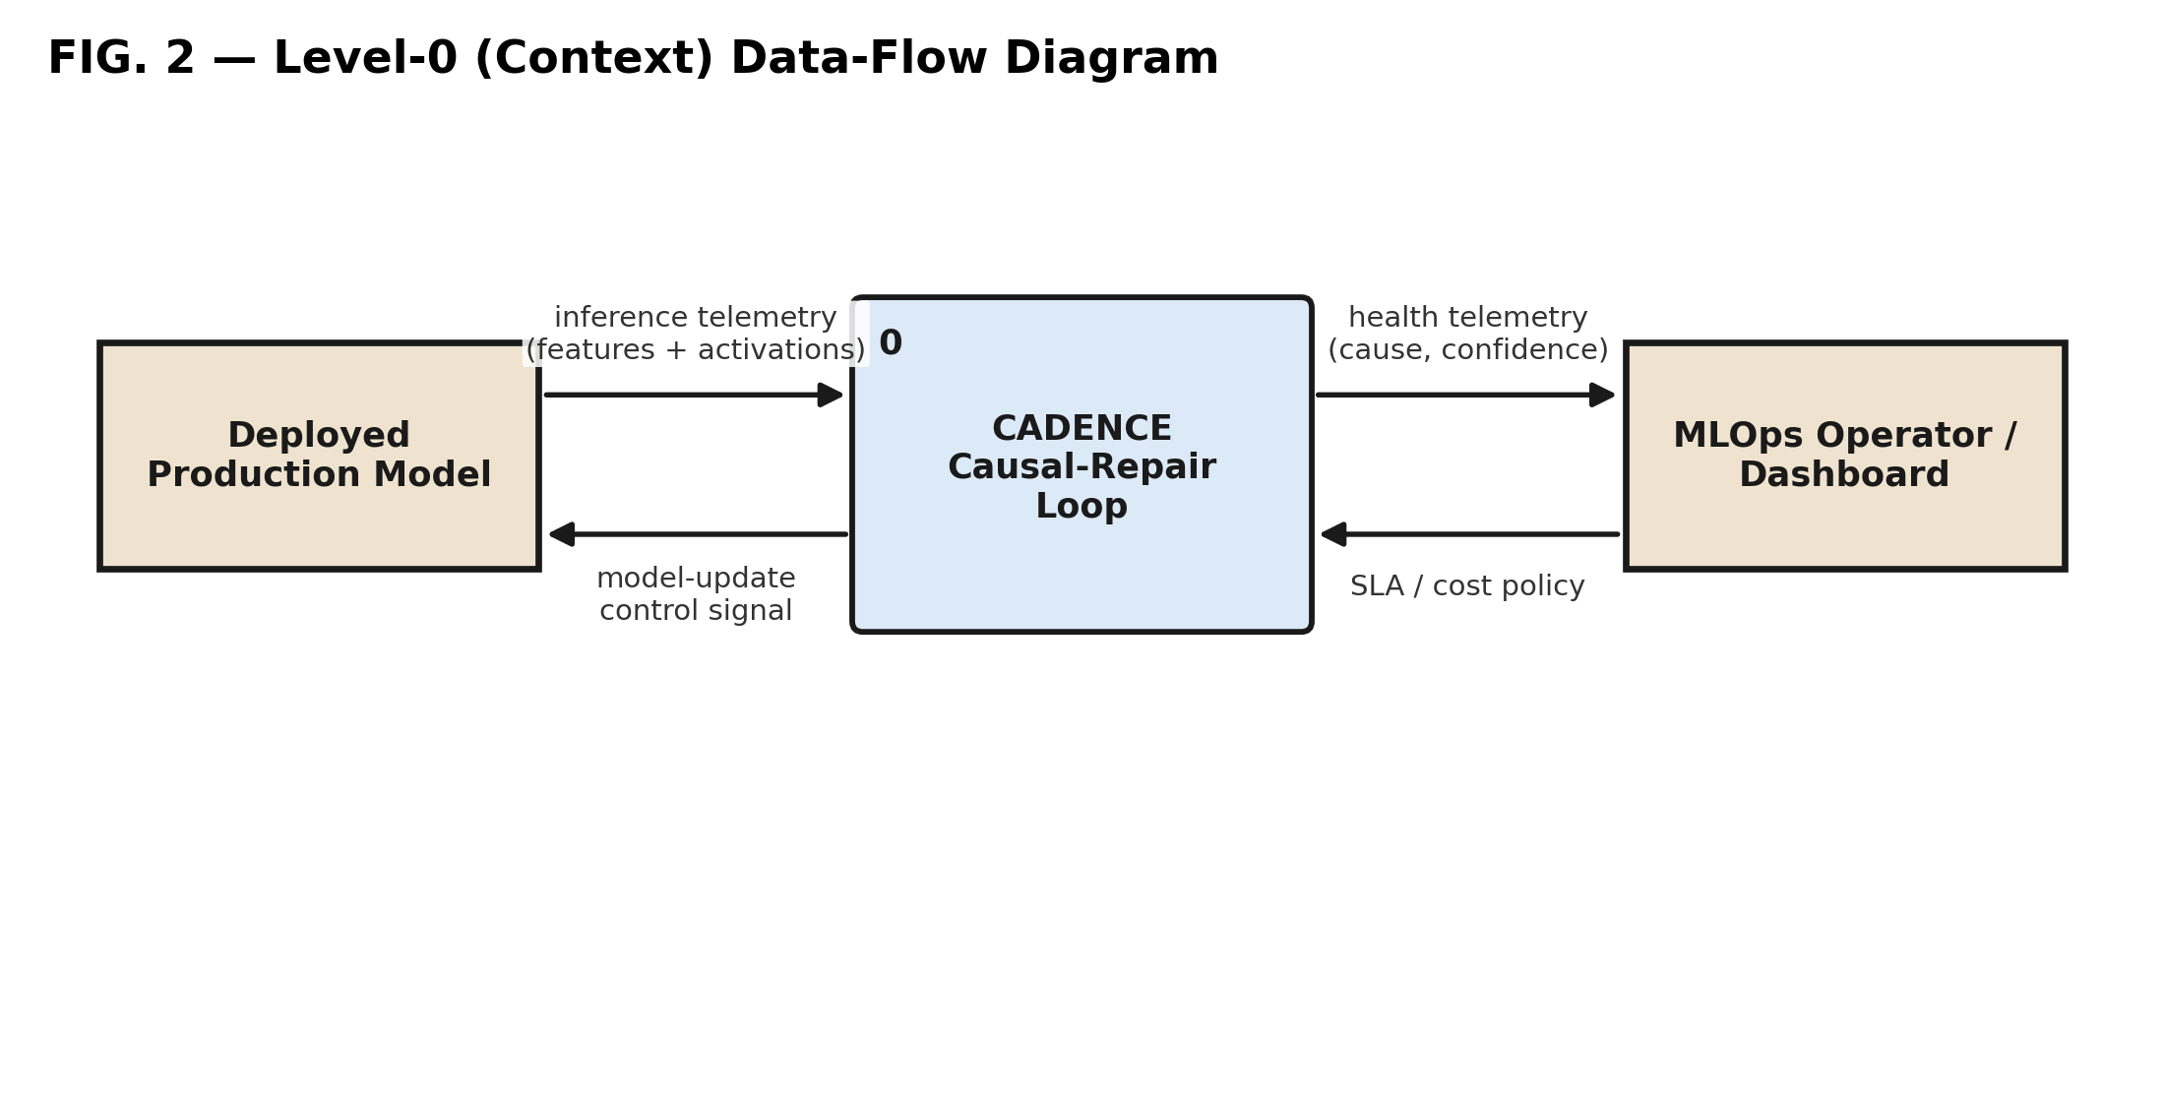
Figure 2 — Level-0 (context) data-flow diagram.
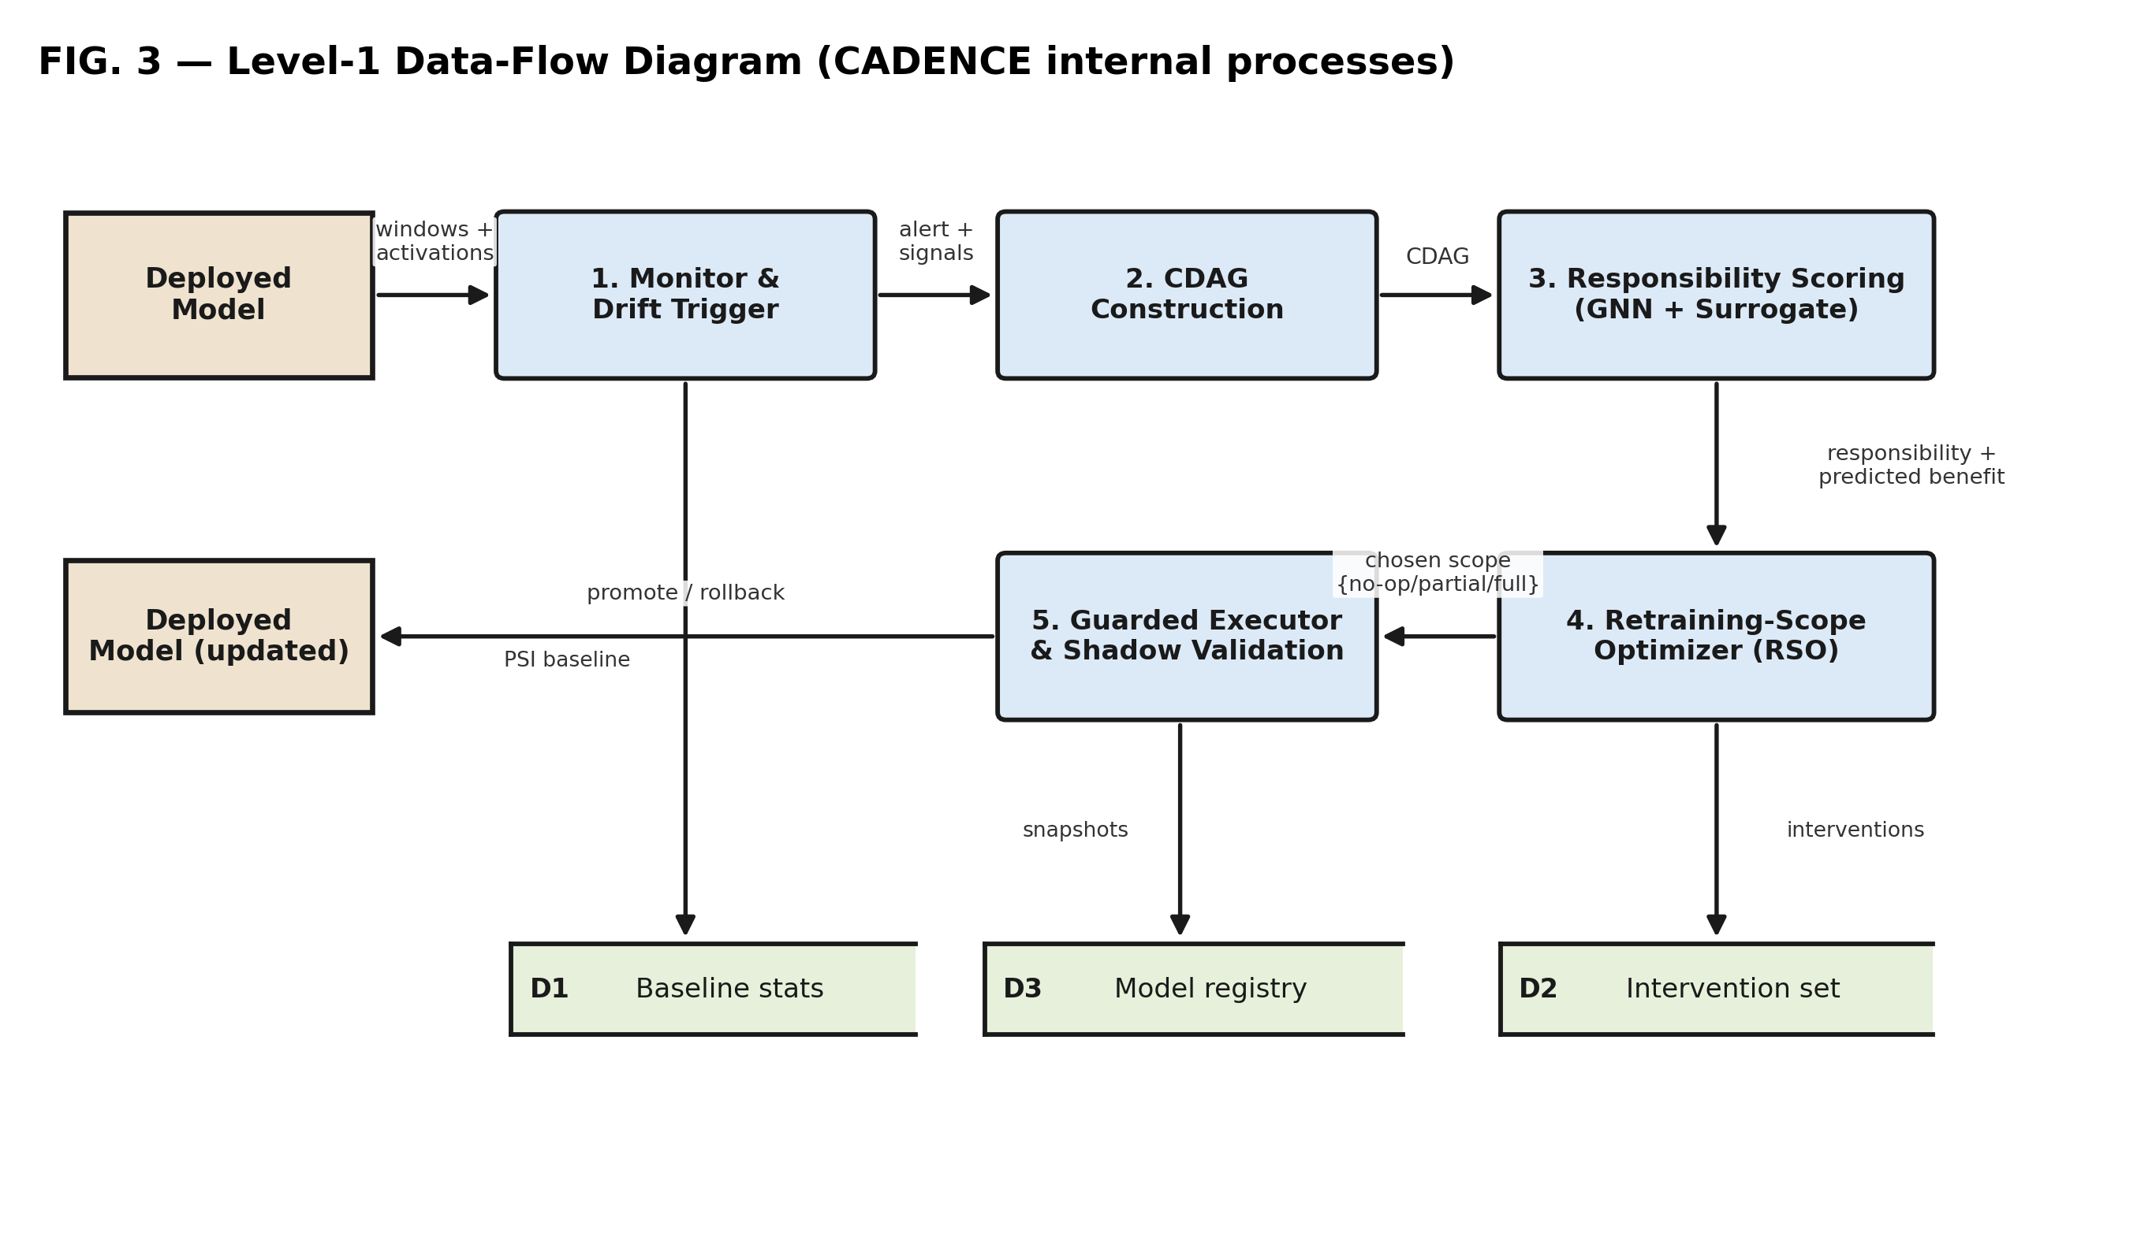
Figure 3 — Level-1 data-flow diagram (processes and data stores).
3.4.2 Streaming Collector (110) and Drift/SLA Trigger (120)
A privacy-filtered streaming collector (110) samples input feature windows and internal post-activation vectors during ordinary inference. The trigger (120) computes a per-feature distributional statistic D (for example a Population Stability Index) against baseline statistics, and, where labels are available, a windowed performance statistic P relative to a service-level threshold. Two trigger embodiments are provided: in a first embodiment the trigger fires on a disjunction (D breached OR P below threshold); in a second embodiment, for false-alarm suppression, the trigger fires on a conjunction (D breached AND P degraded). The applicable embodiment is selected by configuration.
3.4.3 CDAG Generator (130) and Node Set
Referring to Figure 5, on a trigger the CDAG generator forms a node set comprising feature nodes (210) summarizing external input statistics, internal model-state nodes (220) obtained from tapped internal representations of the deployed model, and a performance node (230). A skeleton is estimated by a constraint-based conditional-independence procedure, edge weights (240) by a continuous-optimization relaxation subject to an acyclicity constraint, and the continuous weights are masked by the discovered skeleton to form the weighted directed CDAG. The graph is rebuilt on a trigger over rolling windows (online-triggered), and the number of internal-state nodes per layer is configurable.
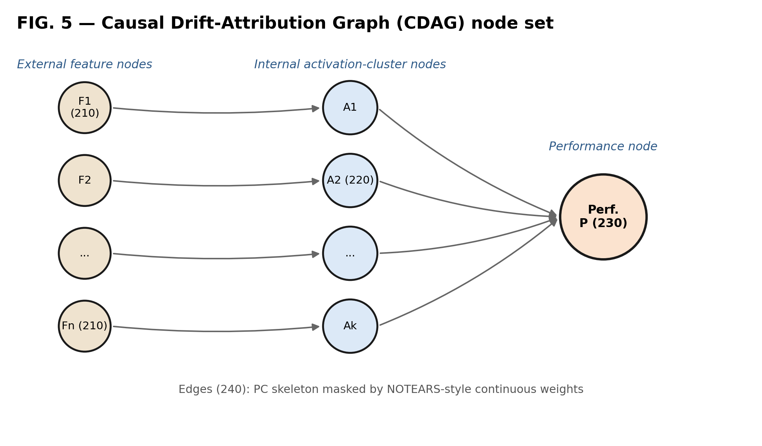
Figure 4 — CDAG node set: external feature nodes (210), internal model-state nodes (220), performance node (230), edges (240).
Scope of “causal.” As used herein, the graph provides a structured inductive bias and an attribution ranking; the system does not assert identification of a unique causal graph, and operates under the working assumptions of the constraint-based procedure (a Markov and faithfulness assumption over the windowed variables, a temporal precedence in which input and activation statistics precede the performance node, and a bounded-latent-confounding regime). Where these assumptions are weak, the learned readout of process (140) still yields a useful responsibility ranking, which is the quantity relied upon by the downstream decision.
3.4.4 Responsibility Scorer (140)
A graph message-passing model ingests the CDAG and its per-node signal features and produces a per-node embedding eᵢ and a non-negative responsibility value rᵢ. Because message passing aggregates evidence over the neighborhood, rᵢ is robust to a partially-recovered graph and identifies the responsible node even where no single edge from that node to the performance node is present in the recovered skeleton.
3.4.5 Counterfactual Recovery Surrogate (150)
A candidate intervention associated with a node comprises applying the mapping Φ (Section 3.4.7) to that node to obtain a target parameter set, and performing a bounded partial retrain of that set. The post-repair performance obtainable by such an intervention on node i, holding other parameters fixed, is denoted Pᵢ, and the recovery Rᵢ is its improvement over the current performance Perf_current:
$$P_{i} = E[ Perf( Y | do( repair node i ) ) ] ; R_{i} = P_{i} - {Perf}_{current}$$
A learned surrogate g_θ predicts the post-repair performance P̂ᵢ from the node embedding eᵢ produced by the responsibility scorer (140) and a context vector comprising the current performance and a severity value; the predicted recovery R̂ᵢ is obtained by subtraction and is the quantity consumed by the optimizer (160):
$${P̂}_{i} = g_{θ}( e_{i} , [ {Perf}_{current} , severity ] ) ; {R̂}_{i} = {P̂}_{i} - {Perf}_{current}$$
In a preferred embodiment the surrogate g_θ is a multilayer perceptron of two hidden layers whose target is the measured post-repair performance Perf_post; it is trained by minimizing the mean-squared error between the predicted post-repair performance and the measured post-repair performance:
$$L(θ) = E_{sandbox} {( g_{θ}( e_{i} , [ {Perf}_{current} , severity ] ) - {Perf}_{post} )}^{2}$$
The intervention-sandbox store is populated offline by (a) injecting a drift of a sampled type and severity, (b) performing a candidate repair mapped from a sampled node by the mapping Φ, and (c) recording the measured post-repair performance, producing (graph, candidate-node, pre-repair, post-repair, mechanism) tuples. The surrogate and the responsibility scorer are trained jointly by back-propagating L through the surrogate into the graph message-passing model. Validation is by a held-out split; in a preferred embodiment a mechanism-held-out split is used, in which the surrogate is validated on drift mechanisms not present in training, to measure and report cross-mechanism generalization. An uncertainty of R̂ᵢ is estimated in embodiments by a variance over a model ensemble or Monte-Carlo dropout. An out-of-distribution guard computes, in a preferred embodiment, a Euclidean distance from eᵢ to its nearest neighbours in the stored sandbox embedding set (or a Mahalanobis distance to the sandbox embedding distribution) and compares it to a threshold set at a high percentile of the training-set distances; when the distance exceeds the threshold, the guard increases said uncertainty and subtracts an uncertainty penalty from the objective J for that node, biasing the optimizer away from the untrusted estimate. A separate unrecoverable-drift guard halts further repair when successive repairs fail to recover performance and flags a need for new labels. Critically, at decision time the predicted recoveries for the plurality of candidate nodes are obtained by a single forward pass of the graph message-passing model (140) and the surrogate (150), so that no candidate node requires a separate retrain of the deployed model in order to estimate its benefit; the sandbox retrains that generate the training tuples are performed only offline, during surrogate training, and are not repeated per decision. The surrogate thereby amortizes the cost of hypothesis evaluation across all candidate repairs, which is what renders the responsibility-and-recovery-coupled scope selection tractable online.
3.4.6 Retraining-Scope Optimizer (160)
Referring to Figure 7, the optimizer selects, at each decision step, an action a_t from the maintenance action space A = { no-op, partial, full }. The state comprises the distributional statistic, current and recent performance, the service-level margin, and an attribution-concentration measure. The optimizer maximizes a constrained objective:
$$J(a) = E[ ΔPerf(a) ] - w·C(a) - λ·max( 0 , SLA - Perf(a) )$$
$$a^{*} = {argmax}_{a} J(a) s.t. E[ SLA-violation ] ≤ δ$$
$$λ ← clip( λ + η·( v - δ ) , 0 , λ_{max} )$$
Coupling of attribution to the decision. The expected performance change dPerf(a) is coupled to the responsibility values rᵢ and the predicted recoveries R̂ᵢ as follows. A target node is selected by combining responsibility and predicted recovery,
$$i^{*} = {argmax}_{i} ( r_{i} · {R̂}_{i} )$$
$$ΔPerf(no-op) = 0 ; ΔPerf(partial) = {R̂}_{i^{*}} ; ΔPerf(full) = {R̂}_{full}$$
The predicted full-retrain recovery R̂_full is obtained, in various embodiments, from a second recovery surrogate trained on full-retrain sandbox interventions, from a running statistic of realized full-retrain recoveries maintained by the model registry (190), or, in a conservative embodiment, is treated as an upper-bound estimate under which the full-retrain action is always predicted-feasible and serves as the default action that is selected when no partial-retrain action is predicted-feasible; the full-retrain action is thereby available as a guaranteed fallback, and the decision rule of the independent claims does not depend upon a particular estimator of R̂_full.
Thus the responsibility value rᵢ determines which node's predicted recovery R̂ᵢ enters the objective J. Each action has a predicted post-repair performance, namely P̂(no-op) = Perf_current, P̂(partial) = P̂_{i*}, and P̂(full) = P̂_full; an action is predicted-feasible when its predicted post-repair performance satisfies the service-level constraint. In the preferred embodiment the optimizer performs a least-cost feasible selection: it selects, among the predicted-feasible actions, the action of least estimated compute cost C(a), and where no action is predicted-feasible it selects the action maximizing J, the objective J otherwise ranking actions and breaking ties. This yields a cost-efficient, selective corrective scope: a no-operation where doing nothing is predicted-feasible; a partial retrain of the subnetwork mapped from i* where a partial retrain is predicted-feasible, cheaper than a full retrain, and the attribution is concentrated; and a full retrain otherwise. Here C(a) is an estimated compute cost of action a, in one embodiment proportional to the number of parameters updated by the action multiplied by the number of training rows and epochs (so that C(partial) < C(full) whenever the mapped subnetwork is a strict subset of the model); w is a cost weight; and λ is a dual variable updated toward a target violation rate δ by projected dual ascent from the realized violation rate v. The optimizer is treated as interchangeable and, in various fallback embodiments, the action-selection rule is a reinforcement-learning policy, a contextual bandit, or a greedy rule of the form a* = argmaxₐ J(a); the optimizer type is not itself relied upon for novelty.
3.4.7 Attributed Node → Retrainable Subnetwork Mapping
Referring to Figure 6, a mapping Φ maps an attributed node to a retrainable scope of the deployed model by a concrete procedure comprising three steps: (i) node → component, in which an internal-state node (220) is mapped to the layer or component index from which its representation was tapped (recorded at graph construction), and a feature node (210) is mapped to the input-facing component through which that feature first enters the model; (ii) component → parameter set, in which the component index is mapped to the set S of trainable parameters θ_S of that component (for a neural layer, its weight and bias tensors; for a component exposing multiple sub-blocks, a designated sub-block), the remaining parameters being placed in a frozen set; and (iii) scope → data, in which a retraining data window is assembled from the current drifted window and, optionally, a replay sample of retained-competence data. Where a plurality of nodes are responsible (for example the top-k by rᵢ, or all nodes with rᵢ above a threshold), Φ returns the union of their parameter sets. Where a responsible node has no independently-retrainable component S, or where the union spans substantially the whole model, the mapping escalates to a full retrain. In the preferred embodiment the mapping Φ is implemented as a stored lookup table associating each node identifier with a component identifier and, in turn, with a list of the parameter tensors of that component, said table being populated at graph-construction time from a tap registry that records, for each tapped representation, its originating component; at decision time the optimizer passes the resulting parameter-set descriptor S as an argument of the adapter partial-fit operation (105).
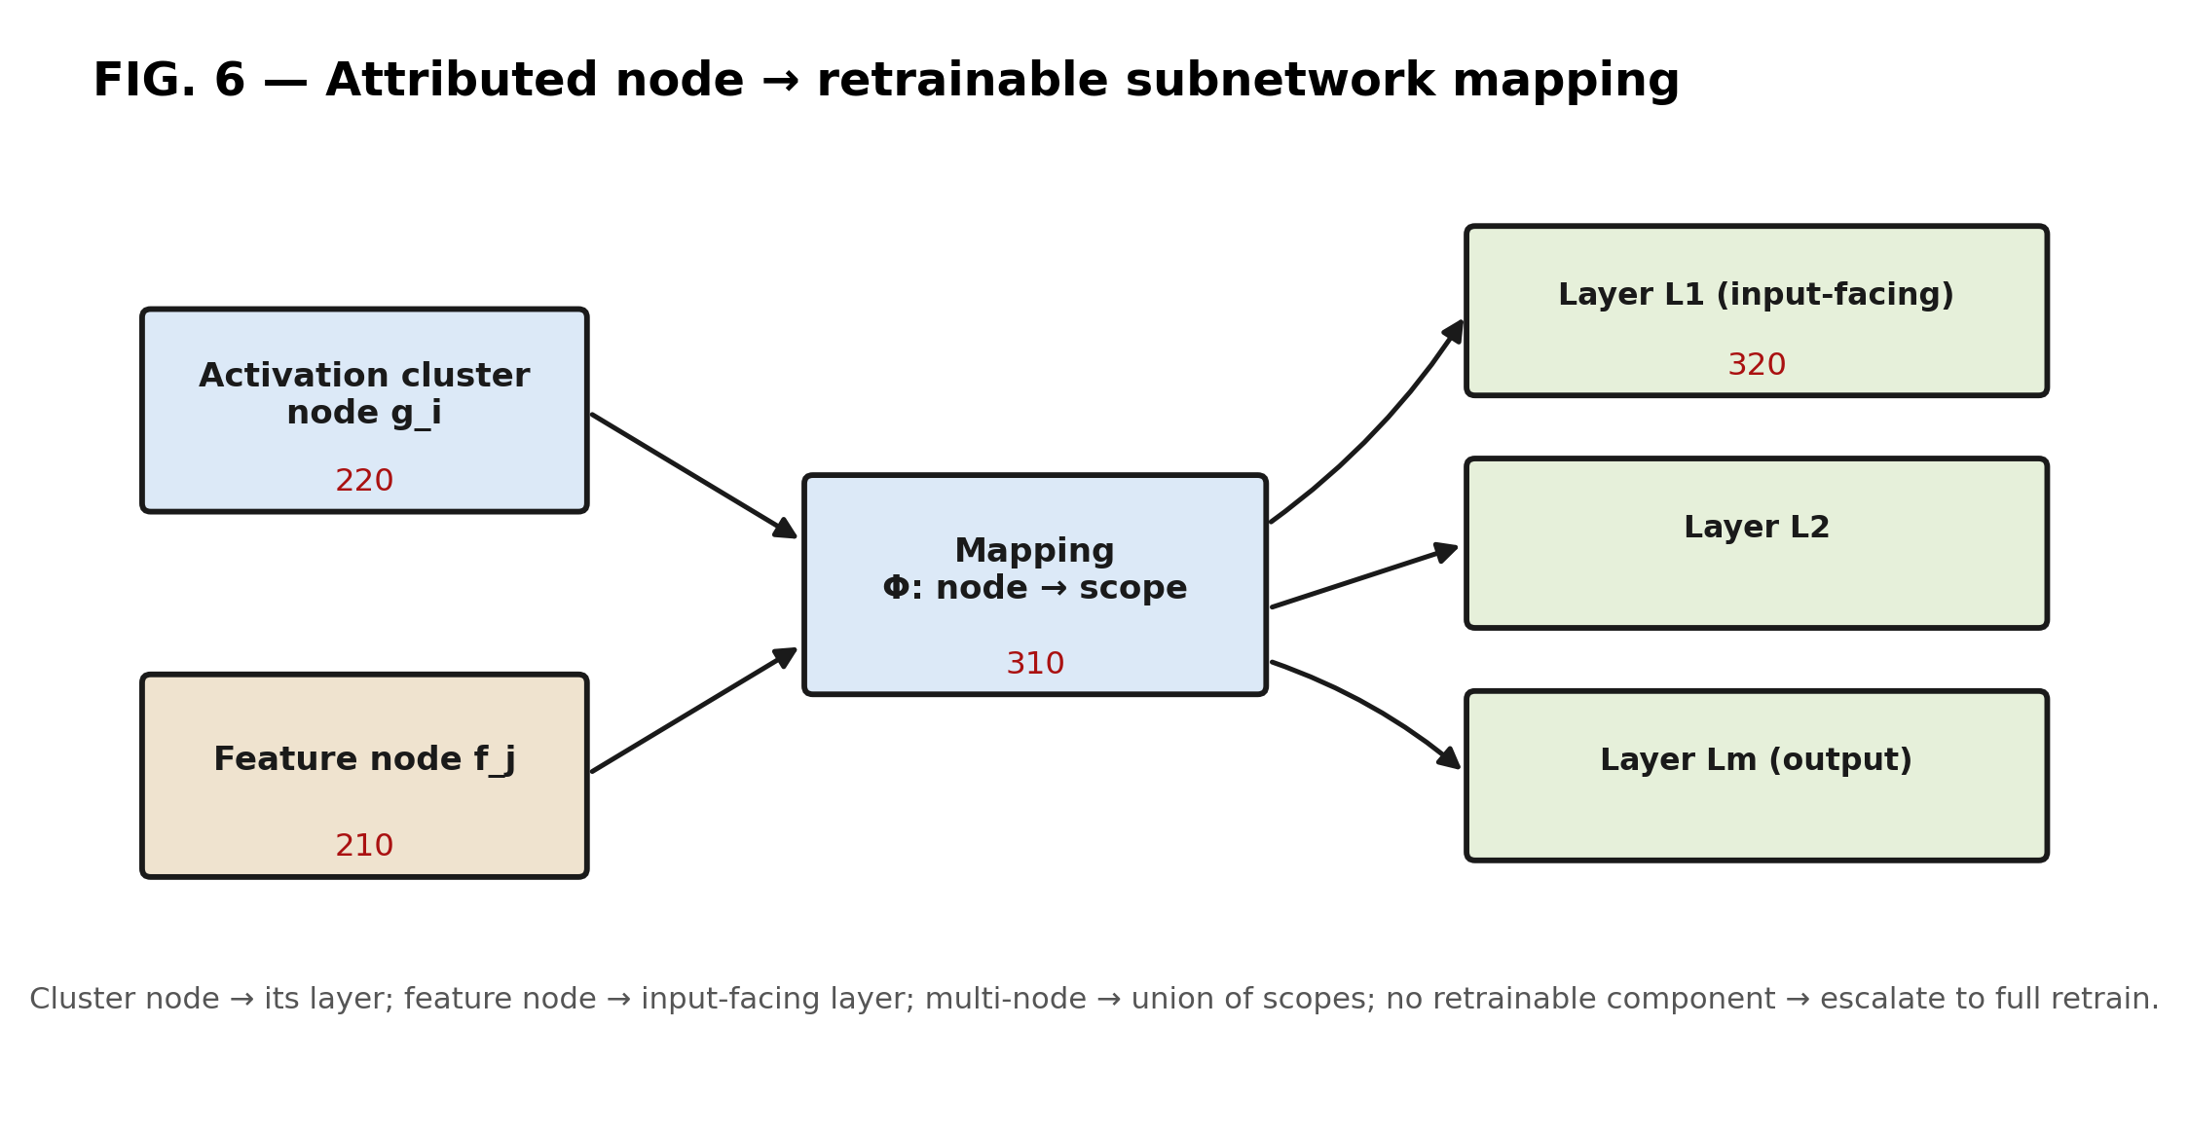
Figure 5 — Mapping Φ from attributed node (210/220) to retrainable subnetwork/layer (320).
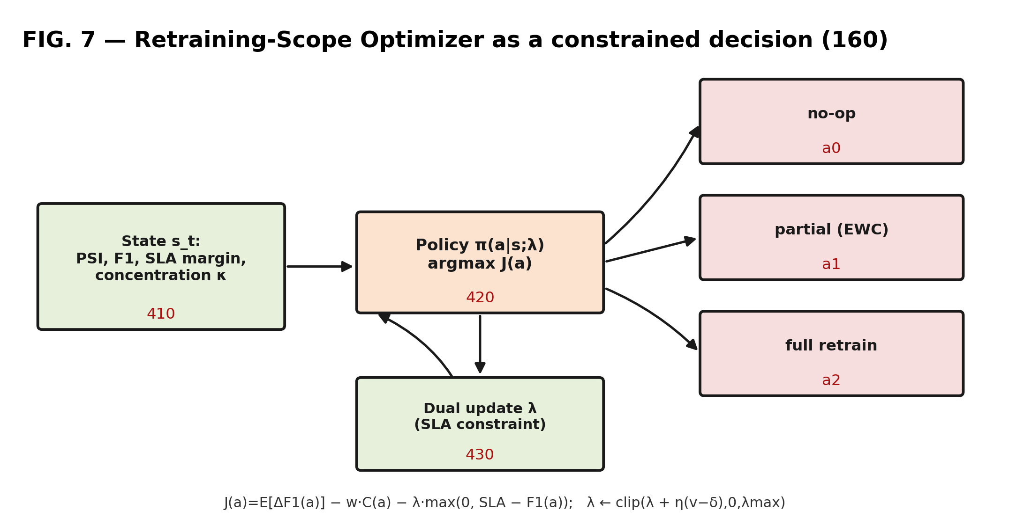
Figure 6 — Retraining-scope optimizer (160) as a constrained decision with dual update (430).
3.4.8 Forgetting-Constrained Executor (170), Validation (180) and Rollback
For a partial-retrain action, the executor updates only the parameters in the mapped set S and freezes the remainder; in a gradient-descent embodiment this is enforced by masking the gradient so that the update to any parameter not in S is zero. The update additionally minimizes a parameter-deviation penalty that constrains parameters associated with previously-served competence:
$$Loss = L_{task}( θ ; drift window ) + λ_{ewc} \sum_{j}{F_{j} {( θ_{j} - θ_{j}^{*} )}^{2}}$$
where θ* are the parameter values of the promoted prior model, and Fⱼ is a per-parameter importance estimated, in a preferred embodiment, as the diagonal Fisher information
$$F_{j} = E_{x∽retained} {( \frac{∂}{∂θ_{j}} log p_{θ}( y | x ) )}^{2}$$
computed, in the preferred embodiment, once at the time a model is first promoted, over a sample of the then-current training data, and stored as a per-parameter importance vector with the model snapshot for use by subsequent partial retrains; upon each subsequent promotion the importance vector is recomputed or accumulated. Where retained-competence data is unavailable at retrain time, the stored importance vector is used directly. Only parameters in S receive a non-zero gradient, while the Fisher penalty applies across the retained parameters, so that the update adapts the responsible subnetwork to the drift while limiting deviation of the parameters most important to prior competence; the coefficient λ_ewc, the epoch budget, and the optional replay ratio are configurable. For a full-retrain action, the executor refits the model, optionally with replay. Every candidate model is validated in shadow/canary mode (180) against a held-out window; if the post-repair performance meets the service level it is promoted to the model registry (190), otherwise the prior snapshot is restored. The realized post-repair performance is fed back to recalibrate the surrogate (150).
3.4.9 Attribution-Concentration Guard and Health Telemetry (195)
An attribution-concentration measure is computed over the non-negative responsibility values, in one embodiment:
$$κ = \frac{\max_{i} r_{i}}{\sum_{i}{r_{i}}} ( r_{i} ≥ 0 )$$
When κ exceeds a threshold (concentrated), a targeted partial repair is preferred; when κ is below the threshold (diffuse), the guard escalates to a full retrain; the threshold is fixed or adaptive, and, in embodiments, the guard additionally conditions on the predicted recovery R̂ so that a highly-concentrated but low-predicted-recovery attribution defers action. The health-telemetry output (195) comprises the attributed cause, the attribution confidence, κ, the selected action, the estimated and realized recovery, and the compute expended, for downstream governance and audit.
3.4.10 Adapter Interface (105)
The deployed model is reached only through a narrow adapter interface exposing: score(x) returning a prediction; activation_tap(layer_id, x) returning an internal representation; partial_fit(target_scope, D) updating only the target scope on data D; full_fit(D) refitting the model; and snapshot()/restore(snapshot_id) for versioned promotion and rollback. The identical loop thereby operates over heterogeneous model families, each supplying an internal-state analogue for node generation:
Model family | Internal-state analogue used for internal node (220) generation
Neural network | Clustered hidden-layer post-activation statistics per tapped layer.
Gradient-boosted trees | Leaf/path co-activation and per-split attribution statistics across the ensemble.
Linear / logistic | Per-feature contribution (weight times feature) statistics.
Transformer | Clustered per-layer / per-head token-representation statistics.
Where a model family exposes no internal-state analogue supporting targeted partial repair, the executor degrades gracefully to a full retrain; the attribution and benefit-prediction stages continue to operate over the feature nodes.
3.4.11 Algorithm 1 — Causal Attribution-Based Selective Retraining
Input : model M (adapter A); stream S; baseline B; weight w; dual-lr η; SLA τ; target δ
Output: continually repaired, validated model M

1 for each window X(t) in stream S:
2 D ← dist_stat(X(t), B); P ← perf_stat(M, X(t))
3 if not TRIGGER(D, P): continue
4 G ← BUILD_CDAG( features(X(t)), A.activation_tap(*, X(t)) )
5 (e, r) ← GNN(G) // embeddings e; responsibility r[i] ≥ 0
6 for each node i:
7 P̂[i] ← SURROGATE( e[i], [P, severity] ); R̂[i] ← P̂[i] − P
8 κ ← max(r) / Σ(r) // attribution-concentration guard
9 a ← LEAST_COST_FEASIBLE( {no-op, partial, full}; P̂, τ, C ) // ranked by J
10 if a = partial and κ < κ0: a ← full // escalate on diffuse cause
11 i* ← argmax_i ( r[i] · R̂[i] ); scope ← Φ(i*) // node → subnetwork
12 M' ← A.partial_fit(scope, X(t)) with EWC penalty OR A.full_fit(X(t))
13 if SHADOW_PERF(M') ≥ τ: M ← A.promote(M') ELSE A.restore(snapshot)
14 λ ← clip(λ + η·(v − δ), 0, λmax); RECALIBRATE(SURROGATE)
15 EMIT_TELEMETRY( cause, κ, a, R̂, realized = SHADOW_PERF(M') )
3.4.12 Runtime Pipeline and Technical Effect
Referring to Figure 7 (runtime pipeline), at runtime the monitor evaluates each window; upon a trigger the CDAG is constructed, responsibility and predicted recovery are computed, the concentration is tested, the optimizer selects an action under the constraints, the executor applies and shadow-validates the repair, and the update is promoted or rolled back.
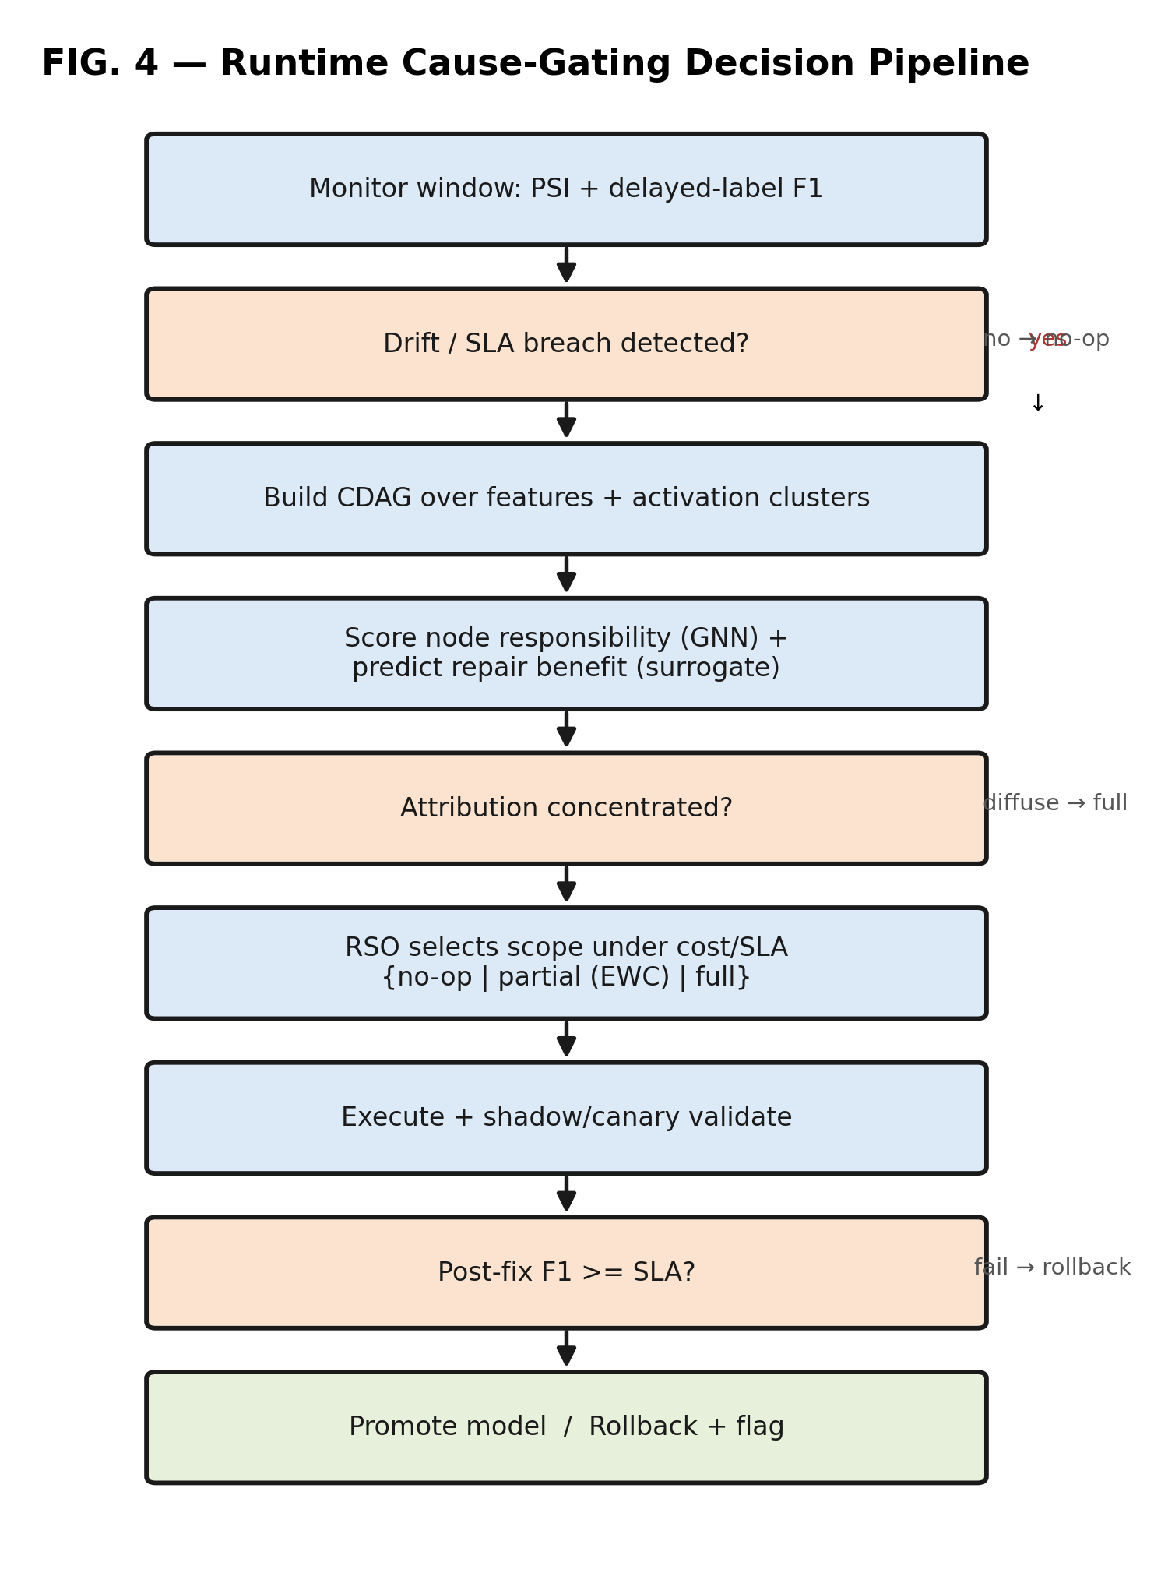
Figure 7 — Runtime cause-gating decision pipeline.
Technical effect / technical contribution. The claimed combination produces effects on the operation of the computing system beyond an incidental result: it reduces the number of parameter-update and floating-point operations required to adapt a deployed model by confining modification to a mapped subnetwork rather than the whole model; it reduces the memory and data footprint of an adaptation by constraining the parameters modified and the data replayed; it modifies model state in a controlled, reversible manner via snapshot, shadow validation and rollback, so that a corrective update does not interrupt or degrade the live serving path; and it allocates constrained compute resources across candidate corrective actions under an explicit budget and service-level constraint. These are technical means directed to a technical problem in the functioning of a deployed machine-learning system, and are relied upon for the technical-contribution assessment.
3.4.13 Illustrative Alternatives
- Discovery: any conditional-independence test and any acyclicity-regularized objective may be substituted for the constraint-based and continuous stages.
- Readout: graph-convolutional, sample-and-aggregate, or attention-based message passing may be used.
- Action space: the discrete maintenance action space may be generalized to a continuous fraction-of-subnetwork action or to a tuple comprising scope, epoch budget, learning rate and data window.
- Forgetting control: the parameter-deviation penalty may be a diagonal or full importance matrix, a synaptic-intelligence penalty, gradient-episodic memory, or exemplar replay.
- Deployment: beside an online serving stack, on edge/wearable devices, or as a scheduled maintenance service; the model is reached only through the adapter (105).
3.4.14 Preferred Embodiment (Best Mode)
In the preferred embodiment reduced to practice, the deployed model is a feed-forward neural network reached through the adapter (105). Internal-state nodes (220) are formed by k-means clustering of the post-activation vectors of each tapped hidden layer into a configured number of clusters per layer; each node's four-component signal comprises a mean, a standard deviation, a shift statistic, and a drift z-score of the associated quantity over the window. The skeleton is estimated at a conditional-independence significance level of about 0.05, and the continuous edge weights by a NOTEARS-style acyclicity-regularized objective with an L1 sparsity coefficient of about 0.05, computed over on the order of ten to fifteen rolling windows, the continuous weights being masked by the skeleton. The responsibility scorer (140) is a two-layer graph-convolutional network with a small embedding dimension trained jointly with the surrogate. The surrogate (150) is a two-hidden-layer perceptron that reaches a coefficient of determination of about 0.9 from on the order of fifty to one hundred sandbox interventions. The optimizer (160) uses the objective J with a fixed cost weight and an augmented-Lagrangian dual variable bounded by a maximum, updated toward a target violation rate. Partial retraining fine-tunes the single mapped hidden layer for a small number of epochs under a diagonal-Fisher parameter-deviation penalty with a configured coefficient, freezing all other parameters by gradient masking. Shadow validation promotes the candidate model only when its post-repair performance meets the service level, and otherwise restores the prior snapshot. These values are illustrative of the best mode known to the inventors and may be varied without departing from the invention.
E. RESULTS AND ADVANTAGES:
A reduction-to-practice prototype was evaluated under a pre-registered protocol on public benchmarks; each figure below is measured, negative results are reported, and every value is traceable to a versioned results ledger recording the dataset, preprocessing, model, hyperparameters, seeds, run count, statistical test and hardware. Each value herein is to be verified by the inventors against the results ledger prior to inclusion in any inventor declaration or complete specification.
- Attribution vs. correlation on contested drift: on synthetic drift with a known injected root cause, the responsibility scorer improves mean reciprocal rank from 0.10 to 0.41 and root-vs-rest AUROC from 0.67 to 0.91 over a PSI baseline on the contested scenarios (paired test, p < 0.001, ten seeds; Figure 9), and dominates input-gradient and permutation baselines on ranking AUROC.
- Surrogate amortization: the recovery surrogate attains a coefficient of determination near 0.89 on held-out interventions and reaches useful accuracy from on the order of fifty to one hundred sandbox interventions.
- Cost-constrained repair on real drift: on a real electricity-market drift benchmark, the policy reduces retraining compute by approximately 69% for a 1.7-point performance reduction relative to a reactive full-retrain baseline (Figure 10); with a learned policy on contested scenarios the scope selection achieves higher performance at approximately 66% lower compute than a trigger-driven full-retrain baseline on recoverable drift.
- Forgetting constraint: on a genuinely multi-task benchmark, parameter-deviation-limited partial retraining reduces forgetting of a preserved task from a roughly forty-point performance loss under naive full retraining to a negligible change (p < 0.001), robust to a full-retrain-with-replay baseline.
- Concentration guard: as the number of jointly-responsible features grows, the attribution-concentration measure κ falls monotonically, confirming the escalate-to-full guard fires in the correct direction.
- Net-of-overhead accounting: the framework accounts for its own monitoring, graph-construction and inference overhead and identifies the retraining-cost regime above which the net saving holds — a stated operating boundary rather than an unbounded claim.
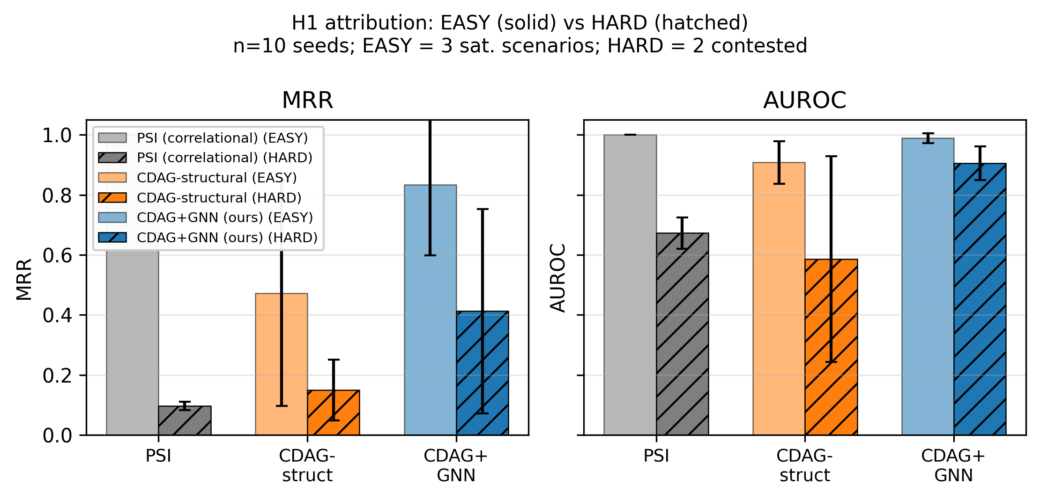
Figure 9 — Attribution quality on contested vs. saturated drift subsets (supporting data).
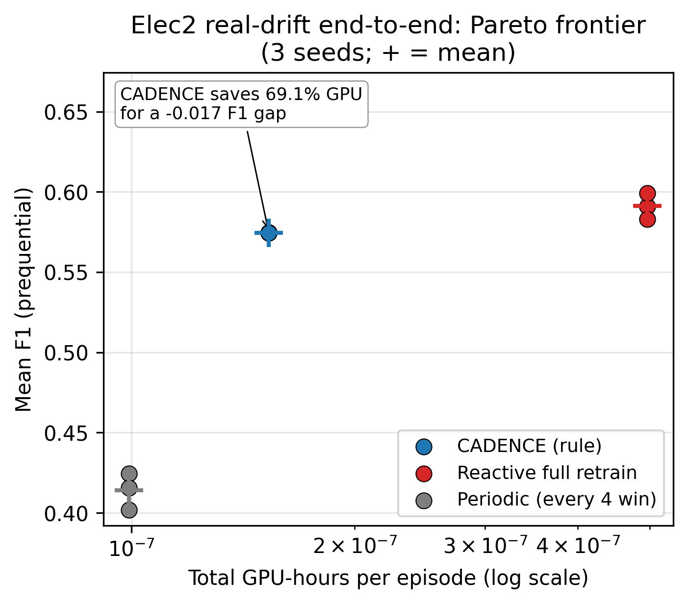
Figure 10 — Cost/quality operating point on real drift (supporting data).
F. EXPANSION:
Alternative embodiments include a continuous or hierarchical scope action space; substitution of the discovery, readout, or forgetting-control components as enumerated; high-dimensional operation via node-count capping and sparse/approximate discovery; edge/wearable deployment with a lightweight monitor; and extension of the health-telemetry stream to drive automated governance, alerting, and compliance-audit workflows. Applicable production domains include fraud detection, credit-risk scoring, recommendation, churn prediction, and physiological-signal monitoring.
G. WORKING PROTOTYPE/ FORMULATION/ DESIGN/COMPOSITION:
A reduction-to-practice prototype has been implemented as an approximately fourteen-thousand-line software system with a comprehensive automated test suite, model adapters for neural, tree-ensemble, and linear/text models, a resumable experiment harness with an atomic ledger, and a pre-registered evaluation protocol; it executes the complete closed loop end-to-end on commodity graphics hardware.
H. EXISTING DATA:
The invention is supported by measured results on public datasets including a credit-card-fraud dataset, a real electricity-market drift benchmark, a credit-scoring dataset, a multi-task image benchmark, and a text-review dataset, together with synthetic drift benchmarks carrying a known injected root cause. All quantitative claims are reproducible from a versioned results ledger recording, per experiment, the exact command, seeds and configuration.
PROPOSED CLAIMS (draft — for finalization by a registered patent agent):
The following claims are a proposed starting structure defining the boundary of the invention; they are to be reviewed, narrowed and finalized by a registered patent agent together with a prior-art claim chart. A narrow independent claim with a broad dependent-claim fallback tree is intended.
Element-by-element claim chart (template — to be completed against granted patents)
The chart maps each element of Claim 1 to the closest reference identified in the preliminary search of Section 3.3 and to the distinguishing limitation relied upon. The “Disclosed?” column is to be confirmed by a registered patent agent against the full claim text of each reference, and the search extended, before filing.
Element of Claim 1 | Closest prior art (preliminary) | Disclosed? | Distinguishing limitation relied upon
(c) Graph over external features AND internal model-state | US11928011B2 (causal graph over data variables only) | No | Unified feature-and-activation node set; the reference and other drift/attribution art operate on input/data variables, not internal model state.
(d)-(e) Responsibility value + predicted recovery of a candidate intervention | US11928011B2 (root-cause tagging; no recovery surrogate) | No | Per-node recovery predicted by a learned surrogate without a per-candidate retrain, from the same graph embedding as the responsibility value.
(f)-(g) Least-cost feasible action from attribution, predicted recovery, cost and SLA | US20230139718A1; US10762444B2 (drift-to-retrain timing) | No | Scope (which/how-much), not timing, chosen so partial's expected change equals the target node's predicted recovery under a cost/SLA constraint.
(h) Update only mapped subnetwork; parameter-deviation penalty | EP3745318A1; US12518197B2 (selective / forgetting-safe update) | No | Strict-subset parameter update on the causally-attributed subnetwork, importance-weighted deviation penalty, gradient-frozen remainder — driven by the attribution, not a fixed rule.
(i) Isolated validation and rollback; serving uninterrupted | US11928011B2 (A/B or canary testing) | Yes | Reversible promotion/rollback in a path isolated from the live serving path, gated on the service level.
(j) Surrogate recalibration from realized recovery | None identified (preliminary search) | No | Closed-loop recalibration of the learned recovery predictor from realized post-repair outcomes.
Independent claims
Claim 1. A computer-implemented method for maintaining a deployed machine-learning model that continues to serve predictions during the method, the method comprising: (a) receiving, through an adapter interface, external input-feature statistics and internal model-state representations of the deployed model; (b) detecting a degradation of a performance metric of the deployed model; (c) constructing a responsibility graph comprising external-feature nodes derived from the input-feature statistics, internal-state nodes derived from the internal model-state representations, and a performance node, and determining, by a causal-structure-informed procedure, weighted directed relationships among the nodes; (d) generating, by a graph message-passing model over the responsibility graph and for each of a plurality of the nodes, a node embedding and a non-negative responsibility value quantifying a contribution of the node to the detected degradation; (e) generating, by a learned recovery surrogate operating on the node embedding and without executing a retrain for each candidate, a predicted recovery for a candidate intervention associated with each of a plurality of the nodes; (f) selecting a target node as a node that maximizes a product of the responsibility value of the node and the predicted recovery of the candidate intervention associated with the node; (g) selecting a maintenance action from a maintenance action space comprising at least a no-operation action, a partial-retrain action and a full-retrain action, wherein an expected performance change of the partial-retrain action is the predicted recovery of the target node, wherein each action of the maintenance action space has a predicted post-repair performance and is predicted-feasible when its predicted post-repair performance satisfies a service-level constraint, and wherein the selected maintenance action is a least-cost action among the predicted-feasible actions, a compute cost of each action being estimated from a number of parameters updated by the action; and (h) responsive to selecting the partial-retrain action, mapping the target node to a set of parameters of a corresponding subnetwork of the deployed model and updating only said set of parameters while freezing the remaining parameters, the update being subject to a parameter-deviation penalty that weights a deviation of each parameter by a per-parameter importance estimate, and deploying the resulting model.
Claim 2. A system for maintaining a deployed machine-learning model, comprising one or more processors and memory storing instructions that configure the system to provide: an adapter interface exposing a scoring operation, an activation-tap operation, a partial-fit operation accepting a target-parameter-set descriptor, a full-fit operation, and snapshot and restore operations; a graph generator configured to construct a responsibility graph having external-feature nodes, internal-state nodes derived from tapped internal representations of the deployed model, and a performance node; a graph message-passing model configured to output a node embedding and a non-negative responsibility value for each of a plurality of the nodes; a recovery surrogate configured to output, from a node embedding and without a per-candidate retrain, a predicted recovery; a retraining-scope optimizer configured to select a maintenance action by maximizing an objective in which an expected performance change of a partial-retrain action equals the predicted recovery of a target node, the target node being a node that maximizes a product of the responsibility value of the node and the predicted recovery of the node, subject to a service-level constraint enforced by a dual variable and a penalized compute cost; an executor configured to update, via the partial-fit operation, only a parameter set of a subnetwork mapped from the target node while freezing remaining parameters and applying a parameter-deviation penalty weighted by a per-parameter importance estimate; a validation module configured to evaluate a resulting model in a path isolated from a live serving path; and a model registry configured to promote the resulting model or restore a prior snapshot; wherein the system is configured to perform the method of Claim 1.
Claim 3. A non-transitory computer-readable medium storing instructions that, when executed by one or more processors, cause the processors to: construct a responsibility graph over external-feature nodes and internal model-state nodes of a deployed model; generate, by a graph message-passing model, a per-node responsibility value and a node embedding, and, by a recovery surrogate operating on the node embedding, a per-node predicted recovery; select a maintenance action from at least a no-operation action, a partial-retrain action and a full-retrain action, wherein an expected performance change of the partial-retrain action equals a predicted recovery of a target node, the target node being a node that maximizes a product of the responsibility value of the node and the predicted recovery of the node, subject to a service-level constraint and a penalized compute cost; for the partial-retrain action, update only a parameter set of a subnetwork mapped from the target node while freezing remaining parameters and applying a parameter-deviation penalty; and validate the resulting model in an isolated path and promote it or restore a prior snapshot.
Dependent claims
Claim 4. wherein the internal model-state nodes are derived by clustering internal post-activation representations of one or more tapped layers of the deployed model.
Claim 5. wherein constructing the graph comprises estimating a skeleton by a constraint-based conditional-independence procedure and estimating edge weights by a continuous acyclicity-regularized optimization, the edge weights being masked by the skeleton.
Claim 6. wherein the responsibility value of a node is generated by neighborhood message passing such that the responsibility value is determined even in the absence of a direct edge from the node to the performance node.
Claim 7. wherein the recovery surrogate maps a node embedding and a context vector comprising a pre-repair performance and a severity to the predicted post-repair performance, and is trained on tuples generated by injecting a drift, performing a candidate repair, and recording a measured post-repair performance.
Claim 8. further comprising detecting that a candidate intervention lies outside a training distribution of the recovery surrogate and, responsive thereto, increasing an uncertainty of the predicted post-repair performance and biasing the selection away from said intervention.
Claim 9. wherein selecting the maintenance action comprises maximizing an objective that rewards predicted performance change and penalizes compute cost, subject to a bound on a service-level-violation rate enforced by a dual variable updated toward a target violation rate.
Claim 10. further comprising computing an attribution-concentration measure equal to a ratio of a maximum of the responsibility values to a sum of the responsibility values, and, when said measure is below a threshold, converting the partial-retrain action to the full-retrain action, the threshold being one of a fixed value and a value adapted from a history of realized recoveries.
Claim 11. wherein mapping the attributed node to the target subnetwork comprises mapping an internal model-state node to a layer from which its representation was tapped, mapping a feature node to an input-facing layer, and mapping a plurality of responsible nodes to a union of their subnetworks.
Claim 12. wherein the parameter-deviation constraint comprises a penalty weighted by a per-parameter importance estimate associated with previously-retained model competence.
Claim 13. further comprising, before deploying the resulting model, validating the resulting model by executing it in a shadow or canary path isolated from a live serving path, promoting the resulting model by a versioned snapshot replacement when it satisfies the service-level constraint, and otherwise restoring a prior snapshot by automatic rollback.
Claim 14. further comprising emitting a machine-readable telemetry stream comprising the attributed cause, an attribution confidence, the attribution-concentration measure, the selected maintenance action, and the realized post-repair performance.
Claim 15. wherein the deployed model is a neural network and an internal model-state node is derived from clustered hidden-layer activations.
Claim 16. wherein the deployed model is a gradient-boosted-tree ensemble and an internal model-state node is derived from leaf/path co-activation statistics, and the partial-retrain action degrades to a full-retrain action where no independently-retrainable subnetwork exists.
Claim 17. wherein the deployed model is a linear or text model and an internal model-state node is derived from per-feature contribution statistics.
Claim 18. wherein detecting the performance degradation comprises a disjunction of a distributional-shift condition and a performance-degradation condition in a first embodiment, and a conjunction thereof in a second embodiment.
Claim 19. wherein the maintenance action space comprises a continuous or hierarchical scope action defining a fraction of a subnetwork to be updated.
Claim 20. wherein the graph is reconstructed on the detecting over rolling windows rather than continuously, and a node count is bounded by a selection over candidate features and model-state clusters.
Claim 21. wherein the retraining-scope optimizer comprises one of a reinforcement-learning policy, a contextual bandit, and a greedy rule selecting the action maximizing said objective.
Claim 22. wherein updating only said set of parameters reduces a number of floating-point operations and a quantity of training data processed relative to the full-retrain action, and wherein validating in the path isolated from the live serving path leaves the live serving path uninterrupted during the updating.
Claim 23. wherein the predicted recovery is a difference between a predicted post-repair performance output by the recovery surrogate and a current performance, the expected performance change of the no-operation action is zero, and the expected performance change of the full-retrain action is a full-retrain recovery estimate obtained by one of: a second recovery surrogate trained on full-retrain interventions; a running statistic of realized full-retrain recoveries; and an upper-bound estimate under which the full-retrain action is treated as predicted-feasible and is selected when no partial-retrain action is predicted-feasible.
Claim 24. further comprising updating the recovery surrogate using a realized post-repair performance of the deployed model, thereby recalibrating subsequent predicted recoveries.

4. USE AND DISCLOSURE (IMPORTANT):
Please answer the following questions (to be completed and marked by the inventors):
Have you described or shown your invention/ design to anyone or in any conference? | YES ( ) | NO ( ✓ )
Have you made any attempts to commercialize your invention (for example, have you approached any companies about purchasing or manufacturing your invention)? | YES ( ) | NO ( ✓ )
Has your invention been described in any printed publication, or any other form of media, such as the Internet? | YES ( ) | NO ( ✓ )
Do you have any collaboration with any other institute or organization on the same? Provide name and other details. | YES ( ) | NO ( ✓ )
Name of Regulatory body or any other approvals if required. | YES ( ) | NO ( ✓ )
Note: items 1 and 3 above are to be re-confirmed by the inventors before filing — for example, any conference submission or presentation, or the project source-code repository being public — since a prior public disclosure can affect novelty.

5. Provide links and dates for such actions if the information has been made public (Google, research papers, YouTube videos, etc.) before sharing with us.
__________________________________________________________________ (To be completed by the inventors.)
6. Provide the terms and conditions of the MOU also if the work is done in collaboration within or outside university (Any Industry, other Universities, or any other entity).
Not applicable / to be completed by the inventors and the institution.
7. Potential Chances of Commercialization.
High. The system targets the recurring operational cost of maintaining deployed machine-learning models in fintech, healthcare, and large-scale production ML, by reducing unnecessary retraining compute and energy while improving repair precision and auditability.
8. List of companies which can be contacted for commercialization along with the website link.
MLOps and model-observability vendors; cloud machine-learning platform providers; enterprises operating large fleets of production models in fraud, credit-risk, and recommendation. (Specific names and website links to be completed by the inventors.)
9. Any basic patent which has been used and we need to pay royalty to them.
None known to the inventors. The prototype builds upon open-source components used under their respective permissive licenses; no third-party patent royalty is known to be required.
10. FILING OPTIONS:
Please indicate the level of your work which can be considered for provisional / complete / PCT filings (mandatory to mention): ☐ Provisional (India) ☐ Complete (India) ☐ PCT / International. (To be selected by the institution.)
11. KEYWORDS:
Concept drift; causal drift attribution; graph message passing; counterfactual recovery surrogate; constrained retraining-scope optimization; parameter-deviation-constrained partial retraining; catastrophic forgetting; cost-aware / energy-aware retraining; selective model repair; shadow/canary validation; model registry; MLOps; production machine learning.

(Letter Head of the external organization)
NO OBJECTION CERTIFICATE
This is to certify that University/Organization Name or its associates shall have no objection if Lovely Professional University files an IPR (Patent/Copyright/Design/any other…….) entitled “System and Method for Causal Attribution-Based Selective Retraining of Deployed Machine-Learning Models” including the name(s) of ……………… as inventors who is(are) student(s)/employee(s) studying/ working in our University/ organization.
Further Name of the University/Organization shall not provide any financial assistance in respect of said IPR nor shall raise any objection later with respect to filing or commercialization of the said IPR or otherwise claim any right to the patent/invention at any stage.
(Authorised Signatory)
Inventors' Declaration and Signatures
We, the undersigned inventors, hereby declare that the invention disclosed herein is our original work; that all inventors materially contributing to the conception of the claimed invention have been named; that, to the best of our knowledge, the invention does not infringe the rights of any third party; and that we have no objection to the institution proceeding with the assessment, protection, and commercialization of the said invention in accordance with its intellectual-property policy.
Gona Lalith ______________________________ Date: ____________
Ankita Maji ______________________________ Date: ____________
Nihar Kanakam ______________________________ Date: ____________
Quaise Mallick ______________________________ Date: ____________
Shailaja Singh ______________________________ Date: ____________
Jasmeen Khatun ______________________________ Date: ____________
Dr. Ravin Kumar ______________________________ Date: ____________

