Presentation (Script)

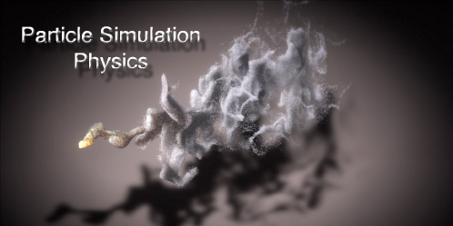

To define a particle system in general terms, it is a useful technique in computer graphics used commonly to model irregular types of natural phenomena such as fire, smoke, water, fog, grass, etc.

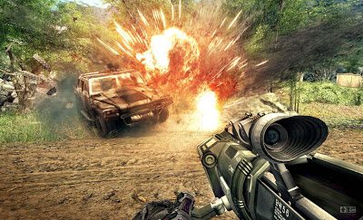

Emitters

Each particle has an emitter. The emitter controls the initial settings of the particle, such as location, velocity, and the number of particles released at a single time.

Here we have different types of particle emitters that one can program. Conic emits in one general direction, but specifies a radius of emission; directional emits only in a single direction; rectangular emits similarly like the conic, except is bounded by the rectangular sides upon emission; radial emits particles in any direction as long as it’s on the same plane; omnidirectional emits particles in all directions; and spherical has particles bounded to a spherical shape.

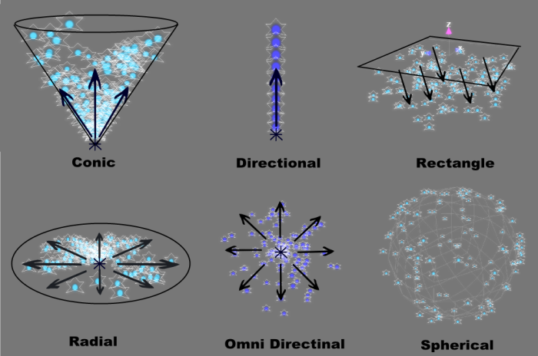

A Particle’s Life Cycle

Particles do not live forever. The reason being is that the amount of particles would continuously increase until the program stopped due to the large amount of data that needed to be stored. Particle systems allow for new particles to be born after old ones die out, thus giving the illusion that there are an infinite number of particles on screen and prevents the overall program from stopping.
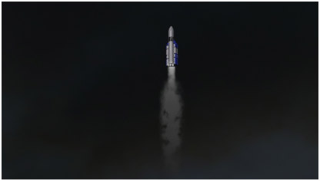

The three stages of a particle within the system are creation, dynamics, and extinction.

The creation stage, or generation, gives the particle all its initial attributes such as position, velocity, color, lifespan, age, shape, size, and transparency. The particle is always created close to or at the emitter, whose location is more often already determined once the program starts. Some of the traits or attributes will remain the same throughout their lifespan, while others will change over time.

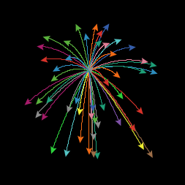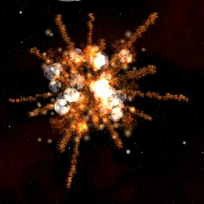

The dynamics stage involves all the movement and changing of attributes of the emitted particle. The color may increase/decrease as it moves across the screen, velocity may slow down/speed up, and direction may change depending on the type of emitter used. A particle’s changing attributes can be due to functions of time or in relation to other particles.
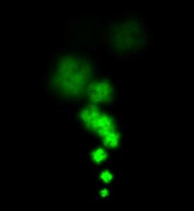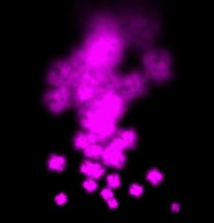

The extinction of particles is based off its age and lifetime. When a particle is first initialized, its age starts at 0 and increases based on the number of frames that have passed. Once the maximum age has been reached, the particle is destroyed and a new one will be created in its place. Depending on the program written, a particle may have an early termination. For example, going out of bounds of the frame, hitting the ground, or the particle’s color fading into the background.



Physics and Mechanics

Algorithm and Implementation

Case Study

References

Game Physics Engine Development: How to Build a Robust Commercial-Grade Physics Engine for your Game (Chapters 1-4) by Ian Millington
- Gives detailed information about the mathematics and physics behind particle systems. Also provides C++ algorithms of different types of particle systems.

http://natureofcode.com/book/chapter-4-particle-systems/
- Provides a basic summary of what particles systems are and how to make one using the Processing environment.

https://www.youtube.com/watch?v=_F8lbnTR6ew
- Gives the algorithm for a Java particle system used in the presentation.

