|  |  |
| --- | --- |
|  | **Memorandum** |

|  |  |  |  |
| --- | --- | --- | --- |
| **To:** | Accounting Teachers | **Date:** | 19 October, 2021 |
|  |  |  |  |
| **From:** | CAPDM | **Copies:** |  |
|  |  |  |  |

**RE: *FinAccs - the Accounting Equation App***

FinAccs implements the Accounting Equation (AE) and provides a number of examples ‘tagged’ up in a simple XML structure that works within the AE framework. FinAccs comes with an XML Schema to allow authors to structure their own questions to add to a growing library.

FinAccs is a Javascript-based app that can be embedded into a web page. It will load in any local questions for selection, but also provides a drag-and-drop area for other questions to be opened up, as well as a ‘Choose’ button to similar effect.

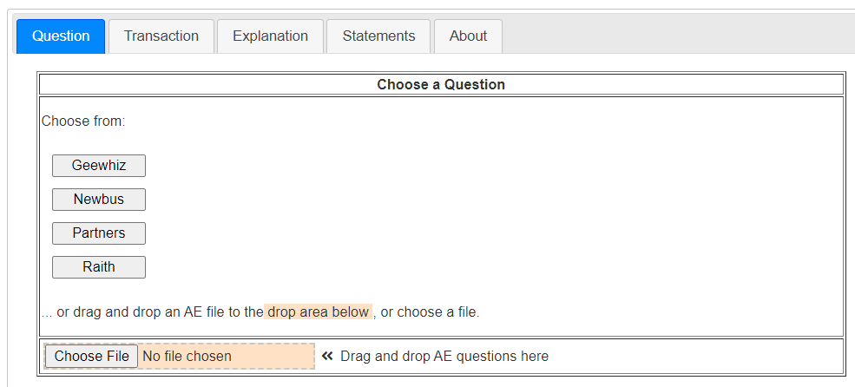

# Questions and Transactions

Once loaded, a question is presented as a series of Transactions to be undertaken. Normally one would work through the transactions in sequence, but double-clicking on the ► allows you to start at any particular transaction. This could be useful, for example, in situtations where a teacher wants students to home in on particular features exhibited in a transaction.

Each transaction can represent many entries in the Accounting Equation. Some may look simple, but there can be a complexity to them!

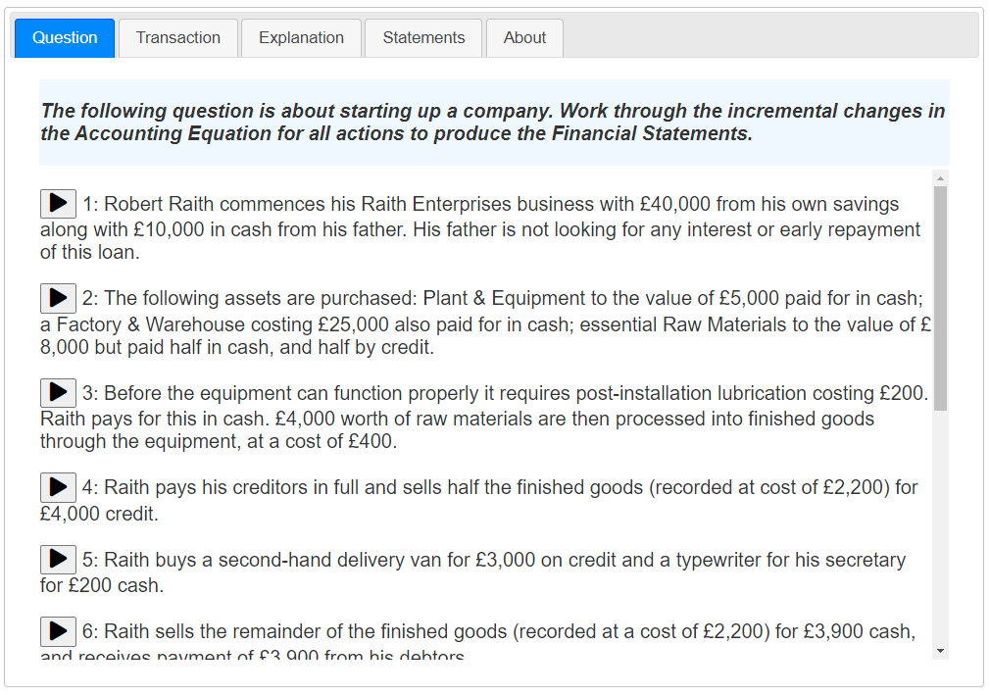

# The Accounting Equation and Transactions

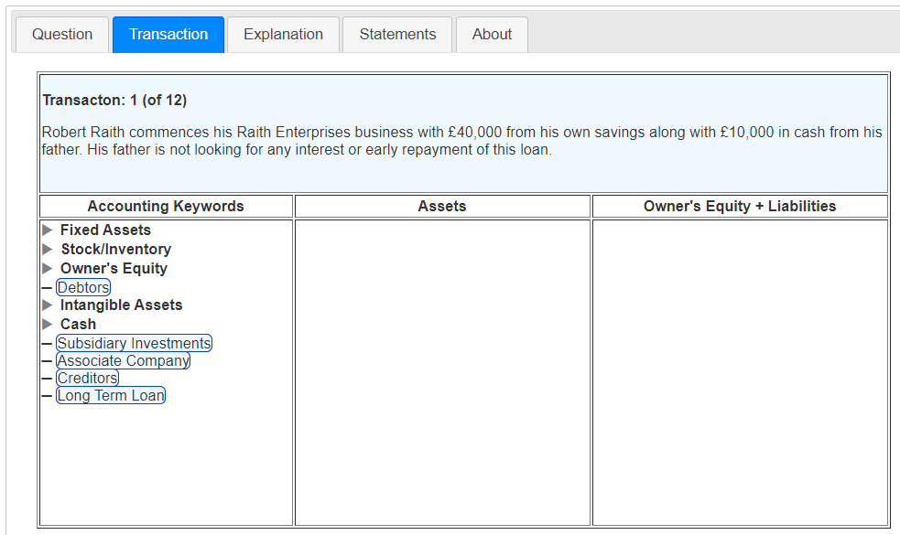

The AE is used within the Transaction tab and the current transaction appears along the top of the table. There are three panes within the lower section of this table:

1. An expandable tree of accounting category keywords, with ‘draggable’ leaf nodes, e.g.Creditors.
2. The Asset side of the AE.
3. The Owner’s Equity and Liabilities side of the AE.

Drag a leaf node over the the correct side of the AE and drop it. For example, open up Owner’s Equity and drag Capital Introduced over to the right hand side of the AE. When dropped, you will see a dialog showing you what you have selected and asking you for an amount.

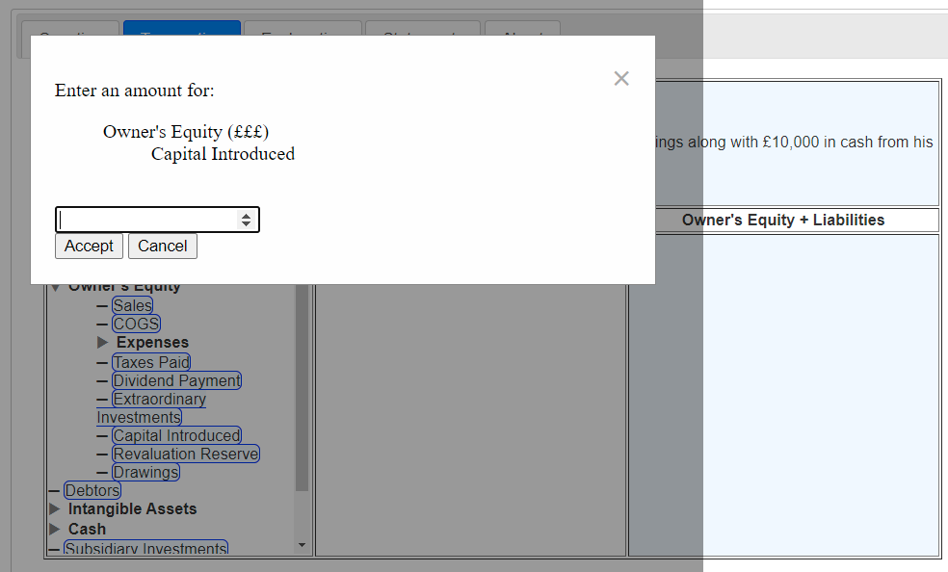

Fill in the correct value for the action.

# Completing a Transaction

There are generally a number of individual actions required to complete a transaction.

For example, the transaction:

***“Robert Raith commences his Raith Enterprises business with £40,000 from his own savings along with £10,000 in cash from his father. His father is not looking for any interest or early repayment of this loan.”***

disguises no fewer than four separate actions, hence entries to the AE.

Correct entries will appear in green, whereas incorrect ones will appear in red. Any incorrect entry can be removed by double-clicking on the small ꭓ to the left of the entry.

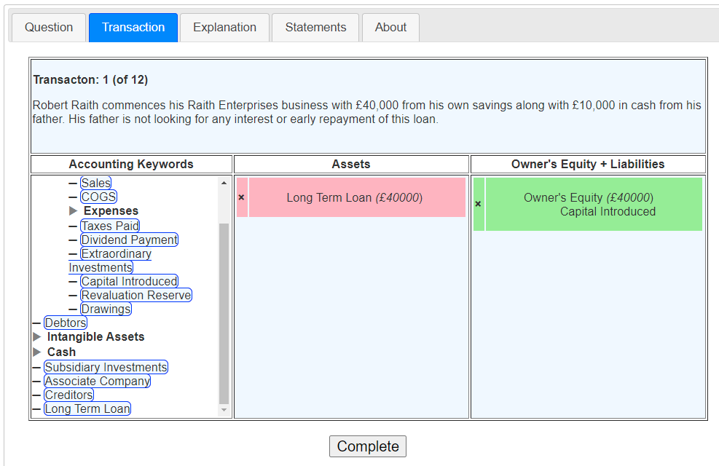

When you think you have all the entries correct then you can complete the transaction with the Complete button.

At this point you will be told if you have all the correct entries, in which case you will proceed to the next Transaction. If you have made mistakes then you have an option:

* Continue with the current attempt, OR
* Let the App fill in the correct actions for you, then tick over to the next transaction. Nobody is looking, after all – but you won’t learn much this way!

# Explanation

The Explanation tab shows the details of the previous transaction. For example, the entries required for the example above would be:

|  |
| --- |
| ***Transaction 1: Robert Raith commences his Raith Enterprises business with £40,000 from his own savings along with £10,000 in cash from his father. His father is not looking for any interest or early repayment of this loan.*** |
| |  |  | | --- | --- | | Action | ***Raith injects 40,000 of his own savings into the new company.***  **EQUITY: Amount = £40,000.00**  **Owner's Equity | Capital Introduced** | | Action | ***Raith's equity injection is balanced by a cash asset.***  **ASSET: Amount = £40,000.00**  **Cash | Non-Operational | From Owners** | | Action | ***This amount is topped up by his father who offers Fred a long term loan***  **EQUITY: Amount = £10,000.00**  **Long Term Loan** | | Action | ***which is represented by a cash asset.***  **ASSET: Amount = £10,000.00**  **Cash | Non-Operational | From Creditors** | |

Where the detail, such as **Cash | Non-Operational | From Creditors**, comes from the hierarchy of accounting keywords used in the AE Transaction tab.

# Statements

This tab has three sub-tabs, each containing one of the three key accounting statements:

* Balance Sheet
* Profit & Loss Statement
* Cash Flow Statement.

These are built up for you as you work through the transactions.

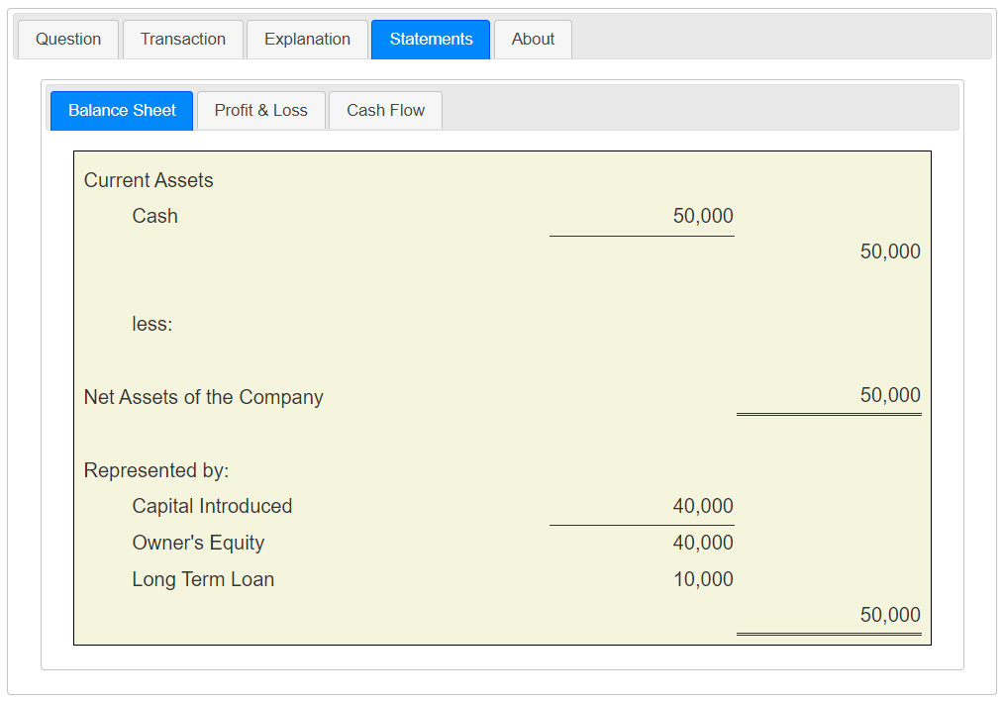

This would be the indicative[1] Balance Sheet after the actions of the transaction detailed above. There is a similar progressive sheet for the P&L and for Cash Flow.

# An operational issue

Reloading the page or causing it to be reloaded (e.g. by moving away) is trapped and pops up an Alert. It will cause the App to be reloaded, taking you back to the front page and list of questions.

If you did this accidentally (which is difficult) then don’t worry as you can always re-start at any particular transaction. FinAccs doesn’t save your work, but you can always continue where you left off as you had to see the correct actions up until that point.

# For potential Authors

The FinAccs XML Schema can be found here:

<https://demodev.capdm.net/GR/ac/finaccs.xsd>

A fairly complex example (Raith Enterprises) can be found here:

<https://demodev.capdm.net/GR/ac/finaccs_ae/raith_ae.xml>

and a template for a new question here:

<https://demodev.capdm.net/GR/ac/finaccs_ae/question_ae-TEMPLATE.xml>

Requirements:

1. Question file names must end in _ae.xml
2. Questions must parse against the Schema (this is checked on load)

Good luck.

# For potential Developers

FinAccs is Copyright CAPDM Ltd. but is made available as free software, including source on request. You can redistribute it and/or modify it under the terms of the GNU General Public License.

If you do use it and develop it further, or indeed develop more questions, then do offer a copy back to CAPDM Ltd. as we will maintain a distribution and a collection of questions.

1. Indicative! It may not be as detailed as a BS should be but it should be good to show the key principles.