News-Based Inflation Risk and Price Dynamics
in Africa: Evidence from a Panel VAR
CAPE Economic Research and Consulting
May 2026
Abstract
[Abstract to be supplied.]
Keywords:[To be supplied]
JEL: [To be supplied]

Introduction
Inflation prediction has been central to economic management over the years. The accuracy and effectiveness of the method employed is key to the strength of policy intervention. Approaches to investigating the drivers of inflation have mostly relied on backward-looking data sets, usually produced with a lag (Orphanides 2001). The drivers of inflation explored in literature typically include GDP, money supply, and interest rates (Malope et al. 2026). These data sets can take months from the point of policy action to be published, denying policymakers the ability to make timely decisions to curb inflation. This challenge is particularly more pronounced in Africa, where data infrastructure is less effective (Jerven 2013), and institutional limitations make it difficult to address these data needs for policymaking.
Several surveys have been introduced as proxies for lagged inflation measurement. The most prominent of these the Michigan Survey of Consumers, the Survey of Professional Forecasters and others have been evaluated for their forecasting performance and rationality (Thomas 1999). However, these surveys still come with structural delays and are mostly monthly, reflecting sentiments gathered over the preceding weeks rather than present moments. A similar pattern holds in Africa: the Central Bank of Nigeria’s Inflation Expectation Survey report (Central Bank of Nigeria 2025) samples thousands of businesses and is likewise released on a monthly basis. The usefulness of such surveys is limited, as they lack the ability to track rapid shifts in inflation dynamics as they occur.
Recent technological developments have introduced machine learning approaches to inflation prediction. Neural networks were used by Nakamura (2005), who forecast quarterly US CPI and found the model outperformed autoregressive benchmarks at short horizons. However, results have been mixed; Choudhary and Haider (2012) found autoregressive models performed better in some countries while artificial neural networks performed better in others. A further limitation is that the drivers behind these predictions often cannot be ascertained,machine learning models are often characterised as black boxes because, although they outperform traditional methods in certain instances by capturing complex nonlinear relationships, they do not reveal the variables that drive such predictions (Araujo and Gaglianone 2023).
Information analysis has been introduced into the analysis of price dynamics. Attempts include the analysis of social media data to construct real-time indicators for inflation perception, and results show that the data obtained tracked actual inflation and survey-based expectations. News is not just information but holds the power to frame the perception of economic agents and influence their decisions (Tetlock 2007), while also anchoring their expectations for future trends (Carroll 2003). News has similarly been applied to the study of macroeconomic variables such as GDP, with Elshendy and Fronzetti Colladon (2017) finding that macroeconomic news is an important predictor of GDP. The focus of this paper, however, is the information embedded in news reports as a real-time source for indicating shifts in price dynamics.
News offers information at no additional cost; it also captures economic sentiment in real time (Angelico et al. 2022). This is important on a resource-constrained continent like Africa, where the data availability gap has motivated the use of alternative high-frequency sources to support timely policymaking (Buell et al. 2021).
This paper proposes a news-based inflation risk index for Africa that is traceable, monotonic, and has volume comparability across countries, to ensure countries with lower volumes of articles do not reflect low risk due to this characteristic. The African Inflation Risk Index (AIRI) was derived by subjecting news articles to layers of traceable processes to ensure reproducibility and clarity, addressing the “black box” limitation of machine learning approaches to forecasting inflation (Araujo and Gaglianone 2023). These processes include screening each article through a dictionary-based economic relevance filter, similar to lexicon-based approaches built specifically for scoring economic and financial news text (Shapiro, Sudhof, and Wilson 2020), and then, based on how this language was framed, assigning a severity tier to each article. A confidence weight was also assigned according to the credibility of the signal. In all, article scores are summed over the inflation-tagged subset of the corpus and divided by the total article count for the period.
To investigate the ability of the index to predict inflation, we conduct a Panel Vector Autoregressive analysis on all 46 African countries to check if the AIRI is statistically related to realised inflation after controlling for other factors. Also, because we expect the variability to differ by country characteristics, we investigate the difference in its predictive strength in low-inflation and high-inflation countries, and lastly, we check the forecast value of the generated index by comparing its forecast error to baseline AR models and models that include other macroeconomic variables.
The remainder of this paper is organized as follows: Section 2 reviews the relevant literature. Section 3 describes the data sources and methodology used to construct the African Inflation Risk Index, presents the panel VAR specification and estimation strategy, and outlines the forecast evaluation framework. Section 4 discusses the empirical results. Section 5 concludes with implications for policy.

Literature Review

The Evolution of Inflation Measurement
Conventional inflation measurement relies on realised price indices ,the Consumer Price Index and related measures ,which record price changes only after they have occurred. This backward-looking character creates a structural information gap: the expectations driving pricing decisions are invisible to statistical agencies until they have materialised in observed transactions (Mishkin 2007). Knight (1921) and Keynes (1936) established that economic decisions are governed by forward-looking beliefs rather than realised outcomes, while Friedman (1968) and Phelps (1968) formalised this by anchoring inflation in expectations, a dimension price indices cannot capture.
The empirical consequences are well documented. Mankiw and Reis (2002) and Sims (2003) showed that information disseminates slowly across agents, generating systematic gaps between actual and expected inflation. Coibion and Gorodnichenko (2012) and Coibion and Gorodnichenko (2015) demonstrated these gaps are predictable and persistent, while Coibion et al. (2023) provided experimental evidence that inflation expectations independently alter household behaviour even absent contemporaneous price changes. D’Acunto et al. (2022) further confirmed that subjective beliefs drive firm pricing strategies, establishing that the expectation-formation process causally precedes the price dynamics that indices eventually record. Forward-looking inflation surveillance therefore requires access to the information environment in which expectations form, not merely the price records that result.
Shiller (2017) identified news media as the primary channel through which economically consequential narratives propagate and shape collective expectations. Tetlock (2007), García (2013), and Nyman, Kapadia, and Tuckett (2021) confirmed empirically that news-based signals contain forward-looking information about market conditions, economic activity, and systemic risk. Baker, Bloom, and Davis (2016) operationalised this insight through the Economic Policy Uncertainty (EPU) index, showing newspaper-based indicators are strongly associated with investment, employment, and output. Barbaglia, Consoli, and Manzan (2023) further demonstrated that topic-specific risk pillars outperform generic uncertainty indices for forecasting inflation, directly validating the pillar-level architecture of the African Inflation Risk Index (AIRI). Gentzkow, Kelly, and Taddy (2019) justified rule-based, interpretable construction over opaque machine-learning approaches for policy-relevant surveillance.
Despite this progress, the literature remains concentrated on advanced economies. The EPU covers fewer than fifteen African countries; the World Uncertainty Index (Ahir, Bloom, and Furceri 2018) relies on standardised reports rather than domestic corpora. No existing index provides a pillar-level inflation risk measure for Africa, and no study has formally tested whether such signals predict realised inflation across the continent using panel methods. This gap is consequential: African economies face structural data delays, commodity-driven inflation, rapid exchange rate pass-through, and weak monetary policy credibility—precisely the conditions under which narrative signals should most reliably precede realised price movements (Buell et al. 2021; Olamide, Ogujiuba, and Maredza 2022; Kasekende, Atingi-Ego, and Durevall 2018). This study addresses the gap by subjecting the AIRI inflation pillar to panel econometric testing, providing the first systematic evidence on whether news-based inflation risk narratives constitute a credible forward-looking indicator of realised inflation across African economies.

Inflation Measurement and Data Constraints in Africa
A shift in perspective from theory to the harsh structural realities and data constraints is necessary for research on inflation dynamics in Africa. Compared to industrialised countries, where demand-side pressures are more deeply embedded, inflation in Africa is far more vulnerable to supply-side shocks. These are mostly caused by major currency devaluations, shocks to the world’s food supply, and the impact of climate change on local agricultural output (Durevall and Sjö 2012).
A persistent issue that exacerbates structural instability is a lack of data. While African nations have been mostly reliant on the traditional Consumer Price Index (CPI), the developed world uses high-frequency administrative data infrastructure to track changes in the economy. The conventional indexes, however, are low frequency (usually monthly), have considerable reporting time delays, and are not sufficiently precise to reflect the localised character of price shocks (Blinder et al. 2024; Yeboah, Agyei, and Korsah 2025). Moreover, there has been considerable geographical diversity over the years. Long-run inflation series are severely data-limited, yet the inflation mechanisms and persistence vary dramatically throughout the continent, between resource-rich and non-resource-rich nations (Kelikume 2018; Phiri 2016). The environment is varied and data-poor, making it difficult to respond in real time with policies and challenging to use standard monetary policy processes such as inflation targeting.
Researchers are consequently turning to other, higher-frequency digital indicators to overcome these limits. Nowcasting accuracy has been attained in other regions by utilising text-mining and natural language processing (NLP) techniques, ranging from basic lexicon-based models to cutting-edge Large Language Models (LLMs) such as InflaBERT, which are used to analyse real-time economic data from textual news and social media (Allard, Teiletche, and Zinebi 2024; D. P. Nguyen et al. 2025). It has also been established that the tone and attitude of central bank monetary policy announcements in Africa have a significant impact on inflation expectations (Odu, Aminu, and Ado 2024).
However, despite this promise, traditional econometric techniques that are not text-based continue to predominate in economic research, and the use of news-based indicators in the empirical African literature remains quite restricted (Yeboah, Agyei, and Korsah 2025). There are clear methodological gaps at the national level. For instance, there is no automated text analysis of central bank communications for significant economies like Ghana or South Africa. Traditional CPI indicators are information-lagged; the use of news-based inflation risk indicators can therefore be a game-changer and a proactive tool to fill gaps in continental data and enable the collection of macroeconomic signals.

Inflation Forecasting: Methods and Evolution
The evolution of inflation forecasting methods cannot merely be described as an evolution from simple to more complex approaches, but rather a morphology through a search for the most effective and accurate approach as time and technology evolved. Starting with the Phillips curve, whose explanation of inflation rests on the unemployment gap, Phillips (1958) found an inverse relationship between unemployment and the rate of change of wages in the United Kingdom. Samuelson and Solow (1960) applied the approach to the United States and found the same inverse relationship between unemployment and inflation. Friedman (1968), however, argued that the relationship was unstable, positing that it worked only because workers and firms were assumed not to form expectations about future inflation. The expectations-augmented Phillips curve was subsequently introduced to address this concern, formalised empirically through the Non-Accelerating Inflation Rate of Unemployment (NAIRU),the unemployment rate consistent with stable inflation, but the structural approach was further challenged by Lucas’s critique of econometric policy evaluation, which used the Phillips curve as its central illustration of how relationships can break down when agents adjust their expectations.
Following the Phillips curve’s breakdown in the 1970s and failed replication attempts, Galí and Gertler (1999) argued that the failure stemmed from using the wrong measure of slack; by replacing the output gap with real marginal cost, they were able to restore the inflation relationship. Atkeson and Ohanian (2001) later compared the forecasting performance of NAIRU-based Phillips curve models against a naïve benchmark and found that none of the Phillips curve forecasts was more accurate than the naïve alternative.
In response to the limitations of structural models, Sims (1980) proposed the Vector Autoregression, a less theoretically dependent and more data-driven framework, modelling macroeconomic variables jointly using their own past values rather than imposing structural restrictions. Stock and Watson (2001) applied a three-variable VAR of unemployment, interest rates, and inflation to US data and found it to be an effective forecasting tool. Cooley and LeRoy (1985), however, critiqued Sims (1980) for an identification problem, arguing that the VAR had hidden structure despite being presented as atheoretical; Sims himself acknowledged its constraint to a small number of variables, a problem he called “profligate parameterisation.”
Extensions that followed include: the Structural VAR, which added identification restrictions to improve interpretability (Blanchard and Quah 1989); the Bayesian VAR, which imposed discipline on coefficient estimates through priors (Litterman 1986); and the Factor-Augmented VAR, which enriched the information set with common factors extracted from large macroeconomic datasets (Bernanke, Boivin, and Eliasz 2005). Despite this evolution, Stock and Watson (1999) found that the simple autoregressive model performed as well as or better than many competing models across the G7 economies and the AR model has since become the standard benchmark for inflation forecasting evaluations, as further established by Stock and Watson (2007).
Following the global financial crisis of 2008 and the rapid development of machine learning tools, these methods have been applied to inflation forecasting. This approach has proven accurate, as demonstrated by Medeiros et al. (2021), who forecasted United States inflation using LASSO regression and random forest methods. Neural network models were similarly applied by Chakraborty and Joseph (2017), who showed that this approach performs better at forecasting during periods of structural breaks. However, a major challenge with machine learning is its opacity, the main drivers of inflation cannot be readily identified, creating a tension between accuracy and interpretability. Gentzkow, Kelly, and Taddy (2019) note that models achieving strong forecasting performance through complex nonlinear relationships typically cannot explain what drives their predictions or why those predictions change over time.
An emerging approach to inflation forecasting is the news-based framework, which carries the advantage of being forward-looking, though most evidence remains concentrated in advanced economies. Shapiro, Sudhof, and Wilson (2022) established the link between media narratives and price dynamics in the United States. In Norway, Larsen, Thorsrud, and Zhulanova (2021) used machine learning tools to demonstrate that media-reported topics are strong predictors of inflation. In Europe, Barbaglia, Consoli, and Manzan (2023) found that topic-specific sentiment indicators targeting inflation-related narratives substantially outperform both generic sentiment measures and standard AR benchmarks in out-of-sample forecasting, with predictive gains concentrated at horizons of three to six months. Different methods have also been explored in the African literature to forecast inflation.
For Africa, A. D. M. Nguyen et al. (2017) employed a Global VAR to identify the drivers of inflation in Sub-Saharan Africa, while Alper, Hobdari, and Uppal (2016) investigated the heterogeneity of inflation dynamics across income groups in Sub-Saharan Africa. Both studies relied on backward-looking official data for their predictions. The literature on news-based approaches to inflation forecasting in Africa is scarce, the closest attempt was by Salisu, Salisu, and Salisu (2024), who constructed an economic policy uncertainty index for Nigeria using newspaper text. However, this exercise was limited to a single country.
No existing study has applied a news-based inflation forecasting framework to all African countries. African economies are characterized by the conditions under which news-based signals should be most valuable; high inflation volatility, weak expectation anchoring, severe data constraints, and limited availability of high-frequency official statistics. The present study directly addresses this gap by providing the first systematic panel VAR assessment of whether the AIRI contains incremental predictive information for realised inflation across all 46 African economies, whether that predictive content varies systematically across country groups defined by inflation history, and whether the AIRI improves the forecast value of macroeconomic models.

Methodology
This section attempts to formalize the evaluation of the predictive power of the AIRI inflation pillar. The Panel VAR is used to establish the statistical relationship between the lagged values of the AIRI and realized inflation and evaluate its predictive power across varying macroeconomic contexts (high and low inflation). The forecast evaluation checks if the AIRI inflation pillar improves forecast accuracy in models.

Data
We compute inflation risk as a decomposed component of the aggregate news-based index for Africa. The index captures inflation threats framed in newspaper narrative. The article-level scoring architecture used to derive the index includes economic relevance screening, ordinal severity tiering, confidence weighting, and multi-pillar mapping that identifies the inflation risk. By definition, the inflation risk index used in this paper is the normalised sum of article risk scores restricted to inflation-tagged articles, scaled to policy-friendly levels. The key characteristics of the index include monotonicity, non-negativity, and traceability, i.e. each contribution can be traced to a specific article, its matched dictionary term, severity tier, and weight component. Also, because the denominator is the total corpus size rather than the count of inflation articles, a country with more media output does not mechanically record more inflation risk, hence achieving volume comparability across countries.

Data Processing

Corpus Assembly.
All news articles are scraped for each country c at time period $t$, , and the total count of all articles, N_{c,t} = |I_{c,t}|, is used as the denominator, where I_{c,t} denotes the set of all articles retained for country c in period t. This allows for the anchoring of the pillar to the full corpus rather than just inflation-related articles, to ensure that the measure reflects the prominence of inflation narrative within the entire media landscape and comparison across countries with differing publication volumes.

Economic relevance screening.
R_{i} = 1{x_{i} matches ECON_RELEVANCE_TERMS}.
$R_{i}∈\{0,1\}$. Only relevant articles proceed to scoring.
Every article scraped is passed through a dictionary-based economic relevance filter. An article is tagged relevant if its concatenated title and body matched at least one term in the economic relevance dictionary ($R_{i}=1$); otherwise, it is assigned zero. This ensures that other news cycles, such as politics, sports, or crime, will not contaminate the inflation signal.

Inflation risk mapping.
Broadly, every relevant article is checked against the full set of risk pillar dictionaries defined in the AERI framework. Let p ∈ {1, ..., P} index the P risk pillars tracked by the framework (inflation risk, FX/external risk, debt/fiscal risk, and others), and let I_{p,i} ∈ {0, 1} indicate whether article i matches pillar p's dictionary. This assignment can be multi-label: a single article may simultaneously activate more than one risk pillar. Of the P pillars available, this paper isolates one: inflation risk.
Each article is checked against the inflation risk dictionary, with terms including consumer prices, cost-of-living pressure, price surges, currency-driven pass-through, and others. The indicator $I_{\text{inf},i}$ equals one when the article matches this dictionary and zero otherwise.

$$I_{\text{inf},i}=1\{x_{i}\text{ matches INFLATION_PILLAR_TERMS}\}$$

Severity tiering.
Articles receive an ordinal severity tier $S_{i}$ from 0 to 4 based on their relevance, reflecting how strongly the economic issue is framed as threatening. Dictionaries are tiered, escalating from mild concerns to extreme events through deterioration and crisis language. Non-relevant articles are fixed to zero severity.
S_{i} ∈ {0, 1, 2, 3, 4}, S_{i} = 0 if R_{i} = 0; otherwise S_{i} = max{matched tier in SEVERITY_TIER_TERMS}.

Confidence weighting.
A confidence weight $W_{i}$ is applied to reflect each article’s impact according to the credibility of its signal. The following features add to a baseline of one: a high-salience risk cue in the headline adds 0.5, because titles summarise editorial emphasis; body text exceeding a minimum length threshold adds 0.2, to capture substantive content; and activation of at least two pillars adds 0.3, indicating interconnected rather than isolated stress. The weight is capped at the interval $\left[1,2\right]$ so that no single unusually phrased article can dominate the aggregate.
$$W_{i}=\text{clip}\left(1+0.5⋅{\text{TitleHint}}_{i}+0.2⋅{\text{LongText}}_{i}+0.3⋅{\text{MultiPillar}}_{i}, 1, 2\right)$$
where ${\text{TitleHint}}_{i}$, ${\text{LongText}}_{i}$, ${\text{MultiPillar}}_{i}∈\{0,1\}$ are indicators for a headline risk cue, body length above threshold, and activation of at least two pillars, respectively, with
$${\text{MultiPillar}}_{i}=1\left\{\sum_{p=1}^{P}{I_{p,i}}≥2\right\}$$

Article-level risk score.
The article is scored by multiplying its relevance, severity, and confidence, which ensures logical consistency. Irrelevant articles contribute zero, and mildly framed relevant articles contribute little. Every score rises based on its severity and confidence. Because of this feature, every generated index is therefore traceable to observed textual features.
$$A_{i}=R_{i}⋅S_{i}⋅W_{i}$$
so that $A_{i}∈\{0\}∪\left[1,8\right]$: zero when irrelevant, and between 1 (Tier-1 severity, baseline weight) and 8 (Tier-4 severity, maximum weight 2) when relevant.

Aggregation to the country-period inflation risk index.
Inflationc,t=100⋅i∈ac,t​Ai⋅Iinf,iNc,t
Substituting the article score gives the fully expanded form:
Inflationc,t=100Nc,ti∈ac,t​Ri⋅Si⋅clip1+0.5⋅TitleHinti+0.2⋅LongTexti+0.3⋅MultiPillari, 1, 2⋅Iinf,i
To derive the index, article scores are summed over the inflation-tagged subset of the corpus, divided by the total article count for the country-period, and scaled by 100. This results in an average inflation risk intensity per article, which rises when inflation narrative becomes more frequent, more severe, and more credible, and is insulated from mechanical differences in media volume across countries.
To test the index derived, 46 countries (because of data limitation) from 2015 to 2025 were used to check the statistical relationship between the AIRI and realized inflation.

Empirical Analysis of AIRI: Stylized Facts on Inflation Risk vs. Inflation Rate Across Countries
This note presents the full set of stylised-fact charts comparing the AIRI inflation-risk indicator with headline CPI inflation across 46 economies, with an interpretation placed directly beneath each chart (or group of charts making the same point).

1. Country-Level Correlation Between AIRI and Headline Inflation
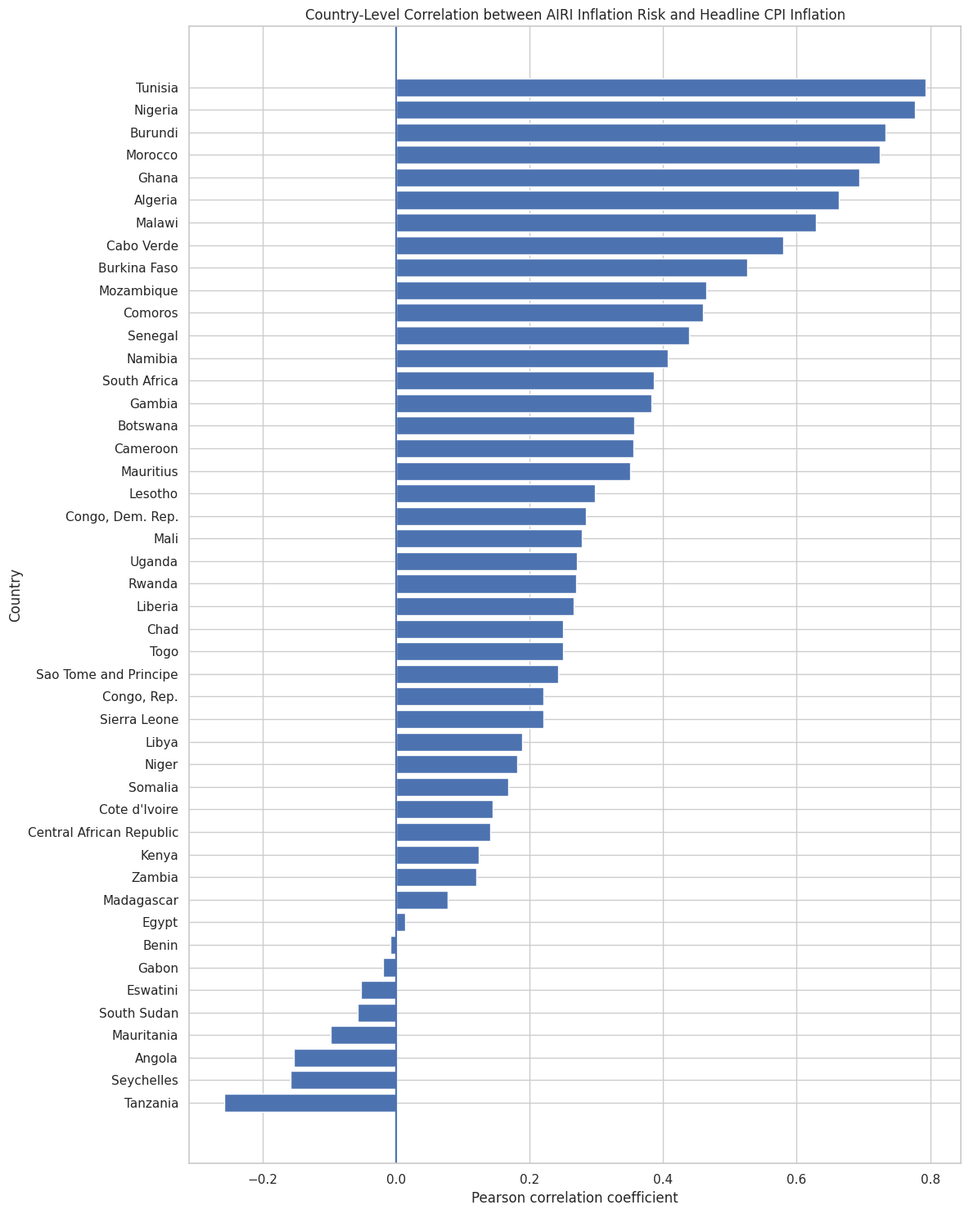
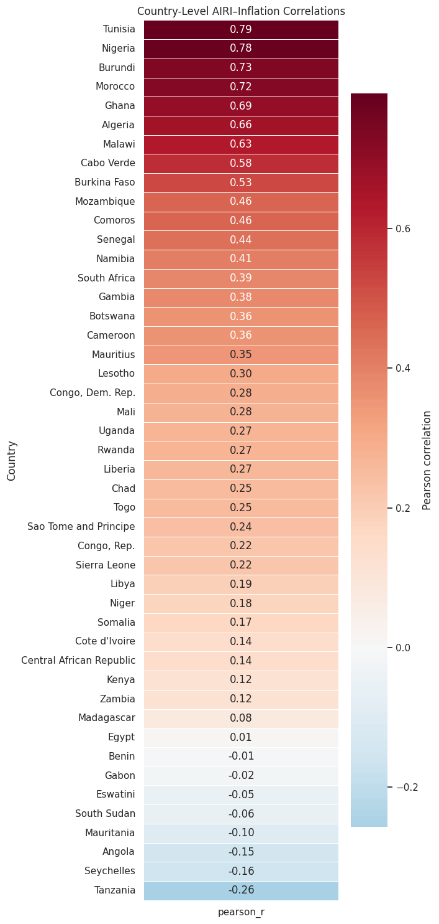
Figure 1a–1b. Country-level Pearson correlation between AIRI inflation risk and headline CPI inflation, ranked bar chart (left) and colour-coded heat map (right).
There is considerable cross-country variation. Tunisia (r = 0.793), Nigeria (r = 0.777), Burundi (r = 0.733), Morocco (r = 0.724), Ghana (r = 0.693), Algeria (r = 0.663), Malawi (r = 0.629), Cabo Verde (r = 0.580), and Burkina Faso (r = 0.526) show particularly strong positive relationships between AIRI inflation risk and realised inflation, meaning increases in the raw inflation-risk measure tend to coincide relatively closely with increases in observed CPI inflation in these economies. Across the full panel, the average country-level correlation is 0.281, and the median is 0.268; 38 of 46 countries (82.6%) show a positive relationship, and 32 are statistically significant at the 5% level. Only nine countries clear the “strong” threshold of r ≥ 0.50, while a handful of countries like Tanzania at r = -0.257, along with Seychelles, Angola, Mauritania, South Sudan, Eswatini, Gabon and Benin — show a negative or essentially flat relationship. In short, AIRI carries real signal about realised inflation in most countries, but its reliability is highly country-specific rather than universal.

2. Cross-Country Relationship Between Average Inflation and Average AIRI Risk
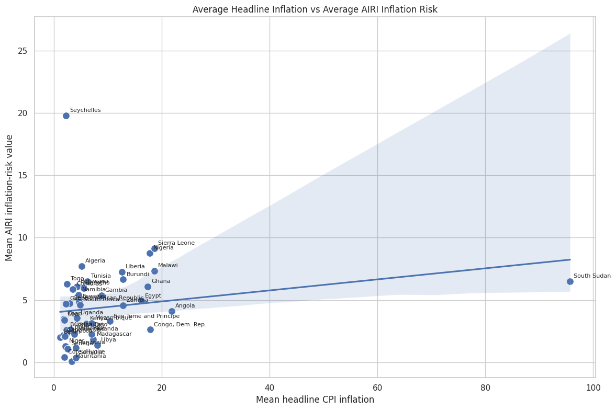
Figure 2. Mean headline CPI inflation versus mean AIRI inflation-risk value, one point per country, with a fitted regression line.
At the level of country averages, higher long-run inflation is associated with a higher average AIRI reading, but the fit is loose and is heavily influenced by a few outliers. Seychelles sits far above the line, combining a low mean CPI (around 4%) with an unusually high mean AIRI value (around 20), while South Sudan sits far to the right, with an extreme mean CPI (around 96%) but only a moderate AIRI reading (around 6.5). The other 44 countries cluster tightly in the lower-left corner, with mean CPI below roughly 20% and mean AIRI below roughly 10. This means the overall positive slope is driven disproportionately by a small number of extreme cases rather than reflecting a tight, general relationship between typical inflation levels and typical AIRI readings.

3. Distribution of the Pooled Panel
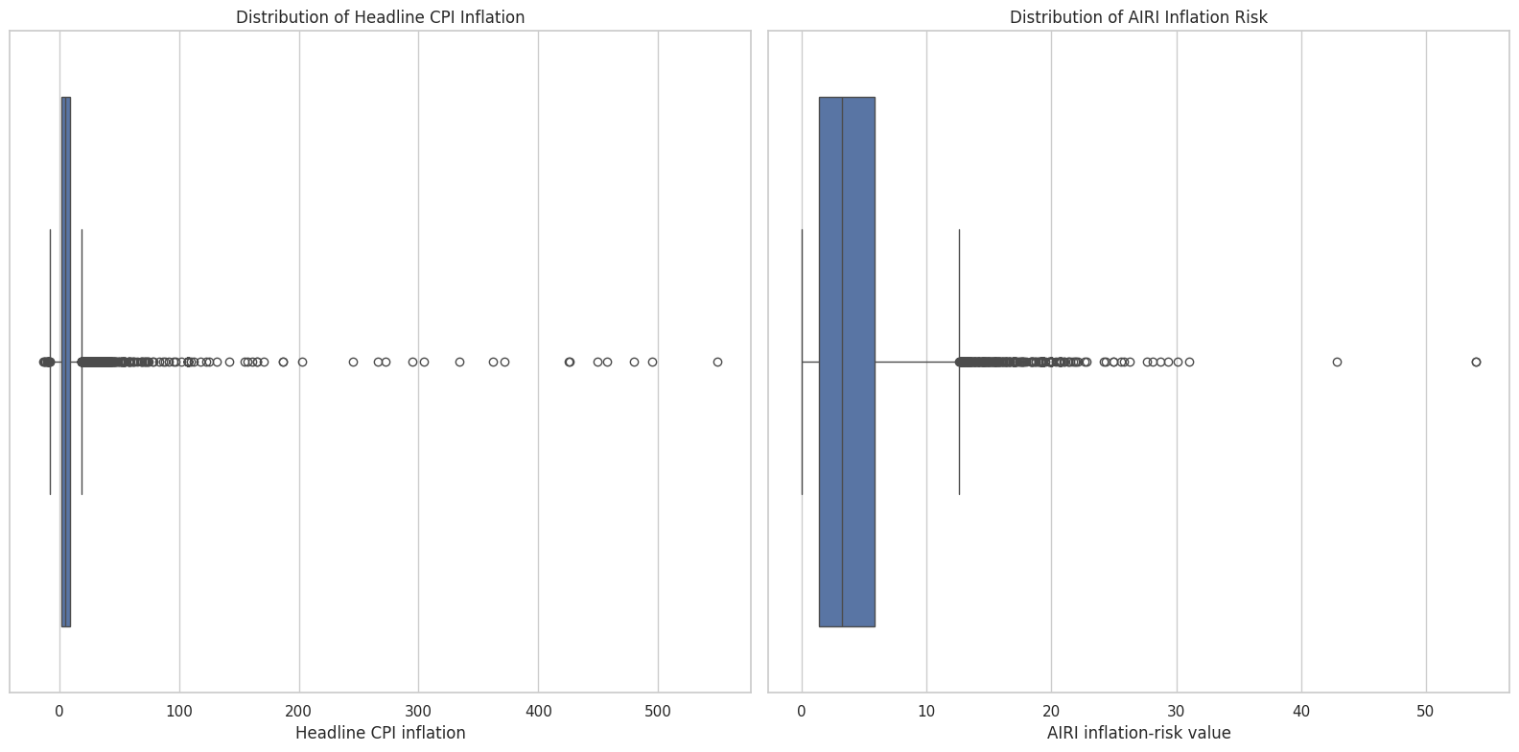
Figure 3. Box plots of headline CPI inflation (left) and AIRI inflation risk (right) pooled across all countries and time periods.
Pooling all country-month observations together, both series are heavily right-skewed. The interquartile box for CPI inflation sits close to single digits, but a long tail of outliers extends beyond 500%, driven chiefly by hyperinflation episodes such as South Sudan’s. AIRI risk shows the same shape on a more compressed scale: a narrow box roughly between 0 and 6, with outliers reaching above 50. Because both variables spend most of their time in a narrow “normal” range and are dominated in the tails by a small number of crisis episodes, the strength of the AIRI–CPI relationship in any given country depends heavily on how well those tail episodes line up between the two series, which helps explain the wide dispersion of country-level correlations seen in Figure 1.

4. Country-by-Country Spread of CPI Inflation and AIRI Risk
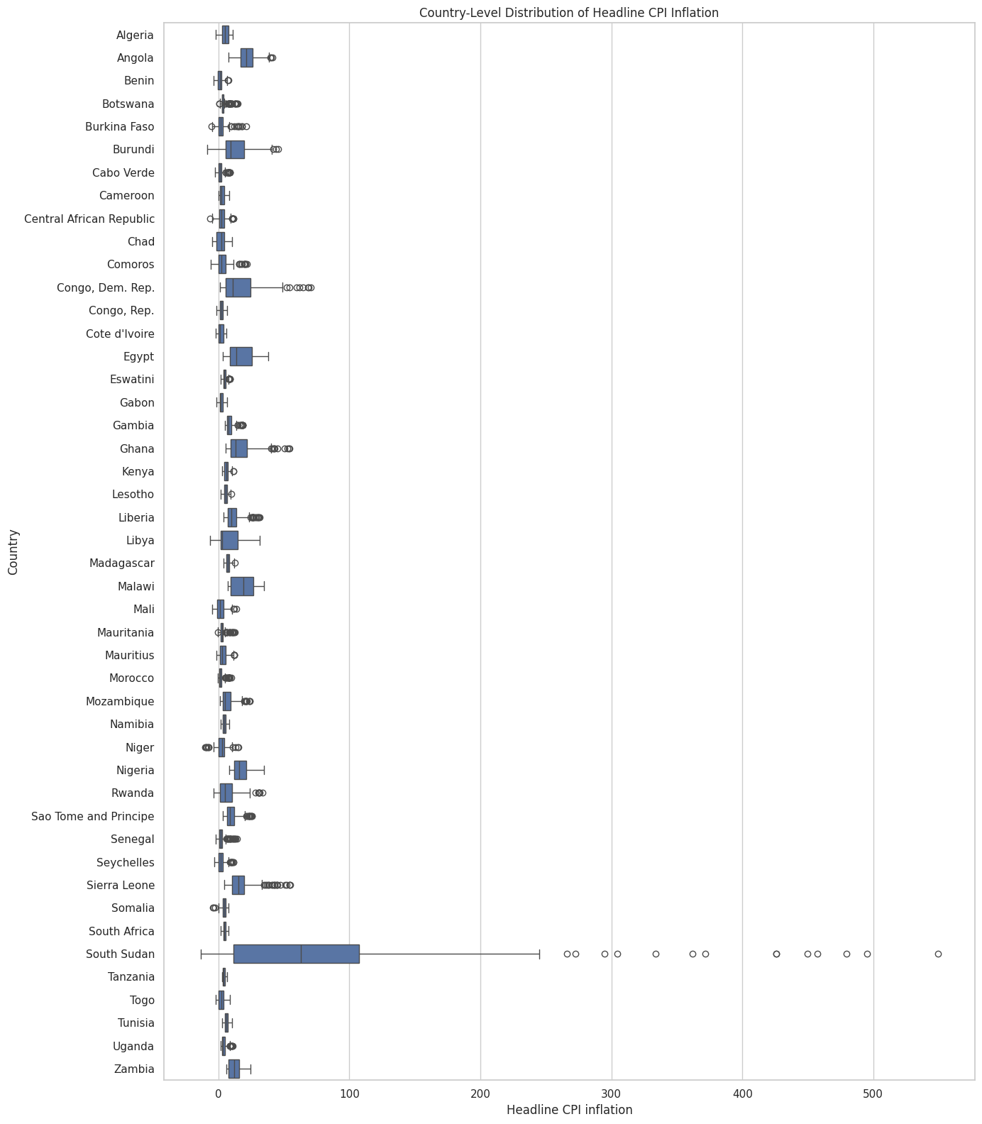
Figure 4a. Country-level distribution of headline CPI inflation.
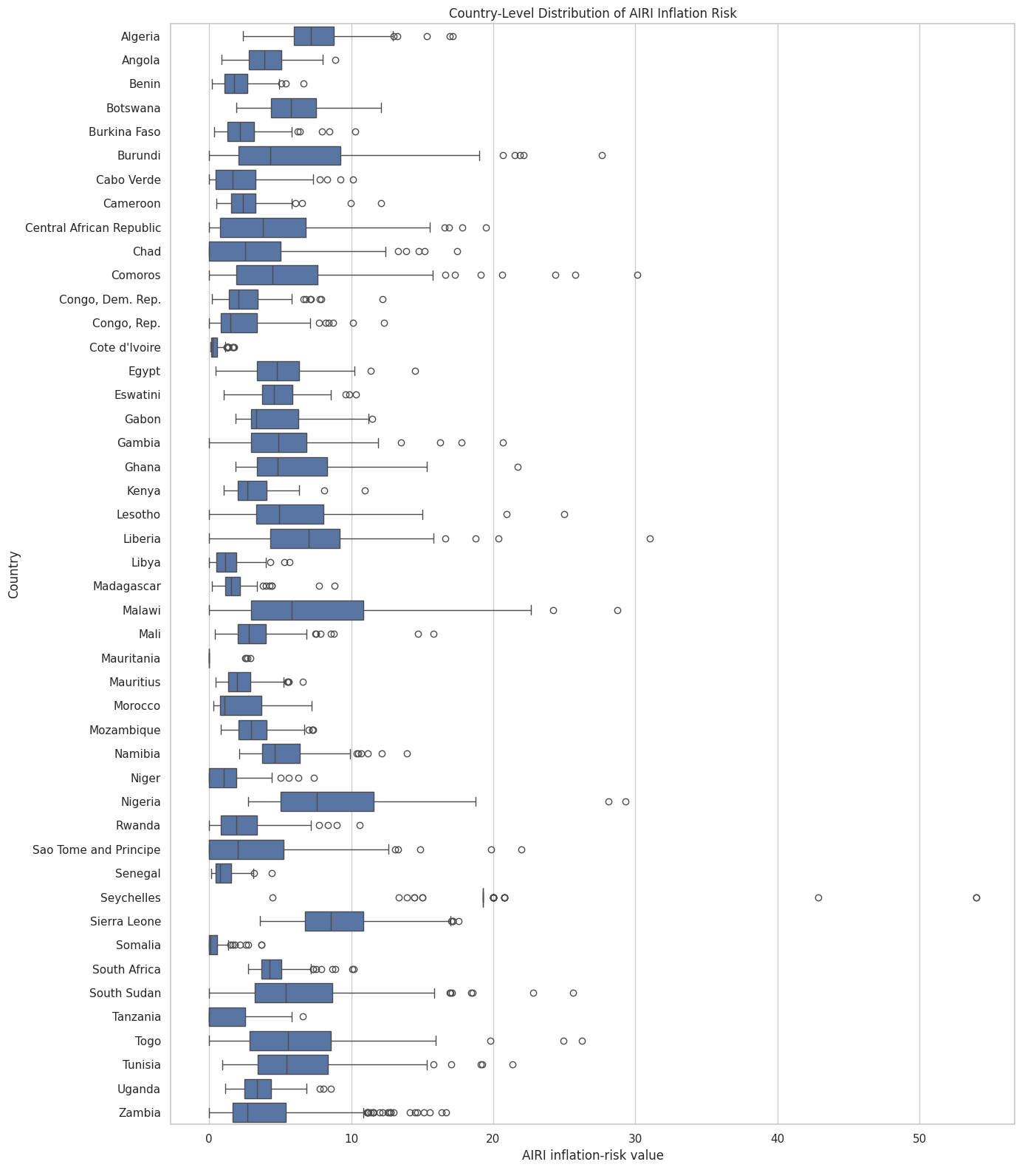
Figure 4b. Country-level distribution of AIRI inflation risk.
Breaking the pooled distribution down by country shows that extreme inflation is concentrated in a small number of economies. South Sudan is in a class of its own for CPI inflation, with a median above 50% and outliers beyond 500%, while most other countries have compact boxes below roughly 20–30%; Angola, Congo (Dem. Rep.), Egypt, Ghana, Sierra Leone and Malawi form a second tier of moderately high and volatile inflation. The AIRI distribution tells a related but not identical story: Nigeria, Sierra Leone, Malawi, Comoros, Liberia and Burundi display the widest AIRI boxes, and Seychelles has the single most extreme AIRI outlier (above 50) despite not standing out at all in the CPI chart; a further sign, consistent with Figure 2, that the AIRI measure and realised inflation can diverge sharply for particular countries.

5. Panel-Wide Trend Over Time
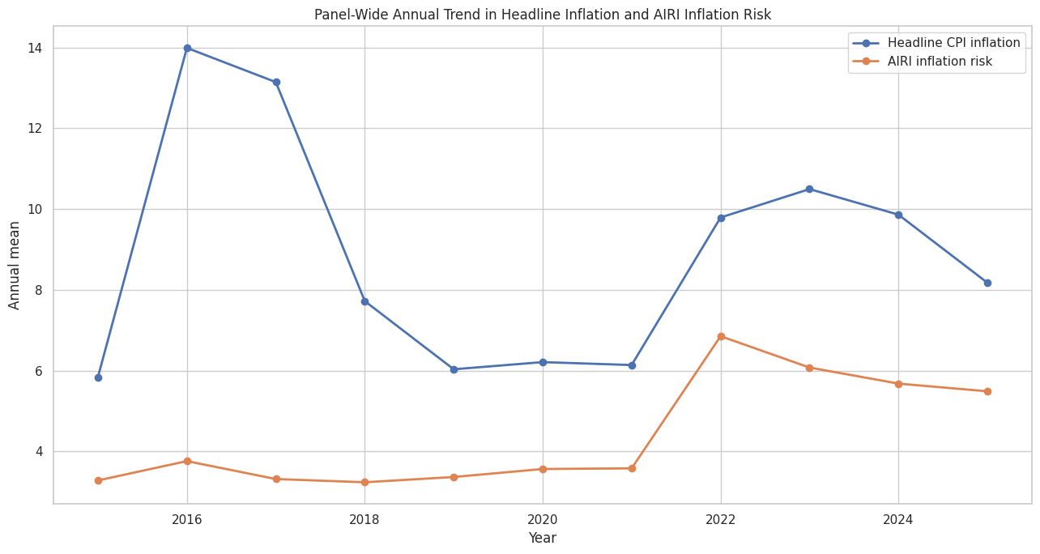
Figure 5a. Annual panel-wide mean of headline CPI inflation and AIRI inflation risk, raw units.
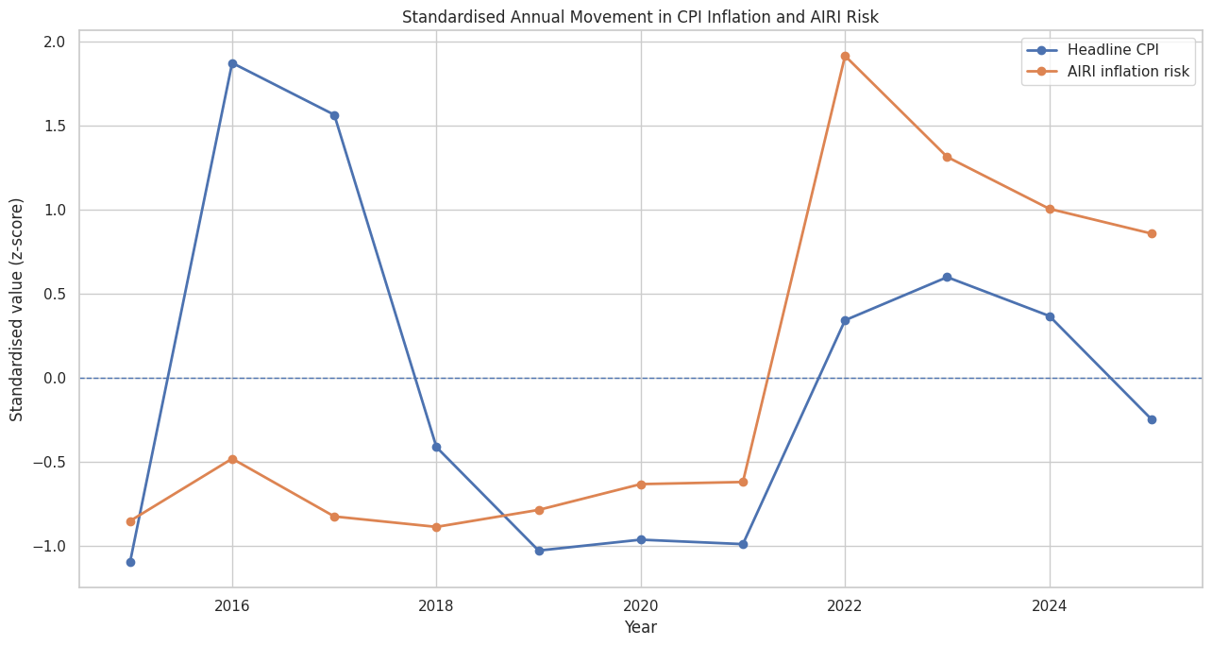
Figure 5b. The same two series expressed as standardised (z-score) annual movements.
The panel-wide annual averages trace two inflation cycles: a peak around 2016 and a much larger one from 2022 onward, following the global post-pandemic inflation shock, with a trough in between around 2018–2021. AIRI risk tracks the second episode much more closely than the first. In standardised terms, CPI jumps sharply in 2016 (z ≈ 1.9) while AIRI barely moves and is even slightly below its own long-run average (z ≈ -0.5); but in 2022 both series spike together, with AIRI actually showing the larger standardised move (z ≈ 1.9 versus 0.3 for CPI). After 2022, CPI falls back toward its historical average faster than AIRI, which stays elevated (z of roughly 0.9–1.3) through 2023–2025. This pattern suggests the AIRI measure was particularly responsive to the recent global inflation shock, but is more sluggish than realised inflation both in missing earlier, more localised episodes and in signalling the subsequent disinflation.

6. Countries Where AIRI Tracks Inflation Well versus Poorly
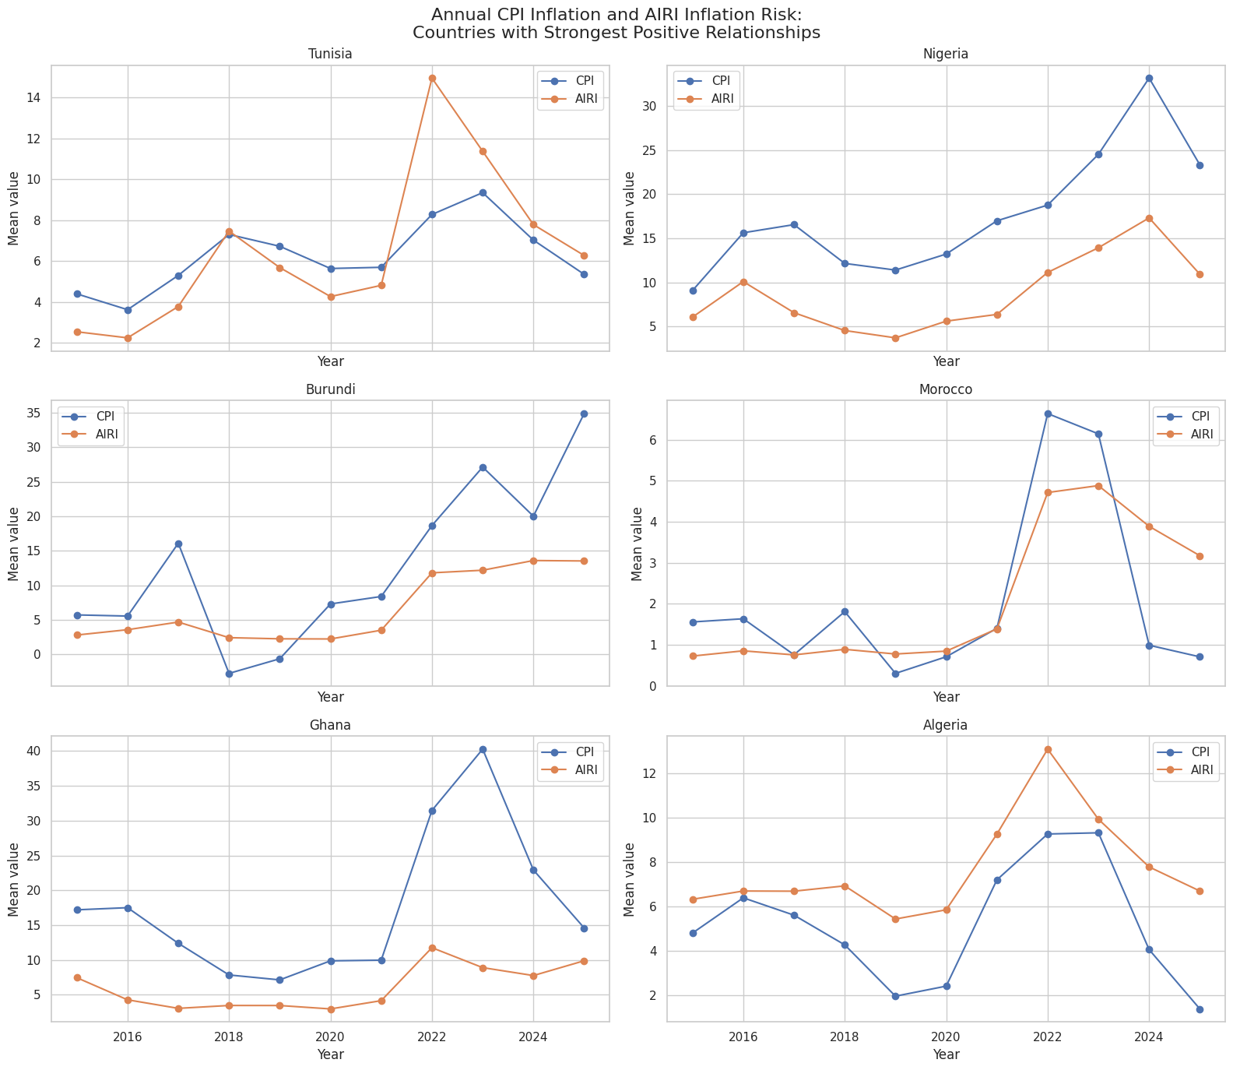
Figure 6a. Annual CPI inflation and AIRI risk for the six countries with the strongest AIRI–CPI relationship.
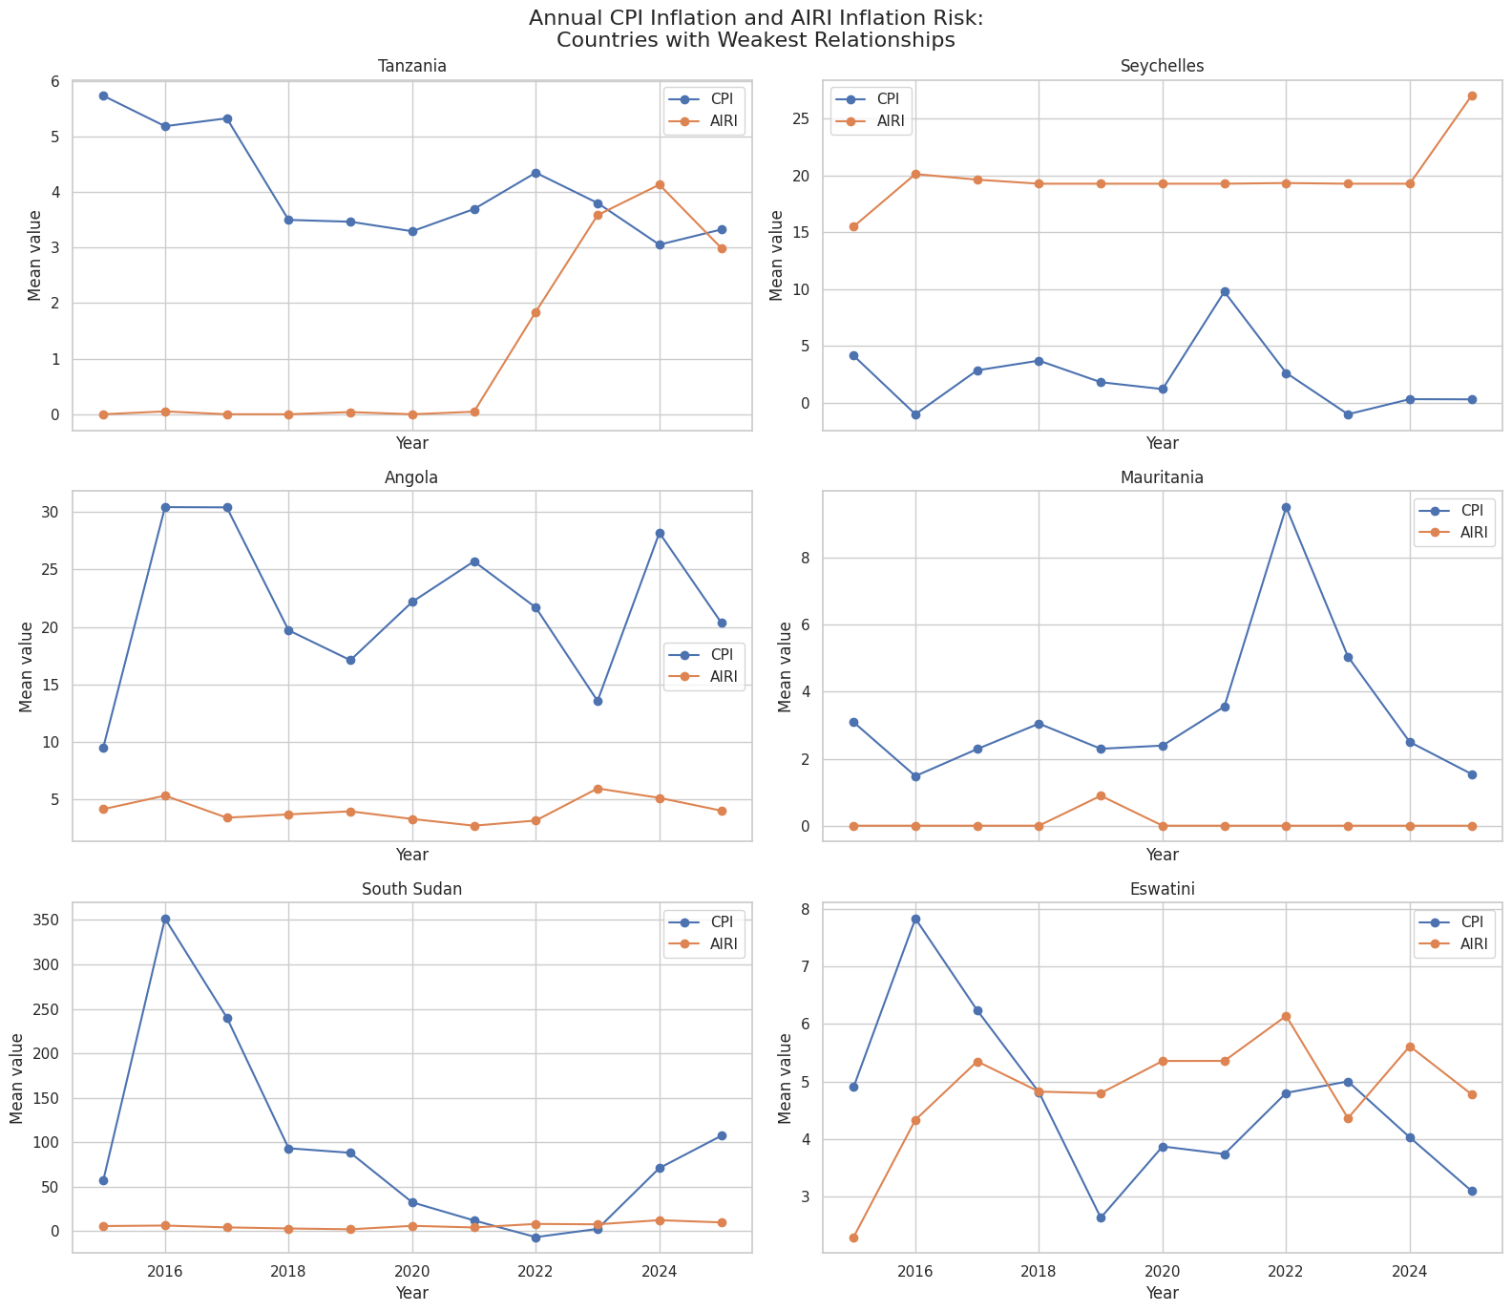
Figure 6b. Annual CPI inflation and AIRI risk for the six countries with the weakest AIRI–CPI relationship.
Contrasting the six strongest-relationship countries (Tunisia, Nigeria, Burundi, Morocco, Ghana, Algeria) with the six weakest (Tanzania, Seychelles, Angola, Mauritania, South Sudan, Eswatini) shows clearly where the aggregate correlation in Figure 1 comes from. In the strong-relationship countries, the two lines rise and fall together and share common turning points, most visibly around the 2022 spike. For example, Tunisia’s AIRI jumps to about 15 alongside CPI’s jump to about 8.4, and Algeria’s two series peak together in 2022 before declining together into 2025. In the weak-relationship countries, the series are effectively decoupled: in Mauritania and Tanzania, AIRI sits near zero for almost the whole sample regardless of what CPI is doing; in Seychelles, AIRI stays persistently high (18–20) while CPI oscillates mildly between about -1% and 10%; and in South Sudan, CPI swings wildly — from roughly 350% in 2016 down to near zero and back above 100% by 2025 — while AIRI barely registers any movement. This suggests AIRI behaves more like a slow-moving structural risk signal in some countries, one that can become almost uninformative, or even move independently of, realised inflation when that inflation is driven by idiosyncratic shocks, currency collapse, or conflict.

7. Shape of the AIRI–Inflation Relationship in the Top Countries
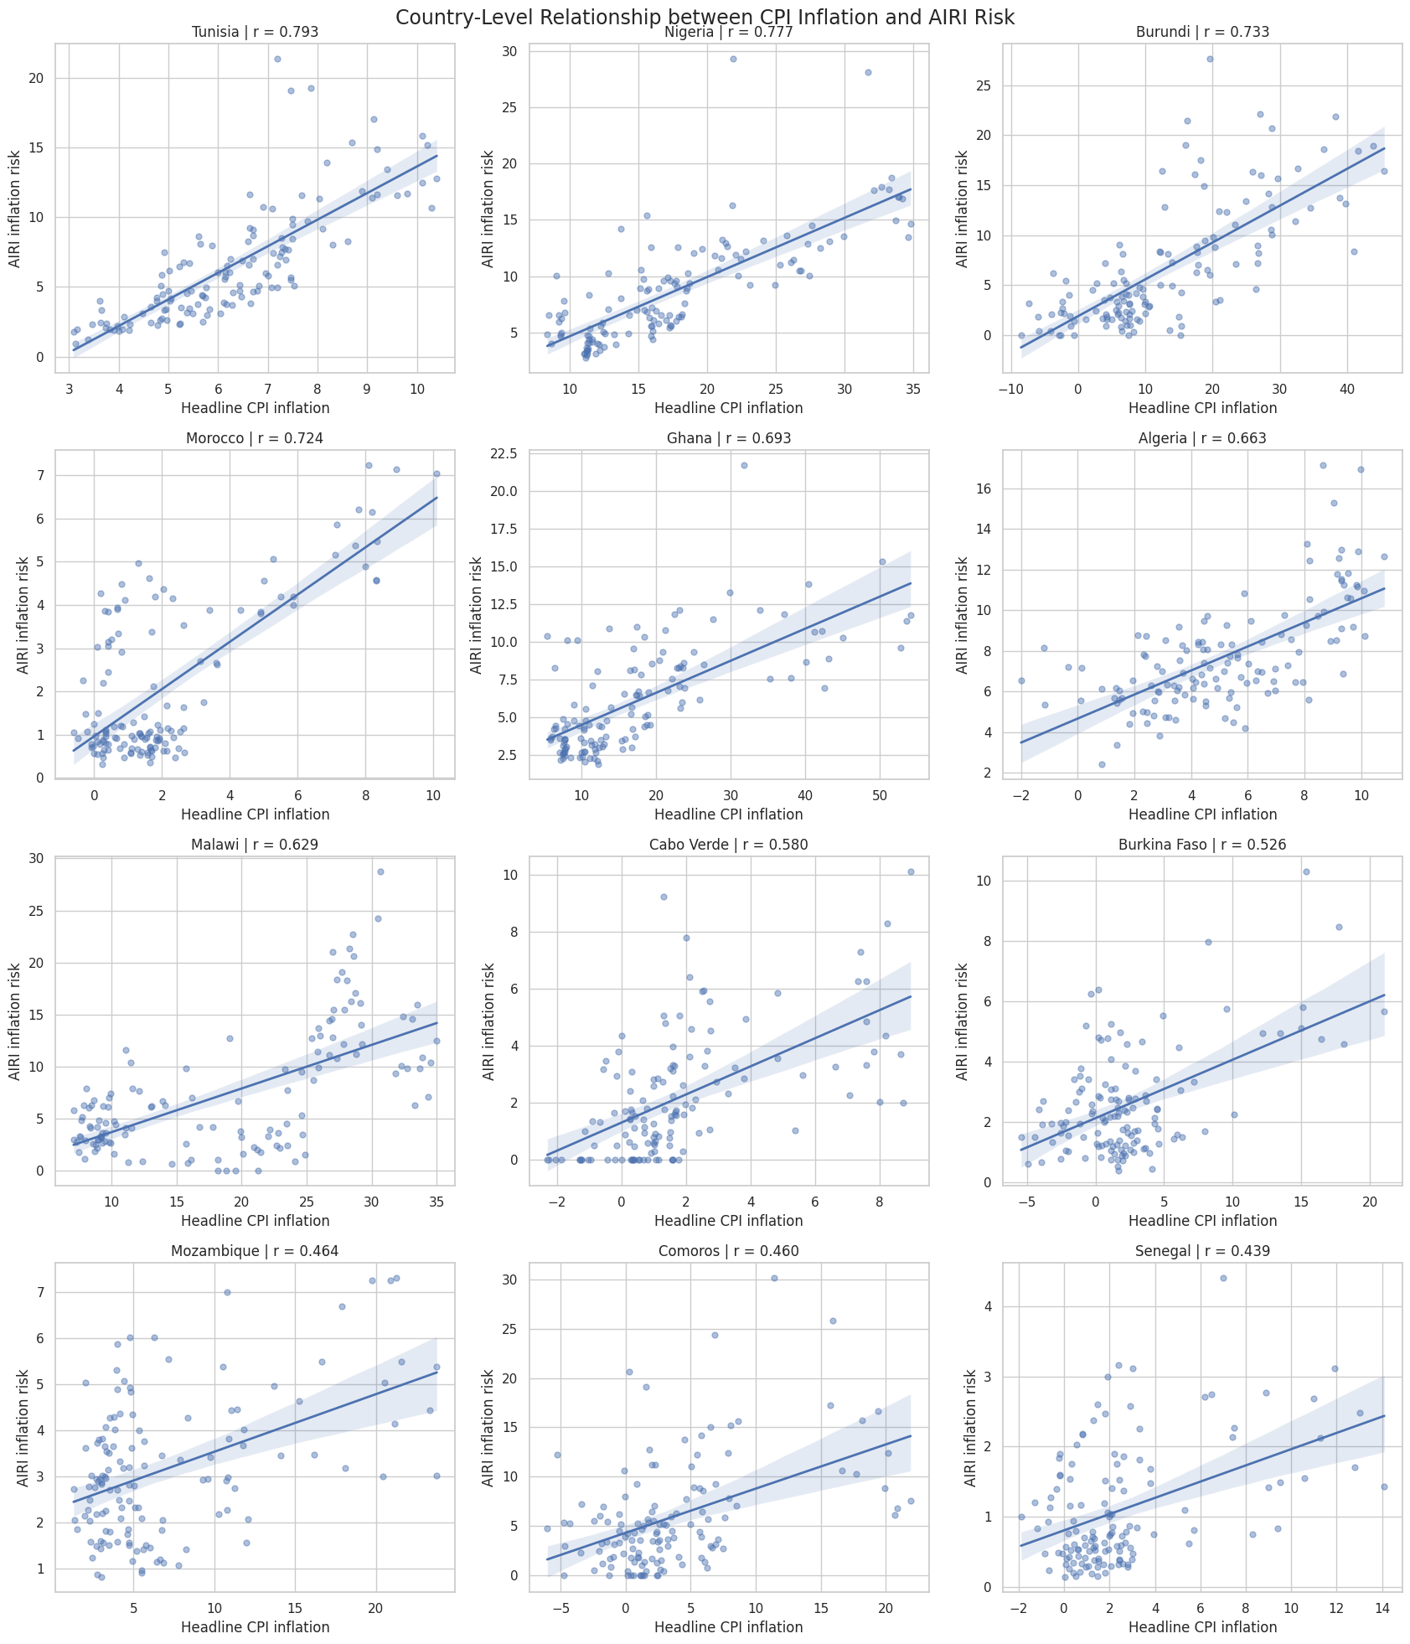
Figure 7. Country-level scatter plots of AIRI risk against headline CPI inflation, with fitted regression line, for the twelve countries with the strongest correlations.
Looking at the underlying scatter of monthly observations rather than the single correlation coefficient in Figure 1, shows that even the “top 12” countries differ in how reliable their relationship is. Tunisia, Nigeria and Morocco show a fairly linear, tightly banded relationship with narrow confidence bands around the fitted line, indicating a genuinely proportional co-movement. Others further down the ranking, such as Cabo Verde, Comoros and Senegal, show noisier clouds of points, often with many observations clustered near zero on both axes and only a handful of higher-inflation episodes pulling the regression line upward. This confirms that a “positive and significant” country correlation can reflect either a consistently proportional relationship or one driven mainly by a few extreme episodes within an otherwise flat pattern.

8. Volatility Comparison
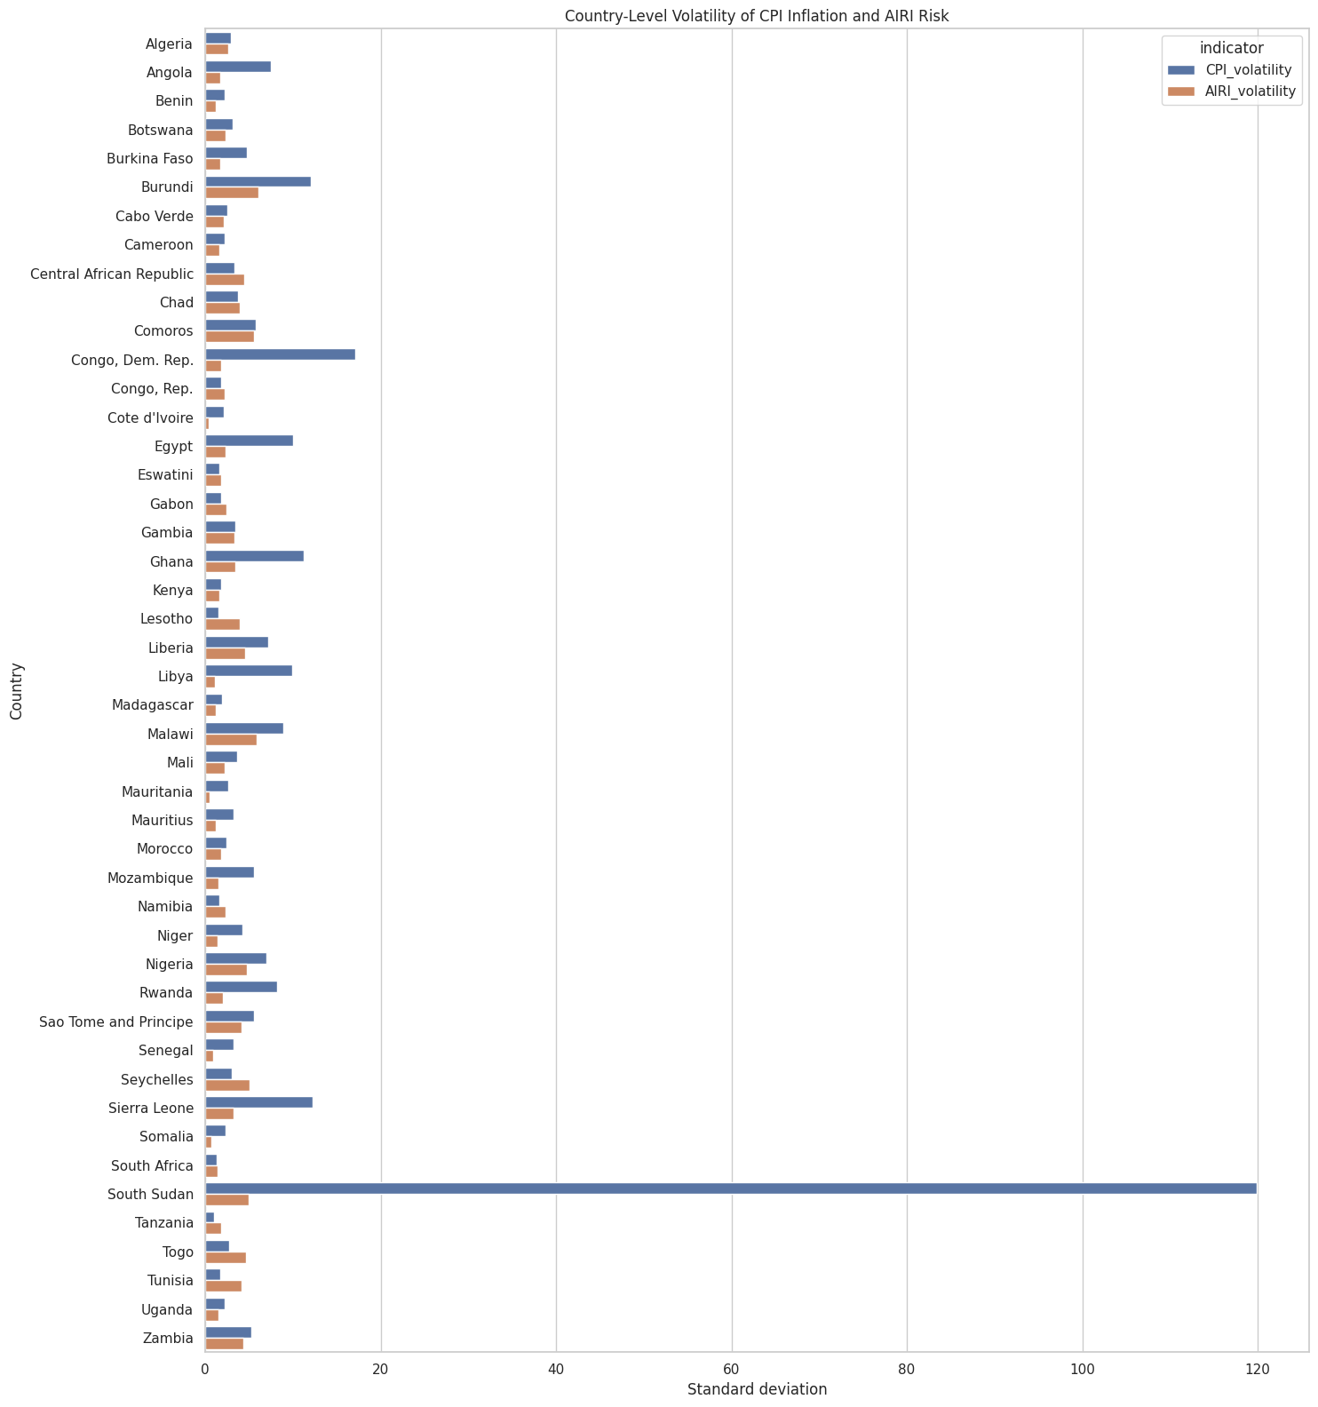
Figure 8. Country-level standard deviation (volatility) of headline CPI inflation versus AIRI inflation risk.
Ranking countries by the standard deviation of CPI inflation against that of AIRI risk shows that CPI inflation is, with virtually no exceptions, far more volatile than AIRI. The gap is most extreme for South Sudan, where CPI volatility (≈120) is more than twenty times AIRI volatility (≈5), but the same pattern holds for Congo (Dem. Rep.), Sierra Leone, Libya, Egypt, Ghana and Burundi as well. Because AIRI is a structurally smoother, lower-variance series than realised CPI inflation, it is mechanically unable to track the sharpest inflation swings even in countries where the two series are correlated on average, which is part of why even the strongest country correlations in Figure 1 still leave much of the variation in CPI unexplained.

9. Macroeconomic Correlation Matrix
 | m | delta_e | pi | airi_pi | g
m | 1.000 | 0.206 | 0.082 | -0.013 | -0.082
delta_e | 0.206 | 1.000 | 0.171 | 0.059 | -0.067
pi | 0.082 | 0.171 | 1.000 | 0.129 | -0.168
airi_pi | -0.013 | 0.059 | 0.129 | 1.000 | -0.048
g | -0.082 | -0.067 | -0.168 | -0.048 | 1.000
Figure 9. Pooled pairwise correlations between money growth (m), currency depreciation (delta_e), CPI inflation (pi), AIRI risk (airi_pi) and real GDP growth (g).
At the pooled macroeconomic level, money growth, currency depreciation, CPI inflation, AIRI risk and real GDP growth are all only weakly correlated with one another since no off-diagonal coefficient exceeds 0.21 in absolute value. Money growth and currency depreciation have the strongest pairwise link (0.206), consistent with standard monetary and exchange-rate channels of inflation, and inflation is negatively correlated with growth (-0.168), consistent with a growth–inflation trade-off. Notably, the correlation between AIRI inflation risk pillar and Headline CPI inflation at this pooled, cross-country level is only 0.129, which is much weaker than the 0.281 average correlation reported country-by-country in Figure 1.

10. Time-Varying (Rolling) Correlation
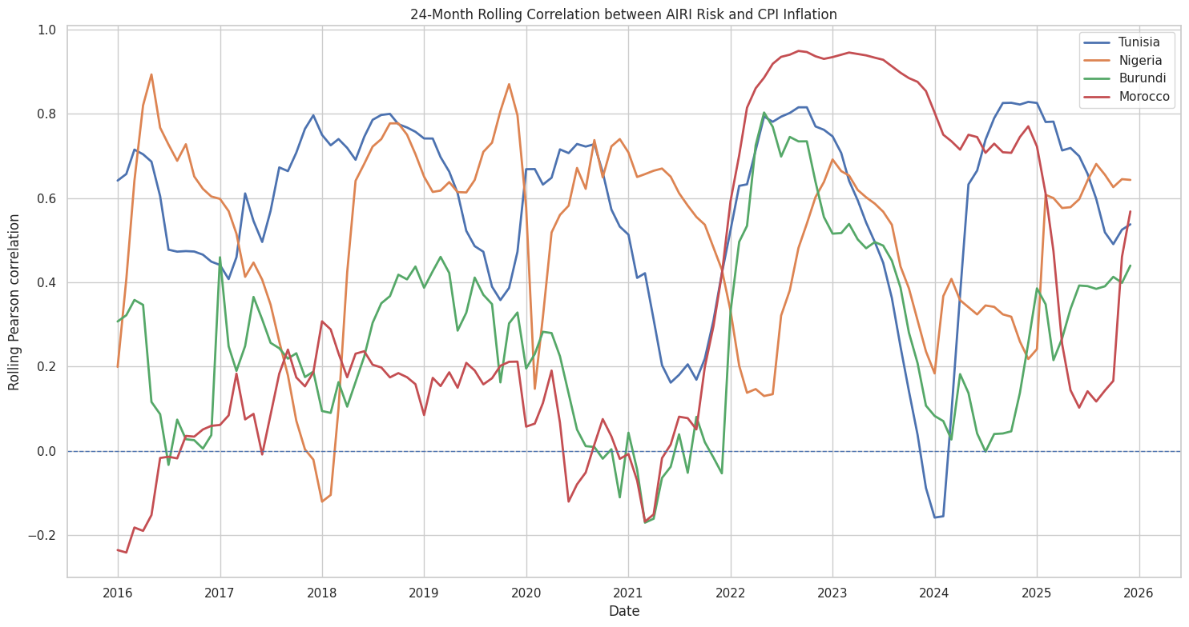
Figure 10. 24-month rolling Pearson correlation between AIRI risk and CPI inflation for Tunisia, Nigeria, Burundi and Morocco.
The rolling correlation shows that even for the four best-performing countries in the full-sample ranking, the AIRI–CPI relationship is far from stable through time. All four lines fluctuate substantially, occasionally swinging from above 0.8 to near zero or negative within a couple of years — Tunisia’s rolling correlation, for instance, falls to about -0.16 in 2024 before recovering above 0.8 by 2025. The clearest common feature is a broad convergence toward high correlation (roughly 0.7–0.95) during the 2022–2023 global inflation shock, when all four lines rise together; outside that window the countries behave much more idiosyncratically, at times differing from one another by 0.5 or more at the same point in time. This confirms that the AIRI–CPI relationship is regime-dependent: it strengthens markedly during large, common inflation shocks and weakens or becomes unstable in quieter periods.

11. Where AIRI Over- or Under-States Realised Inflation
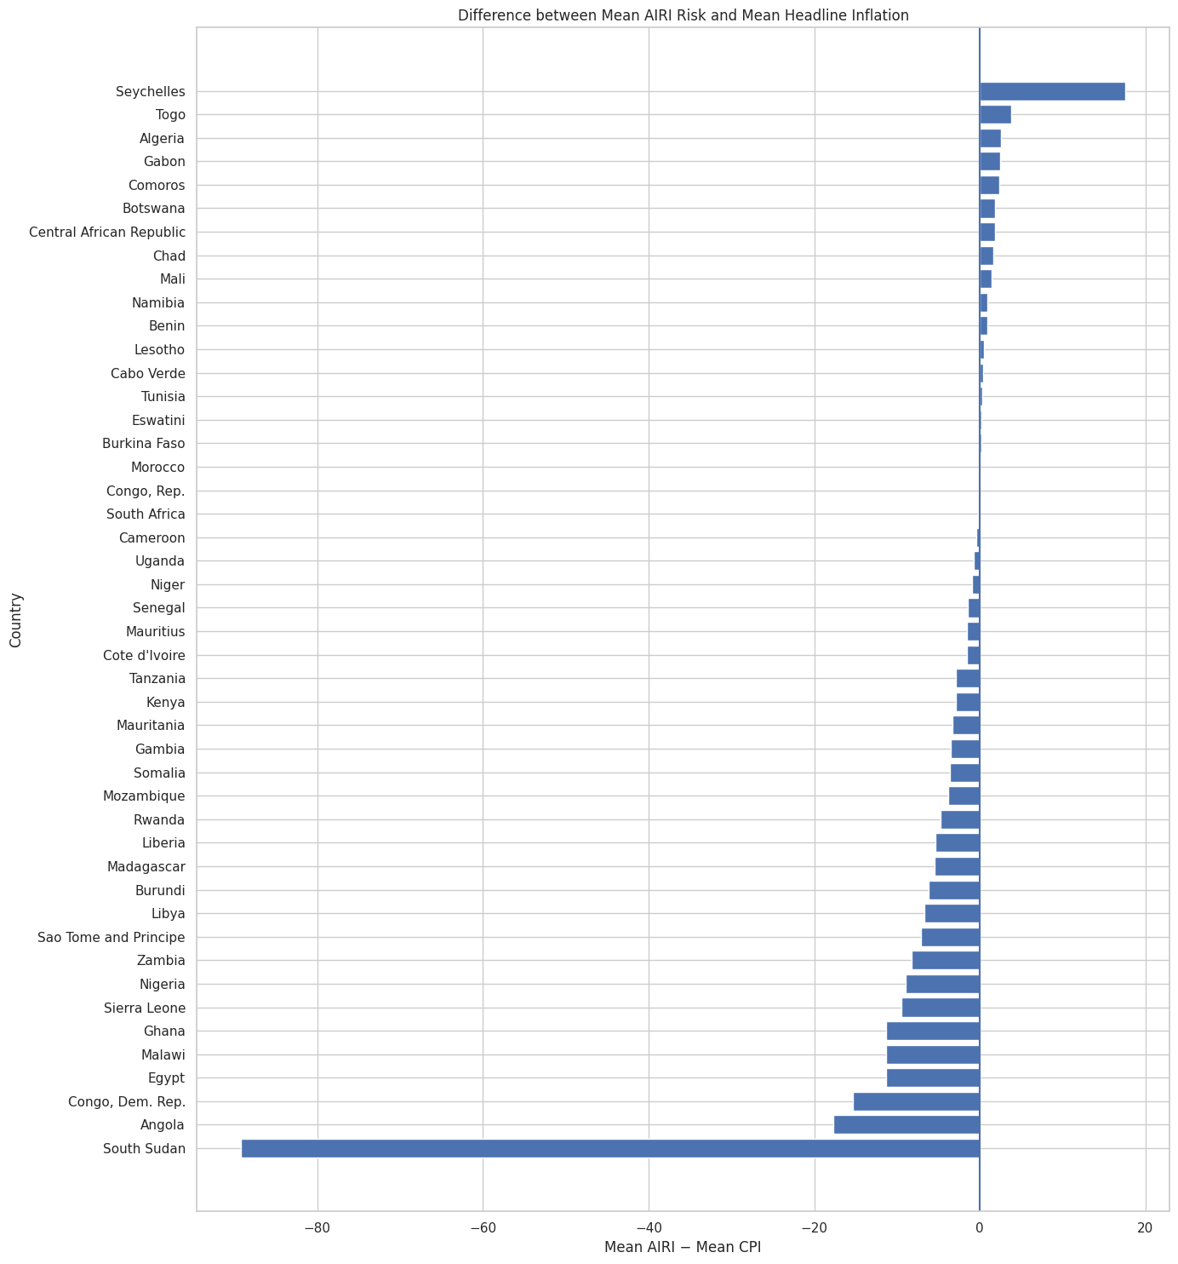
Figure 11. Difference between each country’s mean AIRI risk and its mean headline CPI inflation, ranked.
Ranking countries by the gap between mean AIRI risk and mean CPI inflation highlights differences in level, separately from the correlation results above. Seychelles is the only country where AIRI substantially overstates inflation relative to CPI, by roughly 18 points on average. At the other extreme, South Sudan, Angola, Congo (Dem. Rep.), Egypt, Malawi, Ghana and Sierra Leone all show AIRI running far below realised inflation, which is most dramatic in South Sudan, where the gap is about -90 points, reflecting hyperinflation episodes that the AIRI measure comes nowhere close to matching in scale. The majority of countries in the middle of the chart cluster close to zero, meaning AIRI and CPI are of a broadly similar order of magnitude in most “normal-inflation” economies, with the largest gaps concentrated in the same handful of extreme or crisis-affected countries that also stand out in Figures 2, 4 and 8.

12. Country-Level Summary
Metric | Value
Number of countries | 46
Average country-level Pearson correlation | 0.281
Median country-level Pearson correlation | 0.268
Countries with positive AIRI–CPI correlations | 38 (82.6%)
Countries with negative correlations | 8
Countries with statistically significant correlations (5%) | 32
Countries with strong positive correlations (r ≥ 0.50) | 9
Strongest positive relationship | Tunisia (r = 0.793)
Weakest relationship | Tanzania (r = -0.257)
Taken together, these headline statistics support an overall reading of the stylized facts above: AIRI carries genuine, statistically detectable signal about realised inflation in most economies (a positive relationship in 82.6% of countries, significant in 32 of 46), but that signal varies enormously in strength, is diluted once countries are pooled together, is structurally less volatile than realised inflation, and can weaken, become unstable over time, or break down entirely in a minority of countries with unusual inflation dynamics such as hyperinflation, currency crises, or conflict.

Panel VAR Methodology
To investigate whether the AIRI predicts realised inflation when other factors have been accounted for, we estimate a panel vector autoregressive model for all 46 countries in Africa. The Panel VAR captures the dynamic relationship between variables, considering all variables as endogenous. The estimation allows for the computation of the direction of the statistical relation through Granger causality. The response of realised inflation to changes in the AIRI will be computed by the Impulse Response Function (IRF).

Model Specification
Following Love and Zicchino (2006) and Canova and Ciccarelli (2013), the reduced-form Panel VAR of order $p$ is specified as:
$$Y_{n,t}=A_{0}\left(c\right)+\sum_{k=1}^{p}{A_{k}}Y_{n,t-k}+u_{n,t}$$
where $c=1,…,N$ indexes countries ($N=54$) and $t=1,…,T$ indexes monthly time periods (January 2015 to December 2025). $Y_{n,t}$ is the $5×1$ vector of endogenous variables:
$$Y_{n,t}={\left[\text{AIRI}π_{n,t},Δe_{n,t},m_{n,t},g_{n,t},π_{n,t}\right]}^{⊤}$$
where $\text{AIRI}π_{n,t}$ is the AIRI inflation pillar score for country $c$ at time $t$, scaled to the interval $\left[0,200\right]$ and normalised by total article volume, and $π_{n,t}$ is month-on-month headline CPI inflation. We identify other variables that have been tested in the literature to predict inflation, in order to account for factors that can influence realised inflation: $Δe_{n,t}$ is the month-on-month percentage change in the nominal exchange rate, local currency per USD (Razafimahefa 2012); $m_{n,t}$ is money supply (M2) growth (Okedigba et al. 2024; Alimi 2012); and $g_{n,t}$ is real GDP growth (Barnichon and Peiris 2007). All five variables are treated as endogenous, so each can respond to shocks in any of the others. $A_{0}\left(c\right)$ is a $5×1$ vector of country-specific intercepts, capturing the fact that countries differ in their average level of risk narrative and inflation regardless of dynamics. $A_{k}$ for $k=1,…,p$ are $5×5$ matrices of lag coefficients, and $u_{n,t}$ is the $5×1$ vector of reduced-form disturbances, with $E\left[u_{n,t}\right]=0$, $E\left[u_{n,t}u_{n,t}'\right]=Σ$, and $E\left[u_{n,t}u_{n,s}'\right]=0$ for $t≠s$.
Equation (11) imposes slope homogeneity: carries no country subscript, so the dynamic relationship among the five variables is assumed identical across all 46 countries, with only the intercept allowed to vary. Given the well-documented heterogeneity of inflation dynamics across Africa (Nsafoah, Dery, and Ilori 2025), this assumption is tested rather than taken for granted, following Pesaran and Smith (1995).$A_{k}A_{0}\left(c\right)$
We estimate two versions of equation (11). The first is a pooled fixed-effects Panel VAR: country intercepts are removed by within-group demeaning, and a single set of coefficients ${\hat{A}}^{FE}$ is estimated by OLS across the full panel.
The second is the Mean Group estimator (Pesaran and Smith 1995): a separate VAR of order is estimated by OLS for each of the 46 countries individually, and the coefficient matrices are averaged across countries:$p$
AkMG=N-1c​Akc
Mean Group places no restriction on $A_{k}$ across countries and remains consistent whether or not slope homogeneity holds, whereas the pooled fixed-effects estimator is consistent only if homogeneity holds.
The two sets of estimates are compared using the Hausman-type poolability test of Pesaran and Smith (1995):
$$H=\left({\hat{A}}^{MG}-{\hat{A}}^{FE}\right)'{\left[\text{Var}\left({\hat{A}}^{MG}\right)-\text{Var}\left({\hat{A}}^{FE}\right)\right]}^{-1}\left({\hat{A}}^{MG}-{\hat{A}}^{FE}\right)$$
which is asymptotically $χ^{2}$ distributed under the null of slope homogeneity. Rejecting the null indicates that the pooled coefficients are inconsistent and that the country-specific dynamics captured by Mean Group should be used for inference, including the causality test in Section 3.2.3, which relies directly on country-by-country coefficient variation.
Table 3: Variable Definitions and Data Sources
Variable | Definition | Source
$$\text{AIRI}π\left(c,t\right)$$ | AIRI inflation pillar score, country $c$, month $t$. Normalised by total article volume; scale 0–200 | Akande et al. (forthcoming)
$$π\left(c,t\right)$$ | Month-on-month headline CPI inflation (%) | IMF International Financial Statistics
$$Δe\left(c,t\right)$$ | Month-on-month change in nominal exchange rate, local currency/USD (%) | IMF International Financial Statistics
$$g\left(c,t\right)$$ | Real GDP growth (%) | World Bank WDI / IMF WEO
$$m\left(c,t\right)$$ | Money supply (M2) growth (%) | IMF International Financial Statistics

Pre-Estimation Diagnostics
Before estimation, each variable is tested for stationarity using the Im, Pesaran, and Shin (2003) panel unit root test, which allows the autoregressive coefficient to vary across countries and is therefore appropriate given the heterogeneity documented across the panel (Kelikume 2018; Phiri 2016). Where a series is non-stationary in levels, first differences are used and long-run relationships are assessed with the Westerlund (2007) panel cointegration test.
Cross-sectional dependence is tested using the Pesaran (2004) CD test, applied to the residuals of the estimated Panel VAR rather than to each variable’s raw univariate autoregression, so that the test reflects dependence remaining after the model’s own dynamics have been accounted for.

Granger Causality
To test whether AIRI statistically precedes inflation, a Granger causality test is carried out. The null hypothesis of non-causality from $\text{AIRI}π$ to $π$ is:
$$H_{0}:A_{k}\left[\text{AIRI}π→π\right]=0 \text{for all }k=1,…,p$$
Given the cross-country heterogeneity already established, the Dumitrescu and Hurlin (2012) test is used rather than a pooled panel Granger test, since a pooled test would impose a common causal coefficient across all 46 countries and understate the relationship in countries where it is in fact strong. The test computes a country-specific Wald statistic for each country and averages them:$W^{c}$
W=N-1c​Wc
Its standardised form is asymptotically standard normal under the null of homogeneous non-causality as $N,T→∞$. Rejecting the null establishes that AIRI carries predictive information for inflation beyond inflation’s own history—the paper’s central empirical claim, and one that does not depend on any of the identifying assumptions in Section 3.2.4.

Impulse Response Function (IRF) Analysis
Granger causality establishes whether AIRI predicts inflation, but not the size or duration of that relationship. Impulse Response Functions are used to trace the path of inflation following a one-time shock to AIRI (Canova and Ciccarelli 2013).
Because the reduced-form residuals $u_{n,t}$ are correlated across the five equations, a shock cannot be isolated to one variable without first imposing a causal ordering. A Cholesky decomposition of the error covariance matrix $Σ$ is used for this purpose (Love and Zicchino 2006), under the ordering:
$$Y_{n,t}={\left[\text{AIRI}π_{n,t},Δe_{n,t},m_{n,t},π_{n,t},g_{n,t}\right]}^{⊤}$$
This ordering reflects the speed with which each variable can plausibly respond within a given month: news-based sentiment ($\text{AIRI}π$) adjusts fastest and is unconstrained by administrative reporting; the exchange rate reprices within the day; money supply can adjust within the reporting month; headline inflation is released reasonably quickly (monthly CPI); and GDP growth is compiled last, with the longest lag and most revisions of the five. GDP growth is therefore allowed to respond contemporaneously to all four other variables, but a shock to GDP growth only feeds back into them with at least a one-month delay.
To ensure that the result is not an artefact of the ordering, we reverse the order to test for robustness:
$$Y_{n,t}^{alt}={\left[Δe_{n,t},m_{n,t},g_{n,t},π_{n,t},\text{AIRI}π_{n,t}\right]}^{⊤}$$
Structural IRFs are traced over $h∈\{1,2,…,12\}$ months, with 95% confidence bands constructed using panel-style block bootstrapping with 1,000 replications (Abrigo and Love 2016), which resamples whole country time series to preserve cross-sectional and temporal dependence.

Forecast Evaluation
This section seeks to establish the forecasting value of the AIRI inflation pillar. This is achieved through an out-of-sample forecast evaluation to test whether including the AIRI inflation pillar in a benchmark model improves forecast accuracy relative to benchmark models.
The forecast evaluation is structured around a nested model comparison. Three panel regression models are specified, each adding one additional layer of information. This enables us to trace any improvement in forecast accuracy to the specific change implemented in the new model, moving from the AR benchmark to a model that includes the AIRI inflation pillar.
The AR benchmark follows the proposition of Stock and Watson (1999) and Atkeson and Ohanian (2001) that the naïve method of forecasting inflation from its own past values is difficult to outperform, and should serve as the standard that any meaningful model must supersede. The model is specified as:
$$π_{c,t+h}=α_{c}+\sum_{i=1}^{p}{γ_{i}}π_{c,t-i}+λ_{t}+ε_{c,t+h}$$
where $π_{c,t+h}$ is inflation in country $c$ at horizon $h$ months ahead, $α_{c}$ denotes country fixed effects, $λ_{t}$ denotes time fixed effects, $p$ is the optimal lag length selected by the Bayesian Information Criterion, and $ε_{c,t+h}$ is the error term.
The macro benchmark extends Model 0 by incorporating a standard set of macroeconomic control variables—the nominal exchange rate, money supply, and GDP growth—known to influence inflation dynamics in African economies (A. D. M. Nguyen et al. 2017; Alper, Hobdari, and Uppal 2016):
$$π_{c,t+h}=α_{c}+\sum_{i=1}^{p}{γ_{i}}π_{c,t-i}+\sum_{j=1}^{J}{δ_{j}}X_{j,c,t}+λ_{t}+ε_{c,t+h}$$
where $X_{j,c,t}$ denotes the $j$-th macroeconomic control variable observed at time $t$ and $δ_{j}$ is its coefficient.
The AIRI model further augments Model 1 with the AIRI inflation pillar:
$$π_{c,t+h}=α_{c}+\sum_{i=1}^{p}{γ_{i}}π_{c,t-i}+\sum_{j=1}^{J}{δ_{j}}X_{j,c,t}+β⋅{\text{AIRI}}_{c,t}+λ_{t}+ε_{c,t+h}$$
where ${\text{AIRI}}_{c,t}$ is the AIRI inflation pillar observed at time $t$ and $β$ is the key coefficient capturing the incremental predictive contribution of AIRI for future inflation after conditioning on inflation persistence and the standard macroeconomic information set. A positive and statistically significant $β$ indicates that the AIRI inflation pillar contains genuine predictive information beyond what conventional macroeconomic variables already provide.
All three models are estimated separately at forecast horizons $h∈\{1,3,6,12\}$ months using a recursive expanding window, in which the estimation sample expands forward through time at each forecast origin—a design that mirrors the information set available to a real-time forecaster (Stock and Watson 1999).
Forecast accuracy is evaluated using the Root Mean Squared Error (RMSE).
RMSEm=1Ttestt∈Ttest​πc,t+h-πc,t+hm2

Also, the Clark–West MSFE-adjusted statistic was employed. This approach accounts for the sampling noise generated by the nested model. Because Model 2 nests Model 1, the standard Diebold–Mariano test is biased against detecting genuine forecast improvements in nested comparisons (Clark and West 2007). The Clark–West MSFE-adjusted statistic is therefore used as the primary test:
$${\hat{d}}_{t}={\left(π_{c,t+h}-{\hat{π}}_{c,t+h}^{1}\right)}^{2}-\left[{\left(π_{c,t+h}-{\hat{π}}_{c,t+h}^{2}\right)}^{2}-{\left({\hat{π}}_{c,t+h}^{1}-{\hat{π}}_{c,t+h}^{2}\right)}^{2}\right]$$
$$CW=\frac{\overset{‾}{d}}{{\hat{σ}}_{d}/\sqrt{T_{test}}}$$
The null is rejected if $CW>1.645$ at the 5 per cent significance level.

Results and Discussion
Pre evaluation test
To determine the most appropriate unit root test for checking the stationarity in our data, a Cross sectional dependence (CD) test was first carried out on the data to check if individual countries show any co-movement due to regional similarities and shared exposures. The test involves the consideration of the correlation coefficient between individual countries’ residuals (Pesaran, 2004). This is essential because the Im-Pesaran-Shin panel (IPS) unit root test assumes that each country’s process is unrelated to the others, however, neighboring African countries have similar exposures to shocks such as oil price and they are more likely to move together in situations of such shocks.
Under the null hypothesis of zero cross dependence (γᵢ = 0), the CD test is carried out at the 5% 2-sided nominal significance level; the null is rejected if the CD statistic is greater than 1.96
Table 4: Pesaran Cross-Sectional Dependence (CD) Test Results
Variable | RAW: CD stat | RAW: p | CD Present
Inflation (π) | 82.3 | 0.000 | yes
AIRI Pillar | 84.1 | 0.000 | yes
GDP Growth | 120.0 | 0.000 | yes
Money Growth | 21.1 | 0.000 | yes
FX Growth | 78.4 | 0.000 | yes

The panel exhibits significant cross-sectional dependence (Pesaran, 2004/2021). Ignoring this can severely bias standard panel unit root tests, because O'Connell (1998) shows that failing to control for cross-sectional dependence can inflate the level of significance as seen in O'Connell (1998). We therefore supplement the standard IPS test (Im, Pesaran & Shin, 2003) with the cross-sectionally augmented IPS test (CIPS; Pesaran, 2007).
CIPS builds each country's Dickey-Fuller regression using the country's own past values, but also the average of all countries in the panel at each point in time. This average accounts for common shocks the countries are exposed to. The computed CIPS statistic is compared to the Pesaran ( 2007) critical value. If the CIPS statistic is more negative than the critical value then the series is stationary. For our panel (46 countries, 131 months), the relevant critical values from Pesaran's tables are approximately -2.11 at the 5% level and -2.23 at the 1% level. The IPS test was also done for robustness, in this case, the p-value is the indicator of stationarity.

Table 5: IPS and CIPS Panel Unit Root Test Results
Variable | IPS | IPS p value | CIPS | 1% threshold (-2.23)?
Inflation (π) | -10.8 | 0.000 | -2.29 | YES | Stationary
AIRI Pillar | -12.4 | 0.000 | -4.40 | YES | Stationary
GDP Growth | -13.5 | 0.000 | -3.01 | YES | Stationary
Money Growth | -48.2 | 0.000 | -5.73 | YES | Stationary
FX Growth | -47.6 | 0.000 | -5.84 | YES | Stationary
Tables 4 and 5 show that both tests agree, indicating that the existence of cross-sectional dependence between countries doesn’t affect the stationarity of our series.
Panel VAR Result
Lag Selection
Before estimating the panel VAR, a common lag order was selected for the countries. We ran a separate var selection for the three criteria; Akaike Information Criterion (AIC), Hannan–Quinn Criterion (HQ), and Schwarz Criterion / Bayesian Information Criterion (SC/BIC). SC/BIC showed the strongest, most consistent agreement across countries, recommending lag 2 for 83% of the countries.
Table 6: Lag Selection Criteria (AIC, HQ, SC/BIC)
Criterion | Modal lag
AIC | 6 (24/46, 52%)
HQ | 3 (36/46, 78%)
SC / BIC | 2 (38/46, 83%)
Mean group Panel Result
We selected the Mean Group Panel VAR approach to account for the uniqueness of context across African countries. Pesaran et al. (1995) proposed that forcing a single coefficient on heterogeneous contexts results in biased conclusions. The Mean Group approach runs the regression separately for each country, allowing the coefficient to vary by the uniqueness of each country, then averages the resulting coefficients. African economies exhibit substantial heterogeneity in inflation experience. In the present sample, headline inflation ranges from 1.15% in Benin to 95.71% in South Sudan; there are countries like South Africa with 4.8% and Angola with 21.8%. Also, media coverage, which forms the base for the AIRI, varies across countries. Nguyen et al. (2015) shows that country-specific characteristics, such as oil and food import dependence, exposure to weather shocks, importance of agriculture, and others shape how inflationary shocks transmit within a given African economy. Hence, a justification for the approach. The result is as follows.

Table 7: Mean Group Panel VAR Results — Inflation Equation
Predictor | Estimate | P value
Inflation (lag 1) | 1.160 | 0.000
Inflation (lag 2) | -0.231 | 0.000
Intercept | 0.213 | 0.038
AIRI (lag 1) | 0.0801 | 0.040
GDP Growth (lag 1) | -0.117 | 0.048
Exchange Rate Growth (lag 1) | 0.0357 | 0.058
GDP Growth (lag 2) | 0.0889 | 0.086
Exchange Rate Growth (lag 2) | 0.0198 | 0.171
Money Growth (lag 1) | -0.00845 | 0.496
AIRI Inflation Pillar (lag 2) | -0.00777 | 0.604
Money Growth (lag 2) | -0.000392 | 0.974
The result shows that AIRI is a leading indicator of inflation at lag one even after controlling for inflation’s persistence. A one unit increase in the AIRI is associated with 0.08 percentage point increase in next period inflation at 5% level of significance. This suggests that AIRI is a valid real time alternative to the mainstream macroeconomic variables whose reporting lag is usually large. The result aligns with the burgeoning literature that demonstrates that news based information contains predictive information for macroeconomic variables as shown in Baker, Bloom, and Davis (2016) and Goshima et al. (2020)
Table 8: Panel Granger Causality Test Results
Sample | N | Z-bar | p-value | Sig. (5%)?
Full Panel | 46 | 3.199 | 0.001 | Yes
Hight inflation | 23 | 3.547 | 0.000 | yes
LOW inflation | 23 | 0.977 | 0.329 | No
Also, the panel Granger causality test rejects the null hypothesis that AIRI does not Granger-cause inflation for the full sample (Z-bar = 3.199, p = 0.001), confirming that AIRI carries predictive information for inflation. Splitting the panel by inflation regime reveals that this result is different across country groups: in HIGH-inflation economies, the null is rejected while in LOW-inflation economies it cannot be rejected. This asymmetry indicates that AIRI's predictive relationship with inflation is concentrated in countries experiencing higher inflation. This confirms the state-dependence mechanism documented by Coibion and Gorodnichenko (2015), explaining that the rate at which economic agents update their expectations and react to information signals depends on the state of the economy; suggesting that agents in low-inflation economies are less likely to have frequent news reports about inflation compared to areas where it is persistent.
The impulse response function traces the dynamic effect of a shock to AIRI on inflation. The result shows that the effect on inflation starts from horizon one and peaks 0.419 at horizon 5 and starts to decay, also, the result stayed significant until horizon 12 and retains 76% of its peak magnitude, 0.319. This indicates that the AIRI produces a persistent effect on inflation. Therefore, not only does AIRI predict inflation, the magnitude of the predictive relation builds over several months.

Table 9: Impulse Response Function (IRF) Results
Horizon | (IRF) | All sig. h≥1?
0 | 0.027 | No
1 | 0.287 | Yes
2 | 0.318 | Yes
3 | 0.401 | Yes
4 | 0.410 | Yes
5 | 0.419 | Yes
6 | 0.415 | Yes
7 | 0.405 | Yes
8 | 0.389 | Yes
9 | 0.372 | Yes
10 | 0.355 | Yes
11 | 0.337 | Yes
12 | 0.319 | Yes

Forecast Evaluation
The Clark-West test was prioritized because of the nested nature of our forecast model. Clark and West (2005) proposed that the MSPE (Mean Squared Prediction Error) adds to the forecast error of larger models because additional variables introduce noise.
Table 10: Out-of-Sample Forecast Evaluation
Horizon | M0/M2 CW stat | P value | M1/M2 CW stat | P value | RMSE M0 | RMSE M1 | RMSE M2
1 | 2.637 | 0.0042 | 2.955 | 0.002 | 5.960 | 5.961 | 5.950
3 | 2.095 | 0.0181 | 2.532 | 0.006 | 8.632 | 8.494 | 8.500
6 | 1.701 | 0.0445 | 1.955 | 0.025 | 12.648 | 12.408 | 12.409
12 | 0.783 | 0.2168 | 1.005 | 0.157 | 18.537 | 17.993 | 18.009
The Clark-West asked the question is model M2 better than M0 and is M2 better than M1. Table 10 shows that AIRI plus other macroeconomic variables model (M2) is better than the baseline model AR model and M1 (forecast model including inflation lag and macroeconomic variables) up to a 6-month horizon at the 5% level of significance. Also, For robustness the RMSEs were compared for the models, as expected, the impact was marginal. The forecast error declines against the baseline comparing M0 to M2 across all time horizons, however, comparing the M1 to the M2 showed only an improvement in forecast error at horizon 1.

Conclusion
The level of inflation is a critical metric that feeds into economic planning, not only because it concerns welfare but because economic expansions sponsored by investment activities largely depend on policymakers' ability to control inflation. Data availability and timeliness influence the effectiveness of policymaking. African economies are frequently exposed to inflation shocks, yet conventional inflation predictors are constrained by reporting lags and data limitations that leave policymakers reacting to price pressures only after they have already materialized.
This paper proposes an index, the African Inflation Risk Index (AIRI), that identifies inflation risk leveraging on indications in news media across African countries. Desirable qualities of this index include its timeliness, transparency, and auditability. Statistical tests were carried out to investigate the predictability of the AIRI index.
The empirical results support AIRI's value as a leading indicator. The Mean Group Panel VAR, adopted specifically to accommodate the heterogeneity in African economies, found that AIRI's first lag is a statistically significant predictor of next-period inflation even after controlling for inflation's own persistence, exchange rate growth, GDP growth, and money growth. This result is consistent with a growing literature demonstrating that news-based indicators have macroeconomic information.
Panel Granger causality tests corroborated this finding, rejecting the null hypothesis that AIRI does not Granger-cause inflation. Splitting the panel by inflation regime revealed that this predictive relationship is not uniform: it is significant in high-inflation economies, but cannot be statistically distinguished from zero in low-inflation economies. The impulse response function result also effect on inflation starts from horizon one and peaks 0.419 at horizon 5 and starts to decay, also, the result stayed significant until horizon 12 and retains 76% of its peak magnitude, 0.319.For the out-of-sample forecast evaluation, using the Clark-West test appropriate given the nested structure of the competing models, found that AIRI significantly improves inflation forecasts at horizons of up to six month.
From the statististical proofs we see that the AIRI index is a useful alternative to mainstream inflation predictors

Abrigo, Michael R. M., and Inessa Love. 2016. “Estimation of Panel Vector Autoregression in Stata.” The Stata Journal 16 (3): 778–804.
Ahir, Hites, Nicholas Bloom, and Davide Furceri. 2018. “The World Uncertainty Index.” IMF Working Paper WP/18/315. International Monetary Fund.
Alimi, Santos R. 2012. “The Quantity Theory of Money and Its Long-Run Implications: Empirical Evidence from Nigeria.” European Scientific Journal 8 (12).
Allard, Marc-Antoine, Paul Teiletche, and Adam Zinebi. 2024. “Enhancing Inflation Nowcasting with LLM: Sentiment Analysis on News.” https://arxiv.org/abs/2410.20198.
Alper, C. Emre, Niko A. Hobdari, and Ali Uppal. 2016. “Food Inflation in Sub-Saharan Africa: Causes and Policy Implications.” IMF Working Paper 16/247. International Monetary Fund.
Angelico, Cristina, Juri Marcucci, Marcello Miccoli, and Filippo Quarta. 2022. “Can We Measure Inflation Expectations Using Twitter?” Journal of Econometrics 228 (2): 259–77.
Araujo, Gustavo S., and Wagner P. Gaglianone. 2023. “Machine Learning Methods for Inflation Forecasting in Brazil: New Contenders Versus Classical Models.” Latin American Journal of Central Banking 4 (2): 100087.
Atkeson, Andrew, and Lee E. Ohanian. 2001. “Are Phillips Curves Useful for Forecasting Inflation?” Federal Reserve Bank of Minneapolis Quarterly Review 25 (1): 2–11.
Baker, Scott R., Nicholas Bloom, and Steven J. Davis. 2016. “Measuring Economic Policy Uncertainty.” Quarterly Journal of Economics 131 (4): 1593–1636.
Barbaglia, Luca, Sergio Consoli, and Sebastiano Manzan. 2023. “Forecasting with Economic News.” Journal of Business & Economic Statistics 41 (3): 708–19.
Barnichon, Régis, and Shanaka J. Peiris. 2007. “Sources of Inflation in Sub-Saharan Africa.” IMF Working Paper WP/07/32. International Monetary Fund.
Bernanke, Ben S., Jean Boivin, and Piotr Eliasz. 2005. “Measuring the Effects of Monetary Policy: A Factor-Augmented Vector Autoregressive (FAVAR) Approach.” Quarterly Journal of Economics 120 (1): 387–422.
Blanchard, Olivier, and Danny Quah. 1989. “The Dynamic Effects of Aggregate Demand and Supply Disturbances.” American Economic Review 79 (4): 655–73.
Blinder, Alan S., Michael Ehrmann, Jakob De Haan, and David-Jan Jansen. 2024. “Central Bank Communication with the General Public: Promise or False Hope?” Journal of Economic Literature 62 (2): 425–57.
Buell, Bryce, Reda Cherif, Chuling Chen, Karl Walentin, Jiaqi Tang, and Nils Wendt. 2021. “Impact of COVID-19: Nowcasting and Big Data to Track Economic Activity in Sub-Saharan Africa.” IMF Working Paper WP/21/124. International Monetary Fund.
Canova, Fabio, and Matteo Ciccarelli. 2013. “Panel Vector Autoregressive Models: A Survey.” Advances in Econometrics 31: 205–46.
Carroll, Christopher D. 2003. “Macroeconomic Expectations of Households and Professional Forecasters.” Quarterly Journal of Economics 118 (1): 269–98.
Central Bank of Nigeria. 2025. “Inflation Expectation Survey Report.” Central Bank of Nigeria.
Chakraborty, Chiranjit, and Andreas Joseph. 2017. “Machine Learning at Central Banks.” Bank of England Staff Working Paper 674. Bank of England.
Choudhary, M. Ali, and Adnan Haider. 2012. “Neural Network Models for Inflation Forecasting: An Appraisal.” Applied Economics 44 (20): 2631–35.
Clark, Todd E., and Kenneth D. West. 2007. “Approximately Normal Tests for Equal Predictive Accuracy in Nested Models.” Journal of Econometrics 138 (1): 291–311.
Coibion, Olivier, Dimitris Georgarakos, Yuriy Gorodnichenko, and Maarten van Rooij. 2023. “How Does Consumption Respond to News about Inflation? Field Evidence from a Randomized Control Trial.” American Economic Journal: Macroeconomics 15 (3): 109–52.
Coibion, Olivier, and Yuriy Gorodnichenko. 2012. “What Can Survey Forecasts Tell Us about Information Rigidities?” Journal of Political Economy 120 (1): 116–59.
———. 2015. “Information Rigidity and the Expectations Formation Process: A Simple Framework and New Facts.” American Economic Review 105 (8): 2644–78.
Cooley, Thomas F., and Stephen F. LeRoy. 1985. “Atheoretical Macroeconometrics: A Critique.” Journal of Monetary Economics 16 (3): 283–308.
D’Acunto, Francesco, Yuriy Gorodnichenko, Olivier Coibion, and Michael Weber. 2022. “The Subjective Inflation Expectations of Households and Firms: Measurement, Determinants, and Implications.” Journal of Economic Perspectives 36 (3): 157–84.
Deb, Pragyan, Julia Estefania-Flores, Melih Firat, Davide Furceri, and Siddharth Kothari. 2023. “Monetary Policy Transmission Heterogeneity: Cross-Country Evidence.” IMF Working Paper WP/23/204. International Monetary Fund.
Dumitrescu, Elena-Ivona, and Christophe Hurlin. 2012. “Testing for Granger Non-Causality in Heterogeneous Panels.” Economic Modelling 29 (4): 1450–60.
Durevall, Dick, and Bo Sjö. 2012. “The Dynamics of Inflation in Ethiopia and Kenya.” IMF Working Paper WP/12/105. International Monetary Fund.
Elshendy, Mahmoud, and Andrea Fronzetti Colladon. 2017. “Big Data Analysis of Economic News: Hints to Forecast Macroeconomic Indicators.” International Journal of Engineering Business Management 9.
Friedman, Milton. 1968. “The Role of Monetary Policy.” American Economic Review 58 (1): 1–17.
Galí, Jordi, and Mark Gertler. 1999. “Inflation Dynamics: A Structural Econometric Analysis.” Journal of Monetary Economics 44 (2): 195–222.
García, Diego. 2013. “Sentiment During Recessions.” Journal of Finance 68 (3): 1267–1300.
Gentzkow, Matthew, Bryan Kelly, and Matt Taddy. 2019. “Text as Data.” Journal of Economic Literature 57 (3): 535–74.
Goshima, Kenji, Hideyuki Ishijima, Mototsugu Shintani, and Hiroki Yamamoto. 2020. “Forecasting Japanese Inflation with a News-Based Leading Indicator of Economic Activities.” Studies in Nonlinear Dynamics & Econometrics.
Im, Kyung So, M. Hashem Pesaran, and Yongcheol Shin. 2003. “Testing for Unit Roots in Heterogeneous Panels.” Journal of Econometrics 115 (1): 53–74.
Jerven, Morten. 2013. Poor Numbers: How We Are Misled by African Development Statistics and What to Do about It. Cornell University Press.
Kasekende, Elizabeth, Michael Atingi-Ego, and Dick Durevall. 2018. “Monetary Policy Transmission in Sub-Saharan Africa: A Cross-Country Review.” IMF Working Paper. International Monetary Fund, African Department.
Kelikume, Ikechukwu. 2018. “An Estimation of Inflation Threshold for Africa.” International Journal of Management, Economics and Social Sciences 7 (4): 283–300.
Keynes, John Maynard. 1936. The General Theory of Employment, Interest and Money. Macmillan.
Knight, Frank H. 1921. Risk, Uncertainty, and Profit. Houghton Mifflin.
Larsen, Vegard H., Leif Anders Thorsrud, and Julia Zhulanova. 2021. “News-Driven Inflation Expectations and Information Rigidities.” Journal of Monetary Economics 117: 507–20.
Litterman, Robert B. 1986. “Forecasting with Bayesian Vector Autoregressions—Five Years of Experience.” Journal of Business and Economic Statistics 4 (1): 25–38.
Love, Inessa, and Lea Zicchino. 2006. “Financial Development and Dynamic Investment Behavior: Evidence from Panel VAR.” The Quarterly Review of Economics and Finance 46 (2): 190–210.
Malope, B. M., R. Chifurira, T. Zewotir, and K. Chinhamu. 2026. “Dynamic Interactions Among Exchange Rates, Price Stability, and Financial Flows in African Economies: Panel VAR Analysis.” Frontiers in Applied Mathematics and Statistics 12: 1803306.
Mankiw, N. Gregory, and Ricardo Reis. 2002. “Sticky Information Versus Sticky Prices: A Proposal to Replace the New Keynesian Phillips Curve.” Quarterly Journal of Economics 117 (4): 1295–1328.
Medeiros, Marcelo C., Gabriel F. R. Vasconcelos, Álvaro Veiga, and Eduardo Zilberman. 2021. “Forecasting Inflation in a Data-Rich Environment: The Benefits of Machine Learning Methods.” Journal of Business and Economic Statistics 39 (1): 98–119.
Mishkin, Frederic S. 2007. “Inflation Dynamics.” International Finance 10 (3): 317–34.
Nakamura, Emi. 2005. “Inflation Forecasting Using a Neural Network.” Economics Letters 86 (3): 373–78.
Nguyen, Anh D. M., Jemma Dridi, Filiz D. Unsal, and Oral Williams. 2017. “On the Drivers of Inflation in Sub-Saharan Africa.” International Economics 151: 71–84.
Nguyen, D. P., D. T. V. Duc, N. M. Trang, V. Q. Ket, and N. A. Hoang. 2025. “Sentiment Index as a Predictor of CPI: A Lexicon-Based Approach Using Economic News Data in Vietnam.” Journal of Open Innovation: Technology, Market, and Complexity 11: 100620.
Nsafoah, Dennis, Cosmas Dery, and Ayobami E. Ilori. 2025. “Revisiting the Drivers of Inflation in Sub-Saharan Africa After COVID-19.” Empirical Economics 68 (3): 1073–1112.
Nyman, Rickard, Sujit Kapadia, and David Tuckett. 2021. “News and Narratives in Financial Systems: Exploiting Big Data for Systemic Risk Assessment.” Journal of Economic Dynamics and Control 127: 104119.
O’Connell, Paul G. J. 1998. “The Overvaluation of Purchasing Power Parity.” Journal of International Economics 44 (1): 1–19.
Odu, Ada Tony, Umaru Aminu, and Nuhu Ado. 2024. “New Evidence from the Monetary Policy Communication and Inflation Expectations Nexus in Africa.” Scientific African 23: e01993.
Okedigba, D. O., A. A. Akintola, A. Umaru, Q. E. Mcdonald, E. M. Inusa, B. O. Fashoro, I. M. Etudaiye, R. Joshua, and F. N. Osagu. 2024. “Exploring Sub-Saharan Africa’s Money Supply-Inflation Nexus: A GARCH-MIDAS Approach.” Scientific African 23: e02111.
Olamide, Ebenezer, Kanayo Ogujiuba, and Andrew Maredza. 2022. “Exchange Rate Volatility, Inflation and Economic Growth in Developing Countries: Panel Data Evidence from SADC.” Economies 10 (3): 67.
Orphanides, Athanasios. 2001. “Monetary Policy Rules Based on Real-Time Data.” American Economic Review 91 (4): 964–85.
Pesaran, M. Hashem. 2004. “General Diagnostic Tests for Cross Section Dependence in Panels.” CESifo Working Paper 1229. CESifo.
Pesaran, M. Hashem. 2007. “A Simple Panel Unit Root Test in the Presence of Cross-Section Dependence.” Journal of Applied Econometrics 22 (2): 265–312.
Pesaran, M. Hashem, and Ron Smith. 1995. “Estimating Long-Run Relationships from Dynamic Heterogeneous Panels.” Journal of Econometrics 68 (1): 79–113.
Pfäuti, Oliver. 2023. “The Inflation Attention Threshold and Inflation Surges.” https://arxiv.org/abs/2308.09480.
Phelps, Edmund S. 1968. “Money-Wage Dynamics and Labour-Market Equilibrium.” Journal of Political Economy 76 (4): 678–711.
Phillips, A. W. 1958. “The Relationship Between Unemployment and the Rate of Change of Money Wage Rates in the United Kingdom, 1861–1957.” Economica 25 (100): 283–99.
Phiri, Andrew. 2016. “Inflation Persistence in African Countries: Does Inflation Targeting Matter?” Economics and Business Letters 5 (3): 65–71.
Razafimahefa, Ivohasina F. 2012. “Exchange Rate Pass-Through in Sub-Saharan African Economies and Its Determinants.” IMF Working Paper 12/141. International Monetary Fund.
Salisu, Afees, Sulaiman Salisu, and Subair Salisu. 2024. “A News-Based Economic Policy Uncertainty Index for Nigeria.” Quality & Quantity 58 (5): 4987–5002.
Samuelson, Paul A., and Robert M. Solow. 1960. “Analytical Aspects of Anti-Inflation Policy.” American Economic Review 50 (2): 177–94.
Shapiro, Adam Hale, Moritz Sudhof, and Daniel J. Wilson. 2020. “Measuring News Sentiment.” Working Paper Series 2017-1. Federal Reserve Bank of San Francisco.
———. 2022. “Measuring News Sentiment.” Journal of Econometrics 228 (2): 221–43.
Shiller, Robert J. 2017. “Narrative Economics.” American Economic Review 107 (4): 967–1004.
Sims, Christopher A. 1980. “Macroeconomics and Reality.” Econometrica 48 (1): 1–48.
———. 2003. “Implications of Rational Inattention.” Journal of Monetary Economics 50 (3): 665–90.
Stock, James H., and Mark W. Watson. 1999. “Forecasting Inflation.” Journal of Monetary Economics 44 (2): 293–335.
———. 2001. “Vector Autoregressions.” Journal of Economic Perspectives 15 (4): 101–15.
———. 2007. “Why Has US Inflation Become Harder to Forecast?” Journal of Money, Credit and Banking 39 (1): 3–33.
Tetlock, Paul C. 2007. “Giving Content to Investor Sentiment: The Role of Media in the Stock Market.” Journal of Finance 62 (3): 1139–68.
Thomas, Lloyd B. 1999. “Survey Measures of Expected U.S. Inflation.” Journal of Economic Perspectives 13 (4): 125–44.
Westerlund, Joakim. 2007. “Testing for Error Correction in Panel Data.” Oxford Bulletin of Economics and Statistics 69 (6): 709–48.
Yeboah, Samuel Duku, Samuel Kwaku Agyei, and David Korsah. 2025. “Nexus Between Geopolitical Uncertainty and Inflation Rates in Emerging Economies in Sub-Saharan Africa.” Research in Globalization 11: 100289.

