Race Work

Michael Samuel

January 28, 2019

### * All-Cause age-adjusted death rates have been decreasing for all race/ethnic groups in recent years (and for maany decades prior).

### * The decrease has been proportionally most rapid for Afircan Americans

### * Nevertheless, this death rate is higher for African Americans across all year-periods

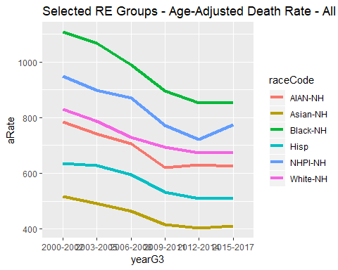

### * This shows the ratio of the death rate of African Americans to whites (the largest group), and shows the rate among African Americans is proportionally decreasing more rapidly than the white rate

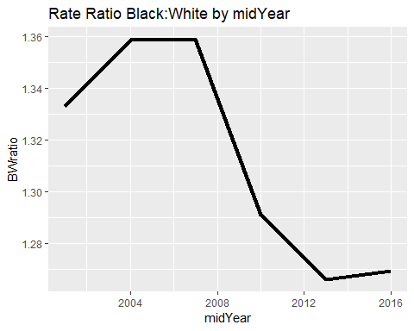

### * Nevertheless, the Black rate is higher than all other groups

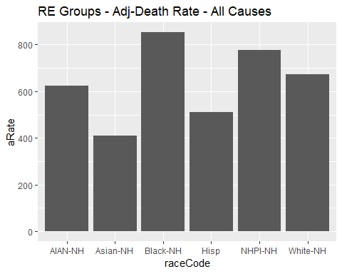

### * The rate is higher for blacks “total”“, and for black females and males. This higher rate is statitcally significant

## raceCode sex Ndeaths pop aRate aLCI aUCI  
## 1 AIAN-NH Female 1825 263300 576.2 549.3 604.4  
## 2 Asian-NH Female 37490 8288000 346.8 343.3 350.4  
## 3 Black-NH Female 27890 3413000 716.7 708.1 725.3  
## 4 Hisp Female 66710 22950000 427.4 424.1 430.8  
## 5 NHPI-NH Female 1341 218800 694.2 656.3 734.0  
## 6 White-NH Female 239700 22550000 573.6 571.2 576.1  
## 7 AIAN-NH Male 1952 260300 670.1 639.9 701.5  
## 8 Asian-NH Male 37620 7445000 491.2 486.2 496.2  
## 9 Black-NH Male 30980 3342000 1015.0 1003.0 1026.0  
## 10 Hisp Male 81200 23400000 609.8 605.2 614.4  
## 11 NHPI-NH Male 1481 216100 864.1 817.9 912.4  
## 12 White-NH Male 243500 22450000 786.0 782.8 789.2  
## 13 AIAN-NH Total 3777 523600 624.1 603.8 645.0  
## 14 Asian-NH Total 75110 15730000 409.5 406.5 412.5  
## 15 Black-NH Total 58870 6755000 853.2 846.2 860.3  
## 16 Hisp Total 147900 46350000 511.1 508.4 513.9  
## 17 NHPI-NH Total 2822 435000 775.6 745.9 806.2  
## 18 White-NH Total 483200 45010000 672.3 670.3 674.3

### * Looking at trends in age-adjust Years of Life Lost, the patterns are similary, but the differnece are even greater, since Blacks are differentially impacted by conditions with death at young age (e.g. homicide)

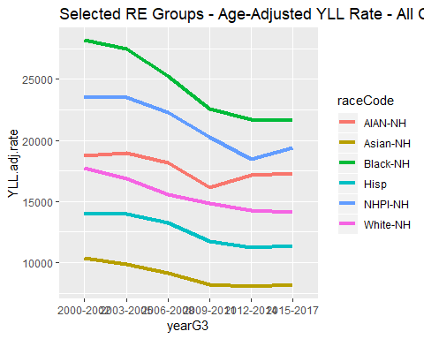

workX <- full_join(t.workA,tX,by="nameOnly")  
write_csv(workX,"raceWorkExploreAA.csv", na ="")