Abstract
This dataset is a collection of 1-m resolution mean radiant temperature (Tmrt) rasters generated using digital surface models and the Solar and longwave environmental irradiance geometry (SOLWEIG) model. The dataset provides hourly Tmrt covering Maricopa County, Arizona (USA) metropolitan area for one of the hottest days in the summer of 2024 (June 6, 2024, peak air temperature of 41.9 ℃) from 07:00 hrs to 20:00 hrs (Mountain Standard Time). The dataset is divided to cover these sub-spatial extents Maricopa Central (Anthem ,Carefree ,Cave Creek ,Paradise Valley, Phoenix ,Scottsdale ,Tempe) ; Maricopa East (Chandler ,Fountain Hills ,Gilbert ,Mesa ,Queen Creek ,Rio Verde ,Sun Lakes) ; Maricopa West (Avondale, Buckeye, Citrus Park, El Mirage, Glendale, Goodyear, Litchfield Park, Peoria, Sun City, Sun City West, Surprise, Wickenburg, Youngtown).The dataset can serve as a guide for heat mitigation programs within the area and as input for heat exposure studies.
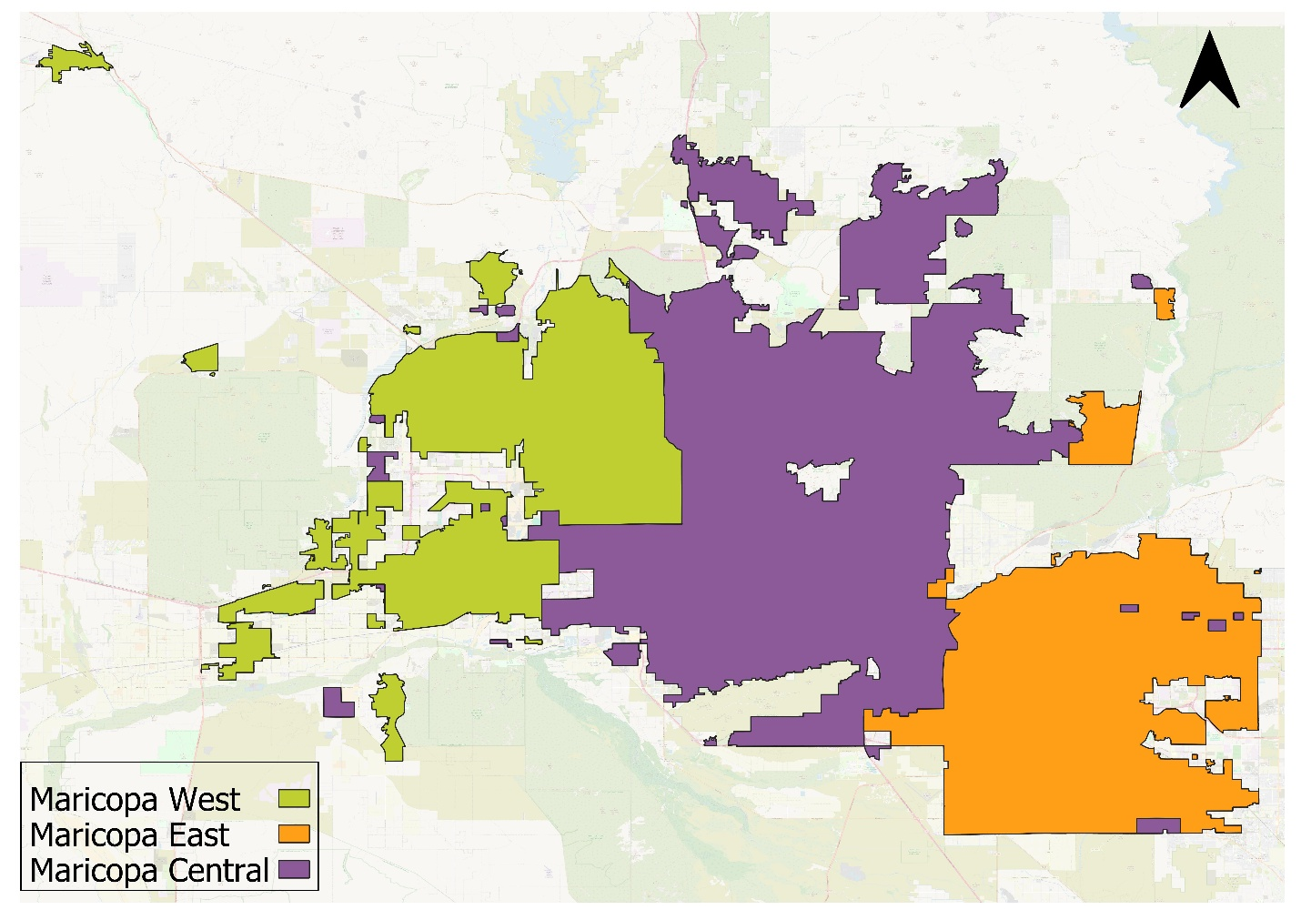

Methodology
We used the SOLWEIG model to estimate Mean Radiant Temperature (MRT). SOLWEIG requires three surface models — a Digital Elevation Model (DEM), a Building Surface Model (BSM), and a Canopy Digital Surface Model (CDSM) — along with meteorological forcing data. The surface models were generated from high-resolution LiDAR Point Cloud (LPC) data obtained from the USGS. Meteorological inputs, including air temperature, wind speed, relative humidity, and solar radiation, were sourced from the Phoenix Encanto weather station which is part of the AZMet network.
The DEM was derived from ground points only, while the BSM was generated by masking a full surface model with building footprints from Microsoft. Non-building areas were filled with DEM values. The CDSM was created by subtracting the DEM from the full surface model for non-building pixels, with building pixels set to zero. All pixels with canopy heights less than or equal to 1.3 m were also set to zero, as they were not considered vegetation canopy. Direct and diffuse shortwave radiation components were estimated within SOLWEIG.

