Abstract
This dataset is a collection of 1-m resolution Mean Radiant Temperature (Tmrt) and shade raster files generated using digital surface models and the Solar and LongWave Environmental Irradiance Geometry (SOLWEIG) model. The dataset provides hourly Tmrt and shade estimates from 07:00 to 20:00 Mountain Standard Time for three Phoenix Area Social Survey (PASS) neighborhood areas in metropolitan Phoenix, Arizona, identified as 711, W15, and U18. The data cover 15 clear-sky days across five months in 2025, with three selected days per month from May through September, representing the transition into, during, and out of the summer heat season.
For each selected day and hour, the dataset includes both Tmrt and shade raster files, with the shade raster files representing shade from buildings and vegetation. Because the PASS neighborhood boundaries are irregular, each neighborhood area was enclosed within a bounding box. These boxes were further expanded using a 5 km buffer to enable analysis of different route types originating within the neighborhoods and extending to destinations outside them. The raster data cover these buffered regions. Neighborhood boundary maps are provided with this dataset so that they can be used to extract MRT or shade data for just the neighborhoods.
This dataset extends prior 1-m Tmrt raster products for Maricopa County by adding multi-day seasonal coverage and paired shade information at the neighborhood scale. It can support studies of pedestrian heat exposure, neighborhood-scale heat vulnerability, tree and building shade benefits, and the design and evaluation of urban heat mitigation strategies.

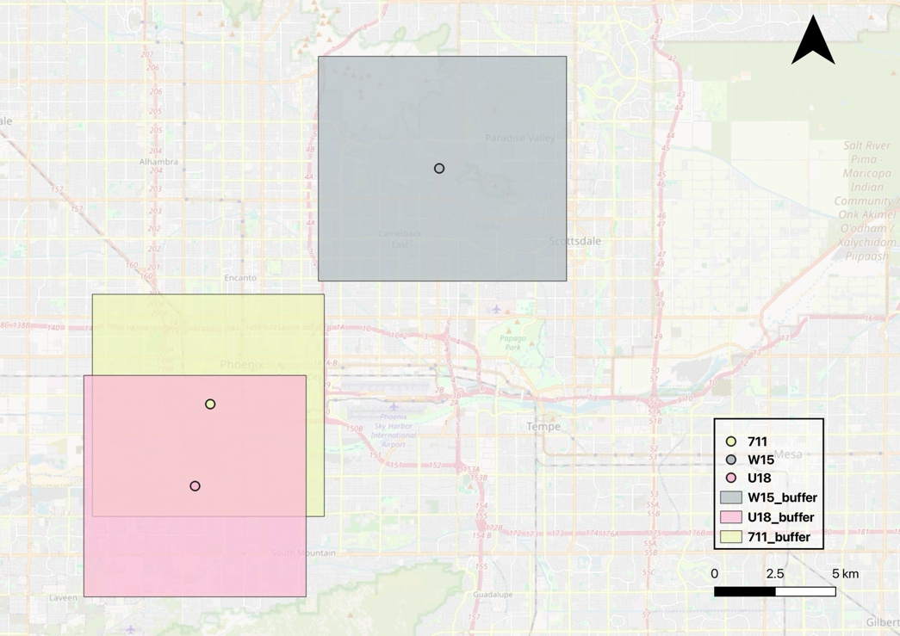

Methodology
We used the SOLWEIG model to estimate Mean Radiant Temperature (MRT). SOLWEIG requires three surface models — a Digital Elevation Model (DEM), a Building Surface Model (BSM), and a Canopy Digital Surface Model (CDSM) — along with meteorological forcing data. The surface models were generated from high-resolution LiDAR Point Cloud (LPC) data obtained from the USGS. Meteorological inputs, including air temperature, wind speed, relative humidity, and solar radiation, were sourced from the Phoenix Encanto weather station which is part of the AZMet network.
The DEM was derived from ground points only, while the BSM was generated by masking a full surface model with building footprints from Microsoft. Non-building areas were filled with DEM values. The CDSM was created by subtracting the DEM from the full surface model for non-building pixels, with building pixels set to zero. All pixels with canopy heights less than or equal to 1.3 m were also set to zero, as they were not considered vegetation canopy. Direct and diffuse shortwave radiation components were estimated within SOLWEIG.
For each selected date and hour, SOLWEIG was used to generate 1-m resolution Tmrt rasters and corresponding shade rasters. The shade rasters represent areas shaded by buildings and vegetation canopy.
The dataset covers five months from May through September 2025. For each month, three clear-sky days were selected to represent the early, middle, and late portions of the month, resulting in 15 selected days. For each selected day, hourly outputs were generated from 07:00 to 20:00 Mountain Standard Time. The dates can be found in the following table.

Month | Dates
May | 6, 15, 25
June | 5, 15, 25
July | 5, 14, 26
August | 4, 16, 29
September | 6, 15, 24

https://globalfutures.asu.edu/caplter/wp-content/uploads/sites/33/2024/08/PASS2021report_final-1.pdf

