This document will cover a step by step process of setting up and configuring the local environment used to develop the Community Lifeline Ministries website. *Note: links and paths in this guide will be enclosed in square brackets and italicized.*

The following software packages will be required:

* PHPStorm (Version: 2018.2.3 (build 182.4323.68))
  + It is available from here: [<https://www.jetbrains.com/phpstorm/>] the student edition is free with a Lewis University email.
* XAMPP (Version: Control Panel v3.2.2)
  + This is a stack software solution which provides the Apache web server and MySQL for a local environment. It is available here: [<https://www.apachefriends.org/index.html>]

Before we jump into the install process let me give a quick overview of the expected process. You can use this as a checklist to ensure you did everything.

* **Install XAMPP** - *(Preferably to the root C drive on windows)*
* **Install PHPStorm**
* **Clone/Pull Git Repository** [[*https://github.com/CAPSTONE-2018/community-lifeline-ministries*](https://github.com/CAPSTONE-2018/community-lifeline-ministries)]
* **Configure PHPStorm project settings**
* **Configure and setup our local database**
* **Create a database connection in PHPStorm**
* **Load the database with our developer data**
* **Fire up the project and ensure we can Login**
  + *Local Username: admin*
  + *Local Password: admin*

1. **Install XAMPP**

First download and install the XAMPP package available here, [[*https://www.apachefriends.org/index.html*](https://www.apachefriends.org/index.html)]. When installing, make sure you install it to [*C:/xampp*] If you do not install it to this path then you may run into read and write permission issues.

1. **Install PHPStorm**

This is a typical install, select any path you want and follow the prompts. Once it is installed you will be presented with a dialog asking you to select your settings. I personally selected the dark theme and then clicked skip/use defaults for everything else.

1. **Clone/Pull Git Repository** [[*https://github.com/CAPSTONE-2018/community-lifeline-ministries*](https://github.com/CAPSTONE-2018/community-lifeline-ministries)]

Since this is a website and we will be hosting it locally for development we need to create our repository in a specific location. However, we need to prepare that location first. Navigate to your XAMPP install, it should be [*C:/xampp/htdocs*], then gut the folder, deleting everything inside it.

Once [*C:/xamp/htdocs*] is empty, open PHPStorm, you should be presented with this screen.

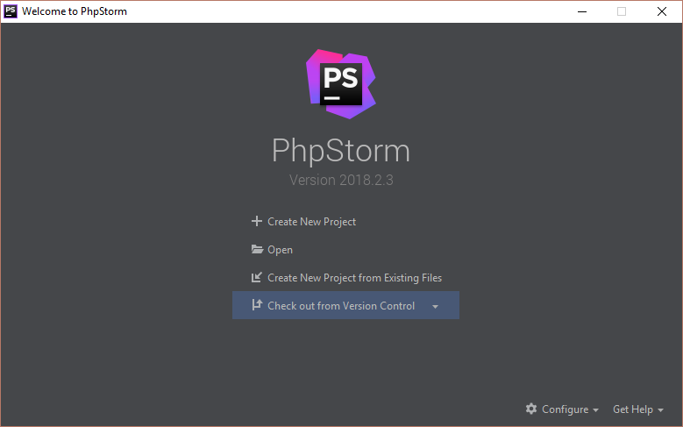

Select, “Check out from version control” and then select “Git”. On the next dialog there should be an option to log into your GitHub account, I suggest that you do, but you do not have to. By logging in you will be able to use PHPStorms build in Git repository management tools, you can also login at a later time. Anyway, on the clone dialog page enter the repository address in the URL field [[*https://github.com/CAPSTONE-2018/community-lifeline-ministries*](https://github.com/CAPSTONE-2018/community-lifeline-ministries)] and for the Directory field enter [*C:\xampp\htdocs\CLM*]. (Shown below). Then click “Clone”

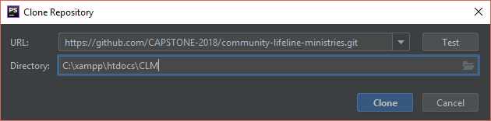

*\*\* Note: there are a few absolute paths currently (10/7/2018) in the project which require that directory path to be* [*C:\xampp\htdocs\community-lifeline-ministries*] *but since the end goal is to ensure all paths are relative I have reamed it to help catch those errors. Ideally once we are complete you can name that folder anything as everything will be relative.*

1. **Configure PHPStorm project settings**

Now you should be in the PHPStorm IDE, time to configure the settings. Go to “File”, then “Settings”. In the settings dialog that opened, go to “Languages & Frameworks”, then “PHP”. In this tab, next to the field “CLI Interpreter” click the ellipses “…”, we need to add an interpreter. In the “CLI Interpreters” dialog, click the little plus “+” in the top-left corner, then “Local path to interpreter”. Fill it out as shown below. In the name field I chose “PHP from XAMPP”, in the “PHP executable” field put the path to the php.exe which in the php folder in you XAMPP install; if you have followed along it is [*C:\xampp\php\php.exe*]. Hit “Apply” and “OK”.

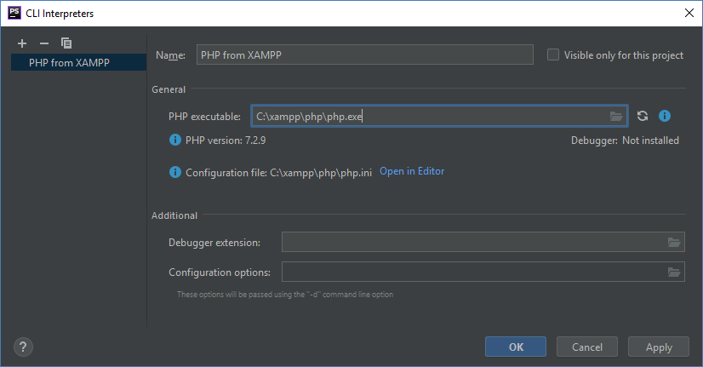

Now that the PHP settings are configured we have to address the project build settings. Back in the “Settings” dialog, navigate to “Build, Execution, Deployment”. In that tab, go to Deployment and then the small plus sign “+”. The “Add Server” dialog should appear. For the name I chose “XAMPP Apache” and for Type select “Local or mounted folder”, click “OK”

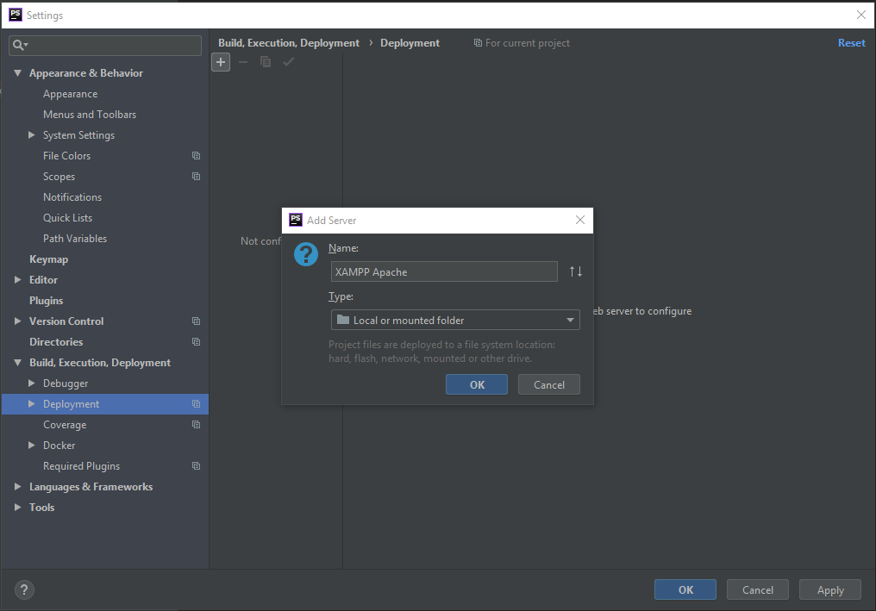

Now we need to point it to our project in the htdocs folder. With the “XAMPP Apache” server you just created selected, under the “Connection” tab, in the “Upload/download project files” section, set the “Folder” field to [*C:\xampp\htdocs\CLM*]. Click “Apply”

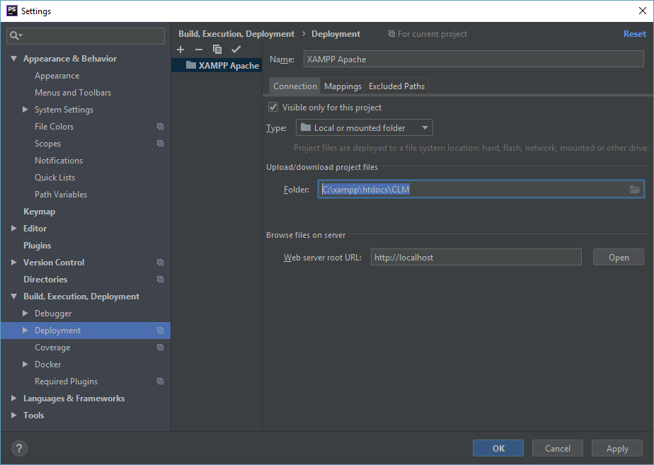

Now under the “Mappings” tab, we need to set the “Web path on server ‘XAMPP Apache’” to [*/CLM/*]. Then click “Apply” and “OK”

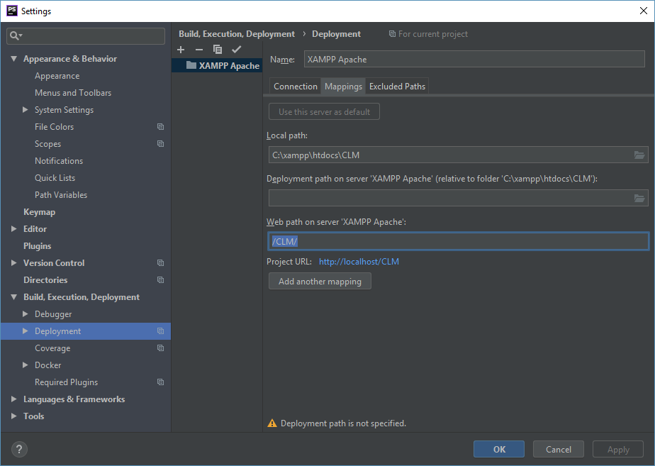

1. **Configure and setup our local database**

With PHPStorm setup, we just need to create and format a database. To do this open the XAMPP Control Panel. Click “Start” on both the “Apache” module and the “MySQL” module. Once they are running, click “Admin” on the “MySQL” module. This should open a webpage in your browser displaying your SQL databases. Depending on the size of the page either click “Import” or “More”, then “Import”. On the import tab, click “Choose File” and select the “lifeline.sql” file from the community lifeline ministries project. If you followed the directions exactly the path should be [*C:\xampp\htdocs\CLM\db\lifeline.sql*] then select “Go” at the bottom of the page. Upon competition, off to the left side you should see a new database appear named “community_lifeline”. Once you see that, close the browser.

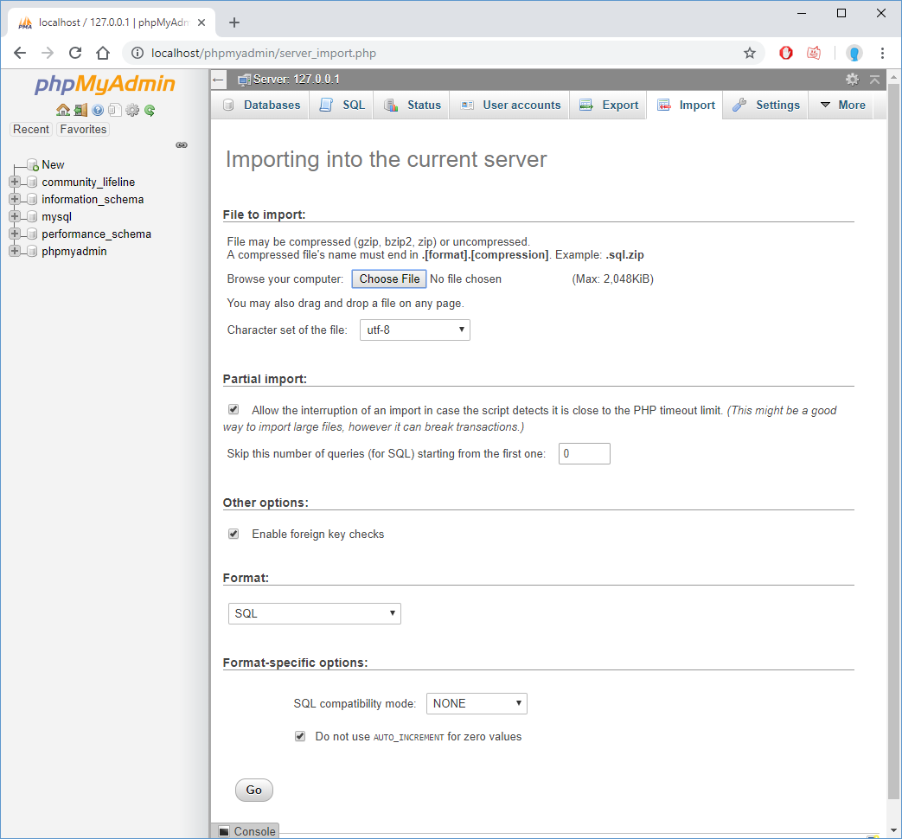

1. **Create a database connection in PHPStorm**

Now we need to connect the PHPStorm environment to our database and populate it with some test data. To do this return to your PHPStorm project. On the top-right you should see a “Database” flag, click it to expand the panel. Click the little plus sign “+” near the top of that panel and choose “Data Source” then “MySQL”. The “Data Sources and Drivers” dialog should appear. Now we need to fill in a few fields. In the “Database” field put “community_lifeline”. In the “User” field put “root”. And the “Password” field should be left blank, noting in there. Now if there is a “Test Connection” button press that to test the connection. If there is not a “Test Connection” button, then near the bottom there should be some clickable test that reads something along the lines of “Download Drivers”, click that, wait a minute or so, then the “Test Connection” button should appear. If the test connection is successful, you have successfully linked the database, so click “Apply” and “OK”

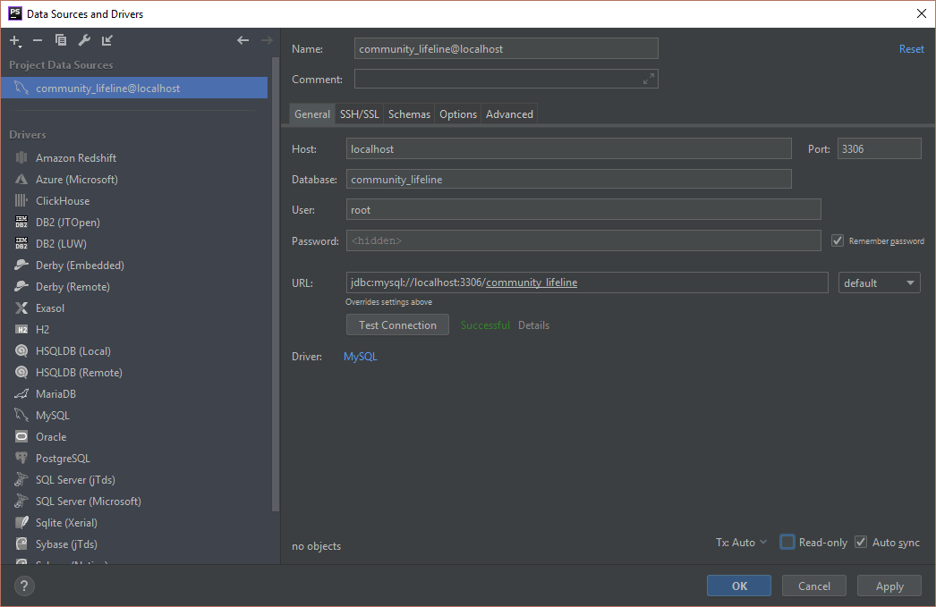

1. **Load the database with our developer data**

Now that the database connection is established we can load it with some test data. In the left panel in PHPStorm with our CLM project loaded, click and expand the “db” folder, then right click “developer-data.sql” and “Run ‘developer-data.sql”… (See below)

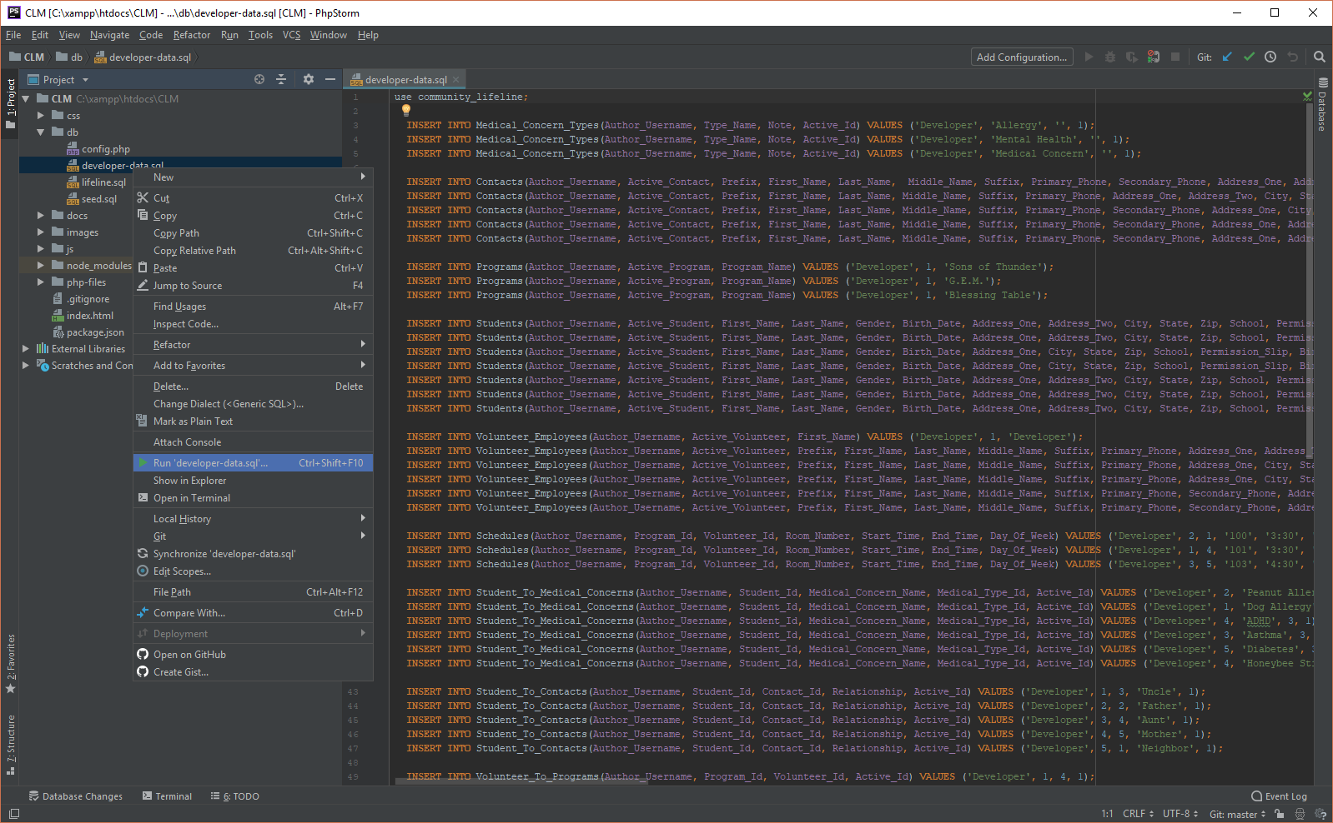

The “Execution Target” dialog should appear, select both “community_lifeline@localhost” and “community_lifeline”, then click “OK”. This will execute all the SQL commands in that file populating the data in our database. Console text should appear near the bottom of the PHPStorm window and no errors should be reported if execution was successful. If you’d like to make sure it executed properly, return to the XAMPP Control Panel and click “Admin” on the “MySQL” module and check the records under the “community_lifeline” database.

1. **Fire up the project and ensure we can Login**

Finally, our local environment is all set up. Now we just need to test it really quick. Return to the XAMPP Control Panel and ensure that both the “Apache” and “MySQL” modules are running, if they are running the background of the module text will be green, there will be PID(s) and Port(s) listed, and the button will read “Stop” instead of start, and the “Admin” buttons will be clickable. Assuming they are running, back into the PHPStorm environment, double-click the “index.html” file, this will open and show the source code in the PHPStorm IDE. In the top-right of the source code section, if you mouse over, you will see a list of browser icons. Click your preferred browser and the webpage should load. (Screenshot below)

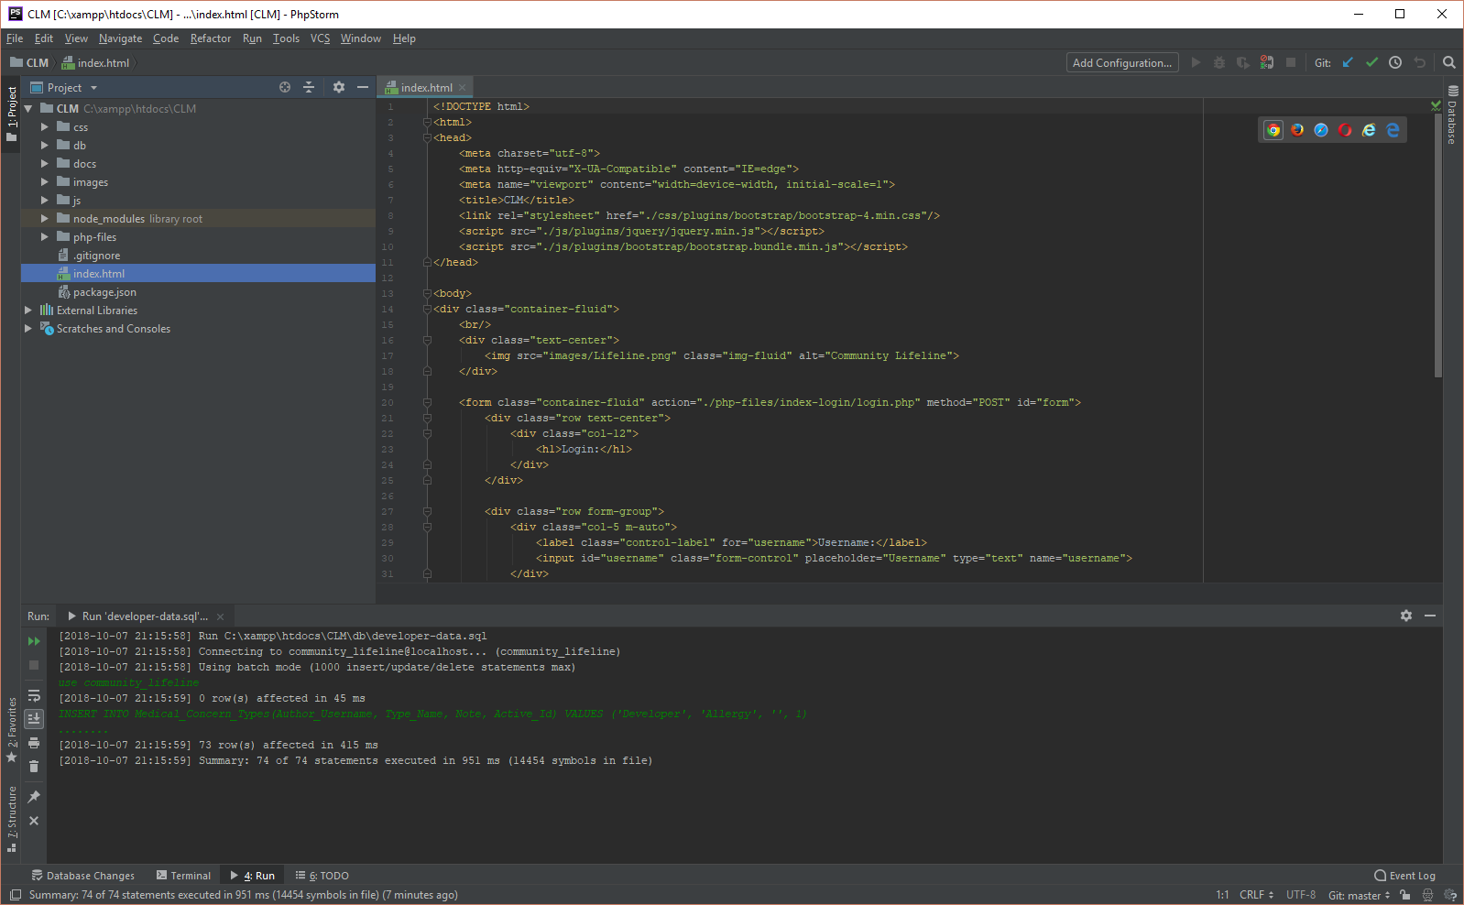

Once it loads, you should see a login page. The Username is “admin” and the Password is “admin” click login and you should be brought to the Main-Menu.php page. If so you have successfully installed the environment. If not, I’ve listed a couple easy mistakes below.

* Common mistakes and fixes

1. Ensure that both “Apache” and “MySQL” are running from the XAMPP Control Panel.
2. Clicking “Admin” from the XAMPP Control Panel ensure the “community_lifeline” database has data in it.
3. Ensure that the connection to the database is functioning in PHPStorm, you can check this from the panel that you configured the database connection in by clicking the “Test Connection” button.
4. Carefully double check the file paths set while configuring the “Build, Develop, Deployment” tab in settings. Also verify that the paths are valid.