TECHCRM
AI Architecture and Model Accuracy
Deal scoring, lead scoring, and LLM extraction
11 September 2026

Repository | D:\CRM · branch main
Stack | React 18 · Spring Boot 4 · PostgreSQL 14 · FastAPI
Deal scorer | XGBoost 3.3.0 regressor, 1,000 training rows
Language models | Llama 3.1 8B Instruct + 3 QLoRA adapters
Hardware | NVIDIA RTX A4000, 16 GB · 7.4 GB used in service
Verification | Live end-to-end run, all services up

1. Executive summary
TechCRM scores sales leads and deals using two different kinds of model, deliberately separated. Language models read unstructured meeting text and produce structured fields; a gradient-boosted regressor turns those fields into a score. The language model never produces a score, and the regressor never reads text.

Headline results
Model | What it does | Headline accuracy
XGBoost deal scorer | 17 fields → deal score 0–100 | R² 0.903 · MAE 4.36 points
deal_state adapter | meeting + previous state → 17 fields | 0.29 points end-to-end error
meeting_extraction adapter | lead meeting → 5 signals | 99.57% token accuracy (task-level not measured)
lead_scoring adapter | lead profile → score 0–100 | 96.11% token accuracy (task-level not measured)

Two findings deserve attention before the numbers are read as comparable.
- Only one of the three adapters has been measured on the job it actually does. The other two report only token-level metrics, which say whether the next token was predicted correctly, not whether the business answer was right.
- The lead_scoring adapter is the weakest-measured model in the system and the one with the widest reach — it assigns a priority to every lead that enters the CRM.

2. System architecture
Five processes. The browser talks only to the Spring API; the model services are reachable from the backend alone.
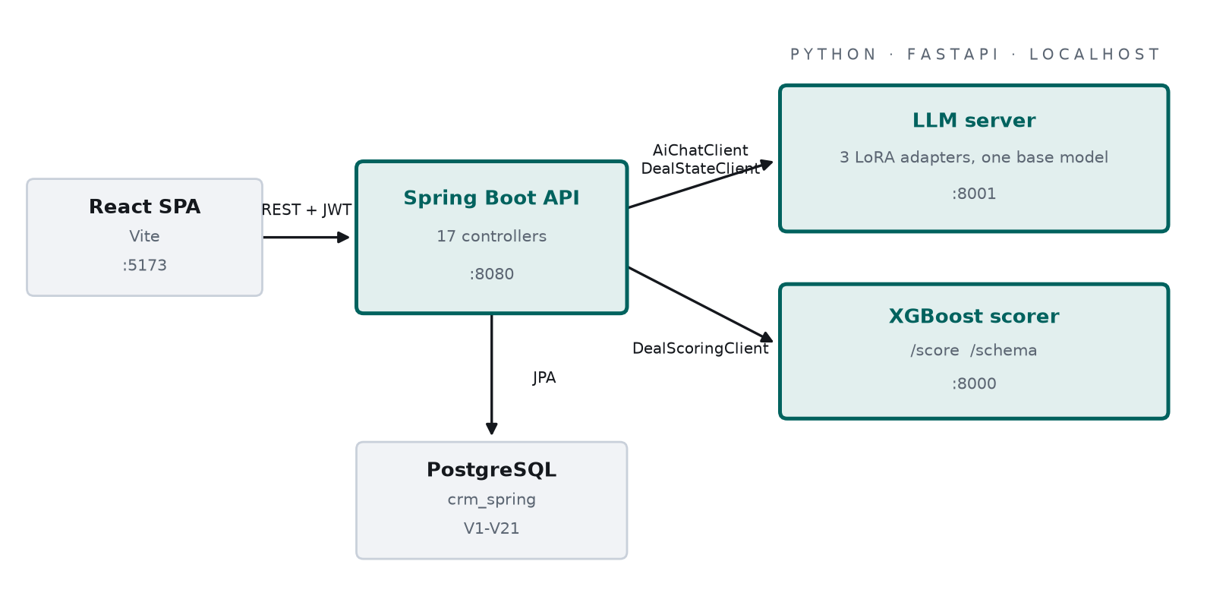
Figure 1 — Service topology. Everything the browser sees passes through port 8080.
Process | Port | Entry point | Role
React SPA | 5173 | frontend/ | User interface
Spring Boot API | 8080 | backend/ | Orchestration, persistence, auth
PostgreSQL | 5432 | crm_spring | 21 Flyway migrations
XGBoost scorer | 8000 | XgBoost/serve_api.py | Deal score
LLM server | 8001 | Llama3_CRM/scripts/main.py | All three LoRA adapters

The backend degrades rather than fails when a model service is unavailable. A meeting write-up is always saved; a deal keeps its previous score rather than being wiped; a lead is stored unscored and can be re-scored later.

2.1 One base model, three adapters
All three fine-tunes attach to a single 4-bit copy of Llama 3.1 8B Instruct. A LoRA adapter is roughly 160 MB of low-rank deltas against a ~6 GB quantised base, so the marginal cost of a third task is negligible — while running each in its own process would mean a second and third full copy of the base model, which does not fit in 16 GB of VRAM.
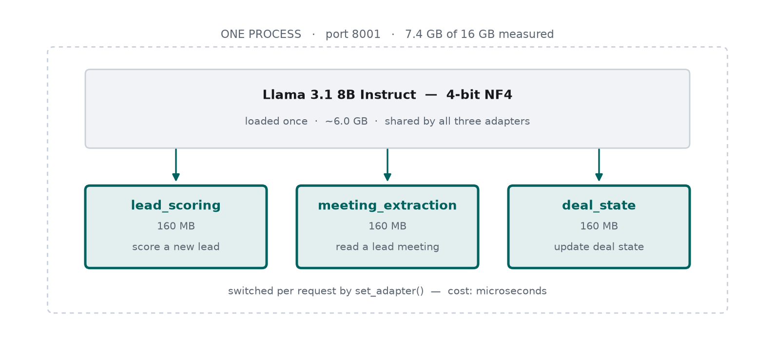
Figure 2 — Adapters are swapped per request by set_adapter(). Measured footprint: 7.4 GB of 16 GB with all three attached.

3. Lead workflow
A lead is captured, scored by the first adapter, worked through a sequence of meetings that move its score, and finally qualified by a person before it can become an opportunity.
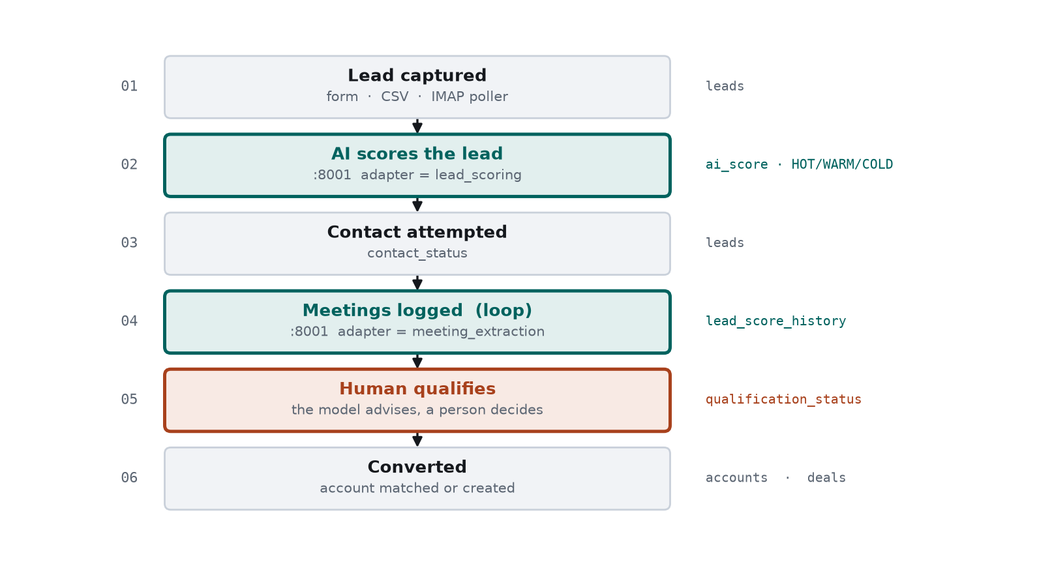
Figure 3 — Lead lifecycle. Green steps call a language model; the orange step is a human decision the model cannot make.
The model advises and a person decides. Re-scoring a lead never overturns a qualification decision already made: applyAiScore deliberately leaves qualification_status untouched in every case.

3.1 How the score moves
- The reading is recomputed on save rather than trusted from the preview call — the notes may have been edited in between.
- A lead's capture-time score is written lazily as meeting 0, so its timeline starts where the lead actually began.
- If extraction is unavailable, a keyword heuristic substitutes and the row is tagged HEURISTIC rather than MODEL.

4. Deal scoring
One POST runs the entire chain synchronously. Every stage is committed before the next runs, so a failure halfway through leaves a partial chain that can be inspected rather than nothing at all.
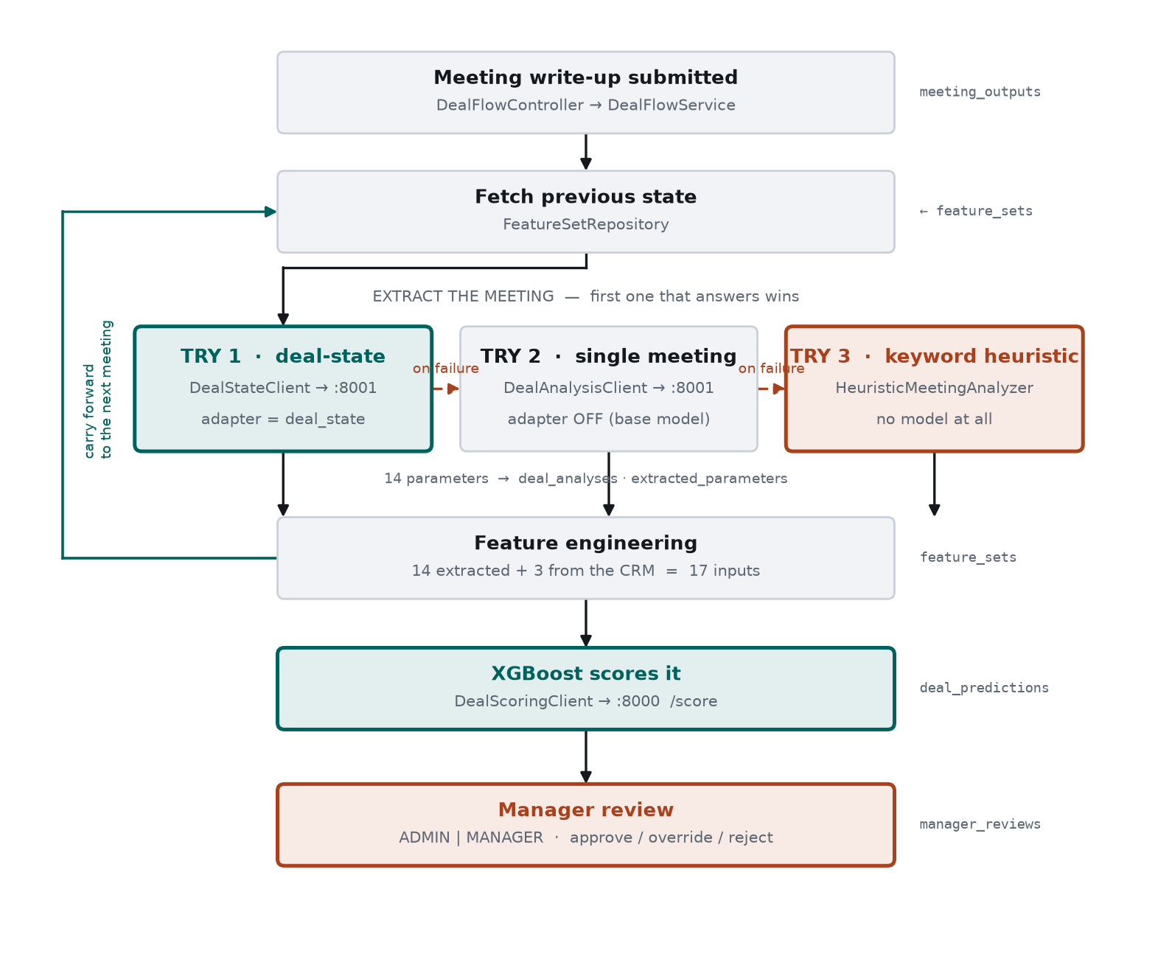
Figure 4 — Deal scoring. Three extraction attempts in order; the first that answers wins. feature_sets is written at the end and read back as the next meeting's input.

4.1 Where the 17 model inputs come from
Kind | Count | Handling
Categoricals | 12 | Snapped onto the trained vocabulary — exact, then case-insensitive, then substring. No match falls back to a neutral default and is recorded in imputed_fields.
relationship_strength | 1 | First number wins: "7", "7/10" and "7 out of 10" all give 7.0. Clamped 0–10.
main_objections | 1 | Split on ; or , then each token matched against the ten known objections and rejoined.
Supplied by the CRM | 3 | total_meetings, lead_score and engagement_score are arithmetic the backend performs exactly. They are discarded from the model's reply and recomputed.

That last row matters for accuracy. The deal_state adapter's own provenance records 40% field accuracy on lead_score — it is a weighted sum an 8B model cannot reliably land. Because the backend recomputes it, the weakness never reaches the scorer.

4.2 What the scorer returns
Output | How it is produced
deal_score | XGBoost regression, clipped to 0–100. A clipped flag marks predictions that fell outside.
band | ≥ 75 HIGH · ≥ 50 MEDIUM · ≥ 25 LOW · otherwise VERY LOW
win_probability | A logistic squash of the score, tuned so 75 maps to 0.75. NOT a trained classifier — no win/loss label was ever in the training data.
confidence | Mean extraction confidence, counting imputed fields as zero so a heavily-defaulted reading reports as less trustworthy.

5. Model accuracy

5.1 XGBoost deal scorer
Trained on 1000 rows split 800 train / 200 test, seed 42.
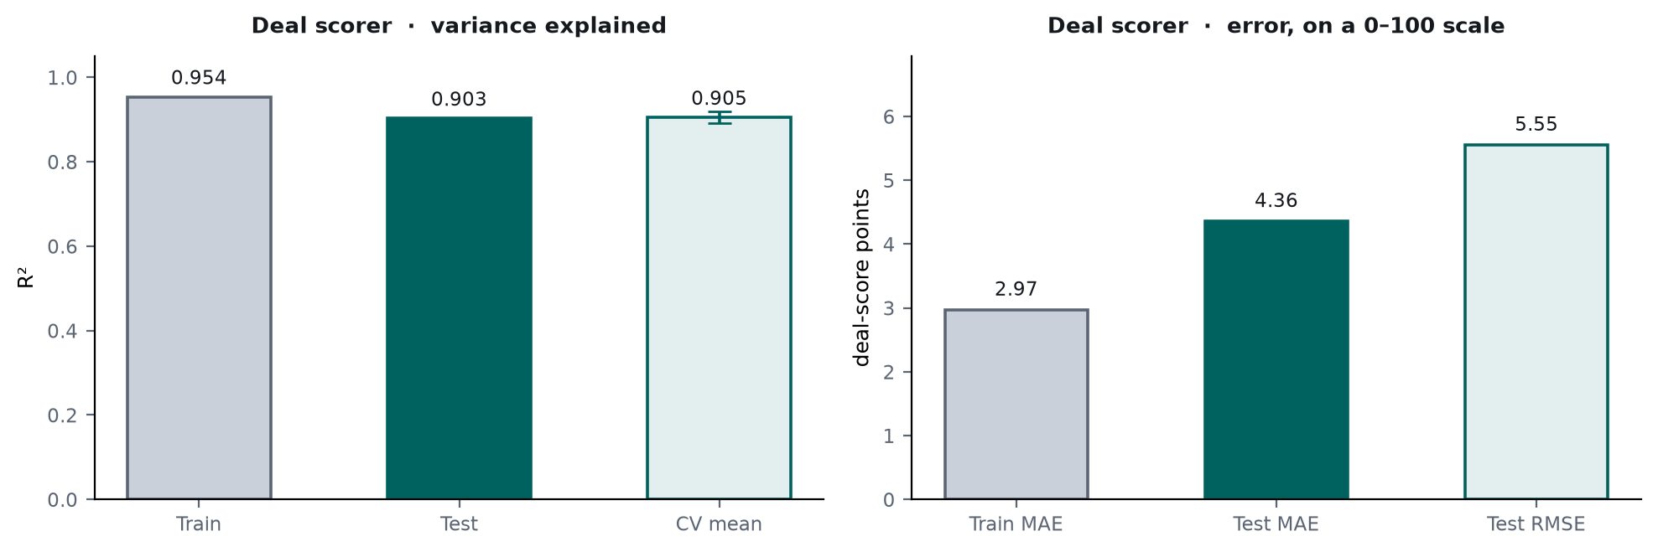
Figure 5 — Deal scorer performance. The error bar on CV mean is ±1 standard deviation across five folds.
Metric | Test | Train | 5-fold CV
R² | 0.9026 | 0.9536 | 0.9048 ± 0.0142
Adjusted R² | 0.8773 | 0.9511 | —
MAE (points) | 4.357 | 2.972 | —
RMSE (points) | 5.554 | 3.781 | 5.382 ± 0.287
MAPE | 10.26% | 6.97% | —
SMAPE | 9.71% | 6.83% | —
Rows | 200 | 800 | —

The train-to-test R² gap is 0.0510 and the cross-validated R² varies by only ±0.0142 across folds. Both indicate the model is not overfitting. A typical prediction is within 4.4 points of the correct value on a 0–100 scale — comfortably inside a 25-point priority band.

5.2 The three LoRA adapters
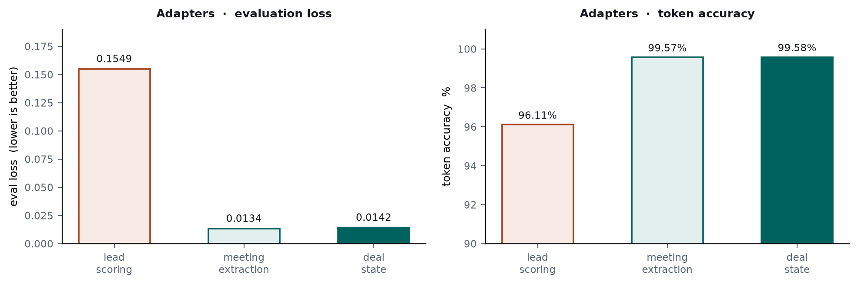
Figure 6 — Training-level metrics. These measure token prediction, not task success.
Adapter | Rows | Epochs | Eval loss | Token acc. | Task-level eval
lead_scoring | 500 | 8 | 0.15493 | 96.11% | Not measured
meeting_extraction | 494 | 4 | 0.01335 | 99.57% | Not measured
deal_state | 800 | 5 | 0.01420 | 99.58% | Yes — see 5.4

5.3 Why token accuracy is not accuracy
Most of a structured target is braces, field names and quoting, which a model predicts almost perfectly from the first training steps. That inflates token accuracy and depresses eval loss regardless of whether the business reading is correct. A run can look converged while getting every field wrong.
This is not a hypothetical: the deal_state adapter scores 99.58% token accuracy and only 33.3% on exact whole-state correctness. The first number says the JSON is well-formed; the second says what fraction of readings were completely right.

5.4 Deal-state adapter — task-level accuracy
Measured over 30 held-out deal journeys the adapter never saw.
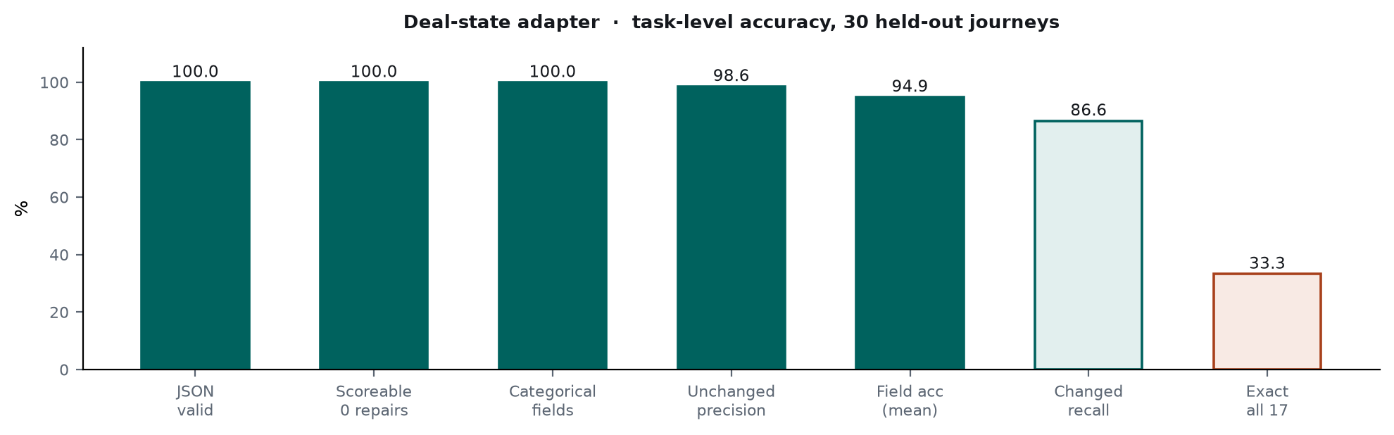
Figure 7 — Task-level accuracy. The categorical fields the scorer depends on are 100% correct; the exact-match figure is dragged down by two arithmetic fields.
Metric | Result | What it means
JSON valid | 100% | Always emitted a parseable object
Scoreable, zero repairs | 100% | Output needed no correction to be accepted by the scorer
Categorical fields | 100% | Every word-valued field correct
Unchanged precision | 98.6% | Fields it left alone were correctly left alone
Field accuracy (mean) | 94.9% | Per-field correctness across all 17
Changed recall | 86.6% | Of fields that should have moved, how many did
Exact state, all 17 | 33.3% | Every field right simultaneously

Known weakness, and why it does not reach the score
Two numeric fields are weak: lead_score at 40% and engagement_score at 80% field accuracy. Both are weighted sums the model must land exactly, and an 8B model does not do reliable multi-term arithmetic. Both are pure functions of fields the model gets right, and the backend recomputes both — so the error is discarded before scoring.

5.5 Output accuracy — what the errors actually cost
Field accuracy answers how often a field is right. It does not answer how wrong the final number is, and the two come apart: a field can be wrong and barely move the score, or wrong in a way that moves it twenty points. Only the regressor knows which. So the real chain is run twice per held-out example — once from the ground-truth state, once from the model's — and the scores compared.
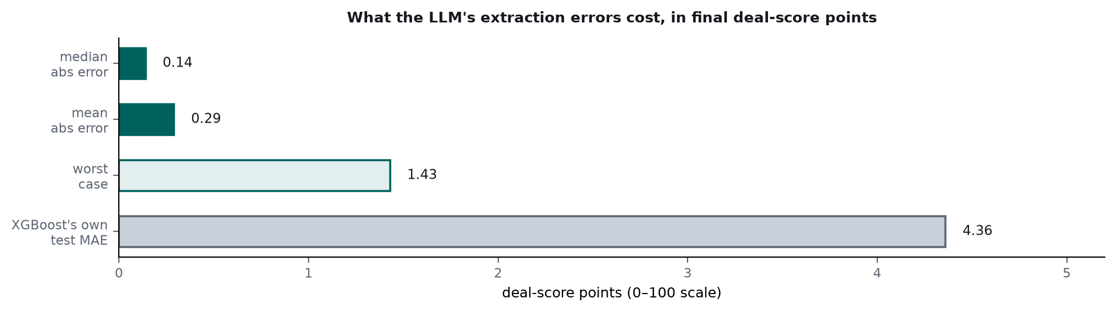
Figure 8 — End-to-end error in deal-score points, with the scorer's own test error shown for scale.
Measure | Value
Mean absolute error | 0.29 points
Median absolute error | 0.14 points
Worst case | 1.43 points
Bias | 0.07 points
Within 3 points of ground truth | 100%
Same priority band | 100%

The extraction step contributes 0.29 points of error to a score whose own model has a test error of 4.36 points. The language model is therefore not the limiting factor in deal-score accuracy — the regressor is. Every held-out case landed in the same priority band as the ground truth.

6. Live end-to-end verification
Run on 11 September 2026 against all services, through the backend REST API rather than by calling the models directly.
Step | Result | Latency
Sign up, organization created | user role ADMIN | —
Create lead | aiScore 50 · WARM · qualification PENDING | 10.3 s
Qualify (human step) | HTTP 200 | —
Convert to opportunity | OPP-000019 · account auto-created | —
Meeting 1 submitted | deal-state/1.0.0 · 0 repairs · score 36.41 LOW | 14.9 s
Meeting 2 submitted | deal-state/1.0.0 · 0 repairs · score 62.21 MEDIUM | 14.1 s

6.1 The carry-forward behaviour, demonstrated
Meeting 1 established customer_requirements = "Customized Integration". Meeting 2 discussed budget approval and a competitor, and never mentioned integration at all. The field was nonetheless carried forward rather than reverting to a neutral default:
customer_sentiment Positive Updated by this meeting.
budget_status Fully Approved Updated by this meeting.
decision_maker_involvement Yes Updated by this meeting.
main_objections No Objections Updated by this meeting.
customer_requirements Customized Integration Carried forward from meeting 1.
risk_factors No Risk Identified Carried forward from meeting 1.
implementation_readiness Partially Ready Carried forward from meeting 1.
This matters more than it appears. customer_requirements and risk_factors are one-hot columns in the scorer. An incorrect value in an ordinal column raises a schema error and returns HTTP 400; an incorrect value in a one-hot column raises nothing — the column is silently dropped and the feature scores zero. Without carry-forward, the deal would have been scored confidently on evidence that had quietly disappeared.
The adapter also removed "Price Too High" from main_objections once meeting 2 showed the pricing concern resolved — a behaviour it was specifically trained for, rather than generic extraction.

7. Open items
# | Item | Impact
1 | The lead_scoring adapter has no task-level evaluation. Its eval loss (0.155) is an order of magnitude higher than the other two. | Unknown accuracy on the model that prioritises every lead. evaluate_meeting.py exists but its output was never saved.
2 | DealScoringClient.score(Deal) — the deal-edit-form path — guards only four of twelve categorical fields, then sends an empty string for any null. | Strict mode rejects the payload with HTTP 400 and the deal is silently left unscored.
3 | The scoring vocabulary is declared independently in the frontend constants, DealParameters.java, and the trained bundle. | A retrain changes only the third. No automated check compares them.
4 | XgBoost/requirements.txt omits fastapi and uvicorn, and files matplotlib under training-only although deal_score_pipeline.py imports it at module level. | A fresh install of the documented serving set cannot start the API.

Recommended next step
Run evaluate_meeting.py against the lead_scoring adapter and save the output. It is the only model in the system whose real-world accuracy is unknown, it has the widest reach of the three, and the evaluation harness already exists.

