Gin Sang ID:1001810116
Patil, Chirag Naresh ID: 1002223067

List of sites/sources referred:
The class slides are used to study the algorithms, and we use the pseudo and our knowledge of the material to transfer the pseudocode to pythoncode.
https://www.geeksforgeeks.org/cutting-a-rod-dp-13/ (just referred for understanding)

Time complexity of each of the algorithms:
Cut - Rod:( 2^n)
Stems from its recursive nature, where each call to Cut-Rod(p, n) spawns multiple recursive calls for all possible subproblems. For n = 1, there are 2 calls: the original function call and one recursive call. For n=2, this doubles to 4 calls as each subproblem branches further. This pattern continues, doubling at each level of recursion. Every level of recursion tree adds twice the calls of the previous level, leading to explosive growth as n increases.

Bottom-Up-Cut-Rod: O(n^2)
The algorithm avoids the inefficiency of recursion by solving the problem iteratively. It builds a solution for smaller rod lengths first and uses these results to compute solutions for larger lengths. For a rod length n, the algorithm computes the maximum revenue for all subproblems for lengths 1 to n, storing the results. Each subproblem involves checking all possible cuts, resulting in n operations for each of n subproblems. This makes the time complexity O(n^2), unlike the recursive approach, it does not recompute subproblems, making it much more efficient.

Extended-Bottom-Up-Cut-Rod: O(n^2)
The Extended-Bottom-Up-Cut-Rod algorithm builds on the Bottom-Up-Cut-Rod approach by not only calculating the maximum revenue for each rod length but also storing the first cut that yields this maximum. This allows the optimal cutting solution to be reconstructed efficiently after the revenue is computed. The algorithm still iteratively solves all subproblems from lengths 1 to n, and for each length, evaluates n possible cuts. The time complexity remains O(n^2), because it does not add any additional steps beyond storing the optimal cuts. Like the bottom-up approach, it avoids the exponential growth of recursive calls.

Comparison graph
For time difference between Cut-Rod and Bottom-Up-Cut-Rod.
Initially, for small rod lengths, the time difference is negligible because the recursive algorithm does not yet encounter significant overhead. However, as the rod length increases, the time difference grows exponentially due to the O(2^n) time complexity of the recursive approach. Around a rod of length 25, the time difference exceeds the 60second threshold.
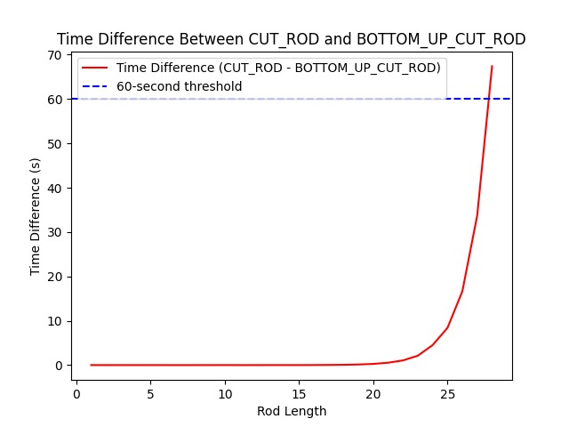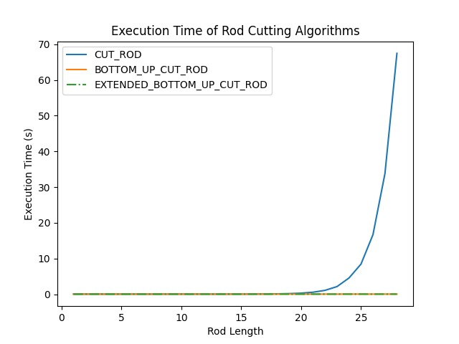
For Execution Time of Rod Cutting Algorithms:
The blue curve, representing Cut-Rod, shows exponential growth as the rod length increases, reflecting its O(2^n) time complexity. In contrast, both the Bottom-Up-Cut-Rod and Extended-Bottom-Up-Cut-Rod follow a polynomial growth pattern (O(n^2)), which is significantly more efficient. It is important to note that the bottom-up algorithms appear almost linear in this graph because their growth is dwarfed by the explosive growth of the recursive Cut-Rod algorithm.

Contribution of each team member:
Patil, Chirag Naresh:
Design the algorithm and also tried to verify it with different types of input to achieve the 60 seconds difference and also tried to achieve all targets with the teammates and just helped together with overall testing.


Gin:
In depth review and testing of the code. Identify any mistakes or improvements that can be done, and relay it back to the partner. Responsible for making sure all the required materials are completed. Did the report.
Honor Code:



