1. In the below elements which of them are values or an expression? eg:- values can be integer or string and expressions will be mathematical operators.

* **It is a Expression**

'hello' , **It is a string value**

-87.8 , **It is a float value**

- **It is an Expression, subtraction**

/ **It is an Expression, division**

* **It is an Expression, Add**

6 **It is a number value**

2. What is the difference between string and variable?

**String is one of the data type in Python. String is the text data. We should use single or double quotes to define the string.**

**Variable is used to store any String, number, or float number in memory and use for output purpose.**

**In below example,   
“Pijush Roy” is the string  
name and marks is the variable**

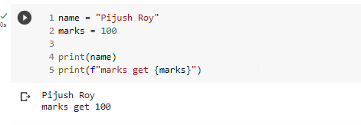

3. Describe three different data types.

**String Data Type:- . String is the textual data in Python. We should use single or double quotes to define the string.**

**Boolean Data Type: Boolean data type contains TRUE or FALSE value**

**Number Data Type: Different number data types are INT (like 55), FLOAT (like 50.55), Colplex (like 2+3j)**

4. What is an expression made up of? What do all expressions do?

**In Python, an expression is a combination of one or more stings or values or operators that can be use to produce output. Expressions may simple or complex.**

**All expressions in Python produce a output as value, and they can be used in a variety of ways, such as:**

* **In variable assignment**
* **In argument to a function**
* **In a conditional statement or loop**

5. This assignment statements, like spam = 10. What is the difference between an expression and a statement?

**In Python, an expression is a combination of one or more stings or values or operators that can be used to produce output. Expressions may simple or complex.**

**Statement is a complete line of code that performs an action A statement may or may not produce a value.**

**In spam = 10, value 10 assigned into variable spam**

6. After running the following code, what does the variable bacon contain?

bacon = 22

bacon + 1 **Ans 23**

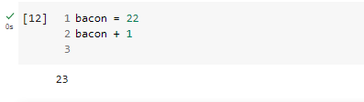

7. What should the values of the following two terms be?

'spam' + 'spamspam' = spamspamspam

'spam' * 3 = spamspamspam

8. Why is eggs a valid variable name while 100 is invalid?

**In Python, the first character of a variable name must be a letter (either uppercase or lowercase), an underscore _**

**For that reason, “eggs” or “Eggs” or “_eggs” is valid variable name**

**But 100 start with number, so it is not valid for variable.**

9. What three functions can be used to get the integer, floating-point number, or string version of a value?

**Int, Str, Float**

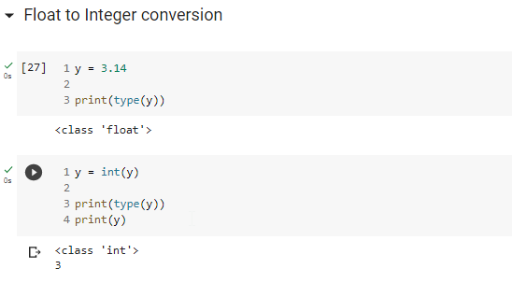

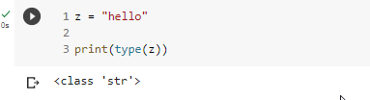



10. Why does this expression cause an error? How can you fix it?

'I have eaten ' + 99 + ' burritos.'

