1.What are the two values of the Boolean data type? How do you write them?

**True and False**

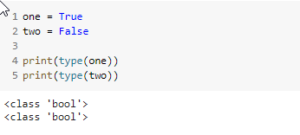

2. What are the three different types of Boolean operators?

**And Operator = When all conditions are True, return True, else False**

**Or Operator = When any conditions are True, return True, else False**

**Not Operator = If condition is True, it return false. If condition is False, it return True.**

3. Make a list of each Boolean operator's truth tables (i.e. every possible combination of Boolean values for the operator and what it evaluate).

|  |  |  |
| --- | --- | --- |
| **AND Operator** |  |  |
| **If A** | **If B** | **Result** |
| **TRUE** | **TRUE** | **TRUE** |
| **TRUE** | **FALSE** | **FALSE** |
| **FALSE** | **TRUE** | **FALSE** |
| **FALSE** | **FALSE** | **FALSE** |
|  |  |  |
| **OR Operator** |  |  |
| **If A** | **If B** | **Result** |
| **TRUE** | **TRUE** | **TRUE** |
| **TRUE** | **FALSE** | **TRUE** |
| **FALSE** | **TRUE** | **TRUE** |
| **FALSE** | **FALSE** | **FALSE** |
|  |  |  |
| **NOT Operator** |  |  |
| **If Not TRUE** |  | **FALSE** |
| **If Not FALSE** |  | **TRUE** |

4. What are the values of the following expressions?

(5 > 4) and (3 == 5)

not (5 > 4)

(5 > 4) or (3 == 5)

not ((5 > 4) or (3 == 5))

(True and True) and (True == False)

(not False) or (not True)

5. What are the six comparison operators?

* **Equal to ==**
* **Not equal to !=**
* **Greater than >**
* **Less than <**
* **Greater than or equal >=**
* **Less than or equal <=**

6. How do you tell the difference between the equal to and assignment operators?Describe a condition and when you would use one.

**= used for assign value in variable**

**== used for company two values equal or not. If equal, then return TRUE otherwise return FALSE**

7. Identify the three blocks in this code:

spam = 0

if spam == 10:

print('eggs')

if spam > 5:

print('bacon')

else:

print('ham')

print('spam')

print('spam')

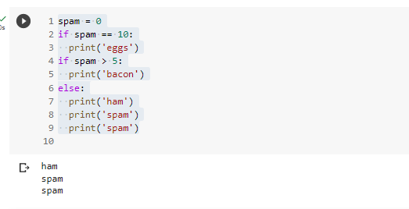

**Frist two if conditions are not True, so print the else statement.**

8. Write code that prints Hello if 1 is stored in spam, prints Howdy if 2 is stored in spam, and prints Greetings! if anything else is stored in spam.

**spam = 2**

**if spam == 1:**

**print("Hello")**

**elif spam == 2:**

**print("Howdy")**

**else:**

**print("Greetings!")**

9.If your programme is stuck in an endless loop, what keys you’ll press?

**Ctrl + C key need to press to stop programme.**

10. How can you tell the difference between break and continue?

**break and continue are two keywords in Python that can be used to control the flow of a loop.**

**Break is used for to stop the loop when certain condition is met.  
Continue is used for certain condition where skip the loop and start next loop.**

11. In a for loop, what is the difference between range(10), range(0, 10), and range(0, 10, 1)?

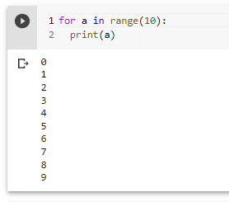 **Range start from 0, Range end 10-1, Jump number 2**

12. Write a short program that prints the numbers 1 to 10 using a for loop. Then write an equivalent program that prints the numbers 1 to 10 using a while loop.

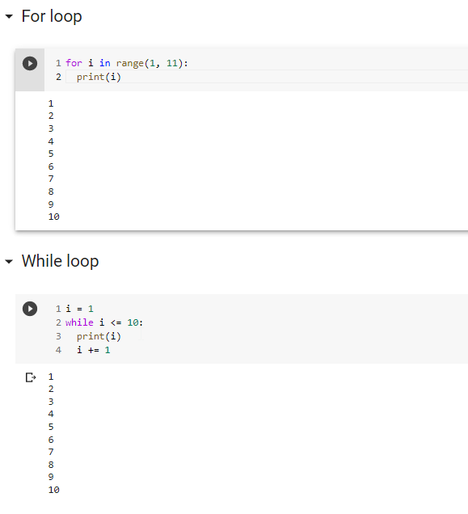

13. If you had a function named bacon() inside a module named spam, how would you call it after importing spam?

**import spam**

**spam.bacon()**