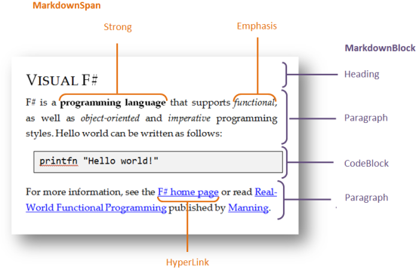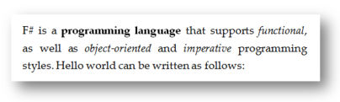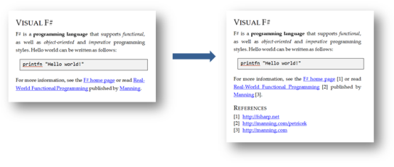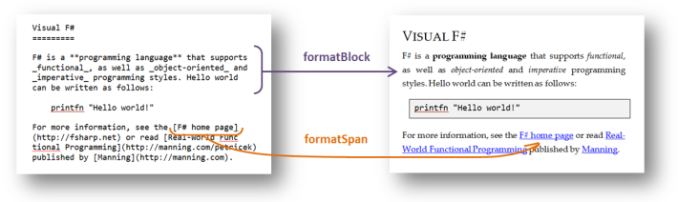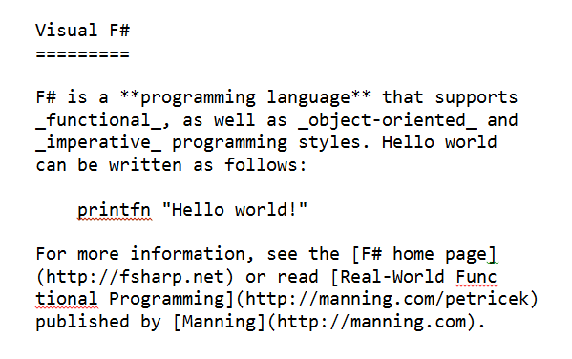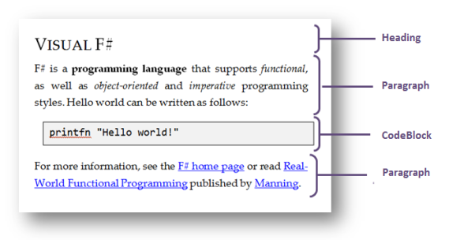x

**Section 6:** Processing documents

**Section 5:** Producing HTML

**Section 4:** Parsing blocks

**Section 3:** Parsing spans

**Section 2:** Representing documents