**Inline text formatting**

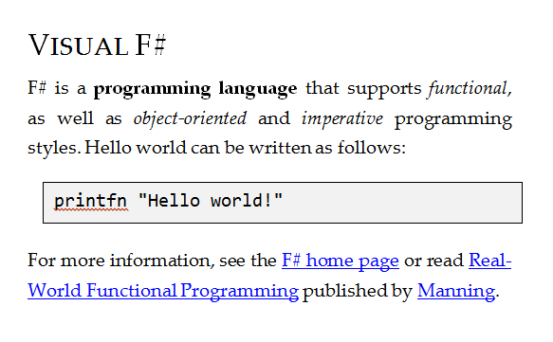

**Document consists of several block elements**

**MarkdownSpan**

Strong

Emphasis



CodeBlock

**MarkdownBlock**

Paragraph

Heading

HyperLink

Paragraph

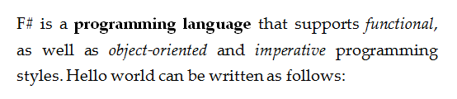



**CodeBlock**

**Paragraph**

**Heading**

**Paragraph**

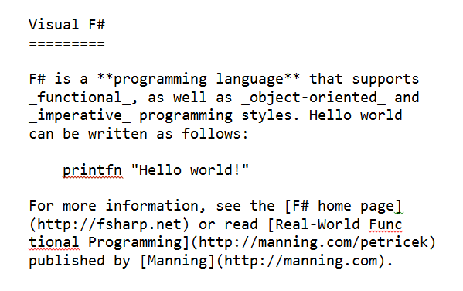

**formatBlock**

**formatSpan**

