Ravi’s Yoga Studio

# OVERVIEW

My business is a Yoga Studio, providing yoga training services and also building good health for a community.

# THE MAIN CONSUMER PROFILE TO BE TARGETED

1. Basic age range 40-80
2. Medium/high income
3. Well-Informed about the benefits of yoga
4. People with chronic diseases such as diabetes.
5. Consumer classification:
   1. Elderly people who usually stay at home and want the remainder of their life to be healthy.
   2. Middle aged or elderly people having chronic disease and don't want it to grow severely.
   3. Anyone aspiring to have a healthy lifestyle.

# STRATEGIC GOAL/VISION

To become a trusted symbol of good health and offer services around the city.

# STATUS OF THE BUSINESS

The business is a startup that is currently going through the infrastructure building & branding phase.

# COMPETITION

Already established local yoga businesses run by individuals and personal trainers. Gurus having ashrams.

# 

# BUSINESS NEEDS

1. Peaceful and healthy infrastructure.
2. Marketing needs (freelance marketeer, social media coverage…) building a brand.
3. Hire instructors and local businesses.
4. Referrals via hospitals to chronic disease patients.

# 

# Yoga Teachers Recruitment Process

1. Receiving vacancy information internally.
2. Advertising the job.
3. Collecting applications for the job.
4. Screening the applicants.
5. Schedule an interview for a suitable candidate.
6. Interviewing screened applicants.
7. Offer letter to qualified applicants.d
8. Send a rejection mail to all rejected students.

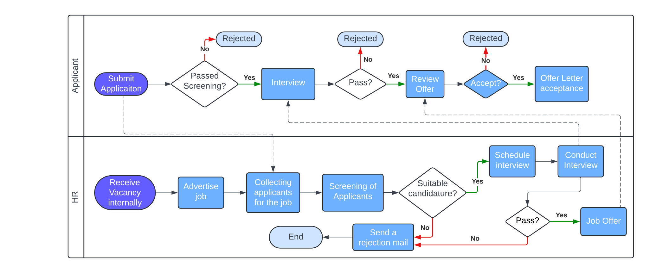

# 

# Yoga Studio BUSINESS PROCESS STEPS

1. The potential client is asked to fill in a request on the website.
2. We’ll call him back and schedule a visit.
3. Propose them the packages A,B and also an addon.
4. If it’s Package A it’s a regular session at the studio, if it’s Package B then it's a personal trainer with home visits, later an add-on is proposed if a package is chosen for a diet plan.
5. After choosing a plan and/or add-on registration and scheduling is done as per convenience.
6. Customer feedback is taken each week/month and implied upon to improve customer satisfaction.

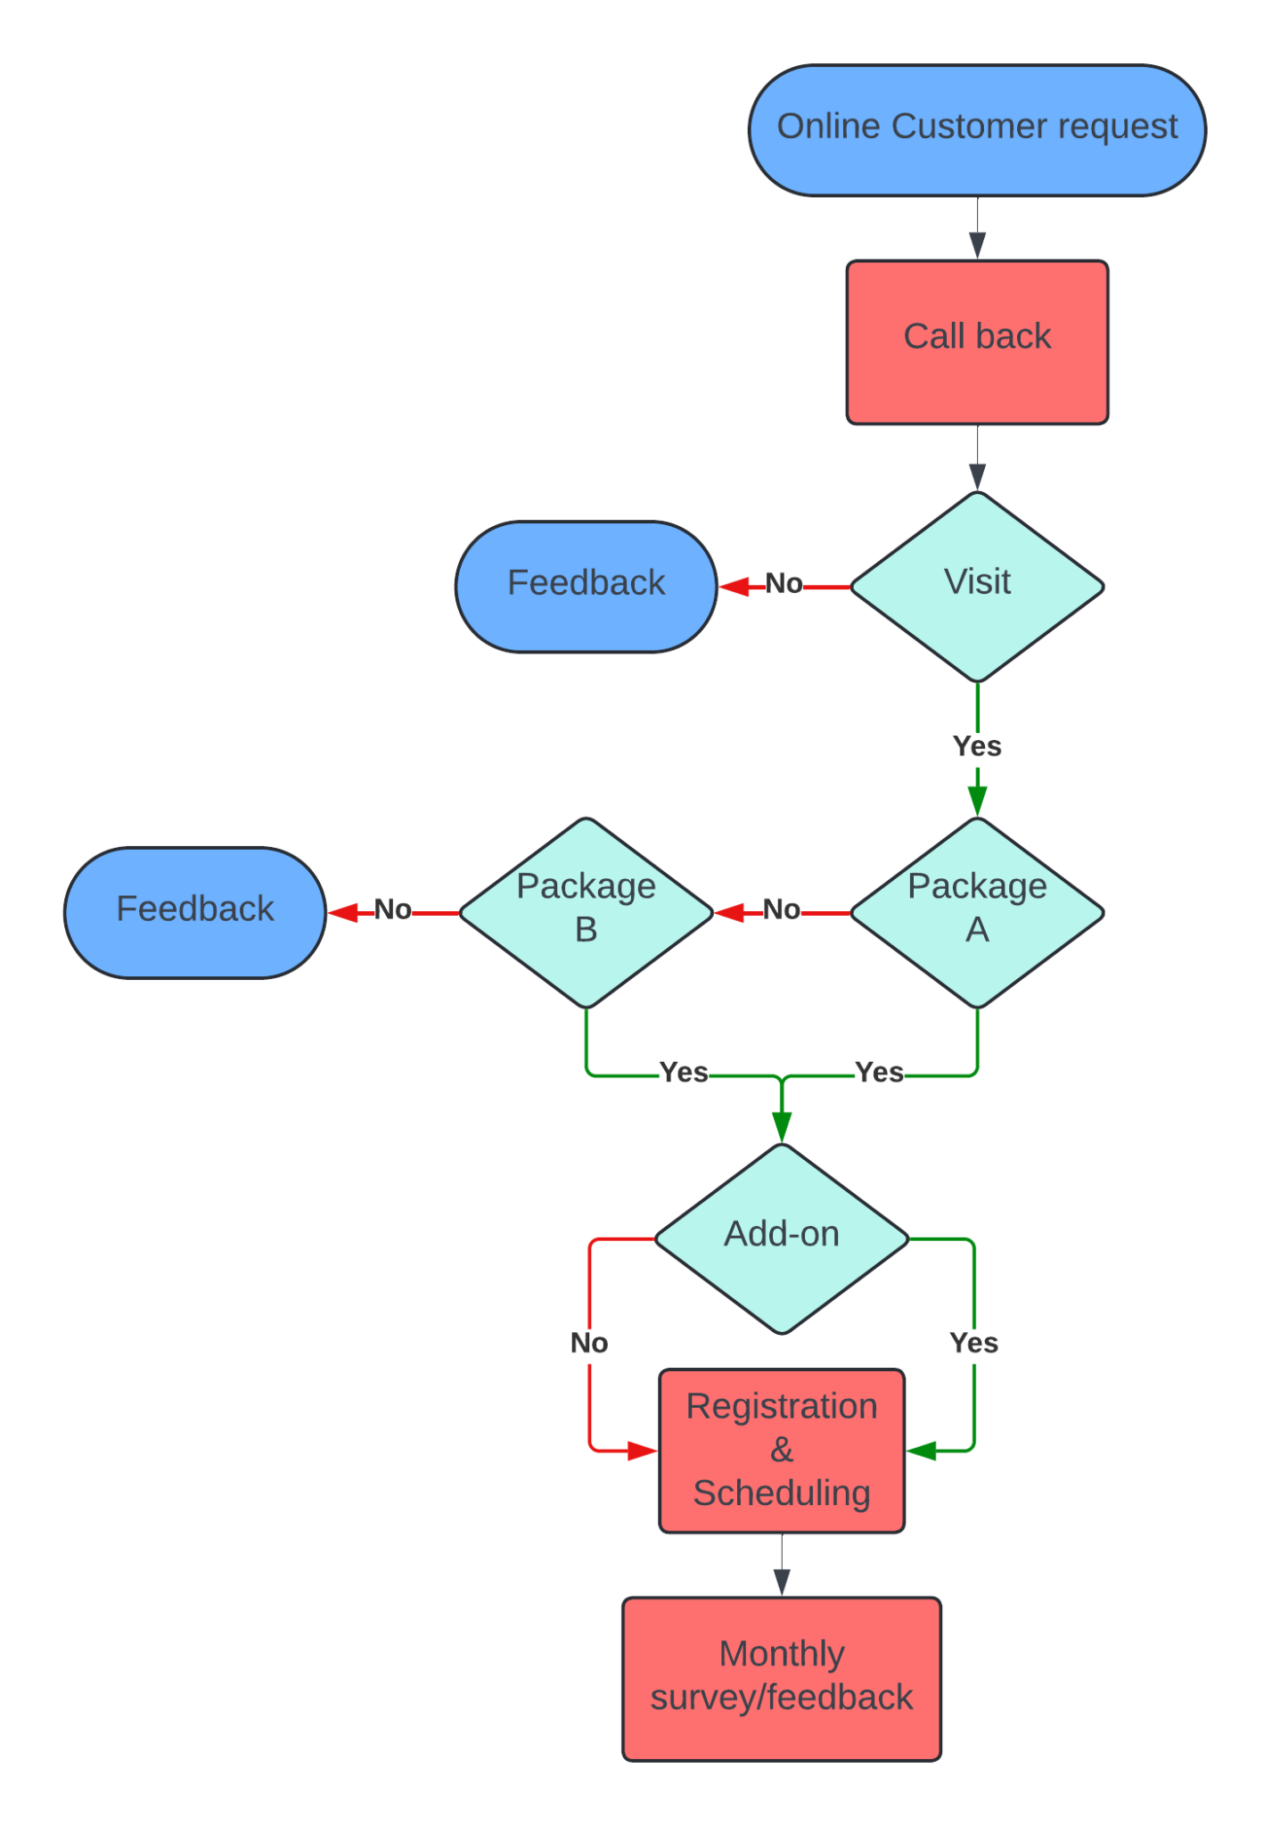

# Problem: Need for yoga trainers is increasing while the recruitment process is slow since there’s only One HR.

# Yoga Trainer recruitment process automation & improvement

1. Install and HR system, which,
   1. Receives vacancies internally
   2. Publish an online exam to assess the candidates
2. Applicants take an online exam after registration,
   1. If they pass the screening exam, there will be an interview, And the system will schedule the interview and send it to the applicants
   2. If they fail, the system will send auto generated rejection mail to those candidates.

