**EPICS Beamline PVs with APS-U**

**Mark Rivers**

**June 18, 2024**

This document described how to locate the relevant beamline EPICS medm screens that work with APS-U. Once the screens for a beamline are located and running it is easy to find the names of the EPICS Process Variables (PVs) by right clicking on a blank area on the display, selecting “PV Info”, and then left clicking on the widget with the PV of interest.

**Top-level Screen XFD-Display.adl**

The top-level screen is called XFD-Display.adl. It can be started by running the following script on a Linux machine with medm installed.

/APSshare/adlsys/xfd-display

That brings up this screen:

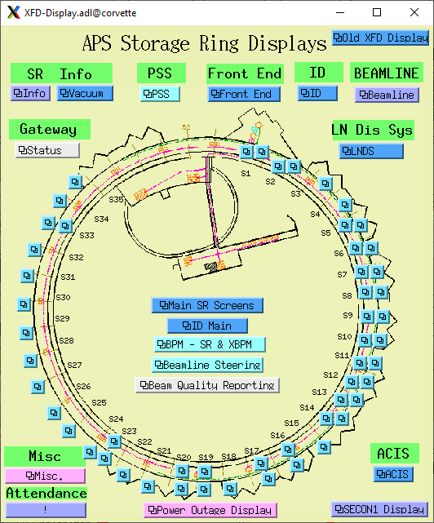

Clicking on the left S13 related display button can bring up the 13-BM PSS screen:

Clicking on the left S13 related display button can bring up the 13-BM FEEPS screen.

From that screen we can bring up the FEEPS Engineering screen:

Clicking on the right S13 related display button on XFD-Display can bring up the 13-ID PSS screen:

Clicking on the right S13 related display button can bring up the 13-ID FEEPS screen:

Clicking on XFD-Display/Beamline button shows the status of all front-ends and ID gaps:

Selecting XFD-Display/ID/ID Quick Controls brings up this screen:

Selecting the 13US related display on the above screen brings up control of the sector 13 upstream undulator:

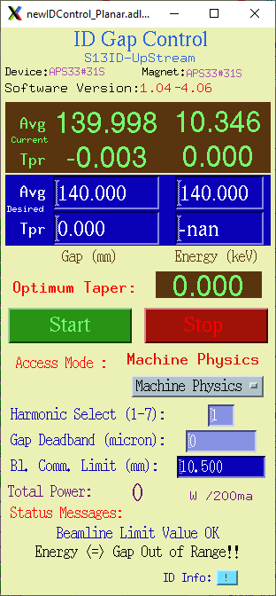

Similarly selecting 13DS brings up control of the sector 13 downstream undulator:

Selecting PV Info for the average gap control value (140 in blue above) brings up this screen.

This shows that the name of the PV for the average gap is S13ID:DSID:GapSetC.VAL. That is the PV one needs to write to control the gap.

Similarly, selecting PV for the Energy control (also 140 in blue above) brings up this screen:

This shows that the name of the PV for the average gap is S13ID:DSID:EnergySetC.VAL. That is the PV one needs to write to control the energy.

The “BPM – SR & XBPM” in the center of XFD-Display can bring up this BM XPM display:

Clicking on P1 or P2 in the BM 13 fields above opens this display:

The “BPM – SR & XBPM” in the center of XFD-Display can bring up this ID XPM display:

Clicking on the ID 13 number fields fields above opens displays like this:

The “BPM – SR & XBPM” in the center of XFD-Display can bring up this BM source point display:

The “BPM – SR & XBPM” in the center of XFD-Display can bring up this ID source point display:

