**Performance of Galil controllers versus OMS controllers at High Motor Speeds**

**Mark Rivers**

**November 22, 2024**

We have found that when we changed from the OMS motor controllers in the VME crates to the Galil controllers we needed to reduce the speed of some motors to avoid stalling. This applies to motors using the Step-Pak drivers, so it is not due to a difference in the driver modules. It seems that it might be due to some difference in the pulse/direction signals from the controller to the driver.

An example of a motor that needed a decrease in velocity is the upstream pitch motor for the vertical mirror in 13-BM-B. This is motor13IDA:m43.

These are the important fields in the line in the motors.template file for this motor when it was running in the VME crate. EGU is mm.

DIR, VELO, VBAS, ACCL, BDST, BVEL, BACC, SREV, UREV, PREC

Neg, 0.5, .01, 2., 0, .0, .0, 400, .016071, 4

These are the same fields in the line in the Galil_motors.template file for this motor when it is running with the Galil controller:

Neg, 0.2, .01, 2., 0, .0, .0, 400, .016071, 4

The only difference is that the velocity (VELO) has been decreased from 0.5 to 0.2

To calculate the velocity in steps/s we use SREV and UREV.

SREV/UREV = 400/.01671 = 24889.6 steps/mm.

In the VME crate VELO=0.5, so the OMS was outputting SREV/UREV*VELO = 12444.8 steps/s.

With the Galil the VELO was reduced to 0.2 so, it is outputting 4977.9 steps/s

The driver module is an ACS SPD-6U, unipolar driver. It was set for half-step and 4 amps output current. That means that the OMS output was 12444.8/2 = 6222.4 full steps/s, and Galil output now is 4977.9/2 = 2488.9 full steps/s.

The motor being driven is a SloSyn M063-LS09, which is rated at 2.25V, 4.6A.

**Tests in electronics lab with Galil and Step-Pak driver**

I configured a test setup on the electronics lab that is identical to that driving the mirror motor, i.e. Galil DMC-4183 with pulse/direction output, ACS SPD-6U driver card set for half-step and 4A. The Step-Pak transition card is the RJ-45 version in both the mirror Step-Pak and the lab. I used the same model SloSyn motor as that on the mirror.

**I was able to drive the motor up to 45,000 half-steps per second without stalling.** This is 3.2 times faster than the OMS was driving the mirror, and 8.0 times faster than the Galil is currently driving the mirror. I did observe the motor to stall if I was not holding it, and it then moved, presumably due to a resonance and getting out of phase.

**Tests in electronics lab with Galil on-board driver**

I then tested a DMC-4183-4140-4140 with Elco connectors. This is the 3A maximum current driver version. It has a fixed 64 microsteps per full step. I configured the driver for the maximum 3A output.

**I was able to drive the motor at 480,000 microsteps/s**. This corresponds to 480,000/64 = 7500 full steps/s. This is faster than the 6222.4 full steps/s that the OMS was driving the mirror motor previously.

**Tests on the ID-B roof with Galil and Step-Pak driver**

I disconnected the Elco cable for the mirror pitch (13IDA:m43) from the Step-Pak and connected the test motor instead. **I was able to drive it at the 0.5 mm/s speed that was previously used with the OMS controller.**

**Measurements of the Galil motion profile**

I wanted to test whether the motion profile from the Galil was a smooth trapezoidal profile in velocity, or whether there might be discontinuous jumps in velocity. I ran the motor with the Galil and Step-Pak in the lab at 40,000 steps/s, 0.5 second acceleration time, and a move of 120,000 steps. I ran camonitor on the .RBV field of the motor, capturing the timestamp and the motor’s theoretical readback position. The updates were received at about 50 Hz, i.e. 20 ms apart. I then used IDL to analyze and plot the data.

The following is a plot of the RBV value as a function of time.

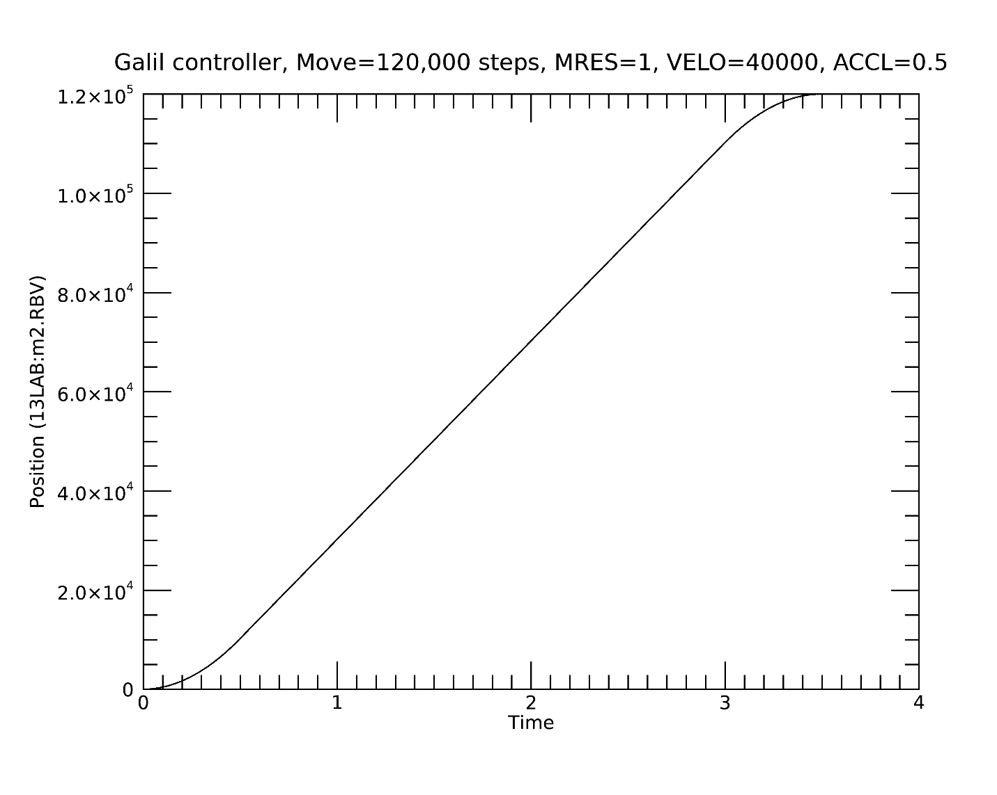

I then computed the velocity of the motor at each point from the difference in timestamp and position at point N and N+1. This is a plot of the velocity. It increases from 0 to 40,000 in 0.5 seconds at the beginning and decreases from 40,000 to 0 in 0.5 seconds at the end, as expected.

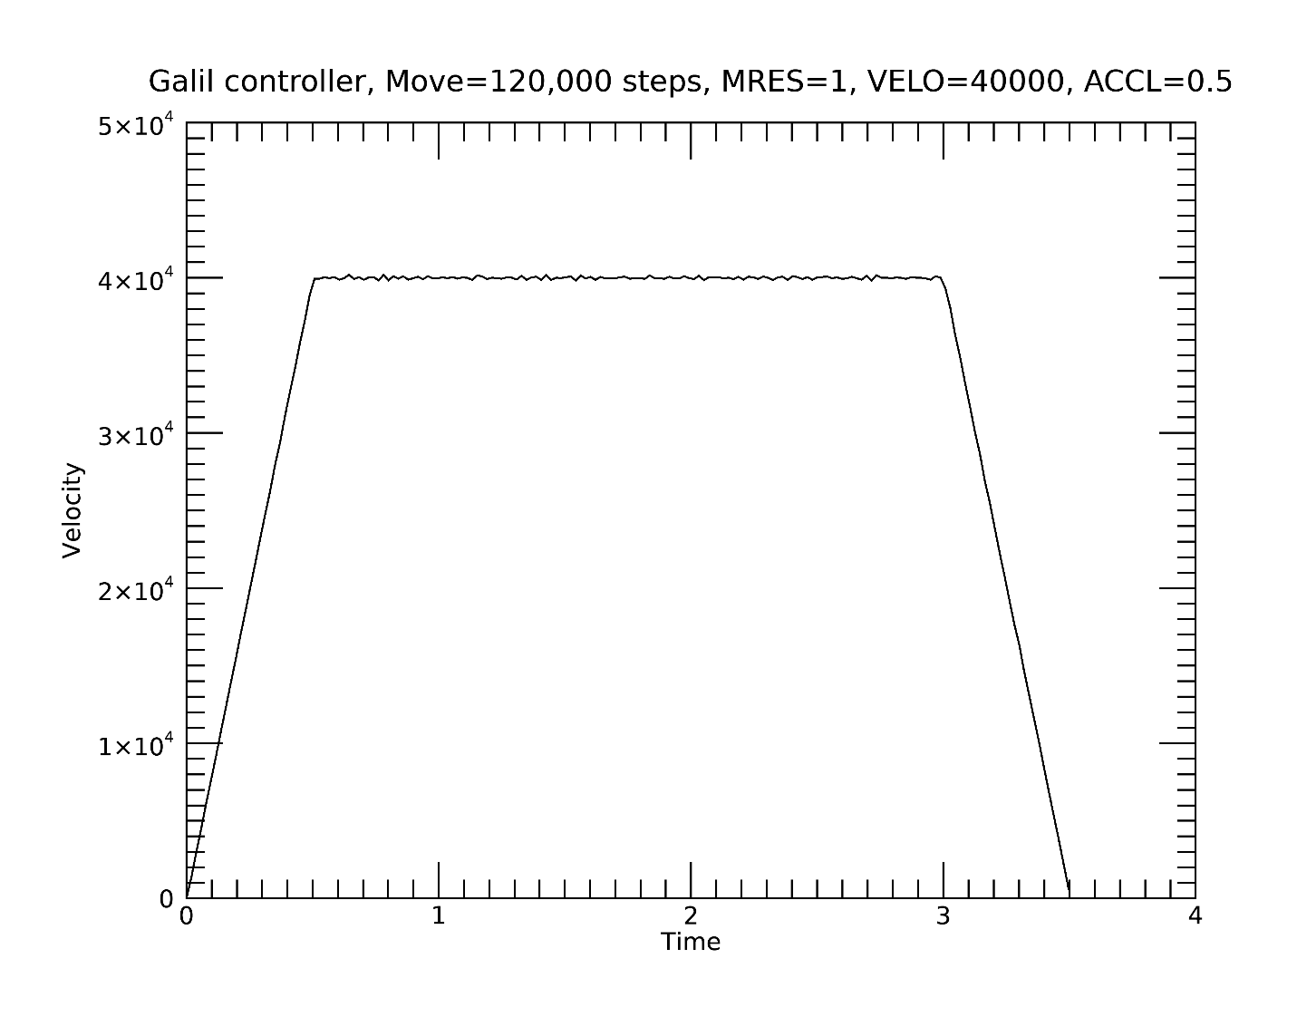

I then computed the acceleration of the motor at each point from the difference in timestamp and velocity at point N and N+1. This is a plot of the acceleration. It is 8000 steps/s/s at the beginning and -8000 steps/s/s at the end. There is a little noise, but no significant discontinuities that might cause stalling.

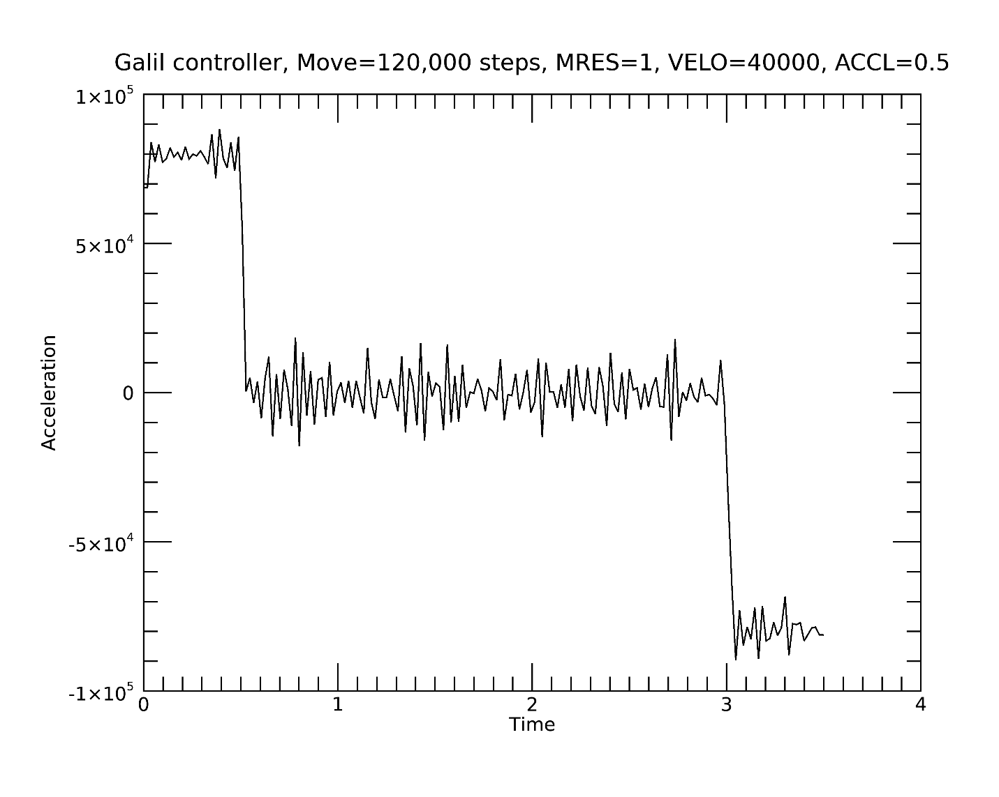

**Conclusions**

I have not been able to find any problems with the Galil controller when used with the Step-Pak driver or the on-board 3A drivers when running the test motor, which is identical to the real motor in the mirror tank. Both can run faster than we were previously running with the OMS.

The reason for needing to run the real motors slower with the Galils is thus still not known.