Space-Time Adaptive Processing algorithm

DOCUMENT CONTROL

 | - : | A : | B : | C : | D :
Written by: | Eric Lenormand

Revision index | Modifications
A | T. Petrisor
B
C
D

CONTENTS
1. Objectives 3
2. MTI application 3
2.1.1. Description of algorithm 4

Objectives
This example application is drawn from the airborne radar domain. For legacy reasons, it makes use of sometimes naive well-known radar processing techniques and is not a real operational one. But care has been taken to ensure that its main characteristics, i.e. the main issues from an implementation point of view are representative of what engineers in this industrial domain have to deal with when implementing on distributed platforms.
Those characteristics are mainly:
- a large part of the application is data-flow, manipulating multi-dimensional arrays of data
- data reordering ( switching dimensions of arrays ) is often needed
- the processing chain uses different operators, with in particular different needs in terms of precision and dynamic range
- the computational load is high enough to clearly involve parallel computing hardware
- real-time performance is one of the key requirements, both in terms of computation throughput and latency. This may result from some operational requirements and/or embedded architecture constraints such as memory limitations.

MTI application

The application is a simplified view of an MTI (Moving Target Indication) application, whose goal is to
receive the echo from the ground of a periodic sequence of radar pulses, and to detect the objects that are moving on the ground among all the other generally still reflecting surfaces under the radar beam (ground clutter).
Basically, radar processing permits to estimate both the position of a target through the delay between transmission of a signal (pulse) and reception of its echo, and its speed through the Doppler effect that affects echoes of several identical pulses sent periodically: the speed of the target results in a (small) variation of its distance from the radar, which is only visible as a phase shift on the radar signal ( e.g. around 10 GHz). In this basic approach, Doppler processing consists in a bank of filters (e.g. a Fast Fourier Transform) each one tuned towards a particular phase shift between successive echoes.
This kind of Doppler processing is in some situations sufficient to separate reflecting objects on the basis of their speed. When the beam is directed toward the ground, the largest part of the echoed energy is supposed to come from the still objects that compose the ground (called clutter), while the moving objects of interest send weak but phase-shifted echoes. However, the radar beam is not perfectly sharp and has a width of a few degrees, which results in giving to some still objects on the ground at the borders of the beam a relative speed with respect to the aircraft (due to the aircraft's own speed) and creating undesired interferences over the moving targets echoes: this creates an ambiguity between intrinsic speeds and azimuths of targets.
Adaptive filtering techniques, where fixed filters are replaced by filters that are computed at run-time from the received signal itself, help to minimize at best the effects of this unwanted clutter signal: this is the Space Time Adaptive Processing (STAP) is a powerful method to remove this ambiguity, consisting in computing from the signal received both from different antenna (or sub-arrays) and at different times a set of filters that will permit to make the distinction.

Description of algorithm

The STAPalgorithm is drawn and extrapolated from [1] and [2].

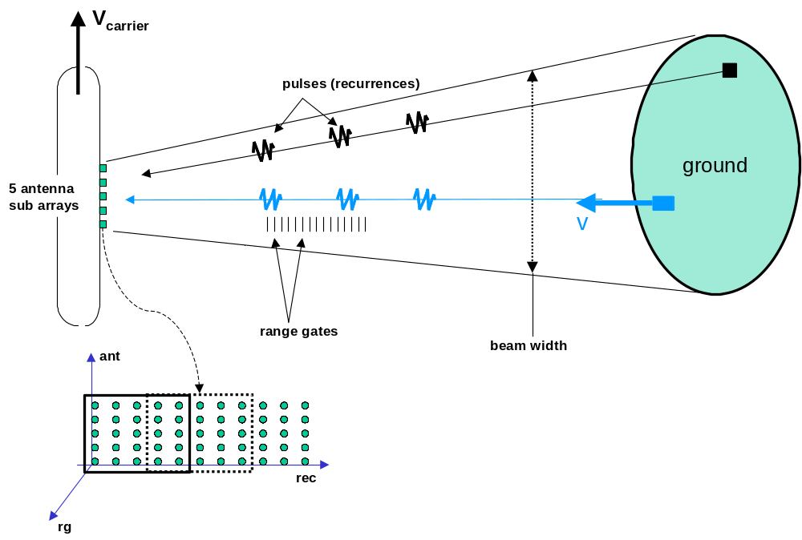

An aircraft illuminates the ground, with a beam orthogonal to its velocity, by sending repeatedly sequences of periodic pulses (denoted rec), called bursts. The periods and numbers of pulses may vary from burst to burst (although in the current example, the number of pulses remains the same ). The echoed signal is received on 5 sensors (ant) that are supposed regularly spaced and aligned. The receive time of an echoed pulse depends on the number of the pulse and of the distance of the reflecting surface on the ground. A measure of the latter is done by sampling the received signal at a given frequency, resulting in the distance being sampled into range gates (rg) (typically 15 meters for a 10 MHz sampling).Then the signal received by the radar processor is a 3D array with dimensions (Nrg, Nrec, Nant).
A block diagram of the MTI example application is given hereafter.
This diagram is captured from our internal SpearDE design environment. Each node in the graph is a nest of loops that iterates its own kernel. Kernels are the functions that are given in the C code of the benchmark. The correspondence between node names and kernels is given hereafter:

PulseCompression: Pulse_Comp
Av_Cov: CovAvCov
Mat_Inversion: Mat_Invert
SteerVects: Calc_steervect
Calc_Filter: Calc_Filter
Apply_Filt: Apply_Filter
Coh_Sum_2: Int_Dop
Average_Power: average_power
Add_Edges: tfac_add_edges
Thresholding: tfac
MaxAngle: MaxPower
V_compens: CorrecV
Plots: Mat2Plot
RemAmbig: RemAmbiguity

The edges between nodes represent each a flow of data (array) exchanged between two nodes. Most of the nodes need more inputs, which are static, or slowly varying parameters; for clarity, they are not shown in the graph.
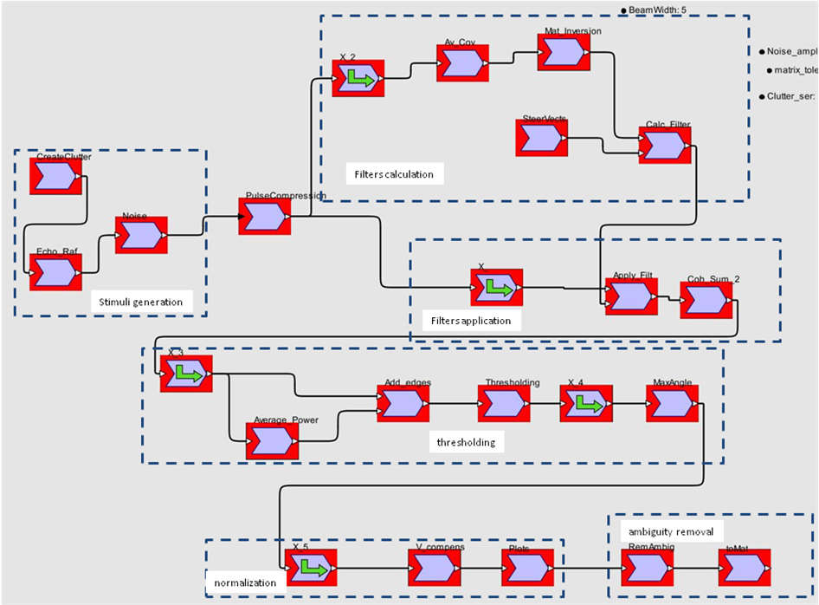

The first part in the graph consists in generating the returned signal: it is not part of the benchmark, where stimuli are read from an ascii file (InputStimuli.txt) which contains several bursts, each with a specific pulse repetition period (Tr) and a sequence of complex values.
The other parts are the actual STAP processing, with intra-burst and inter-burst processings. The intra-burst processing acts on each burst, with the following steps:
- PulseCompression is a 16-taps digital filter (convolution) matched to the shape of the pulse: a chirp. Outputs Z[Nrg - 15][Nrec][Nant]
- Covariance: For every range gate rg, and every rec from 0 to Nrec-5, computes
  - M[ rg, rec, a+5b, c+5d] = Z[rg][rec+b][a] * Y[rg][rec+d][c]^{T}
- AverageCov : Estimates the 25 * 25 interference covariance matrix (R[rg]) from different values of M. The approach taken here is merely to average M over pulses (rec). In the benchmark Covariance and AverageCov are grouped into a unique function ( AvCov)
- Mat_Inversion: inverts R[rg] with Gauss elimination method. In practice (not in the benchmark), this inversion may become instable. This is where floating point arithmetic is mandatory.
- SteerVects: computes vectors ST [v] [θ] for each possible angle θ and velocity v for the target. One considers 20 velocity assumptions, and 20 angles within the full beamwidth angle. Each ST is a 25-complex vector (a(v, θ) in Ref[1])
- Calc_Filter: Computes Vector W[rg][v][ θ] = Rinv[rg] ST[v][ θ] / ST[v][ θ]^{T} Rinv[rg] ST[v][ θ]
- Apply_Filter: Computes Y[rg][rec][v][ θ] = W[rg][v][ θ]^{T} VZ[rg][rec], with VZ[rg][rec] a 25-complex vector whose component (a+5b) is Z[rg][rec+b][a]
- Coh_Sum: Sums coherently Y[rg][rec][v][ θ] over rec dimension, to produce YC[rg][v][ θ]. This needs a table of coefficients (tab_coh)
- Average_Power, Add_Edges, Thresholding compute the average power of YC for each θ, pads with average power on edges on rg and v dimensions, and selects data of YC that have locally the highest energy data ( in a 5 by 7 rectangle on resp. v and rg ) and exceed the average power multiplied by a thresholding constant. Finally MaxAngle selects the angle θ with the maximum energy at each couple (v, rg).
- V_compens normalizes the thresholded outputs by compensating on v the effects of the aircraft own velocity at non orthogonal beams
- Plots finishes the burst processing by transforming the very sparse (rg, v, θ ) into a small number of plots where those values are artificially encoded into a complex value.

The inter-burst part operates on the result of several intra-burst processings
- The ambiguity removal (RemAmbig) operates on several bursts. Velocities detected at each burst are intrinsically ambiguous with a modulo proportional the pulse repetition frequency (1/Tr). By varying Tr from burst to burst, this ambiguity can be decided.

Special nodes with a green arrow can be seen in the SpearDE graph: they represent the reordering of arrays that are sometimes necessary between functions. They are invoked as functions with the same name in the C code. However, in real time implementations, those functions should be considered as pure data transfers.

References:

[1] STAP processing without noise-only reference: requirements and solutions, in F. Le Chevalier, S Maria, CIE 06 International Conference on Radar
[2] Radars aéroportés et spatiaux: Hardange, Lacomme, Marchais. Editions MASSON

