How to create models with UMLsec in Eclipse/Papyrus

Preparation: Install Papyrus

- Install Eclipse MDT (Helios SR1 release)
(Windows users please use the win32 version, the 64-bit variant does currently not work with Papyrus.)
- Use the discovery interface ("Help" => "Install Modeling Component") and select Papyrus.
- Proceed through installation steps.
- Exit Eclipse
- Copy the de.umlsec.profile.umlsec Plugin into the dropins folder below your Eclipse installation folder.
- Start Eclipse
- Papyrus is now ready for modelling UMLsec models.

Create a model and import the UMLsec profile:
- Create a Papyrus project
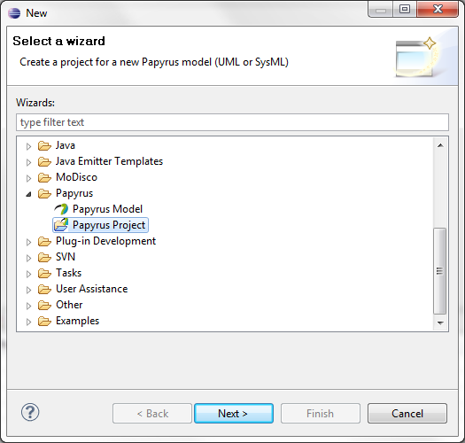
Alternatively use an existing project as container for your models and select „Papyrus Model“ in the dialog. (Please skip step 2.)
- Define a project name
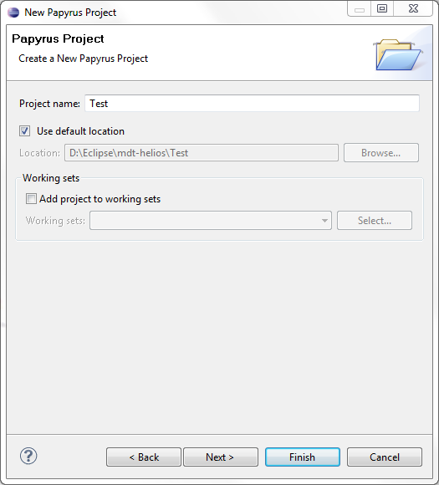
- Select „UML“ as the type of model you want to create.
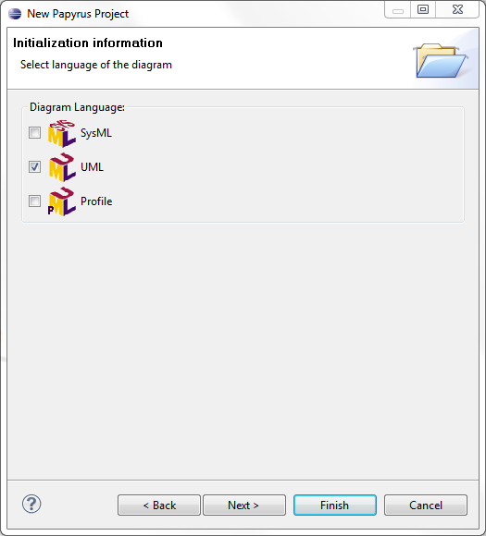
- Enter the diagrams name. Select the with diagram type.
AND: Select that you want to load the UML model with basic primitive types as a template. (This will make modelling easier for you)
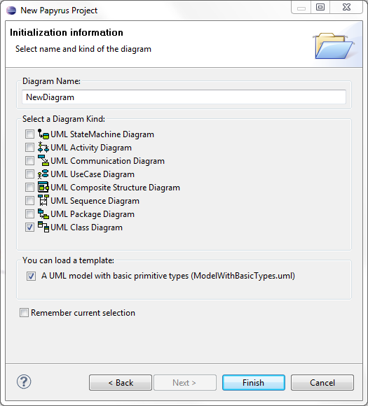
- Click „Finish“. The new empty diagram will be opened.
- In the Project Explorer select the .uml file of your model.
- Right click the .uml file and select „Open with >> UML Model Editor“
- The following screen will appear: 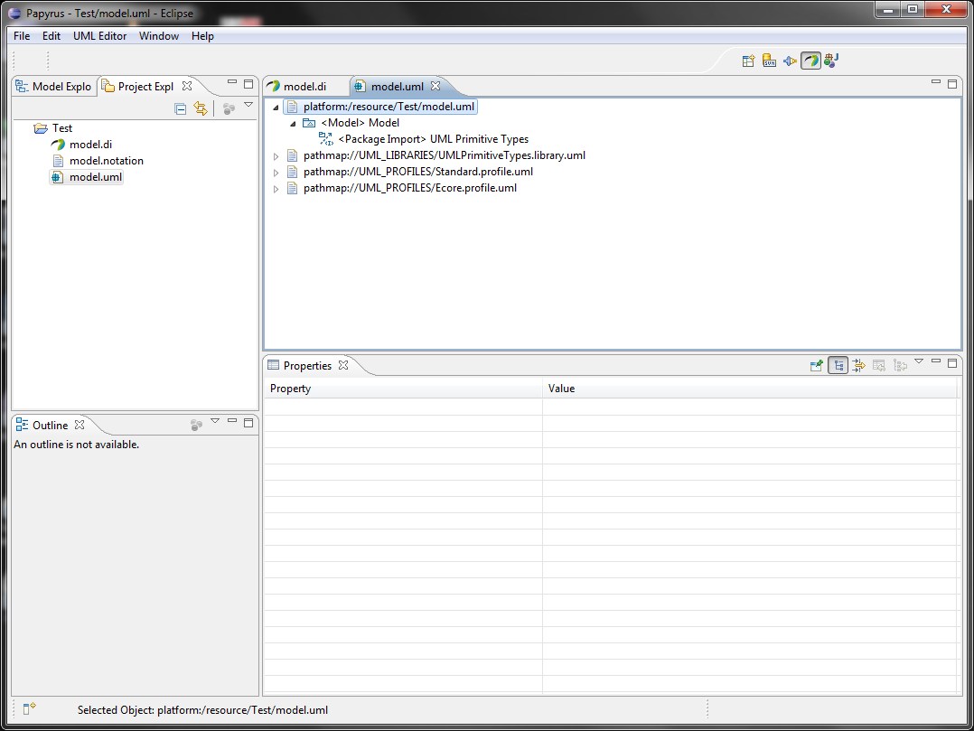
- Select the „<<Model>> Model“ node
- Select the Menu „UML Editor >> Package >> Apply Profile“.
- Select the „UMLsec“ profile in the following screen.
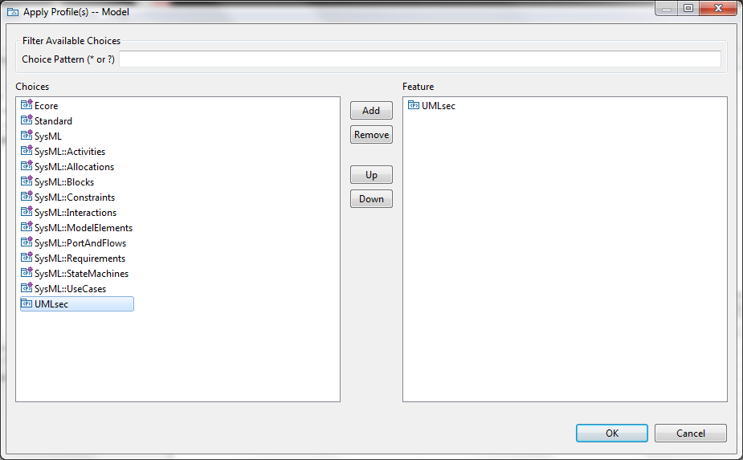
- Click „Add“ and „Ok“ to apply the profile.
- Close the UML model editor and the diagram editor.
- In the following dialog click „No“
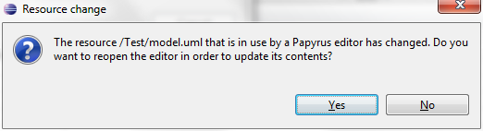
- If you re-open your diagram, the UMLsec profile is available and can be used: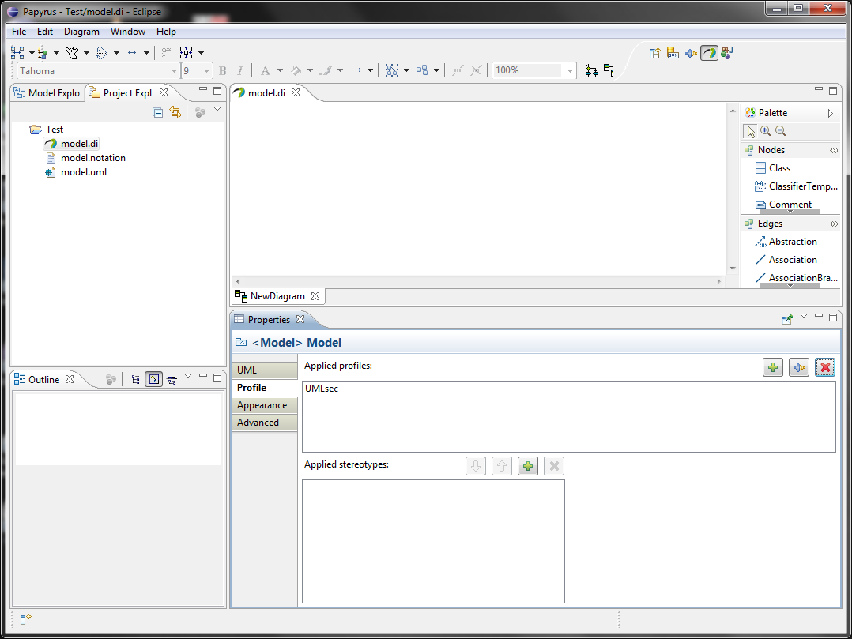

Happy Modelling!

