Howto export a profile to be used in Papyrus

- Right-click the profile project
- Choose „Export“ from the context menu
- Choose „Deployable plug-ins and fragments“ and click „Next“
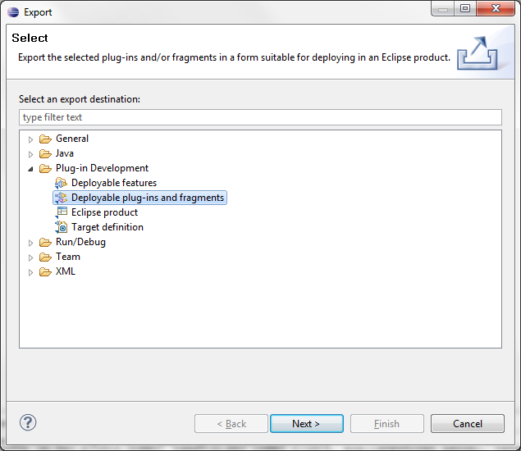
- Select the profile project to be exported
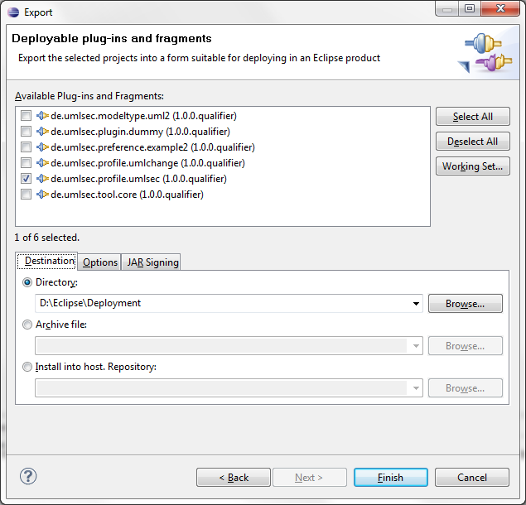
- In the „Destination“ tab select the folder to which the profile plugin will be exported.

- In the „Options“ tab choose the options as follows
(should be the default selection)
Note: Keep the default value of the option „qualifier replacement“. It is a time stamp.
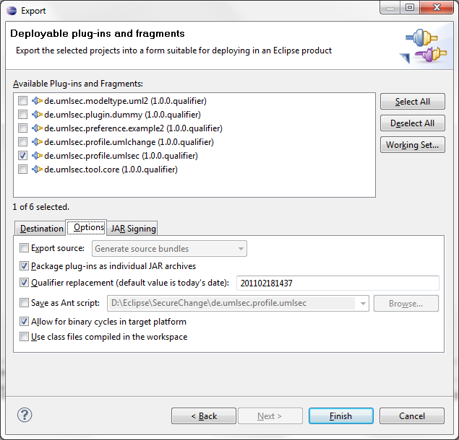
- Keep the „JAR Signing“ disabled.
- Click „Finish“
- After some seconds you find the exported plugin in the folder you specified in step 5.
You can copy it into your Papyrus installation and use it there. (See extra Howto)

