**RMA Report**

**Objective**: RMA Returns data organized by state and product type identifying key information to streamline operations.

1. SQL commands to**capture usable data**
   1. N**umber of returns** **by state:**

SELECT Customers.State AS State, COUNT(*) AS Returns

FROM Orders INNER JOIN RMA ON Orders.OrderID=RMA.OrderID

INNER JOIN Customers ON Customers.CustomerID=Orders.CustomerID

GROUP BY State ORDER BY Returns DESC;

* 1. **Percentage of returns by product type**:

SELECT Orders.Description AS Part, SKU,

(COUNT(*) * 100 / (SELECT COUNT(*) FROM Orders

INNER JOIN RMA ON Orders.OrderID = RMA.OrderID))

AS Return_Percentage FROM Orders

INNER JOIN RMA ON Orders.OrderID = RMA.OrderID

GROUP BY Description ORDER BY Return_Percentage DESC;

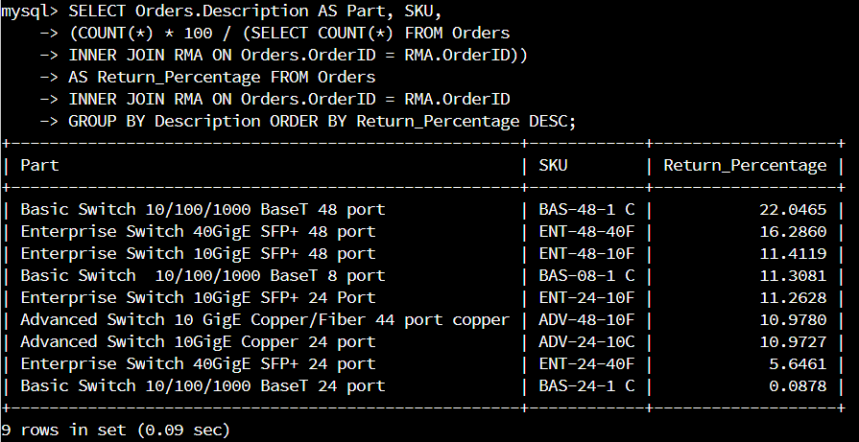

1. **Analysis**
   1. **Number of Returns by State:**

The data shows us that while Massachusetts has the highest number of returns, 6 of the top 10 states with a high number of returns are in the Southern Region of the U.S.

* 1. **Percentage of Returns by Product Type:**

Of the 9 Quantigration products, the product with the highest rate of returns is the Basic Switch 10/100/1000 BaseT 48 port. The top 3 returned products are all from the 48 port line of products.

1. S**ummary of analysis:**

Answer the following:

* 1. How does the data provide the product manager with usable information?

The data provides the product manager with an overview of which Quantigration products are being returned and where they are being returned from. This is useful for the product manager to instruct the sales team to make better recommendations about what products will best suit customers’ needs, and the QC and manufacturing teams on which products to scrutinize for defects.

* 1. What are the potential flaws in the data that has been presented?

This data is incomplete. In order to get better understanding, one would need to analyze the return numbers against the total number of products sold, and the population of customers in each state.

* 1. Are there any limitations on your conclusions, or any other ways of looking at it that you haven’t considered?

Yes. One could benefit from further consideration of which products are most frequently sold in what state, returns by state for each individual product, most frequent reason for return of each product, and then investigate the root cause of defects for the product with the most returns due to a defect.