**CAS Programme Aims**

* **enjoy** and find significance in a range of CAS experiences
* purposefully **reflect** upon their experiences
* identify **goals**, develop **strategies** and determine further actions for **personal growth**
* explore new possibilities, embrace new **challenges** and adapt to new roles
* actively participate in planned, sustained, and **collaborative CAS projects**
* understand they are members of local and **global communities** with responsibilities towards each other and the environment.

CAS formally begins at the start of the Diploma Programme and continues regularly, ideally on a weekly basis, for at least **18 months** with a reasonable balance between creativity, activity, and service.

“Students engage in **CAS experiences** involving one or more of the three CAS strands. A CAS experience can be a single event or may be an extended series of events.

Further, students undertake a **CAS project** of at least one month’s duration that challenges students to show initiative, demonstrate perseverance, and develop skills such as collaboration, problem-solving, and decision-making. The CAS project can address any single strand of CAS, or combine two or all three strands. “ (IB DP, CAS Guide 2015)

All CAS students are expected to maintain and complete a **CAS portfolio (Managebac at ISA)** as evidence of their engagement with CAS.

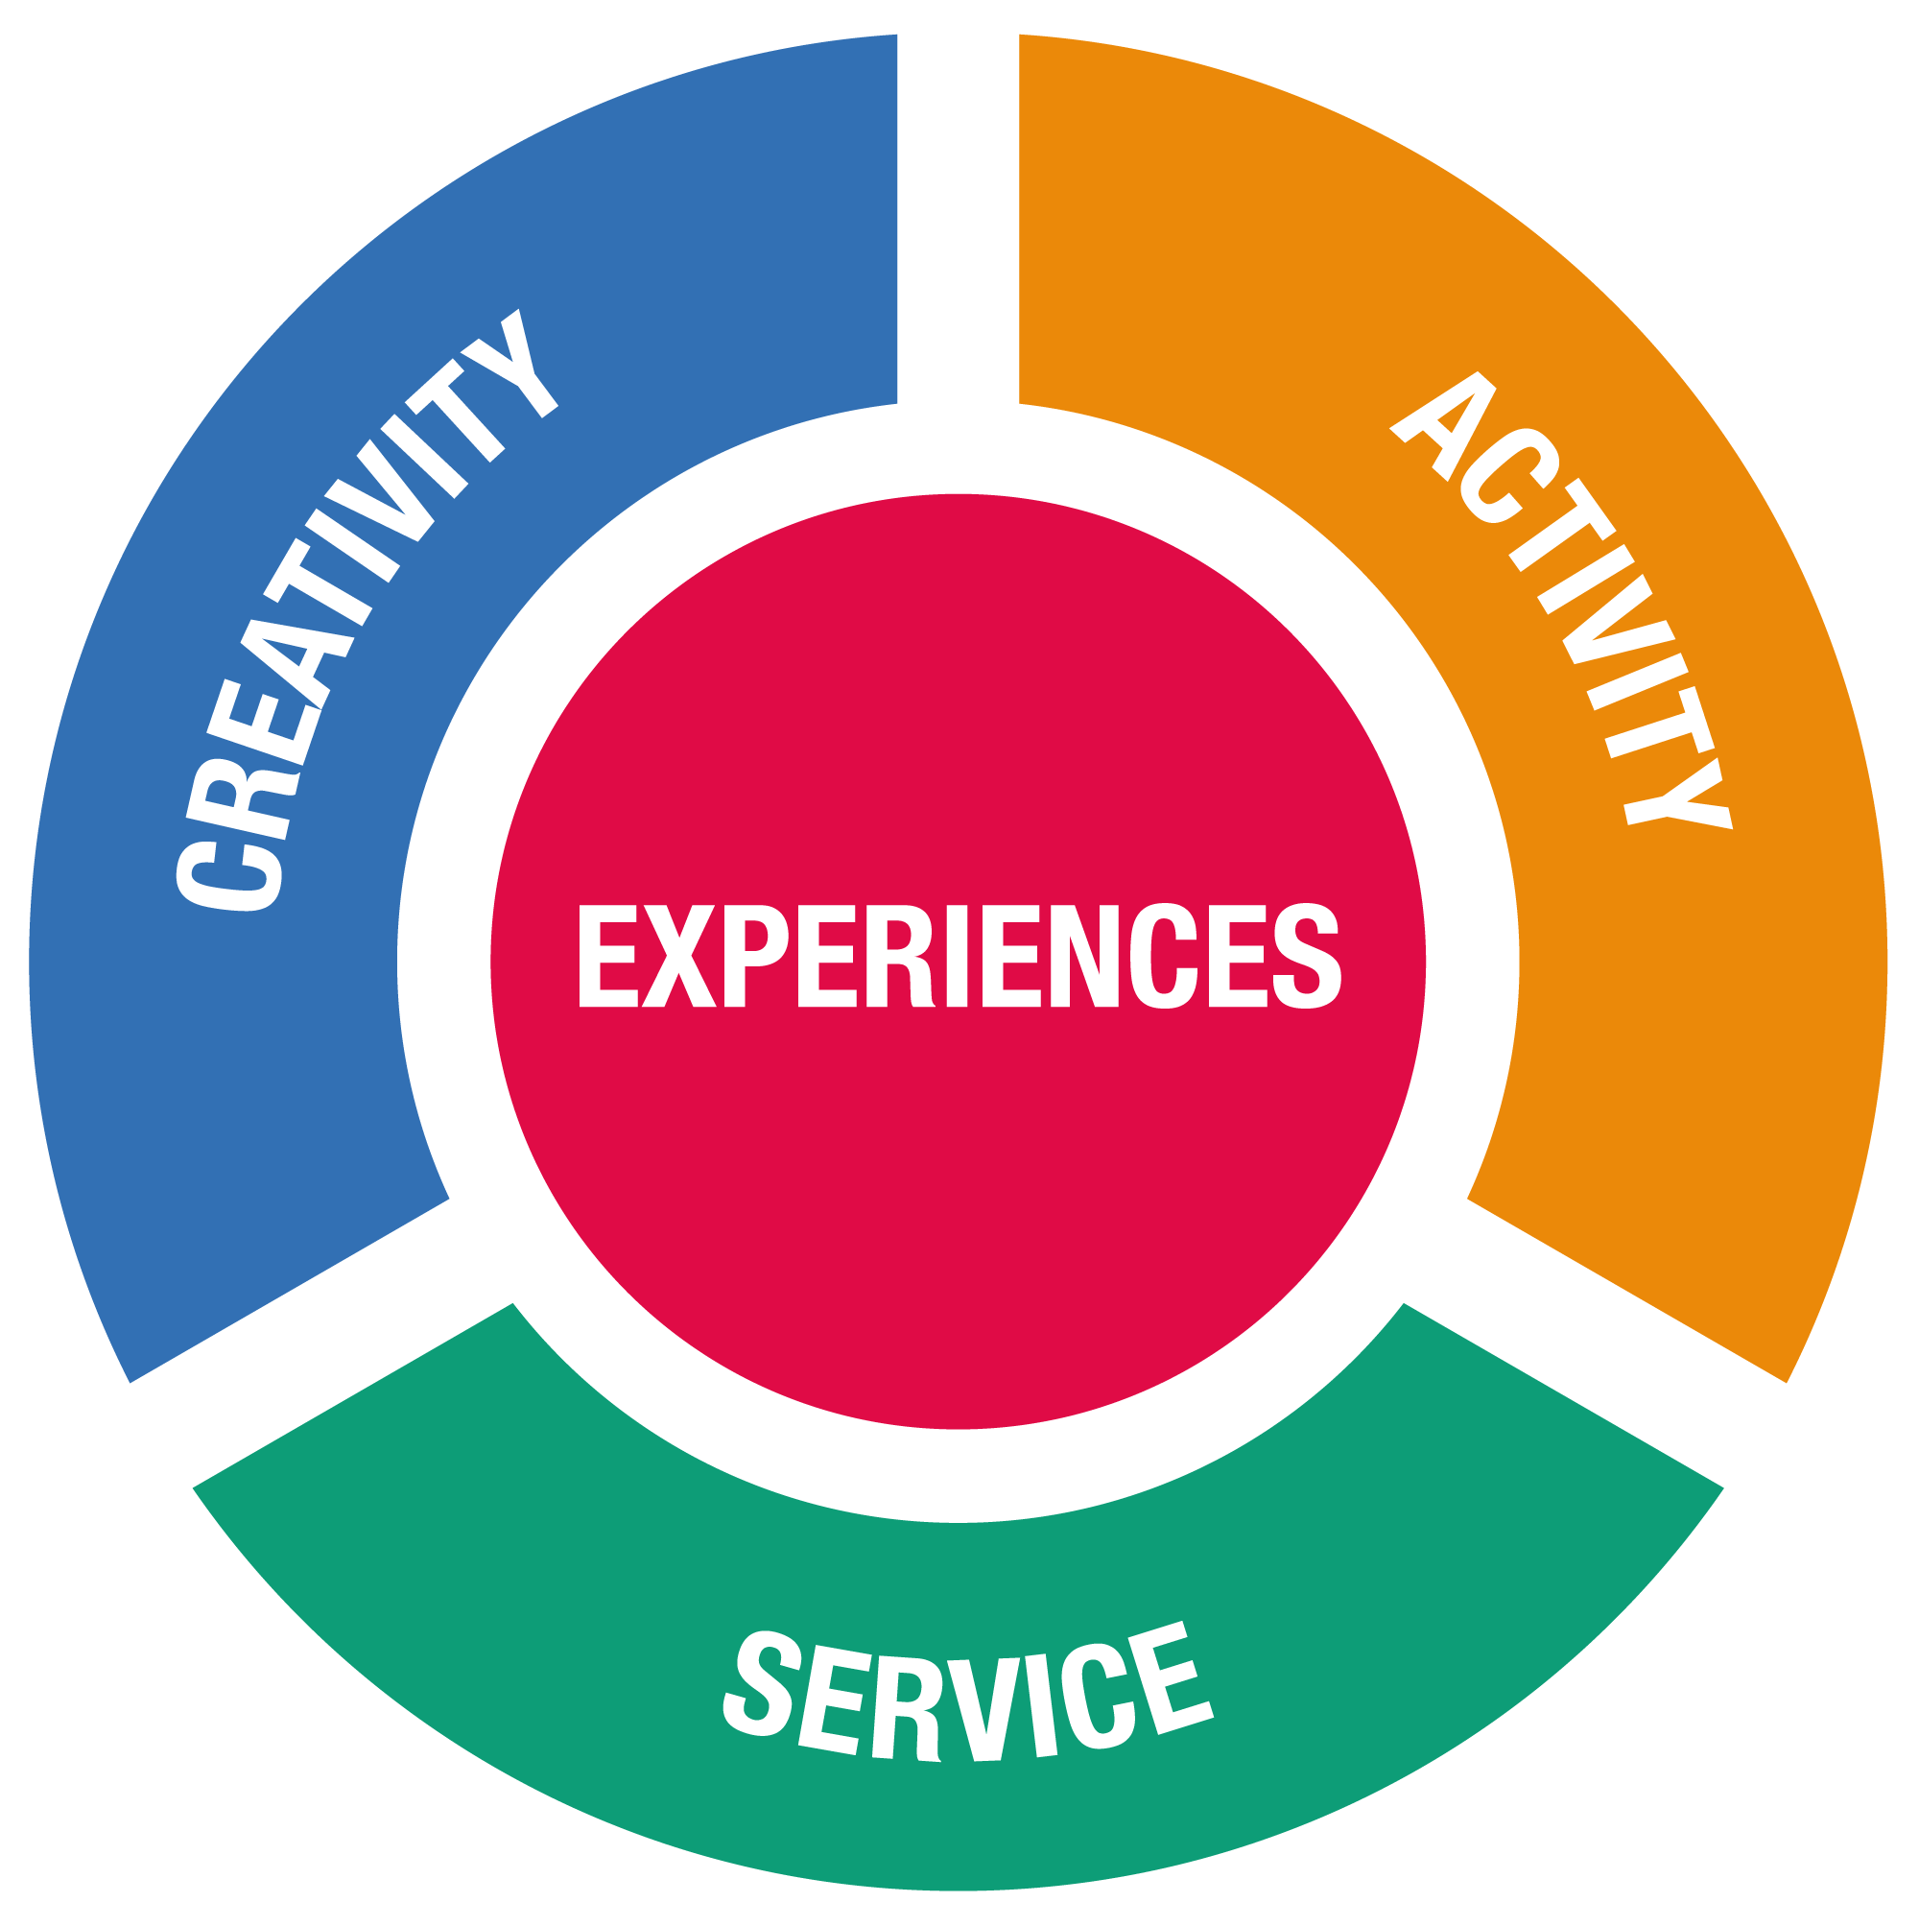

**CAS Strands**

• **Creativity**—exploring and extending ideas leading to an original or interpretive product

or performance

• **Activity**—physical exertion contributing

to a healthy lifestyle

• **Service**—collaborative and reciprocal engagement with the community in response

to an authentic need

**CAS**

**CAS Project: collaborative series of CAS experience**

**______________**

**CAS stages used**

**Series of CAS experience**

**______________**

**CAS stages**

**used**

**Single CAS experience**

**______________**

**CAS stages may/**

**May not be used**

**CAS Stages**

**Reflection**

**Investigation**

Reflection

Reflection

**Action**

**Preparation**

Reflection

**Demonstration**

**CAS Learning Outcomes**

1. Identify own strengths and develop areas for growth
2. Demonstrate that challenges have been undertaken, developing new skills in the process.
3. Demonstrate how to initiate and plan a CAS experience
4. Show commitment to and perseverance in CAS experiences
5. Demonstrate the skills and recognize the benefits of working collaboratively
6. Demonstrate engagement with issues of global significance
7. Recognize and consider the ethics of choices and actions

**ISA 4 step reflection template:**

1. Description
2. Interpretation
3. Connections
4. Action Plans

**Refection in CAS:**

* Reflection is central to building a deep and rich experience of CAS. Students explore their own actions and reflect on their personal growth.
* The emphasis in CAS is on affective reflection, characterized by reflecting on attitudes, feelings, values, principles, motivation, emotions and self-development.
* Students will be encouraged to informally reflect on their CAS experiences throughout the CAS programme, but are required to reflect formally when developing a CAS portfolio.

**Examples of CAS Journeys**

**Student A [C3A4S4]**

**Grade 11**

|  |  |  |
| --- | --- | --- |
| **Experience** | **Strands** | **Duration** |
| Duke of Edinburgh Award – Gold | A and S | all year |
| Photography | C | all year |
| Basketball | A | One term |
| Habitat for Humanity – **project** | A and S | All year |
| Football | A | One term |
| Amnesty International | C and S | all year |

**Grade 12**

|  |  |  |
| --- | --- | --- |
| Sound and Light | C and S | Half a year |
| Basketball | A | One term |
| Gay Straight Alliance | C and S | Half a year |
| Meditation | A | Half a year |

**Student B [C5A4S3]**

**Grade 11**

|  |  |  |
| --- | --- | --- |
| **Experience** | **Strands** | **Duration** |
| Like a Girl – **project** | C and S | All year |
| Hockey | A | One term |
| Fair Trade | C and S | All year |
| Refugee Buddies | C, A and S | All year |
| Model United Nations | C | All year |

**Grade 12**

|  |  |  |
| --- | --- | --- |
| Like a Girl | C and S | Half a year |
| Refugee Buddies | C, A and S | Half a year |
| Softball | A | One term |
| Yoga | A | Half a year |
| Art Club | C | Half a year |

**Student C [C6A3S5]**

**Grade 11**

|  |  |  |
| --- | --- | --- |
| **Experience** | **Strands** | **Duration** |
| Debate Club | C | All year |
| Competitive Debating (helping younger students with specific skills) **project** | C and S | All year |
| Special Olympics | C and S | All year |
| Student Council | C and S | All year |
| United Through Sport | A and S | All year |
| Tennis | A | One term |
| Indoor Climbing | A | One term |
| Creative Writing | C | Half a year |

**Grade 12**

|  |  |  |
| --- | --- | --- |
| Competitive Debating | C and S | Half a year |
| Tennis | A | One term |
| Indoor Climbing | A | Half a year |
| Voice | C and S | Half a year |

**Please note:**

* **CAS Project:** 
  + 1. A CAS experience where you must show you work towards achieving at least 3 Learning Objectives ( Initiative & Planning, Collaborative Skills and Strength & Growth)   
    2. Your project has to be longer than one month.   
    3. Although it can have one strand (Creativity, Action or Service) preferably you will have at least two of these.

4. Show evidence of using CAS Stages.

* Each student will be responsible for scheduling and shaping their CAS journey based on their own interests and opportunities.
* The student has to demonstrate all strands (C, A or S) and meet all learning objectives, which will be demonstrated through their reflections and involvement. Joining a club will not automatically satisfy any strand or show achievement of learning objectives.