**Batch: B3 Roll No.: 1611109**

**Experiment / assignment / tutorial No: 09**

**Grade: AA / AB / BB / BC / CC / CD /DD**

**Signature of the Staff In-charge with date**

|  |
| --- |
| **Title:** Introduction to GitHub version control |

**Activity:**

1. **Introduction to Version Control.**

Version control systems are a category of software tools that help a software team manage changes to source code over time.

It keeps track of every modification to the code in a special kind of database.

If a mistake is made, developers can turn back the clock and compare earlier versions of the code to help fix the mistake while minimizing disruption to all team members.

1. **Importance of Version Control.**

Collaboration between developers.

Storing version properly.

Understanding what happened.

Backup.

Restoring Previous Versions.

1. **Applications of Version Control.**
2. Each user updates a file before working on it, to ensure starting with the latest changes and revisions
3. Each user checks out (or locks) the file to prevent other team members from conflict
4. After making changes (and verifying them in a local build or other method), the user checks in (or commits) the file to the team's shared repository
5. Web development
6. System management
7. Home directory management

GITHUB

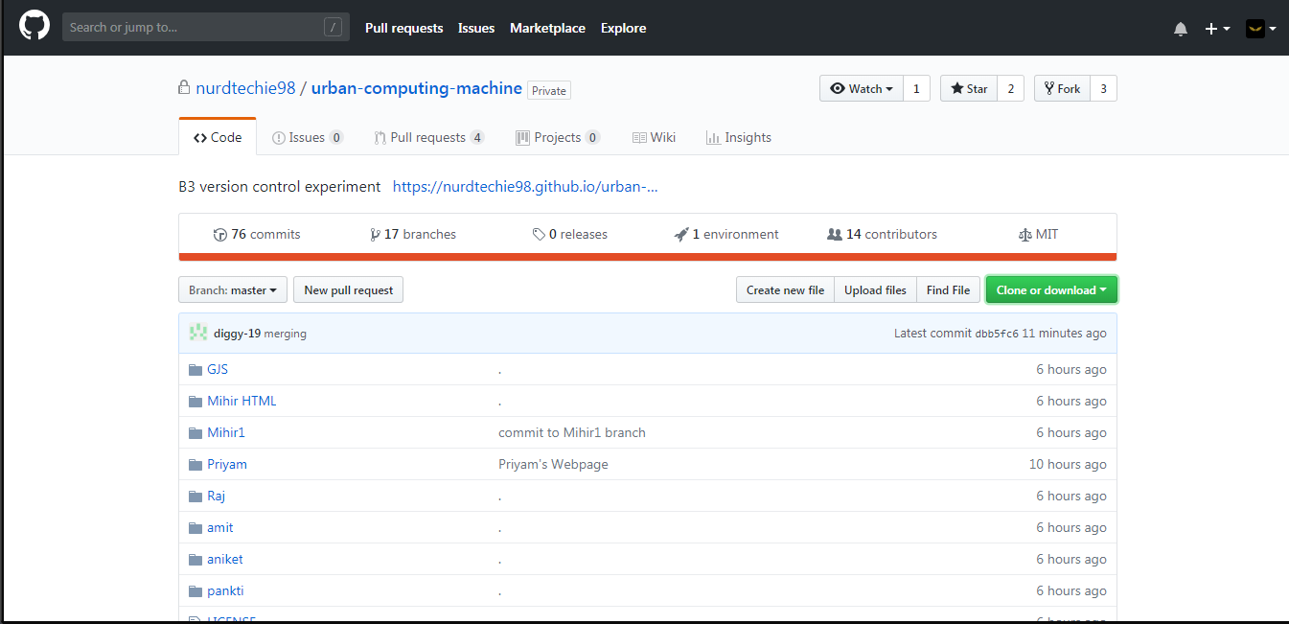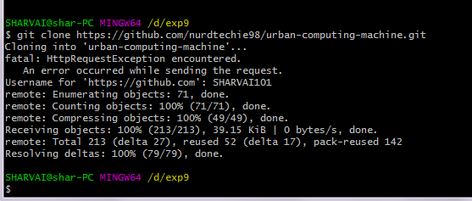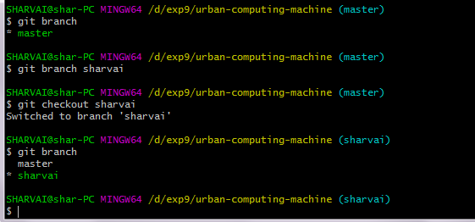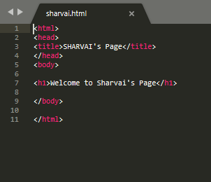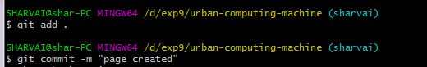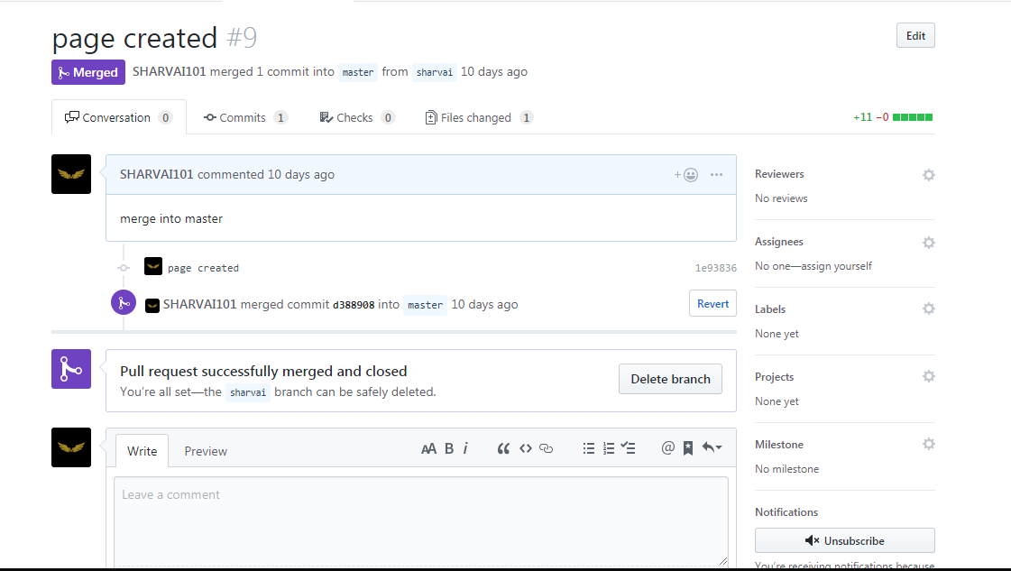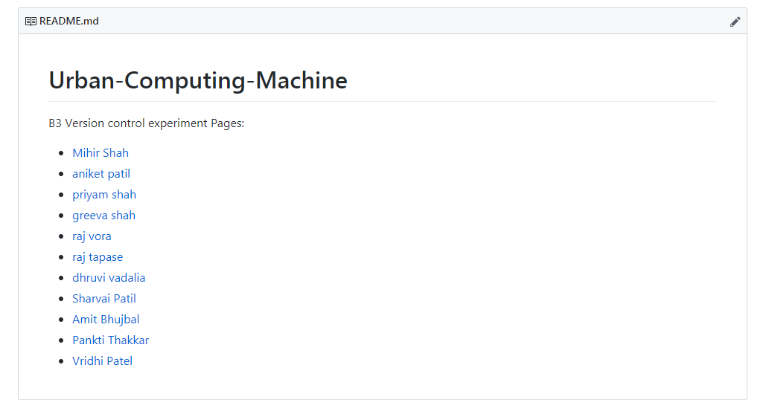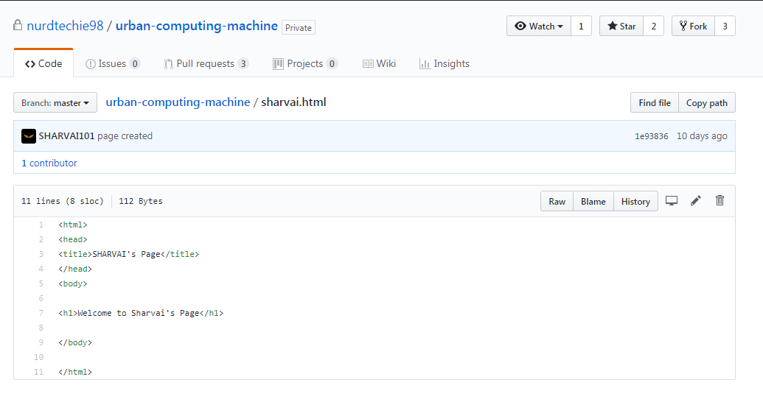

**Conclusion**: Hence I understood the installation and use of GitHub as well as creation of repository, branches and applying pulling, pushing request to the file.