Invisible Cities – Air Quality

Group Project Report

Group 3 – Qiuwen Ju, Tom Keel, Zixin Lyu & Jay Wilson

**Introduction**

Our project visualisation educates visitors to our website about the levels of air pollution in major cities and the consequences for the people that live there. The global scientific measurements that make up a city’s air quality index are linked to simple cartoon depictions that provoke an an instinctive response in visitors and a short history of air pollution betrays how slowly authorities respond to incidents. The goal is to produce a reaction in anyone who looks at this information – that we must do more to provide clean air in urban environments anywhere in the world.

**Early decisions**

Different topics were discussed at first. Our team had ideas such as displaying information about transport or green spaces within a city, but interests were divided until we explored linking these topics together and discovered the idea of air quality. Once this became our theme we discovered that it was a more passionate topic – all of us live in cities and we have all had direct experience of breathing clean and polluted air.

Visually our aims were more diverse. At first we wanted a 3-D spinning globe, 3-D streets displaying airborne particles blown by the wind past a family, live pollution information accessed using air monitoring stations around the world, satellite maps of pollutant levels where there were no monitoring stations, and child-like cartoon faces forming lasting memories for website visitors.

**Interactivity**

Spinning globe – hover over any country to highlight its land area in a different colour. The colour is related to the percentage of GDP contributed by the industrial sector in the expectation that heavily industrialised countries will have the worst pollution. The fraction of a country’s GDP earned by industry is provided by the CIA website.

World maps and clicking on individual cities – some cities have more pollution data about them than others and we wanted to make it obvious to the user how to select these cities. Clicking on the major cities with a square icon instead of a circle icon provides the extra information available for them, such as pollutant readings from the city in the past twenty-four hours. The pop-up information includes a coloured cartoon face for an instant reaction.

Historical sliding bar – the history of air pollution is littered with slow reaction from local and national authorities after an incident has occurred. The technical content in this history tour is reduced so that readers consider the impact on human life more, and for the same reason there are cultural references to festivals, films and fashion.

**Static**

Home page – the first powerful image seen by the visitor sets the mood for the topic of urban air pollution. The people look tiny on the bridge, the bridge is but a slim strand crossing a ponderous murky river and over the distant riverbank tower huge buildings hidden behind haze and clouds. The aim is to indicate the size of the problem without any indication of an answer.

Splash-page text – a slim sans-serif font is used to for a modern look to match many contemporary websites. For example, <https://www.copernicus.eu/en> (primarily EU satellite earth-measurements and research) is an example of the recent fashionable use of sans-serif font. It uses bright blue and green colours on its home page to promote our planet’s attractive vitality, which our home page does not have nor do. In contrast, another website concerned with air pollution, <http://aqicn.org/city/beijing/>, looks old-fashioned because it uses serif font, unchanged from the early days of the internet.

Street level

Extra information

**Styling**

Photograph selected by Qiuwen – dominant brown and greyish-blue are used to indicate pollution on our home page, selected. These colours match the tones in Chai Jing’s “Under The Dome” documentary about pollution in China, displaying grey urban skies in outdoor scenes, subdued blue lighting on stage in a dimly-lit theatre and a brown and beige cartoon explaining how pollutants enter our bloodstream.

Home page title – a slim sans-serif font is used to for a modern look to match many contemporary websites. For example, <https://www.copernicus.eu/en> (primarily EU satellite earth-measurements and research) is an example of the recent fashionable use of sans-serif font. It uses bright blue and green colours on its home page to promote our planet’s attractive vitality, which our home page does not have nor do. In contrast, another website more directly concerned with air pollution, <http://aqicn.org/city/beijing/>, looks old-fashioned because it uses a serif font, unchanged from the early days of the internet.

The warning message under the title is there to emphasize the secondary purpose of this project; our team is not just practising our website visualisations and displaying skills at obtaining and presenting data so that we get good marks on the course, we are keen to see environmental change happen in our world. We are not at Greta Thunberg’s level, she used the cathedral fire at Notre-Dame to urge European politicians to act on climate change, but we hope our website adds to this momentum. Jay provided the text, the idea coming from an unpublished original card game that he created to educate his teenage children about money and life.

There are different shapes for some cities, square markers attract the viewer’s attention that more information is available. There are no instructions to hover over a square representation of a city but our expectation of a user’s implicit interaction (Atterer, Wnuk & Schmidt, 2006) is that someone will move to and click an object on a screen because the limited functionality of a mouse permits them to do little else.

We selected the same colour index to indicate air quality as used on a quick search of existing websites images. Green is good air quality, going through a reverse rainbow-like sequence back to red before using violet and brown for the poorest air. The cartoon faces have a similar sequence, going from green (happy) to orange (neutral) to red (sad) but finishing on grey for the worst pollution to indicate that someone’s life is severely affected. The cartoon faces were hand-drawn by Jay to add a natural look and emphasize that air pollution readings affect real people. They link numerical measurements to the effect that polluted air has on someone’s health and life-expectancy.

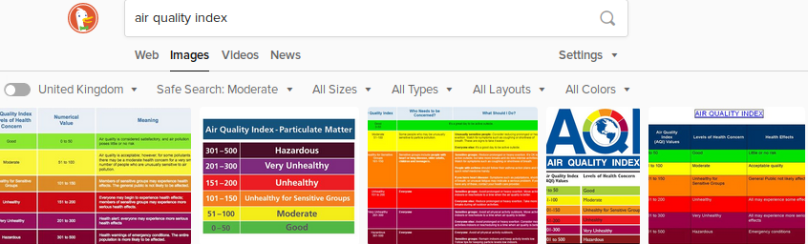

We provided cartoon faces for maximum impact. A person’s response “generalises equally well to upright cartoon faces as to human or cat faces despite their very different low-level image properties” (Tong, Nakayama, Moscovitch, Weinrib & Kanwisher, 2000) and we wanted to make sure our website was memorable. This contrasts with many other air quality websites which have plenty of information but do not create the same immediacy and memories for the viewer.

**Technologies**

Tom introduced our team to GitHub and documented common command-line git instructions to ensure everyone kept in step. He also introduced us to Webstorm, a multi-tasking IDE (Integrated Development Environment) that inspects code, renders a webpage in the manner of one of a choice of browsers, includes Git support and is also free for thirty days use.

He also got our website deployed from GitHub on to Netlify. Netlify offers a one-stop-shop method of developing a website but we did not explore this because we were more experienced with GitHub already. We lost control of the website by using Netlify, at the time of writing it is the mostly meaningless [https://globe-view--determined-bohr-fab812.netlify.com/#page6](https://globe-view--determined-bohr-fab812.netlify.com/" \l "page6) but again, it is free to use.

At the beginning there were two options for our 3-D spinning globe. The dedicated example Jay found at <http://planetaryjs.com/examples/quake/index.html> seemed promising because it had similar elements to those we wanted to display: data elements displayed on a rotating sphere with a side-bar explaining the visualisation, but Jay and subsequently Tom discovered that the display was difficult to alter. Tom recommended we worked with Mike Bostock’s D3 globe as displayed by Patricl Stotz here <http://bl.ocks.org/PatrickStotz/1f19b3e4cb848100ffd7>

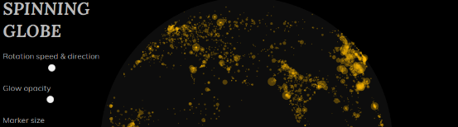

but we did not want cities

Lyu found and researched the sister websites, <http://aqicn.org/city/beijing> and <https://waqi.info/> and set up the API keys and downloads from air pollution monitoring stations that our website runs on. Where possible she enhanced the live measurements on these websites by collecting previous readings from the past twenty-four hours to display in an inset on the main page. This data was available for two hundred major cities. The data had to be collected and saved to speed up the response of the webpage, because if the API were triggered to collect the past day’s data only when a user clicked on a city there was a two minute delay before anything was displayed.

Jay used GIMP to digitally enhance and standardise the photographs of the cartoon faces he drew on paper. All faces were scaled to fit the same 128x128 png (Portable Network Graphic) file, given a flat colour of green, amber, red or grey, and each of the four colours was put on three backgrounds of white, black and alpha (transparent).

Satellite data from the Copernicus project for related readings – leaf area index, ozone

CSS, JS,

website tools

Python modules shapely

**Challenges and solutions**

Because we were attempting so many firsts with this project we made many decisions that we later changed or dropped entirely.

We had never worked together before and the difference in our experience levels showed when we tried to collaborate using GitHub (<https://github.com/>). The normal pattern of command-line edits, commits and merges did not go well and Tom changed the way we worked to using less global updates so that it was not so disruptive.

We used two API successfully, one from a Chinese website published in English (<https://aqicn.org/api/>) and the other from the Copernicus programme run by the EU (<https://www.esa.int/Our_Activities/Observing_the_Earth/Copernicus>). Together, the first API covered the publicly available air pollution data for all the world’s major cities and the second API covered ozone levels around the globe measured by satellite (ESA, European Space Agency, online) where no ground measurements were made or published. These measurements from space are important because the AQI for the two largest African cities – around twenty million inhabitants each – is unknown as neither Egypt nor Nigeria publish results for Lagos nor Cairo.

However, what we could do with the data downloaded from these two API was very different. The ground-based measurements provided live data readings at hourly or daily intervals. This gave Lyu the opportunity to provide two visualisations: a simple reading for cities where daily measurements was taken or a graph of the past twenty-four hours for cities with hourly measurements. However, it was necessary to use her laptop as a staging post to save the previous day’s API data to GitHub because updating the webpage with live data directly from the API caused a two minute delay before the information was displayed. Querying GitHub files made the webpage much more responsive.

Using the data from a satellite was more challenging. ESA stores the petabytes (!) of data transmitted by their Sentinel satellites in several data hubs for international researchers to access it. Obtaining an API key for the Copernicus data service involved a week-long wait before it would work. Jay downloaded and displayed a sample .GRIB file (of temperature anomalies in 1979, a careful look shows that this map is centred on the Pacific Ocean)

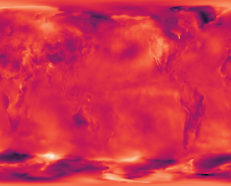

but more recent measurements of ozone and LAI (Leaf Area Index, a scale of 1-10) were downloaded in 300MB+ .nc format files and Python frequently crashed reporting a “Memory Error” while trying to create a dataframe.

We found that 3-D globes are not easy to add information too. Tom discovered that an attractive rotating globe with earthquakes (<http://planetaryjs.com/examples/quake/index.html>) was difficult to modify. And the vector graphics approach used by D3 (<https://www.d3indepth.com/geographic/>) is not suitable for a raster map, but raster data is what satellite instruments collect as they orbit over the planet beneath them. The website <https://www.maptoglobe.com/> provides a globe-making service using raster image files but with stitching visible across the back:

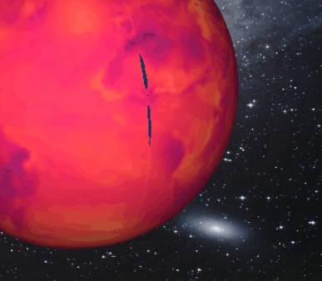

The raster form of the Copernicus data is ideal for selecting a patch of the Earth’s surface to display a 30km square patch (equal to 900 square kilometres) of ozone or LAI values centred on a city, and ESA provides a Climate Data Object (CDO, but not Microsoft’s CDO) program that performs exactly this function in a single command [example]. Their example was for displaying wind-speed patterns around the eye of a hurricane without a the need for spotter aeroplane, but the program would not have run on a simple webserver.

There is a potential fix for both the two issues of pre-loading the twenty-four hour ground-based air pollution data and running the CDO program using the Linux command-line – by using a separate server hosted online in the current environment of AWS and Azure cloud computing.

The remaining issues were smaller and easier to solve. An initial design decision to use a sliding webpage that scrolled smoothly and vertically when the radio buttons were clicked was dropped because the transition produced an unattractive jump from one background to another over the scrolling horizontal line.

Displaying different red tones across the globe to show the difference between levels of pollution failed to provide enough difference for our eyes to spot the different values so Tom changed the scale to tones that went from purple to gold – a wider colour spectrum and a changing shade

Storing data

**Later additions**

Tom thought of linking a generic cause such as industrialisation to the AQI readings and Jay thought of the general effect of lengthy exposure to polluted air on life expectancy, which ranged from fifty-two to eighty-four years in 2017 (Worldbank, online, accessed 16th May 2019)

**Potential**

**Conclusion**

**References**

Atterer, R., Wnuk, M., & Schmidt, A. (2006). Knowing the user’s every move. Proceedings of the 15th International Conference on World Wide Web - WWW ’06. doi:10.1145/1135777.1135811

Frank Tong, Ken Nakayama, Morris Moscovitch, Oren Weinrib & Nancy Kanwisher (2000) RESPONSE PROPERTIES OF THE HUMAN FUSIFORM FACE AREA, Cognitive Neuropsychology, 17:1-3, 257-280, DOI: [10.1080/026432900380607](https://doi.org/10.1080/026432900380607)

https://www.cia.gov

*European Space Agency [online] Available at:*

[*https://www.esa.int/Our_Activities/Observing_the_Earth/Copernicus/Sentinel-5P/Copernicus_Sentinel-5P_ozone_boosts_daily_forecasts*](https://www.esa.int/Our_Activities/Observing_the_Earth/Copernicus/Sentinel-5P/Copernicus_Sentinel-5P_ozone_boosts_daily_forecasts) *[accessed 15 May 2019]*

Netlify *https://www.netlify.com/*

*Thunberg, Greta* *https://in.reuters.com/article/france-notredame-thunberg-idINKCN1RS1TV*

Webstorm IDE[*https://www.jetbrains.com/webstorm/*](https://www.jetbrains.com/webstorm/)

Worldbank website, https://data.worldbank.org/indicator/SP.DYN.LE00.IN

**Bibliography**

*sample references*

*in-text (Vey, Lough and Baczynska, 2019)*

*(Muldoon et al., 2007)*

*Full list*

*Anstead, N. and O’Loughlin, B. (2011). The Emerging Viewertariat and BBC Question Time. The International Journal of Press/Politics, 16(4), pp.440-462.*

*European Council, [online] Available at:* [*https://www.consilium.europa.eu/en/european-council/president/*](https://www.consilium.europa.eu/en/european-council/president/) *[Accessed 20 April 2019]*

*Loader, B. and Mercea, D. (2011). NETWORKING DEMOCRACY?. Information, Communication & Society, 14(6), pp.757-769.*

*Muldoon, O., Trew, K., Todd, J., Rougier, N. and McLaughlin, K. (2007). Religious and National Identity after the Belfast Good Friday Agreement. Political Psychology, 28(1), pp.89-103.*

**Notes for display**

Globe – background, point data for cities

2D map – subset

Unity – everything

Map – storyboard to focus on different areas

Historical slider bar

Industrial percentage per country for the spinning globe.