

**${DOCUMENT}**

${COMPANY}

Information Security

**Background information**

Version : ${VERSION}

Document State : ${STATE}

Classification : ${CLASSIFICATION}

Company : ${COMPANY}

Activity : ${ACTIVITY}

Number of employees : ${NB_EMPLOYEES}

Document name : ${DOCUMENT}

Date : ${DATE}

Security consultant : ${CONSULTANT}

Client’s representative : ${CLIENT}

Contents

1 Introduction 2

1.1 Company presentation 2

1.2 Warning 2

1.3 Breakdown by sectors of the checks carried out 2

2 Result of CASES Diagnostic 3

2.1 Overview 3

2.2 Maturity evolution 3

2.3 Compliance in each security field 4

2.4 Table of recommendations 5

APPENDIX A : Notes Taken 6

# Introduction

## Company presentation

${ORGANIZATION_INFORMATION}

Activity of the company: ${ACTIVITY}

Number of employees: ${NB_EMPLOYEES}

## Warning

The purpose of a CASES Diagnostic, carried out at the Client’s request, is to appreciate the maturity of an organisation in relation to the good practices applicable in terms of information security. The three criteria taken into account for the Diagnostic are confidentiality, integrity and availability.

The present document, based on the CASES Diagnostic, is for the Client’s use only, and is confidential.

Given the methodology used and the very limited interview time for the Diagnostic (two hours), it is understood by the Parties that the overall results cannot in any way be considered exhaustive. Consequently, the appreciation of the real risk and the list of risks and vulnerabilities detected are based on the information supplied by the Client and/or its representatives. SMILE G.I.E. cannot be held responsible for any error or omission in the analysis resulting from this appreciation, whether it is due to a third party or not.

The CASES Diagnostic may include recommendations (see appendix B for explanations). It is understood by the Parties that the recommendations are neither exclusive nor exhaustive.

## Breakdown by sectors of the checks carried out

The figure below presents the various sectors covered by the assessment. It should be noted that “pure” IT (Information System) accounts for only one third of the checks carried out.

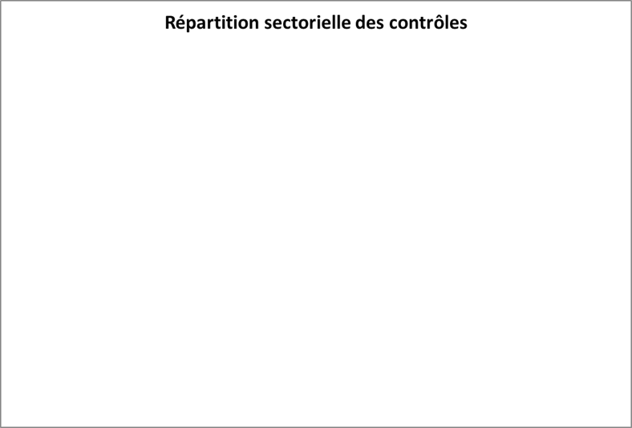

${LEGEND_PIE}

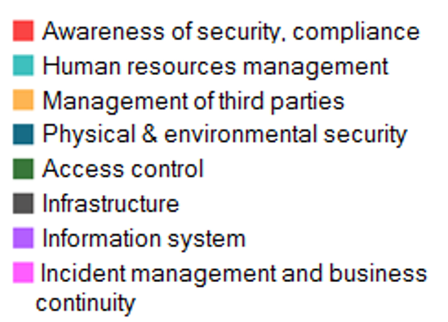

# Result of CASES Diagnostic

## Overview

${EVALUATION_SYNTHESYS}

## Maturity evolution

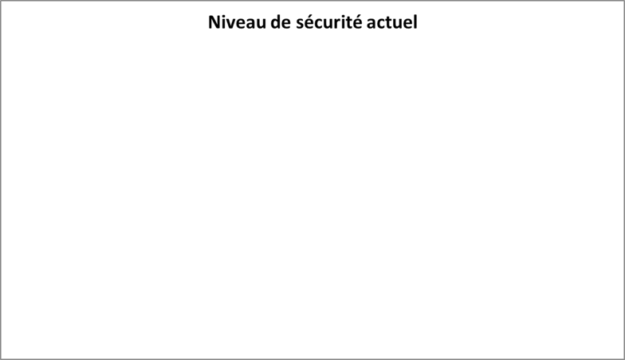

${LEGEND_BAR}

${LEGEND_DATE}

## Compliance in each security field

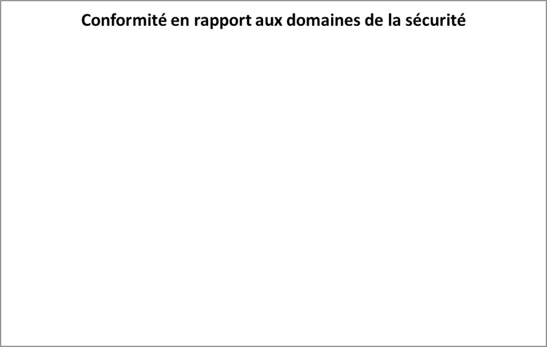

|  |  |  |
| --- | --- | --- |
|  | **Current** | **Aimed** |
| ${PRISE_NOTE_CATEG} | **${CATEG__PERCENT}** | **${CATEG__PERCENT_TARG}** |

## Table of recommendations

The following table lists the recommendations made. It is arranged by degree of severity, then by direct cost to take into account (some organizational measures have no other costs than the time taken in-house for implementation).

Details of the scores used as the basis for the recommendations are given in appendix A.

**Legend of the table of recommendations**

Each recommendation has their importance level:

**●●●** : Really important risk which needs an emergency care.

**●●** : Important risk which need some care sooner or later.

**●** : Minor risk or advice that could make a better level of security.

${LEGEND_BLOCKING}

${RECOMMENDATION_TABLE}

# APPENDIX A : Notes Taken

**Legend of the detailed assessment table**

| Information to collect | Collected information | Current maturity | | | | Recommendation | Aimed maturity | |
| --- | --- | --- | --- | --- | --- | --- | --- | --- |
| **** | **** | **** | **** | ■ | ■ |

**Information to collect**: Question asked during the interview, subject to deal with.

**Collected information**: Information get during the interview.

**Current maturity**:

| **** |
| --- |

The security measure is correctly implemented.

| **** |
| --- |

The security measure is partially implemented.

| **** |
| --- |

The security measure is not implemented.

| **** |
| --- |

The security measure is not applicable.

**Recommendation**: What should ideally be done to get rid of the risk.

**Aimed maturity**: Aimed maturity after the set-up of the recommendation.

${LEGEND_BLOCKING}

${NOTES_TABLE}