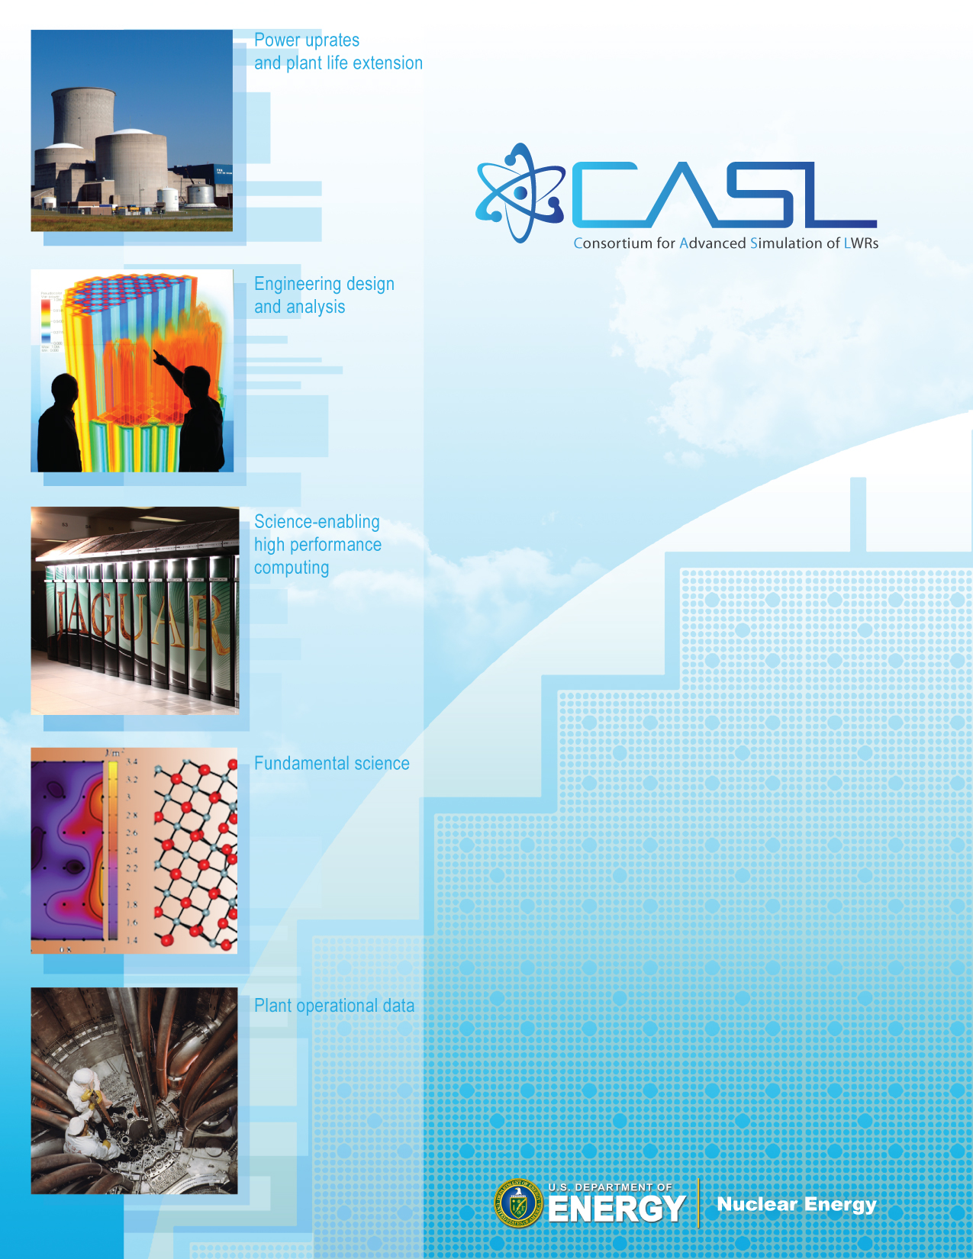Fe

**VERA Common Input**

**User Manual**

Scott Palmtag  
Andrew Godfrey

February 23, 2015

CASL-U-2014-0014-002



**Oak Ridge National Laboratory**

***in partnership with***

Electric Power Research Institute

Idaho National Laboratory

Los Alamos National Laboratory

Massachusetts Institute of Technology

North Carolina State University

Sandia National Laboratories

Tennessee Valley Authority

University of Michigan

Westinghouse Electric Company

***and individual contributions from***

Anatech Corporation Pacific Northwest National Laboratory

ASCOMP GmbH Pennsylvania State University

CD-adapco, Inc Rensselaer Polytechnic Institute

Core Physics, Inc. Southern States Energy Board

City University of New York Texas A&M University

Florida State University University of Florida

Notre Dame University University of Tennessee

Imperial College London University of Wisconsin



REVISION LOG

**Plan of Record**

**Period 2: January–June 2011**

**Volume 1**

| **Revision** | **Date** | **Affected Sections** | **Revision Description** |
| --- | --- | --- | --- |
| Rev. 0 | 11/25/2013 | All | Original Released Version for RSICC 2013 release |
| Rev. 1 | 03/31/2014 | All | Major revision for Milestone L3:PHI.VCS.P8.01 |
| Rev. 2 | 02/23/2015 | All | Minor Revision for RSICC release |
|  |  |  |  |

# 