FLIGHT INSPECTION SYSTEM OF RADIO NAVAIDS
CFIS is used for the airborne evaluation of accuracy and performance of ground navigation facilities. The system provides the capability to inspect the following aids:
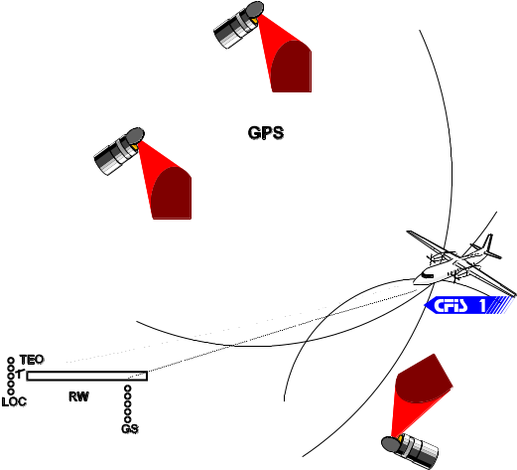
Fig 1: Flight inspection of ILS
RW - runway, TEO: radiotheodolit, GPS - Global Positioning System, LOC: localiser, GS: glide path
- Instrument Landing System (ILS);
- ILS associated approach markers (MKR);
- VHF omnidirectional range (VOR);
- Distance Measuring Equipment (DME);
- Non-Directional Beacon system (NDB);
- communication (VHF);
- radar systems;
It is a modern, computerised system designed for the acquisition, recording, processing, analysis, display, and reporting of flight inspection data. It acquires various conditional signals from the avionics.
Main tasks of this system are as follows:
- measurement and registration all signals vital for evaluation of navaid work correctness from avionics during flight inspection;
- monitoring in real time chosen values to be used by a flight inspector;
- processing of data to establish features of inspected navaid;
- making reports of the inspection analysis;
- data maintenance and archive for postpone stability analyse.
The main objective is to enable the flight inspector to check correctness of the emitted signals by inspected navaid and consequently to certificate the device as conforming to international standards.
Fig 1 illustrates an example procedure of glide path flight inspection (GS). This transmitter is only one part of the instrument landing system (ILS), which enable to safely land under low visibility condition. It is provided to navigate precisely and follow the appropriate path in the vertical direction.
The main objective of the mentioned above procedure is to check the glide path angle. During this procedure the inspection plane equipped with CFIS system keep moving on a line with speed about 250km/h and try to follow the glide path. In this time all signals necessary to assess device correctness are gathered from two independent receivers. This receiver is a part of measurement channel.

CAS  94-028 Łódź ul. Chodkiewicza 1a  tel/fax: +48 (42) 6862547; +48 (42) 6865028 | www.cas.eu  techsupp@cas.eu

