HC-SR505
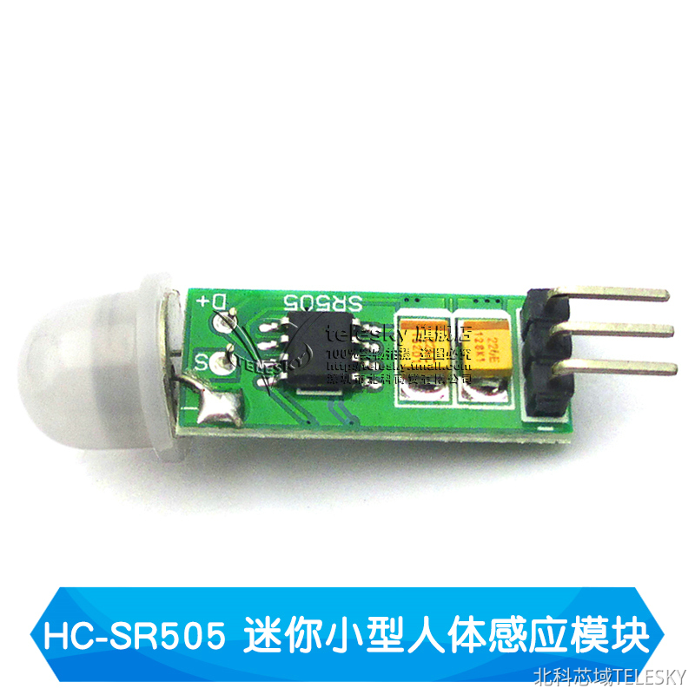
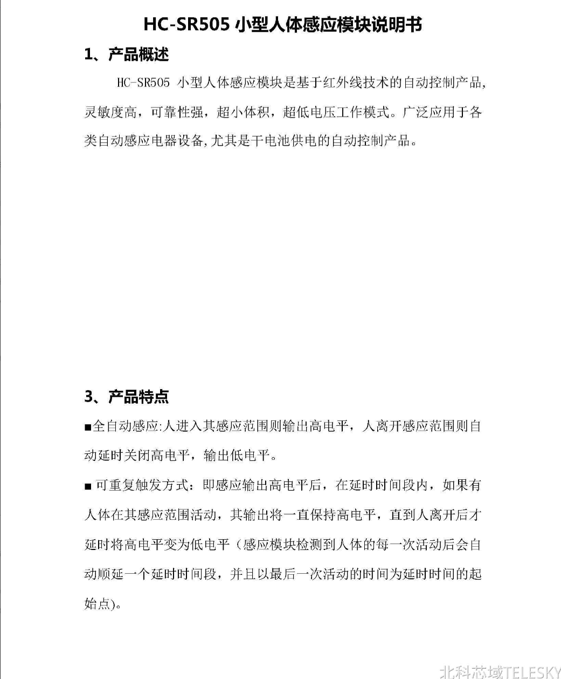

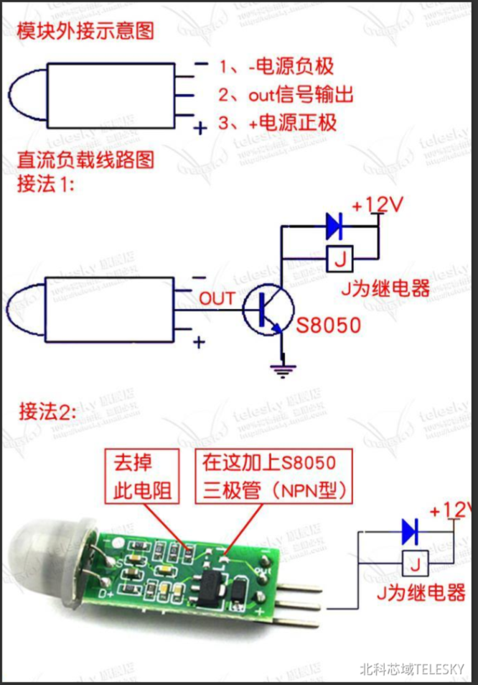
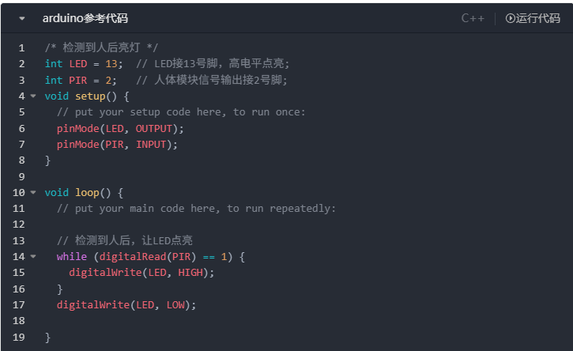
/* 检测到人后亮灯 */
int LED = 13; // LED接13号脚，高电平点亮;
int PIR = 2; // 人体模块信号输出接2号脚;
void setup() {
// put your setup code here, to run once:
pinMode(LED, OUTPUT);
pinMode(PIR, INPUT);
}

void loop() {
// put your main code here, to run repeatedly:

// 检测到人后，让LED点亮
while (digitalRead(PIR) == 1) {
digitalWrite(LED, HIGH);
}
digitalWrite(LED, LOW);

}

