Table 1. Data Format Description
Column Name (Number) | Explanation | Note
Vehicle ID (0) | ID number for each vehicle. | ID may not be continuous, but is unique for each vehicle in each dataset.
Global Time (s) (1) | Time in seconds referenced to 12:00:00 AM.
Frame ID (2) | Frame number in the corresponding video. | The beginning portion of the video with severe vibrations might be cut until the frame becomes stable.
Local X (ft) (3) | Position in the cross-section direction. | The reference point is this vehicle’s center location.
Local Y (ft) (4) | Position in the direction along the road. | The reference point is this vehicle’s center location.
Global X (Longitude) (5) | Vehicle’s GPS longitude location.
Global Y (Latitude) (6) | Vehicle’s GPS latitude location.
Width (ft)(7) | Vehicle width.
Length (ft)(8) | Vehicle length.
Class (1 motor; 2 auto; 3 truck)(9) | Vehicle class. | (motorbikes are not detected in the case study videos)
Speed (ft/s)(10) | Vehicle speed. | Calculated by the moving average method (2s interval).
Acceleration (ft/s2)(11) | Vehicle acceleration. | Calculated by the moving average method (2s interval).
Lane Num(12) | Lane number. | Ramp is -1, then 0,1,2 to the other side.
Preceding Vehicle ID(13) | Preceding Vehicle ID | -1 when there is no leading vehicle or the leading vehicle is out of scope.
Space Headway (ft)(14) | Distance between this vehicle’s front bumper to its preceding vehicle’s front bumper. | -1 when there is no leading vehicle or the leading vehicle is out of scope.

If you have any questions, please contact: xiaopengli@usf.edu

Appendix
- How we convert local locations to GPS coordinates
To convert local locations to GPS coordinates accurately especially when a road segment is in a curved shape, a polynomial curve fitting method is applied to the datasets. For each dataset, a polynomial curve fitting function is firstly used to fit GPS coordinates of the location. For example in Figure 1, a sample GPS of coordinates $\left(X_{i}^{G},Y_{i}^{G}\right), i∈[1,I]$ of the road segment captured by a video are selected to generate a polynomial curve fitting function $Y^{G}=f^{G}(X^{G})$. Then an array of points $(M_{i}^{G},X_{i}^{G})$ of local moving distance $M_{i}^{G}$ and GPS coordinate $X_{i}^{G}$ can be calculated with the Equation $M^{G}=\int_{o}^{X^{G}}{}\sqrt{\left({X^{G}}^{2} +{Y^{G}}^{2}\right)}$/$364000$, where $364000$ is the parameter of unit conversation between GPS coordinates to feet. Therefore, another polynomial curve fitting function can be applied to fit $(M_{i}^{G},X_{i}^{G})$, $X^{G}=f^{M}(M^{G})$.
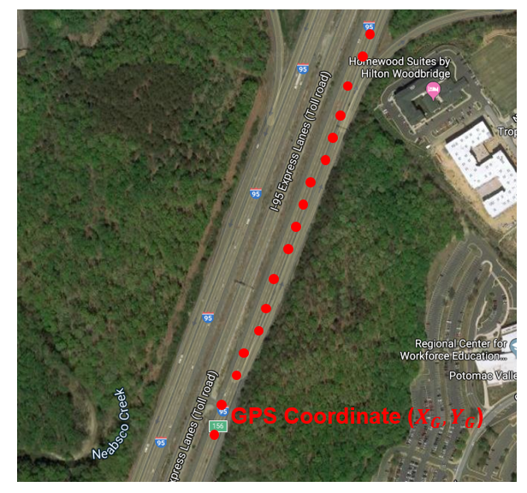
Figure 1. GPS Coordinates of Sample Points of a Segment of I-95

The format of local locations of vehicles are shown in Figure 2. As shown in the figure and Table 1, Local X is vehicles' center location in the direction perpendicular to the lane and Local Y is vehicles' center location in the direction parallel to the road. By considering local Y as the moving distance of vehicles, the fitting function $X^{G}=f^{M}(M^{G})$ can be used to calculate the GPS coordinate $X^{G}$, $X^{G}=f^{M}(Y)$. Then the GPS coordinate $Y^{G}$ can be calculated with function $Y^{G}=f^{G}(X^{G})$. So that the GPS coordinates $(X^{G},Y^{G})$ are obtained with the proposed method.
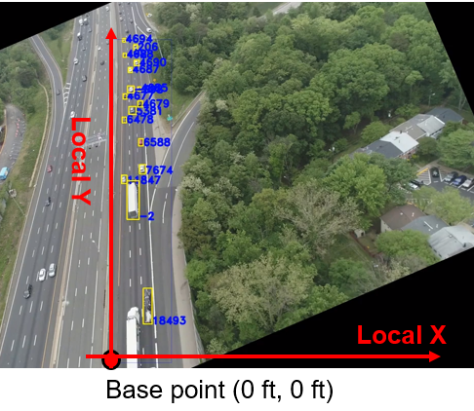
Figure 1. Format of Local Locations of Vehicles

