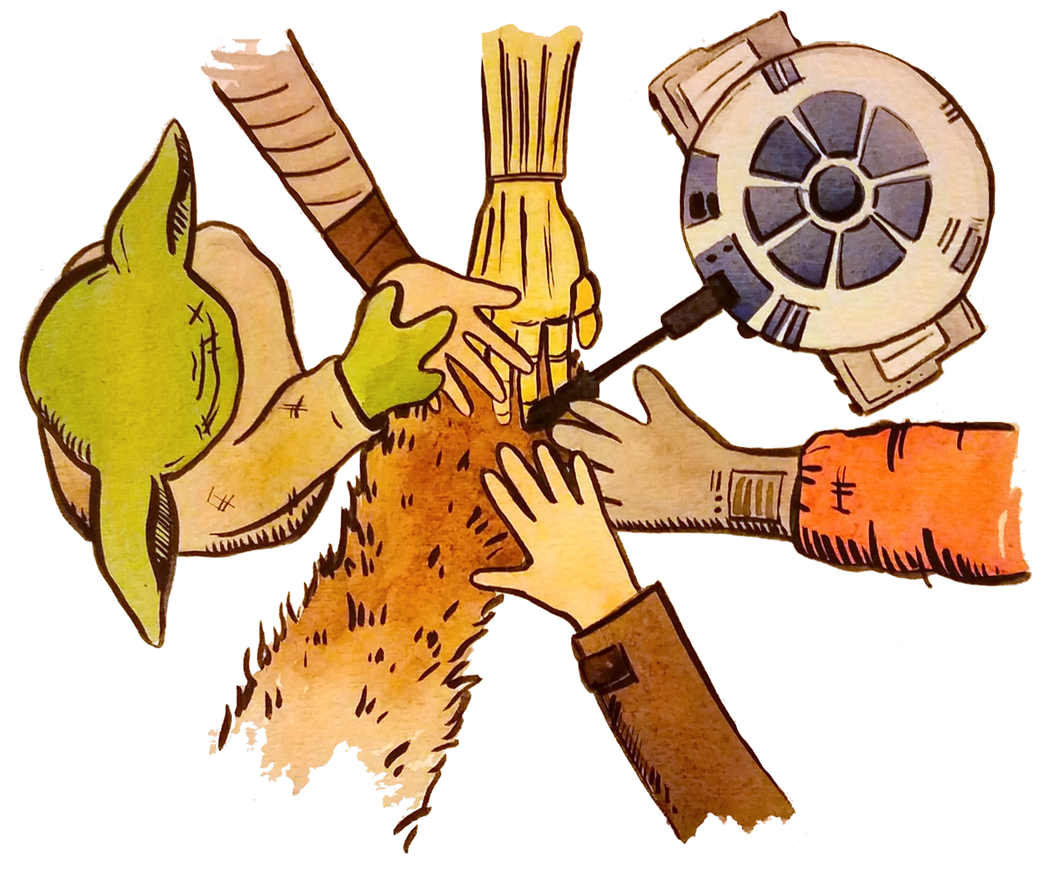

**Fall 2022 Openscapes Cohorts AFSC NWFSC PIFSC SEFSC SERO SWFSC WRCO**