

CACert Automated Training System
(CATS)

Admin Handbook

CATS Admin Handbook
After you logged into the CATS Server you get the following screen:
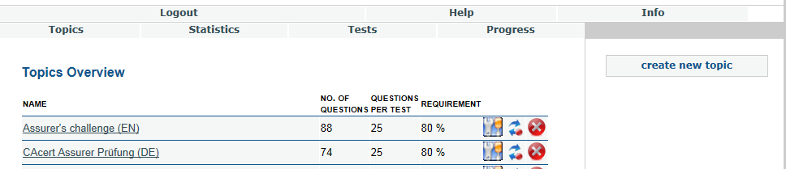
With Topics you can choose the different challenges that are available.
With Statistics you can get the overview over the test results.
With Tests you can start the different challenges to try them out yourself.
With Progress you can see your own results and progress of the challenges that you have started.
Help points to the admin handbook pdf file.
Info give you info about your own settings
With create new topic you can create a new challenge

Basic functions

With the toolbox you start the editing mode of the entry.
With the “arrows” you can change the state of the entry from activated to deactivated and vice versa.
With the red cross you delete the entry without the chance to recover it.

Editing a challenge
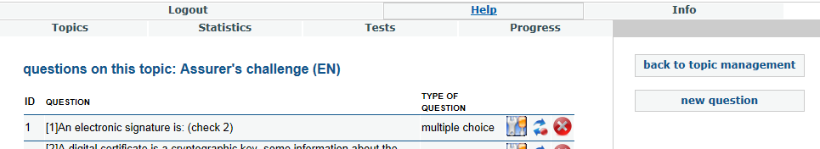
With the back to topic management you go back to the challenge overview
With new question you can create a new question
With the icon buttons you can edit, activate/deactivate or delete the question.

Creating a new question
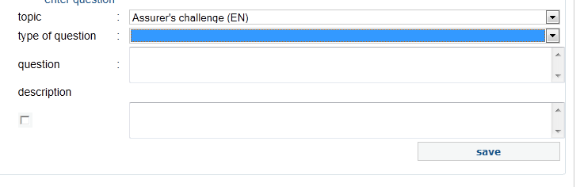
At topic you choose the challenge into which the new question should go to.
You can currently choose four different types of questions:
- With single selection you can give an arbitraty number of answers, but only one answer can be correct. This is shown in the for of a set of “radio buttons”.
- With multiple choice an arbitraty number of answers may be defined as correct, this is shown as a set of “checkboxes”. As a hint you should usually give the number of correct questions in the question's text like “(Tick three)”.
- True / false corresponds to single selection with the fixed answers “True” and “False”. This answers are shown in the user interface language which the user selected, and not necessarily in the language of the challenge. Since this may confuse a user true / false questions should be avoided, use single selection instead.
- Fill in the blanks creates a cloze where several “blanks” must be filled with one of a given set of answers. This type is tricky to configure and has some quirks, please don't use it without a good reason.
At question you enter the question text shown to the user. As a convention to simplify question identification (“There's a typo in the german question 123”) and translation, the question text with the question number in square brackets. For the english question use thr ID which is shown after the question is saved. For translated questions it should be the ID of the corresponding english question.
With description you set the explaining text that is displayed to the user at the end of the test. You can use this to give more information, for example why the answer is indeed correct, or refer to more detailed information.
The tickbox enables saving of the description.
The question definition can be saved by klicking “save”.
Then the answer section is displayed.

Editing a question
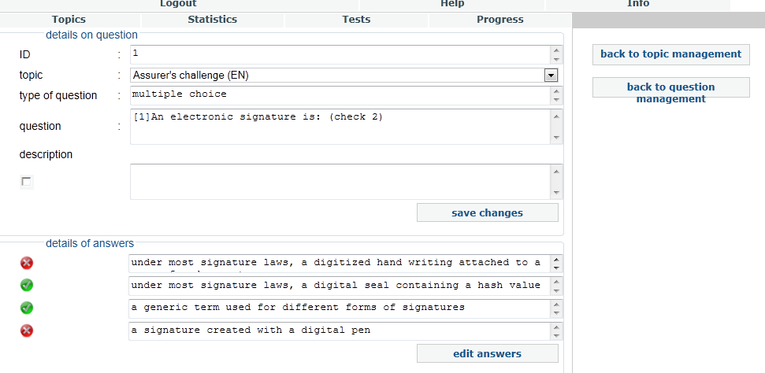
With the back to topic management you go back to the challenge overview
With back to question management you go back to the question overview.

This is considered a bug (https://bugs.cacert.org/view.php?id=1115), the description should always be saved.

