1.1 INTRODUCTION TO MAPS NOTES - PART I
1.1 Identify types of maps, the types of information presented in maps, and different kinds of spatial patterns and relationships portrayed in maps.

1.1.1 TYPES OF MAPS

- Reference Maps:

- Thematic Maps:

Type of Map | Explanation | Draw or Paste an Example
1.1 INTRODUCTION TO MAPS NOTES - PART II
1.1 Identify types of maps, the types of information presented in maps, and different kinds of spatial patterns and relationships portrayed in maps.

1.1.2 TYPES OF SPATIAL PATTERNS ON MAPS

LOCATION | DISTANCE
- Absolute Location  - Relative Location | - Absolute Distance  - Relative Distance
DIRECTION | PATTERN
- Absolute Direction  - Relative Direction | - Clustering  - Dispersal/Distribution  - Patterns & Spatial Associations
1.1 INTRODUCTION TO MAPS NOTES - PART III
1.1 Identify types of maps, the types of information presented in maps, and different kinds of spatial patterns and relationships portrayed in maps.

1.1.3 MAP PROJECTIONS & DISTORTIONS

- Map projections ________________________________________________ in shape, area, distance and direction.
- Map Projection:
- Maps are ____________________ in what they portray - different projections are used for different ______________.
- Map projections are...S.A.D.D, because they distort

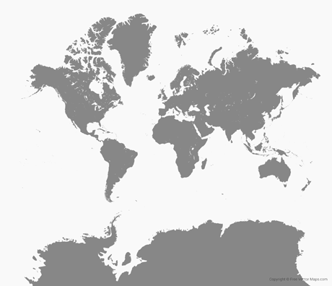
MERCATOR (1569)
ADVANTAGES | DISADVANTAGES

PETERS EQUAL AREA |  | Illustrate the REAL size of Africa compared to Greenland here.
ADVANTAGES | DISADVANTAGES

ROBINSON |  | 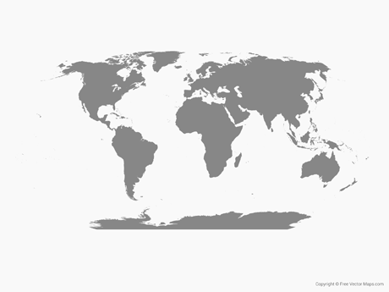
ADVANTAGES | DISADVANTAGES

Ultimately, what is the point?

1.2 & 1.3 GEOGRAPHIC DATA
1.2 Identify different methods of geographic data collection.
1.3 Explain the geographic effects of decisions made using geographical information.

Identify different methods of geographic data collection.

- How is data gathered?
  - Fieldwork/Field Observations:
    - Examples:
    - Another Example - The US Census
      - What is the point?
  - Geospatial Technologies

    - Geospatial technologies are utilized by…

 | EXPLANATION | EXAMPLE
GIS
GPS
Remote Sensing
1.4 SPATIAL CONCEPTS
1.4 Define major geographic concepts that illustrate spatial relationships.

The Spatial Perspective
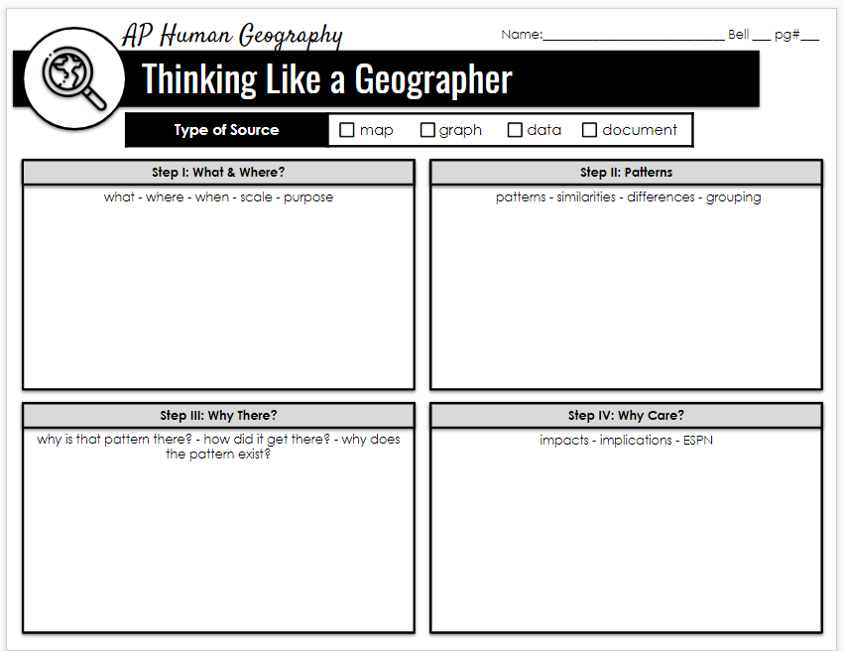

How do we describe what a location is like?

- __________________________
  - __________________________________________: Factors that contribute to the __________________________________________ ____________________________________________________.
    - Example: _____________________________________________________________________________________________________
  - _____________________________________________________________: _______________________________________________ that humans created which make up the _________________________________. ____________________________________________.
    - Example: _____________________________________________________________________________________________________
  - __________________________________________: A location _______________________ a _________________________________________. No _______________________________________________ .
    - Example: _____________________________________________________________________________________________________.

How do we describe where a place is located?

- __________________________
  - Absolute v. Relative

  - __________________________ -> _________________________________________ - usually reflective of the __________________ & __________________ of a place.
    - Example: _____________________________________________________________________________________________________
  - _________________________________________: _________________________________________ of a location; includes __________
__________________________________________________________________________________________________________________________.

Climate

- Tropical latitudes are near the ________________________. The climate is typically _________________ because those locations get _____________________________________________________________________________ __________________________________.
- High latitudes receive __________ sunlight, so these places are ___________________ year round.
- _____________________ also impacts climate as well.
- __________________________ = colder climate.
- __________________________ = warmer climate.

Patterns - Spatial Analysis

- Clustering:
- Dispersal/Distribution:
- Patterns & Spatial Associations: Indication that two (or more) phenomena may be___________________________, ______________________________________________________ with one another. _____________________________________.
- _______________________________________________: The process geographers use to ___________________________________________ space into ______________________________________________________________________________________________.
Why there? Why care? Spatial Interactions

- Spatial Interaction: ____________________________________________________________________________________________________________
____________________________________________________________________________________________________________________________________.
WHAT GEOGRAPHIC CONCEPTS DO WE USE TO EXPLAIN THE CONNECTEDNESS (OR LACK THEREOF) OF PLACES/LOCATIONS/PHENOMENON?

- The ____________________ between two places __________________ as the ________________between the two places ________________.  - Examples: | - The increasing sense of ___________________________ and __________________________ which seems to bring humans in ____________________ places ________________________________________.  - Due to:
- ____________________: the process by which a characteristic ____________________ across space from ___________________________ to another. Examples include: ______________________________________________________________

Sample Spatial Analysis - China

Follow along with your teacher and take notes on the spatial analysis of population and air pollution in China.

WHAT
WHERE
PATTERNS
WHY THERE
WHY CARE

1.5 HUMAN-ENVIRONMENTAL INTERACTION
1.5 Explain how major geographic concepts illustrate spatial relationships.

- Cultural Ecology: _______________________________________________________________________________________________________________
- Environmental Determinism: ________________________________________________________________________________________________
_____________________________________________________________________________________________________________________________________
  - How was environmental determinism used to justify racism?
  - Explain one example of how environmental determinism is accurate.

- Possibilism: ____________________________________________________________________________________________________________________
_____________________________________________________________________________________________________________________________________
- Describe how the following examples illustrate the concept of possibilism.
Palm Islands, Dubai

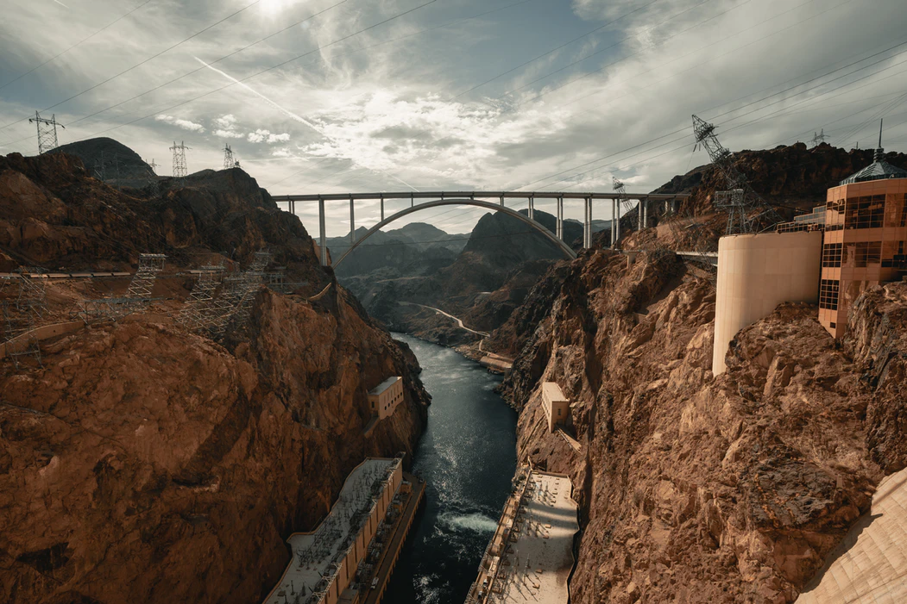
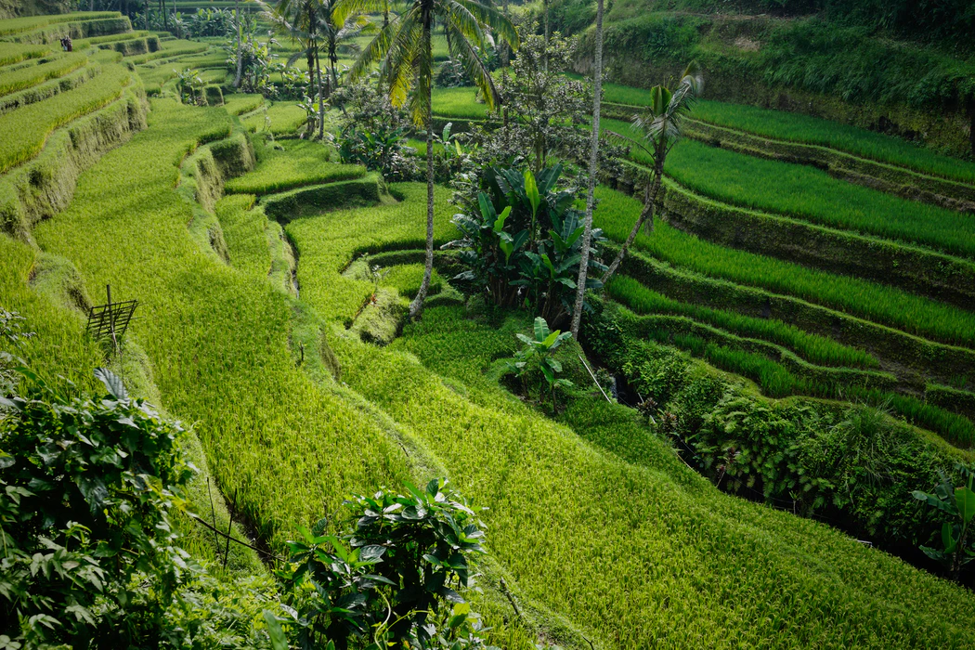

1.6 SCALE OF ANALYSIS
1.6 Define scales of analysis used by geographers & Explain what scales of analysis reveal.

_______________________ in and out to ______________________________________________.
Small Scale Maps:

Large Scale Maps:

Label the map scales below and summarize the analysis.
Map: Share of the Population Living in Extreme Poverty  Scale:  What conclusions can be drawn from this map? | Map: Percentage of People in Poverty for the United States and Puerto Rico: 2018  Scale:  What conclusions can be drawn from this map?
**Different _____________ reveal ______________ in spatial patterns.**
How do the two maps show different (and sometimes inaccurate) conclusions?

Map: County Poverty Rate for the United States: 2013-2017
Scale:

What conclusions can be drawn from this map THAT ARE DIFFERENT FROM THE PREVIOUS MAP(s)?

Maps: Highest & Lowest Median Household Incomes in Cincinnati

Scale: ______________________________: smallest scale of analysis - comprise about __________________________________ people.

What conclusions can we draw about Cincinnati on this map that we were UNABLE to conclude from the other maps?

Graph: Maternal Mortality in Ethiopia and sub-Saharan Africa

Scale:

What conclusions can be drawn from this graph?

1.7 SCALE OF ANALYSIS
1.7 Describe different ways that geographers define regions.
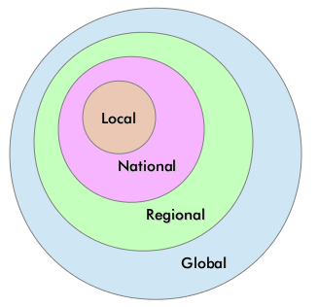

Geographers apply regional analysis at ____________________________

Regions are defined as an area with ______________ or more _______________________________________________ or ________________ of activity.

1. A formal region is _____________________________________________________________________________________________________
Description & Examples
ECONOMIC
SOCIAL
POLITICAL
ENVIRONMENTAL

2. A functional region is ___________________________________________________________________ and the relationship is typically based around ________________________, ____________________, ___________________________________.
- Examples: ________________________________________________________________________________________________________

3. A perceptual/vernacular region is based on a person’s ________________________ or ________________________ of a certain location.

- Boundaries often ________________________ because people have a different sense of what _________________________________________________________________________________________________________.
- Examples: _________________________________________________________________________________________________________

*Regional boundaries are often __________________________________________________________________________________________

Unit 1 FRQ
The map shows the major rivers, mountain ranges, desert regions, and population densities in China. Mapping the distribution of a population is a geographer’s first step to understanding where people settle and why some areas have greater population densities than other areas.
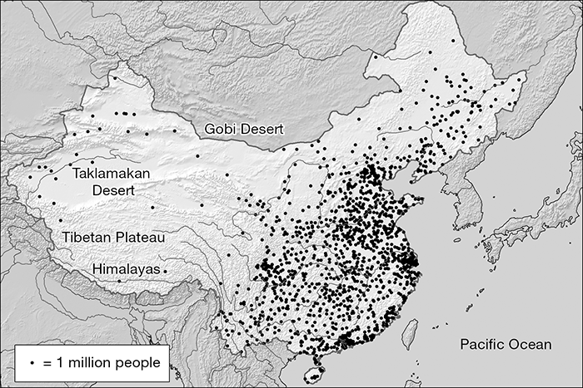
Prompt:
- Identify what each point symbol on the map represents.
- Identify TWO topographic features shown on the map.
- Describe TWO ways that topography affects the spatial pattern of population distribution shown on the map.
- Describe ONE way that the availability of natural resources may affect population distribution.

Please respond in at least 4 sentences

____________________________________________________________________________________________________________________________________________________________________________________________________________________________________________________________________________________________________________________________________________________________________________________________________________________________________________________________________________________________________________________________________________________________________________________________________________________________________________________________________________________________________________________________________________________________________________________________________________________________________________________________________________________________________________________________________________________________________________________________________________________________________________________________________________________________________

