RAW-LAYER EXTRACTION
FROM 4D TO SNOWFLAKE
Architecture - Data flow - Table preparation - Audit logging
CURRENT IMPLEMENTATION

Figure 1. Current 4D-to-Snowflake raw-layer flow
Implemented today: ETL_PIPELINE_LOG captures detailed run events. Future reference: PIPELINE_RUN_LOG is the proposed parent summary; it is not created by the current code.
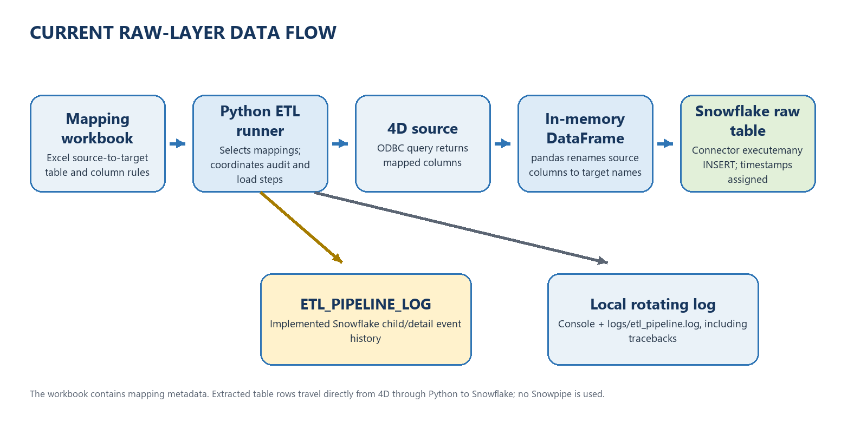

Contents

If the contents list is blank in Word, right-click it and select Update Field ? Update entire table.

End-to-end flow
The Python runner is scripts/run_initial_etl.py. At a high level, an ETL run:
- Reads connection settings from environment variables (normally .env).
- Connects to Snowflake and checks the connection with SELECT 1.
- Creates or prepares the Snowflake child audit table.
- Reads the Excel worksheet(s) that map 4D source tables and columns to
Snowflake target tables and columns.
- Checks whether each Snowflake target table exists.
- Creates a missing target table, or prepares an existing table.
- Connects to 4D through ODBC.
- Selects the mapped columns from 4D into a pandas DataFrame.
- Inserts the DataFrame rows into Snowflake using the Snowflake connector.
- Closes the 4D connection, Snowflake cursor, and Snowflake connection.
- Writes the final pipeline status to the logs
The Excel file is mapping metadata, not an intermediate data export. The extracted rows are held in Python memory during the run; this implementation does not export the data to JSON or Excel.

Connections

4D connection
connections/fourd_connection.py connects using pyodbc. It uses either the configured ODBC DSN or a driver/server/port connection string. The required settings are:
- FOURD_SERVER
- FOURD_PORT
- FOURD_USERNAME
- FOURD_PASSWORD
Optional settings include FOURD_DSN, FOURD_DRIVER, and FOURD_DATABASE. FOURD_QUERY_TIMEOUT_SECONDS controls the query timeout and defaults to 1800 seconds. After connecting, the ETL reads from the same 4D connection for each selected table in the run.

Snowflake connection
connections/snowflake_connection.py connects using snowflake.connector.connect. The connection configuration is built from:
- SNOWFLAKE_ACCOUNT
- SNOWFLAKE_USER
- SNOWFLAKE_WAREHOUSE
- SNOWFLAKE_DATABASE
- SNOWFLAKE_SCHEMA
- SNOWFLAKE_ROLE
- SNOWFLAKE_AUTHENTICATOR
After connecting, the code runs SELECT 1 to verify connectivity. The connection is reused for audit writes, target-table preparation, and data inserts during that run.

Mapping and source extraction
The workbook 4D_to_Snowflake.xlsx contains one mapping worksheet per table as well as the Snowflake_table_names index worksheet. For a selected target, the runner resolves the worksheet whose name normalizes to that target name. For example, ACCOUNT_CONTACTS maps to Account Contacts.
The mapping reader in etl/metadata.py groups rows by normalized target table and reads the source table, source column, source data type, target column, Snowflake data type, and constraint. It ignores blank mapping rows and target columns labeled not in snowflake
For each target table, the runner builds a 4D query containing only the mapped columns, with square-bracket quoted identifiers, for example:
pandas.read_sql reads the query result into a DataFrame. The ETL then renames the DataFrame columns to their Snowflake target names and passes the rows to the Snowflake connector.

Snowflake target-table preparation
For each mapped table, the runner checks Snowflake's INFORMATION_SCHEMA.TABLES.

If the target table does not exist
It builds and executes CREATE TABLE IF NOT EXISTS using the Snowflake data types from the mapping. It applies a primary key where the mapping identifies one. Mapped CREATED_TIMESTAMP and UPDATED_TIMESTAMP fields are defined with DEFAULT CURRENT_TIMESTAMP() NOT NULL.

If the target table already exists
The ETL currently:
The Snowflake role needs permission to alter these target tables. The ETL explicitly supplies CURRENT_TIMESTAMP() for both managed timestamp columns on each inserted row; it does not rely on altering defaults on an existing table. Existing targets must have compatible timestamp columns for these inserts.

Implemented child audit log: ETL_PIPELINE_LOG
It creates or prepares <SNOWFLAKE_DATABASE>.<SNOWFLAKE_SCHEMA>.ETL_PIPELINE_LOG. Its current columns are:
Column | Purpose
RUN_ID | UUID shared by audit events for one ETL invocation
RUN_STEP_NO | Increasing event number within the invocation
TABLE_NAME | Target table associated with the event, when applicable
STEP | Pipeline operation or event name
STATUS | Event status, such as STARTED, SUCCESS, FAILURE, or SKIPPED
MESSAGE | Human-readable event details
ERROR_MESSAGE | Error details and, for failed steps, the traceback
Start_TIME_STAMP | Time the individual audit event was inserted
End_TIME_STAMP | Time the individual audit event was end

Events are inserted as each step starts and completes. Failures in a step are recorded with FAILURE and the exception traceback, then re-raised so the ETL does not silently continue. The overall pipeline records SUCCESS or FAILURE when it reaches a final outcome.

Example current events for a CLAIMS load
The exact number of events depends on whether the target exists, whether any columns need widening or timestamp repair, and whether an error occurs. A run will generally include events corresponding to:
- ETL_PIPELINE started.
- CONNECT_SNOWFLAKE success.
- ENSURE_AUDIT_TABLE success.
- LOAD_MAPPING started and success.
- OPEN_SNOWFLAKE_CURSOR started and success.
- CHECK_TARGET_TABLE started and success.
- CREATE_TARGET_TABLE success if missing, or skipped if it already exists.
- DROP_STATUS_COLUMN started and success for an existing table.
- Any WIDEN_CLOB_COLUMN and ENFORCE_TIMESTAMP_COLUMN steps required for an existing table.
- CONNECT_4D started and success.
- EXTRACT_SOURCE_DATA started and success.
- INSERT_TARGET_DATA started and success.
- CLOSE_4D_CONNECTION and CLOSE_SNOWFLAKE_CURSOR.
- ETL_PIPELINE final success.
For each operation wrapped as a step, the logger normally records a STARTED event and then SUCCESS; on an exception it records FAILURE. Some lifecycle events are recorded directly as one event. Thus the log is an event history, not one row per table with separate start and end columns.
Example query to review one run in order:
SELECT RUN_ID, RUN_STEP_NO, TABLE_NAME, STEP, STATUS, MESSAGE,
ERROR_MESSAGE, TIME_STAMP
FROM <SNOWFLAKE_DATABASE>.<SNOWFLAKE_SCHEMA>.ETL_PIPELINE_LOG
WHERE RUN_ID = '<run-uuid>'
ORDER BY RUN_STEP_NO;

Snowflake-side audit events can only be recorded after Snowflake is reachable and the audit table is available. Failures before that point are available in the local log.

Purpose and scope
This document describes the current Python ETL implementation that extracts mapped table data from 4D and inserts it into Snowflake raw-layer tables. It also records a proposed parent/child audit-log design for future use by both UW and EIS.
The distinction between current and planned behavior is important:
- ETL_PIPELINE_LOG is implemented as the Snowflake child/detail audit log.
- PIPELINE_RUN_LOG is a proposed parent/summary log.
- The current child log stores a timestamp per audit event, rather than
separate step start and end timestamp columns.

parent/child logging

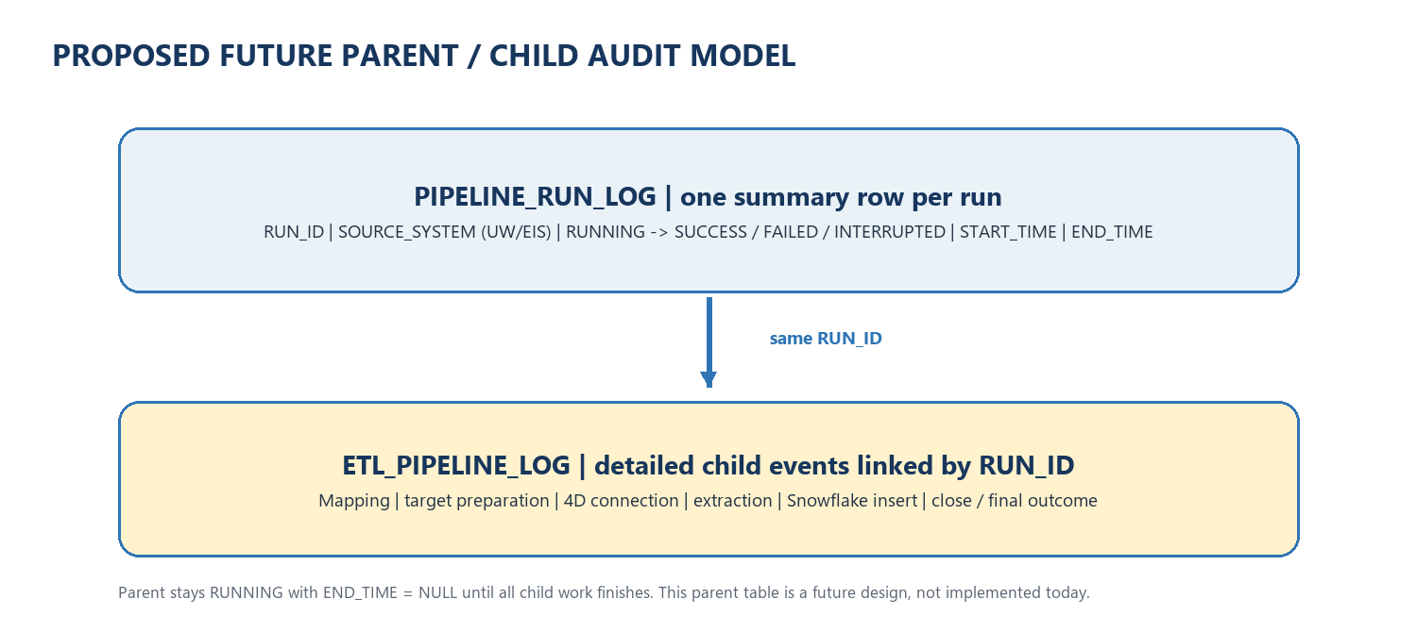
Figure 2. parent summary and linked child detail events
The following is a design reference,

Parent: PIPELINE_RUN_LOG
The parent table should contain one summary row per ETL invocation Suggested columns:
Suggested column | Purpose
RUN_ID | Primary run identifier; same value referenced by child rows
SOURCE_SYSTEM | UW or EIS, so both source domains use the same model
PIPELINE_NAME | Name of the extraction pipeline
TABLE_NAME or RUN_MESSAGE | Table or batch description, such as Loading CLAIMS
STATUS | RUNNING, SUCCESS, FAILED, or INTERRUPTED
START_TIME | Time the overall run starts
END_TIME | Null until all work for the run has reached an outcome
MESSAGE | Summary, final result, or failure description

At startup, the process inserts one parent row with RUN_ID, source system, table or batch message, STATUS = 'RUNNING', START_TIME, and a null END_TIME. While child steps execute, the parent remains RUNNING and its end time remains null. After all selected table work and child logging complete, the process updates the parent row with the terminal status, final message, and END_TIME.
For example, for a single UW CLAIMS extraction, the parent row can say Loading CLAIMS and remain RUNNING while the child log stores the detailed steps. Only when the child workflow has finished does the parent become SUCCESS or FAILED and receive its end time.

Child: ETL_PIPELINE_LOG
The child table remains the detailed step log. Each child event should include the parent's RUN_ID as a reference value, along with table name, step number, step name, status, message, error details, and event timestamp. For richer duration reporting, a future version can add separate STEP_START_TIME and STEP_END_TIME fields, or pair STARTED and terminal events using the same run ID, table, step number, and step name.
The parent status vocabulary (RUNNING, SUCCESS, FAILED, INTERRUPTED) is the proposed summary lifecycle. The current child logger uses event values such as STARTED, SUCCESS, FAILURE, and SKIPPED; do not treat these as already-migrated parent statuses.

Failure and interruption handling
1. If any child step fails, save the error in the child log and update the parent status to FAILED, along with the end time.
2. If the process stops unexpectedly, the parent may remain in RUNNING status. A scheduled job should find these old runs and mark them as INTERRUPTED, with the end time and reason for interruption.
3. The parent should be marked as SUCCESS only when all child steps have completed successfully. If some steps are still running or have failed, the parent should not be marked as successful.

Shared use for UW and EIS
UW and EIS should use the same parent/child structure, step-numbering conventions, and run-ID relationship. Record the source domain in a field such as SOURCE_SYSTEM, rather than creating separate logging logic for each. The current project documents and implements the UW-oriented 4D-to-Snowflake flow; the same approach can be applied to EIS after its connection and mapping configuration are wired into a runner.

Operational considerations
- Verify source and target mapping before loading a new table.
- Ensure the Snowflake role can create the audit/target tables and alter
existing target columns where required.
- Review the Snowflake child audit rows after a run.
- Check for partial or duplicate inserts before retrying.
- Treat tracebacks and source details in logs as potentially sensitive.

