4D Raw Extract to Snowflake
Simple User Guide
For daily operations, initial loads, incremental loads, and checking results

Prepared for the ETL project team
October 2026

1. Main parts and purpose
Part | What it does
4D database | Stores the business source data.
Mapping workbook | Tells the ETL which 4D columns match which Snowflake columns.
ETL program | Reads the mapping, extracts rows from 4D, and loads them into Snowflake.
Snowflake | Stores the copied raw and processed ETL data.
ETL log tables | Record when steps started, ended, failed, or succeeded.

2. Data flow
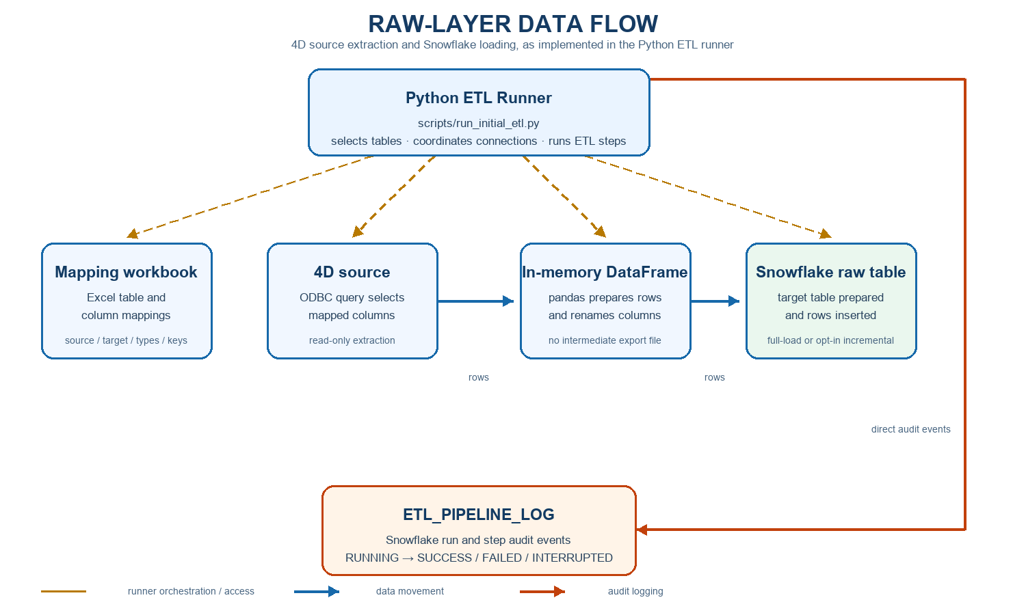

3. How the ACCOUNT_CONTACTS current table and history table work
The normal table is ACCOUNT_CONTACTS. When incremental loading is used, the code automatically creates a second table named ACCOUNT_CONTACTS_H. The H means history.
Table | Purpose
ACCOUNT_CONTACTS | Contains the latest successful incremental batch.
ACCOUNT_CONTACTS_H | Stores older current-table records when a later incremental batch is loaded.
ETL_INCREMENTAL_BATCH_LOG | Records each incremental run and whether it found changes.

How ACCOUNT_CONTACTS_H is created
- The current table ACCOUNT_CONTACTS is created from the mapping first.
- When the incremental command is run, the code adds _H to the table name and checks whether ACCOUNT_CONTACTS_H exists.
- If it does not exist, Snowflake creates it with the same columns as ACCOUNT_CONTACTS.
- The code adds HISTORY_BATCH_ID to identify which run archived the record and ARCHIVED_AT to record when it was archived.
Automatic rule: The code creates ACCOUNT_CONTACTS_H during the first incremental run. The initial full source load is not copied into history.

What happens during later incremental runs
- The ETL checks 4D for new, changed, or removed records.
- If no source records changed, it does not update either the current table or the history table.
- If a changed batch is found, the rows currently in ACCOUNT_CONTACTS are copied to ACCOUNT_CONTACTS_H.
- The current ACCOUNT_CONTACTS rows are then removed and replaced by the changed batch.
- The incremental batch is recorded as successful in the ETL log tables.
Example: If ACCOUNT_CONTACTS currently contains 100 records and 3 records change in 4D, all 100 old records move to ACCOUNT_CONTACTS_H and the 3 changed records become the current rows.

4. Choose the correct load type
Load type | What it means | When to use
Full load | Copies the complete data again. | First setup or when the complete table must be refreshed.
Initial incremental setup | Creates history/state objects and loads the full source once. | First time incremental loading is used for a table.
Daily incremental load | Reads changes since the previous successful run. | Regular day-to-day updates.

5. Run one table

Full load for one table
py -3.12 scripts\run_initial_etl.py --table "Table Name"
Example:
py -3.12 scripts\run_initial_etl.py --table "Master File"
Remember: A table name is required here. This command does not run every table.

Daily incremental load for one table
py -3.12 scripts\run_initial_etl.py --table "Table Name" --incremental
Run this command on the first day and again on later days. The runner decides what is new or changed.

6. Run several tables

Full load
py -3.12 scripts\run_initial_etl.py --tables CLAIMS REPORTS "Master File"

Incremental load
py -3.12 scripts\run_initial_etl.py --tables CLAIMS REPORTS "Master File" --incremental

7. Run every mapped table
Do not use --table or --tables when you want every mapped table:

Full load every mapped table
py -3.12 scripts\run_initial_etl.py

Incremental load every mapped table
py -3.12 scripts\run_initial_etl.py --incremental
Use care: Running every table can take longer and should be done only when every mapped table needs a full or incremental refresh.

8. Watch the run
When the run finishes normally, the program prints a success message and writes a message to the local ETL log.
- Console: the messages shown in the PowerShell window.
- Local log: logs\etl_pipeline.log
- Snowflake log: ETL_PIPELINE_LOG, with start time, end time, status, and run details.
- Incremental details: ETL_INCREMENTAL_BATCH_LOG and the table’s history table, where available.

9. What the status words mean
Status | Meaning
RUNNING | The step is still active.
SUCCESS | The step finished correctly.
FAILED | The step stopped because of an error.
INTERRUPTED | The run was stopped, for example with Ctrl+C.
SKIPPED | The step was not needed for this run.

