4D Raw Extract to Snowflake
For daily operations, initial loads, incremental loads, and checking results

Prepared for the ETL project team

1. Main parts and purpose
Part | What it does
4D database | Stores the business source data.
Mapping workbook | Tells the ETL which 4D columns match which Snowflake columns.
ETL program | Reads the mapping, extracts rows from 4D, and loads them into Snowflake.
Snowflake | Stores the copied raw and processed ETL data.
ETL log tables | Record when steps started, ended, failed, or succeeded.

2. Data flow
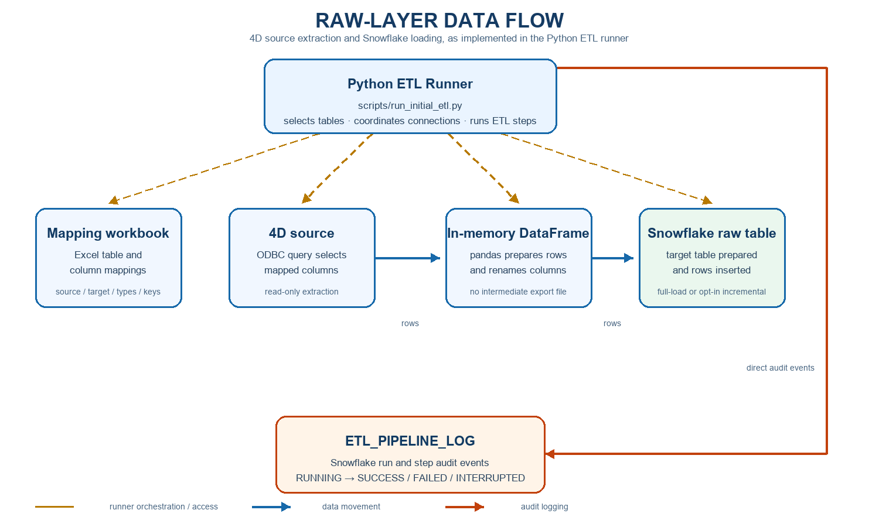

3. Before you start
- Confirm that 4D and Snowflake are available.
- Confirm that the mapping workbook contains the correct table and columns.
- Confirm that you have the required 4D and Snowflake access.
- For the first incremental run, confirm that the Snowflake database and schema are safe development targets.

4. Choose the correct load type
Load type | What it means | When to use
Full load | Copies the complete data again. | First setup or when the complete table must be refreshed.
Initial incremental setup | Creates history/state objects and loads the full source once. | First time incremental loading is used for a table.
Daily incremental load | Reads changes since the previous successful run. | Regular day-to-day updates.

5. Run one table

Full load for one table
py -3.12 scripts\run_initial_etl.py --table "Table Name"
Example:
py -3.12 scripts\run_initial_etl.py --table "Master File"
Remember: A table name is required here. This command does not run every table.

Daily incremental load for one table
py -3.12 scripts\run_initial_etl.py --table "Table Name" --incremental
Run this command on the first day and again on later days. The runner decides what is new or changed.

6. Run several tables

Full load
py -3.12 scripts\run_initial_etl.py --tables CLAIMS REPORTS "Master File"

Incremental load
py -3.12 scripts\run_initial_etl.py --tables CLAIMS REPORTS "Master File" --incremental

7. Run every mapped table
Do not use --table or --tables when you want every mapped table:

Full load every mapped table
py scripts\run_initial_etl.py

Incremental load every mapped table
py scripts\run_initial_etl.py --incremental

8. Watch the run
When the run finishes normally, the program prints a success message and writes a message to the local ETL log.
- Console: the messages shown in the PowerShell window.
- Snowflake log: ETL_PIPELINE_LOG, with start time, end time, status, and run details.
- Incremental details: ETL_INCREMENTAL_BATCH_LOG and the table’s history table, where available.

9. What the status words mean
Status | Meaning
RUNNING | The step is still active.
SUCCESS | The step finished correctly.
FAILED | The step stopped because of an error.
INTERRUPTED | The run was stopped, for example with Ctrl+C.
SKIPPED | The step was not needed for this run.

10. Safe operating rules
- Do not share passwords or .env settings.
- Do not run a development or trial command against the production database.
- Do not rerun the same full load if duplicate records could be created.
- Check the mapping workbook before a new table is added.
- Wait for the run to finish; do not close PowerShell during processing.
- Keep ETL_PIPELINE_LOG for basic run evidence and support checks.

Quick command list
Task | Command
Full load one table | py -3.12 scripts\run_initial_etl.py --table "Table Name"
Incremental load one table | py -3.12 scripts\run_initial_etl.py --table "Table Name" --incremental
Full load all tables | py -3.12 scripts\run_initial_etl.py
Incremental load all tables | py -3.12 scripts\run_initial_etl.py --incremental

