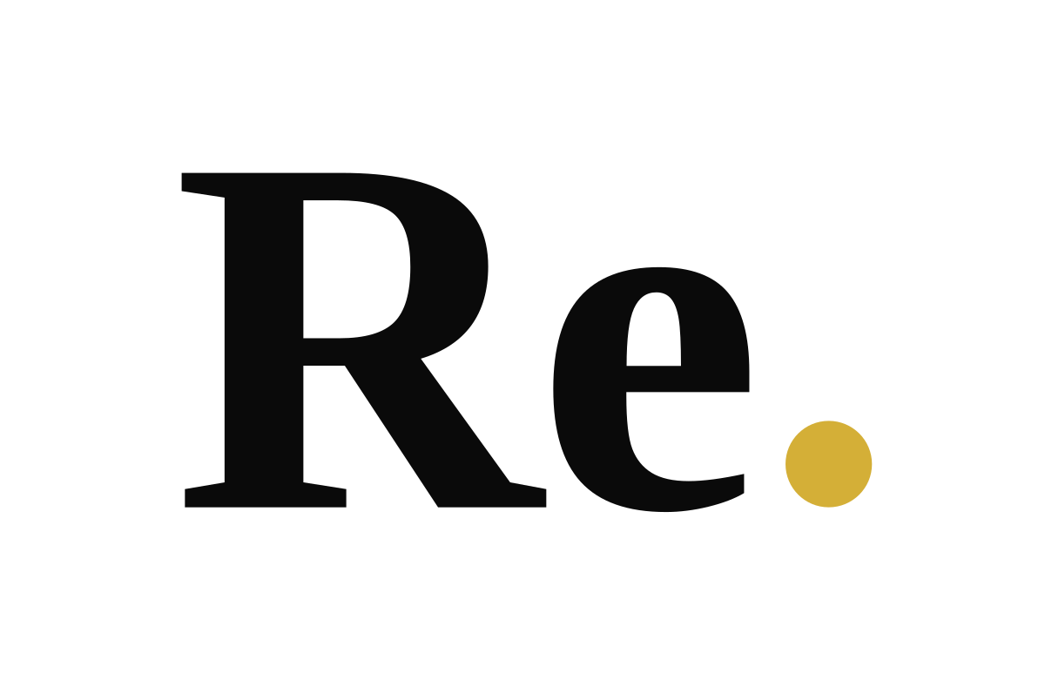
Brand Identity Guidelines
Logo · Colour · Typography · Graphic language · Naming
We do things again. Better.
Re. LLC · Abu Dhabi, UAE · Version 1.0 · September 2026

01 The mark
Two letters of serif authority, and a gold dot where the decision lands.
The Re. wordmark is the only logo. It is set in a bold, high-contrast serif in Times-Bold territory; the full stop is a solid gold circle sitting on the baseline. The typography carries heritage and intellect; the dot carries decision and value. Nothing else is added — no symbol, no descriptor lock-up, no strapline inside the mark.
The name carries three meanings at once: the prefix of change (rethink, rebuild, reposition), the formal 'Re:' — in the matter of your business — and the full stop, which marks the moment analysis ends and action begins.

Primary wordmark — Re. Noir on white or ivory
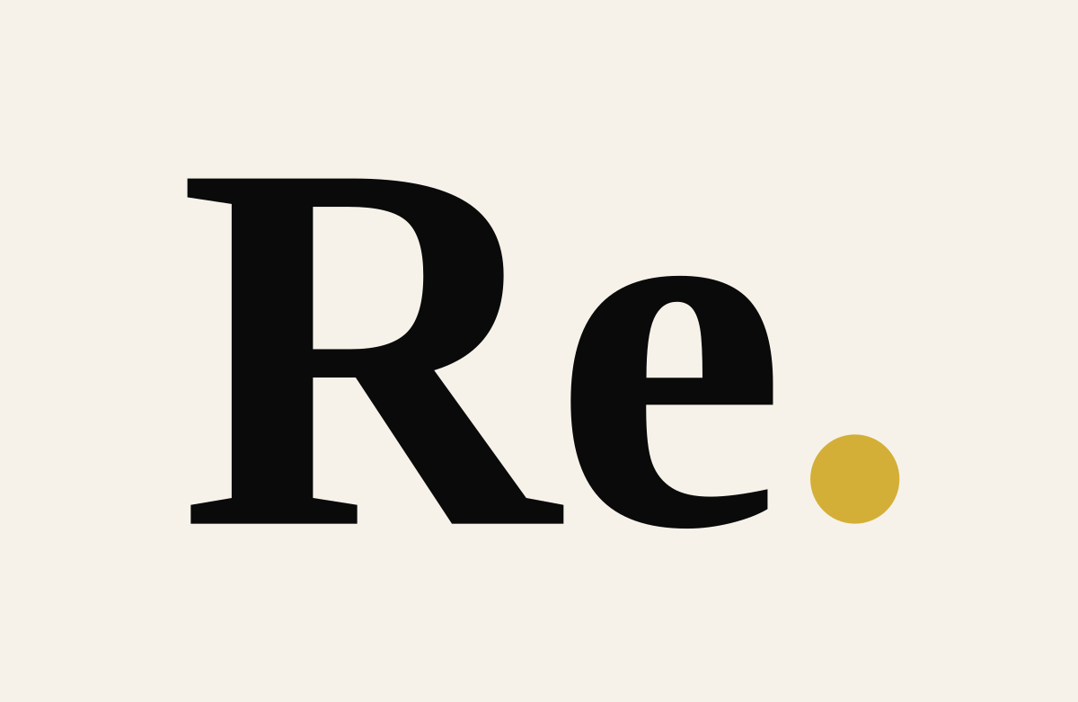

Reverse wordmark — Paper White on Re. Noir
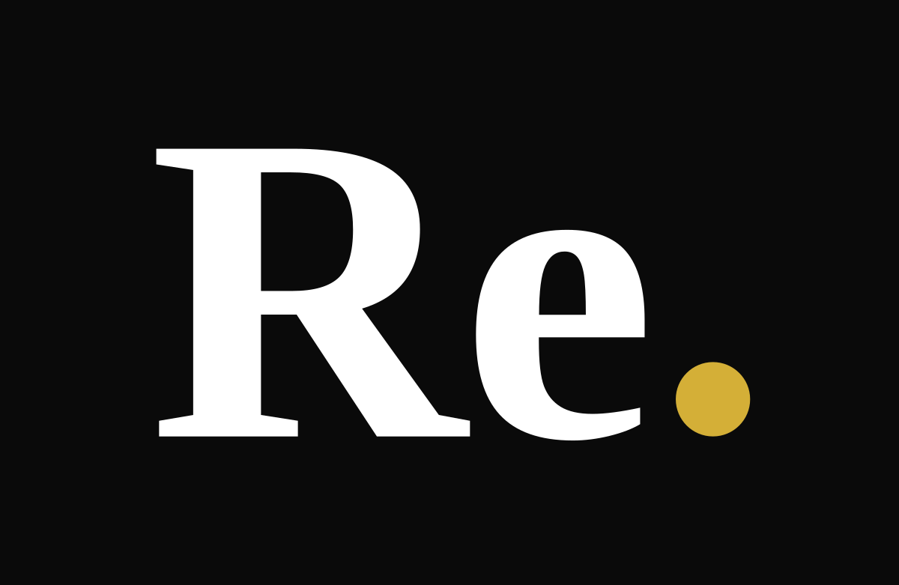
In both versions the dot is always Re. Gold #D4AF37. It never changes to black, white or grey, and it is never dropped.

Secondary mark — the gold dot monogram

The dot alone is the official secondary mark: favicon, app icon, wayfinding, pattern unit, chart emphasis and section marker. It supports the wordmark; it does not replace it on any surface where the audience may not yet know Re.

02 Logo rules
Rule | Standard
Clear space | Minimum clear space on all four sides equals twice the diameter of the gold dot. Nothing — type, imagery, rules, other logos — enters this zone. The supplied files already include this space.
Minimum size | Digital: 24 px high (approx. 50 px wide). Print: 8 mm wide. Below this, use the dot monogram.
Backgrounds | Noir wordmark on Paper White, Ivory or light photography. White wordmark on Re. Noir or dark photography. Never on mid-tones, gold, or busy imagery.
Placement | Top-left or bottom-left on documents; centred on covers and avatars; small and quiet on slides — the content is the hero, not the logo.
Proportion | Scale the wordmark as one object. The relationship between letters and dot is fixed and never adjusted.
Files | Always use the supplied SVG or PNG. Never retype 'Re.' in a font and add a period — the dot is a drawn circle, not a typographic full stop.

Misuse — never
- Stretch, condense, rotate, outline or add a drop shadow, gradient or bevel.
- Recolour the letters (no gold letters, no grey letters) or recolour the dot.
- Place a symbol, icon, cutlery, chef hat, building, globe or arrow beside the mark.
- Lock a tagline or descriptor into the logo artwork. Taglines sit separately, in the body typeface.
- Set the wordmark in any other typeface, or use 'Re' without the dot.
- Use the wordmark inside a box, circle or frame, or on a photograph without sufficient contrast.

03 Colour
The brand lives in black, white and warm neutrals. Gold is scarce by design.
 | Colour | HEX | RGB | CMYK | Role
 | Re. Noir | #0A0A0A | 10 · 10 · 10 | 0/0/0/96 | Primary. Type, backgrounds, authority.
 | Paper White | #FFFFFF | 255 · 255 · 255 | 0/0/0/0 | Primary background, reverse type.
 | Ivory | #F6F2EA | 246 · 242 · 234 | 3/3/8/0 | Warm background for documents and slides.
 | Stone | #C8C0B0 | 200 · 192 · 176 | 22/20/30/0 | Secondary neutral, rules, charts.
 | Re. Gold | #D4AF37 | 212 · 175 · 55 | 18/28/85/2 | Signature accent. The dot, one key figure, one highlight per page.
 | Ink Grey | #4A4A4A | 74 · 74 · 74 | 0/0/0/85 | Secondary text, captions.

Discipline
- One gold element per composition: the dot, one number, or one line. Never gold headlines, gold panels or gold backgrounds.
- Documents and slides default to Ivory; digital surfaces default to Paper White; covers and social avatars default to Re. Noir.
- Charts are monochrome (Noir, Ink Grey, Stone) with a single gold data point of emphasis.
- Scarcity is what keeps the palette premium and keeps Re. from looking like a bank.

04 Typography
Use | Primary (licensed) | Digital-safe fallback
Headlines / wordmark | High-contrast serif — Canela, GT Sectra or Freight Display | Georgia / Times New Roman Bold
Body & interface | Grotesque sans — Neue Haas Grotesk or Inter | Arial / Helvetica
Numbers & data | Sans with tabular figures — Inter (tabular) | Arial, tabular spacing

- Heading style. Headlines: sentence case, tight leading, full stops permitted at line ends. Never all-caps headlines.
- Body style. Short paragraphs, generous white space, ragged right, three lines maximum on brand surfaces.
- Data style. Large gold key figures with grey supporting labels. The number is the hero.
- Labels. Small caps or letter-spaced sans for section labels and descriptors (e.g. HOSPITALITY ADVISORY · ABU DHABI).
Until the licensed typefaces are purchased, use the fallbacks consistently across every surface — Times New Roman Bold for headlines, Arial for body. The wordmark files are outlined and do not depend on any installed font.

05 Graphic language
- The dot. Bullet, map-marker, chart-point, pattern unit and punctuation of every layout — one gold dot per composition.
- Lines. Thin single rules (0.5 pt) in Stone or Ink Grey structure pages. No boxes, no shadows, no gradients.
- Grid. Editorial 12-column grid; asymmetric layouts; images cropped tight and architectural.
- Diagrams & data. Monochrome charts with a single gold data point; no 3D, no clip-art; icon set limited to 1.5 pt line-weight custom glyphs.
- Presentations. Black or ivory slides, one idea per slide, numbers oversized, logos small.
- Social avatar. Wordmark centred with generous margin; ivory or black background; nothing else.
- LinkedIn banner. Wordmark set to the right of the profile-photo zone with a letter-spaced descriptor beneath.

06 Photography
Shoot the business behind the experience.
Real venues, real service, real prep — never staged stock, never motivational quote cards. Three registers:
- Architectural — symmetry, negative space, materials, dawn or late-night light.
- Operational — hands, the pass, prep, briefings; motion blur allowed; mise en place as still life.
- Human — candid focus on staff and leaders mid-work; no posed smiles to camera.
Grade: warm blacks, controlled highlights, muted colour with occasional brass or gold tones. Composition leaves clean space for typography. The test: if a frame could appear in a lifestyle magazine's advertorial, reshoot it; if it could open a documentary about how great venues really run, keep it.
Founder portrait: environmental, not studio — in a venue, at the pass or at a table with a P&L open; natural light; Noir or Ivory wardrobe; no arms-crossed corporate pose.

07 Naming & service architecture
The Re. device frames the work; plain, commercial English describes it.
Re. is a hospitality-led advisory firm. The service offer is presented as three pillars, with hospitality consultancy as the core and the two supporting pillars framed as protection and performance for the same operation.
Pillar | Role | Plain-English descriptor (contracts, scopes, invoices)
Hospitality Consultancy | Core pillar | Strategy & concepts · Pre-opening · Operational audits & SOPs · Guest experience · Menu engineering · P&L, cost control & turnaround · Organisation, training & service standards · Franchise readiness · Investor advisory
Health & Safety Advisory | Supporting pillar | HSE compliance · Food safety (HACCP-aligned) · Risk assessments · Hygiene audits · Staff safety training · Municipality & regulatory readiness · Safety SOPs and checklists
Sustainability Advisory | Supporting pillar | Sustainable operations · Waste reduction · Responsible sourcing · Energy & water efficiency · Sustainable packaging · ESG-aligned practices · Sustainability audits for hotels and restaurants

Rules for the Re. device
- The wordmark is the only place the device is mandatory. In running text the company is written 'Re.' with its full stop, and the sentence continues normally: 'Re. was founded in Abu Dhabi.'
- Re.-prefixed words (Re.think, Re.build, Re.position, Re.perform) are reserved for headlines, campaign lines and section titles — never body copy, never more than once per message.
- The three pillars are always referred to by their plain names on commercial surfaces. Branded pillar names are not used.
- The methodology is The Re.Method — Read · Rethink · Rebuild · Run · Return — and may carry the device as proprietary IP.
- Master line: 'We do things again. Better.' Category line: 'Hospitality, rethought.' Conversion line (pitches, LinkedIn, proposals): 'Results, not reports.'

08 Voice in one page
Confident, not arrogant. Experienced, not old-fashioned. Commercial, not cold. Direct, but sophisticated.
- Short sentences. Full stops are a brand asset.
- Lead with the point; explain after. Never bury the recommendation.
- Every claim carries a number, an example or a consequence. The number is the adjective.
- Say 'we recommend', never 'it could be considered'. Own the advice.
- No exclamation marks. No 'synergy', 'elevate', 'passion', 'world-class', 'unlock', 'seamless', 'bespoke', 'solutions', 'holistic', 'delight'.
Founder attribution: Charbel Basbous, Co-Founder & Managing Director, is the named public face of Re. across the website, company profile and LinkedIn. Founder posts carry the view; the company page carries the proof.

09 Asset index
All files are in the Re_Identity_Kit folder. SVGs are outlined vector artwork for designers, printers and web; PNGs are ready-to-use exports.
File | Use
Re_Wordmark_Black_transparent (.svg / 400 · 1200 · 3000 px) | Primary logo on white, ivory or light backgrounds — documents, website, print
Re_Wordmark_White_transparent (.svg / 400 · 1200 · 3000 px) | Reverse logo on Noir or dark backgrounds — covers, slides, dark web sections
Re_Wordmark_Black_on_White / on_Ivory / White_on_Black (1200 px) | Flattened versions for email signatures, quick placements, supplier requests
Re_Dot_Monogram (transparent / on_Black / on_Ivory) | Secondary mark — favicon source, app icon, pattern, chart emphasis
favicon_16 / 32 / 48 / 180 / 512 | Website favicon set and Apple touch icon
Re_Avatar_Black / White / Ivory (1080 px) | Instagram and LinkedIn profile pictures (Black is the default)
LinkedIn_Company_Banner_1584x396 | Company page cover
LinkedIn_Personal_Banner_1584x396 | Founder profile cover
Re_Cover_1920x1080_Black | Deck title slide, video end-card, website hero placeholder

