Getting started with bamazomCustomer app.

At the git bash command line enter node bamazonCustomer.js

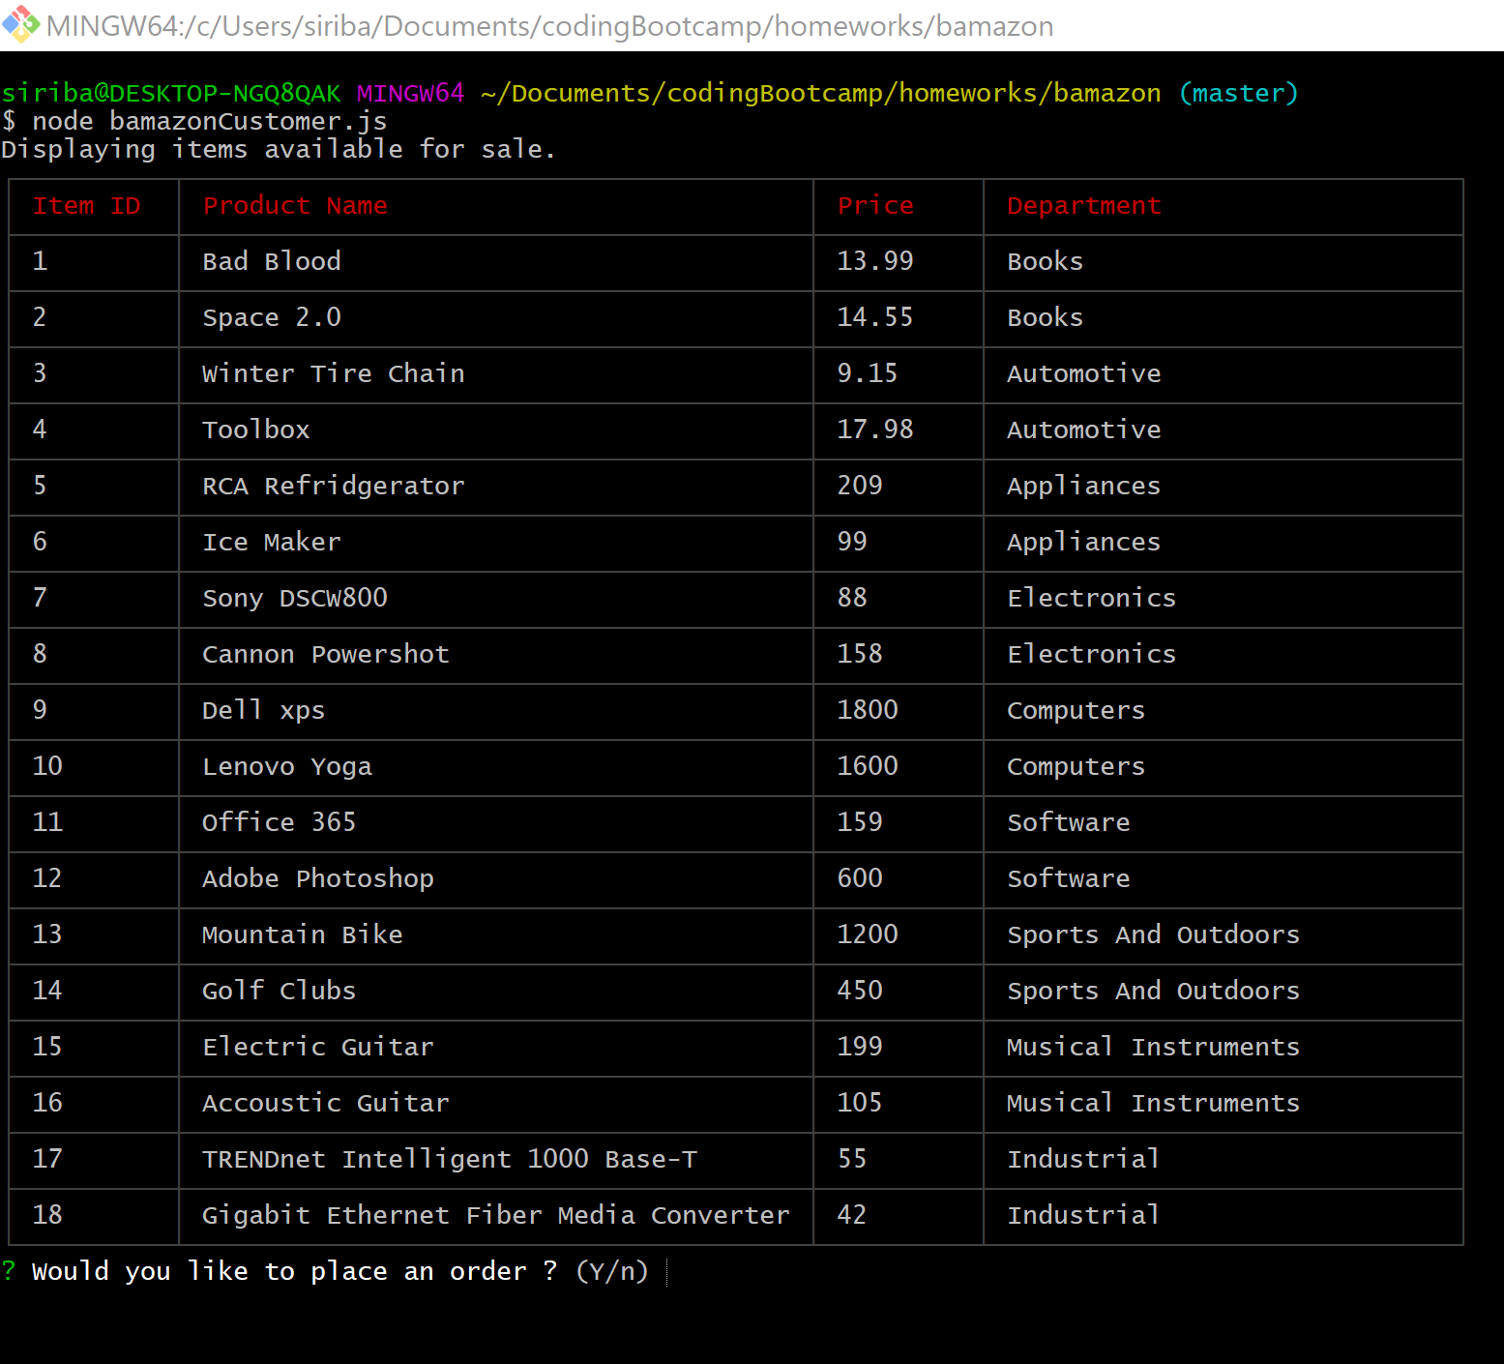

Say yes to place an order

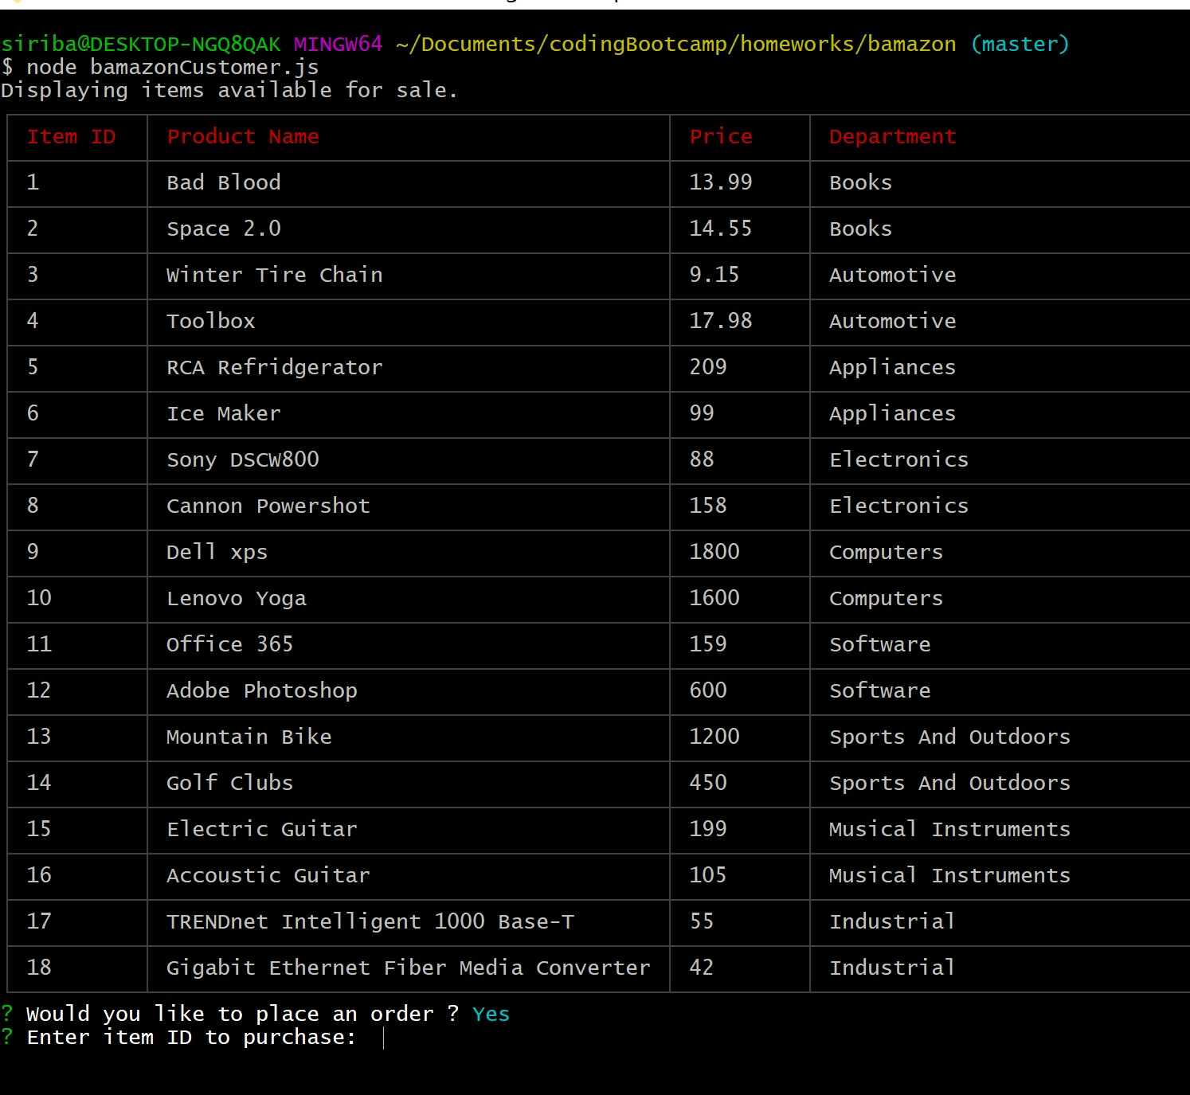

Enter item id and quantity, if there is stock, order is processed

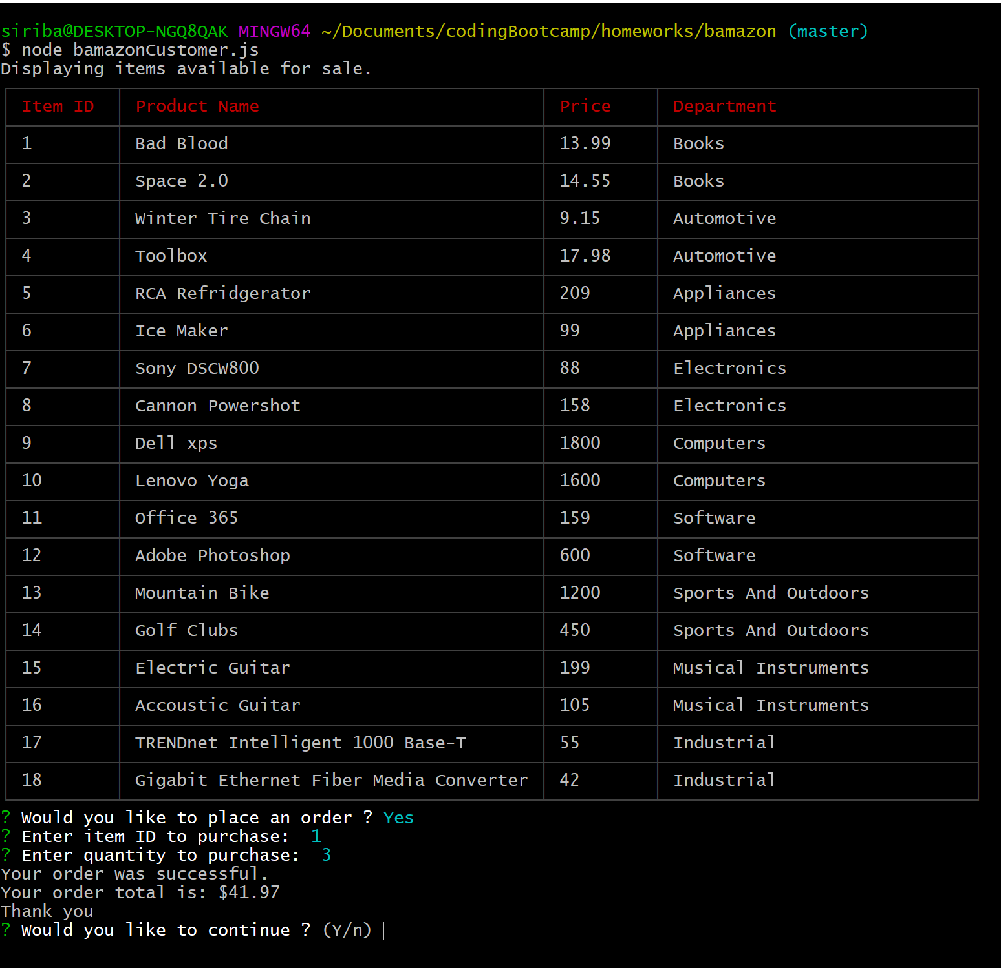

Your order total is confirmed and asked whether to continue.  
if yes, the list of items is displayed for more selection and orders  
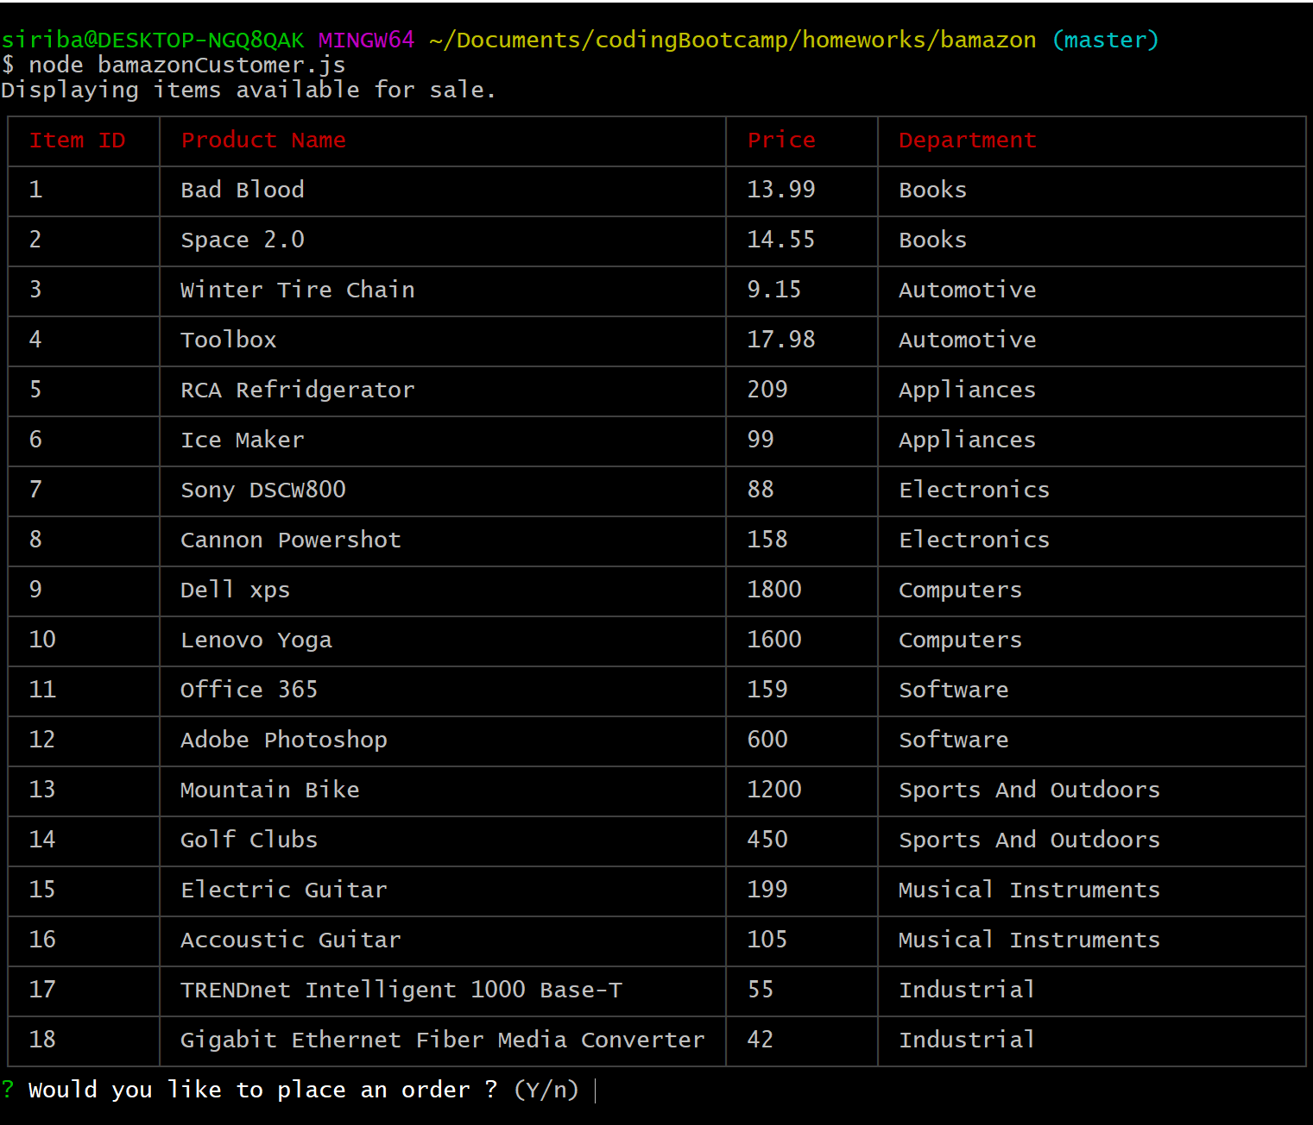

If you chose no to continue, the app terminates and disconnects the database.

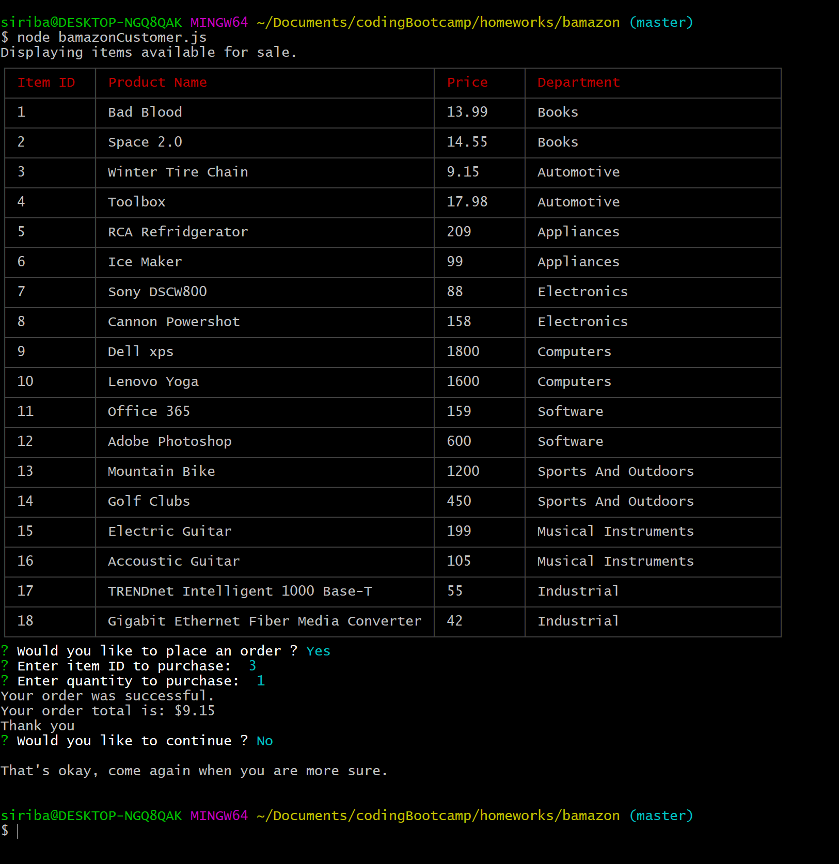

If you enter quantity more that stock, order should not process.

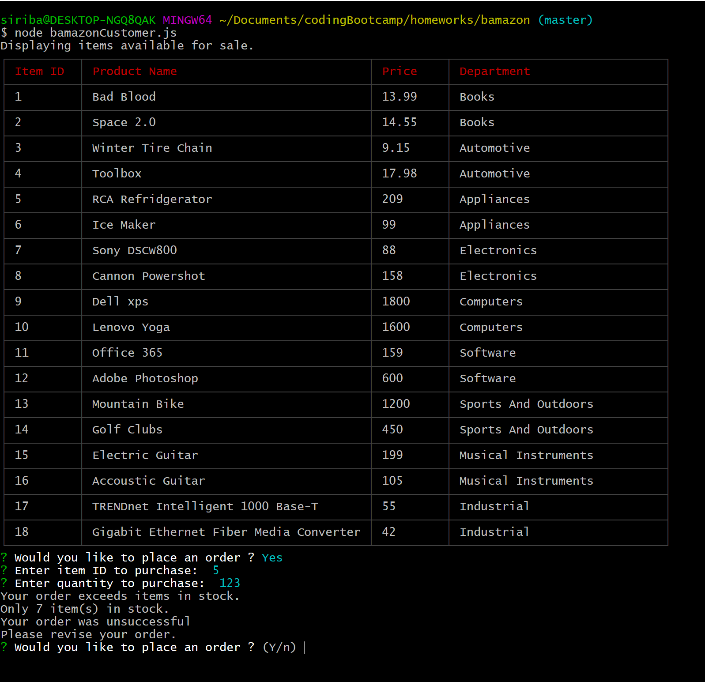

Chose yes to place an order

