Game Design Document

Fill up the following document

1. Write the title of your project.

Space Invasion

1. What is the goal of the game?

Survive the space invasion by destroying enemy ships.

1. Write a brief story of your game.

Aliens are invading Earth and you have to destroy the space ships to

protect earth.

1. Which are the playing characters of this game?

* Playing characters are the ones who respond to the user based on the input from the user.
* Cars, monkeys, dinos, wizards, etc., are the playing characters in the game.

|  |  |  |
| --- | --- | --- |
| Number | Character Name | What can this character do? |
| 1 | Playing space ship | Move up and down and shoot |
| 2 |  |  |
| 3 |  |  |
| 4 |  |  |
| 5 |  |  |
| 6 |  |  |
| 7 |  |  |
| 8 |  |  |

1. Which are the Non-Playing Characters of this game?

* Non-Playing characters are the ones that don't have an action or behavior when the user interacts with the game.
* Hurdles, stones, bananas, coins, etc., are non-playing characters in the game.

|  |  |  |
| --- | --- | --- |
| Number | Character Name | What can this character do? |
| 1 | Enemy rocket ship | Move forward and attempt to collide with player space ship |
| 2 | Enemy gun ship | Move forward and try to shoot you |
| 3 |  |  |
| 4 |  |  |
| 5 |  |  |
| 6 |  |  |
| 7 |  |  |
| 8 |  |  |

Draw your imagination of this game. What does this game look like?

* Draw the game either on your computer or on paper.
* Add images of the game scenes to show each of the playing and non-playing characters at least once.

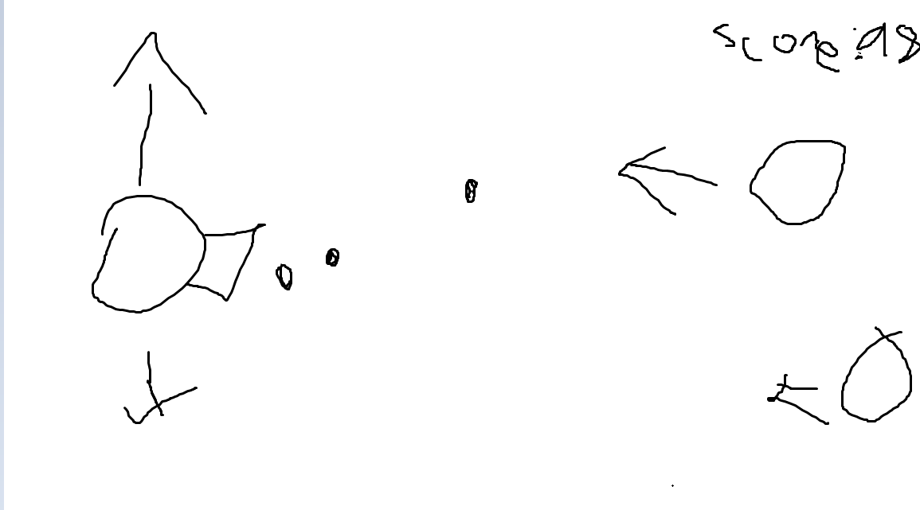

How do you plan to make your game engaging?

Some enemy ships will have guns that will try to shoot you.