Programming Design (II) Project 3 【Candy crush】

**report**

資訊四 F74004046 劉慎之

--------------------------------------------------------------------------------------------------

* 【程式執行方式】：

利用Qt creator 來執行建立出執行檔之後便可以執行遊戲

★ 【遊戲執行畫面】：

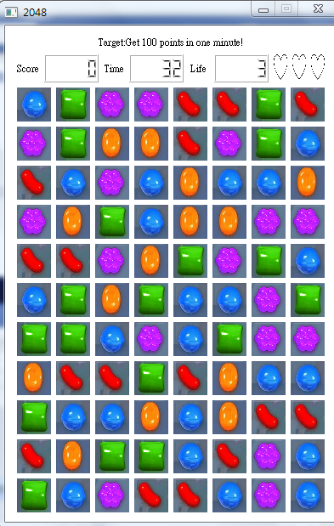 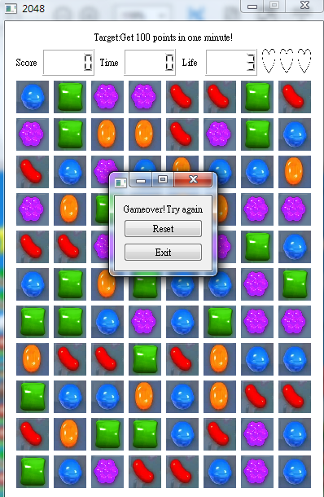 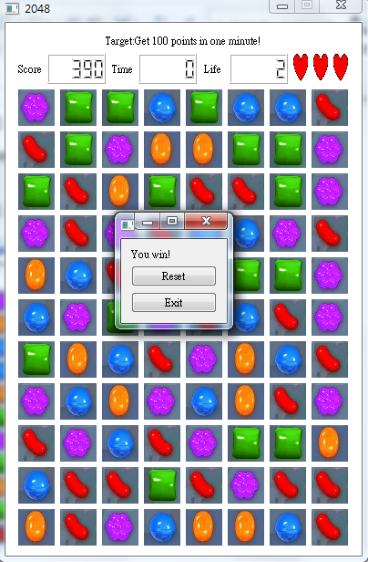

★ 【UML class diagram】：

|  |
| --- |
| qwidget |

|  |
| --- |
| Widget |
| * ui:Ui::Widget * tileclick:int * tx:int * ty:int * cx:int * cy:int * score:int * life:int * time:int * mode:int * tile[11][8]:Tile* * star:Star* * resetb:QPushButton* * exit:QPushButton* * endgame:QWidget* * layout:QVBoxLayout* * word:QLabel* |
| + <<constructor>>Widget(QWidget *parent = 0);  + <<destructor>>~Widget();   * createboard():void * startgame():void * endGame(int ch):void * exchange(Tile *Box1,Tile *Box2):void * emptyMove():void * fillempty():void * checkclick():int * allclear():int * rowclear():int * vclear():int * checkempty():int   signal scorechanged(int score):void  signal lifechanged(int life):void  signal timechanged(int time):void  + checkboard():void  + countdown():void  + reset():void  + quits():void |

