Figures
A literature-guided public-data evidence hierarchy prioritises a PLK1-centred mitotic/redox programme in lung adenocarcinoma
Target journal: BMC Genomics · 5 main figures + 2 additional-file (supplementary) figures. Figures are 400-dpi renderings; editable vector PDFs are provided in the submission package.

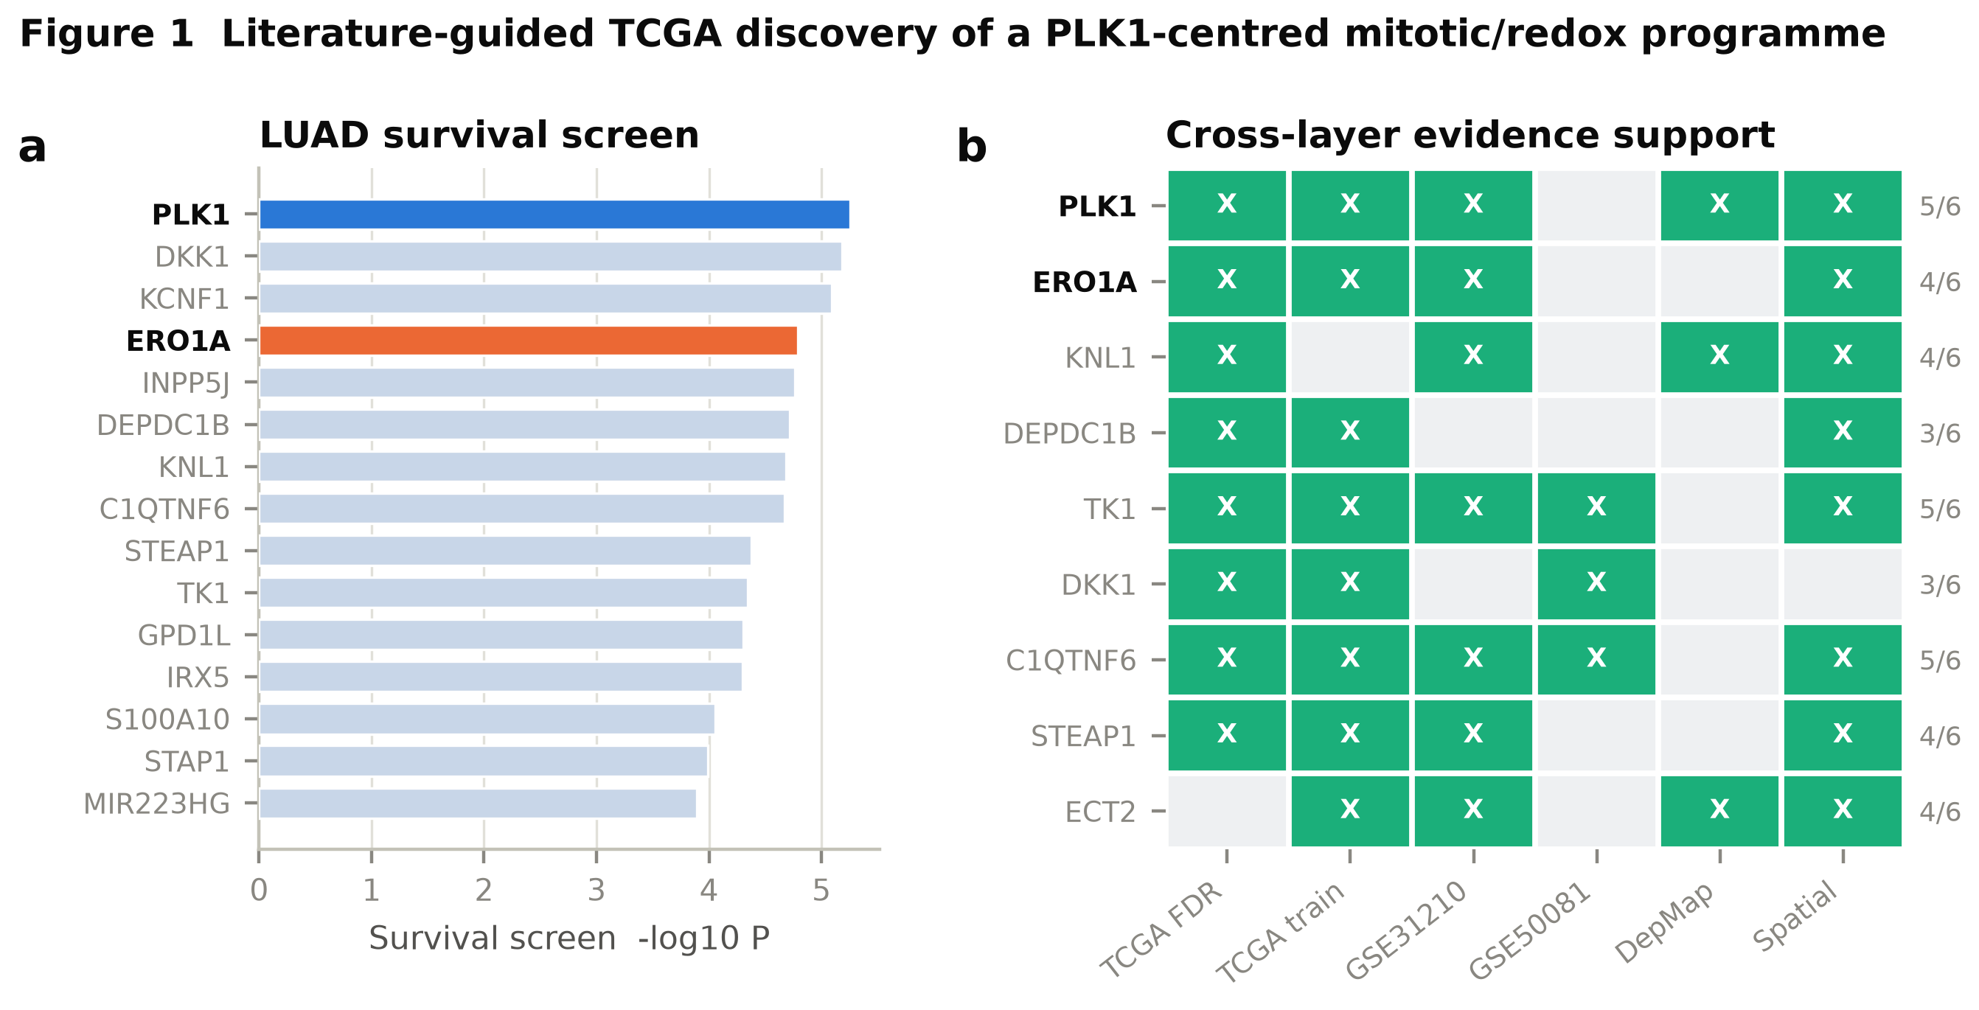
Figure 1. Literature-guided TCGA discovery of a PLK1-centred mitotic/redox programme.
(a) Genome-wide TCGA-LUAD survival screen; the top 15 genes are ranked by -log10 log-rank P, with the lead candidates PLK1 (blue) and ERO1A (orange) highlighted. (b) Cross-layer evidence-support matrix for the nine programme genes across six independent evidence layers (TCGA FDR significance, TCGA-train log-rank, GSE31210 and GSE50081 replication, DepMap dependency, spatial support); the right-hand column gives the per-gene support count.

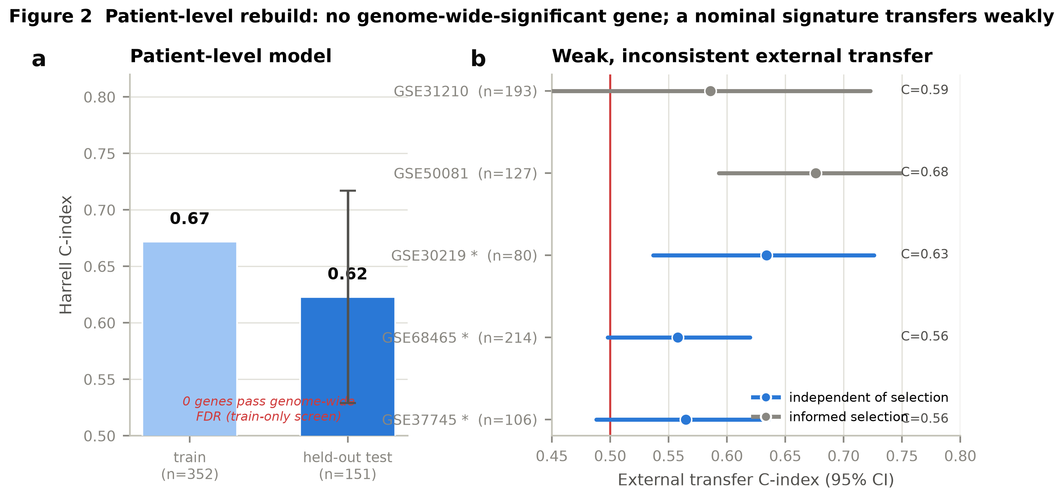
Figure 2. A nine-gene score: construction, held-out separation and multi-cohort transfer.
(a) Frozen Cox coefficients of the nine programme genes fitted in the TCGA training partition (red, risk-increasing; blue, protective). (b) Harrell C-index of the prior ridge scaffold versus the consensus score on TCGA training and held-out data; the dashed line marks random discrimination (0.5). (c) Forest plot of hazard ratio per 1-SD score (95% CI) on external transfer; the score is significant in four of five cohorts (blue) and does not replicate in GSE37745 (orange), which is retained as a transparent null. C-index and Cox P values are annotated.

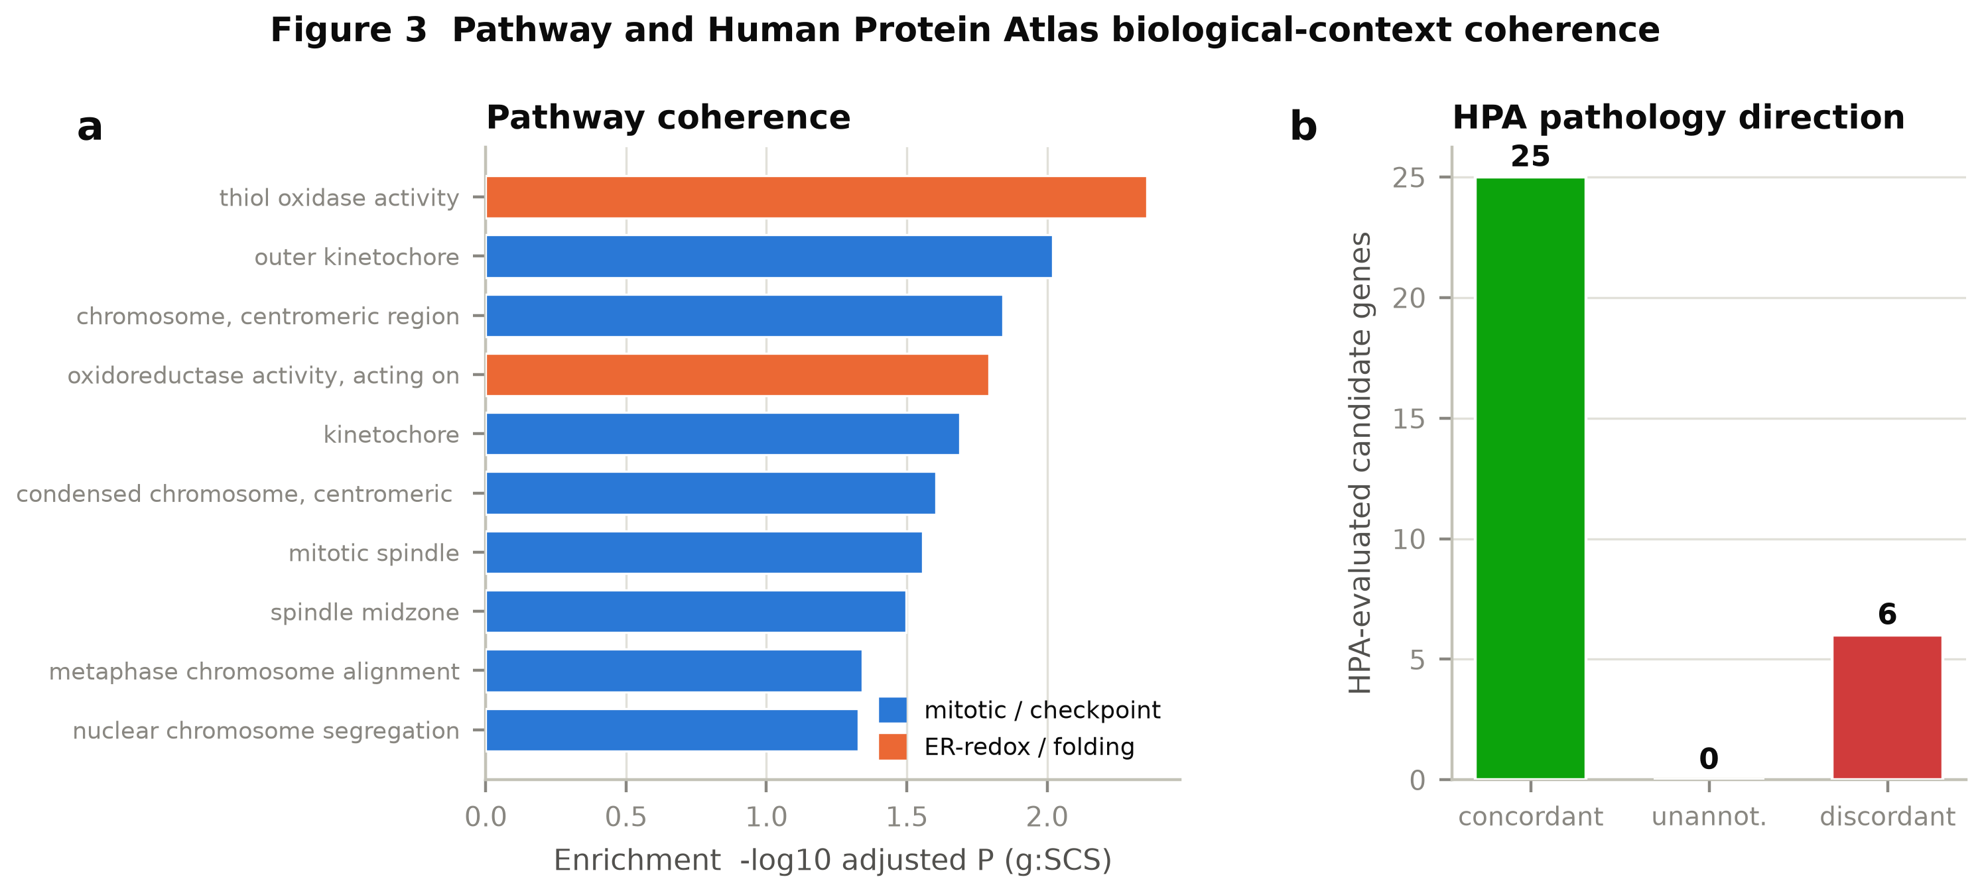
Figure 3. Pathway and Human Protein Atlas biological-context coherence.
(a) g:Profiler enrichment (-log10 adjusted P, g:SCS correction) of the candidate programme, coloured by theme (blue, mitotic/checkpoint; orange, ER-redox/folding). (b) Distribution of Human Protein Atlas pathology-direction concordance across evaluated candidate genes.

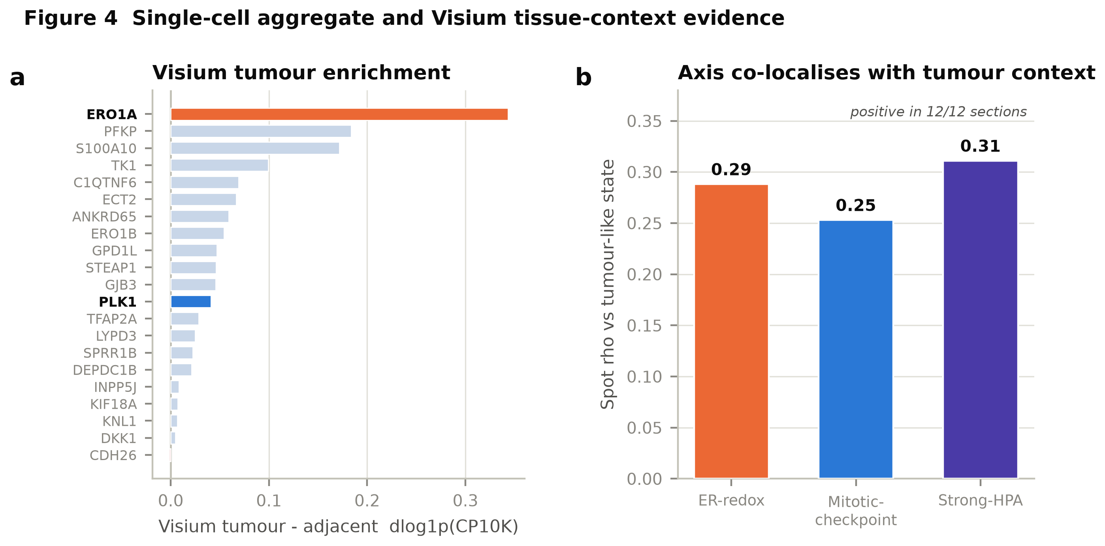
Figure 4. Single-cell aggregate and Visium tissue-context evidence.
(a) E-MTAB-13530 Visium tumour-minus-adjacent candidate-gene expression (delta log1p CP10K); ERO1A (orange) and PLK1 (blue) are highlighted. (b) Spot-level Spearman correlation of each programme axis with the tumour-like state, the cross-method-robust spatial signal; positive in all 12 tumour sections.

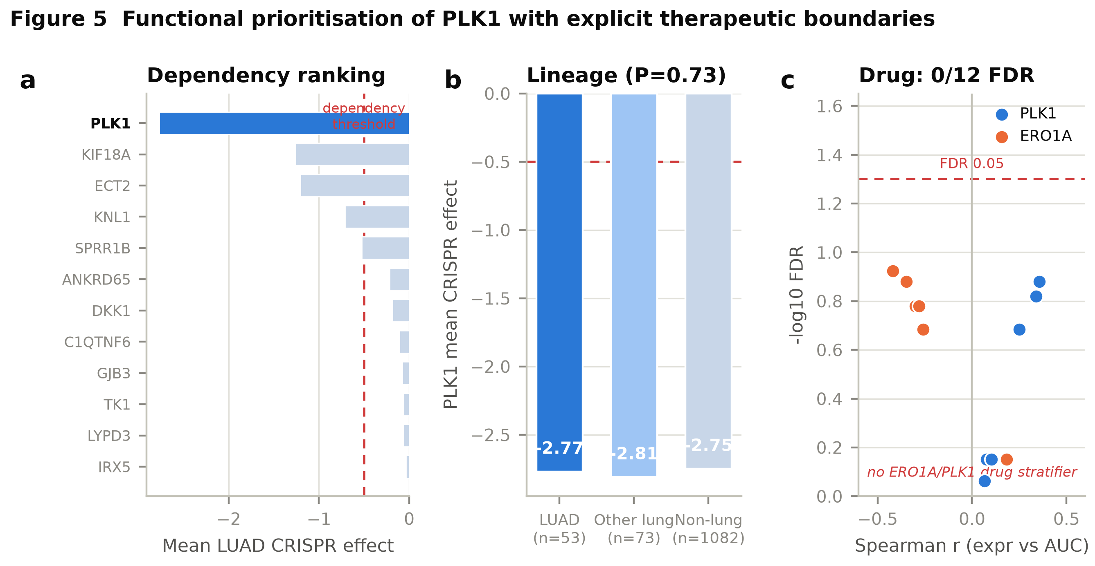
Figure 5. Functional prioritisation of PLK1 with explicit therapeutic boundaries.
(a) DepMap Public 26Q1 dependency ranking (mean LUAD CRISPR effect); PLK1 (blue) is the strongest dependency, past the -0.5 common-dependency threshold. (b) PLK1 mean CRISPR effect across LUAD, other-lung and non-lung models, showing common essentiality rather than LUAD selectivity (Mann-Whitney P=0.73). (c) Expression-drug associations (Spearman r versus -log10 FDR) for PLK1 (blue) and ERO1A (orange); none of the 12 tests passes FDR<0.05 (dashed line), so no PLK-inhibitor stratifier is supported.

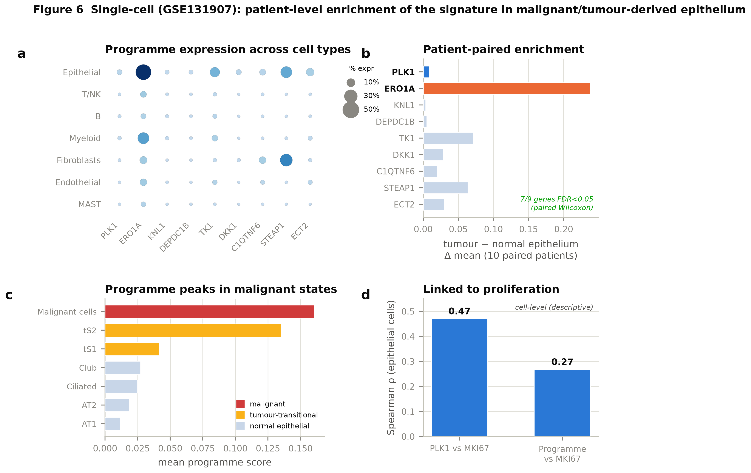
Figure 6. Single-cell (GSE131907): patient-level enrichment of the signature in malignant/tumour-derived epithelium.
(a) Programme-gene expression across annotated cell types (dot size = percent expressing, colour = mean expression). (b) Malignant (tumour-origin) versus normal epithelial differential expression; 7 of 9 genes are enriched at the patient level (paired Wilcoxon across 10 patients with matched normal and tumour epithelium, FDR<0.05). (c) Programme score peaks in malignant and tumour-transitional epithelial states versus normal epithelium. (d) Programme and PLK1 correlate with proliferation (MKI67) across epithelial cells.

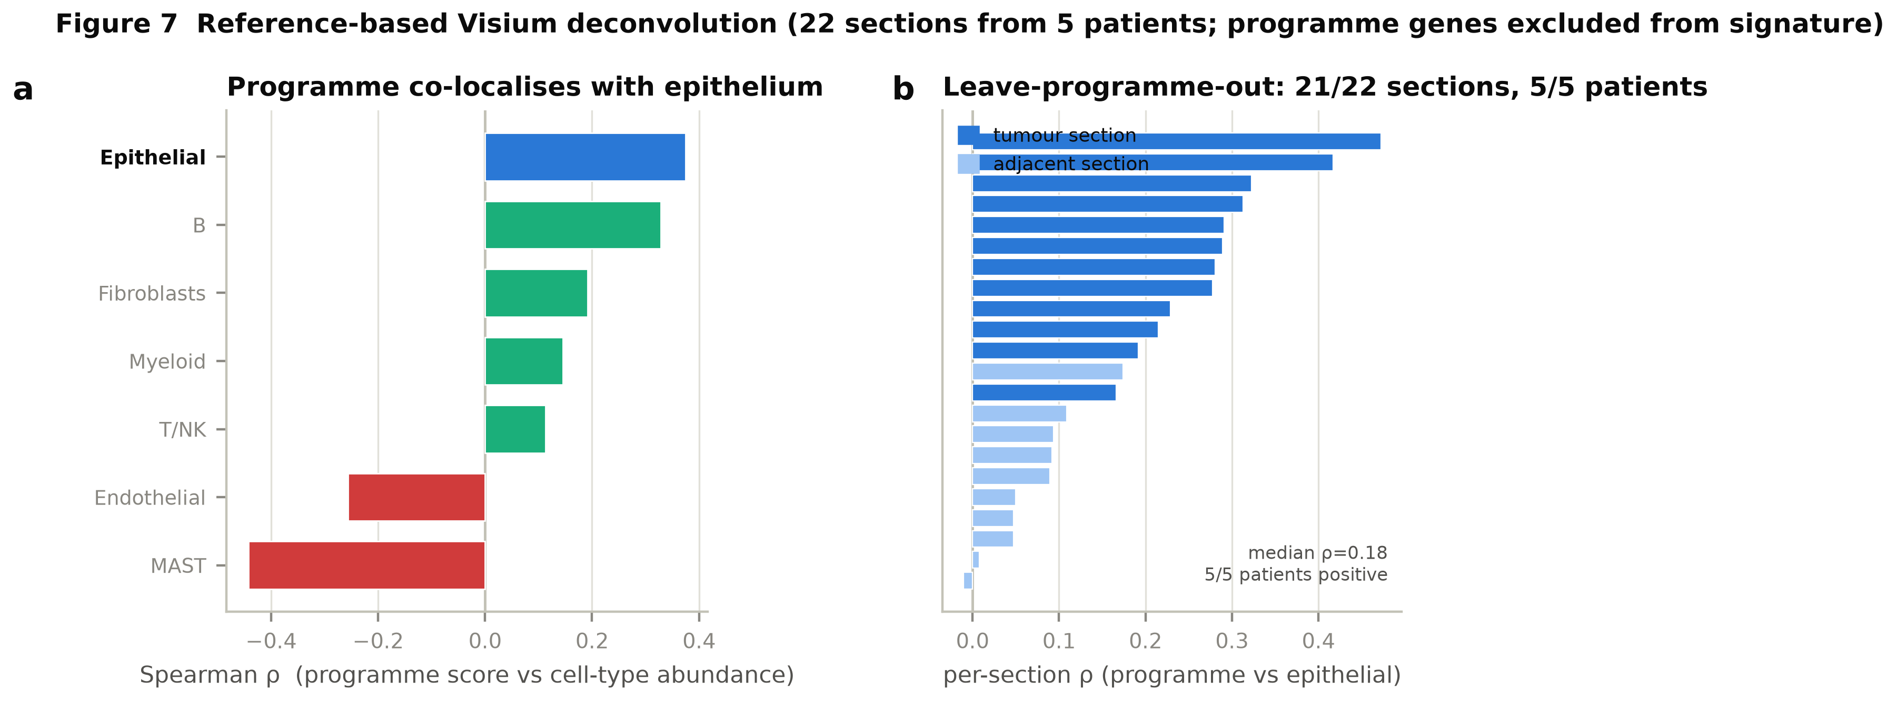
Figure 7. Reference-based Visium deconvolution (programme genes excluded from the signature; 22 sections, five patients).
(a) Spearman correlation between programme score and inferred cell-type abundance across ~53,000 spots; the programme co-localises with the epithelial compartment and negatively with mast/endothelial cells. (b) With programme genes excluded from the signature, the programme-versus-epithelial correlation is positive in 21/22 sections and 5/5 patients; the patient-level test is under-powered (n=5).

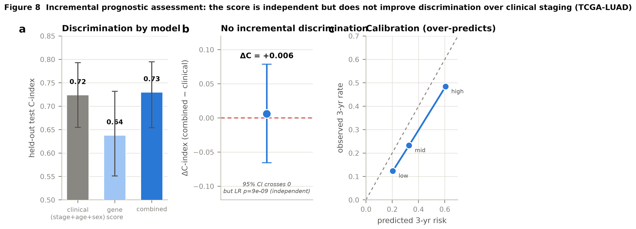
Figure 8. Incremental prognostic assessment (TCGA-LUAD; train-fit, test-evaluated).
(a) Harrell C-index for the gene score alone versus the score-plus-clinical nomogram (all TCGA and held-out test); the score is independent (LR p<1e-8) but adds no discrimination over clinical staging (clinical 0.72, gene 0.64, combined 0.73). (b) Incremental delta-C-index over the clinical model is +0.006 (95% CI crosses 0). (c) Three-year calibration over-predicts risk.

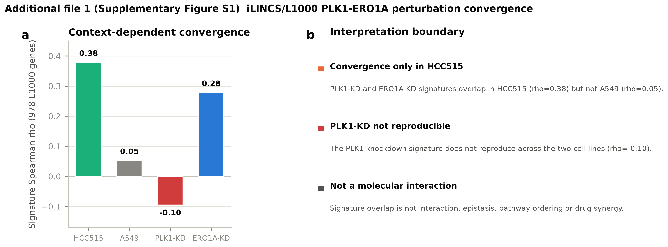
Additional file 1 (Supplementary Figure S1). iLINCS/L1000 PLK1-ERO1A perturbation convergence.
(a) Signature-level Spearman correlation (978 shared L1000 genes): within-cell PLK1-knockdown vs ERO1A-knockdown convergence in HCC515 and A549, and cross-cell knockdown reproducibility. (b) Interpretation boundary: convergence appears only in HCC515, the PLK1 knockdown signature is not reproducible across cell lines, and signature overlap does not establish molecular interaction, epistasis, pathway ordering or drug synergy.

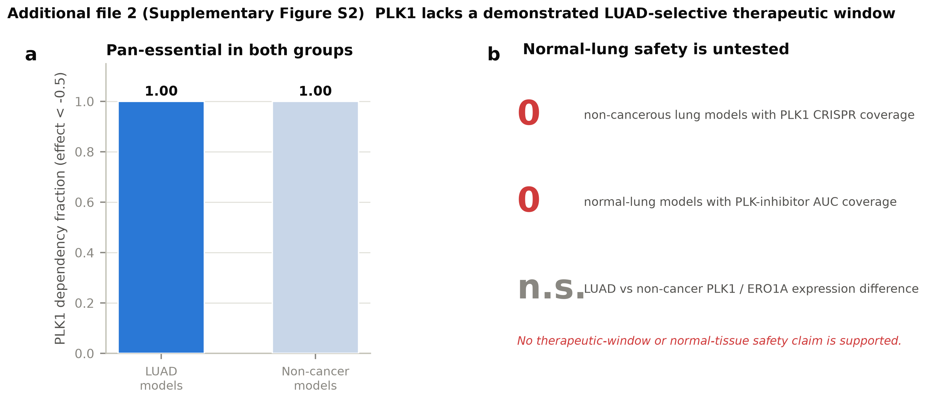
Additional file 2 (Supplementary Figure S2). PLK1 lacks a demonstrated LUAD-selective therapeutic window.
(a) PLK1 CRISPR dependency fraction in LUAD versus non-cancer models: pan-essential (1.00) in both. (b) Coverage audit: no non-cancerous lung model has PLK1 CRISPR or PLK-inhibitor coverage, and LUAD versus non-cancer PLK1/ERO1A expression differences are non-significant; no therapeutic-window or normal-tissue safety claim is supported.

