**Python**

**題目要求：**

1. 設計一加解密機制

2. 須利用ASCII碼完成

**提示：**

Char -> ASCII -----> ord('a') -> 97

ASCII -> Char -----> char(97) -> 'a'

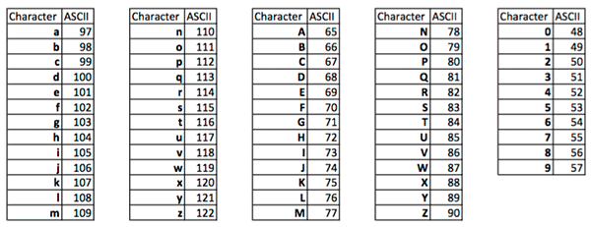

**Input/Output:**

In [1]:1

In [2]:NPTU_Information_MIS_CBF104014

Output [1]:234240252255285219330306333342327291348315333330285231219249285201198210147144156144147156

In[3]:2

In[4]:234240252255285219330306333342327291348315333330285231219249285201198210147144156144147156

Output [2]:NPTU_Information_MIS_CBF104014