Cheatsheet
Glossary
Concepts | Explanation with example
Object | Everything in programming is an object (a “thing” you can use). Objects can do actions (methods). Example: light_matrix is an object that can display text.
Variable | A name used to store a value. Example: x = "Sunflower"
Comment | Notes in code to help humans understand. Python ignores them. Example: # this is a comment
String | Any character written inside quotes. Example: “Hello”
Function | Reuseable block of code that performs specific task. Example: def greet()
Parameter | A placeholder in a function that gets filled with a value when the function is run. Example: def greet(name)
Indentation | Spaces at the start of a line that tell Python the code belongs inside a function or loop.
Module | A toolbox of ready-made code you can use in your program by importing it.
Method | A function that belongs to an object.
Argument | The actual value passed into a function. Example: greet("WORLD")
Constant | A fixed value that does not change. Example: color.RED here .RED is constant.
List | Collection of items in specific order. Example: numbers = [1,2,3]
range(n) | Generates numbers from 0 to n-1. Example: range(3) → 0,1,2
for loop | A way to repeat code for each item in a list, without writing the same code again and again.
async | Used to create a program that runs tasks step by step in order.
await | Waits for the current task to finish before moving on to the next task.
runloop | Runs an async program. Example: runloop.run(main())

Differences
Concepts | Differences
Variable vs Object | Variable = a name that stores something.  Object = the actual thing/data stored.  Example: name = "Sunflower" → name = variable, "Sunflower" = object
Method vs Function | Function = independent block of code.  Method = a function that belongs to an object.  Example: print() (function), light_matrix.write() (method)
Parameter vs Argument | Parameter = placeholder in function.  Argument = real value passed in.  Example: def greet(name) → parameter; greet("John") → argument
await vs time.sleep() | await = waits for a task inside async program (robot finishes action properly).  time.sleep() = pauses whole program for some time
for i in range(n):  vs  for i in list: | range(n) = loops numbers (0 to n-1).  list = loops actual items.  Example: range(3) → 0,1,2 vs ["a","b","c"]

📦 Modules List
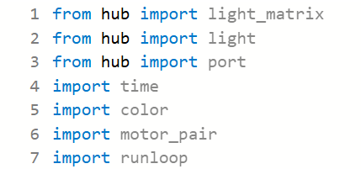
💡 Methods of light_matrix module
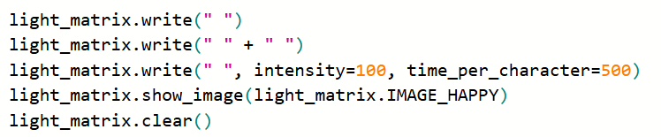
🎨 Methods of light module
⏱ Methods of time module
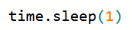
🔁 for Loop Components
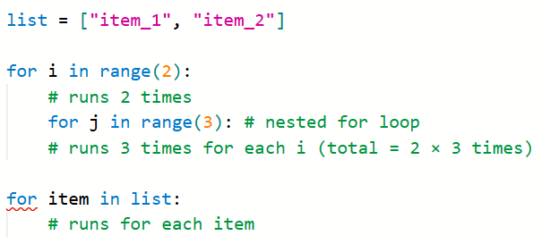
⚙️ Methods of motor_pair module
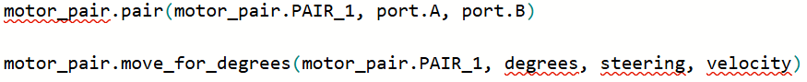
🔄 Runloop Structure
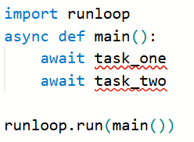
🎨 Constants of Color module
BLACK | BLUE | GREEN | RED
MAGENTA | AZURE | YELLOW | WHITE
PURPLE | TURQUOISE | ORANGE

😊 Image Constants of light_matrix module
😀 Faces & Emotions
IMAGE_HAPPY | IMAGE_SMILE | IMAGE_SAD | IMAGE_ANGRY
IMAGE_CONFUSED | IMAGE_ASLEEP | IMAGE_SURPRISED | IMAGE_SILLY
IMAGE_FABULOUS | IMAGE_MEH

❤️ Symbols
IMAGE_HEART | IMAGE_HEART_SMALL | IMAGE_NO
IMAGE_TARGET | IMAGE_YES

🕒 Clock
IMAGE_CLOCK1 | IMAGE_CLOCK2 | IMAGE_CLOCK3 | IMAGE_CLOCK4
IMAGE_CLOCK5 | IMAGE_CLOCK6 | IMAGE_CLOCK7 | IMAGE_CLOCK8
IMAGE_CLOCK9 | IMAGE_CLOCK10 | IMAGE_CLOCK11 | IMAGE_CLOCK12

➡️ Directions
IMAGE_GO_RIGHT | IMAGE_GO_UP
IMAGE_GO_LEFT | IMAGE_GO_DOWN

🔷 Shapes
IMAGE_TRIANGLE | IMAGE_TRIANGLE_LEFT | IMAGE_SQUARE | IMAGE_SQUARE_SMALL
IMAGE_DIAMOND | IMAGE_CHESSBOARD

🐾 Animals
IMAGE_RABBIT | IMAGE_COW | IMAGE_DUCK | IMAGE_TORTOISE
IMAGE_BUTTERFLY | IMAGE_GIRAFFE | IMAGE_SNAKE

🎵 Music & Objects
IMAGE_MUSIC_CROTCHET | IMAGE_MUSIC_QUAVER | IMAGE_MUSIC_QUAVERS
IMAGE_PITCHFORK | IMAGE_XMAS | IMAGE_ROLLERSKATE

🎉 Objects
IMAGE_PACMAN | IMAGE_TSHIRT | IMAGE_HOUSE | IMAGE_GHOST
IMAGE_STICKFIGURE | IMAGE_SWORD | IMAGE_SKULL | IMAGE_UMBRELLA

