Section 1: Introduction

Introduction
Have you ever wondered how computers and robots know what to do?
They don't think for themselves – they follow instructions. Programming is how we give those instructions, in a special language, that computers and robots understand. Today, you are going to learn one of those languages: Python.
In this workshop, you’ll use Python to control a LEGO SPIKE Prime robot. You’ll make it move, light up, play sounds, and react to its surroundings.

What is Python?
Python is a text-based programming language.
It is easy to read and write.
It is used by both beginners and professionals to:
- build games, applications, and websites.
- study data and create smart tools using machine learning
- to automate boring or repetitive tasks, making work quicker and easier
- control robots (like LEGO SPIKE Prime)

Setting up the SPIKE Prime Code Editor
The Code Editor is where we write our Python programs. When we press Play, the robot reads our code and follows those instructions.
Open the SPIKE Prime webpage → New project → Python → Create. Name your file demo.py (all Python files end in .py).
https://spike.legoeducation.com/prime/lobby/
The screen is split into two main sections:
- The top section is where you write your code.
- The bottom section (Console) shows messages and errors.
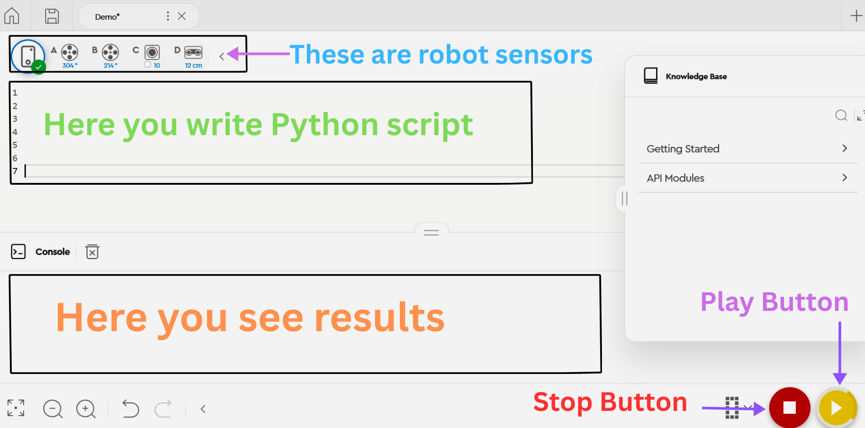

Ports and Sensors
Sensors allow the robot to detect and react to the world around it.
Each part of the robot plugs into a lettered port:
- A – Left Motor
- B – Right Motor
- C – Colour Sensor
- D – Distance Sensor
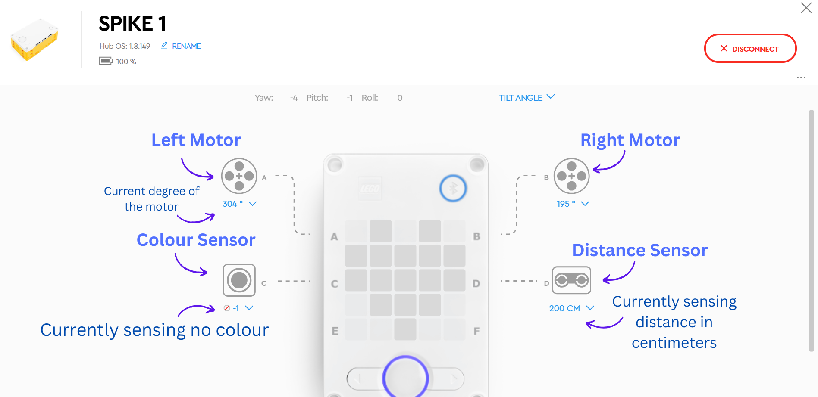

Section 2: Your First Program: “Hello LEGO”
When learning a new programming language, you often start with the “Hello World” program. This is a simple check that everything is working.
👉 Carefully type this into demo.py, then press the yellow Play button:
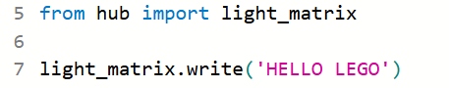
What will happen when you run it?
The hub (screen) will display the text: HELLO LEGO
How does the code work?
from hub import light_matrix
  - hub and light_matrix are modules.
  - Explanation: The hub is like a toolbox. Inside there are different tools we can use to control robots. One of those tools is called light_matrix, which lets us control the hub screen on top of the robot, which lets us control the hub screen on top of the robot.
light_matrix.write('HELLO LEGO')
- .write() is a function (method) of the light_matrix tool (object).
- Explanation: It is used to display text on the hub screen. Whatever you put inside the quotes ' ' or " " will appear on the hub screen.
💡 Tip 1: You can change how bright the letters appear on the Light Matrix or how fast each character shows up! Write only the values of intensity and time per character, eg: light_matrix.write('HELLO', 80, 400)
80 = intensity (0 = dim, 100 = bright) | 400 = time per character in milliseconds (smaller = faster)

Comments
Sometimes, you want to write notes in your code to explain what it does. They do not affect how the program runs. A comment start with the # (hashtag) symbol.
👉 Add the comments to your code, then press the yellow Play button:
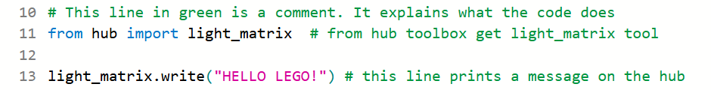
Did anything happen? No — nothing changed! That’s because comments do not run.
💡 Tip 2: In this activity you don’t need to type any of the comments you see in green. They are just to explain what the code does.

Exercise 1
1. Can you make the robot greet you by your name?
Challenge: Can you make the message brighter and faster? (Hint: use intensity and time_per_character — see Tip 1.)

Section 3: Functions
In the last example, you used .write() to make the robot show text. But what if you want the robot to do something again and again without typing the same code each time?
That’s what a function is!
A function is a reuseable block of code that performs a specific task. You define a function using the word def, followed by:
- the function name
- brackets ()
- a colon :
The code that belongs to the function is written underneath it and indented (moved slightly to the right). This tells Python that those lines are part of the function.
You play the function by writing its name with brackets, for example: function_name()
Let’s make a simple function that says “Hi!”

👉 Carefully type the following code, then press the yellow Play button:

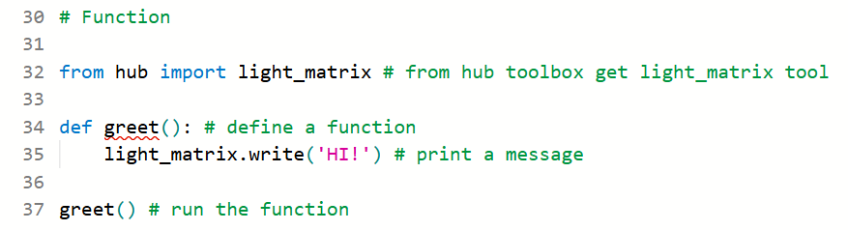
What will happen when you run it?
The hub screen will display the message: HI!

How does the code work?
def greet():
- def creates a function called greet.
light_matrix.write("Hi!")
- This instruction is stored inside the function. It tells the robot to display Hi! on the hub screen.
greet()
- This is when the function runs. Python goes to the saved instructions inside the greet function and executes them, so the robot shows the message Hi!
💡 Tip 3: You can run greet() as many times as you want, and the robot will say “HI!” each time.

👉 Carefully update your code with the following lines, then press the yellow Play button:

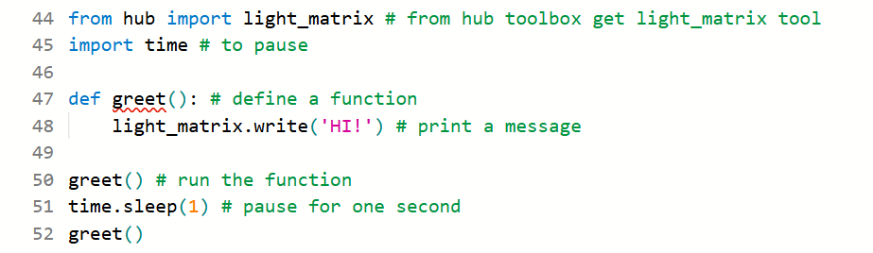
What happens when you run it?
Hub displays HI! → one second pause → HI! again
How does the code work?
import time
- Time is a module, it has tools to control timing in our program.
time.sleep(1)
- .sleep() is a function (method) of the time module. It pauses the program for 1 seconds before the next task plays.
💡 Tip 4: You can increase or decrease the value of time.sleep() to make pause longer or shorter.

Add a Parameter
Sometimes we want the robot to display different names each time.
- We can do this by adding a parameter to the function.
- A parameter is like a “blank space” or placeholder that the function can use when it runs. You fill in this blank space with different values each time you call the function.
Example:
- If the function has a parameter called name, you can give it 'WORLD' one time, 'LEGO' another time, and the robot will greet whoever you choose.
👉 Carefully type the following code, then press the yellow Play button:

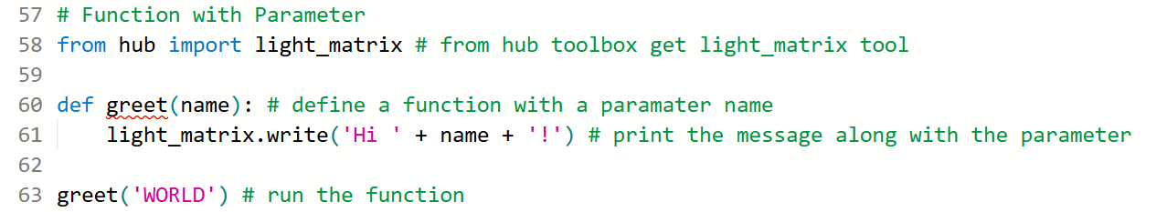
What will happen when you run it?
The hub screen will display: Hi WORLD! The robot is now greeting a specific name.
How does the code work?
def greet(name):
- def creates a function greet that takes a parameter called name.
light_matrix.write('Hi ' + name + '!')
- This line displays text on the hub screen. Here, plus sign + is used to join separate items, for example: Hi WORLD!
greet('WORLD')
- This runs the greet function and fills the name parameter with 'WORLD'. The hub screen will display: Hi WORLD!

Exercise 2
1. Can you make the robot greet you and your partner? (Hint: run greet() function twice and use tip 4 to see both names one after the other)

Section 4: Lights
In this section, you will learn how to display images and control center light on your SPIKE Prime robot.
The robot has:
- A light matrix screen on top that can show images
- A centre power light that can change colours

Displaying a Face on the Hub
The light matrix can show images, such as animals, faces (moods), and clock faces.
👉 Carefully type the following code, then press the yellow Play button:

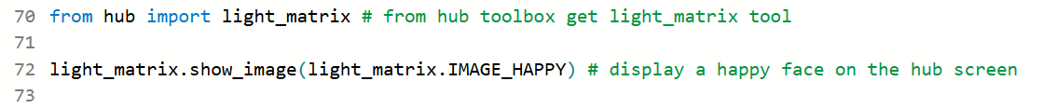
What will happen when you run it?
The hub screen will light up with a happy face.

How does the code work?
light_matrix.show_image(light_matrix.IMAGE_HAPPY)
- .show_image() is a function (method) of the light_matrix tool (object) - it tells the screen what to show
- .IMAGE_HAPPY is an image of happy face (constant)
💡 Tip 5: You can replace IMAGE_HAPPY with other faces, like IMAGE_SILLY, IMAGE_SAD, or IMAGE_ANGRY.

Exercise 3

1. Can you:
- Add sad and angry faces? (Hint: Use tip 5)
- Then make the faces last longer? (Hint: Use tip 4)
Introducing “for” Loops (Making Repeating Tasks Easy)
In the last example, if we wanted many faces, we had to use same commands again and again…
But remember — we are programmers!
Programming is about making repetitive tasks easy. So instead of writing the same lines many times, we use something called a “for” loop.
👉 Carefully type the following code, then press the yellow Play button:

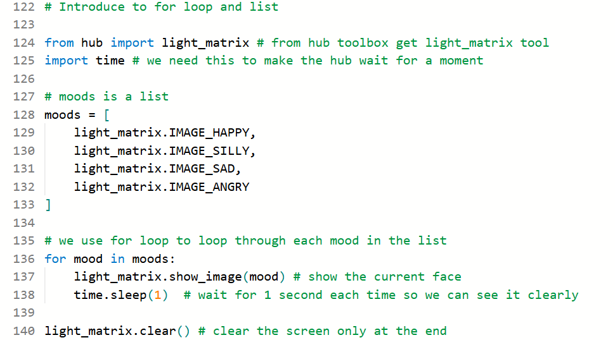
What will happen when you run it?
You will see each faces for one second i.e. happy face → silly face → sad face → angry face. At the end, the screen will clear.
How does the code work ?
moods = [ … ]
- This creates a list called moods. A list is like a container that stores multiple items. In this case, the items are different faces the robot can show.
for mood in moods:
- This is a for loop. It goes through each face in the list one by one so the robot can show all the faces without writing the same line of code again and again.
light_matrix.show_image(mood)
- It tells the hub screen to display the current face from the list.

Controlling the Centre Light
Did you know you can change the colour of the centre light?
👉 Carefully type the following code, then press the yellow Play button:
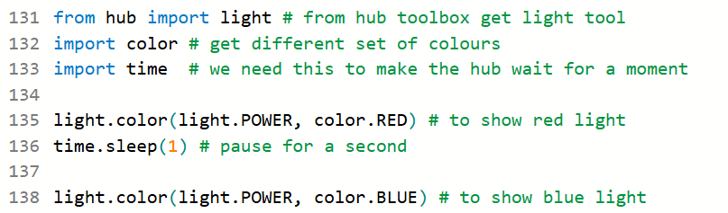
What will happen when you run it?
The button glows 🔴 → 1 second pause → then glows🔵

How does the code work?
import light
- light is toolbox (module). It has tools to control the hub’s center light
import color
- color is a toolbox (module). It has different colours.
light.color(light.POWER, color.RED)
- .color() is a function (method) of the light tool (object).
- .POWER tells hub to control power (center light) button .RED to glow power button in colour red.
💡 Tip 6: You can use more colours such as color.ORANGE, color.YELLOW, color.GREEN, color.AZURE, color.BLUE, color.PURPLE

Exercise 4

Make a Rainbow : Can you display all the colours of the rainbow using a loop? Hint: Use “for” loop, list and tip 6. The color module does not have all the colours of the rainbow, so use the purple and azure in place of violet and indigo.

Section 5: Motors
In this section, we will learn to program the motors to move our robot in straight lines and circles.
👉 Carefully type the following code, then press the yellow Play button:
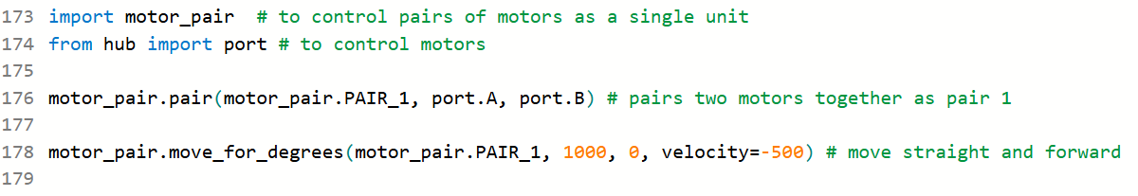
What will happen when you run it?
Robot moved forward, in straight line to some distance.

How does the code work?
import motor_pair
- motor_pair is a (module) toolbox like hub toolbox (module).
- It has many tools that help control two motors together as a pair. This becomes very useful when you want to start and stop both motors at the same time.
from hub import port
- hub and port are also toolboxes (modules).
- Inside the toolbox, there is port, which tells the robot where the motors are plugged in (for example port A or port B).
motor_pair.pair(motor_pair.PAIR_1, port.A, port.B)
- .pair() is a function (method) of the motor_pair (module).
- This connects two motors together as one pair. In this case, the motor on port A and the motor on port B are grouped into PAIR_1 so they can move together.
motor_pair.move_for_degrees(motor_pair.PAIR_1, 1000, 0, velocity=-500)
- .move_for_degrees() is a function (method) of the motor_pair (module).
- This tells the motor pair to move for a specific number of degrees of wheel rotation.
- 1000 means the motors will rotate 1000 degrees.
- 0 means no steering, so the robot moves straight.
- velocity controls the speed and direction of the robot. Example: A negative velocity (-500) makes the robot move forward, while a positive value would make it move in the opposite direction.
Exercise 5
Here we’ll explore how the robot moves.
- Can you change the distance using degrees? Hint: The degrees value controls how far the robot moves.

Can you change direction and speed using velocity? Hint: The velocity value controls how fast the robot moves.
- Can you change direction using steering? Hint: The steering value controls the direction of the robot.

- Challenge: Can you make your robot run in a circle?

Run Loop, Async, and Await
Sometimes we want the robot to perform several tasks in one program one after the other, such as: move → turn → move again
The code below shows the general structure of a program using a run loop.
import runloop
async def main():
await task_one
await task_two
runloop.run(main())
👉 Carefully type the following code, then press the yellow Play button:

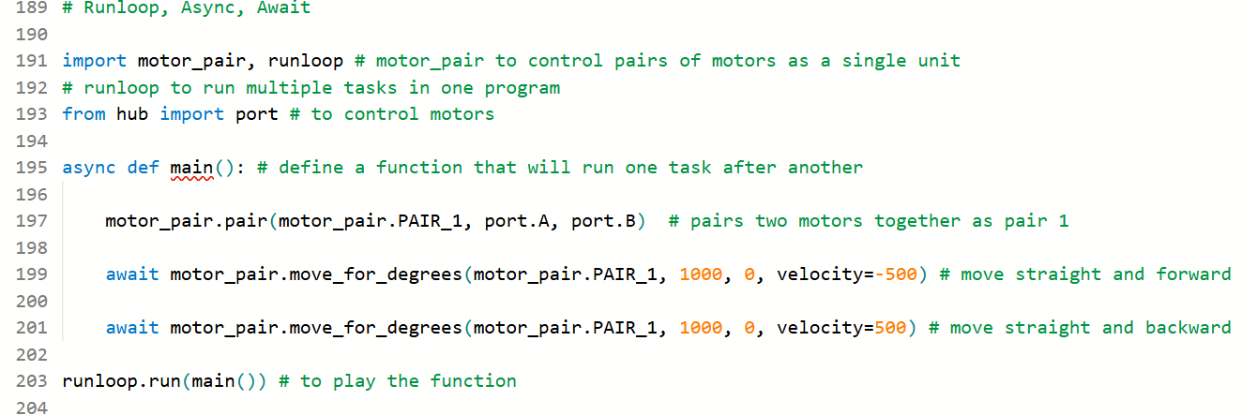

What will happen when you run it?
The robot moves forward then backward in a straight line.

How does the code work?
import runloop
- the runloop module to let the robot do multiple tasks one after another.
async def main():
- This creates a special program. Using async lets the robot finish one task before starting the next.
await motor_pair.move_for_degrees(motor_pair.PAIR_1, 1000, 0, velocity=-500)
- Because we used await, the robot finishes the first movement before starting the next one.
runloop.run(main())
- This tells the robot to run all the commands in order.
Exercise 6

1. Make the robot move forward, turn, and then come back to where it started!
Hint: Change the steering value to make the robot turn:
- steering = 0 → straight
- steering > 0 → turn left
- steering < 0 → turn right

Challenges
1. Make traffic lights:
Can you make the robot act like a traffic light, showing red, yellow and green in this order, three times? (Hint: Use time and colour modules along with two for loops - Tip 4 and 6.)

2. Tell a story:
For example:
- Display “I AM READY”
- Drive forward with a happy face
- Spin with a silly face
- Come back with a sad face
- Display “THE END” at the end
Hint: Use light_matrix, port, light, motor_pair and runloop modules. Put all your steps inside async def main() and run it with runloop.run(main()).

