**Potential Lead Compounds (small-molecules/peptide/nucleosides) for Training**

## Repurposing Therapeutics for COVID-19:

<https://chemrxiv.org/articles/Repurposing_Therapeutics_for_the_Wuhan_Coronavirus_nCov-2019_Supercomputer-Based_Docking_to_the_Viral_S_Protein_and_Human_ACE2_Interface/11871402>

 Micholas Dean Smith and Jeremy Smith used Summit (IBM AC922 Summit – Oak Ridge Leadership Computing Facility) to screen a small molecule library (~ 8000 compounds) and carried out Docking and Molecular Dynamics simulations to identify hits that could bind to the main "spike" protein (aka S-protein) of the caronavirus. You can read the article, Repurposing Therapeutics for COVID-19: Supercomputer-Based Docking to the SARS-CoV-2 Viral Spike Protein and Viral Spike…, from The Preprint Server for Chemistry, ChemRxiv. You can watch the following video on how the drugs could bind to virus-proteins and disrupt the virus host binding interactions, <https://www.olcf.ornl.gov/wp-content/uploads/2020/03/corona_split_video.mp4?_=1>. The video link is part of the following ORNL article, ORNL Team Enlists World’s Fastest Supercomputer to Combat the Coronavirus – Oak Ridge Leadership Computing Facility.

**What software/Database was used?**

* **AutoDock Vina**: <http://vina.scripps.edu/>
* MD software **GROMACS**: <http://www.gromacs.org/>
* DB: **SWEETLEAD**: <https://simtk.org/projects/sweetlead>

**What do we have?**

* Ligands (~ 9,120) in AutoDock vina format (pdbqt)
* Receptor structure

 Here is the list of compounds and their chemical structures.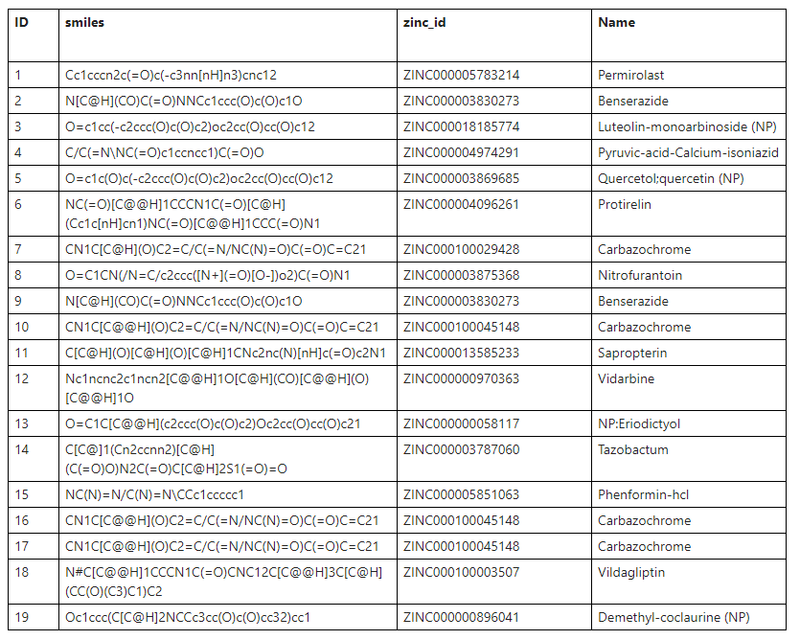

Please note, NP, means Natural Product

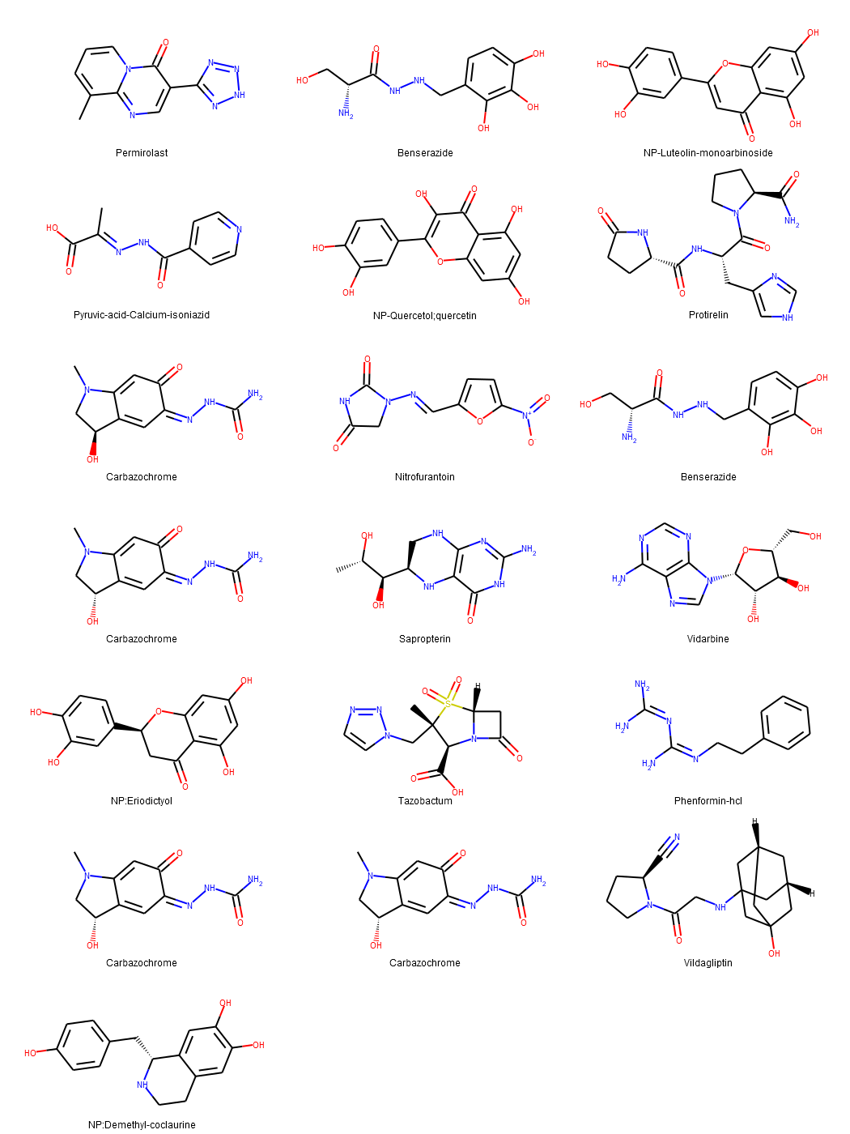

## Searching inhibitors for three important proteins of COVID-19 through molecular docking studies

<https://arxiv.org/ftp/arxiv/papers/2004/2004.08095.pdf>

In this communication, molecular docking studies of 18 ligands were carried out with the three important proteins of SARS-CoV-2, i.e., RNA-dependent RNA polymerase (RdRp), angiotensin-converting enzyme 2 (ACE2) and spike glycoprotein (SGp). From the obtained results, we observed that all the tested molecules showed better dock score in compared to the hydroxychloroquine claimed to be effective against COVID-19. Combining the dock score and other medicinal properties, we believe the limonin can be further explored for potential use against COVID-19.

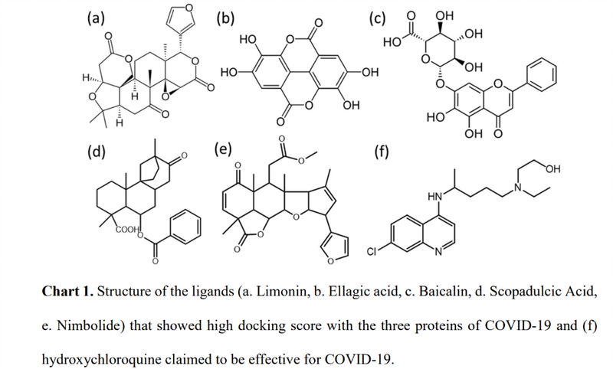

## Molecular docking and binding mode analysis of selected FDA approved drugs against COVID-19 selected key protein targets: An effort towards drug repurposing to identify the combination therapy to combat COVID-19

<https://arxiv.org/ftp/arxiv/papers/2004/2004.06447.pdf>

ACE2, RdRp, NSP12, NSP16 Targets to identify Protein AA residues

**NOT SURE WHAT THE TARGET IS. THEY USED NSP12, SPIKE and NSP16-10 and docked to all of them**

Therefore, many existing viral targets are structurally expected to be similar to SARS-CoV and likely to be inhibited by the same compounds. Here, we selected three viral key proteins based on their vital role in viral life cycle: ACE2 (helps in entry into the human host), viral nonstructural proteins RNA-dependent RNA polymerase (RdRp) NSP12, and NSP16 which helps in replication, and viral latency (invasion from immunity). The FDA approved drugs chloroquine (CQ), hydroxychloroquine (HCQ), remdesivir (RDV) and arbidol (ABD) are emerging as promising agents to combat COVID-19.

Our hypothesis behind the docking studies is to determine the binding affinities of these drugs and identify the key amino acid residues playing a key role in their mechanism of action.

## Modelling and docking of Indian SARS-CoV-2 spike protein 1 with ACE2: implications for co-morbidity and therapeutic intervention

<https://arxiv.org/ftp/arxiv/papers/2004/2004.06361.pdf>

 Identifying SPIKE-2 - ACE2 interactions

## Computational Drug Repositioning and Elucidation of Mechanism of Action of Compounds against SARS-CoV-2

<https://arxiv.org/ftp/arxiv/papers/2004/2004.07697.pdf>

A radical approach to reduce the gene expression (ACE2 etc.)

* Drugs predicted to downregulate ACE2 and TMPRSS2 genes by the Gene2drug tool (p < 0.05).
* Drugs predicted to downregulate SARS-CoV-2 human interactors by the Gene2drug tool (p < 0.05, top 20 reported).
* Drugs predicted to revert the transcriptional signature induced by SARS-CoV-2 infection through the MANTRA tool

## Prediction of potential inhibitors for RNA-dependent RNA polymerase of SARSCoV-2 using comprehensive drug repurposing and molecular docking approach

<https://arxiv.org/ftp/arxiv/papers/2004/2004.07086.pdf>

RdRP Target

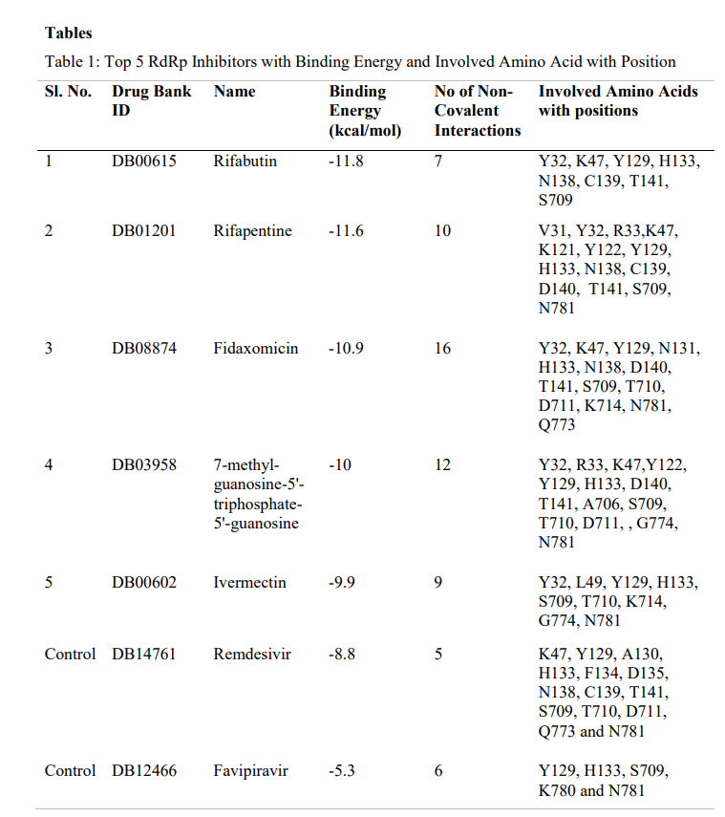

## Network Medicine Framework for Identifying Drug Repurposing Opportunities for COVID-19

<https://arxiv.org/pdf/2004.07229.pdf>

The list of the 81 drugs selected for repurposing.

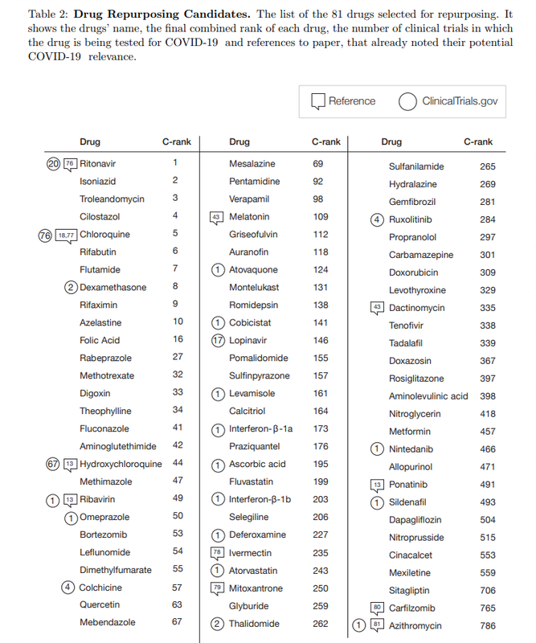

## Anti-HCV, Nucleotide Inhibitors, Repurposing Against COVID-19

RdRP TARGET

In this study, sequence analysis, modeling, and docking are used to build a model for Wuhan COVID-19 RdRp. Additionally, the newly emerged Wuhan HCoV RdRp model is targeted by anti-polymerase drugs, including the approved drugs Sofosbuvir and Ribavirin.

**Key findings:**The results suggest the effectiveness of Sofosbuvir, IDX-184, Ribavirin, and Remidisvir as potent drugs against the newly emerged HCoV disease.

<https://pubmed.ncbi.nlm.nih.gov/32119961/>

**What software was used?**

Swiss Model web server is used to build a model for RdRp

Molprobity web for structure analysis

SCIGRESS, <https://www.fqs.pl/en/chemistry/products/scigress>, is used to minimize the model and to perform molecular docking experiments.

The minimization of the model is performed using the MM3 force field

 AutoDock Vina for docking

**These small molecules was selected but this can be downloaded from any compound libraries like PubChem, ZINC, DrugBank etc.**

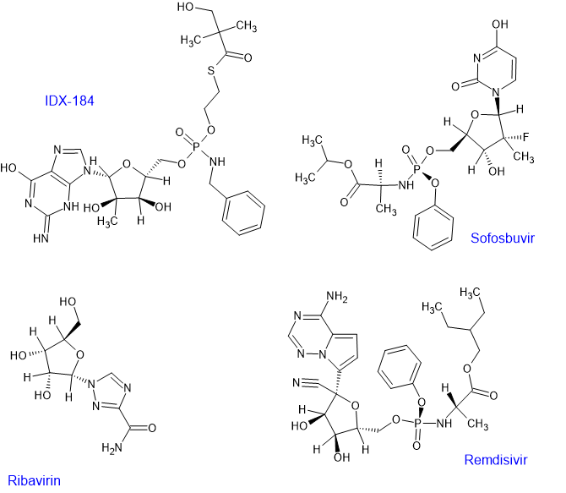

## The potential chemical structure of anti-SARS-CoV-2 RNA-dependent RNA polymerase.

RdRP Target

<https://pubmed.ncbi.nlm.nih.gov/32167173>

RNA-dependent RNA polymerase (RdRp) is an important protease that catalyzes the replication of RNA from RNA template and is an attractive therapeutic target. In this study, we screened these chemical structures from traditional Chinese medicinal compounds proven to show antiviral activity in severe acute respiratory syndrome coronavirus (SARS-CoV) and the similar chemical structures through a molecular docking study to target RdRp of SARS-CoV-2, SARS-CoV, and Middle East respiratory syndrome coronavirus (MERS-CoV).

**What software was used?**

idock for docking, (<https://github.com/HongjianLi/idock>)

 “Achilles” Blind Docking Server, available at: [http://bio‐hpc.eu/software/blind‐docking‐server/](http://bio-hpc.eu/software/blind-docking-server/).

**What database was used for ligands?**

ZINC

**What compounds were used for docking?**

Eighty‐three chemical structures from traditional Chinese medicinal compounds and their similar structures were retrieved from ZINC15 database.

(Ravi: It is not clear what these 80 Chinese Medicinal Compounds are)

Theaflavin was found to be the potent compound

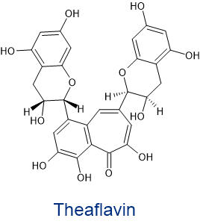

## In Silico Screening of Chinese Herbal Medicines With the Potential to Directly Inhibit 2019 Novel Coronavirus

**Proteases Target**

**Paper doesn’t include the list of CHINESE MEDICINES**

**Objective:**In this study we execute a rational screen to identify Chinese medical herbs that are commonly used in treating viral respiratory infections and also contain compounds that might directly inhibit 2019 novel coronavirus (2019-nCoV), an ongoing novel coronavirus that causes pneumonia.

**Results:**Of the natural compounds screened, 13 that exist in traditional Chinese medicines were also found to have potential anti-2019-nCoV activity. Further, 125 Chinese herbs were found to contain 2 or more of these 13 compounds. Of these 125 herbs, 26 are classically catalogued as treating viral respiratory infections. Network pharmacology analysis predicted that the general in vivo roles of these 26 herbal plants were related to regulating viral infection, immune/inflammation reactions and hypoxia response.

<https://pubmed.ncbi.nlm.nih.gov/32113846/>

**What software were used?**

**AutoDock (v4.0)** and **SwissModel**for Docking and Modeling respectively.

**What DB was used for small-molecules?**

**PubChem:**<https://pubchem.ncbi.nlm.nih.gov/>

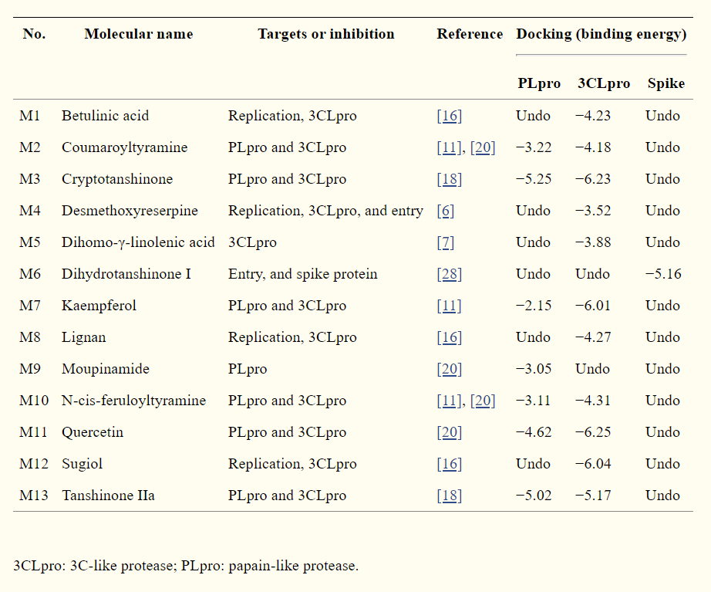

 These molecules were reported to inhibit viral entry, and were docked with spike proteins

## Rapid Identification of Potential Inhibitors of SARS-CoV-2 Main Protease by Deep Docking of 1.3 Billion Compounds

<https://pubmed.ncbi.nlm.nih.gov/32162456/>

MPro Protein Target

In the current study we applied DD to all 1.3 billion compounds from ZINC15 library to identify top 1,000 potential ligands for SARS-CoV-2 Mpro protein. The compounds are made publicly available for further characterization and development by scientific community.

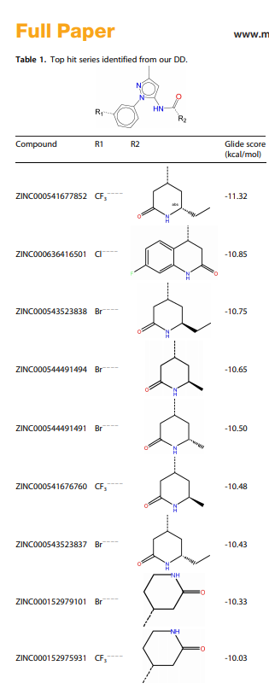

## Computers and viral diseases. Preliminary bioinformatics studies on the design of a synthetic vaccine and a preventative peptidomimetic antagonist against the SARS-CoV-2 (2019-nCoV, COVID-19) coronavirus

General Peptide based inhibitor design

The goal of this work was to find a short section or sections of viral protein sequence suitable for preliminary design proposal for a peptide synthetic vaccine and a peptidomimetic therapeutic, and to explore some design possibilities

<https://www.ncbi.nlm.nih.gov/pmc/articles/PMC7094376/>

From the point of synthesis of a peptide as a plausible analogue of an immunogenic part (“epitope”) of a protein for development of diagnostics and the peptide of interest is:

**(NH3+)-GPSKRSFIEDLLFNKVTLAC-(COO−)**

 The rationale is that the section KRSFIEDLLFNKV is exposed as associated with S2′ at the surface but highly conserved as shown in the second (i.e. “FIEDLL”) alignment in Section [4.3](https://www.ncbi.nlm.nih.gov/pmc/articles/PMC7094376/#sec4.3).

**Potential small molecule inhibitors**

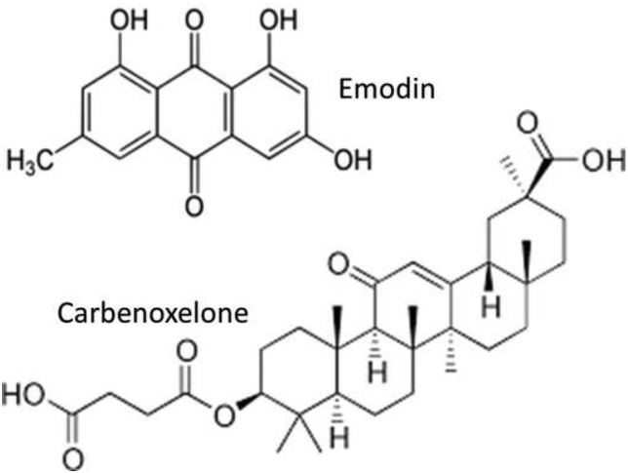

## The first-in-class peptide binder to the SARS-CoV-2 spike protein

<https://www.biorxiv.org/content/10.1101/2020.03.19.999318v1.article-info>

Peptide Binder COv-2 SPIKE target

Using molecular dynamics simulations based on the recently solved ACE2 and SARS38 CoV-2-RBD co-crystal structure, we observed that the ACE2 peptidase domain (PD) α1 helix is important for binding SARS-CoV-2-RBD. Using automated fast-flow peptide synthesis, we chemically synthesized a 23-mer peptide fragment of the ACE2 PD α1 helix composed entirely of proteinogenic amino acids. Chemical synthesis of this human derived sequence was complete in 1.5 hours and after work up and isolation >20 milligrams of pure material was obtained. Bio-layer 43 interferometry revealed that this peptide specifically associates with the SARS-CoV-2-RBD with low nanomolar affinity. This peptide binder to SARS-CoV-2-RBD provides new avenues for COVID-19 treatment and diagnostic modalities by blocking the SARS-CoV-2 spike protein interaction with ACE2 and thus precluding virus entry into human cells.

**Software used: MD NAMD and LC-MS experiments**

 Here are the peptide fragments they have reported.



## Coronavirus treatment: Vaccines/drugs in the pipeline for COVID-19

<https://www.clinicaltrialsarena.com/analysis/coronavirus-mers-cov-drugs/>

 Collection of Vaccines/drug in the pipeline

## Inhibition of SARS-CoV-2 infection (previously 2019-nCoV) by a highly potent pan-coronavirus fusion inhibitor targeting its spike protein that harbors a high capacity to mediate membrane fusion

<https://www.biorxiv.org/content/10.1101/2020.03.09.983247v1.article-info>

 We found that one of the lipopeptides, EK1C, exhibited highly 115 potent inhibitory activity against SARS-CoV-2 S-mediated membrane fusion and PsV 116 infection, about 240- and 150-fold more potent than EK1 peptide, respectively

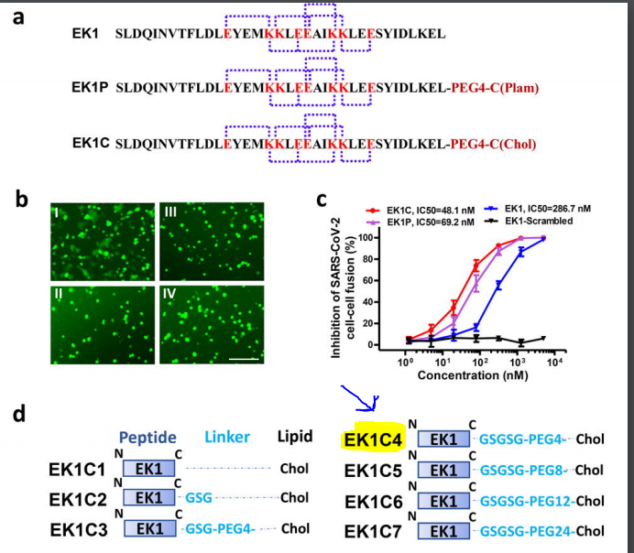

## **Unrevealing Sequence and Structural Features of Novel Coronavirus Using in silico Approaches: The Main Protease as Molecular Target**

<https://pubmed.ncbi.nlm.nih.gov/32210741>

 M-Pro Protease Target

Our results showed that several HIV inhibitors such as lopinavir, ritonavir, and saquinavir produce strong interaction with the active site of SARS-CoV-2 main protease. Furthermore, broad library protease inhibitors obtained from PubChem and ZINC (www.zinc.docking.org) were evaluated. Our analysis revealed 20 compounds that could be clustered into three groups based on their chemical features. Then, these structures could serve as leading compounds to develop a series of derivatives optimizing their activity against SARS-CoV-2 and other coronaviruses.

**What DB was used?**

In order to contribute with further studies related to developing more effective drugs, in this work was evaluated a broad library of protease inhibitors available in the ZINC database (over 100 compounds) and PubChem (over 200 compounds).

What Software was used?

**Achilles Blind Docking server:**<https://bio-hpc.ucam.edu/achilles/>

**VINA:**<http://vina.scripps.edu/>

**VegaZZ 3.1.0.21:**<https://www.ddl.unimi.it/cms/index.php?Software_projects:VEGA_ZZ>

**NAMD** (for MD simulations): <https://www.ks.uiuc.edu/Research/namd/>

**Binding energy (BE) values of the best 20 compounds selected as potential inhibitors of SARS-CoV-2 protease. Compound structures were obtained from ZINC database (Bold) and PubChem (italics), lowest BE compound of each group are shown in red.**

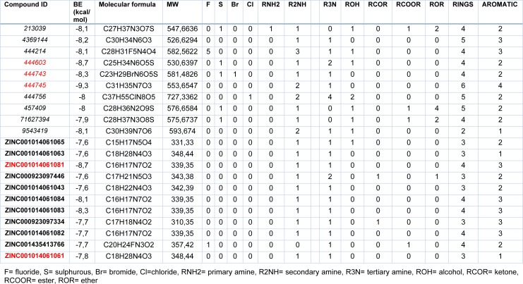

Protease inhibitors also identified in the paper

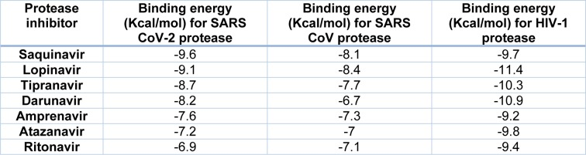

## Structure of M(Pro) from COVID-19 Virus and discovery of its inhibitors

The study was published in Nature, 2020  **(Important Reference)**

MPro Protease Target

The authors have identified MPro, protease, inhibitors and also solved the inhibitor-bound complex using HTS.

Software/Techniques used:

"To understand the binding interaction of these molecules with COVID-19 virus Mpro, two different molecular docking methods, i.e., Glide (v8.2)38 and iFitDock were used to predict their binding poses. Then a 3D molecular similarity calculation method, SHAFTS41, was used for molecular alignment poses enumeration by matching the critical pharmacophore and volumetric overlay between the N3 molecule within the Mpro structure and the six drug candidates. However, the selenium atom of ebselen could not be treated by any of these above methods, so sulfur was used to replace it in the calculations. Then the  
obtained optimal superposition of these molecules was used to assess the reasonability of the predicted binding poses from the two docking methods, and only the binding orientations which were consistent among different methods were kept for constructing the initial complexes. Finally, these complexes were further optimized and re-scored by using MM-GBSA module42 of Schrödinger, and the residues within 5 Å around the ligand were refined.

## Inhibition of the Main Protease 3CL-pro of the Coronavirus Disease 19 via Structure-Based Ligand Design and Molecular Modelingtitled section

<https://arxiv.org/pdf/2002.09937.pdf>

## A Large-scale Drug Repositioning Survey for SARS-CoV-2 Antivirals ****

<https://www.biorxiv.org/content/10.1101/2020.04.16.044016v1.full.pdf>

we profiled a library of known drugs encompassing approximately 12,000 clinical-stage or FDAapproved small molecules. Here, we report the identification of 30 known drugs that inhibit viral replication. Of these, six were characterized for cellular dose-activity relationships, and showed effective concentrations likely to be commensurate with therapeutic doses in patients. These include the PIKfyve kinase inhibitor Apilimod, cysteine protease inhibitors MDL-28170, Z LVG CHN2, VBY-825, and ONO 5334, and the CCR1 antagonist MLN-3897.

## COVID-19 Docking Server: An interactive server for docking small molecules, peptides and antibodies against potential targets of COVID-19

<https://arxiv.org/pdf/2003.00163>

 READ THE PAPER TO GET ALL THE STRUCTURAL AND NSprotein information

## A SARS-CoV-2-Human Protein-Protein Interaction Map Reveals Drug Targets and Potential Drug- Repurposing

bioRxiv preprint doi: <https://doi.org/10.1101/2020.03.22.002386>. **(Important Reference)**

## Deciphering the Protein Motion of S1 Subunit in SARS-CoV-2 Spike Glycoprotein Through Integrated Computational Methods

<https://arxiv.org/pdf/2004.05256.pdf>

## Old Drugs for Newly Emerging Viral Disease, COVID-19: Bioinformatic Prospective

<https://arxiv.org/ftp/arxiv/papers/2003/2003.04524.pdf>

## Screening of Therapeutic Agents for COVID-19 using Machine Learning and Ensemble Docking Simulations

<https://arxiv.org/pdf/2004.03766.pdf>

 INTERESTING PAPER

## On the Inhibition of COVID-19 Protease by Indian Herbal Plants: An In Silico InvestigationUntitled section

<https://arxiv.org/ftp/arxiv/papers/2004/2004.03411.pdf>

## In Silico Screening of Some Naturally Occurring Bioactive Compounds Predicts Potential Inhibitors against SARS-COV-2 (COVID-19) Protease

<https://arxiv.org/ftp/arxiv/papers/2004/2004.01634.pdf>

 In the present study, we investigated Jensenone as potential inhibitor candidates for COVID-19 Mpro

## Molecular docking studies on Jensenone from eucalyptus essential oil as a potential inhibitor of COVID 19 corona virus infection

<https://arxiv.org/ftp/arxiv/papers/2004/2004.00217.pdf>

## In Silico Investigations on the Potential Inhibitors for COVID-19 Protease

<https://arxiv.org/ftp/arxiv/papers/2003/2003.10642.pdf>

We have calculated log P and log S values in addition to molecular docking and PASS predictions. Among the seven studied compounds, mepacrine appears as the potential inhibitor of the COVID-19 followed by chloroquine, hydroxychloroquine and phomarin. Therefore, these anti-malarial drugs may be potential drug candidate for the treatment of this novel coronavirus

## Multidrug treatment with nelfinavir and cepharanthine against COVID-19

<https://www.biorxiv.org/content/10.1101/2020.04.14.039925v1.full>

## FEP-based screening prompts drug repositioning against COVID-19

<https://www.biorxiv.org/content/10.1101/2020.03.23.004580v1>

## Classical drug digitoxin inhibits influenza cytokine storm, with implications for COVID-19 therapy

<https://doi.org/10.1101/2020.04.09.034983>

## Structural basis for the inhibition of COVID-19 virus main protease by carmofur, an antineoplastic drug

<https://doi.org/10.1101/2020.04.09.033233>

## Reversal of Infected Host Gene Expression Identifies Repurposed Drug Candidates for COVID-19

<https://doi.org/10.1101/2020.04.07.030734>

## A data-driven drug repositioning framework discovered a potential therapeutic agent targeting COVID-19

<https://doi.org/10.1101/2020.03.11.986836>

## Nucleotide Analogues as Inhibitors of SARS-CoV-2 PolymeraseUntitled section

<https://doi.org/10.1101/2020.03.18.997585>

## The target landscape of N4-hydroxycytidine based on its chemical neighborhood

<https://doi.org/10.1101/2020.03.30.016485>

## The potential SARS-CoV-2 entry inhibitor

<https://doi.org/10.1101/2020.03.26.009803>

## Triphosphates of the Two Components in DESCOVY and TRUVADA are Inhibitors of the SARS-CoV-2 Polymerase

<https://doi.org/10.1101/2020.04.03.022939>

## In vitro screening of a FDA approved chemical library reveals potential inhibitors of SARS-CoV-2 replication

<https://doi.org/10.1101/2020.04.03.023846>

## Molecular Modeling Evaluation of the Binding Effect of Ritonavir, Lopinavir and Darunavir to Severe Acute Respiratory Syndrome Coronavirus 2 Proteases

<https://doi.org/10.1101/2020.01.31.929695>

## Identification of antiviral drug candidates against SARS-CoV-2 from FDA-approved drugs

<https://doi.org/10.1101/2020.03.20.999730>

## Atazanavir inhibits SARS-CoV-2 replication and pro-inflammatory cytokine production

<https://doi.org/10.1101/2020.04.04.020925>

## Molecular Docking Analysis of Some Phytochemicals on Two Sars-Cov-2 Targets

<https://doi.org/10.1101/2020.03.31.017657>

## Nucleotide Analogues as Inhibitors of SARS-CoV Polymerase

<https://doi.org/10.1101/2020.03.12.989186>

## Discovery of baicalin and baicalein as novel, natural product inhibitors of SARS-CoV-2 3CL protease in vitro

<https://doi.org/10.1101/2020.04.13.038687>

## Evaluation of 19 antiviral drugs against SARS-CoV-2 Infection

<https://www.biorxiv.org/content/10.1101/2020.04.29.067983v1.full.pdf>

 The global pandemic of the severe acute respiratory syndrome coronavirus 2 (SARS-CoV-2 or 2019- nCoV) has prompted multiple clinical trials to jumpstart search for anti-SARS-CoV-2 therapies from existing drugs, including those with reported in vitro efficacies as well as those ones that are not known to inhibit SARS-CoV-2, such a Ritonavir/lopinavir and Favilavir. Here we report that after screening 19 antiviral drugs that are either in clinical trials or with proposed activity against SARS-CoV-2, remdesivir was the most effective. Chloroquine only effectively protected virus-induced cytopathic effect at around 30 µM with a therapeutic index of 1.5. Our findings also show that velpatasvir, ledipasvir, litonavir, lopinavir, favilavir, sofosbuvir do not have direct antiviral effect.

## Evolutionary Multi-Objective Design of SARS-CoV-2 Protease Inhibitor Candidates

<https://arxiv.org/pdf/2005.02666.pdf>

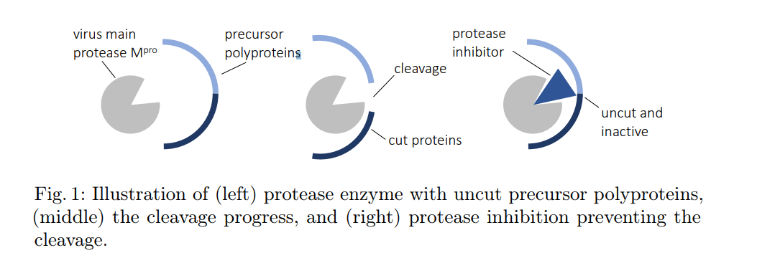

## Alpha 1 Antitrypsin is an Inhibitor of the SARS-CoV2–Priming Protease TMPRSS2

<https://www.biorxiv.org/content/10.1101/2020.05.04.077826v1.full.pdf>

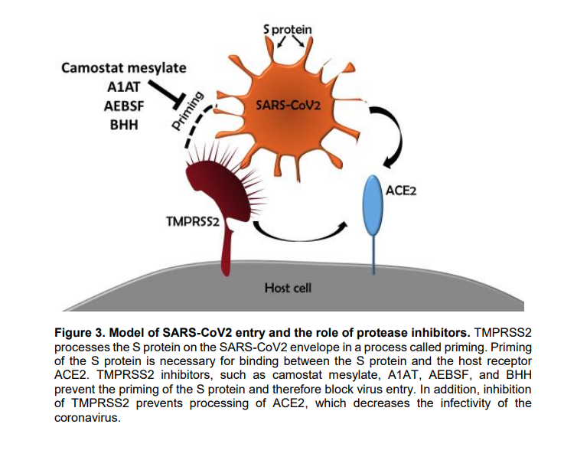

## The race to find a SARS-CoV-2 drug can only be won by a few chosen drugs: a systematic review of registers of clinical trials of drugs aimed at preventing or treating COVID-19

<https://www.medrxiv.org/content/10.1101/2020.05.05.20091785v1.full.pdf>

The objective of this comprehensive systematic review is to gather and synthesize the information included in the clinical trial registers of candidate drugs to prevent and treat COVID-19 according to the pharmacological group and specific drugs name, study design, main outcomes, number and characteristics of participants recruited, and It is made available under a CC-BY-NC-ND 4.0 International license . (which was not certified by peer review) is the author/funder, who has granted medRxiv a license to display the preprint in perpetuity. medRxiv preprint doi: https://doi.org/10.1101/2020.05.05.20091785.this version posted May 9, 2020. The copyright holder for this preprint expected completion date. In addition, we graphically represent which drugs are most likely to achieve consistent results over the coming months of 2020

## Protein-ligand interaction study to identify potential dietary compounds binding at the active site of therapeutic target proteins of SARS-CoV-2

<https://arxiv.org/ftp/arxiv/papers/2005/2005.11767.pdf>

**Objective:**Total 186 biologically important phenylpropanoids and polyketides compounds from different Indian medicinal plants and dietary sources were screened to filter potential compounds that bind at the active site of the therapeutic target proteins of SARS-CoV-2. Method: The molecular docking studies were carried out by using the Autodock Vina. The in silico ADMET and drug-likeness properties of the compounds were predicted from SwissADME server.

**Result:** The molecular docking study of the 186 compounds with the therapeutic target proteins (Mpro, PLpro, RdRp, SGp and ACE2) of SARS-CoV-2 resulted 40 compounds that bind at the active site with dock score above -8.0 kcal/mol.

**Virtual Screening of Plant Metabolites against Main protease, RNA-dependent RNA polymerase and Spike protein of SARS-CoV-2: Therapeutics option of COVID-19**

<https://arxiv.org/ftp/arxiv/papers/2005/2005.11254.pdf>

 Covid-19, a serious respiratory complications caused by SARS-CoV-2 has become one of the global threat to human healthcare system. The present study evaluated the possibility of plant originated approved 117 therapeutics against the main protease protein (MPP), RNA-dependent RNA polymerase (RdRp) and spike protein (S) of SARS-CoV-2 including drug surface analysis by using molecular docking through drug repurposing approaches. The molecular interaction study revealed that Rifampin (-16.3 kcal/mol) were topmost inhibitor of MPP where Azobechalcone were found most potent plant therapeutics for blocking the RdRp (-15.9 kcal /mol) and S (-14.4 kcal/mol) protein of SARS-CoV-2. After the comparative analysis of all docking results, Azobechalcone, Rifampin, Isolophirachalcone, Tetrandrine and Fangchinoline were exhibited as the most potential inhibitory plant compounds for targeting the key proteins of SARS-CoV-2.

## Repurpose Open Data to Discover Therapeutics for COVID-19 using Deep Learning

<https://arxiv.org/ftp/arxiv/papers/2005/2005.10831.pdf>

Supplemental data is not yet available

## Repositioning of 8565 existing drugs for COVID-19

<https://arxiv.org/pdf/2005.10028.pdf>

Supplemental data is not yet available

## Targeting the SARS-CoV-2 Main Protease to Repurpose Drugs for COVID-19

<https://www.biorxiv.org/content/10.1101/2020.05.23.112235v1.full.pdf>

## Repurposing of Miglustat to inhibit the coronavirus Severe Acquired Respiratory Syndrome SARS-CoV-2

<https://www.biorxiv.org/content/10.1101/2020.05.18.101691v1.full.pdf>

## Identification of five antiviral compounds from the Pandemic Response Box targeting SARS-CoV-2

<https://www.biorxiv.org/content/10.1101/2020.05.17.100404v1>

## Identification of five antiviral compounds from the Pandemic Response Box targeting SARS-CoV-2

<https://www.biorxiv.org/content/10.1101/2020.05.17.100404v1>

## Comparative analysis of antiviral efficacy of FDA-approved drugs against SARS-CoV-2 in human lung cells: Nafamostat is the most potent antiviral drug candidate

<https://www.biorxiv.org/content/10.1101/2020.05.12.090035v1.full.pdf>

# Structure Basis for Inhibition of SARS-CoV-2 by the Feline Drug GC376

<https://www.biorxiv.org/content/10.1101/2020.06.07.138677v1>

The pandemic of SARS-CoV-2 coronavirus disease-2019 (COVID-19) caused by SARS-COV-2 continues to ravage many countries in the world. Mpro is an indispensable protein for viral translation in SARS-CoV-2 and a potential target in high-specificity anti-SARS-CoV-2 drug screening. In this study, to explore potential drugs for treating COVID-19, we elucidated the structure of SARS-CoV-2 Mpro and explored the interaction between Mpro and GC376, an antiviral drug used to treat a range of coronaviruses in Feline via inhibiting Mpro. The availability and safety of GC376 were proved by biochemical and cell experiments in vitro. We determined the structure of an important protein, Mpro, in SARS-CoV-2, and revealed the interaction of GC376 with the viral substrate and inhibition of the catalytic site of SARS-CoV-2 Mpro.

# The inhibitory effect of a Corona virus spike protein fragment with ACE2

<https://www.biorxiv.org/content/10.1101/2020.06.03.132506v1.full.pdf>

# The inhibitory effect of a Corona virus spike protein fragment with ACE2

<https://www.biorxiv.org/content/10.1101/2020.06.03.132506v1.full.pdf>

we observe that the hexapeptide binds to the spike receptor domain, which has the effect that this protein only weakly attaches to ACE2, so that the activation of the spike protein receptor might be inhibited in this case. Our results indicate that the hexapeptide might be a possible treatment option which prevents the viral activation through the inhibition of the interaction between ACE2 and the spike receptor protein.

We assume that Tyr at the positions 1, 3, and 5 has to be conserved for the design of a peptide mimetic used as potential drug against SARS CoV-2, while the hexapeptide sequence YKYRYL inhibits the viral interaction with ACE2 as we have shown in this work.

# Predicting inhibitors for SARS-CoV-2 RNAdependent RNA polymerase using machine learning and virtual screening.

<https://arxiv.org/ftp/arxiv/papers/2006/2006.06523.pdf>

Interesting work

Global coronavirus disease pandemic (COVID-19) caused by newly identified SARSCoV-2 coronavirus continues to claim the lives of thousands of people worldwide. The unavailability of specific medications to treat COVID-19 has led to drug repositioning efforts using various approaches, including computational analyses. Such analyses mostly rely on molecular docking and require the 3D structure of the target protein to be available. In this study, we utilized a set of machine learning algorithms and trained them on a dataset of RNA-dependent RNA polymerase (RdRp) inhibitors to run inference analyses on antiviral and anti-inflammatory drugs solely based on the ligand information. We also performed virtual screening analysis of the drug candidates predicted by machine learning models and docked them against the active site of SARSCoV-2 RdRp, a key component of the virus replication machinery. Based on the ligand information of RdRp inhibitors, the machine learning models were able to identify candidates such as remdesivir and baloxavir marboxil, molecules with documented activity against RdRp of the novel coronavirus. Among the other identified drug candidates were beclabuvir, a non-nucleoside inhibitor of the hepatitis C virus (HCV) RdRp enzyme, and HCV protease inhibitors paritaprevir and faldaprevir. Further analysis of these candidates using molecular docking against the SARS-CoV-2 RdRp revealed low binding energies against the enzyme active site. Our approach also identified anti-inflammatory drugs lupeol, lifitegrast, antrafenine, betulinic acid, and ursolic acid to have potential activity against SARS-CoV-2 RdRp. We propose that the results of this study are considered for further validation as potential therapeutic options against COVID-19.

# Targeting Receptor Binding Domain and Cryptic Pocket of Spike glycoprotein from SARS-CoV-2 by biomolecular modeling

<https://arxiv.org/pdf/2006.06452.pdf>

SARS-CoV-2, the causative agent of the disease known as Covid-19, has so far reported around 3,435,000 cases of human infections, including more than 239,000 deaths in 187 countries, with no effective treatment currently available. For this reason, it is necessary to explore new approaches for the development of a drug capable of inhibiting the entry of the virus into the host cell. Therefore, this work includes the exploration of potential inhibitory compounds for the Spike protein of SARS-CoV-2 (PDB ID: 6VSB), which were obtained from The Patogen Box. Later, they were filtered through virtual screening and molecular docking techniques, thus obtaining a top of 1000 compounds, which were used against a binding site located in the Receptor Binding Domain (RBD) and a cryptic site located in the N-Terminal Domain (NTD), resulting in good pharmaceutical targets for the blocking the infection. From the top 1000, the best compound (TCMDC-124223) was selected for the binding site. It interacts with specific residues that intervene in the recognition and subsequent entry into the host cell, resulting in a more favorable binding free energy in comparison to the control compounds (Hesperidine and Emodine). In the same way, the compound TCMDC-133766 was selected for the cryptic site. These identified compounds are potential inhibitors that can be used for the development of new drugs that allow effective treatment for the disease.

# A small molecule drug candidate targeting SARS-CoV-2 main protease

<https://arxiv.org/ftp/arxiv/papers/2006/2006.09125.pdf>

A new coronavirus identified as SARS-CoV-2 virus has brought the world to a state of crisis, causing a major pandemic, claiming more than 433,000 lives and instigating major financial damage to the global economy. Despite current efforts, developing safe and effective treatments remains a major challenge. Moreover, new strains of the virus are likely to emerge in the future. To prevent future pandemics, several drugs with various mechanisms of action are required. Drug discovery efforts against the virus fall into two main categories: (a) monoclonal antibodies targeting the spike protein of the virus and blocking it from entry; (b) small molecule inhibitors targeting key proteins of the virus, interfering with replication and translation of the virus. In this study, we are presenting a computational investigation of a potential drug candidate that targets SARS-CoV-2 protease, a viral protein critical for replication and translation of the virus.

# Crystal structure of SARS-CoV-2 main protease in complex with a Chinese herb inhibitor shikonin

<https://www.biorxiv.org/content/10.1101/2020.06.16.155812v1>

Main protease (Mpro, also known as 3CLpro) has a major role in the replication of coronavirus life cycle and is one of the most important drug targets for anticoronavirus agents. Here we report the crystal structure of main protease of SARS-CoV-2 bound to a previously identified Chinese herb inhibitor shikonin at 2.45 angstrom resolution. Although the structure revealed here shares similar overall structure with other published structures, there are several key differences which highlight potential features that could be exploited. The catalytic dyad His41-Cys145 undergoes dramatic conformational changes, and the structure reveals an unusual arrangement of oxyanion loop stabilized by the substrate. Binding to shikonin and binding of covalent inhibitors show different binding modes, suggesting a diversity in inhibitor binding. As we learn more about different binding modes and their structure-function relationships, it is probable that we can design more effective and specific drugs with high potency that can serve as effect SARS-CoV-2 anti-viral agents.

# X-206 is a potent and selective inhibitor of SARS-CoV-2 infection in vitro

<https://www.biorxiv.org/content/10.1101/2020.06.14.149153v1>

Pandemic spread of emerging human pathogenic viruses such as the current SARS-CoV-2, poses both an immediate and future challenge to human health and society. Currently, effective treatment of infection with SARS-CoV-2 is limited and broad spectrum antiviral therapies to meet other emerging pandemics are absent leaving the World population largely unprotected. Identification of compounds with antiviral properties is thus highly desirable. Here, we have identified distinct members of the family of polyether ionophore antibiotics with potent ability to inhibit SARS-CoV-2 replication and cytopathogenicity in cells. Several compounds from this class displayed more than 100-fold selectivity between viral-induced cytopathogenicity and inhibition of cell viability, however the compound X-206 displayed >500-fold selectivity and was furthermore able to inhibit viral replication even at sub-nM levels. The antiviral mechanism of the polyether ionophores is currently not understood in detail. We demonstrate, through unbiased bioactivity profiling, that their effects on the host cells differ from those of cationic amphiphiles such as hydroxychloroquine. Collectively, our data suggest that polyether ionophore antibiotics should be subject to further investigations as potential broad-spectrum antiviral agents.

# Machine Learning Models Identify Inhibitors of SARS-CoV-2

<https://www.biorxiv.org/content/10.1101/2020.06.16.154765v1>

With the ongoing SARS-CoV-2 pandemic there is an urgent need for the 29 discovery of a treatment for the coronavirus disease (COVID-19). Drug repurposing is 30 one of the most rapid strategies for addressing this need and numerous compounds 31 have been selected for in vitro testing by several groups already. These have led to a 32 growing database of molecules with in vitro activity against the virus. Machine learning 33 models can assist drug discovery through prediction of the best compounds based on 34 previously published data. Herein we have implemented several machine learning 35 methods to develop predictive models from recent SARS-CoV-2 in vitro inhibition data 36 and used them to prioritize additional FDA approved compounds for in vitro testing 37 selected from our in-house compound library. From the compounds predicted with a 38 Bayesian machine learning model, CPI1062 and CPI1155 showed antiviral activity in 39 HeLa-ACE2 cell-based assays and represent potential repurposing opportunities for 40 COVID-19. This approach can be greatly expanded to exhaustively virtually screen 41 available molecules with predicted activity against this virus as well as a prioritization 42 tool for SARS-CoV-2 antiviral drug discovery programs. The very latest model for 43 SARS-CoV-2 is available at www.assaycentral.org.

# The serotonin reuptake inhibitor Fluoxetine inhibits SARS-CoV-2

<https://www.biorxiv.org/content/10.1101/2020.06.14.150490v2>

# Mining of high throughput screening database reveals AP-1 and autophagy pathways as potential targets for COVID-19 therapeutics

<https://arxiv.org/ftp/arxiv/papers/2007/2007.12242.pdf>

(Paper from NCATS; important paper)

Abstract The recent global pandemic of Coronavirus Disease 2019 (COVID-19) caused by the new coronavirus SARS-CoV-2 presents an urgent need for new therapeutic candidates. Many efforts have been devoted to screening existing drug libraries with the hope to repurpose approved drugs as potential treatments for COVID-19. However, the antiviral mechanisms of action for the drugs found active in these phenotypic screens are largely unknown. To deconvolute the viral targets for more effective anti-COVID19 drug development, we mined our in-house database of approved drug screens against 994 assays and compared their activity profiles with the drug activity profile in a cytopathic effect (CPE) assay of SARS-CoV-2. We found that the autophagy and AP-1 signaling pathway activity profiles are significantly correlated with the anti-SARS-CoV-2 activity profile. In addition, a class of neurology/psychiatry drugs was found significantly enriched with anti-SARS-CoV-2 activity. Taken together, these results have provided new insights into SARS-CoV-2 infection and potential targets for COVID-19 therapeutics.

Interesting results

* **measuring the cytopathic effect (CPE) of SARS-CoV-2 virus on Vero E6 cells infected for 72 hours. If compounds have antiviral activity, Vero E6 cells are rescued from the CPE. While there are many drugs with known targets/mechanisms of action for their approved indications, the targets or mechanisms of their antiviral activity are largely unknown, be it against a host of viral target 10-14. It is thus crucial to better understand their antiviral mechanisms to facilitate further drug development.**
* **The NCATS Pharmaceutical Collection (NPC) 16 is a library of ~3,000 drugs approved for marketing in the US (FDA), Europe (EMA), Canada, Australia, and/or Japan (PMDA). The library was specifically created to enable drug repurposing and has been screened at NCATS in nearly 1,000 assays in concentrationresponse (quantitative high throughput screening, qHTS), encompassing a wide range of disease targets and pathways with main disease areas covered including rare and neglected diseases, infectious diseases and cancer.**

# Attacking COVID-19 Progression using Multi-Drug Therapy for Synergetic Target Engagement

<https://arxiv.org/ftp/arxiv/papers/2007/2007.02557.pdf>

SUMMARY COVID-19 is a devastating respiratory and inflammatory illness caused by a new coronavirus that is rapidly spreading throughout the human population. Over the past 6 months, severe acute respiratory syndrome coronavirus 2 (SARS-CoV-2), the virus responsible for COVID-19, has already infected over 11.6 million (25% located in United States) and killed more than 540K people around the world. As we face one of the most challenging times in our recent history, there is an urgent need to identify drug candidates that can attack SARS-CoV-2 on multiple fronts. We have therefore initiated a computational dynamics drug pipeline using molecular modeling, structure simulation, docking and machine learning models to predict the inhibitory activity of several million compounds against two essential SARS-CoV-2 viral proteins and their host protein interactors; S/Ace2, Tmprss2, Cathepsins L and K, and Mpro to prevent binding, membrane fusion and replication of the virus, respectively. All together we generated an ensemble of structural conformations that increase high quality docking outcomes to screen over >6 million compounds including all FDA-approved drugs, drugs under clinical trial (>3000) and an additional >30 million selected chemotypes from fragment libraries. Our results yielded an initial set of 350 high value compounds from both new and FDA-approved compounds that can now be tested experimentally in appropriate biological model systems. We anticipate that our results will initiate screening campaigns and accelerate the discovery of COVID-19 treatments.

# Predicting potential drug targets and repurposable drugs for COVID-19 via a deep generative model for graphsection

<https://arxiv.org/pdf/2007.02338.pdf>

# A computational approach to aid clinicians in selecting anti-viral drugs for COVID-19 trials

<https://arxiv.org/pdf/2007.01902.pdf>

Motivation: COVID-19 has fast-paced drug re-positioning for its treatment. This work builds computational models for the same. The aim is to assist clinicians with a tool for selecting prospective antiviral treatments. Since the virus is known to mutate fast, the tool is likely to help clinicians in selecting the right set of antivirals for the mutated isolate

# DRUG REPURPOSING TO FIND INHIBITORS OF SARS-CoV-2 MAIN PROTEASE

<https://arxiv.org/ftp/arxiv/papers/2006/2006.14790.pdf>

**ABSTRACT**Severe acute respiratory syndrome coronavirus 2 (SARS-CoV-2) is the strain of coronavirus that causes coronavirus disease 2019 (COVID-19), the respiratory illness responsible for the COVID-19 pandemic. Currently there is no known vaccine or specific antiviral treatment for COVID-19 and so, there is an urgent need for expedite discovery of new therapeutics to combat the disease until a vaccine will be available worldwide. Drug repurposing is a strategy for identifying new uses for approved drugs that has the advantage (over conventional approaches that attempt to develop a drug from scratch) that time frame of the overall process can be significantly reduced because of the few number of clinical trial required. In this work, a virtual screening of FDA-approved drugs was performed for repositioning as potential inhibitors of the main protease Mpro of SARS-CoV-2. As a result of this study, 12 drugs are proposed as candidates for inhibitors of the Mpro enzyme. Some of the selected compounds are antiviral drugs that are already being tested in COVID-19 clinical trials (i.e. ribavirin) or are used to alleviate symptoms of the disease (i.e. codeine). Surprisingly, the most promising candidate is the naturally occurring broad spectrum antibiotic oxytetracycline. This compound has largely outperformed the remaining selected candidates along all filtering steps of our virtual screening protocol. If the activity of any of these drugs is experimentally corroborated, they could be used directly in clinical trials without the need for pre-clinical testing or safety evaluation since they are already used as drugs for other diseases.