**Machine-Learning Models**

## A classifier prediction model to predict the status of Coronavirus CoVID-19 patients in South Koread section

European Review for Medical and Pharmacological Sciences, 2020; 24: 3400-3403

<https://www.europeanreview.org/wp/wp-content/uploads/3400-3403.pdf>

This study uses official time series data from the Korea Centers for Disease Control and Prevention (KCDC) for 7869 Coronavirus patients in South Korea between 20/02/2020 and 09/03/2020. The dataset contains fifteen variables including patient ID, sex, birth, year, country, region, disease group infection reason, infection order, infected by, contact number, confirmation date, released date, deceased date and state. This study adopted seven variables as independent variables including sex, birth year, country, region, group, infection reason and confirmed date, where dependent variable is one of the following variables, namely death or recovered. The variables are chosen based on the most used variables in several researches. To avoid missing independent and dependent variables, only 659 and 649 patients are employed for recovered and death cases, respectively.

Classification Model: Our recommendation is to use this model to predict the status of the patients globally.

## One-shot screening of potential peptide ligands on HR1 domain in COVID-19 glycosylated spike (S) protein with deep siamese network

<https://arxiv.org/pdf/2004.02136.pdf>

(interesting paper)

## DeepPurpose: a Deep Learning Based Drug Repurposing Toolkit

<https://arxiv.org/pdf/2004.08919>

(interesting paper)

## Improving Coronavirus (COVID-19) Diagnosis using Deep Transfer Learning

<https://www.medrxiv.org/content/10.1101/2020.04.11.20054643v1.full.pdf>

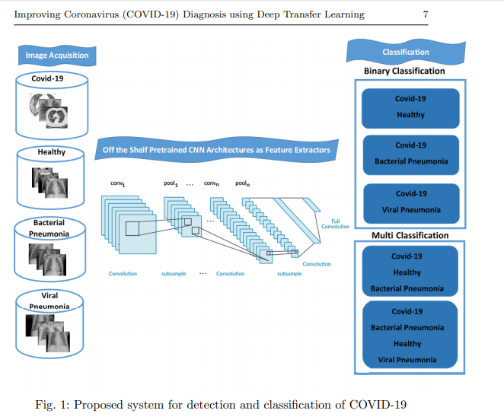

JCS: An Explainable COVID-19 Diagnosis System by Joint Classification and Segmentation

<https://arxiv.org/pdf/2004.07054.pdf>

## Deep Learning COVID-19 Features on CXR using Limited Training Data Sets

<https://arxiv.org/pdf/2004.05758.pdf>

Under the global pandemic of COVID-19, the use of artificial intelligence to analyze chest X-ray (CXR) image for COVID-19 diagnosis and patient triage is becoming important. Unfortunately, due to the emergent nature of the COVID-19 pandemic, a systematic collection of the CXR data set for deep neural network training is difficult. To address this problem, here we propose a patch-based convolutional neural network approach with a relatively small number of trainable parameters for COVID-19 diagnosis.

## Towards an Efficient Deep Learning Model for COVID-19 Patterns Detection in X-ray Images

<https://arxiv.org/pdf/2004.05717.pdf>

## Deep Learning System to Screen Coronavirus Disease 2019 Pneumonia

<https://arxiv.org/ftp/arxiv/papers/2002/2002.09334.pdf>

## Artificial Intelligence Distinguishes COVID-19 from Community Acquired Pneumonia on Chest CTon

<https://doi.org/10.1148/radiol.2020200905>

 In this retrospective and multi-center study, a deep learning model, COVID-19 detection neural network (COVNet), was developed to extract visual features from volumetric chest CT exams for the detection of COVID-19. Community acquired pneumonia (CAP) and other non-pneumonia CT exams were included to test the robustness of the model. The datasets were collected from 6 hospitals between August 2016 and February 2020. Diagnostic performance was assessed by the area under the receiver operating characteristic curve (AUC), sensitivity and specificity

## A Machine Learning Application for Raising WASH Awareness in the Times of Covid-19 Pandemic

<https://arxiv.org/pdf/2003.07074.pdf>

(NLP based modeling)

## Predicting COVID-19 Incidence Through Analysis of Google Trends Data in Iran: Data Mining and Deep Learning Pilot Study section

<https://publichealth.jmir.org/2020/2/e18828/>

Comments: Data was collected from Google Trends and a NN model was built.

## An automatic COVID-19 CT segmentation based on U-Net with attention mechanism

<https://arxiv.org/pdf/2004.06673.pdf>

## Deep-Learning Models based on Chest Xrays

There are many papers.  Growing every day. If we are interested, then we should do a fresh search to catch them all.

## COVID-19 coronavirus vaccine design using reverse vaccinology and machine learning

<https://www.biorxiv.org/content/10.1101/2020.03.20.000141v2.full#T3>

## Rapid in silico design of antibodies targeting SARS-CoV-2 using machine learning and supercomputing

<https://doi.org/10.1101/2020.04.03.024885>

## Automatic Detection of Coronavirus Disease (COVID-19) Using X-ray Images and Deep Convolutional Neural Networks

<https://arxiv.org/pdf/2003.10849>

## Repurpose Open Data to Discover Therapeutics for COVID-19 using Deep Learning

<https://arxiv.org/ftp/arxiv/papers/2005/2005.10831.pdf>

## Accelerating drug repurposing for COVID-19 via modeling drug mechanism of action with large scale gene-expression profiles

<https://arxiv.org/ftp/arxiv/papers/2005/2005.07567.pdf>

## Unveiling the molecular mechanism of SARS-CoV-2 main protease inhibition from 92 crystal structures

<https://arxiv.org/pdf/2005.13653.pdf>

(interesting paper)

MeSH descriptors indicate the knowledge growth in the SARS-CoV-2/COVID-19 pandemic.

<https://arxiv.org/pdf/2005.06259.pdf>

The scientific papers dealing with the novel betacoronavirus SARS-CoV-2 and the coronavirus disease 2019 (COVID-19) caused by this virus, published in 2020 and recorded in the database PUBMED, were retrieved on April 27, 2020. About 20% of the records contain Medical Subject Headings (MeSH), keywords assigned to records in the course of the indexing process in order to summarise the articles’ contents. The temporal sequence of the first occurrences of the keywords was determined, thus giving insight into the growth of the knowledge base of the pandemic.