*HPC Data management prototype*

Design DOCUMENT

Version 1.0

*12/02/2017*

**Version History**

[Provide information on how the development and distribution of the Design Specification will be controlled and tracked. Use the table below to provide the version number, the author implementing the version, the date of the version, the name of the person approving the version, the date that particular version was approved, and a brief description of the reason for creating the revised version.]

|  |  |  |  |  |  |
| --- | --- | --- | --- | --- | --- |
| **Version Number** | **Implemented**  **By** | **Revision**  **Date** | **Approved**  **By** | **Approval**  **Date** | **Description of Change** |
| 1.0 | *Prasad Konka* | *1/28/2016* |  |  | *Initial Draft* |
| 1.0 | Prasad Konka | 2/3/106 |  |  | Changes based on Zhengwu Lu comments |
| 1.0 | Eran Rosenberg | 9/9/2017 |  |  | Added integration sections |
| 1.0 | Prasad Konka | 9/25/2017 |  |  | Addressing Zhengwu comments |
| 1.0 | Eran Rosenberg | 11/5/2017 |  |  | Updates after team review |
| 1.0 | Eran Rosenberg | 12/2/2017 |  |  | Update for the new audit table and background process |

TABLE OF CONTENTS

1 Introduction 5

1.1 Purpose of The Design Specification Document 5

2 General Overview and Design Guidelines/Approach 5

2.1 Assumptions / Constraints / Standards 5

3 Architecture Design 6

3.1 Introduction 6

3.2 HPC DME 7

3.2.1 Metadata 8

3.2.2 Data Archival 14

3.2.3 Data Discovery 16

3.3 Data Sharing 17

3.4 Audit 17

3.5 policy management 17

3.6 reports 18

3.7 Hardware Architecture 18

3.8 Software Architecture 18

3.8.1 API Server 19

3.9 Security Architecture 22

3.10 Communication Architecture 24

3.11 Performance 25

4 System Design 25

4.1 Database Design 25

4.1.1 iRODS Schema 25

4.1.2 HPC DME API Schema 27

4.2 Application Program Interfaces 35

4.3 System Integration 35

4.3.1 Integrated Systems 35

4.3.2 Code Organization 36

4.3.3 IRODS Integration 37

4.3.4 Globus Integration 39

4.3.5 Cleversafe Integration 42

4.3.6 Data Transfer 43

4.4 User Interface Design 45

4.5 System Performance 45

Appendix A: Design Specification Approval 46

APPENDIX B: REFERENCES 47

APPENDIX C: KEY TERMS 48

# Introduction

## Purpose of The Design Specification Document

The Design Specification document documents and tracks the necessary information required to effectively define architecture and system design in order to give the development team guidance on architecture of the system to be developed. Design documents are incrementally and iteratively produced during the system development life cycle, based on the particular circumstances of the IT project and the system development methodology used for developing the system. These documents are initially created during the Planning Phase of the project and updated as necessary throughout the design process. The preliminary versions of these documents are reviewed during the EPLC Stage Gate Preliminary Design Review; the final versions are input to the EPLC project Detailed Design Review. Its intended audience is the project manager, project team, and development team. Some portions of this document such as the user interface (UI) may on occasion be shared with the client/user, and other stakeholder whose input/approval into the UI is needed.

The purpose of this design document is to define architecture and system design to develop a prototype high-performance computing data management environment that will provide a high-reliability storage model for underlying data objects including a dataset registration system, and an API for transfer of large datasets with no-loss of data. The dataset registration system will associate a label with a given managed dataset and will capture extensible metadata including security and access requirements for the managed dataset. This system will also be flexible enough to support export of metadata to a future system, development of service APIs to support integration with secondary systems.

# General Overview and Design Guidelines/Approach

This section describes the principles and strategies to be used as guidelines for designing and implementing the system.

## Assumptions / Constraints / Standards

The proposed design approach considers the following SOA guidelines.  These design principles create technology independent services and hence provide interoperability in the long term.

**Well Defined Services:**

Service interactions must be well-defined with a widely supported standard (REST) describing details to assist the service requestor to invoke the service(s) required.

**Loosely coupled Services:**

The service requester does not need to have any knowledge about the technical part of the service implementation. Therefore, business or technical implementation in the background can be migrated or replaced by other technology, without affecting the service and therefore the service requester.

**Service Granularity:**

Services must be designed for appropriate granularities that offer greater flexibility to service requestors without impacting the performance and security. Services granularity should make it easy for service requestors to assemble services to execute business scenarios.

**Stateless Services:**

Services invocation must be independent of the state of other services and each service invocation has all the required information from one request to another.

**Discoverable Services:**

Services must be discoverable to support reusability of the services. Discoverability is also required to avoid development of solution logic that is already contained in an existing service.

**Use of Enterprise Integration Patterns:**

In order to promote loose coupling and composability, the design should consider following integration patterns.

**Enterprise Service Bus:**

An Enterprise Service Bus (ESB) represents an environment designed to foster sophisticated interconnectivity between services. It establishes an intermediate layer of processing that can help to overcome common problems associated with reliability, scalability, and communications disparity.

# Architecture Design

## Introduction

One of the most significant challenges to overcome for an effective high performance computing (HPC) support effort is effective data management. Data management is defined as effective tracking, annotation and storing of digital datasets, whether created by instrument or by software. Without a reliable managed dataset solution, large datasets are frequently maintained in multiple copies across the physical storage in an isolated fashion, leading to an unnecessary expense as additional storage is required for analysis and storage of new data. A managed, secured, and high-availability solution will minimize the need for maintaining unnecessarily redundant copies of large datasets.

Without an effective data management solution, the HPC effort will struggle with difficulties in staging data for analysis, recovering generated datasets, and inefficiencies created by insufficient physical storage and recomputing results that have once been completed. Strategically, the absence of an effective data management solution will present a barrier to supporting emerging efforts working to leverage the breadth of generated datasets for use in development of computationally and data intensive predictive models as well as efforts to utilize cloud resources for collaboration and analysis.

## HPC DME

The HPC DME, High Performance Computing Data Management Environment, is a highly adaptable and an open ended data storage system supporting storage and management of huge amounts of data and its metadata. HPC DME provides capabilities for storing, managing, discovering, transferring and sharing huge amounts of data across collaborators securely and efficiently.

As shown in the diagram below, raw data generated from a sequencer, analyzed data generated by data analysis along with the metadata generated by LIMS or user defined metadata can securely and efficiently be stored in the HPC DM system. The metadata is stored in a reliable database with reference to the actual data in the archive system. This provides ability to decouple data and metadata so that the data archival storage and its underlying technology is transparent to the implementation.

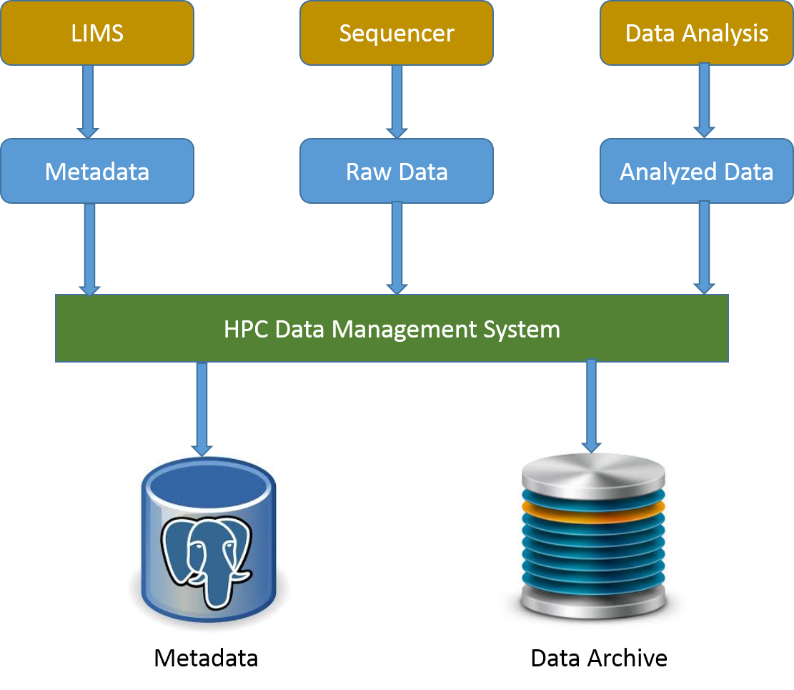

Users can store data for a long term on HPC DME, share and transfer their data such that they do not have to redistribute or maintain copies of the data on other systems by eliminating the data integrity issues. HPC DME stores and associates user defined metadata to any registered data at different levels of data life cycle, enabling the system not only to help identify the data but also enhancing the search capabilities.

The HPC data management system provides a number of application programming interfaces (APIs) to operate and interact with it. These APIs acts as a facade for the underlying implementation to encapsulate and to provide consistent access to the users. The HPC data management system provides a high-reliability storage model for underlying datasets including a dataset registration system, and an API for transfer of large datasets with no-loss of data. By default, the HPC data management system integrates with Globus platform and uses it to perform data transfer tasks. The basic features of HPC data management system help users in registering and uploading their data to the HPC DM archive storage system and managing it. HPC DME archive storage can be a permanent storage for the users’ data and can be used as a platform to search, manage and transfer the data to other storage systems and also to share with other collaborators or users. Each data object is stored with its binary data along with its required and user defined metadata. The associated metadata can be used as search criteria to identify dataset(s).

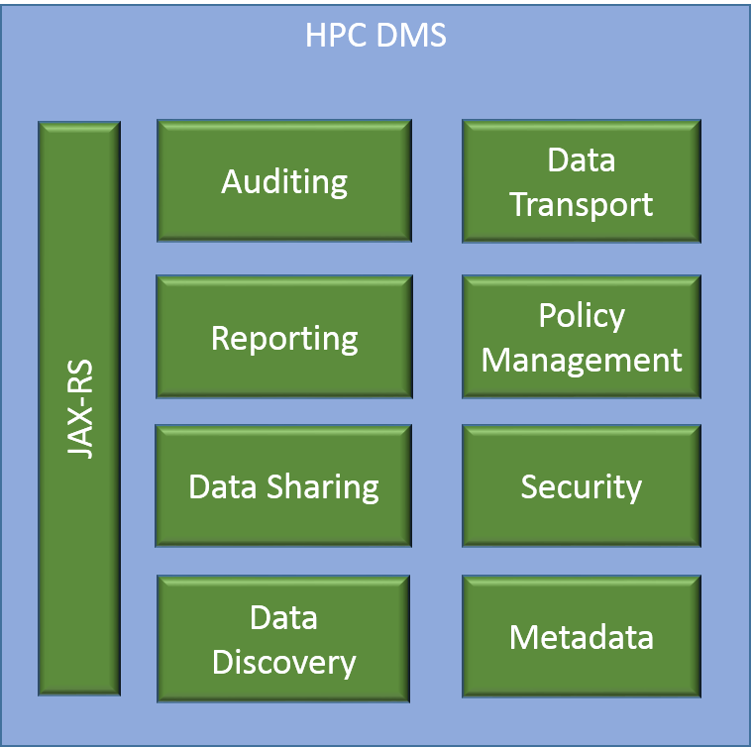

Based on modular application development, HPC DM APIs are developed to provide flexible, pluggable and easily configurable application to support data management requirements. Each of the modules shown in the diagram can be extended or replaced easily without impacting the application. More details on these modules are discussed in the Software Architecture section (3.4) below. The pilot phase of this implementation is focused on integrating with iRODS for metadata management and with Globus for data transfer. With the modular architecture, any future integrations can be supported very easily.

### Metadata

Metadata is defined as the data about the data. It is the information which describes the actual data such as the date and origin of creation, its contents, its condition, processing it has gone through and associations to other objects etc. Metadata is employed to make data searches faster, more specific and also enable and promote data sharing among scientists.

HPC DME collects metadata for each data object/entity registered and stored in a database along with the associations. HPC DME collects two kinds of metadata related to a Collection or data object, namely, administrative and division/center specific. The administrative metadata is the required set of information which needs to be submitted at the time of registration with HPC DME. New metadata variables can be added to both administrative and division/center specific metadata sets after obtaining proper authorizations and permissions. The metadata can also be updated by authorized users. Apart from these two kinds of metadata, HPC DME also manages system generated metadata for each of the entities registered with the system.

One of the primary functions of HPC DME is to connect unstructured data with metadata. Metadata may be attached to files, folders and collections. HPC DME stores metadata in the form of “triples” to its relational database. The triples consist of an attribute field, a value field, and a unit field. The content of each of these fields can be independently defined and applied. This Metadata can be changed and updated through the life cycle of each data object.

Adding metadata to objects or their collections can also be optional. A Division or center has flexibility to define their own metadata and its policies. One may choose not to define any metadata policies. Adding/updating policies at later time may require updates to existing metadata.

Following table shows default required Metadata for a collection in the HPC DME. This list can be modified by a system administrator to add, update or remove any of these attributes. Details on updating metadata attributes configuration is detailed in the section below.

**Metadata for Collection:**

|  |  |  |  |
| --- | --- | --- | --- |
|  | **Metadata Variable** | **Definition** | **Default** |
| **Administrative Metadata** | | | |
|  | collection_type | Collection type name (Default valid values are Project, Dataset, Folder). This is required attribute. |  |
|  | name | Name for the dataset of files as provided by the depositor |  |
|  | description | Description of dataset |  |
|  | source_lab_pi | PI of the lab of the depositor at the time of deposit |  |
|  | lab_branch | Lab or Branch or Program the PI belongs to |  |
|  | pi_doc | Division, Organization, Center the PI belongs to |  |
|  | original_date_created | Date the dataset was created originally | Date the dataset was deposited |
|  | data_creator | Person or Organization lead who created the data | Not Specified |
|  | phi_content | Presence of Protected Health Information in the datasets deposited via HPC DME.  Valid values are (PHI Present, PHI Not Present, Not Specified) | Not Specified |
|  | pii_content | Presence of Personally Identifiable Information in the datasets deposited via HPC DME. Valid values are (PII Present, PII Not Present, Not Specified) | Not Specified |
|  | data_encryption_status | If the data is encrypted or not. Valid values are (Encrypted,  Not Encrypted, Not Specified) | Not Specified |
|  | data_compression_status | If the data is compressed or not | Not Specified |
|  | funding_organization | Organization Funding the generation of Data | Not Specified |

Following table shows default required Metadata for a Project in the HPC DME.

**Metadata for Project:**

|  |  |  |  |
| --- | --- | --- | --- |
|  | **Metadata Variable** | **Definition** | **Default** |
| **Administrative Metadata** | | | |
|  | collection_type | Collection type name (Default valid values are Project, Dataset, Folder) |  |
|  | name | Name for the Project |  |
|  | description | Description of project |  |
|  | source_lab_pi | PI of the lab of the depositor at the time of deposit |  |
|  | lab_branch | Lab or Branch or Program the PI belongs to |  |
|  | pi_doc | Division, Organization, Center the PI belongs to |  |
|  | original_date_created | Date the dataset was created originally | Date the dataset was deposited |
|  | project_type | Default valid values are "Unspecified", "Umbrella Project", "Sequencing", "Analysis" |  |
| **Division/Center specific metadata** | | | |
|  | Internal_project_id | Internal Project Id to track |  |
|  | comments | General text for internal use and reference |  |

**System Generated Metadata Variables for any Collection:**

|  |  |  |
| --- | --- | --- |
| Id | local identifier (serves as foreign key to connect to other metadata in data management system |  |
| uuid | universal dataset identifier (reserved for future use: default is ‘unspecified’) |  |
| create_date | Date the project, dataset or file was registered with HPC DME. |  |
| update_date | Date the project, dataset or file was updated with HPC DME. |  |
| registerd_by | User depositing the dataset |  |
| registered_by_name | Name of the person registering the dataset |  |
| registered_by_doc | Division, Organization, Center of the user registering the dataset |  |

Following table shows default required Metadata for a data object in the HPC DME.

**Metadata for Data object/file:**

|  |  |  |  |
| --- | --- | --- | --- |
|  | **Metadata Variable** | **Definition** | **Default** |
| **Administrative metadata** | | | |
|  | name | Name for the file as provided by the depositor |  |
|  | description | Extensible description of File |  |
|  | source_lab_pi | PI of the lab of the depositor at the time of deposit | Auto Populated |
|  | lab_branch | Lab or Branch or Program the PI belongs to |  |
|  | pi_doc | Division, Organization, Center the PI belongs to |  |
|  | original_date_created | Date the File was created originally | Date the file was deposited |
|  | data_creator | Person or Organization lead who created the data | Not Specified |
|  | phi_content | Presence of Protected Health Information in the datasets deposited via HPC DME.  Valid values are (PHI Present, PHI Not Present, Not Specified) | Not Specified |
|  | pii_content | Presence of Personally Identifiable Information in the datasets deposited via HPC DME. Valid values are (PII Present, PII Not Present, Not Specified) | Not Specified |
|  | data_encryption_status | If the data is encrypted or not. Valid values are (Encrypted,  Not Encrypted, Not Specified) | Not Specified |
|  | data_compression_status | If the file is compressed or not | Not Specified |
|  | funding_organization | Organization Funding the generation of Data | Not Specified |
| **Division/Center specific metadata** | | | |
|  | comments | General text for internal use and reference |  |
| **System Generated Metadata Variables for any Data object / file (Automated)** | | | |
|  | id | local identifier (serves as foreign key to connect to other metadata in data management system |  |
|  | uuid | universal dataset identifier (reserved for future use: default is ‘unspecified’) |  |
|  | dataset_signature_md5 | MD5 checksum |  |
|  | Dataset_signature_sha1 | SHA1 checksum |  |
|  | Data_size | Size of the dataset being deposited |  |
|  | create_date | Date the project, dataset or file was registered with HPC DME. |  |
|  | update_date | Date the project, dataset or file was updated with HPC DME. |  |
|  | registerd_by | User depositing the dataset |  |
|  | registered_by_name | Name of the person registering the dataset |  |
|  | registered_by_doc | Division, Organization, Center of the user registering the dataset |  |
|  | source_globus_path | Data Source Globus Path |  |
|  | source_globus_endpoint | Data Source Globus Endpoint |  |
|  | Date_globus_endpoint | Data Location Globus Endpoint |  |
|  | data_globus_path | Data Location Globus Path |  |

HPC DME provides a flexible way to configure metadata attributes through a policy file. Following is an example of the policy file.

|  |
| --- |
| **Sample Policy File** |
| {"HpcMetadataValidationRules": {  "collectionMetadataValidationRules": [  {  "attribute": "Collection type",  "mandatory": true,  "validValues": [  "project",  "dataset",  "folder"  ],  "ruleEnabled": true,  "DOC": "DOC-NAME"  },  {  "attribute": "Project name",  "mandatory": true,  "collectionType": "project",  "ruleEnabled": true,  "DOC": "DOC-NAME"  },  {  "attribute": "Project type",  "mandatory": true,  "collectionType": "project",  "validValues": [  "Umbrella Project",  "Sequencing",  "Analysis"  ],  "ruleEnabled": true,  "DOC": "DOC-NAME"  }, |

* attribute: Metadata attribute name
* mandatory: Flag to indicate if it is required or not. Valid values are “true”, “false”
* defaultValue: Default value of the attribute if no value is given
* collectionType: Collection type name applicable for this attribute rule. Only one value is allowed.
* validValues: List of valid values for this attribute
* ruleEnabled: Flag to indicate if this rule is enabled or not. Valid values are “true” or “false”. If value is set to “false”, this rule will not be evaluated during validation process.
* DOC: Division name applicable. This rule will only be active for the given DOC. This attribute is not active now.

### Data Archival

The center piece of HPC DME is to reliably store large data and be able to retrieve it when needed. HPC Data transfer API abstracts the underlying implementation to the end user so that the transfer and Storage technologies can be extended or replaced as needed. By default, HPC DME uses Globus API to perform data transfer between Globus endpoint asynchronously. Globus API manages data movement tasks to a hosted service that manages the entire operation, monitoring performance and errors, retrying failed transfers, correcting problems automatically whenever possible, and reporting status to keep users informed.

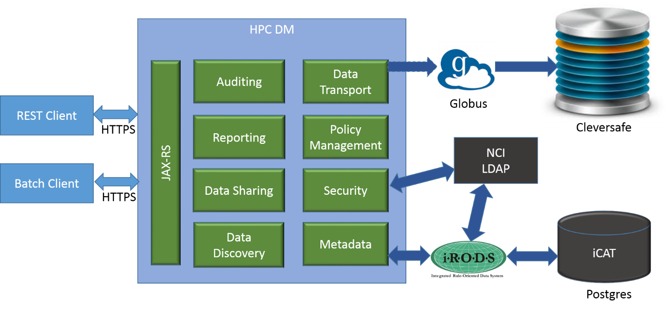

When a data object registration request is submitted to HPC DME through its interface, after successful validation, data object metadata is registered with metadata repository and a data transfer request is initiated with Globus asynchronously. As part of the registration request, the caller would have to provide valid source endpoint and location of the file along with file metadata.

{

"source": {

"fileContainerId": "dabdccc3-6d04-11e5-ba46-22000b92c6ec",

"fileId": "/mnt/IRODsTest/FNL_SF_Archive/Project-test1/D1/test2.fastq"

},

"metadataEntries": [

{

"attribute": "name",

"value": "data-file"

} ]

}

Once the data transfer request is submitted to Globus, its transfer status can be one the following states:

|  |  |
| --- | --- |
| INITIATED | The transfer of a dataset is initiated. |
| IN_PROGRESS | The transfer of a dataset is in progress. |
| SUCCEEDED | The transfer of a dataset has been successful and is complete. |
| FAILED | The transfer of a dataset is not successful when globus fails to transfer files due to errors like file not found etc., after repeated attempts. |

When a data request is submitted to Globus, HPC DME API collects initial response of the request and store it in HPC DME database. This response information is updated in following ways to present up to date information to the users when querying.

1. Cron job running at scheduled intervals query for all requests NOT in SUCCEEDED or FAILED state with Globus to get latest status and update them in HPC DME. If any data objects are in FAILED state, its registration will be rolled back including the metadata saved in metadata repository.

Following are the details of data transfer response captured in HPC DME:

Task ID                : 7ea479c0-ba3d-11e5-9a07-22000b96db58  
Task Type            : TRANSFER  
Status                    : SUCCEEDED  
Is Paused              : No  
Request Time         : 2016-01-13 21:34:59Z  
Deadline                 : 2016-01-14 21:34:59Z  
Completion Time    : 2016-01-13 21:35:02Z  
Total Tasks             : 3  
Tasks Successful    : 3  
Tasks Expired          : 0  
Tasks Canceled       : 0  
Tasks Failed             : 0  
Tasks Pending          : 0  
Tasks Retrying         : 0  
Command                : API 0.10  
Label                    : n/a  
Source Endpoint Name     : nihnci#NIH-NCI-TRANSFER1  
Destination Endpoint Name: nihfnlcr#gridftp1  
Source Endpoint          : e1c6b3bd-6d04-11e5-ba46-22000b92c6ec  
Destination Endpoint     : dabdccc3-6d04-11e5-ba46-22000b92c6ec  
Sync Level               : n/a  
Data Encryption          : No  
Checksum Verification    : No  
Delete                   : No  
Files                    : 1  
Files Transferred        : 1  
Files Skipped            : 0  
Directories              : 1  
Expansions               : 1  
Bytes Transferred        : 30629739  
Bytes Checksummed (Sync) : 0  
Effective MBits/sec      : 81.679  
Faults                   : 0

### Data Discovery

Data discovery in HPC DME enables users to locate the data in the archive system either by metadata or its logical path.

**Discovery by metadata:**

The data discovery functionality enables users to search for collections or files they want to download, transfer or share with other researchers and collaborators, utilizing the associated metadata as search terms. This kind of search based on metadata, improves the search functionality by tremendously expanding the search criteria according to the user specifications and not just the technical aspects of the dataset.

Metadata can be queried by its name, value and a comparator. Following operators are supported to query by attribute value:

* EQUAL
* NOT_EQUAL
* LESS_THAN
* GREATER_THAN
* LESS_OR_EQUAL
* GREATER_OR_EQUAL
* LIKE

**Discovery by path:**

HPC DME supports data virtualization by decoupling its logical path with its physical storage page. When a data object or collection is registered with HPC DME, it is registered with a logical path. For example: /FNLCR_LAB/ProjectX/DatasetY. This provides flexibility for users to organize their data in a structured format irrespective of the physical storage location and its path. HPC DME supports querying these data objects or collections by their logical path.

## Data Sharing

Data sharing is critical part of data collaboration. Through HPC DME, users can share a collection or data file with another user. When a user registers a collection or data object, the user by default becomes OWNER of that collection or data object. User may assign OWN, READ, WRITE permissions to another user. Assigning NONE permission will take away any existing permissions. If you assign a permission on a collection, that permission will be recursively inherited to all its child collections and objects. You may override this behavior by manually changing the permission on child collection or objects. Any permission updates done at higher level will always overwrite any permission update at lower level.

## Audit

HPC DME supports maintaining audit for delete actions on data files. Following information is stored in the application database as part of Audit table.

"USER_ID" text NOT NULL,

"PATH" text NOT NULL,

"METADATA" text NOT NULL,

"ARCHIVE_FILE_CONTAINER_ID" text NOT NULL,

"ARCHIVE_FILE_ID" text NOT NULL,

"ARCHIVE_DELETE_STATUS" boolean NOT NULL,

"DATA_MANAGEMENT_DELETE_STATUS" boolean NOT NULL,

"MESSAGE" text,

"DELETED" date NOT NULL

## policy management

HPC DME supports configuring data management policies (metadata validation rules and hierarchy definition) for each base-path. One DOC can be associated with multiple base-paths and each base-path can be configured with its own policies. Policies are enforced when collections and data objects are registered or updated.

Metadata validation rules are defined in JSON format. Rules are separately defined for validating collections and data objects, but the same JSON format is used in both cases.

Following is an example of the metadata validation JSON

{

"attribute":"<Metadata attribute name>",

"mandatory":<true|false>,

"defaultValue":"<Default value>",

"collectionTypes":[

"<Collection Type1>",

"<Collection Type2>"

],

"validValues":[

"<Value1>",

"<Value2>"

],

"ruleEnabled":<true|false>,

"DOC":["<DOC1>", "<DOC2>"]

}

Hierarchy policy is defined using a JSON format. For collection type in the hierarchy, it is specified whether data objects can be registered. An example of a hierarchy JSON policy is the following:

{

"collectionType": "PI_Lab",

"isDataObjectContainer": false,

"subCollections": [

{

"collectionType": "Project",

"isDataObjectContainer": false,

"subCollections": [

{

"collectionType": "Flowcell",

"isDataObjectContainer": false,

"subCollections": [

{

"collectionType": "Sample",

"isDataObjectContainer": true

}

]

}

]

}

]

}

Policies are stored in the "HPC_DATA_MANAGEMENT_CONFIGURATION" table.

Following is the table’s schema. Please see section 4.1.2 for the data dictionary.

CREATE TABLE public."HPC_DATA_MANAGEMENT_CONFIGURATION"

(

“ID” text PRIMARY_KEY,

"DOC" text NOT NULL,

"BASE_PATH" text NOT NULL,

"S3_URL" text NOT NULL,

"S3_VAULT" text NOT NULL,

"S3_OBJECT_ID" text NOT NULL,

"S3_ARCHIVE_TYPE" text NOT NULL,

"DATA_HIERARCHY" text,

"COLLECTION_METADATA_VALIDATION_RULES" text,

"DATA_OBJECT_METADATA_VALIDATION_RULES" text

)

## reports

HPC DME API supports generating following reports. These reports are generated by directly querying underlying metadata repository.

* Summary report: Summarized report on entire archive storage.
* Summary report by data range: Summarized report on entire archive storage based on date range.
* DOC Report: Summarized report for a selected DOC
* DOC Report by date range: Summarized report of selected DOC for a selected date range
* User Report: Summarized report for a selected User
* User Report by date range: Summarized report of selected User for a selected date range

To address performance concerns, Reports API uses materialized views to query database. These materialized views are refreshed at every 1 hour by the HPC DME scheduled background process. Please see <https://github.com/CBIIT/HPC_DME_APIs/blob/master/src/hpc-server/hpc-dao-impl/src/main/scripts/schema/hpc_report_views.sql> for the schema definitions. These materialized views are built on following ICAT tables.

r_data_main – All data files registered with HPC DME

r_coll_main – All collections registered with HPC DME

r_meta_main – All data file/collection metadata registered with HPC DME

r_objt_metamap – Map between metadata and collection/data file

HPC_DATA_MANAGEMENT_CONFIGURATION – DOCs registered with HPC DME

## Hardware Architecture

[Insert any related hardware architecture documents or provide a reference to where they are stored.]

## Software Architecture

HPC DME system architecture includes following 4 tiers:

1. **API Server:** A server that will host a collection of components and APIs for the various services provided by the system, and provide workflow capabilities and integration with other sub-systems.
2. **Data Management:** An integrated data management system – iRODS.
3. **Data Transfer:** A data transfer service - Globus
4. **Authentication:** Authentication service via NCI LDAP server.

Please see section 3.11 for deployment view of the system detailing the mapping of software components with the physical assets in different tiers.

The proposed architecture, defined by the above components, is designed to address the following key project objectives:

* Effective data management while supporting a variety of dataset formats and managing metadata, annotations, cataloging.
* The flexibility to allow for the evolution of associated dataset formats over time.
* High-performing dataset discovery.
* Reliable, scalable, and high performing data storage and data transfer.
* The application of NIH security best practices for both authentication and authorization by integrating with NCI LDAP and utilizing Spring Security.

### API Server

The HPC-DM API server architecture is a multilayered architecture to support clear separation of concerns and boundaries among the various components of the server. The architecture includes following 6 horizontal layers.

1. REST Web service layer
2. Batch layer
3. Business service layer
4. Application service layer
5. Integration layer
6. DAO layer

Each horizontal layer is comprised of 2 OSGi bundles (dynamically loadable JAR), one contains the layer’s API and the other contains the API’s implementation. A layer’s API bundle is configured (via a manifest file) to export (or make available) the API interface packages. A layer’s implementation bundle is configured to hide all of its code. This approach has the following advantages:

1. It ensures layers are communicating with each other via APIs since the implementation is physically not visible outside the bundle
2. It ensures avoiding circular dependencies among the bundles and thus promotes the architecture reusability.
3. It enables a hot deployment of implementation code, i.e. swapping a layer’s implementation bundle in runtime without stopping the server.

The architecture also includes following 3 vertical layers, which include POJO code that is used by multiple horizontal layers to communicate.

1. Domain layer
2. DTO Layer
3. Common layer

The following diagram depict the API server architecture:

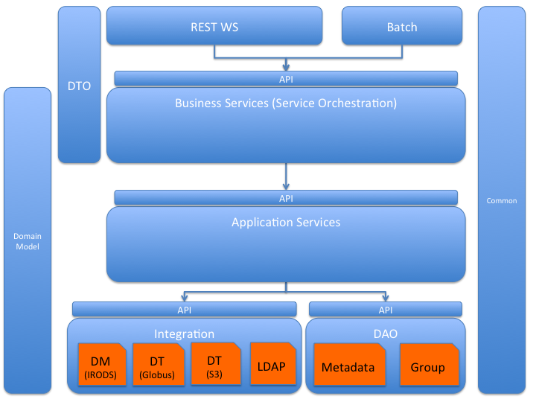

#### REST Web Service Layer:

This layer is responsible to define and implement the RESTful Web Services API. It is responsible for:

* Implementing each REST API by invoking the appropriate Business Service.
* Deploying secured (SSL) and non-secured endpoints.
* User (Service Invoker) authentication and authorization
* Mapping Service Input from JSON/XML to DTO POJO
* Mapping Service Output to JSON/XML and HTTP return code.
* Attach API version to all services response.

#### Server Batch

This layer is responsible for implementing task scheduler, invoking various server’s batch processes. Each scheduled task is implemented by invoking business services.

#### Business Services

This layer is responsible for defining and implementing coarse-grained business services which are the system’s API defined in pure Java. This layer is responsible for:

* Map DTO (The POJO data types used to define the business services API and are mapped to JSON/XML) to Domain Model (The internal POJO used by the system and are not exposed to the services invoker)
* Implementing each coarse-grained business service by orchestrating a series of application services.

#### Application Services

This layer is responsible for defining and implementing fine-grained application services that are used as building blocks to deliver business services. This layer is responsible for:

* Domain Model and Data validation rules
* Implementing application services by applying business logic and invoking API offered by the Integration and DAO layers..

#### Integration Layer

This layer is responsible for defining and implementing an API to the subsystems the server is integrated with. The API is defined generically and completely hides any integrated system details, so the underlying system can be easily replaced if needed. This layer is responsible for:

* ‘Data Management’ API implemented via Jargon API to integrate with iRODS. (https://github.com/DICE-UNC/jargon)
* ‘Data Transfer’ API implemented by REST web services to integrate with Globus
* ‘Authentication’ API implemented with Spring LDAP to integrate with NIH Active Directory Server.

#### DAO Layer

This layer is responsible for persisting data to the database. The current implementation persists data to PostgreSQL DB.

#### Data Transfer Object (DTO) & Domain Model

These vertical layers define POJO data objects that are used in communications between the layers. The DTO are Java representation of data objects used in external API. Domain model are data objects used to implement services and business logic.

#### Common

Common includes utility Java code that is used in all horizontal layers, and also include the system exception classes.

## Security Architecture

HPC DME operations are secured by authentication and authorization.

**Authentication:**

HPC DME authenticates with NCI Active Directory to authenticate a user. HPC DME security integrates with Globus and iRODS to securely interact with their respective APIs. Every call to HPC API is intercepted by HPC Authentication Interceptor to validate user credentials with NIH AD. Once the user is authenticated with HPC API, any subsequent call to iRODS API or Data transfer API would need to be authenticated as well. With the current state of integration with iRODS, a user would need to be authenticated by iRODS system for secure access.

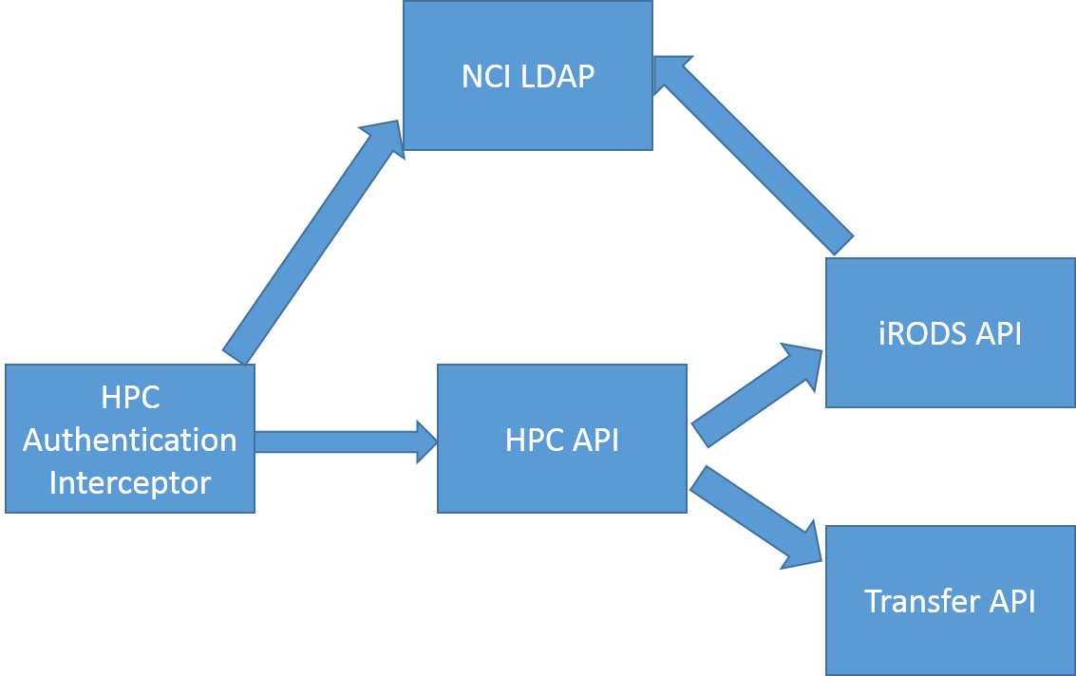

By default, iRODS uses a secure password system for user authentication. The user passwords are scrambled and stored in the iCAT database. Additionally, iRODS supports user authentication via PAM (Pluggable Authentication Modules), which can be configured to support many things, including the LDAP authentication system. PAM can be configured to support various authentication systems; however, the iRODS administrator still needs to add the users to the iRODS database. For this pilot implementation, iRODS is configured to use PAM authentication with NCI LDAP. A pluggable authentication module (PAM) is a mechanism to integrate multiple low-level authentication schemes into a high-level application programming interface (API). It allows programs that rely on authentication to be written independently of the underlying authentication scheme.

Globus is the default data transfer mechanism with the HPC DME implementation. HPC DME API uses its Globus Application account to register data with the Archive. Please see section 4.3.4 about Globus integration details. When users are downloading data files from the Archive, users will have to share destination Globus endpoint location with the HPC DME Application account with write permission.

Users of HPCDME API interface are required to enroll into HPC system to start using HPC system. A System Administrator would enroll a user with HPC DME with NIH AD userId. The HPC DME user-registration service would use same userId to create an account with iRODS when registering with HPC DME automatically. When a user account is created in iRODS, iRODS will create logical name with the userId. By default, the user owns this logical space on iRODS.

HPCDME Server API is configured to support basic authentication credentials over HTTPS. Given credentials are verified against NIH AD for authentication. Authenticated User is verified with HPCDME security system for authorization.

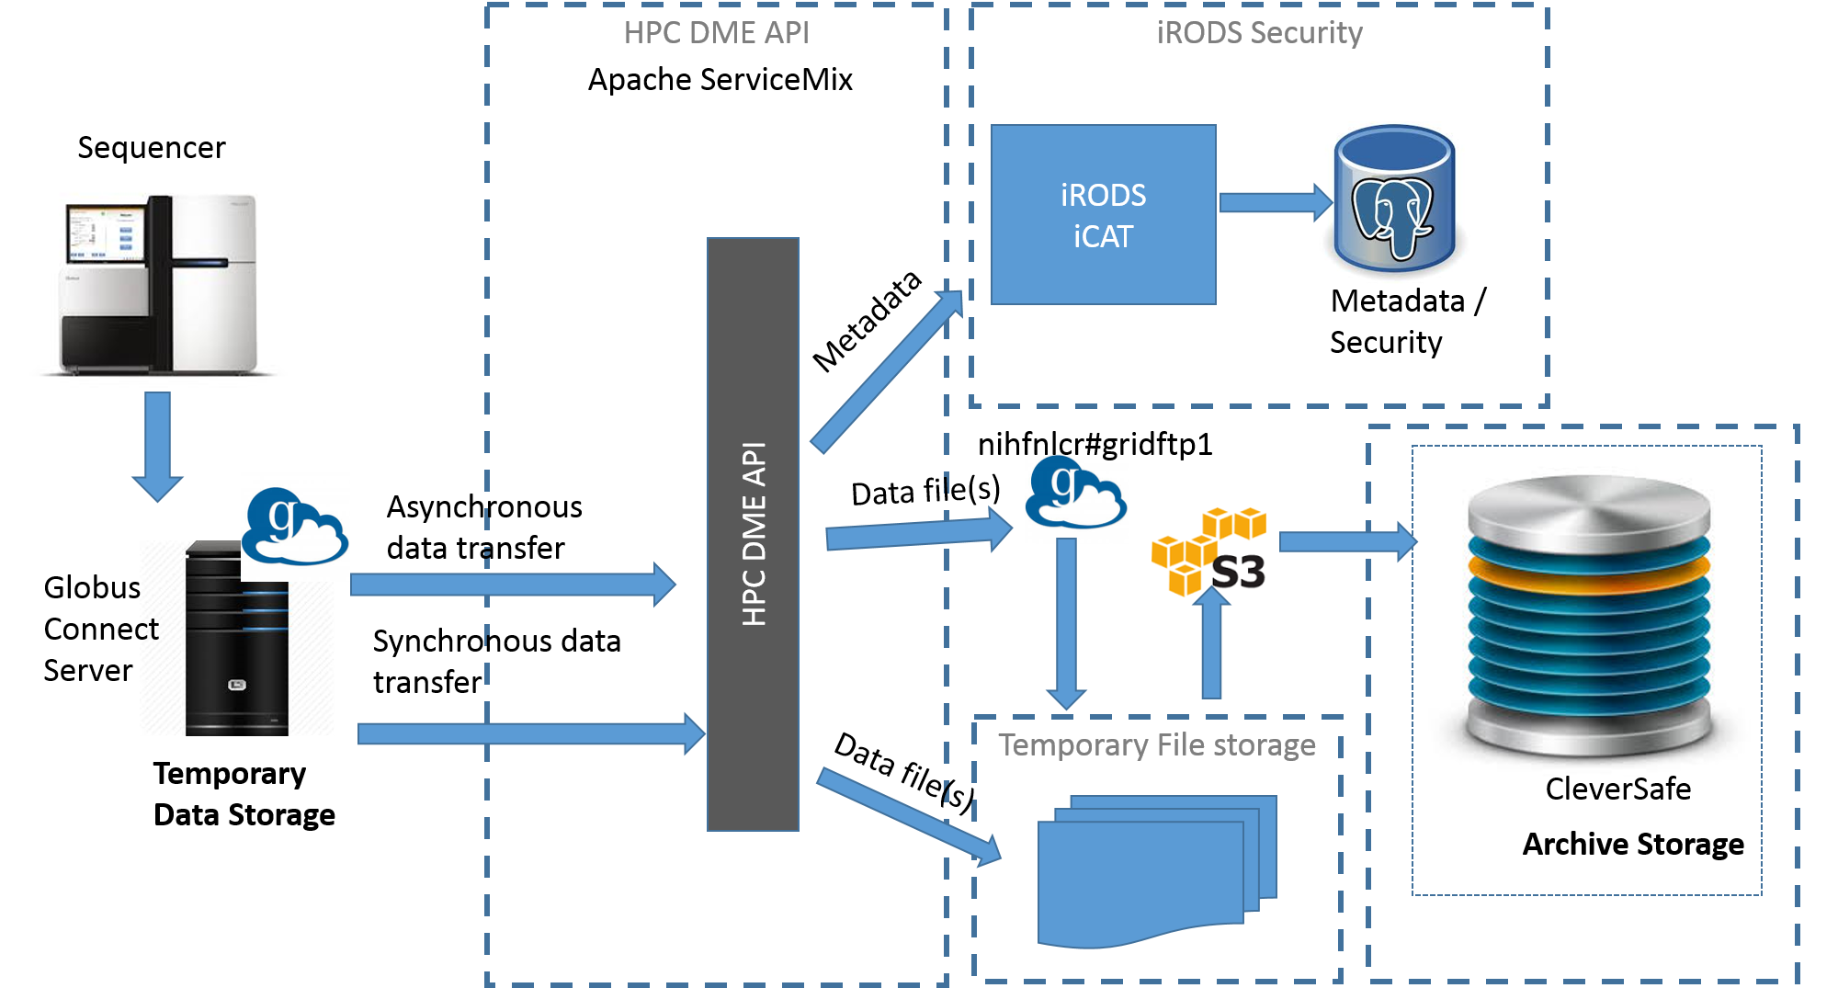

**Authorization:**

HPC DME authorization covers authorizing users with HPCDME API and iRODS features only. HPC DME authorization does not cover or extend Globus authorization policies at this time. As it is detailed in section 4.3.4, HPC DME uses Globus application account as the service account to do any asynchronous data transfers from and to HPC DME archive.

HPCDME Server APIs are protected by user roles extended from iRODS. Through Spring configuration these authorization settings on APIs can be updated easily. Please see <https://github.com/CBIIT/HPC_DME_APIs/blob/master/src/hpc-server/hpc-ws-rs-impl/src/main/resources/META-INF/spring/hpc-ws-rs-bundle-context-osgi.xml> for the configuration settings. HPCDME Server API internally interacts with iRODS Jargon API to work with iRODS securely. HPC DME encapsulates iRODS authorization policies.

iRODS primarily provides three primary roles,

* + Admin - can manage user accounts and access permissions on different objects and collections.
  + User - owner of collections or objects can assign different access types to different users on the owned collections or objects.
  + Groupadmin - can create users, groups and add or delete users from groups

iRODS provides the following access types:

* + Own
  + Read
  + Write
  + None

The default authorization rules for HPC-DME APIs are listed below:

#hpc.ws.rs.auth.security.register-user=SYSTEM_ADMIN GROUP_ADMIN

#hpc.ws.rs.auth.security.update-user=SYSTEM_ADMIN

#hpc.ws.rs.auth.security.update-user=SYSTEM_ADMIN GROUP_ADMIN USER

#hpc.ws.rs.auth.security.get-user=SYSTEM_ADMIN

#hpc.ws.rs.auth.security.get-invoker=SYSTEM_ADMIN GROUP_ADMIN USER

#hpc.ws.rs.auth.security.get-active-users=SYSTEM_ADMIN GROUP_ADMIN USER

#hpc.ws.rs.auth.security.get-all-users=SYSTEM_ADMIN

#hpc.ws.rs.auth.security.authenticate=SYSTEM_ADMIN GROUP_ADMIN USER

#hpc.ws.rs.auth.security.register-group=SYSTEM_ADMIN GROUP_ADMIN

#hpc.ws.rs.auth.security.update-group=SYSTEM_ADMIN GROUP_ADMIN

#hpc.ws.rs.auth.security.get-group=SYSTEM_ADMIN GROUP_ADMIN

#hpc.ws.rs.auth.security.get-groups=SYSTEM_ADMIN GROUP_ADMIN

#hpc.ws.rs.auth.security.delete-group=SYSTEM_ADMIN GROUP_ADMIN

#hpc.ws.rs.auth.security.register-system-account=SYSTEM_ADMIN

#hpc.ws.rs.auth.data-management.register-collection=SYSTEM_ADMIN GROUP_ADMIN USER

#hpc.ws.rs.auth.data-management.get-collection=SYSTEM_ADMIN GROUP_ADMIN USER

#hpc.ws.rs.auth.data-management.download-collection=SYSTEM_ADMIN GROUP_ADMIN USER

#hpc.ws.rs.auth.data-management.get-collection-download-status=SYSTEM_ADMIN GROUP_ADMIN USER

#hpc.ws.rs.auth.data-management.set-collection-permissions=SYSTEM_ADMIN GROUP_ADMIN USER

#hpc.ws.rs.auth.data-management.get-collection-permissions=SYSTEM_ADMIN GROUP_ADMIN USER

#hpc.ws.rs.auth.data-management.register-data-object=SYSTEM_ADMIN GROUP_ADMIN USER

#hpc.ws.rs.auth.data-management.register-data-objects=SYSTEM_ADMIN GROUP_ADMIN USER

#hpc.ws.rs.auth.data-management.get-data-object=SYSTEM_ADMIN GROUP_ADMIN USER

#hpc.ws.rs.auth.data-management.get-data-object=SYSTEM_ADMIN GROUP_ADMIN USER

#hpc.ws.rs.auth.data-management.get-data-object-download-status=SYSTEM_ADMIN GROUP_ADMIN USER

#hpc.ws.rs.auth.data-management.download-data-object=SYSTEM_ADMIN GROUP_ADMIN USER

#hpc.ws.rs.auth.data-management.delete-data-object=SYSTEM_ADMIN GROUP_ADMIN

#hpc.ws.rs.auth.data-management.set-data-object-permissions=SYSTEM_ADMIN GROUP_ADMIN USER

#hpc.ws.rs.auth.data-management.get-data-object-permissions=SYSTEM_ADMIN GROUP_ADMIN USER

#hpc.ws.rs.auth.data-management.download-data-objects=SYSTEM_ADMIN GROUP_ADMIN USER

#hpc.ws.rs.auth.data-management.get-data-objects-download-status=SYSTEM_ADMIN GROUP_ADMIN USER

#hpc.ws.rs.auth.data-management.get-data-management-model=SYSTEM_ADMIN GROUP_ADMIN USER

#hpc.ws.rs.auth.data-search.query-collections=SYSTEM_ADMIN GROUP_ADMIN USER

#hpc.ws.rs.auth.data-search.query-data-objects=SYSTEM_ADMIN GROUP_ADMIN USER

#hpc.ws.rs.auth.data-search.add-query=SYSTEM_ADMIN GROUP_ADMIN USER

#hpc.ws.rs.auth.data-search.update-query=SYSTEM_ADMIN GROUP_ADMIN USER

#hpc.ws.rs.auth.data-search.delete-query=SYSTEM_ADMIN GROUP_ADMIN USER

#hpc.ws.rs.auth.data-search.get-query=SYSTEM_ADMIN GROUP_ADMIN USER

#hpc.ws.rs.auth.data-search.get-queries=SYSTEM_ADMIN GROUP_ADMIN USER

#hpc.ws.rs.auth.data-search.get-metadata-attributes=SYSTEM_ADMIN GROUP_ADMIN USER

#hpc.ws.rs.auth.data-search.refresh-metadata-views=SYSTEM_ADMIN

#hpc.ws.rs.auth.data-browse.add-bookmark=SYSTEM_ADMIN GROUP_ADMIN USER

#hpc.ws.rs.auth.data-browse.update-bookmark=SYSTEM_ADMIN GROUP_ADMIN USER

#hpc.ws.rs.auth.data-browse.delete-bookmark=SYSTEM_ADMIN GROUP_ADMIN USER

#hpc.ws.rs.auth.data-browse.get-bookmark=SYSTEM_ADMIN GROUP_ADMIN USER

#hpc.ws.rs.auth.data-browse.get-bookmarks=SYSTEM_ADMIN GROUP_ADMIN USER

#hpc.ws.rs.auth.notification.subscribe-notifications=SYSTEM_ADMIN GROUP_ADMIN USER

#hpc.ws.rs.auth.notification.get-notification-subscriptions=SYSTEM_ADMIN GROUP_ADMIN USER

#hpc.ws.rs.auth.report.generate-report=SYSTEM_ADMIN GROUP_ADMIN USER

## Communication Architecture

Following diagrams depicts communication workflow of different systems involved with HPC DME. A sequencer or data creator would keep its data in one of its Globus endpoints. A user registered with HPC DME system would invoke HPCDME API with credentials to register the data with the archive system. User credentials are authenticated with NIH AD to store given metadata into HPC DME database. HPCDME API would also initiate data transfer through Globus API asynchronously.

Users of HPC DME interacts with HPCDME REST API over HTTPS protocol. It is expected to have HPCDME API running on ServiceMix and iRODS iCAT instance hosted on same machine to eliminate extra security configuration and setup needs for iRODS.

Please see section 5.19 in the Admin guide for Tech Stack information.

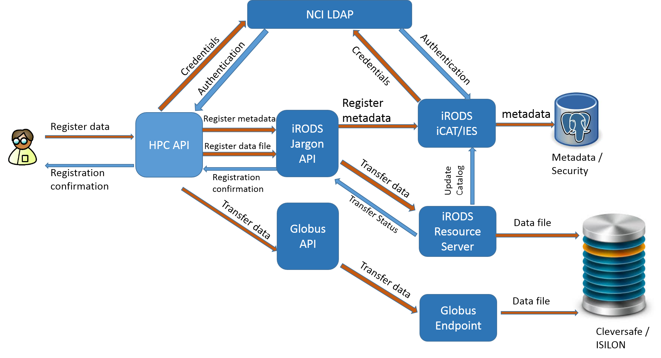

## Deployment View

HPC DME is built with following software components.

1. HPC DME API running on Apache ServiceMix 7.x.
2. iRODS Middleware running on iRODS 4.2.x
3. Metadata and Security repository running on PostgreSQL 9.5
4. HPC DME Web application running on Apache Tomcat 8.x
5. Apache 2 Web Proxy
6. Cleversafe running at ITOG

These components are deployed differently DEV, UAT and Production tiers. The interaction between these components are same across these multiple tiers. The difference is the with limitation of system resources in DEV/ UAT vs Production. Following diagrams shows the deployment model on these tiers.

On DEV/UAT, all the components are deployed on the same VM. DEV/UAT deployment do not have Apache2 proxy.

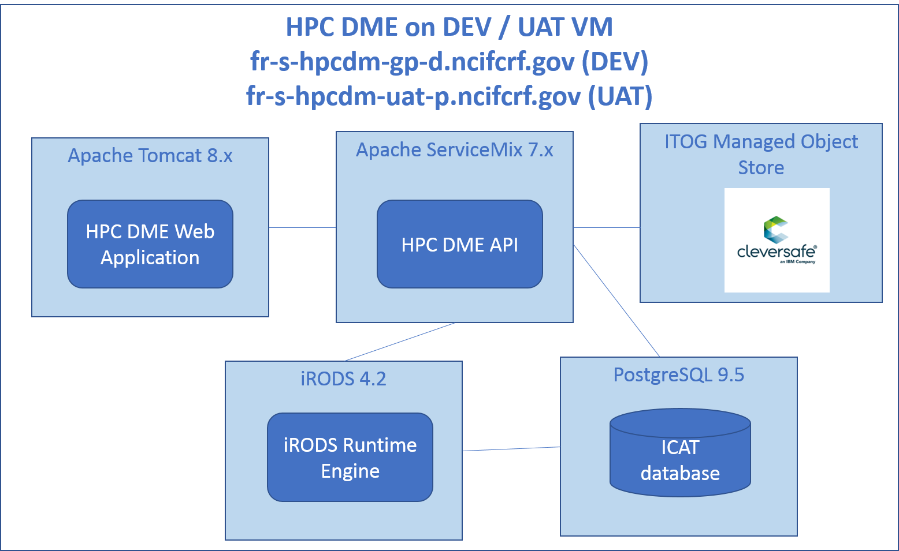

Production deployment is as shown below:

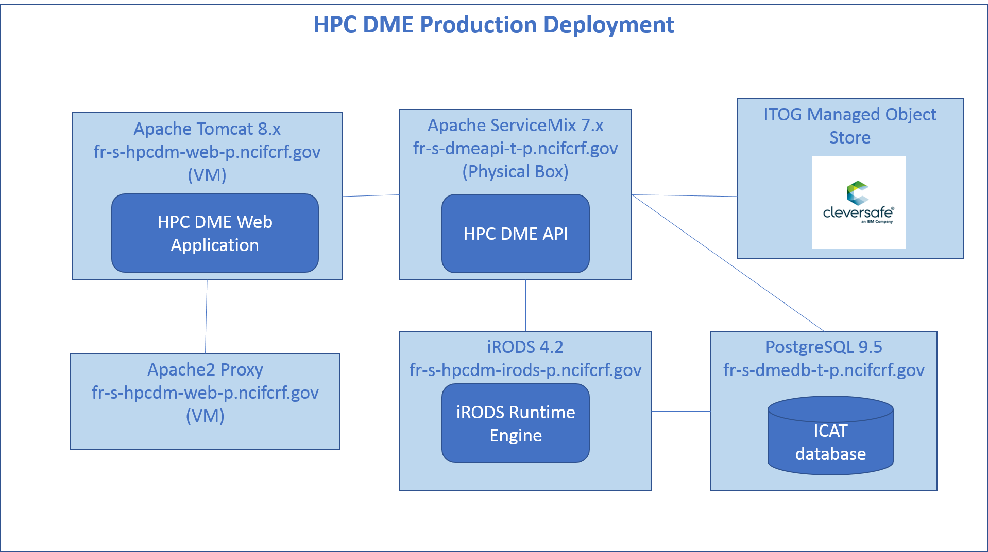

## Performance

[Insert any performance documents or provide a reference to where they are stored.]

# System Design

## Database Design

### iRODS Schema

HPC DME adopts iRODS data model to manage metadata and security around that. Each iRODS deployment—or Zone—is composed of an iRODS Metadata Catalog (iCAT), an iCAT-Enabled Server (IES), and optional Resource Servers. The iCAT is a relational database that holds all the information about data, users, and zone that the iRODS servers—IES and any resource servers—need to facilitate the management and sharing of any data registered with HPC DME. The iCAT contains the information about

• the zone for the purposes of sharing across zones,

• data and their metadata,

• the virtual file system,

• resource configuration, and

• user information.

The iRODS data elements are grouped into several tables. The most important tables which map to HPC requirements are the tables representing Collections, Data Objects and the Metadata. These tables are the coll_main, data_main and meta_main. These tables are shown in the image below. The image also shows the fields which can have a ‘Null’ value and which ones can’t. The collections and the data tables are connected to the metadata table by the map_id column. Metadata may be attached to files, users, groups, collections (iRODS equivalent of sub-directories), and resources.

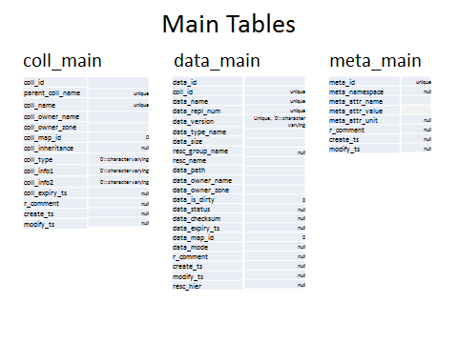

Following diagram shows HPC DME schema.

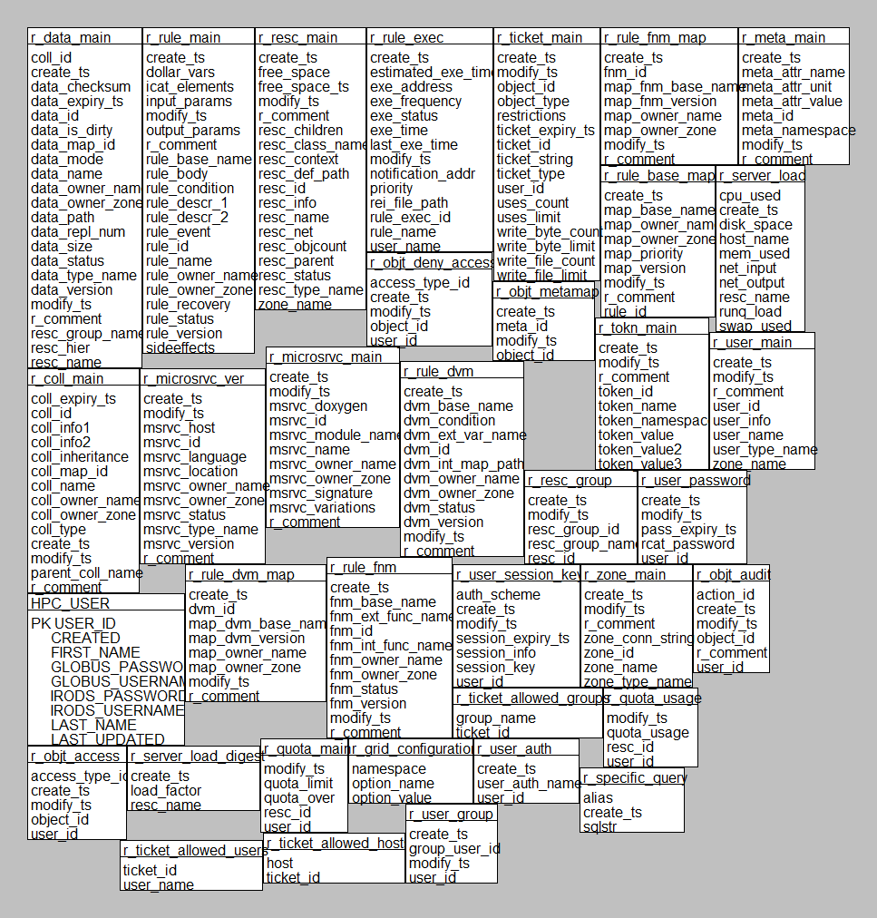

### HPC DME API Schema

Extending iRODS schema, HPC DME API require following additional tables addressing the requirements with complex search, auditing, maintain data registration tasks, reports, notifications etc.

**User Account:**

HPC DME requires users to be registered with its application to access the API, Web UI and CLI. Following table holds user registration information. User accounts are never deleted physically from the database. ACTIVE column stores the status of a user account.

*HPC_USER*

| **Column** | **Type** | **Comments** |
| --- | --- | --- |
| USER_ID | text | The user ID |
| FIRST_NAME | text | The user first name |
| LAST_NAME | text | The user last name |
| DOC | text | The DOC the user belongs to |
| DEFAULT_CONFIGURATION_ID | text | The default configuration ID associated with the user |
| ACTIVE | bool | User active indicator |
| CREATED | date | The date / time the user was created |
| LAST_UPDATED | date | The date / time the user was updated |
| ACTIVE_UPDATED_BY | text | The administrator user ID that activated this user |

**User Query:**

HPC DME users can save a search criteria with a name to access it at later time. Following table stores the information about saved user query.

*HPC_USER_QUERY*

| **Column** | **Type** | **Comments** |
| --- | --- | --- |
| USER_ID | text | The user ID that owns this query |
| QUERY_NAME | text |  |
| QUERY | bytea | The compound metadata query |
| DETAILED_RESPONSE | bool | Detailed response indicator to request when using this query |
| TOTAL_COUNT | bool | Total count parameter to set when using this query |
| QUERY_TYPE | text | The query type - collection or data object |
| CREATED | timestamp | The date / time the query was created |
| UPDATED | timestamp | The date / time the query was updated |

**User Bookmark**

HPC DME users can bookmark interested collection path so that the bookmarked path can be accessed without typing the entire path at later time.

*HPC_USER_BOOKMARK*

| **Column** | **Type** | **Comments** |
| --- | --- | --- |
| USER_ID | text | The user ID that owns this bookmark |
| BOOKMARK_NAME | text | The bookmark name |
| BOOKMARK_GROUP | text | The bookmark group |
| PATH | text | The bookmark path |
| CREATED | timestamp | The date / time the bookmark was created |
| UPDATED | timestamp | The date / time the bookmark was updated |

**System Account:**

HPC DME’s layered security architecture protects archive data from direct access. Service accounts are used to insulate users accessing the data directly. HPC DME also manages its security with integrated applications through service account. Following table holds information about service accounts. Only System Admin has access to update this information. Currently, HPC DME maintain 3 integration points – 1) Cleversafe 2) Globus 3) iRODS. Whenever there is an update to service account credentials, following table should be updated with the credentials. System Admin can update the information via API. Please refer to section 5.2 in HPC Admin guide.

HPC_SYSTEM_ACCOUNT

| **Column** | **Type** | **Comments** |
| --- | --- | --- |
| USERNAME | text | The user name |
| PASSWORD | bytea | The password |
| SYSTEM | text | The system |
| DATA_TRANSFER_TYPE | text | The data transfer type (S3 for Cleversafe etc) |

**Reports:**

HPC DME’s supports generating several summarized reports. These reports uses multiple tables to generate report data with filters provided by users. To improve performance with reports, following materialized views are created.

r_report_meta_main

r_report_source_file_size

r_report_registered_by_doc

r_report_registered_by

r_report_coll_registered_by

r_report_collection_type

r_report_coll_registered_by_doc

r_report_data_objects

These materialized views are refreshed at configured intervals by the background process run by HPC DME API.

**Notifications:**

HPC DME application generates notifications on upload, download, updates etc. Users may subscribe to notifications to get notified via email. Following tables mange notifications and subscriptions.

Following table is manage notification subscriptions. Users may opt to unsubscribe any time.

HPC_NOTIFICATION_SUBSCRIPTION

| **Column** | **Type** | **Comments** |
| --- | --- | --- |
| ID | serial | The notification subscription ID |
| USER_ID | text | The user ID that is subscribed for this notification |
| EVENT_TYPE | text | The event type to trigger the notification |
| NOTIFICATION_DELIVERY_METHODS | _text | The delivery methods the user would like to receive notifications |

Following table manages notification subscriptions with its triggering events.

HPC_NOTIFICATION_TRIGGER

| **Column** | **Type** | **Comments** |
| --- | --- | --- |
| NOTIFICATION_SUBSCRIPTION_ID | int4 | The notification subscription ID to apply the trigger rules |
| NOTIFICATION_TRIGGER | _text | A list of rules that operate on event payload data to determine if the notification should be sent |

Following table manages all current events generated by the applications.

HPC_EVENT

|  |  |  |
| --- | --- | --- |
| **Column** | **Type** | **Comments** |
| ID | serial | The event ID |
| USER_IDS | text | A list of user ID that are subscribed to be notified for this event |
| TYPE | text | The event type |
| PAYLOAD | bytea | The event payload |
| CREATED | timestamp |  |

Following table manages history of all the events. Once an event is processed, it is moved to event history table.

HPC_EVENT_HISTORY

| **Column** | **Type** | **Comments** |
| --- | --- | --- |
| ID | int4 | The event ID |
| USER_IDS | text | A list of user ID that are subscribed to be notified for this event |
| TYPE | text | The event type |
| PAYLOAD | bytea | The event payload |
| CREATED | timestamp | The date/time the event was created |

Following table maintains event notification delivery receipts.

HPC_NOTIFICATION_DELIVERY_RECEIPT

| **Column** | **Type** | **Comments** |
| --- | --- | --- |
| EVENT_ID | int4 | The event ID that notification was sent for |
| USER_ID | text | The user ID that was notified |
| NOTIFICATION_DELIVERY_METHOD | text | The notification delivery method |
| DELIVERY_STATUS | bool | Notification delivery success / failure indicator |
| DELIVERED | timestamp | The data / time the delivery attempt was performed |

**Data Management configuration**

HPC DME manages different division/office/center information, data archive settings and their metadata policies in this table. The policy information in JSON format is stored in this table. Please see APPENDIX A for sample JSON file

HPC_DATA_MANAGEMENT_CONFIGURATION

| **Column** | **Type** | **Comments** |
| --- | --- | --- |
| ID | text | The configuration ID |
| BASE_PATH | text | The base path to apply this configuration to |
| DOC | text | The DOC that own this configuration |
| S3_URL | text | The S3 archive (Cleversafe) URL |
| S3_VAULT | text | The S3 archive (Cleversafe) vault |
| S3_OBJECT_ID | text | The S3 archive (Cleversafe) object id prefix |
| S3_ARCHIVE_TYPE | text | The S3 archive type (Archive / Temp Archive). Note: Temp Archive is currently not used |
| DATA_HIERARCHY | text | The data hierarchy policy |
| COLLECTION_METADATA_VALIDATION_RULES | text | The collection metadata validation rules |
| DATA_OBJECT_METADATA_VALIDATION_RULES | text | The data object metadata validation rules |

**Bulk Data registration**

HPC DME API supports registering bulk data or list of data files together. Following tables keep track of the requests and the status of individual files.

HPC_BULK_DATA_OBJECT_REGISTRATION_TASK

| **Column** | **Type** | **Comments** |
| --- | --- | --- |
| ID | text | The bulk registration task ID |
| USER_ID | text | The user ID who submitted the request |
| STATUS | text | The bulk registration task status |
| ITEMS | text | The list individual data object registrations included in this bulk registration request, in JSON format |
| CREATED | timestamp | The data/time the bulk registration request was submitted |

HPC_BULK_DATA_OBJECT_REGISTRATION_RESULT

| **Column** | **Type** | **Comments** |
| --- | --- | --- |
| ID | text | The bulk registration task ID |
| USER_ID | text | The user ID who submitted the request |
| RESULT | bool | Task success/failure indicator |
| MESSAGE | text | An error message if the task failed |
| ITEMS | text | The list individual data object registrations included in this bulk registration request, in JSON format |
| CREATED | timestamp | The data/time the bulk registration request was submitted |
| COMPLETED | timestamp | The data/time the bulk registration request was completed |

**Bulk Data Download**

HPC DME API supports downloading bulk data (collection) or list of data files together. Following tables keep track of the requests and the status of individual files, and results.

HPC_DATA_OBJECT_DOWNLOAD_TASK

| **Column** | **Type** | **Comments** |
| --- | --- | --- |
| ID | text | The download task ID |
| USER_ID | text | The user ID who submitted the download request |
| PATH | text |  |
| CONFIGURATION_ID | text | The configuration ID to use in the downloading the data object |
| DATA_TRANSFER_REQUEST_ID | text | The data transfer (S3 or Globus) request ID that is currently in progress |
| DATA_TRANSFER_TYPE | text | The data transfer (S3 or Globus) that is currently in progress |
| DATA_TRANSFER_STATUS | text | The data transfer status (S3 or Globus) |
| DOWNLOAD_FILE_PATH | text | The file path used in the 2-hop download |
| ARCHIVE_LOCATION_FILE_CONTAINER_ID | text | The archive location container ID of the data object to be downloaded |
| ARCHIVE_LOCATION_FILE_ID | text | The archive location file ID of the data object to be downloaded |
| DESTINATION_LOCATION_FILE_CONTAINER_ID | text | The download destination container ID |
| DESTINATION_LOCATION_FILE_ID | text | The download destination file ID |
| COMPLETION_EVENT | bool | An indicator whether a completion event was generated when the task completed |
| CREATED | timestamp | The date and time the task was created |

HPC_COLLECTION_DOWNLOAD_TASK

| **Column** | **Type** | **Comments** |
| --- | --- | --- |
| ID | text | The download task ID |
| USER_ID | text | The user ID who submitted the download request |
| TYPE | text | The type of the request - collection or bulk (list of data objects) |
| PATH | text | The collection path to download |
| DATA_OBJECT_PATHS | text | The list of data object paths to download |
| DESTINATION_LOCATION_FILE_CONTAINER_ID | text | The download destination container ID |
| DESTINATION_LOCATION_FILE_ID | text | The download destination file ID |
| STATUS | text | The download task status |
| ITEMS | text | The download items included in this collection / bulk download request |
| CREATED | timestamp | The date and time the task was created |

HPC_DOWNLOAD_TASK_RESULT

| **Column** | **Type** | **Comments** |
| --- | --- | --- |
| ID | text | The download task ID |
| USER_ID | text | The user ID who submitted the download request |
| TYPE | text | The type of the request - data object, collection or bulk (list of data objects) |
| PATH | text | The data object or collection path requested |
| DATA_TRANSFER_REQUEST_ID | text | The data transfer (S3 or Globus) request ID that was last used |
| DATA_TRANSFER_TYPE | text | The data transfer (S3 or Globus) that was last used |
| DESTINATION_LOCATION_FILE_CONTAINER_ID | text | The download destination container ID |
| DESTINATION_LOCATION_FILE_ID | text | The download destination file ID |
| RESULT | bool | The download task success/fail indicator |
| MESSAGE | text | An error message in case the task failed |
| ITEMS | text | The download items included in this collection / bulk download request |
| COMPLETION_EVENT | bool |  |
| CREATED | timestamp | The date and time the task was created |
| COMPLETED | timestamp | The date and time the task was completed |

**Audit on Deletion**

HPC DME API enforces auditing on every update and delete requests on any data file or collection. Following table maintain audit information.

HPC_DATA_MANAGEMENT_AUDIT

| **Column** | **Type** | **Comments** |
| --- | --- | --- |
| USER_ID | text | The user ID who submitted the request |
| PATH | text | The collection or data object path |
| REQUEST_TYPE | text | The request that is recorded for an audit |
| METADATA_BEFORE | text | The collection/data-object metadata before the change |
| METADATA_AFTER | text | The collection/data-object metadata after the change |
| ARCHIVE_FILE_CONTAINER_ID | text | The data object archive file container ID |
| ARCHIVE_FILE_ID | text | The data object archive file ID |
| DATA_MANAGEMENT_STATUS | bool | Data management (iRODS) success/fail indicator |
| DATA_TRANSFER_STATUS | bool | Data transfer (Cleversafe) success/fail indicator |
| MESSAGE | text | Error message if the operation failed (iRODS or Cleversafe) |
| COMPLETED | timestamp | The date/time the request was completed |

## Application Program Interfaces

Please refer to API specification document at https://github.com/CBIIT/HPC_DME_APIs/blob/master/doc/guides/HPC_API_Specification.docx

## System Integration

The HPCDME API server provides a set of data management REST services to deposit, annotate, search and retrieve large data objects. The API is implemented by combining capabilities of several external systems. This document provides the technical details on the how the external systems integration was implemented and lists the resulted dependencies.

### Integrated Systems

The HPCDME API Server is integrated with the following external Systems:

**iRODS**   
An open source data management solution. iRODS provides data registration with metadata catalog. It provides data search, security, audit, rule-engine and data transfer capabilities. (<https://irods.org>).

The integration with iRODS was developed using the Jargon API (<https://github.com/DICE-UNC/jargon/wiki/Jargon-overview>). There are several requirements that could not be satisfied with Jargon, and the server is querying the iRODS DB directly:

1. Complex search: Search by metadata attribute levels and collection types
2. Notifications: Generate events and notify subscribed users
3. Metadata policies: DOC based metadata hierarchies and policies
4. Custom Summarized Reports: Summarized reports by DOC, User and period
5. Bookmarks: User bookmarks to collections
6. Saved Search: Save search criteria with a name

**Globus**   
An open source data transfer and sharing platform. Globus provides ability to transfer large files asynchronously, securely and reliably. (<https://www.globus.org/>)

The integration with Globus was developed using the Globus transfer API using Globus nexus API to authenticate w/ Globus. Both are Java jars from Globus that are packaged with the API server. The transfer API provides convenient Java API to communicate with the Globus REST services (https://docs.globus.org/api/transfer).

**Cleversafe**

IBM’s object storage solution, which is deployed on-premises but can be deployed to public or dedicated cloud. Note that Cleversafe supports the Amazon S3 data transfer API. (<https://www.ibm.com/cloud-computing/products/storage/object-storage/>).

The integration with Cleversafe was developed using the Amazon AWS SDK for Java (<https://aws.amazon.com/sdk-for-java>).

**Active Directory**

Microsoft’s directory and authentication system. The integration was done using the Java standard naming API, and is trivial so not covered in this document.

### Code Organization

The integration code can be found in the following maven projects and is organized in the following java packages:

* **hpc-integration-api**
  + *gov.nih.nci.hpc.integration* – package contains all integration interfaces (This is the pure Java API the ‘application services’ are using to invoke the integration services)
* **hpc-integration-impl**
  + *gov.nih.nci.hpc.integration.globus.impl* – Globus implementation of the Data Transfer Integration API
  + *gov.nih.nci.hpc.integration.s3.impl* – S3 implementation of the Data Transfer Integration API .
  + *gov.nih.nci.hpc.integration.irods.impl* – Implementation of the Data Transfer Management Integration API
  + *gov.nih.nci.hpc.integration.ldap.impl* – LDAP implementation of the Security Authentication Integration API .

The iRODS integration includes direct querying of iRODS DB. The relevant source code can be found in the following maven project

* **hpc-dao-impl**
  + *hpc_hierarchical_metadata.sql* – This is a script to create a set of materialized views based on iRODS table. HPC DM provides a capability to search data object by metadata defined anywhere in the object ‘hierarchy’ (i.e. metadata that are associated with the containing collection hierarchy tree). The purpose of the materialized view is to generate that ‘hierarchical metadata’ table, so search queries can be easily implemented.
  + *HpcMetadataDAOImpl.java* – Implements the data search by querying the hierarchical metadata materialized view.
  + *HpcGroupDAOImpl* – HPC DM provides a capability to search for user groups using case insensitive matching. This capability is not available via the Jargon API, so the implementation queries the iRODS table directly.

### IRODS Integration

#### Jargon API Integration Points

Jargon is a Java API and provides a convenient way to interact with iRODS. The current Jargon version used is 4.1.10.0. The following table lists the integration points that are implemented with Jargon and the specific API that was used. Please see <https://github.com/CBIIT/HPC_DME_APIs/tree/master/src/hpc-server/hpc-integration-impl/src/main/java/gov/nih/nci/hpc/integration/irods/impl> for the integration implementation.

| **Integration Point** | **Jargon API** |
| --- | --- |
| HpcDataManagementProxy.authenticate | IRODSAccessObjectFactory.*authenticateIRODSAccount*()  AuthResponse.*getAuthenticatedIRODSAccount*() |
| HpcDataManagementProxy.disconnect | IRODSAccessObjectFactory.*closeSessionAndEatExceptions*() |
| HpcDataManagementProxy.createCollectionDirectory | IRODSFileFactory.*instanceIRODSFile*()  IRODSFile.*mkdirs*() |
| HpcDataManagementProxy.createDataObjectFile | IRODSFileFactory.*instanceIRODSFile*()  IRODSFile.*createNewFile*() |
| HpcDataManagementProxy.delete | IRODSFileFactory.*instanceIRODSFile*()  IRODSFile.deleteWithForceOption() |
| HpcDataManagementProxy.addMetadataToCollection | CollectionAO.*addBulkAVUMetadataToCollection()* |
| HpcDataManagementProxy.updatCollectionMetadata | CollectionAO.modifyAvuValueBasedOnGivenAttributeAndUnit*()* |
| HpcDataManagementProxy.addMetadataToDataObject | DataObjectAO.*addBulkAVUMetadataToDataObject()* |
| HpcDataManagementProxy.updatDataObjectMetadata | DataObjectAO.modifyAvuValueBasedOnGivenAttributeAndUnit*()* |
| HpcDataManagementProxy.getPathAttributes | IRODSFileFactory.*instanceIRODSFile*() |
| HpcDataManagementProxy.getCollection | CollectionAO.*findByAbsolutePath()*  CollectionAndDataObjectListAndSearchAO.*list DataObjectsAndCollectionsUnderPath()* |
| HpcDataManagementProxy.getCollectionMetadata | CollectionAO.findMetadataValuesForCollection*()* |
| HpcDataManagementProxy.getDataObject | DataObjectAO.*findByAbsolutePath()* |
| HpcDataManagementProxy.getDataObjects | DataObjectAO.*findDomainByMetadataQuery()* |
| HpcDataManagementProxy.getCollectionMetadata | DataObjectAO.findMetadataValuesForDataObject*()* |
| HpcDataManagementProxy.addUser | UserAO.*addUser()* |
| HpcDataManagementProxy.deleteUser | UserAO.*deleteUser()* |
| HpcDataManagementProxy.updateUser | UserAO.*updateUser()* |
| HpcDataManagementProxy.getUserRole  HpcDataManagementProxy.userExists | UserAO.*findByName()* |
| HpcDataManagementProxy.getCollectionPermissions | CollectionAO.listPermissionsForCollection*()* |
| HpcDataManagementProxy.getCollectionPermissionForUser | CollectionAO.getPermissionForUserName*()* |
| HpcDataManagementProxy.setCollectionPermission | CollectionAO.setAccessPermission*()* |
| HpcDataManagementProxy.getDataObjectPermissions | DataObjectAO.listPermissionsForDataObject*()* |
| HpcDataManagementProxy.getDataObjectPermissionForUser | DataObjectAO.getPermissionForDataObjectForUserName*()* |
| HpcDataManagementProxy.setDataObjectPermission | DataObjectAO.setAccessPermission*()* |
| HpcDataManagementProxy.addGroup | UserGroupAO.*addUserGroup()* |
| HpcDataManagementProxy.deleteGroup | UserGroupAO.*removeUserGroup()* |
| HpcDataManagementProxy.groupExists | UserGroupAO.*findWhere()* |
| HpcDataManagementProxy.addGroupMember | UserGroupAO.*addUserToGroup()* |
| HpcDataManagementProxy.deleteGroupMember | UserGroupAO.*removeUserFromGroup()* |
| HpcDataManagementProxy.getGroupMembers | UserGroupAO.*listUserGroupMembers()* |

## 

#### Materialized Views Integration Points

To support hierarchical metadata for collections and data objects, 6 materialized views were created. The following tables depict the dependencies of the materialized views on iRODS DB tables. Please see <https://github.com/CBIIT/HPC_DME_APIs/tree/master/src/hpc-server/hpc-dao-impl/src/main/java/gov/nih/nci/hpc/dao/postgresql/impl> for the integration implementation.

|  |  |
| --- | --- |
| **HPC DM Materialized View** | **Dependent iRODS tables** |
| r_coll_hierarchy_matamap | r_coll_main  r_objt_metamap |
| r_coll_hierarchy_metamain | r_coll_hierarchy_metamap  r_meta_main  r_objt_metamap |
| r_coll_hierarchy_meta_attr_name | r_coll_hierarchy_metamap |
| r_data_hierarchy_matamap | r_data_main  r_objt_metamap |
| r_data_hierarchy_metamain | r_data_hierarchy_metamap  r_meta_main  r_objt_metamap |
| r_data_hierarchy_meta_attr_name | r_data_hierarchy_metamap |

The following table lists the integration points that are implemented with the materialized views / iRODS DB

|  |  |
| --- | --- |
| **Integration Point** | **Materialized View / iRODS DB table** |
| getCollectionPaths  getCollectionCount | r_coll_hierarchy_meta_main  r_objt_access  r_user_main  r_user_group |
| getDataObjectPaths  getDataObjectCount | r_data_hierarchy_meta_main  r_objt_access  r_user_main  r_user_group |
| getCollectionMetadata | r_coll_hierarchy_meta_main |
| getDataObjectMetadata | r_data_hierarchy_meta_main |
| getCollectionMetadataAttributes | r_coll_hierarchy_meta_attr_name  r_objt_access  r_user_main  r_user_group |
| getDataObjectMetadataAttributes | r_data_hierarchy_meta_attr_name  r_objt_access  r_user_main  r_user_group |
| getGroups | r_user_main |

### Globus Integration

#### Globus Application Account

The HPC-DM API server is using a Globus ‘application account’ when submitting transfer and other requests for Globus. The ‘NCI HPC-DM’ Globus project was registered at [**https://developers.globus.org**](https://developers.globus.org). Under this project, application accounts were created for each environment.

The ‘Client ID’ and the ‘Client Secret’ from the ‘application account’ are used to authenticate the API Server and obtain an access token that is used to invoke Globus services.

In order for end users to use the HPC-DM system asynchronous transfer capabilities, they need to have an individual Globus account. Users are expected to create a ‘Shared Globus Endpoint’ and then grant read/write permission to the server’s application account. Please refer to section 3.2 in the User Guide for detail instructions. The username users need to share with is the ‘Client Identity Username’ of the application account, which is in the form of an email address. The following shows the HPC-DM Globus project and the production application account details. Highlighted are the fields discussed above. 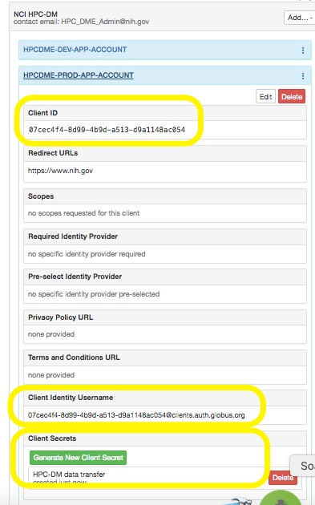

#### Globus Authentication

System accounts are stored in the HPC_SYSTEM_ACCOUNT table. The passwords are stored encrypted. A service is provided to register a system account for HPC. The following shows how to use the systemAccount endpoint to register a Globus ‘app account’

PUT https://…/systemAccount

{

"account": {

"username" : "<Client ID>",

"password": "<Client Secret>",

"integratedSystem": "GLOBUS"

},

"dataTransferType" : "GLOBUS"

}

The method of authenticating the ‘application account’ with Globus is OAuth2 w/ client credentials. We are using the Google OAuth Java API to obtain access token from Globus. See HpcGlobusConnection.authenticate() for implementation details.

The following properties are used in Globus authentication. Unless notified by Globus, these should never change and stay the same for all HPC-DM environments

hpc.integration.globus.globusAuthUrl=https://auth.globus.org/v2/oauth2/token

hpc.integration.globus.globusAuthScope=urn:globus:auth:scope:transfer.api.globus.org:all

#### API Server’s Globus endpoints Asynchronous data upload is performed in ‘two hops’, the first is from the end-user Globus endpoint to the HPC-DM server endpoint. The server has direct file-system access to its Globus endpoint. The second hop is from the server’s file-system into Cleversafe via S3. In the same fashion, the asynchronous download is performed in ‘two hops', but in a reverse order. The following properties are used to configure the server’s Globus endpoints for upload and download. For each endpoint, the direct file-system access path is defined.

hpc.integration.globus.archive.endpoint=<Globus endpoint UUID>

hpc.integration.globus.archive.path=<Globus path>

hpc.integration.globus.archive.directory=<File system path path>

hpc.integration.globus.download.endpoint=<Globus endpoint UUID>

hpc.integration.globus.download.path=<Globus path>

hpc.integration.globus.download.directory=<File system path path>

#### Globus Transfer API Integration Points

Globus provides a Java API which provides a convenient way to interact with its services. The current Transfer API client is 1.0. The following table lists the integration points that are implemented with Globus transfer API.

Globus documentation API can be found here: https://docs.globus.org/api/transfer

| **Integration Point** | **Globus Transfer API** |
| --- | --- |
| HpcDataTransferProxy.acceptsTransferRequests | getResult("/task_list?filter=status:ACTIVE,INACTIVE") |
| HpcDataTransferProxy.uploadDataObject | getResult("/transfer/submission_id")  postResult("/transfer") |
| HpcDataTransferProxy.downloadDataObject | getResult("/transfer/submission_id")  postResult("/transfer") |
| HpcDataTransferProxy.getDataTransferUploadStatus | getResult("/task/") |
| HpcDataTransferProxy.getDataTransferDownloadStatus | getResult("/task/") |
| HpcDataTransferProxy.getDataTransferSize | getResult("/task/") |
| HpcDataTransferProxy.getPathAttributes | getResult(“/<endpoint>/ls?path=<path>”) |
| HpcDataTransferProxy.getFileContainerName | getResult(“/<endpoint>”) |

### Cleversafe Integration

#### Cleversafe Authentication

System accounts are stored in the HPC_SYSTEM_ACCOUNT table. The passwords are stored encrypted. A service is provided to register a system account for HPC. The following shows how to use the /systemAccount REST API to register a CleverSafe ‘app account’

PUT https://…/systemAccount

{

"account": {

"username" : "<Cleversave Username>",

"password": "<Cleversafe Password>",

"integratedSystem": "CLEVERSAFE"

},

"dataTransferType" : "S3"

}

#### Cleversafe Vault Configuration The HPC-DM server supports configuring a separate Cleversafe vault for each DOC. Please work with ITOG System team to get your Cleversafe vault setup and its connection configuration.The following columns in the HPC_DOC_CONFIGURATION combined configures each DOC: S3_URL – The Cleversafe canister URL. S3_VAULT – The vault name. S3_OBJECT_ID – The ‘base path’ in which objects are placed in the vault.

#### Cleversafe S3 API Integration Points

Cleversafe supports S3 API. We use the Amazon AWS S3 Java SDK which provides a convenient way to interact with Cleversafe. We currently use version 1.11.125 of the S3 SDK. The following table lists the integration points that are implemented with S3 Java SDK.

| **Integration Point** | **Globus Transfer API** |
| --- | --- |
| HpcDataTransferProxy.uploadDataObject | TransferManager.upload() |
| HpcDataTransferProxy.downloadDataObject | TransferManager.download() |
| HpcDataTransferProxy.deleteDataObject | AmazonS3.deleteObject() |

Data can be registered with the system synchronously or asynchronously with the archive.

### Data Transfer

With HPC DME, data can be registered with the Cleversafe archive synchronously or asynchronously.

**Synchronous Upload**

When data is transferred synchronously, data along with its metadata is registered as one transaction. Following diagram depicts data upload process. A data file registered with the API is streamed to the API server and it is cached on NAS file system and then transferred to Cleversafe with S3 multipart API. This 2-hop data transfer would work fine for small size files. This poses performance concern for large size files or for large number of files.

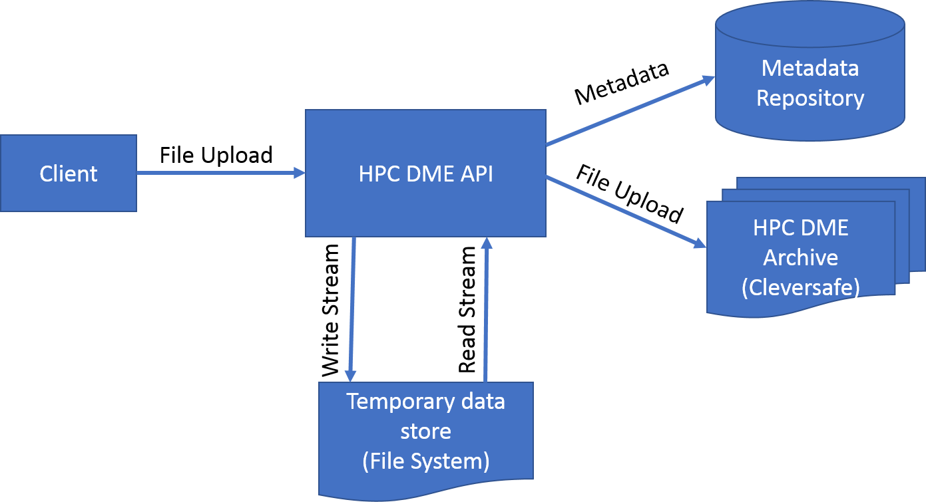

**Synchronous Upload – Pre-signed URL**

When a data file is registered with HPC DME, caller has option to register the file metadata and get pre-signed URL to upload data directly to the archive. It is the user responsibility to upload the data using pre-signed URL. If the data file is already registered, request to get pre-signed URL will result an error response.

The pre-signed URL is generated with expiration date/time. The expiration period is configurable by ‘base-path’ and currently set to 24 hours for all base-paths in DEV. Once the URL expires, the server will generate a notification to the user. To get this notification, users must registered for DATA_TRANSFER_UPLOAD_URL_EXPIRED event. When users get this notification, they will need to re-generate URL and use it to upload data to complete the registration. If user did not upload file again (after re-generating URL), they will get a new notification when the re-generated URL expired.

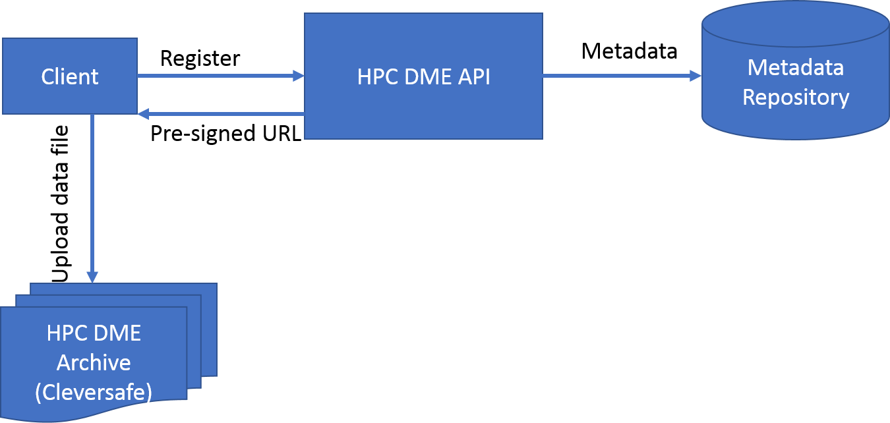

**Asynchronous Upload**

A data file can be registered with the archive asynchronously. In order to use this option, your data file should reside on a Globus endpoint location. This location should be shared with HPC DME Globus Application account. Please see section 3.2 in the User Guide. Following diagram depicts data upload process asynchronously.

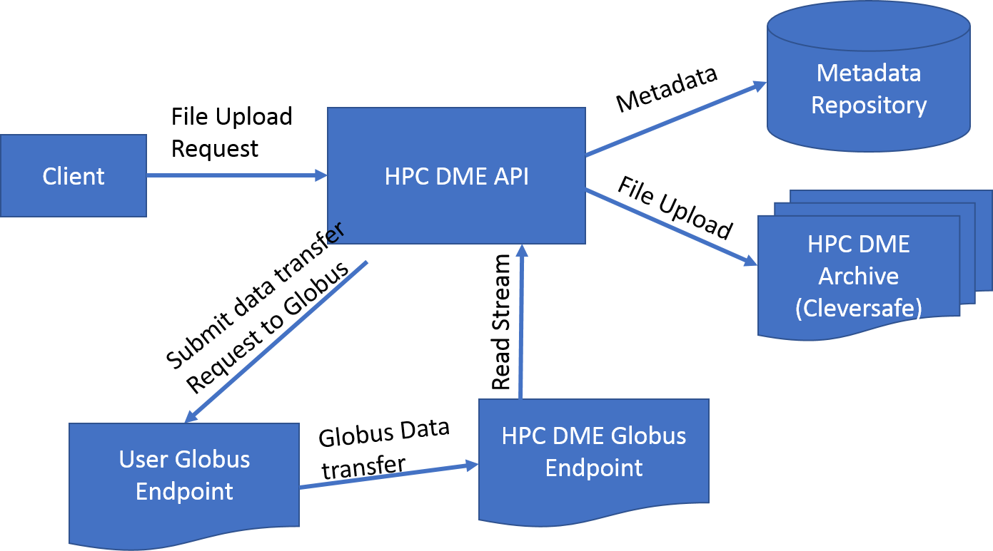

**Synchronous Download**

Following diagram depicts data download process. A data file registered with the archive is streamed to the API server and it is cached on its NAS file system and then streamed to the client.

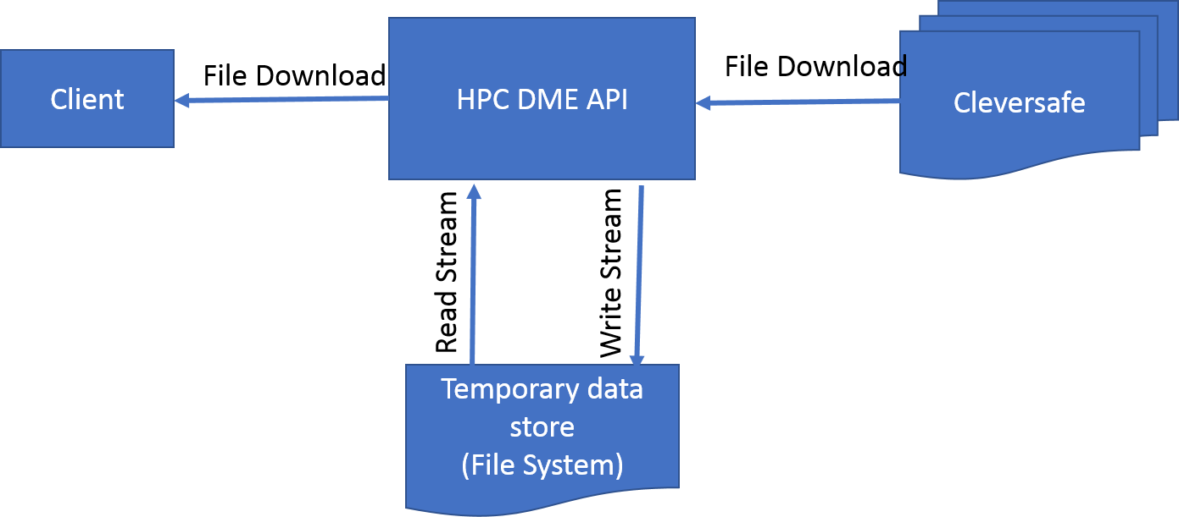

**Asynchronous Download**

Data file(s) or collection can be downloaded from the archive asynchronously to your Globus endpoint. In order to use this option, your download location should be shared with HPC DME Globus Application account with write permission. Please see section 3.2 in the User Guide. Following diagram depicts data download process asynchronously.

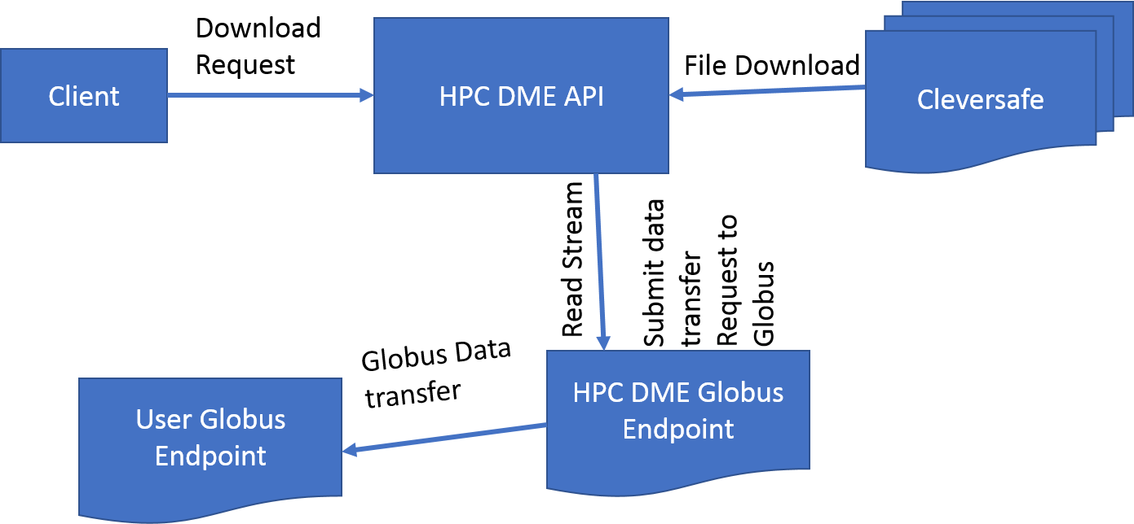

### Background Process

The HPC-DME server includes a ‘scheduler’ that is responsible to perform various tasks in the background at configurable intervals. The scheduler is packaged as a separate servicemix feature, which allows us to deploy it separately (and on a different server) from the API server. The following table provides a list of all the scheduled tasks and their purpose.

| **Schedule Task Name** | **Description** |
| --- | --- |
| processDataTranferUploadReceived | Process data objects that the data transfer upload status is 'received'. |
| processDataTranferUploadInProgress | Update the data transfer upload status of all data objects that the transfer is 'in progress'. |
| processDataTranferUploadInProgressWithGeneratedURL | Update the data transfer upload status of all data objects that users are responsible to upload with a generated upload URL. |
| processTemporaryArchive | Process data objects in temporary archive task. This tasks transfers data from the temporary archive to the (permanent) archive and complete data object registration. |
| completeDataObjectDownloadTasks | Complete (and cleanup) Data Transfer Download Files Tasks. |
| processCollectionDownloadTasks | Process collection download tasks. |
| completeCollectionDownloadTasks | Complete collection download tasks. |
| processBulkDataObjectRegistrationTasks | Process bulk data object registration tasks. |
| completeBulkDataObjectRegistrationTasks | Complete bulk data object registration tasks. |
| processEvents | Process events and send notifications. |
| generateSummaryReport | Generate a summary report event. |
| generateWeeklySummaryReport | Generate a weekly summary report event. |
| refreshMetadataViews | Refresh the metadata materialized Views. |
| refreshReportViews | Refresh the report materizalized views. |

## User Interface Design

[Insert any user interface design documents or provide a reference to where they are stored.]

## System Performance

[Insert any system performance documents or provide a reference to where they are stored.]

Appendix A: Metadata Policy JSON

**Data Hierarchy policy:**

{

"collectionType": "PI_Lab",

"isDataObjectContainer": false,

"subCollections": [

{

"collectionType": "Project",

"isDataObjectContainer": true,

"subCollections": [

{

"collectionType": "Flowcell",

"isDataObjectContainer": true,

"subCollections": [

{

"collectionType": "Sample",

"isDataObjectContainer": true

}

]

}

]

}

]

}

**Metadata policy:**

{

"metadataValidationRules": [

{

"attribute":"collection_type",

"mandatory":true,

"validValues":[

"Project",

"PI_Lab",

"Flowcell",

"Sample",

"Folder"

],

"ruleEnabled":true

},

{

"attribute":"pi_name",

"mandatory":true,

"collectionTypes":[

"PI_Lab"

],

"ruleEnabled":true

},

{

"attribute":"project_id_CSAS_NAS",

"mandatory":true,

"collectionTypes":[

"Project"

],

"ruleEnabled":true

},

{

"attribute":"project_name",

"mandatory":false,

"collectionTypes":[

"Project"

],

"ruleEnabled":true

},

{

"attribute":"lab_contact",

"mandatory":false,

"collectionTypes":[

"Project"

],

"ruleEnabled":true

},

{

"attribute":"bioinformatics_contact",

"mandatory":false,

"collectionTypes":[

"Project"

],

"ruleEnabled":true

},

{

"attribute":"project_start_date",

"mandatory":false,

"defaultValue":"System-Date",

"collectionTypes":[

"Project"

],

"ruleEnabled":true

},

{

"attribute":"grant_funding_agent",

"mandatory":false,

"collectionTypes":[

"Project"

],

"ruleEnabled":true

},

{

"attribute":"flowcell_id",

"mandatory":true,

"collectionTypes":[

"Flowcell"

],

"ruleEnabled":true

},

{

"attribute":"run_name",

"mandatory":true,

"collectionTypes":[

"Flowcell"

],

"ruleEnabled":true

},

{

"attribute":"run_date",

"mandatory":true,

"collectionTypes":[

"Flowcell"

],

"ruleEnabled":true

},

{

"attribute":"sequencing_platform",

"mandatory":true,

"collectionTypes":[

"Flowcell"

],

"ruleEnabled":true

},

{

"attribute":"sequencing_application_type",

"mandatory":true,

"collectionTypes":[

"Flowcell"

],

"ruleEnabled":true

},

{

"attribute":"read_length",

"mandatory":true,

"collectionTypes":[

"Flowcell"

],

"ruleEnabled":true

},

{

"attribute":"pooling",

"mandatory":true,

"collectionTypes":[

"Flowcell"

],

"ruleEnabled":true

},

{

"attribute":"sample_id",

"mandatory":true,

"collectionTypes":[

"Sample"

],

"ruleEnabled":true

},

{

"attribute":"sample_name",

"mandatory":true,

"collectionTypes":[

"Sample"

],

"ruleEnabled":true

},

{

"attribute":"initial_sample_concentration_ngul",

"mandatory":false,

"collectionTypes":[

"Sample"

],

"ruleEnabled":true

},

{

"attribute":"initial_sample_volume_ul",

"mandatory":false,

"collectionTypes":[

"Sample"

],

"ruleEnabled":true

},

{

"attribute":"sfqc_sample_concentration_ngul",

"mandatory":false,

"collectionTypes":[

"Sample"

],

"ruleEnabled":true

},

{

"attribute":"sfqc_sample_size",

"mandatory":false,

"collectionTypes":[

"Sample"

],

"ruleEnabled":true

},

{

"attribute":"RIN",

"mandatory":false,

"collectionTypes":[

"Sample"

],

"ruleEnabled":true

},

{

"attribute":"28s18s",

"mandatory":false,

"collectionTypes":[

"Sample"

],

"ruleEnabled":true

},

{

"attribute":"library_id",

"mandatory":false,

"collectionTypes":[

"Sample"

],

"ruleEnabled":true

},

{

"attribute":"library_lot",

"mandatory":false,

"collectionTypes":[

"Sample"

],

"ruleEnabled":true

},

{

"attribute":"library_name",

"mandatory":false,

"collectionTypes":[

"Sample"

],

"ruleEnabled":true

},

{

"attribute":"sfqc_library_concentration_nM",

"mandatory":false,

"collectionTypes":[

"Sample"

],

"ruleEnabled":true

},

{

"attribute":"sfqc_library_size",

"mandatory":false,

"collectionTypes":[

"Sample"

],

"ruleEnabled":true

},

{

"attribute":"source_id",

"mandatory":false,

"collectionTypes":[

"Sample"

],

"ruleEnabled":true

},

{

"attribute":"source_name",

"mandatory":false,

"collectionTypes":[

"Sample"

],

"ruleEnabled":true

},

{

"attribute":"source_organism",

"mandatory":true,

"collectionTypes":[

"Sample"

],

"ruleEnabled":true

},

{

"attribute":"source_provider",

"mandatory":false,

"collectionTypes":[

"Sample"

],

"ruleEnabled":true

}

]

}

Appendix B: Design Specification Approval

The undersigned acknowledge that they have reviewed the **HPC DME Design Specification** and agree with the information presented within this document. Changes to this **Design Specification** will be coordinated with, and approved by, the undersigned, or their designated representatives.

[List the individuals whose signatures are desired. Examples of such individuals are Business Owner, Project Manager (if identified), and any appropriate stakeholders. Add additional lines for signature as necessary.]

|  |  |  |  |
| --- | --- | --- | --- |
| Signature: |  | Date: |  |
| Print Name: | Zhengwu Lu |  |  |
| Title: | Technical Project Manager |  |  |
| Role: |  |  |  |

|  |  |  |  |
| --- | --- | --- | --- |
| Signature: |  | Date: |  |
| Print Name: |  |  |  |
| Title: |  |  |  |
| Role: |  |  |  |

|  |  |  |  |
| --- | --- | --- | --- |
| Signature: |  | Date: |  |
| Print Name: |  |  |  |
| Title: |  |  |  |
| Role: |  |  |  |

APPENDIX B: REFERENCES

[Insert the name, version number, description, and physical location of any documents referenced in this document. Add rows to the table as necessary.]

The following table summarizes the documents referenced in this document.

|  |  |  |
| --- | --- | --- |
| **Document Name** | **Description** | **Location** |
| *HPC API Specification* |  | <https://ncisvn.nci.nih.gov/svn/HPC_Data_Management/branches/hpc-prototype-dev/doc/guides/HPC_Server_API.docx> |
| *HPC DME Requirements* |  | <https://ncisvn.nci.nih.gov/svn/HPC_Data_Management/branches/hpc-prototype-dev/doc/requirements/HPC_requirements_definition.docx> |
|  |  |  |

APPENDIX C: KEY TERMS

The following table provides definitions and explanations for terms and acronyms relevant to the content presented within this document.

|  |  |
| --- | --- |
| **Term** | **Definition** |
| DTO | Data Transfer Object |
| DAO | Data Access Object |
| HPC DME | High Performance Computing Data Management System |
| API | Application Program Interface |
| SOA | Service Oriented Architecture |
| REST | Representational State Transfer |
| LIMS | Laboratory information management system |
| Collection | Collection is a folder in file system terms. It is a logical container of files or sub-collections |
| Data file | Data file is a physical data stored as a file. |