**HPC DME Dice Automated Testing Tips & References**

**Revision 1.1**

Contents

Tips 2

Tip #1: Try to use DICE on a Linux/Unix/Mac system 2

Tip #2: Obtaining and installing DICE 2

Tip #3: Starting DICE 2

Tip #4: Configuration of HPC DME DICE tests execution 3

Tip #5: Generating authentication token before running HPC DME tests 4

Tip #6: Logging into Globus thru its CLI before testing Globus-related services 4

Troubleshooting 7

Online References 9

**Revision History**

|  |  |  |  |
| --- | --- | --- | --- |
| **Revision #** | **Date** | **Author** | **Notes** |
| 1.0 | 2017 DEC 5 | William Y. Liu | Original revision |
| 1.1 | 2017 DEC 6 | William Y. Liu | Added Tip #6 and related Troubleshooting item |

# **Tips**

## **Tip #1: Try to use DICE on a Linux/Unix/Mac system**

Strongly recommend using DICE on a Linux, Unix, or Mac machine having a Bash shell environment. You may use DICE on a Windows machine utilizing Cygwin as a Bash shell emulator environment, but you might run into Windows-specific issues that would not occur on a machine having a Bash shell environment (you have been warned).

You could SSH to the HPC DME development VM and run DICE on it. It is an Ubuntu Linux system.

## **Tip #2: Obtaining and installing DICE**

To download and install DICE, please follow these steps:

1. Download DICE V1.2 in gzipped tar ball form at <http://www.ece.umd.edu/DSPCAD/projects/dice/packages/dice.tar.gz>
2. Access or download the setup guide for DICE V1.2 at <http://www.ece.umd.edu/DSPCAD/papers/bhat2014x1.pdf>
3. Carefully follow the instructions in the setup guide
   1. It boils down to extracting the tar ball to desired location and then executing bash commands

## **Tip #3: Starting DICE**

To start DICE (must already be successfully installed, of course!), perform the following Bash commands:

[prompt]$ cd <DICE user directory>

[prompt]$ source startup/dice_startup

To verify DICE has started, run the DICE **dxversion** command and confirm that it works, generating output that provides version information about itself.

[prompt]$ **dxversion**

DSPCAD Integrative Command Line Environment (DICE)

DICE Version 1.2, Revision 06/21/2014

Maryland DSPCAD Research Group

University of Maryland at College Park

http://www.ece.umd.edu/DSPCAD/home/dspcad.htm

Be aware that starting DICE only means that it is available for running tests. You still must perform additional commands to tell DICE to run tests.

## **Tip #4: Configuration of HPC DME DICE tests execution**

Before you run HPC DME DICE automated tests, you may need to configure the execution of the tests to suit your needs. For example, you need to configure the tests to execute against the UAT instance of the HPC DME API services. Alternatively, you may need to adjust the Globus-related settings. To perform this configuration, please refer to the README written by George Zakis and available on GitHub at

<https://github.com/CBIIT/HPC_DME_APIs/blob/master/src/hpc-server/hpc-ws-rs-test/src/test/dice/README.txt>

If you have a local clone of the HPC DME GitHub repository, you can find this README at the relative path,

<clone root>/src/hpc-server/hpc-ws-rs-test/src/test/dice/README.txt

The configuration boils down to editing 2 small config files in the following directory,

<clone root>/src/hpc-server/hpc-ws-rs-test/src/test/dice/utils/

Note that in the above, <clone root> is a placeholder for your local directory that resulted from cloning HPC DME GitHub repo.

The 2 files are:

1. server
   * Only specifies which HPC DME API server to test (deployed instance of REST services app)
2. test-configuration
   * Specifies user identity, Globus endpoint, and any other settings

## **Tip #5: Generating authentication token before running HPC DME tests**

Prior to running HPC DME DICE tests (at least tests requiring authenticated access), you must run a Bash script to generate an HPC DM API authentication token. This is illustrated below.

[prompt]$ export HPC_DM_TEST=<clone root>/src/hpc-server/hpc-ws-rs\

[prompt]$ -test/src/test/dice

[prompt]$ $HPC_DM_TEST/uitls/generate_token.sh

Note that in the above, <clone root> is a placeholder for your local directory that resulted from cloning HPC DME GitHub repo. Setting an environment variable named HPC_DM_TEST as shown above is recommended to make it simple to access the directory having the HPC DME DICE files.

## **Tip #6: Logging into Globus thru its CLI before testing Globus-related services**

Some HPC DME API services make use of Globus to perform file transfers asynchronously. To test these services using the applicable DICE-based automated tests, you must make sure that **before** running those tests, you use the Globus CLI program to log into Globus. If you neglect to do this, then those tests shall fail due to lack of authenticated access to Globus.

Assuming the Globus CLI is installed, you run the “globus login” command in Bash shell as shown in the next image.

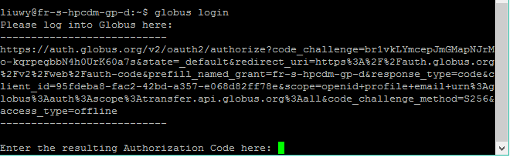

The command will instruct you to visit a specified URL to log into Globus. After you visit that URL and follow the instructions at that page, you shall have an authorization code that you can apply for the CLI. The code is valid for the specified amount of time and must be used before the stated expiration time. The authorization code appears on a screen resembling the next image.

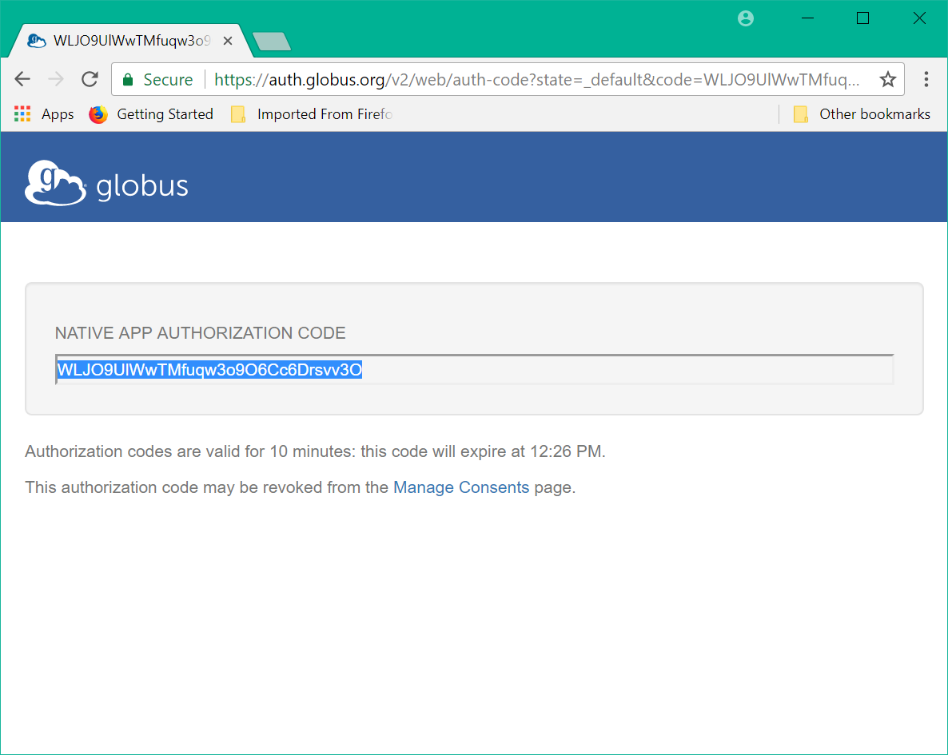

Next, copy the authorization code from the browser window and paste it into the command window at the prompt requesting that code. Press the Enter key to make the Globus CLI apply the authorization code for subsequent commands requiring authenticated access to Globus. See below screen capture clipping for a picture of what has been described in this paragraph.

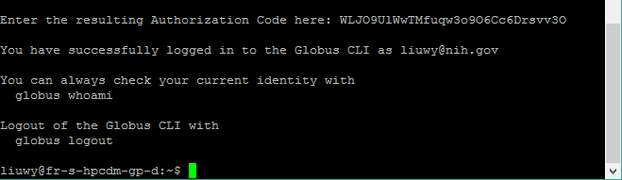

Notice in the above screen capture clipping, the authenticated session can be ended with the “globus logout” command.

# Troubleshooting

**Q**: *I invoke a DICE command, but the system complains the command is not recognized.*

**A**: Make sure DICE is started. Refer to **Tip #3: Starting DICE** for instructions about how to start DICE.

**Q**: *DICE is executing HPC DME API tests as expected, but the tests are failing due to the HPC DME API server denying access (HTTP status 401/Unauthorized).*

**A**: Generate a HPC DME API authentication token following **Tip #5: Generating authentication token before running HPC DME tests**, and then retry the tests. This should solve your problem.

**Q**: *I am having trouble running DICE tests on Windows using Cygwin. The tests produce numerous error messages.*

**A:** It is **strongly** recommended to run DICE on a system having a Bash shell environment. That said, you are probably running into a problem with line-ending character differences between Windows and Linux/Unix/Mac. You may need to convert **every** end-of-line occurrence in **every** applicable DICE testing file from CRLF to LF. You could run commands in Cygwin similar to the following to do such conversion.

[prompt]$ cd <DICE tests dir>

[prompt]$ find -type f -exec dos2Unix {} \;

Note that in the above, the find command is performing dos2Unix on every file in the <DICE tests dir> directory’s directory tree. For more information about these commands, refer to their man pages.

**Q**: *I am encountering errors while running DICE tests, and the errors have something to do with lack of access to Globus. What should I do?*

**A:** You need to make sure that prior to running the tests that exercise HPC DME API services that utilize Globus, you make the Globus CLI start an authenticated session with Globus. Refer to [**Tip #6: Logging into Globus thru its CLI before testing Globus-related services**] for instructions about this.

# **Online References**

DICE webpage <http://www.ece.umd.edu/DSPCAD/projects/dice/dice.htm>

DICE Version 1.2 download link

<http://www.ece.umd.edu/DSPCAD/projects/dice/packages/dice.tar.gz>

* Download DICE 1.2 as a gzipped tar ball using this link

DICE Version 1.2 setup guide

<http://www.ece.umd.edu/DSPCAD/papers/bhat2014x1.pdf>

* Install and launch DICE following instructions in this document

DICE Version 1.1 introduction

<http://www.ece.umd.edu/DSPCAD/papers/bhat2011x3.pdf>

* Read this document for an overview of DICE and a description of its command/utilities