**Granting Write Access of Globus Endpoint to HPCDME**

1. Log into Globus at <http://www.globus.org> using your NCI credentials and select **Manage Data** > **Endpoints**.

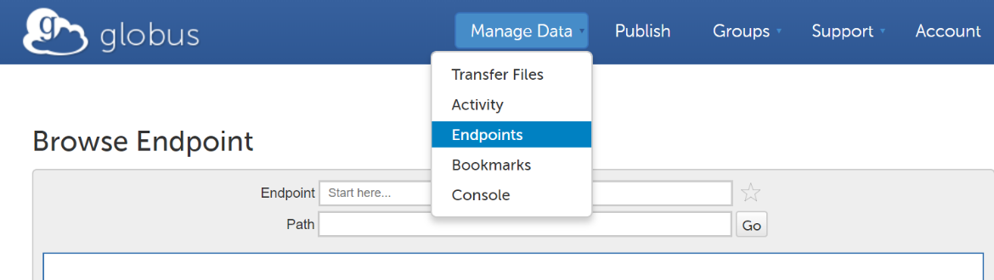

1. Select **shareable by me** item to view endpoint list

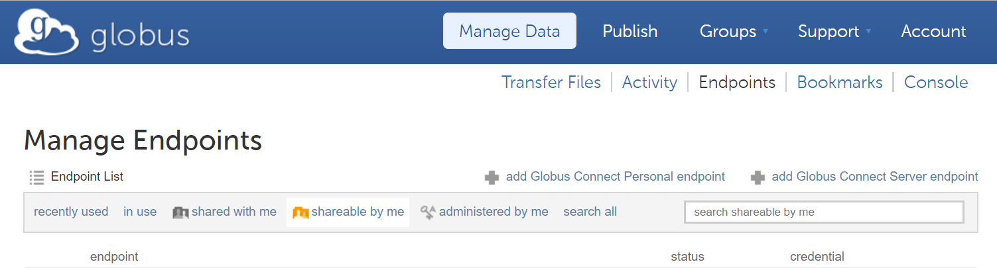

1. Find the endpoint to share with HPCDME and click its name to view details.
2. Click the **Sharing** tab and follow below steps to grant HPC DME write permission on your Globus endpoint.
   1. **Path**: Leave the default of /, or type or browse the desired path where sharing would occur.
   2. **Share With**: Select **group**.
   3. **Group**: Click **Select a Group** button, type "HPCDME-" in the **Search for a Group** viewport and select the proper HPCDME Globus group for your need per the table below.

|  |  |  |
| --- | --- | --- |
| DOC | Tier | HPCDME Globus Group |
| FNLCR | Production | HPCDME-PROD-App-Accts-Pool-FNLCR |
| HiTIF | Production | HPCDME-PROD-App-Accts-Pool-HITIF |
| CCBR | Production | HPCDME-PROD-App-Accts-Pool-CCBR |
| CCR_SBL | Production | HPCDME-PROD-App-Accts-Pool-CCR_SBL |
| All Other DOCs | Production | HPCDME-PROD-App-Accts-Pool-Default |
| FNLCR | User Acceptance Testing /  Pre-production | HPCDME-DEV-App-Accts-Pool-FNLCR |
| HiTIF | User Acceptance Testing /  Pre-production | HPCDME-DEV-App-Accts-Pool-HITIF |
| CCBR | User Acceptance Testing /  Pre-production | HPCDME-DEV-App-Accts-Pool-CCBR |
| CCR_SBL | User Acceptance Testing /  Pre-production | HPCDME-DEV-App-Accts-Pool-CCR_SBL |
| All Other DOCs | User Acceptance Testing /  Pre-production | HPCDME-DEV-App-Accts-Pool-Default |

* 1. **Permissions**: Check **write** option.
  2. Click the **Add Permission** button to commit.

***NOTE: Obtaining UUID of Globus Endpoint***

After step#3, look for the **UUID** attribute toward the bottom of the list of attributes, click copy button beside to copy the UUID value to the clipboard and paste it where needed.

