Development Manual
Table of Contents
Change Log 3
Environment Setting 3
Java 3
Tomcat 3
Maven 3
IDE (Optional) 3
Neo4j Community Server 3
Code Structure 4
Folder Structure 4
NameSpace 4
Logger 4
Library required 5
Deployment 5
Java Style Guide 5
CamelCase for types, camelCase for variables, UPPER_SNAKE for constants 5
No trailing whitespace 5
Indent style 5
We use the "one true brace style" (1TBS). Indent size is 2 columns. 5
Continuation indent is 4 columns. Nested continuations may add 4 columns or 2 at each level. 5
Method declaration continuations. 6
Chained method calls 6
Variable naming 6
Extremely short variable names should be reserved for instances like loop indices. 6
Include units in variable names 7
Don't embed metadata in variable names 7
Avoid embedding the field type in the field name. 7
Avoid embedding scope 7
Space pad operators and equals 7
Documentation 8
Documenting a class 8
Documenting a method 8
Import ordering 9
Use annotations wisely 9
@Nullable 9
@VisibleForTesting 10
Clean code 10
Disambiguate Favor readability 10
Remove dead code 10
Delete unused code 10
Use general types 11
Avoid typecasting 11
TODOs 11
Leave TODOs early and often 11
Leave no TODO unassigned 11
Adopt TODOs 11

Change Log

Date | Editor | Comment
05/15/2019 | Yizhen Chen | Init Doc
05/16/2019 | Yizhen Chen | Update Java version from Oracle Java to OpenJDK
05/20/2019 | Yizhen Chen | Add deployment instructions

Environment Setting

Java
Version: OpenJDK 11.0.2
Download link : https://jdk.java.net/archive/

Tomcat
Version: Tomcat 9
Download link : https://tomcat.apache.org/download-90.cgi

Maven
Version:3.1
Download link: https://maven.apache.org/download.cgi#

IDE (Optional)
Spring Tool Suite (STS)
Version:3.9.8
Download link : https://spring.io/tools3/sts/all
Note: STS embedded with maven. It not require to install maven separately.

Neo4j Community Server
Version: Neo4j Community Edition 3.5.5
Download link: https://neo4j.com/download-center/#releases
Command line to run server : ./bin/neo4j console

Code Structure

Folder Structure

ROOT
|-----src
|----main
|----test
|-----webContent
|----META-INF
|----WEB-INF
|----- doc
|----- pom.xml

Src | Src is the folder where the project's source files are located.
main | function implementation
test | test script (junit)
webContent | WebContent folder is always considered as client side code in Java web projects. It contains like HTML, Css, JavaScript, jQuery, JSP pages etc.
META-INF | The META-INF folder is the home for the MANIFEST.MF file. This file contains metadata about the contents of the JAR.
Web-INF | The WEB-INF directory is part of the directory structure that defines a particular "Web application". The WEB_INF directory contains resources pertaining to the Webapplication including a web.xml file.
Doc | Project’s documents
Pom.xml | A Project Object Model or POM is the fundamental unit of work in Maven.  It is an XML file that contains information about the project and configuration details used by Maven to build the project. It contains default values for most projects.

NameSpace
gov.nih.nci.icdc.*

Logger

ErrorHandler

API endpoint design

Version Control
There are two types of API, REST API and GRAPHQL API.
REST API’s end point will follows http://www.domain.com/{version}/rest/{params}
GRAPHQL API’s end point will follows http://www.domain.com/{version}/graphql/{params}
{version} will be short as v1.v2.v3
REST API for testing :
Based on version : http://www.domain.com/v1/rest/ping

List of APIs
API For Testing purpose:

GraphQL :

query {
findByName(name:"Keanu Reeves") {
born
}
}

EndPoint : http://localhost:8080/ICDC/person

Result Shows Below.

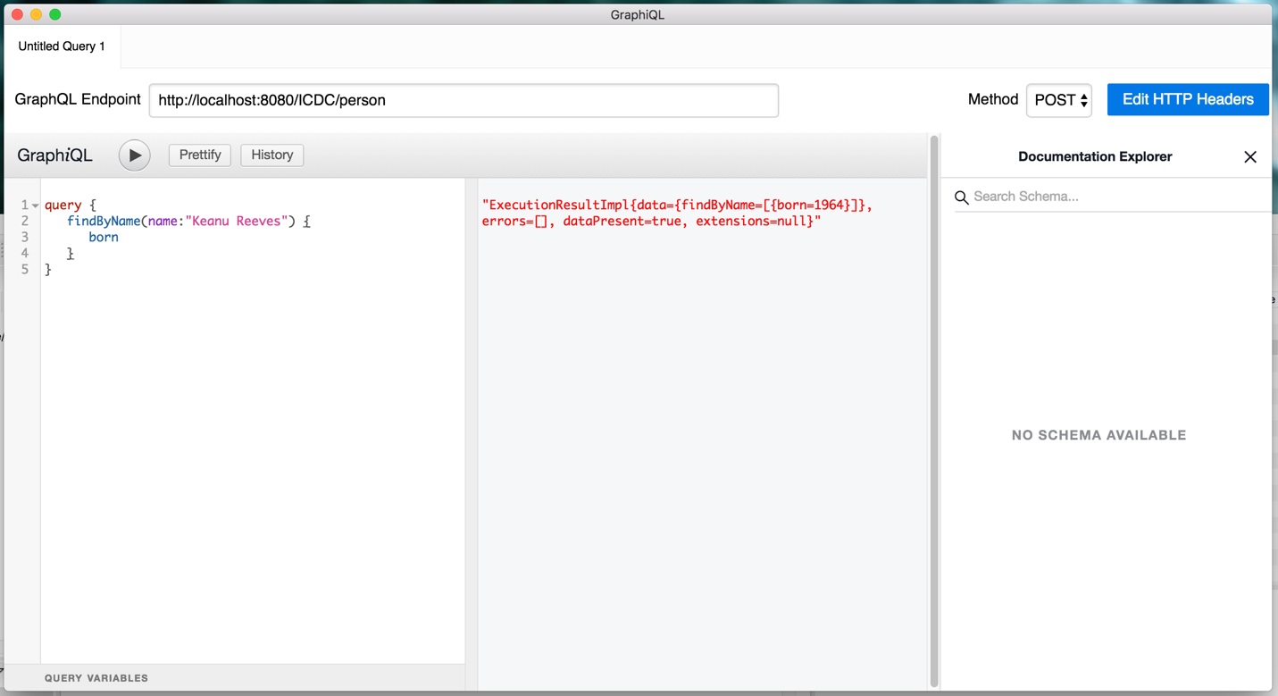

API Documentation with Restocks

Library required
TBD

Deployment(05/22/2019)

- Get Source Code
Create a directory : Mkdir tmp & cd tmp
Download source code :git clone https://github.com/jonkiky/neo4j_for_testing.git
- Build Project
CD project directory: cd project_name
Maven Build : mvn package
- ReName the War file
CD compiled files: cd target
Rename : mv RESTFfullDemo-0.0.1 SNAPSHOT.war ./RESTFfullDemo.war
- Deploy to the tomcat
  - From GUI
    - CD tomcat bin : cd ****/apache-tomcat-9.0.19/bin
    - Start Tomcat : sudo ./startup.sh
    - Browser to the link : http://localhost:8080/manager/html
    - At War file to deploy section , choose file then click deploy.
    - Browser to the link : http://localhost:8080/ RESTFfullDemo
    - Stop tomcat: sudo ./shutdown.sh
  - From Command line
TBD

Java Style Guide
Source: https://github.com/twitter/commons/blob/master/src/java/com/twitter/common/styleguide.md

CamelCase for types, camelCase for variables, UPPER_SNAKE for constants

No trailing whitespace
Trailing whitespace characters, while logically benign, add nothing to the program. However, they do serve to frustrate developers when using keyboard shortcuts to navigate code.

Indent style

We use the "one true brace style" (1TBS). Indent size is 2 columns.
:::java
// Good.
if (x < 0) {
negative(x);
} else {
nonnegative(x);
}

Continuation indent is 4 columns. Nested continuations may add 4 columns or 2 at each level.
// Good.
// - Each component of the message is separate and self-contained.
// - Adding or removing a component of the message requires minimal reformatting.
throw new IllegalStateException("Failed to process"
+ " request " + request.getId()
+ " for user " + user.getId()
+ " query: '" + query.getText() + "'");
Don't break up a statement unnecessarily.

Method declaration continuations.
:::java
// Sub-optimal since line breaks are arbitrary and only filling lines.
String downloadAnInternet(Internet internet, Tubes tubes,
Blogosphere blogs, Amount<Long, Data> bandwidth) {
tubes.download(internet);
...
}

// Preferred for easy scanning and extra column space.
public String downloadAnInternet(
Internet internet,
Tubes tubes,
Blogosphere blogs,
Amount<Long, Data> bandwidth) {

tubes.download(internet);
...
}

Chained method calls
:::java
// Bad.
// - Line breaks are based on line length, not logic.
Iterable<Module> modules = ImmutableList.<Module>builder().add(new LifecycleModule())
.add(new AppLauncherModule()).addAll(application.getModules()).build();

// Good.
// - Method calls are isolated to a line.
// - The proper location for a new method call is unambiguous.
Iterable<Module> modules = ImmutableList.<Module>builder()
.add(new LifecycleModule())
.add(new AppLauncherModule())
.addAll(application.getModules())
.build();

Variable naming

Extremely short variable names should be reserved for instances like loop indices.
:::java
// Bad.
// - Field names give little insight into what fields are used for.
class User {
private final int a;
private final String m;

...
}

// Good.
class User {
private final int ageInYears;
private final String maidenName;

...
}

Include units in variable names
:::java
// Bad.
long pollInterval;
int fileSize;

// Better.
// - Unit is built in to the type.
// - The field is easily adaptable between units, readability is high.
Amount<Long, Time> pollInterval;
Amount<Integer, Data> fileSize;

Don't embed metadata in variable names
A variable name should describe the variable's purpose. Adding extra information like scope and type is generally a sign of a bad variable name.

Avoid embedding the field type in the field name.
:::java
// Bad.
Map<Integer, User> idToUserMap;
String valueString;

// Good.
Map<Integer, User> usersById;
String value;

Avoid embedding scope information in a variable.
Hierarchy-based naming suggests that a class is too complex and should be broken apart.
:::java
// Bad.
String _value;
String mValue;

// Good.
String value;

Space pad operators and equals

:::java
// Bad.
// - This offers poor visual separation of operations.
int foo=a+b+1;

// Good.
int foo = a + b + 1;

Be explicit about operator precedence
Don't make your reader open the spec to confirm, if you expect a specific operation ordering, make it obvious with parenthesis.
:::java
// Bad.
return a << 8 * n + 1 | 0xFF;

// Good.
return (a << (8 * n) + 1) | 0xFF;
It's even good to be really obvious.
:::java
if ((values != null) && (10 > values.size())) {
...
}

Documentation

The more visible a piece of code is (and by extension - the farther away consumers might be), the more documentation is needed.
"I'm writing a report about..."
Your elementary school teacher was right - you should never start a statement this way. Likewise, you shouldn't write documentation this way.
:::java
// Bad.
/**
* This is a class that implements a cache. It does caching for you.
*/
class Cache {
...
}

// Good.
/**
* A volatile storage for objects based on a key, which may be invalidated and discarded.
*/
class Cache {
...
}

Documenting a class
Documentation for a class may range from a single sentence to paragraphs with code examples. Documentation should serve to disambiguate any conceptual blanks in the API, and make it easier to quickly and correctly use your API. A thorough class doc usually has a one sentence summary and, if necessary, a more detailed explanation.
:::java
/**
* An RPC equivalent of a unix pipe tee. Any RPC sent to the tee input is guaranteed to have
* been sent to both tee outputs before the call returns.
*
* @param <T> The type of the tee'd service.
*/
public class RpcTee<T> {
...
}

Documenting a method
A method doc should tell what the method does. Depending on the argument types, it may also be important to document input format.
:::java
// Bad.
// - The doc tells nothing that the method declaration didn't.
// - This is the 'filler doc'. It would pass style checks, but doesn't help anybody.
/**
* Splits a string.
*
* @param s A string.
* @return A list of strings.
*/
List<String> split(String s);

// Great.
// - Covers yet another edge case.
/**
* Splits a string on whitespace. Repeated whitespace characters are collapsed.
*
* @param s The string to split. An {@code null} string is treated as an empty string.
* @return A list of the whitespace-delimited parts of the input.
*/
List<String> split(String s);

Import ordering
Imports are grouped by top-level package, with blank lines separating groups. Static imports are grouped in the same way, in a section below traditional imports.
:::java
import java.*
import javax.*

import scala.*

import com.*

import net.*

import org.*

import com.twitter.*

import static *
No wildcard imports
Wildcard imports make the source of an imported class less clear. They also tend to hide a high class fan-out.
See also texas imports
:::java
// Bad.
// - Where did Foo come from?
import com.twitter.baz.foo.*;
import com.twitter.*;

interface Bar extends Foo {
...
}

// Good.
import com.twitter.baz.foo.BazFoo;
import com.twitter.Foo;

interface Bar extends Foo {
...
}

Use annotations wisely

@Nullable
By default - disallow null. When a variable, parameter, or method return value may be null, be explicit about it by marking @Nullable. This is advisable even for fields/methods with private visibility.
:::java
class Database {
@Nullable private Connection connection;

@Nullable
Connection getConnection() {
return connection;
}

void setConnection(@Nullable Connection connection) {
this.connection = connection;
}
}

@VisibleForTesting
Sometimes it makes sense to hide members and functions in general, but they may still be required for good test coverage. It's usually preferred to make these package-private and tag with @VisibleForTesting to indicate the purpose for visibility.
Constants are a great example of things that are frequently exposed in this way.
:::java
// Bad.
// - Any adjustments to field names need to be duplicated in the test.
class ConfigReader {
private static final String USER_FIELD = "user";

Config parseConfig(String configData) {
...
}
}
public class ConfigReaderTest {
@Test
public void testParseConfig() {
...
assertEquals(expectedConfig, reader.parseConfig("{user: bob}"));
}
}

// Good.
// - The test borrows directly from the same constant.
class ConfigReader {
@VisibleForTesting static final String USER_FIELD = "user";

Config parseConfig(String configData) {
...
}
}
public class ConfigReaderTest {
@Test
public void testParseConfig() {
...
assertEquals(expectedConfig,
reader.parseConfig(String.format("{%s: bob}", ConfigReader.USER_FIELD)));
}
}

Clean code

Disambiguate Favor readability
if there's an ambiguous and unambiguous route, always favor unambiguous.
:::java
// Bad.
// - Depending on the font, it may be difficult to discern 1001 from 100l.
long count = 100l + n;

// Good.
long count = 100L + n;

Remove dead code
Delete unused code (imports, fields, parameters, methods, classes). They will only rot.

Use general types
When declaring fields and methods, it's better to use general types whenever possible. This avoids implementation detail leak via your API, and allows you to change the types used internally without affecting users or peripheral code.
:::java
// Bad.
// - Implementations of Database must match the ArrayList return type.
// - Changing return type to Set<User> or List<User> could break implementations and users.
interface Database {
ArrayList<User> fetchUsers(String query);
}

// Good.
// - Iterable defines the minimal functionality required of the return.
interface Database {
Iterable<User> fetchUsers(String query);
}

Avoid typecasting
Typecasting is a sign of poor class design, and can often be avoided. An obvious exception here is overriding equals.

TODOs

Leave TODOs early and often
A TODO isn't a bad thing - it's signaling a future developer (possibly yourself) that a consideration was made, but omitted for various reasons. It can also serve as a useful signal when debugging.

Leave no TODO unassigned
TODOs should have owners, otherwise they are unlikely to ever be resolved.
:::java
// Bad.
// - TODO is unassigned.
// TODO: Implement request backoff.

// Good.
// TODO(George Washington): Implement request backoff.

Adopt TODOs
You should adopt an orphan if the owner has left the company/project, or if you make modifications to the code directly related to the TODO topic.

